Merge Sort - Divide and Conquer Technique
- التحليل الخاص به عندنا طريقتين
Recursion- tree method | Master method – Master Theorem
----
- هنتعرف على طريقة recursion-tree method
n = 4
Level 0 | 4 | 1 | 5 | 9
Level 1 | 4 | 1 | 5 | 9
Level 2 | 4 | 1 | 5 | 9

- ممكن تفكر وتقول هو لازم tree ؟
الاجابه اه طالما انت دخلت سكة التقسم يبقى tree طالما انت نازل تقسم
- لمعرفه complexity class
نضرب المستويات * عدد العناصر
3 * 4 = 12
n = 8
Level 0 | 8
Level 1 | 4 |  |  |  | 4
Level 2 | 2 |  | 2 |  | 2 |  | 2
Level 3 | 1 | 1 | 1 | 1 | 1 | 1 | 1 | 1

Level 0 | n
Level 1 |  | n/2 |  |  |  | n/2
Level 2 |  | n/4 |  | n/4 |  | n/4 |  | n/4
Last level |  | ----- | nn | nn | nn | nn | nn | nn | ----
K = last level
K + 1 = count of levels

n = 4, k =2
n = 8, k =3
n = 16, k =4
k = log₂n
f(n) = n * K + 1
f(n) = n * log₂n + 1
f(n) = O(nlogn) as n approaches to infinity
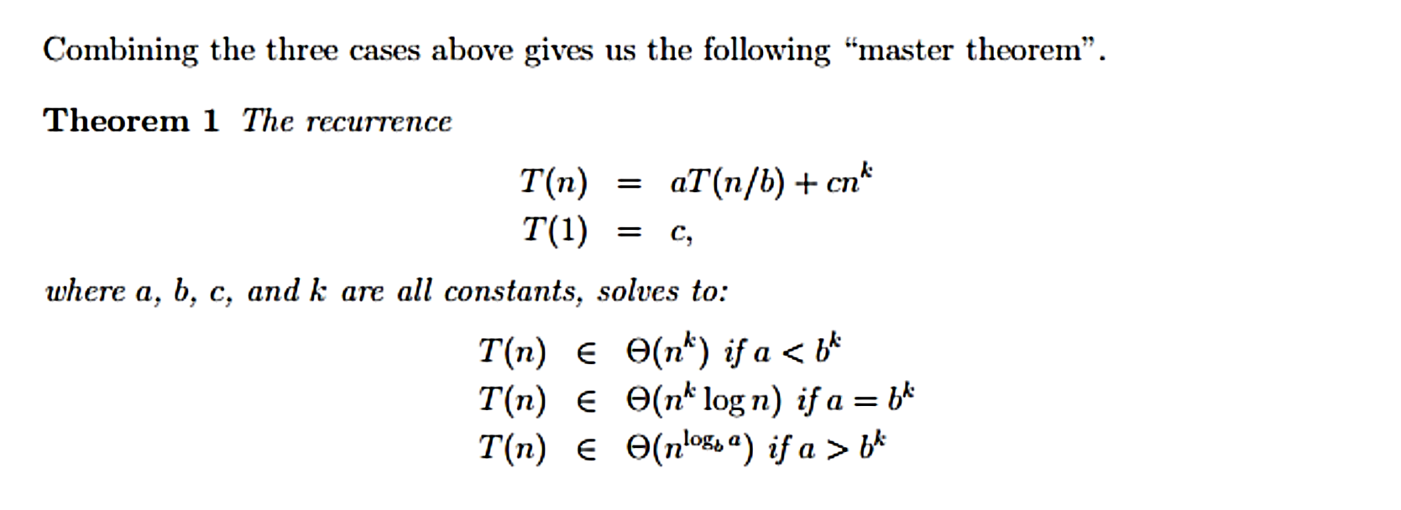
Second Analysis Master Method (Master theorem )

