**Lab (3)**

**Task:**

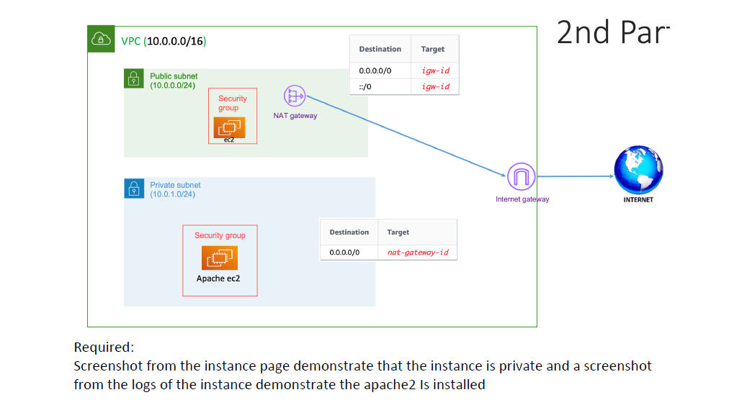

**Solutions**:  
  
1- Create VPC  
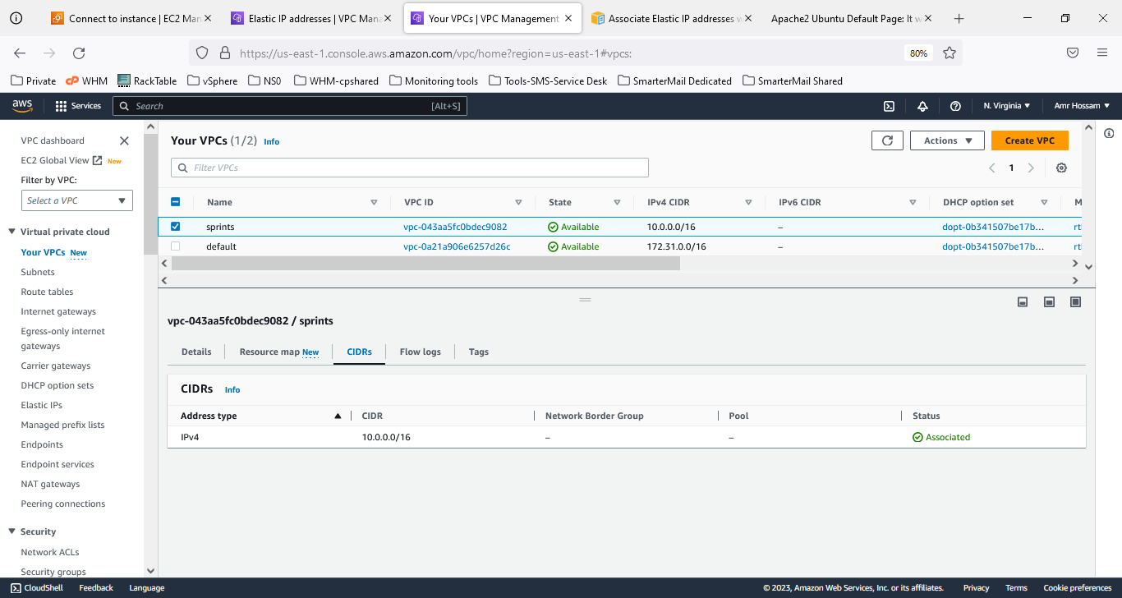  
  
  
2- Create Subnets  
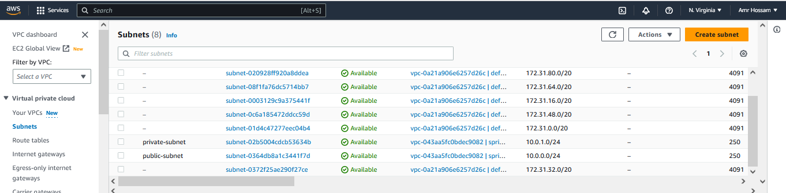

3-Create Gateway  
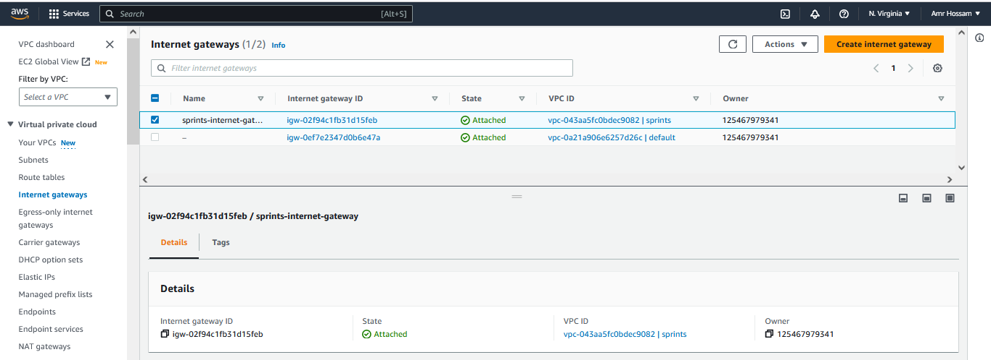

4-Create Route table  
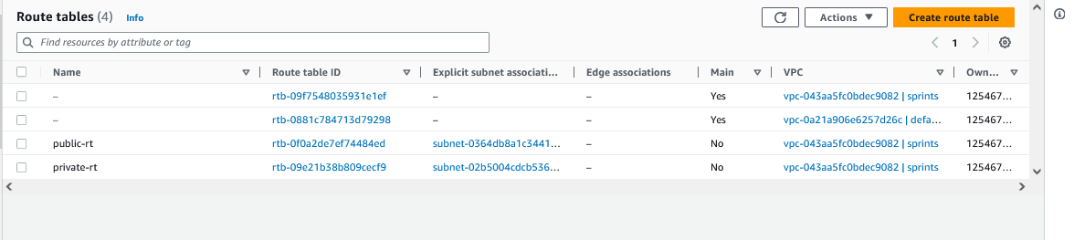  
  
5-Create NAT  
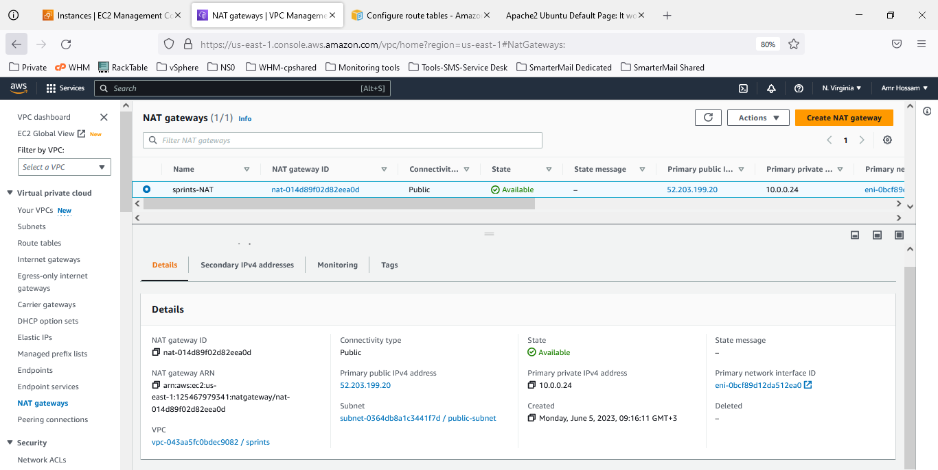  
  
  
6- Create Elastic IP  
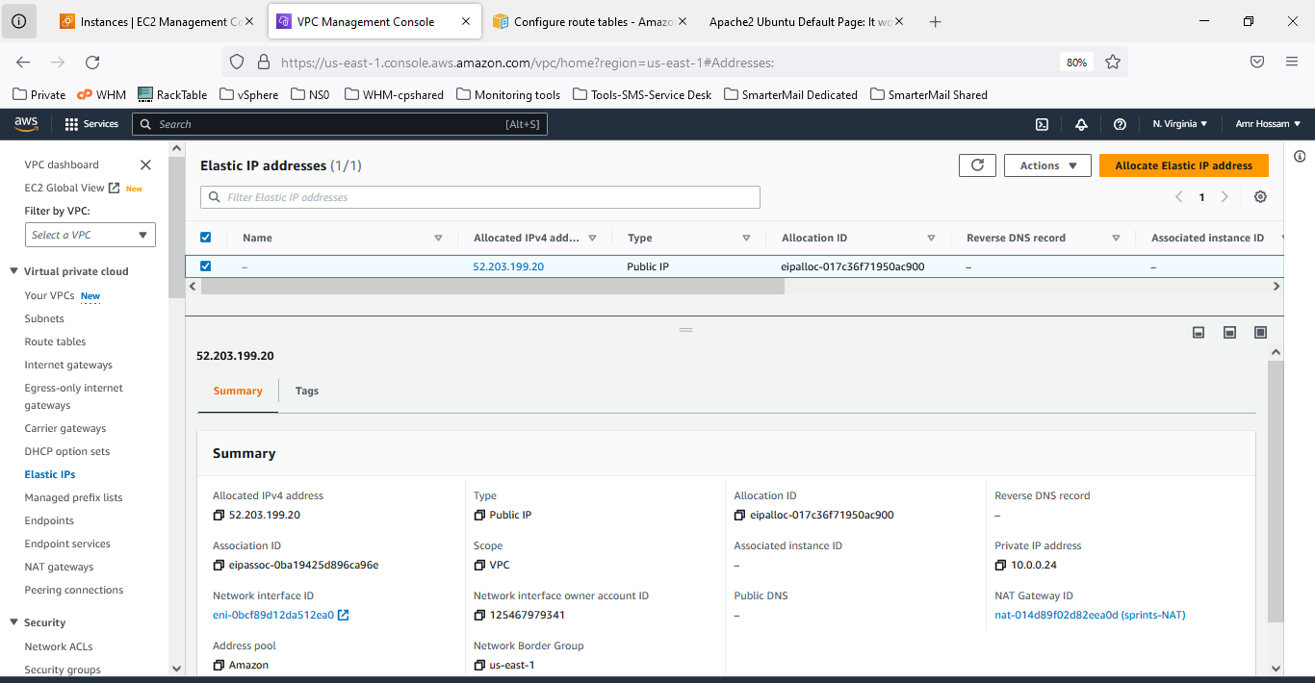

7- Create Ec2 with User data to install apache2 when start up   
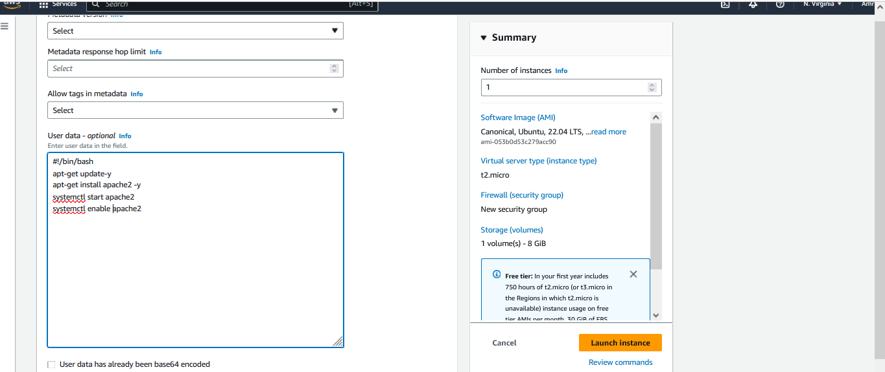

8- All Ec2  
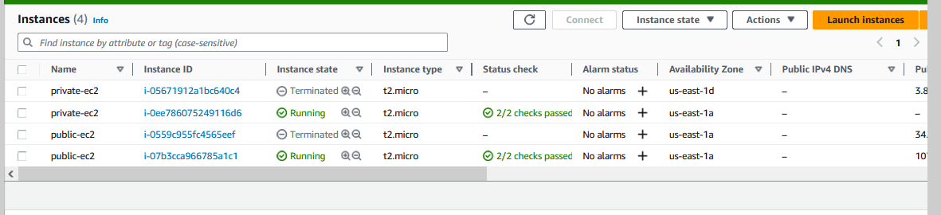

9- Try the apache2 on public ec2  
