**Lab (4)**

1- Launch a jump host Take a screen while you are ssh to the jumphost Also When you ssh from bastion to the private machine Screenshot from the console showing the instances Ips  
  
**Solution:**  
  
 a) Create a public instance (bastion) and Private ec2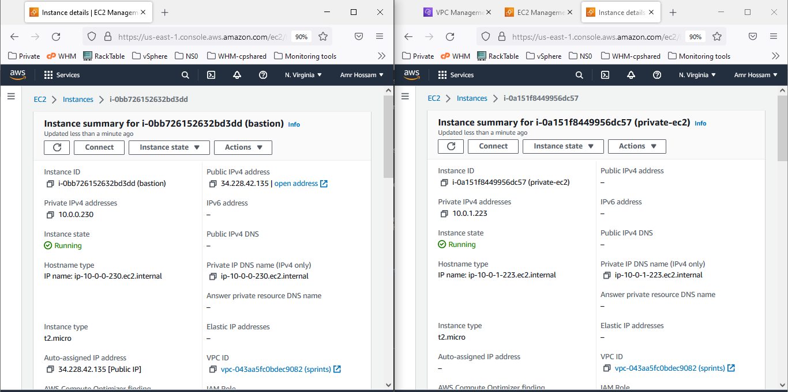  
  
  
  
  
  
  
  
  
  
  
  
  
  
  
  
  
  
  
  
  
  
 b) Secure copy for the key to the public ec2  
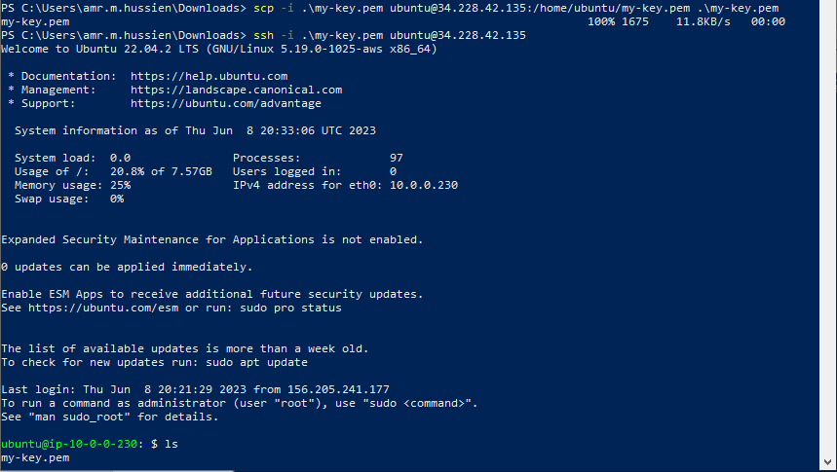  
  
 c) Now you Can access the private ec2 with jumphost  
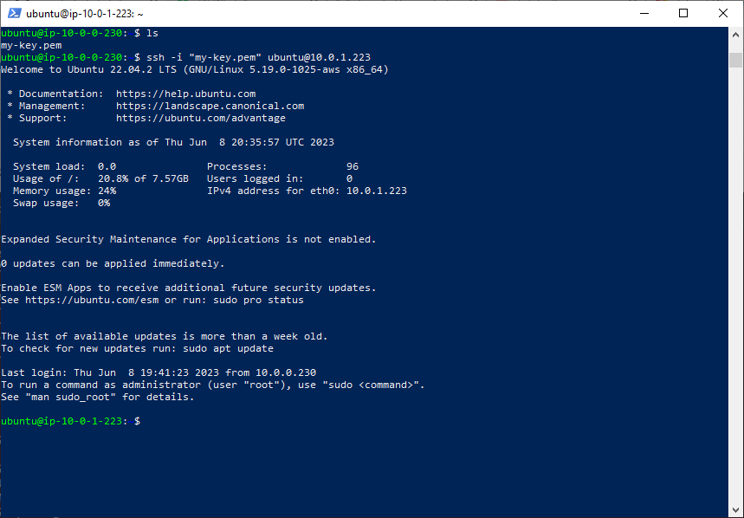  
  
  
2- Question 2:  
  
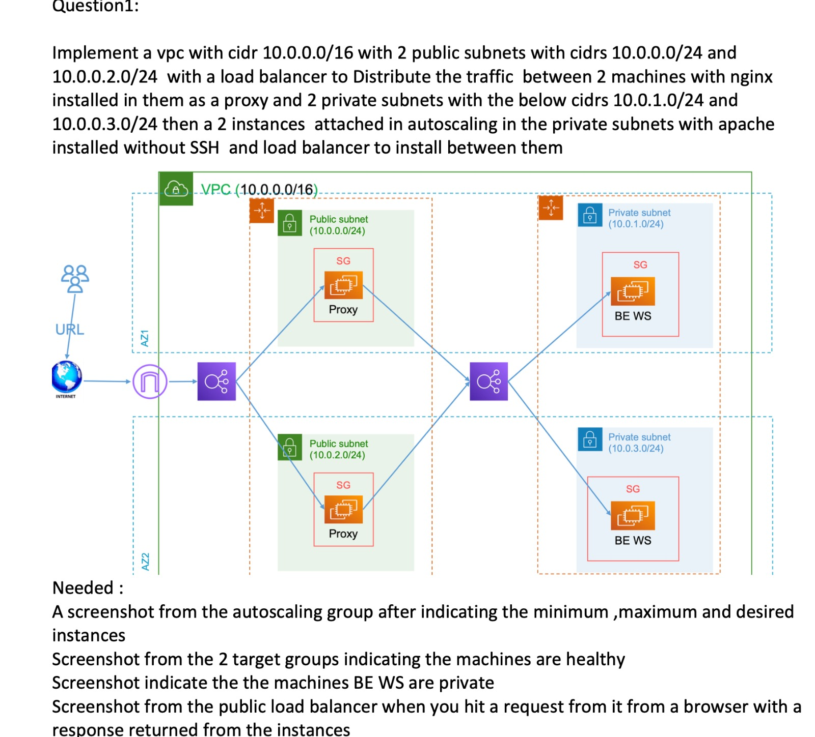  
  
  
  
  
  
  
  
  
  
  
  
  
  
**Solution:**Auto Scaling Group:   
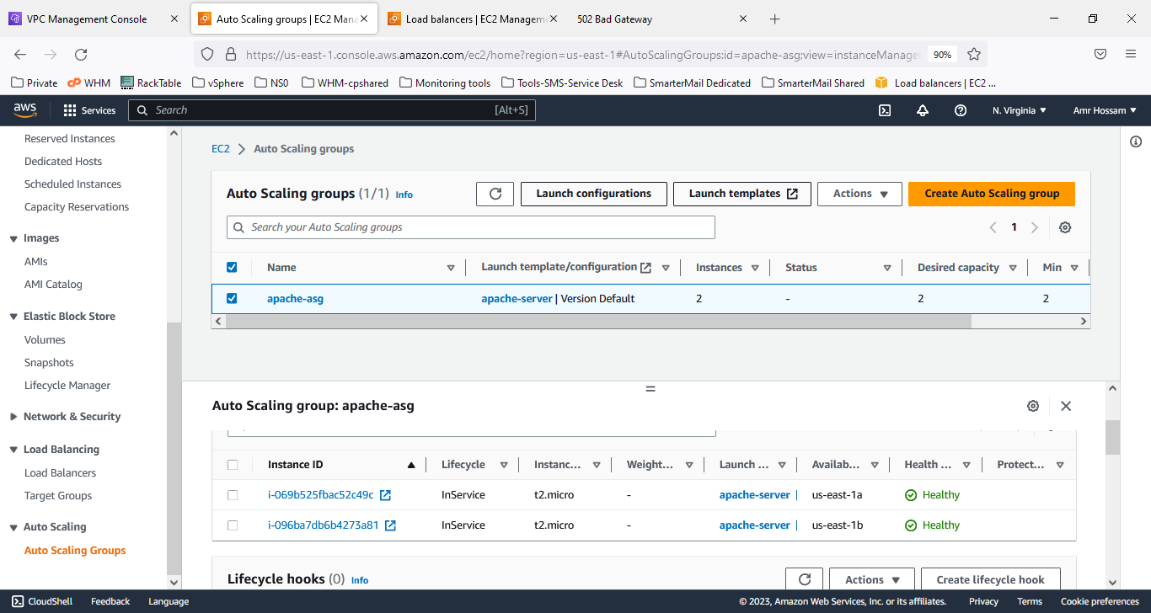  
  
Target Groups with Healthy check:  
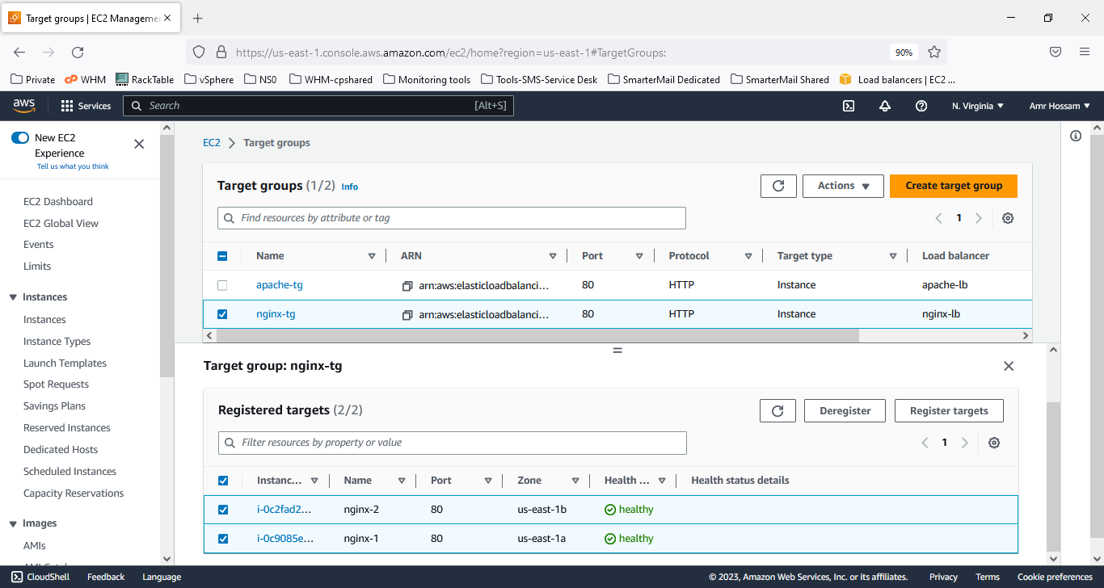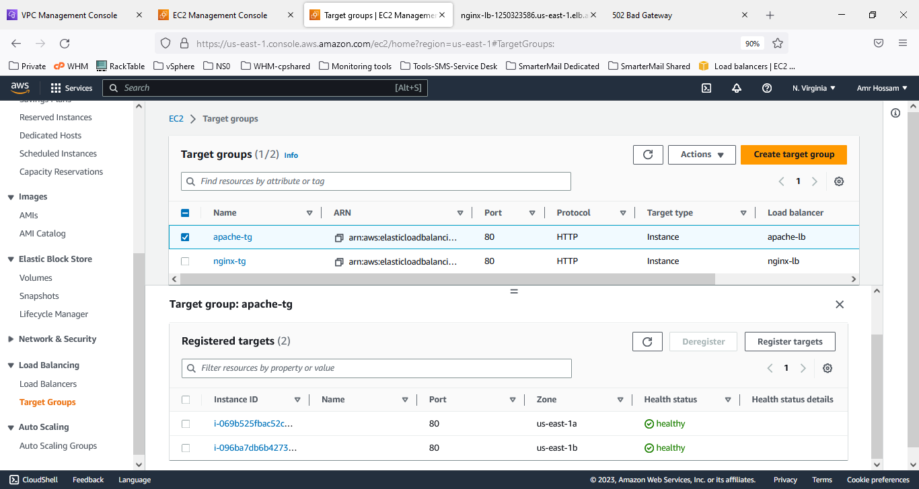  
  
Load Balancer:  
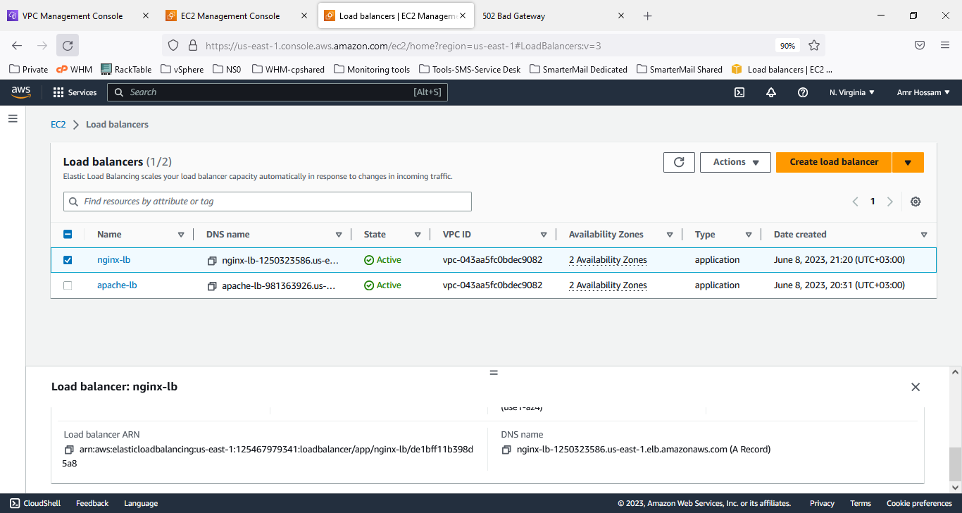  
  
  
  
  
  
  
  
  
Indicates Machines Be AWS are Private  
Public load balancer when you hit a request from a browser with returned response  
  
The output contains the private ips in the body of web