Retail Sales Report

Contents
Retail Sales Report 1
Summary 2
Data Overview 2
Figure 1: Data Overview 2
Customer Age Profile 2
Revenue Over Time 3
Figure 2: Monthly Revenue 3
Product Category Revenue 3
Figure 3: Categories Revenue 3
Product Category Purchase Frequency 4
Figure 4: Category Purchase Count 4
Figure 5: Monthly Category Purchase Count 4
Product Category Revenue by Gender 5
Figure 6: Distribution of Female Purchases 5
Figure 7: Distribution of Male Purchases 5
Spending Distribution by Gender and Category 6
Figure 8: Male Shopping Distribution Across Categories 6
Figure 9: Female Shopping Distribution Across Categories 6
Transaction Value Distribution 7
Figure 10: Transaction Value Quartiles and Revenue Share 7
Key Insights and Business Implications 8
Conclusion 8
Recommendations 8

Summary
This report analyzes retail sales transactions recorded throughout 2023 to identify trends in revenue, product performance, and customer behavior. The findings show that revenue is concentrated in specific product categories and time periods, with customer demographics playing a significant role in purchasing patterns. These insights can support data-driven decisions related to marketing, inventory management, and sales strategy.

Data Overview
The dataset consists of 1000 retail transactions collected over a one-year period.
Each transaction includes:
- Qualitative variables: such as customer gender, product category.
- Quantitative variables: quantity purchased, unit price, transaction value, and customer age.
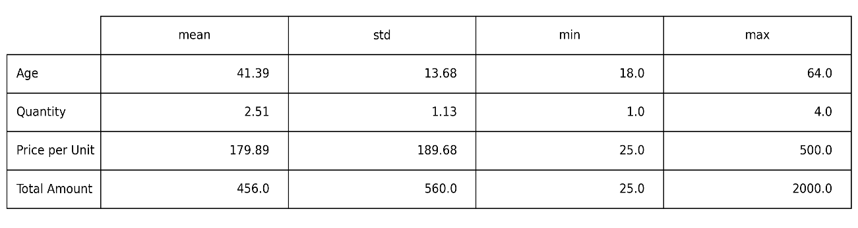
Figure 1: Data Overview

Customer Age Profile
The age distribution of customers shows that most purchases are made by individuals within the adult working-age range on average of 40 years old. Younger and older age groups contribute less to total transaction volume. This suggests that the primary customer base lies within a specific age range that can be prioritized for promotional activities and loyalty initiatives.

Revenue Over Time
Monthly revenue analysis reveals fluctuations across the year, indicating non-uniform sales performance. Certain months exhibit noticeably higher sales levels, suggesting the influence of seasonal purchases, promotions, or consumer demand cycles. Which can give us a better understanding of the best time of the year to initialize marketing campaigns, and inventory management.
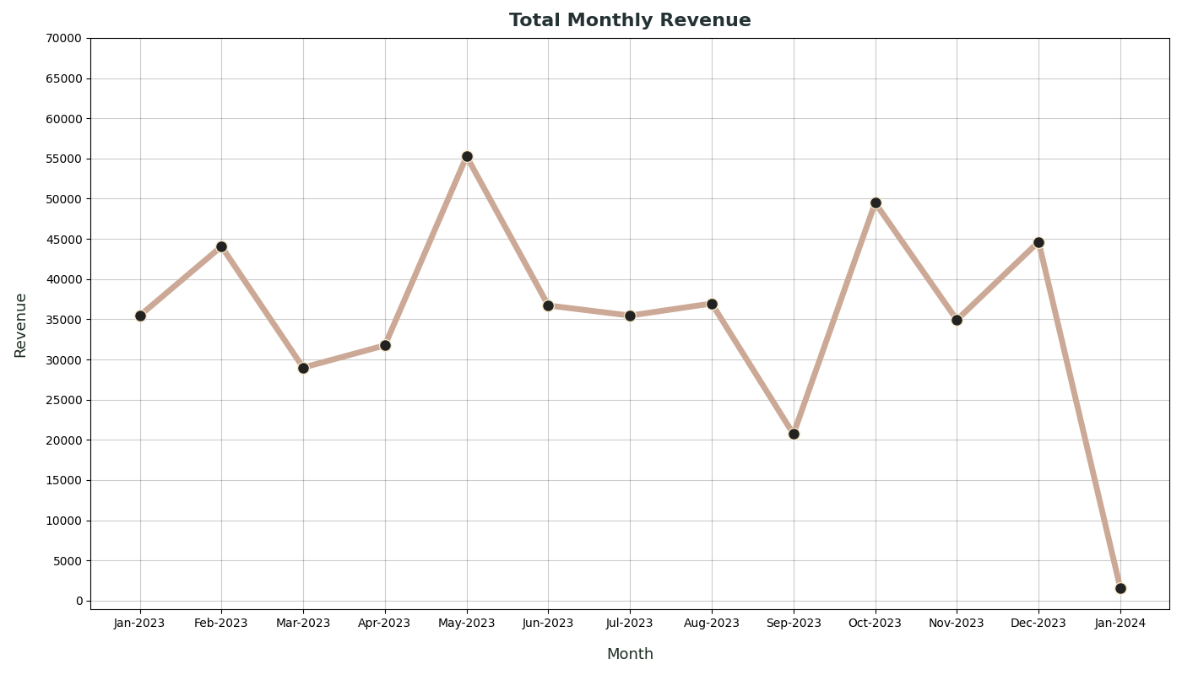
Figure 2: Monthly Revenue

Product Category Revenue
When analyzed by revenue, the three product categories contribute relatively evenly. Clothing remains a strong performer due to its combination of purchase frequency and price, while Electronics contribute slightly more revenue per transaction. Beauty products, although frequently purchased, generate slightly lower revenue per transaction compared to the other categories. Overall, revenue performance is relatively balanced across categories, reflecting both purchase frequency and price.
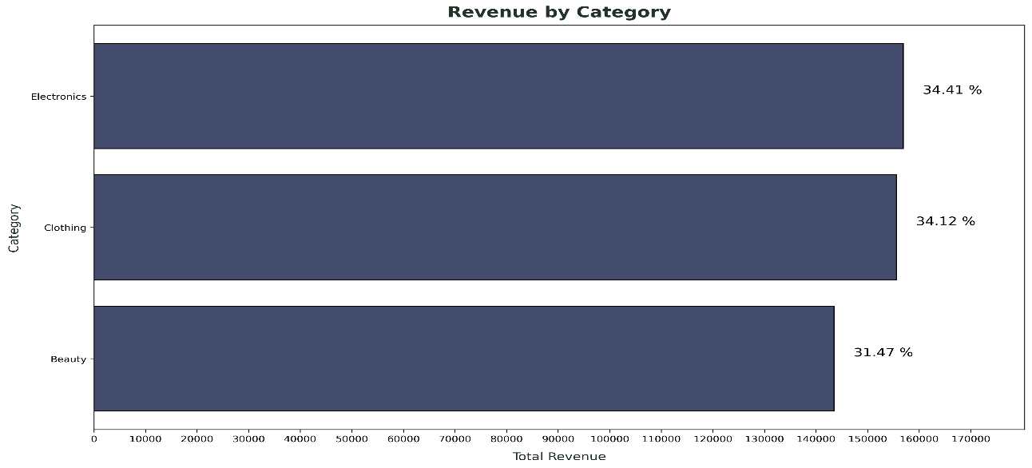
Figure 3: Categories Revenue

Product Category Purchase Frequency
Transaction volumes are relatively balanced across product categories. Clothing records the highest number of transactions, followed closely by Electronics, and then Beauty, indicating substantial customer demand for all three. Month-to-month analysis shows that Clothing achieves higher sales in the first half of the year, Electronics dominate in the second half, and Beauty peaks in July, corresponding to the summer / vacation season.
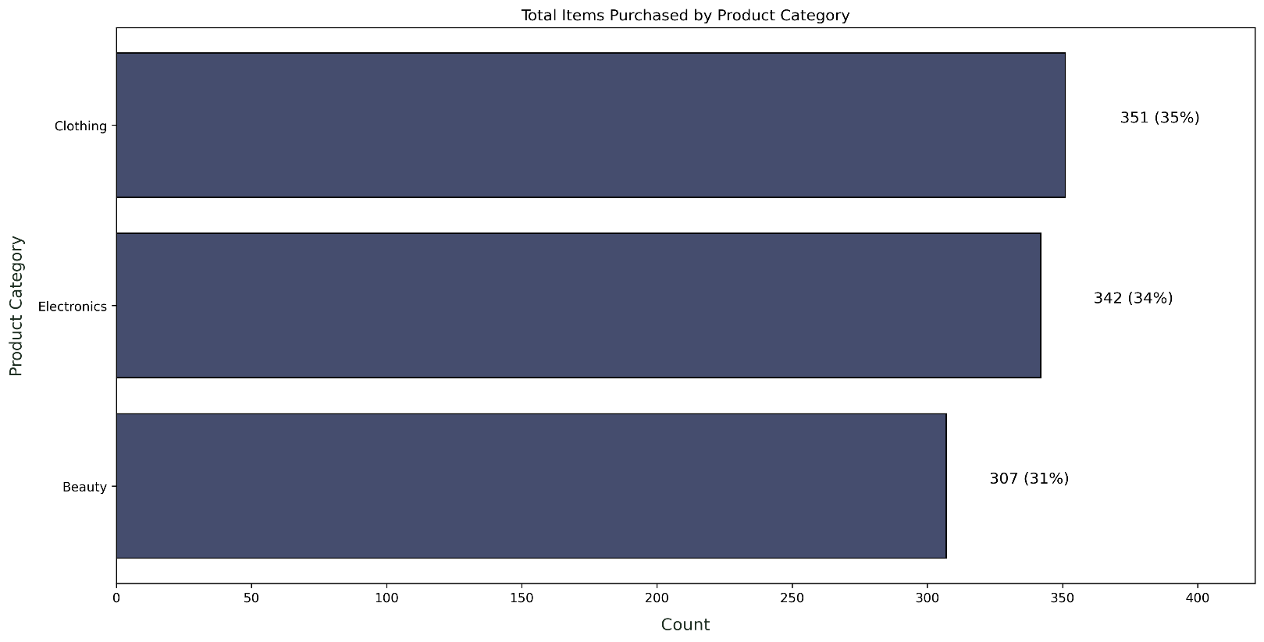
Figure 4: Category Purchase Count
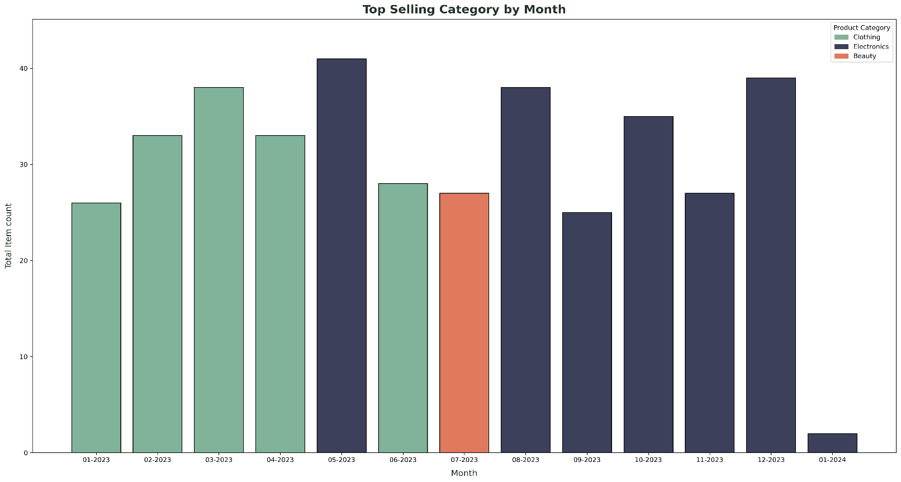
Figure 5: Monthly Category Purchase Count

Product Category Revenue by Gender
Revenue patterns differ slightly between female and male shoppers. For females, Beauty drives revenue in the first half of the year (Q1: 40%, Q2: 35%), followed by Clothing (Q1: 32%, Q2: 34%). In the second half, Clothing and Electronics take the lead (Q3: 38% Clothing, 35% Electronics; Q4: 35% Clothing, 37% Electronics).
Male shopping patterns fluctuate more: Q1 is dominated by Clothing (46%), with Beauty (29%) and Electronics (25%). In Q2, Electronics lead (44%), followed by Clothing (33%) and Beauty (23%). Q3 sees Beauty on top (42%), Electronics (34%), and Clothing (24%), while Q4 is led by Electronics (39%), Beauty (32%), and Clothing (29%).
Overall, total revenue is almost evenly split between genders (Female: 232,840; Male: 223,160), with female spending consistent across the year and male spending peaking in spring and dipping in summer.
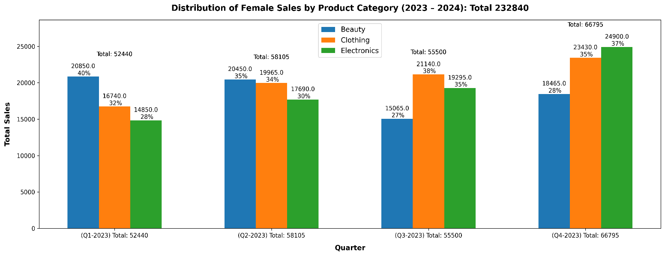
Figure 6: Distribution of Female Purchases
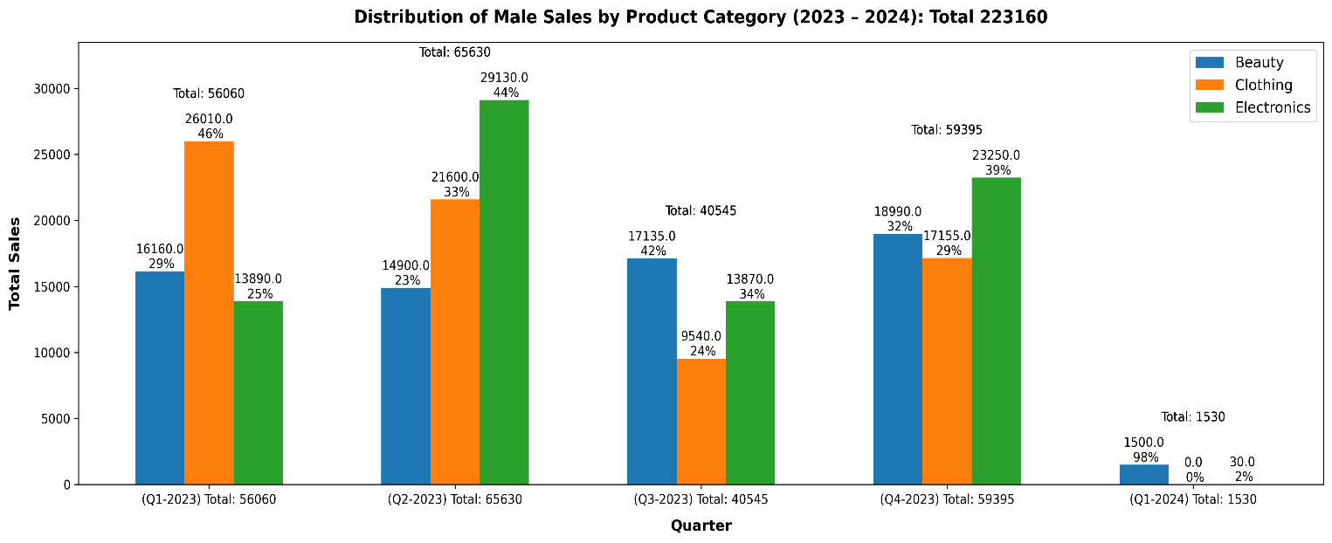
Figure 7: Distribution of Male Purchases

Spending Distribution by Gender and Category
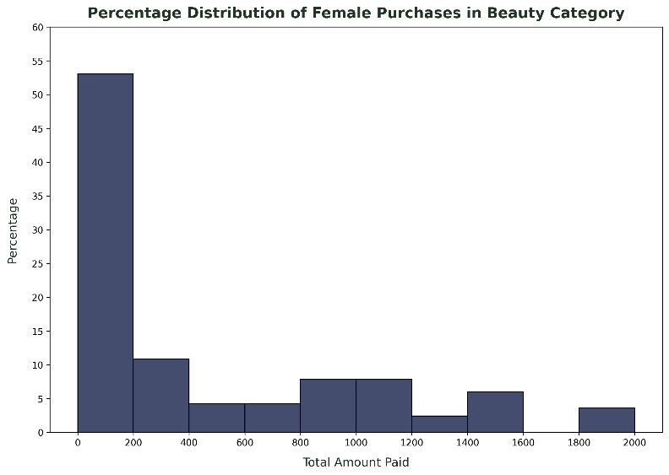
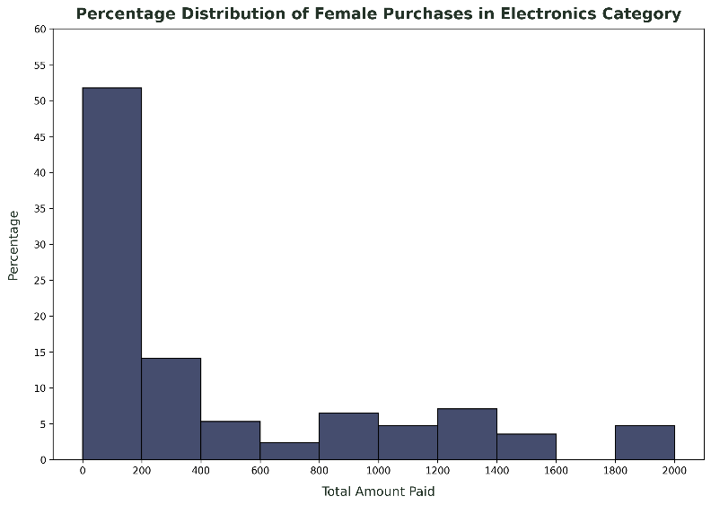
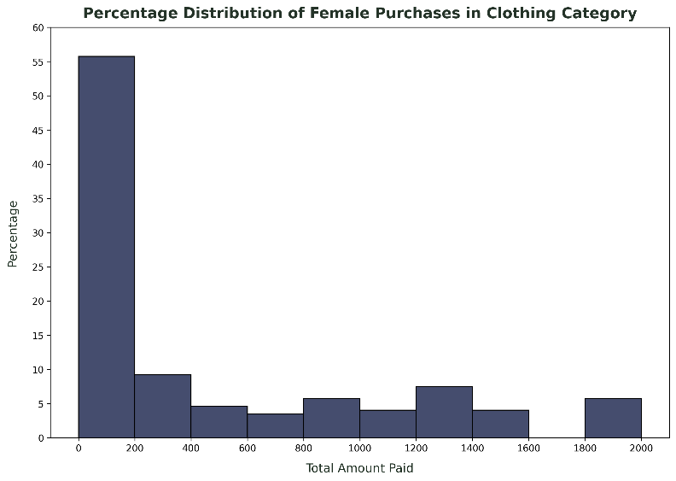
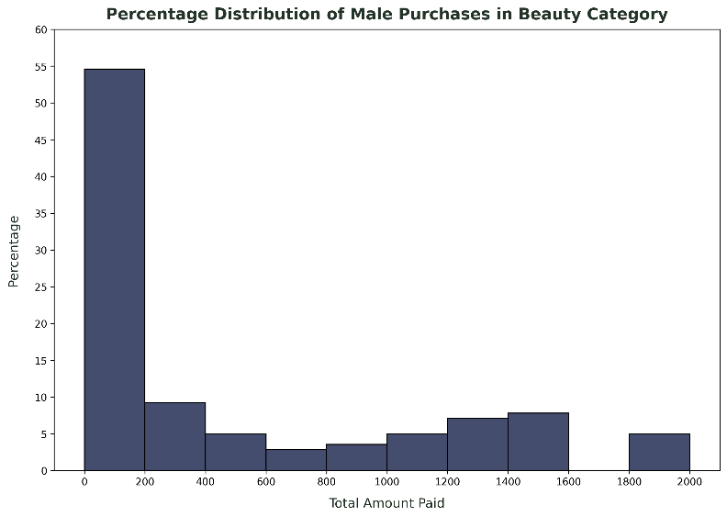
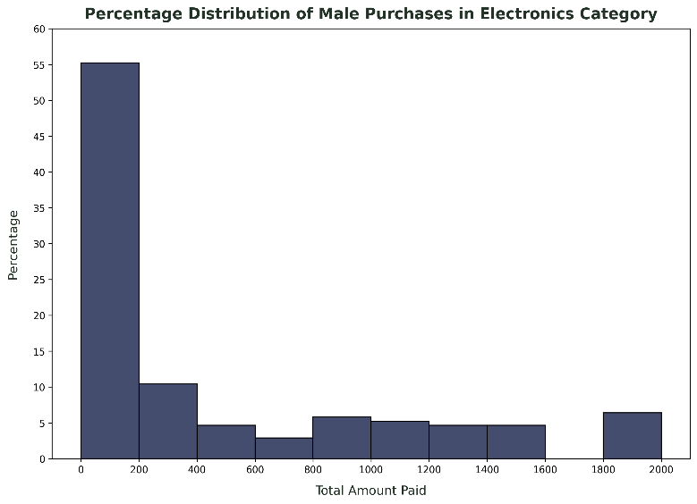
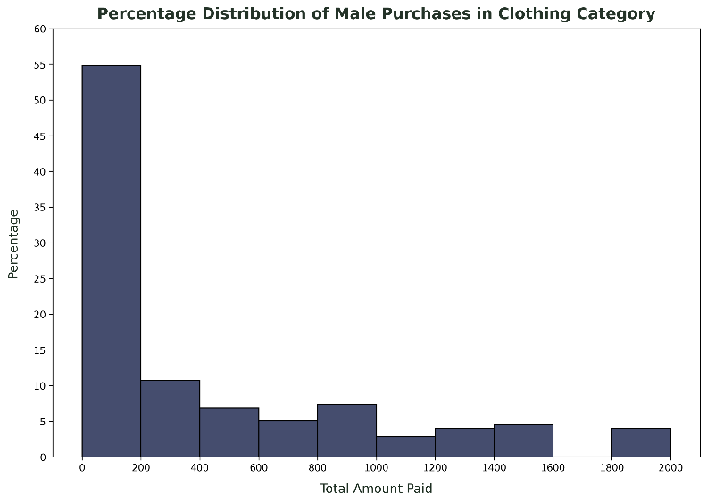
The distribution of transaction values is right-skewed for both female and male shoppers across all product categories, as shown. Most purchases fall within lower spending ranges, while a smaller number of high-value transactions contribute a significant portion of total revenue, highlighting the importance of high-ticket and premium items in overall business performance.
Figure 8: Male Shopping Distribution Across Categories
Figure 9: Female Shopping Distribution Across Categories

Transaction Value Distribution
Breaking down transaction values by quartiles further reinforces this pattern: the fourth quartile, representing the highest-value purchases, contributes the largest share of total revenue. While the lower three quartiles account for most transactions, it is the top-tier purchases that drive overall revenue, underscoring the critical role of premium and high-ticket items in business performance.
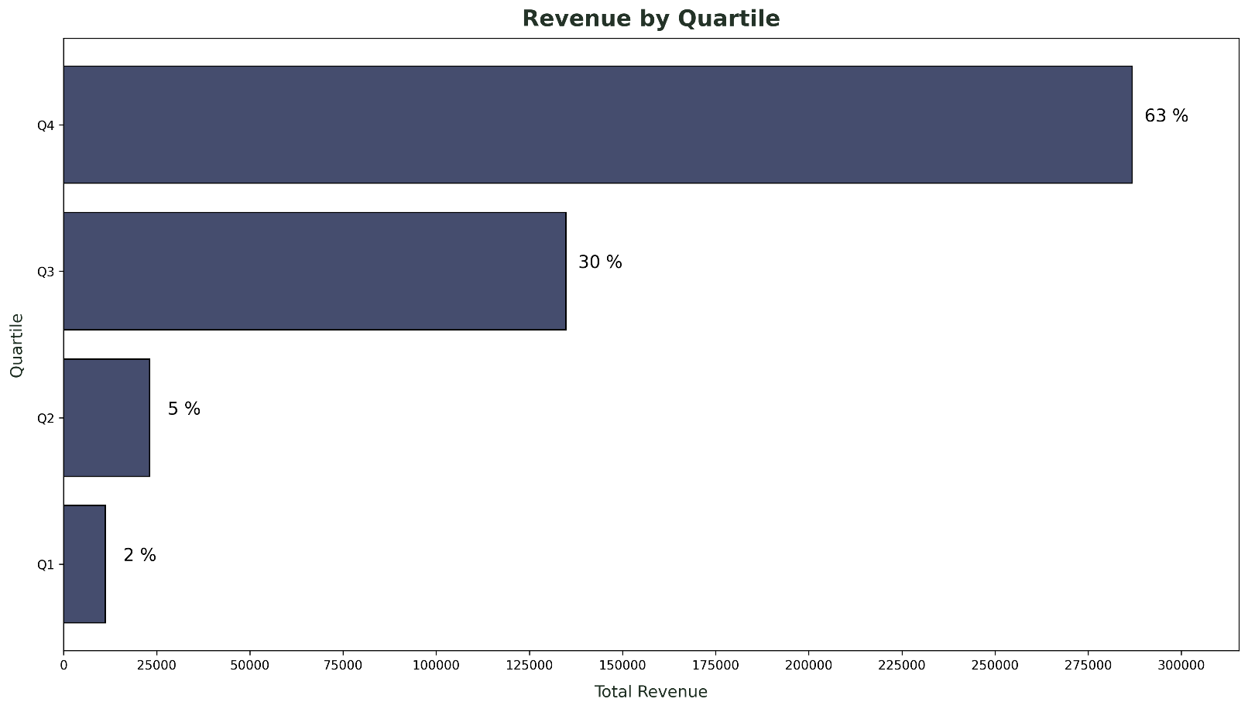
Figure 10: Transaction Value Quartiles and Revenue Share

Key Insights and Business Implications
- Sales performance varies by month, suggesting seasonal demand patterns.
- Customer purchasing behavior differs by gender and age group, indicating potential for targeted marketing strategies.
- A small number of high-value transactions significantly impact total revenue, emphasizing the importance of premium products.

Conclusion
Overall business performance is driven by product category mix, customer demographics, and timing of sales. Focusing on high-revenue categories and aligning marketing with key customer segments can boost profitability, while leveraging seasonal trends enables targeted promotions, optimized inventory, and increased revenue from both high-volume and high-value purchases.

Recommendations
- Focus on High-Revenue Categories: Prioritize Electronics and Clothing in marketing and inventory strategies, as they consistently contribute the largest share of revenue across both genders.
- Leverage Seasonal Trends: Align promotions and campaigns with peak periods, such as Beauty in summer for females and Electronics in spring for males, to maximize engagement and sales.
- Targeted Gender-Based Marketing: Develop tailored campaigns based on gender-specific purchasing preferences, e.g., highlighting premium Beauty products to female shoppers in early quarters and Electronics to male shoppers in spring.
- Promote High-Value Products: Encourage upselling and premium product purchases, as the fourth quartile of transactions contributes disproportionately to revenue. Loyalty programs, bundles, or limited editions can drive these high-ticket purchases.
- Continuous Monitoring: Regularly track quarterly sales by category and gender to adjust strategies in real time, optimizing revenue and marketing Return On Investment.

