­

CUFE-EEE

PROPOSED TO Dr: Heba Ahmed

2021

EPMN302

Elements of Power System

Star to Star

Three Phase

PRESENTED ON: 5-04-2021

To Doctor/ Heba Ahmed  
To T.A/ Abdelrahman.M

AMR Mohmmed Shams   
1190563

Ahmed Ebid

1180514

Contents

Acknowledgements: 2

Abstract: 2

Introduction: 3

Methods & Program Model: 4

Methods & Program Model: 4

# Acknowledgements:

We would like to express our special thanks to our professor, as well as our teaching assistant, who gave us the golden opportunity to do this wonderful project, which helped us in doing a lot of? research and we came to know and learn about many different things which will strengthen us engineering capabilities. Finally, our thanks go to all the people who have supported us to complete the research work directly or indirectly.

# Abstract:

This project discusses the studying of the structure of Power Systems along with the calculations of AC Power systems, Balanced Y-Y. It allows us to calculate most related calculations more accurate to Power Systems. That is made possible through our program, which is developed through MATLAB and Simulink Besides QuickFiled. It simply contains a basic structure of a three-phase power system, through which our program illustrates both data sheet and transposition of three phase

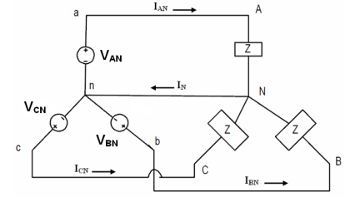

Y_Y 1

# Introduction:

After several sessions and brain storming. We have decided to create a simulation one of suggestions, we did have many ideas. Eventually, we decided to choose the transmission line as it has the basic concept of the course. Yet, the work required was overwhelming we decided to work on Balanced Y-Y three phase system. Each TL has inner conductor (FE) and outer conductor (AL). This is real simulation for a real circuit illustrated through both SW.

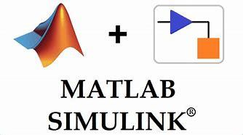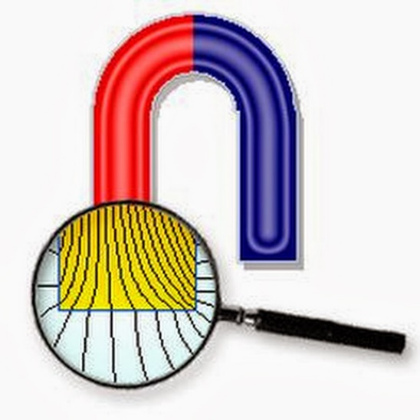

Both Apps have the same circuit. But the MATLAB shows more data related to the wave. On the other hand, QuickFiled is mainly for inductance measurement of TL.

# Methods & Program Model:

The first challenge we had to face was to create a Y-Y balanced Three-Phase system that runs on Simulink. After several attempts we came up with this solid design that uses “powergui” to simulate the system continuously with respect to time. We used three “Ac sources” and three loads “RLC” branches. We also used three transmission lines “RLC”. We connected the sources and the loads using branches and used measurement blocks to help us extract data. Measurement blocks like “Voltage and Current measurement” were used series to the transmission lines to measure current across lines and Voltage Line.

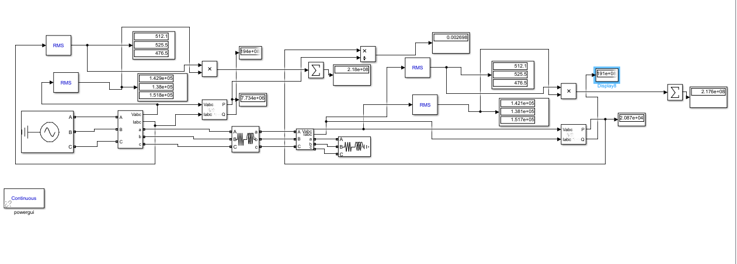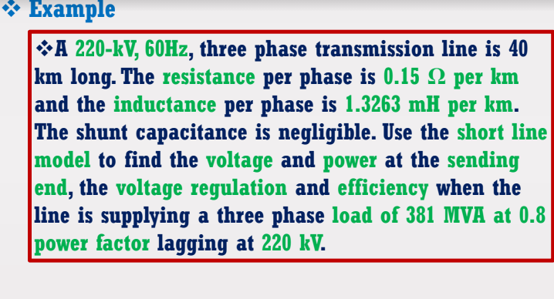

# Methods & Program Model:

I used in Quickfiled some assumptions, 19 Blocks 6 for each line Phase A has 6 blocks three for AL and three for FE. Tow Layers 1- Boundary 2-Ground

• The air is ideal besides the permeability is 1

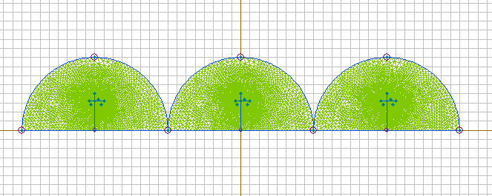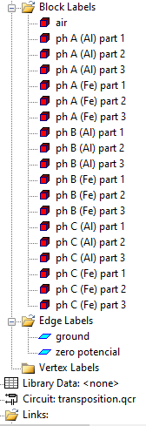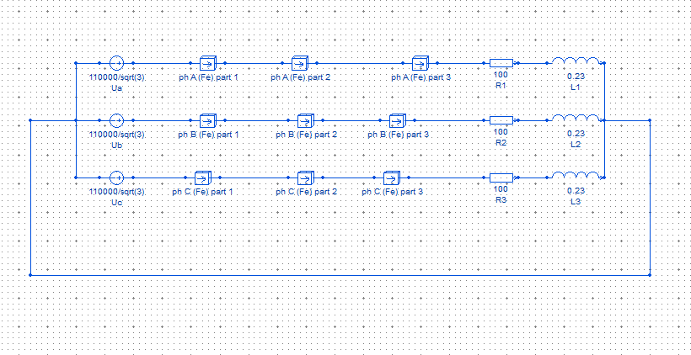

QuickFiled 1

 