1. Introduction

1.1 Purpose of the Document
The purpose of this Design Document is to provide a comprehensive architectural and component-level detailed description of the Pharmacy Web Store system. It serves as a blueprint for the development process, translating the system requirements into a structural design. This document ensures that the implementation of the backend logic, database schema, and user interface is consistent, maintainable, and aligned with the project goals.

1.2 Scope of the Design Phase
This document covers the design of the entire web application ecosystem. Specifically, it includes:
- System Architecture: The high-level Monolithic structure using the MVC pattern.
- Module Design: Detailed breakdown of the Controller logic (Auth, Products, Orders) and View templates.
- Data Storage: The relational database schema designed for Microsoft SQL Server, including tables for users, products, orders, and their relationships.
- User Interface Design: The flow and structure of the frontend pages as realized in HTML/CSS.

1.3 Intended Audience
This document is intended for:
- Developers: To understand the implementation details, database structure, and coding standards.
- Project Managers/Supervisors: To verify that the design meets the specified functional requirements and project scope.
- Database Administrators: To understand the entity relationships and data constraints required for the SQL Server setup.

1.4 Overview of the Contents
The remainder of this document is organized as follows:
- Section 2 provides a high-level overview of the system, its goals, and operational constraints.
- Section 3 details the system architecture, technology stack, and component interactions.
- Section 4 would detail the specific database design and entity-relationship models.
- Section 5 would cover the user interface design and navigation flow.

2. System Overview

2.1 Brief Description of the System

The Pharmacy Web Store is a web-based e-commerce application designed to facilitate the online purchase of pharmaceutical and wellness products. The system provides a user-friendly interface for customers to browse a categorized catalog (e.g., Medication, Skin Care, Vitamins), manage a shopping cart, and place orders securely.
Key features include a robust user account system for managing profiles and multiple delivery addresses, product search and filtering capabilities, and a streamlined "Cash on Delivery" checkout process. The backend is powered by Python (Flask) interacting with a Microsoft SQL Server database to ensure reliable data management for inventory and order history.

2.2 Key Design Goals and Constraints
Design Goals
- Simplicity & Usability: The primary goal is to create an intuitive user experience that allows users to find medications and complete purchases with minimal friction.
- Modularity: Utilizing the MVC (Model-View-Controller) pattern to separate business logic from the user interface, making the code easier to maintain and extend.
- Data Integrity: Ensuring robust data handling for critical information such as stock quantities and order records through relational database constraints
Constraints
- Payment Method: The system is restricted to "Cash on Delivery" only; no external payment gateway integrations (e.g., Stripe, PayPal) are included in this iteration.
- Shipment Tracking: There is no integration with third-party logistics APIs. Order tracking is simulated internally via status updates (e.g., Processing, Shipped) managed by the application.
- Technology Stack: The system must be implemented using Flask and Microsoft SQL Server as per the project requirements.

3. Architectural Design

3.1 System Architecture Diagram
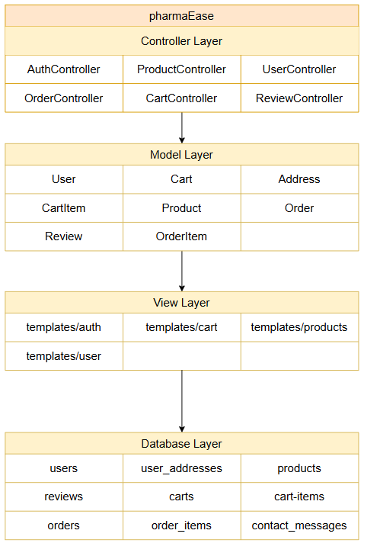

3.2 Discussion of Architectural Style and Components

The MVC pattern separates the application into three interconnected components, ensuring a clean separation of concerns:
- Model Layer (Data & Business Rules):
- Role: Represents the core data and business logic of the application. It interacts directly with the Microsoft SQL Server database to retrieve, store, and manipulate data.
- Key Components:
  - User & Address Models: Manage customer identity, authentication data, and address books.
  - Product Model: Handles catalog data including categories, prices, stock quantities (stock_quantity), and pharmaceutical details (dosage, active ingredients).
  - Cart & Order Models: Manage the shopping session state and process transactional data (subtotals, shipping costs, and order history).
  - Review & Contact Models: Handle user-generated content like product ratings and customer support inquiries.
- View Layer (User Interface):
- Role: The presentation layer responsible for rendering the user interface. It receives data from the controllers and displays it to the user in a readable format using HTML and CSS.
- Key Components:
  - Public Views: ProductCatalogView (browsing items), ProductDetailView (viewing specific medicine details), and CartView.
  - User Views: UserProfileView and CheckoutView (handling address selection and order confirmation).
  - Auth Views: Interfaces for Registration and Login.
- Controller Layer (Logic & Routing):
- Role: Acts as the intermediary between the Model and the View. It processes incoming HTTP requests, invokes the appropriate business logic in the Models, and selects the correct View to render the response.
- Key Components:
  - AuthController: Manages user sessions, login/logout logic, and security.
  - ProductController: Handles search queries, category filtering, and product retrieval strategies.
  - CartController: Manages adding/removing items and calculating session totals.
  - OrderController: Logic for order placement, calculating tax/shipping costs, and updating order statuses (e.g., from 'Processing' to 'Delivered').

3.3 Technology Stack and Tools
The development of the Pharmacy Web Store utilizes a robust and modern set of technologies chosen for their reliability, performance, and ease of integration.
- Frontend (User Interface): HTML5, CSS3
- Backend (Server-Side Logic): python, flask
- Database (Data Persistence): Microsoft SQL Server
- Development & Testing Tools
  - Visual Studio Code (VS Code): The primary Integrated Development Environment (IDE) used for writing and debugging code.
  - SQL Server Management Studio (SSMS): Used for designing the database schema, executing SQL queries, and managing database tables.
  - Git: Version control system used to track changes and manage source code history.

4.1 Model–View–Controller (MVC)

4.1.1 Description of MVC Pattern
- Model: manages the system data and associated operations on that data.
- View: defines and manages how the data is presented to the user.
- Controller: manages user interaction (e.g., key presses, mouse clicks, etc.) and passes these interactions to the View and the Model.
Why It Was Chosen:
- Separation of Concerns: State that MVC is mandated by your constraints because it enforces a clean separation of concerns. This makes the project easier to manage.
- Maintainability: Explain that if you need to change the look of the "Admin Dashboard" (the View), you don't have to touch the logic for how an order is processed (the Model).
- Parallel Development: it allows one developer to work on the backend logic (Model) while another works on the frontend UI (View).
- Reusability: The backend (Controller/Model) could send its data to a mobile app (a new View) without any changes to the business logic.

4.1.2 Mapping of Project Components to MVC
Online Pharmacy System (OTC Only)
- View Layer (User Interface)
  - AuthView (Login, Register, Password Reset)
  - UserProfileView (View personal info, My Reviews)
  - UserProfileEditView (Edit name, email, address, etc.)
  - DeleteAccountView (Confirmation screen)
  - ProductCatalogView (Search, Filters, Categories)
  - ProductDetailView (Usage, Dosage, Side effects, Reviews Section)
  - WriteReviewView (Star rating, Comment input)
  - CartView (Items, Price calculation)
  - CheckoutView (Address, Payment, Summary)
  - OrderTrackingView (Track orders, history, , Shipment Status Timeline)
  - AdminDashboardView
    - InventoryView (Stock CRUD)
    - OrderManagementView (fullfillment, cancellation)
    - ShipmentManagerView (Assign carriers, update tracking)
    - ReviewModerationView (Approve/Reject user reviews)
- Controller Layer (Logic & Routing)
  - AuthController (Login, Register, Sessions)
  - UserController
    - GetProfile()
    - UpdateProfile()
    - DeleteAccount()
  - ProductController (CRUD, Search, Filtering)
  - CartController (Add/Remove/Update items)
  - OrderController (Process payment, Create order, Tracking)
  - InventoryController (Stock management)
  - NotificationController (Emails/SMS)
  - ShipmentController
    - CreateShipment() (Generate label)
    - UpdateTracking()
    - GetShipmentStatus()
  - ReviewController
    - AddReview()
    - GetProductReviews()
    - DeleteReview()
- Model Layer (Data & Business Rules)
  - User (base entitiy)
    - Customer
    - Admin
  - Product
    - OTC medicine
    - WellnessItem
  - Inventory (Stock levels, Reorder threshold)
  - Cart (Session-linked cart)
  - Order (Items, prices, status, timestamps)
  - Payment (Method, status) (Optional entity)
  - Notification (Email, SMS queue) (Optional queue/log)
  - Shipment (Carrier, Tracking Number, Estimated Delivery)
  - Review (Rating, Comment, Verified Purchase flag)

4.1.3 Responsibilities of Model, View, and Controller
- Model Responsibilities: In our Online Pharmacy, the Model is responsible for all data and business rules. It contains classes like User, Order, and Medicine . Its job is to connect to the database to fetch, create, or update records. For example, when a user registers, the Model handles the password hashing and checks if the email is unique. It knows nothing about the HTML, only about the data itself.
- View Responsibilities: The View is responsible for rendering the user interface. It consists of all the HTML templates, such as ‘login.html’ and ‘cart.html’. Its job is to display data given to it by the Controller. For example, the ‘product_browsing.html’ page (FR-003 ) will receive a list of ‘Medicine’ objects from the Controller and loop through them to display each one. The View never communicates directly with the database.
- Controller Responsibilities: The Controller, built with Python Flask, acts as the intermediary. It listens for user requests from the browser. For example, when a user submits the login form (FR-002 ), the LoginController (a Flask route) receives the email and password. It then passes this data to the User Model and asks it to "authenticate." Based on the Model's "true" or "false" response, the Controller decides which View to render next: either the ‘admin_dashboard.html’ or the ‘login.html’ again with an error message.

4.1.4 Interaction Between Components
Example: UC-02 "Login"
- User (Actor): Opens the browser and navigates to the /login URL.
- View: The browser sends a GET request to the server.
- Controller: The Flask route @app.route('/login') catches the GET request and instructs the View to render the login.html template. The user sees the login form.
- User (Actor): The user enters their email and password (from FR-002 ) and clicks "Submit."
- View: The browser packages the form data and sends a POST request to the /login URL.
- Controller: The Flask route @app.route('/login') (this time handling POST) receives the email and password data. It does not check them itself.
- Controller-to-Model: The Controller calls the User Model, executing a function like user.authenticate(email, password).
- Model: The User Model receives the data. It hashes the provided password, retrieves the user record from the database by email, and compares the hashes. It then returns a result (e.g., the User object or None) back to the Controller.
- Controller: The Controller receives the result from the Model.
  - If successful: It identifies the user role (e.g., "Admin"), stores the user's ID in the session, and issues a redirect command to the /admin/dashboard URL.
  - If failed: It adds an error message ("Invalid credentials") to a context variable and tells the View to re-render the login.html template with the error.
- View: The browser receives the Controller's response (either a redirect or the re-rendered login page) and displays it to the user.

