Wound Documentation Management: HoloLens project

By: Aly Said, Amr Abdelraouf

Supervisor: Kai Klinker

C:\Users\Aly\AppData\Local\Microsoft\Windows\INetCache\Content.Word\Untitled.png

TECHNISCHEN UNIVERSITÄT MÜNCHEN

FAKULTÄT FÜR INFORMATIK

Abstract

This documentation concerns a HoloLens application built over unity. The application is a prototype for wound documentation and management to replace and improve the manual process usually carried out by nurses, utilizing augmented reality technologies to automate the wound measurement and capturing. The prototype also includes a web application side where data handling and saving occurs.

Keywords: HoloLens, Augmented Reality, Wound Documentation

Wound Documentation Management: HoloLens project

The HoloLens application is built as a state machine, where the first state has to be completed before proceeding to the next step, otherwise the second step would be stateless. The first step is reading the QR code assigned to the patient by the web application, to be printed and ready somewhere visually accessible in the room. The second step is measuring the patients’ wounds by placing virtual markers for length and width of the wound, the nurse can then proceed to take a documenting picture of the wound. The whole process is completed using hand gestures and voice commands to ensure a hands-free process; to ensure sanitization of the wound is maintained.

## Loading the project.

The project can be imported into unity as unity project, to choose the corrected scene (which would be automatically loaded as default). You should navigate to the scenes folder and select the main scene. Upon loading the scene, the screen will be populated with the objects of the project. The left navigation tab will be loaded with the hierarchy of the objects.

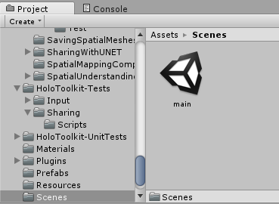

Figure 1. The figure shows the scene named ‘main’ location under the assets folder.

## The screen

The view of the screen showcases the virtual objects to be superimposed onto the real world when the user runs the application, completing the augmented reality pipeline. The objects aligned in the hieratical overview aren’t all 3D objects that can be directly seen by the user. 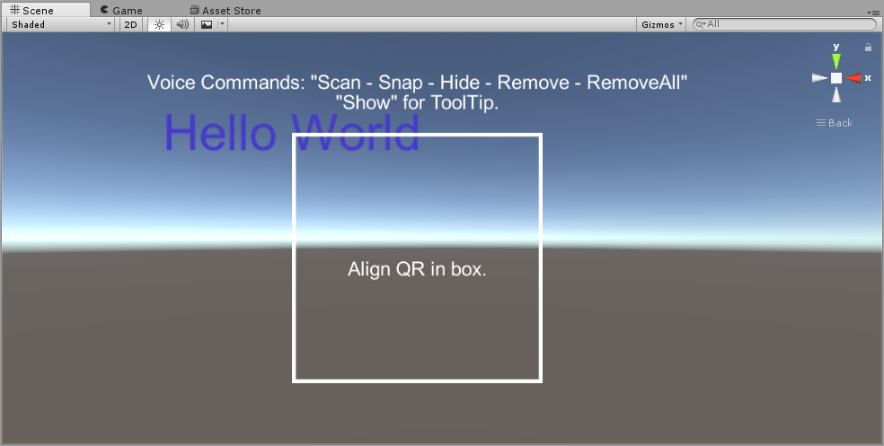

Figure 2. The figure mirrors the users view when opening the application, The voice commands tooltip itself can be controlled through different voice commands. The box to align the QR code within is removable as well. The HoloLens environment is intentionally clean and devoid of crowding virtual objects to allow the nurse to focus on their task.

## The virtual objects

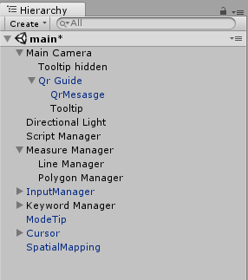The virtual objects each perform a specific role within the wound management system. We will try to explain what is the task for each of the important items are.

Figure 3. The figure lists the important virtual elements within the project.

### Main Camera.

The main camera is an object adapted from the HoloLens toolkit, it models the user and streams directly to the HoloLens screen using the HoloLens cameras. Its children are directly linked to it and thus move with it. As such we included all the tooltips and user messages to be always visible from the nurse’s perspective.

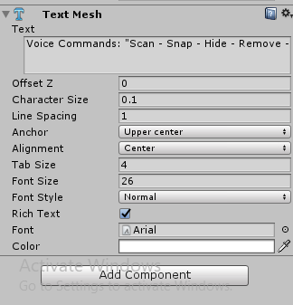 *Figure 4*. The figure shows the voice commands available as displayed on the tooltip.

### Script Manager

The script manger holds all scripts that handle the data capturing and manipulating within the project, as well as the state machine variables. The project contains many scripts, four of which are important to the process and can be edited to transform it. The scripts will be documented with comments for clarification.

* Gaze Gesture Manager: responsible for decoding the QR code, capturing the image for the QR code and playing an audio feedback to confirm the capture or signal an error. It also displays a few digits of the decoded QR string to be stuck over the QR to ensure the success with a visual cue.
* Photo Input: Captures an image for the QR code, helper to Gaze Gesture Manager. Handles ray casting to correctly place the text.
* Photo Capture and Save: Captures image of wound and posts it to server through a post form. This is where the server URL has to be edited, either through the unity interface or through the hardcoded default.
* 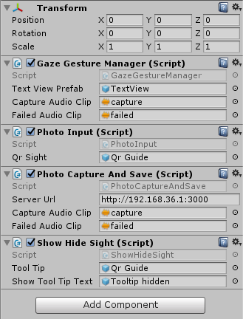Show Hide Sight: Handles the toggle visibility of the QR and voice commands tooltips. To be controlled

*Figure 5*. The figure shows the scripts added to the Script Manger game object, and their custom controls.

### Measure Manager

The measure manager holds the script for creating lines between placed points onto the scene, connecting them and calculating the distance in centimeters.

### Input Manager

The input manager handles all sorts of real world input into the virtual environment, and channels the data to the correct receptor. As such it handles voice commands pipelining as well as gesture recognition.

### Keyword Manager

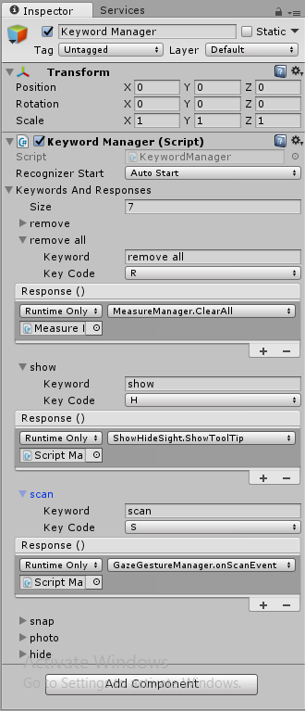The keyword manager is responsible for defining what keywords are to be recognized by the HoloLens and what function should be called when said keywords are recognized.

*Figure 6.* The figure lists the keywords to be recognized by the Input Manger and which function of which script is to be called as a result of it.

### Cursor and Spatial Mapping

These are both elements essential for any HoloLens project, the cursor maps to the user’s hand in the virtual world, while the spatial mapping handles depth perception and object occultation to correctly integrate the augmented reality into the nurse’s view.

## The Prototype

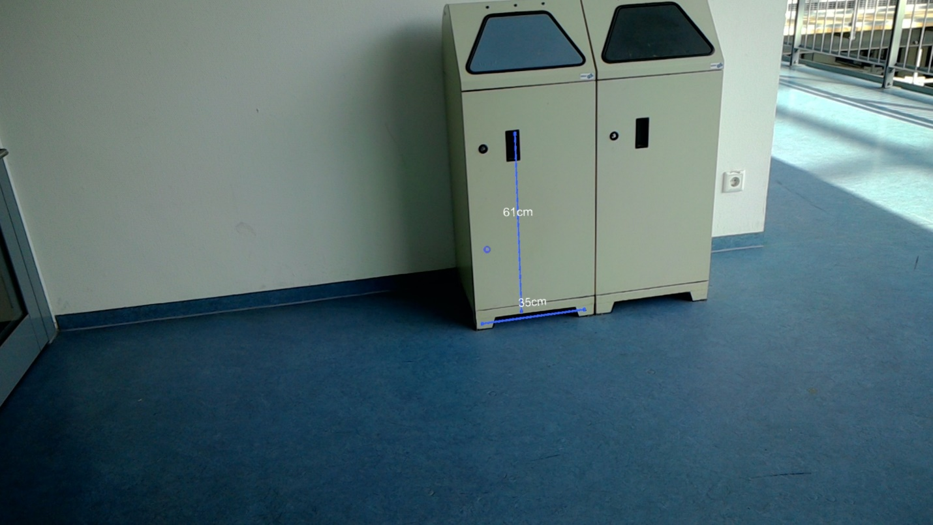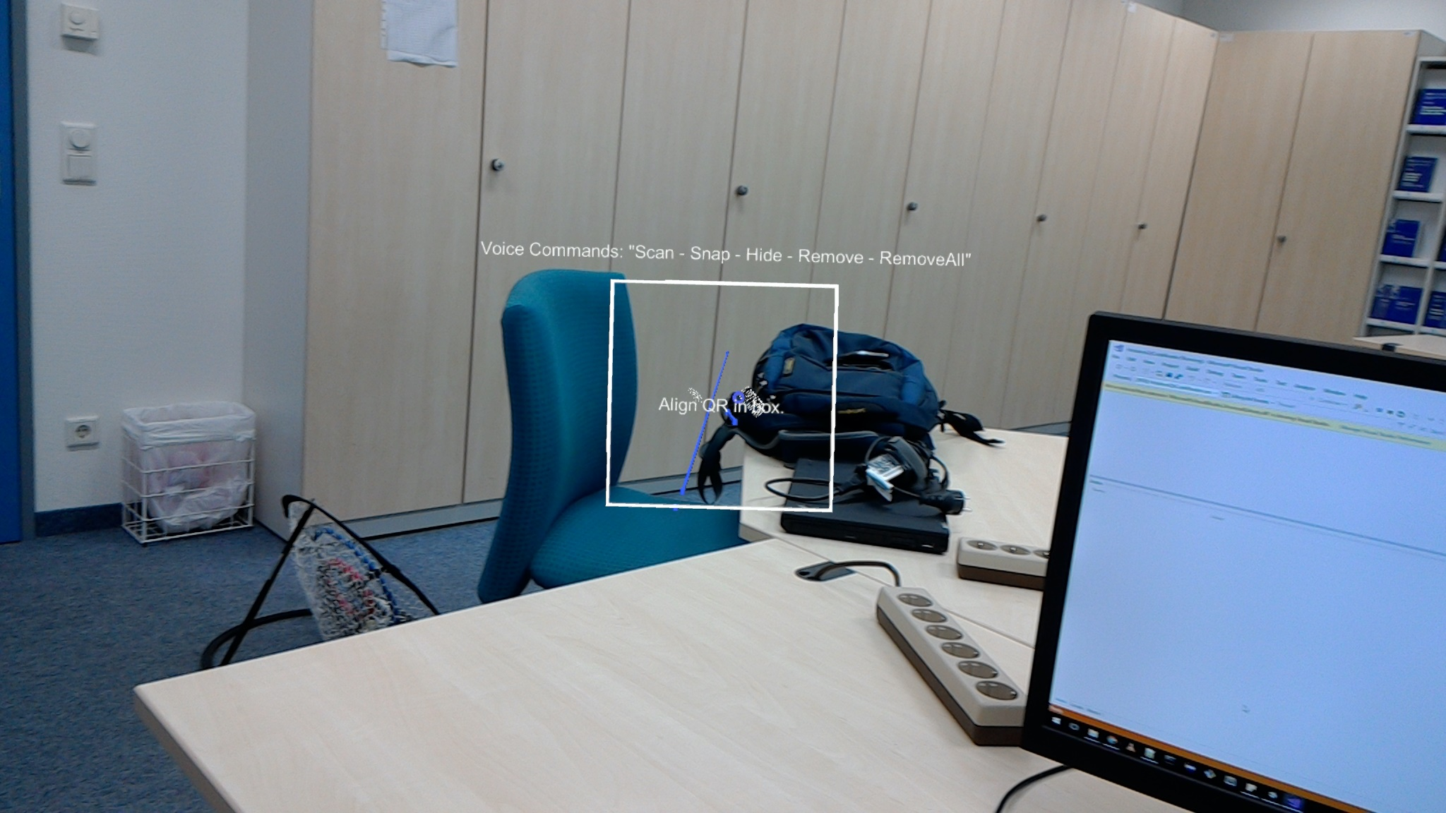The end view for the project prototype has two states, one with and without the Tooltip, the system will operate indifferently from the view. The captured line will be added statically to the augmented environment over the physical objects measured. Once a picture is recorded it is automatically sent to the server specified by the URL within the unity project.

*Figure 6.* The figure shows the Tooltips superimposed over the real world and stuck to the

nurse’s vision area of the screen, the measured objects in the world have their measurements stuck to them no matter where the nurse’s head will be turned.