**Programming**

**Section (1)**

**Assignment Title**

AB_Programming Fall 2023-2024

**Submitted to**

Eng. Dania alsaid

**Submitted by**

**Amr Adi**

**Fall 2023 - 2024**

Part1.

Task1:

1. Outline the steps involved in the process of building an application from writing to execution?

1- Define the problem: To solve the problem using code, you must first understand it before you can begin writing the code.

2- Write algorithm: Write the appropriate algorithm for the problem: In this step, an appropriate and good algorithm must be chosen for the problem.

3- Start write code: When you start writing the code, you must choose the appropriate language you want to work in. When you start writing, the code must be clear and the names of the inputs clear so that anyone after you can modify the code.

4- compiler the code: At this stage, I compile the code to ensure that there are no errors in it and that the code outputs are the same as required, but if there are errors in the code, we move to stage 5 to solve and fix the problem.

5- debugging process: Correcting errors and ensuring that there are no wrong vulnerabilities in the code and fixing them through the debugging process.

6- Run the code: To ensure that the resulting outputs after the run process match the required outputs.

2. Explain what an algorithm is, with examples of their use, choose an algorithm of your interest and explain it in common applications and how the algorithm is utilized, comparing the efficiency of using algorithm against brute forcing approach (try every single solution), and how it will relate to the application development process in the previous question?

An algorithm is a step-by-step arrangement to solve a problem or carry out a specific task. It is a series of carefully planned and precise instructions that, if you implement them, will produce the desired result according to the algorithm. It is generally used to solve problems well.

One of the most useful and efficient algorithms is binary search, which has numerous applications. It operates by comparing the matrix to produce the necessary number or input.

Algorithm Steps.

1- First, you work to target the middle element in the matrix

2- If the value of the middle element is equal to the entered element, then the search is successful, and then the program ends

3- If the entered value is not equal to the middle element, the algorithm compares the entered element if it is larger or smaller than the middle element. If it is larger, it completes the search. on the right side, that is, the larger side of the middle element, and deletes the smaller side from the search process.

4- You repeat this same process until you find the required value

The binary search algorithm is used in many applications, such as searching for information in a database, in data sorting applications, or in searching for specific words in books or dictionaries.

Comparing Efficiency with Brute Force:

When working with labeled data, binary search is more effective than a brute force approach (linear search). In contrast to the brute force strategy, which can include going through every item in the search space until the target is identified or going through every item, binary search dramatically shrinks the search space with each step, which speeds up the search considerably.

It has an important relationship with application development because it can be used in tasks that need to retrieve data or information quickly, for example, such as searching for a person’s name in the list of names on the phone. It is used in very large programs because it is important in quick response and improving performance for the user.

3. There are many algorithms that are used to solve a variety of problems, algorithms play crucial role in multiple fields in computer science such as Artificial Intelligence, Cryptography, Financial Algorithms, Game Development, Internet of Things, and more interesting fields that utilizes algorithms significantly. Write an algorithm from your chose from these fields and provide the following:

1. Describe the steps of your algorithm in pseudo code or flowchart.

Step 1: start.

Step 2: Create a variable num, array, result.

Step 3: call the method.

- declare left, right, mid

- while loop (left less or equal right)

- mid = left + right / 2

- if mid equal num, return mid

- else if mid less num, left equal mid+1

- else if mid less num, right equal mid-1

- return (-1) if the num not found

Step 4: if result equal -1

Step 4: print not found.

Step 5: else

Step 6: print result.

Step 7: end.

3. Demonstrate that this algorithm is a good algorithm.

The temporal complexity of the very effective binary search algorithm is, very short. Compared to linear search, it performs significantly better, especially for huge data sets. The technique is perfect for situations where quick search speeds are essential, including in game development, databases, and other applications, because it reduces the search space by half at each stage.

4. The use of an IDE for development of applications contrasted with not using an IDE such as notepad and Terminal compilation, you Should include a minimum of 5 aspects of comparison with screenshots. (Screenshots of Code)?

IDE is a software development program, and it is considered one of the best programs because it provides many tools and features when working on developing an application using it, and it also contains many programming languages. Unlike other programs, they are very limited, and you cannot work on them to develop large applications only for very small things.

1- It helps you when writing the code, which provides you with automatic completion when writing the command.

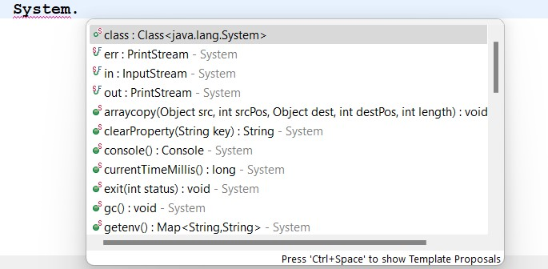

2- It gives you tools and instructions that indicate the error's location and type, making it easier for you to locate and address the problem quickly. Notepad doesn't display errors or problems for you.

3- Easy access to personal files, because it saves the files you work with. While in Notepad, you cannot save files that you want to refer to.

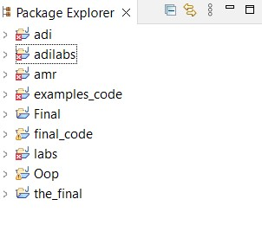

4- It saves time and effort because it helps the programmer with things that need to be repeated more than once because he does them at the push of a button. Unlike Notepad, it does not have an interface to help with things that need to be repeated.

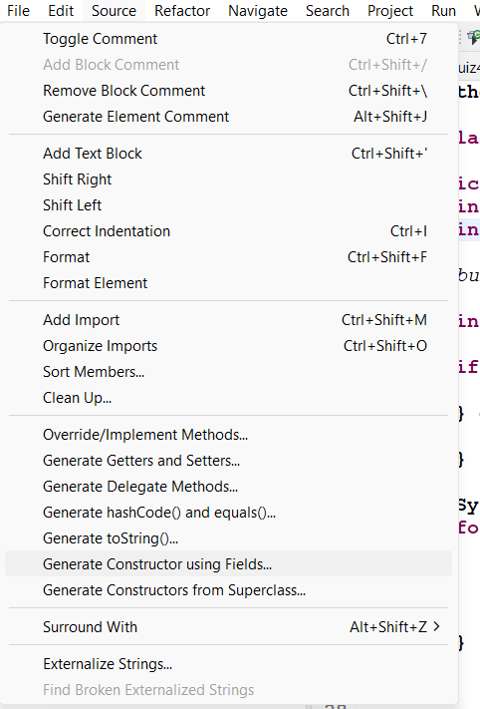

5- Powerful debugging tools with breakpoints, step over and step into, unlike Notepad and other simple programs, it relies entirely on the output after execution to find out the error and does not show him where the error is.

Part 2. Task#1

1. Define what is meant by a programming paradigm and explain the characteristics of different programming paradigms (Procedural, Object-Oriented, and Event-Driven)

programming paradigm: It is a method that organizes programs and has a distinct way of constructing code and different methods. There are three types of programming models, and each type has certain characteristics that are distinct from the other models, which are procedural, object-oriented, and event driven.

1- Procedural:

Computer tasks are guided by programs, which use processes to divide things into smaller, more manageable chunks and rely on common data to manipulate them.

* **Imperative Style:** Procedures, also known as cycles, are collections of instructions that are carried out sequentially and make up programs.

2- Object-Oriented Programming:

Characteristics:

* **Classes and objects:** Programs are arranged according to objects, which are collections of information and actions. Classes, which specify the structure of objects, are instances of objects.
* **Inheritance:** Classes can inherit traits and characteristics from other classes, which encourages the hierarchical structure and reuse of code.
* **Encapsulation:** It is necessary to conduct interactions with objects through clearly specified interfaces since they conceal their internal state.
* **Polymorphism:** Because objects can have various forms, different sorts of things can be represented by the same interface.
* **Component:** Objects from one class are utilized as components in another class during composition. These items are included in the class that contains them.

3- Event-Driven Programming:

Programs known as event handlers react to outside events to control program flow and enable non-blocking execution. Their loose coupling facilitates flexibility and ease of development, and they are frequently employed in GUI applications where user interactions are events.

* **Event Handlers:** Programs react to events that are brought about by system or user events. Specific events can be handled by functions or methods called event handlers.

Part 2. Task#2

1. Explain the debugging process that you have followed in writing your code. Provide examples of different error types that you have dealt with and how you solved them. Show how you used the available debugging facilities in the IDE to solve each error (Screenshots of Code and facilities) (Report).

In writing code, debugging entails finding unexpected behaviour, errors, or irregularities in the program's execution. To determine the root cause of problems, an integrated development environment (IDE), breakpoints, step-by-step execution, and variable scanning are used. During runtime, register data reveals information about the flow of the program and its changing values. The problem and its occurrence are identified, and specific remedies are applied with the help of debugging tools, a comprehensive code review process, and systematic examination of error messages. To ensure that bugs are identified and resolved and produce a more resilient code base, the procedure integrates reasoning, code inspection, and accessible tools.

1- Syntax Errors:

* I put a comma instead of a semicolon.

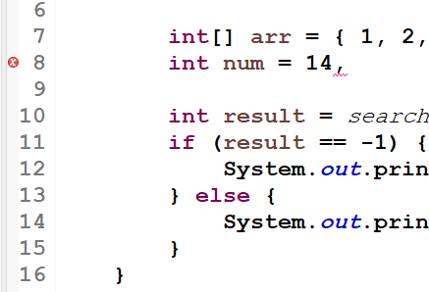

* Error in variable name.

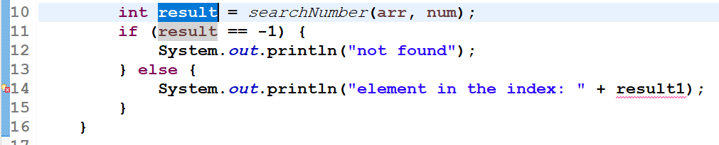

* The wrong parentheses "( )" are placed instead of the correct ones, which are "[ ]".

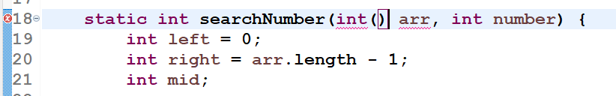

2- Logic Errors: I have error because I put "" around variable.

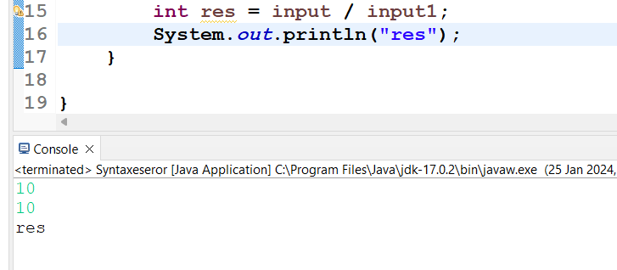

3- Run-time error:

1- ARITHMETIC EXCEPTION Error.

Before Handling:

After Handling:

- Using breakpoints, and try/catch to handling error:

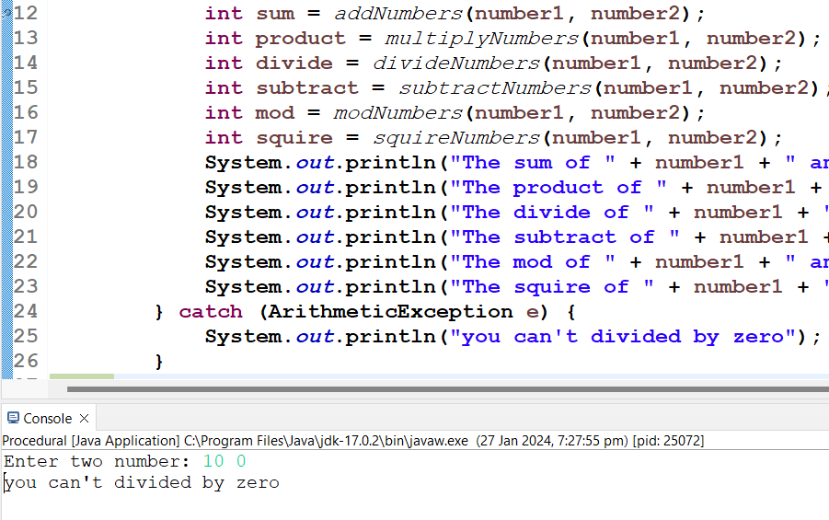

2- NULL POINTER EXCEPTION

Before handling:

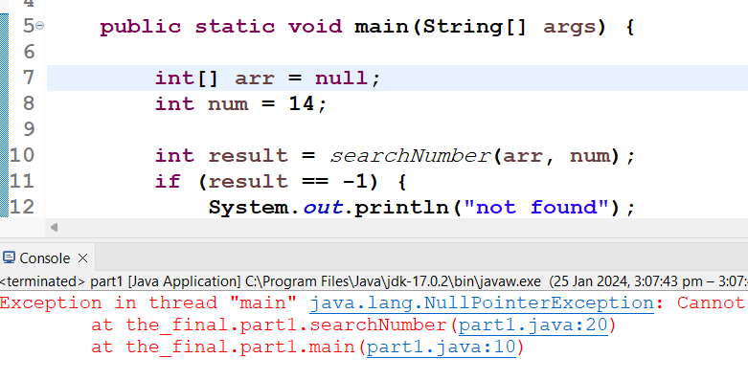

After handling using try and catch:

* Using breakpoints.

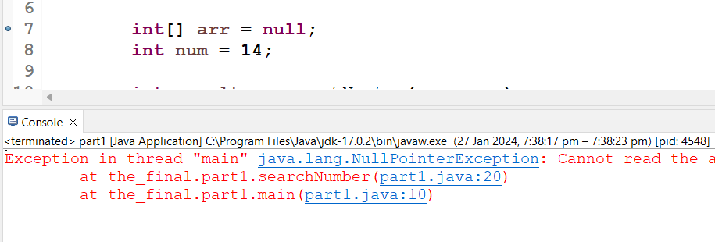

3- ARRAY INDEX OUT OF BOUND EXCEPTION

2. Evaluate how the debugging process can be used to help develop more secure, robust applications (Report).

3. Outline the coding standards that you have used in your code (at least 5 of them), and critically evaluate the role and purpose of coding standards and why it is necessary to follow those standards in a team as well as for the individual. (Screenshots of Code) (Report).

Coding standards are a crucial step in producing code because they give instructions and ensure that code is written consistently. Here are some important coding standards:

- comments



- Indentation

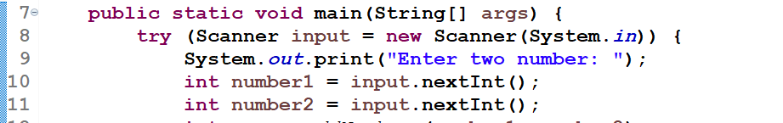

- camel case

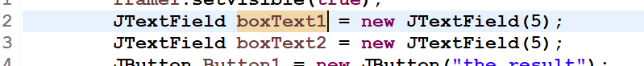

- Clear naming variables:



- use functions:

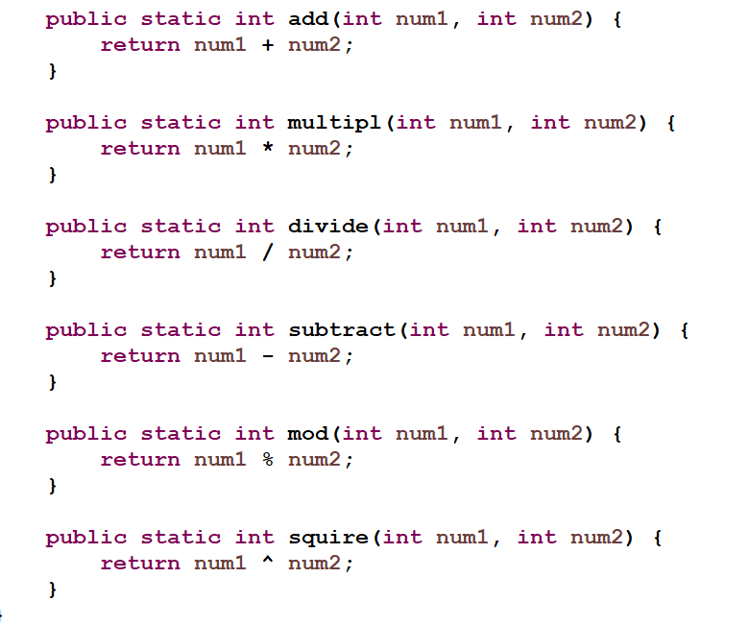

- snake case:

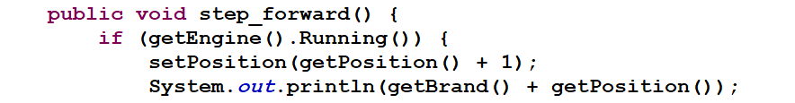

Reference.

Bham.ac.uk. (2020). *The Programming Process*. [online] Available at: https://www.cs.bham.ac.uk/~rxb/java/intro/2programming.html.

‌

Gillis, A. (2022). *What is algorithm?* [online] WhatIs.com. Available at: https://www.techtarget.com/whatis/definition/algorithm.

‌

freeCodeCamp.org. (2020). *Brute Force Algorithms Explained*. [online] Available at: https://www.freecodecamp.org/news/brute-force-algorithms-explained/.

‌

Upadhyay, S. (2022). *What Is An Algorithm? Characteristics, Types and How to write it | Simplilearn*. [online] Simplilearn.com. Available at: https://www.simplilearn.com/tutorials/data-structure-tutorial/what-is-an-algorithm.

‌

A3Logics (2023). *Understanding IDE: A Crucial Element in Mobile App Development*. [online] A3logics Blog. Available at: https://www.a3logics.com/blog/what-is-ide-and-how-it-is-important-in-mobile-app-development [Accessed 11 Dec. 2023].

Geeksforgeeks (2019). *Coding Standards and Guidelines - GeeksforGeeks*. [online] GeeksforGeeks. Available at: https://www.geeksforgeeks.org/coding-standards-and-guidelines/.

‌

Poirot, L. (2023). *3 Types of Errors in Java (With Examples for Each One)*. [online] History-Computer. Available at: https://history-computer.com/types-of-errors-in-java-with-examples/.

‌

‌