***Team I9++***

**Student1 :** *Amr Ayman Elsayed T-11 34-7026*

**Student2 :** *Gehad Abdelhalim T-11 34-14711*

**Student3:** *Islam Mohamed Hamada T-17 34-13150*

***Input:***

The input used was an array which is like this :

{28,1,6,11,16,21,26,31,4,9,14,19,24,29,2,7,12,17,22,27,0,5,10,15,20,25,30,3,8,13,18,23,28,1,6,11,16,21,26,31,4,9,14,19,24,29,2,7,12,17}

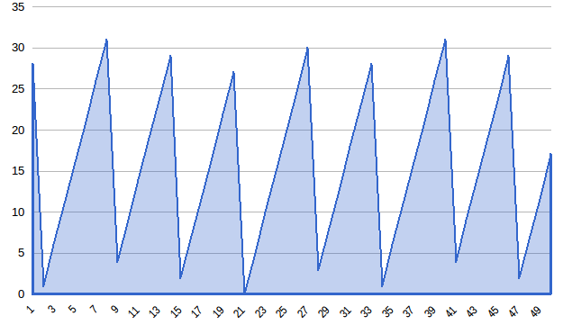

***Output :***

{13,15,17,16,15,13,15,17,19,17,16,15,13,15,17,15,14,13,11,13,15,17,15,14,12,14,16,18,16,15,14,12,14,16,18,16,15,13,15,17,19,17,16,15,13,14,15,15,15,13}

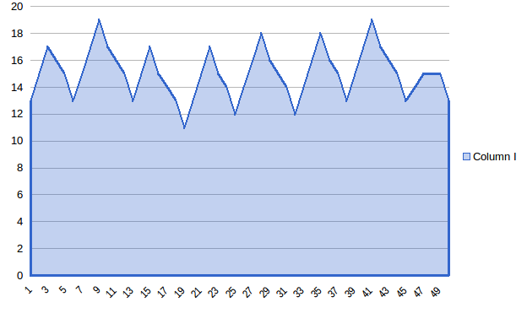

A simple flowchart of the code 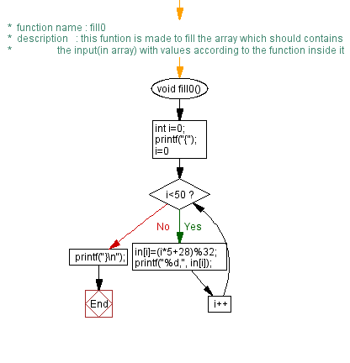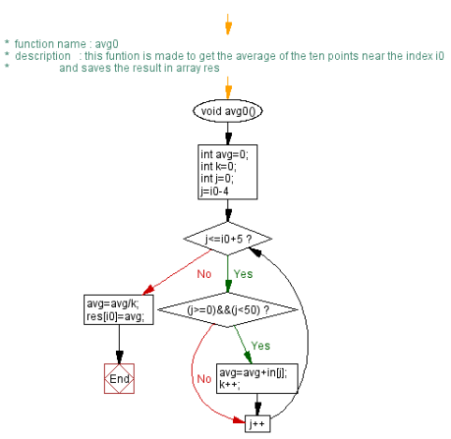

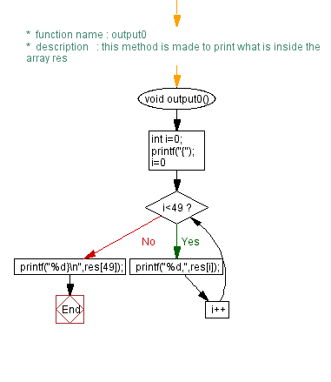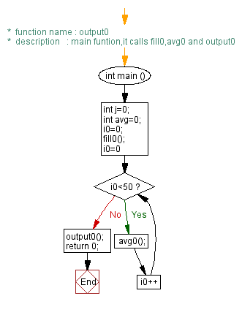

Gcc has 6 optimizations types {O0,O,O2,O3,Os,Ofast}

The 6 results of the 6 types of optimization will be included in the zip folder with the code

From the code size perspective

Os and O seem to reduce the size of the file as O is 179 line and Os has 187 lines , Ofast and O3 have the same size 344 mostly the optimization follow this table

