**Name / fady riad shokrallah riad Code / 2027276**

Laplace equation

And the implementation

Laplace equation $\frac{∂^{2}u}{∂x^{2}}$ + $\frac{∂^{2}u}{∂y^{2}}$ = 0

Replacing the drivatives by their difference approximations , we have

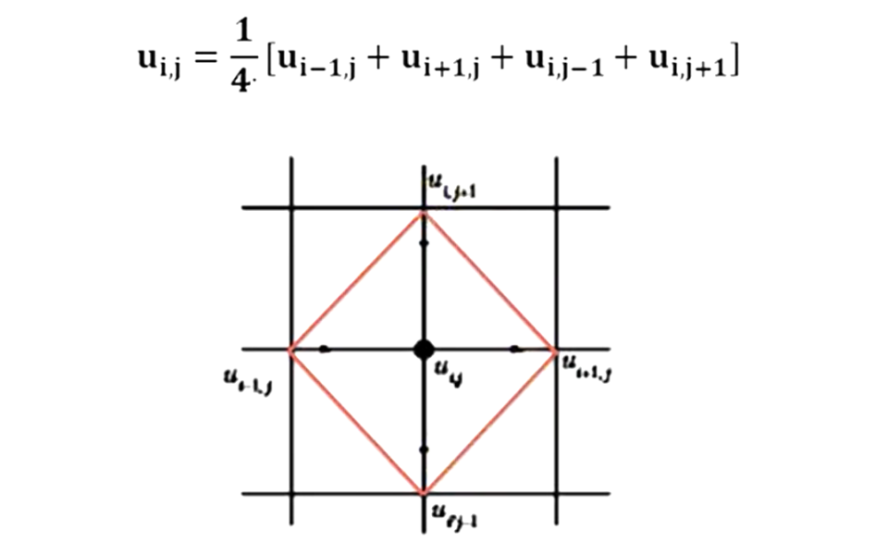

Given the values of u(x , y) on the boundry of square , evaluate the function u(x,y)

Satisfying laplace equation at pivotal points.

