**Name / fady riad shokrallah riad Code / 2027276**

parabolic equation

And the implementation

A partial differential equation is classified as parabolic if ( $B^{2}$- 4AC) = 0 at all points of the region. The solution domain for a parabolic PDE is an open region, as shown in Figure 1-3. For a parabolic partial differential equation there exists one characteristic line. Unsteady heat conduction in one dimension

$\frac{∂T}{∂t}$ = $∝\frac{∂^{2}T}{∂x^{2}}$ (1)

and diffusion of viscosity, expressed as

$\frac{∂u}{∂t}$ = $V\frac{∂^{2}u}{∂y^{2}}$ (2)

are examples of parabolic PDEs. An initial distribution of the dependent variable and two sets of boundary conditions are required for a complete description of the problem. The boundary conditions are prescribed as the value of the dependent variable or its normal derivative or a linear combination of the two.

The solution of the parabolic equation marches downstream within the domain from the initial plane of data satisfying the specified boundary conditions. The parabolic partial differential equation is the counterpart to an initial value problem in an ordinary differential equation (ODE).

Explicit Methods

Note that the value of the dependent variable at time level n is known from the previous solution or given as initial data i.e., the computed values at n + 1 depends only on the past history. To start the solution, an initial condition and two boundary conditions must be specified.

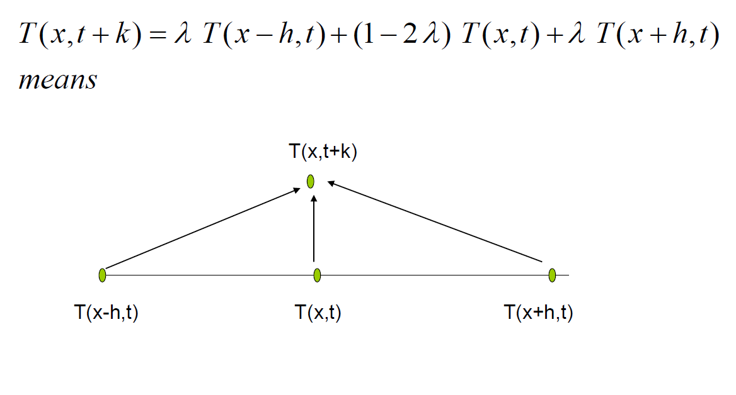

The FTCS Method (Explicit Method)

In this method we apply forward difference on time derivative while central on space derivative.

Let's discretize the 1-D Heat Equation or diffusion equation by using FTCS

Method.

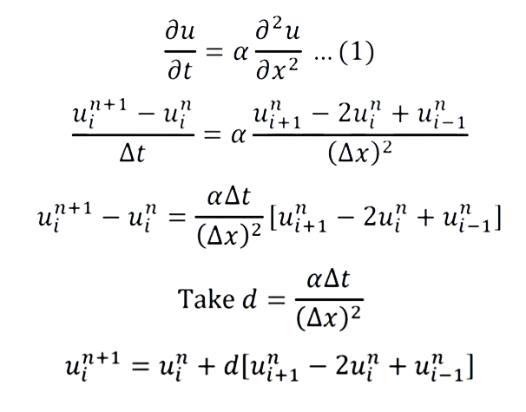

Example :

Given a 1-D heat equation

$\frac{∂u}{∂t}$ = $\frac{∂^{2}u}{∂x^{2}}$; 0 < x < 1 and t >0

u ( 0 , t ) = u ( 1 , t ) = 0 and u (x , 0 ) = sin ($πx$)

take h = $Δx$ = 0.2 , k = $Δt$ = 0.02 . find all values for u for t = 0 to t = 0.06

first , let’s determine the total number nodes in time and spatial domain.

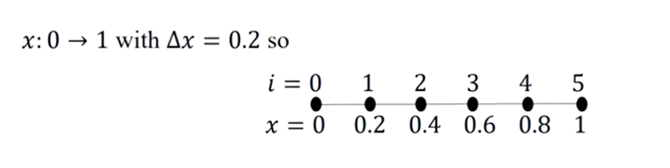

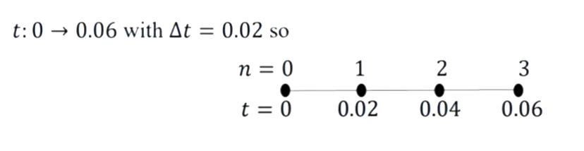

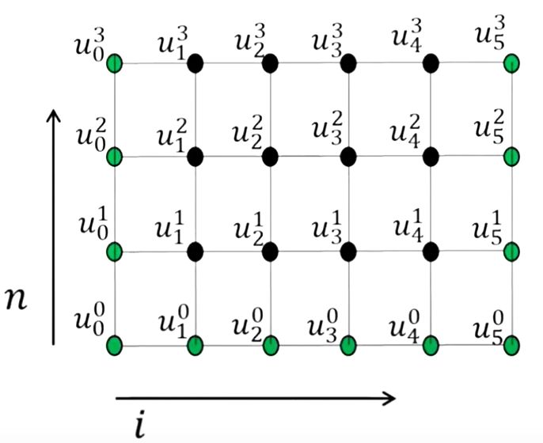

Hear green values are known from initial data in the form of boundary and initial conditions.

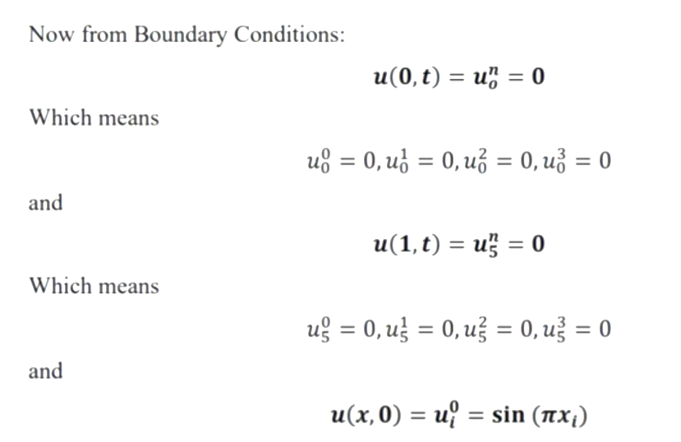

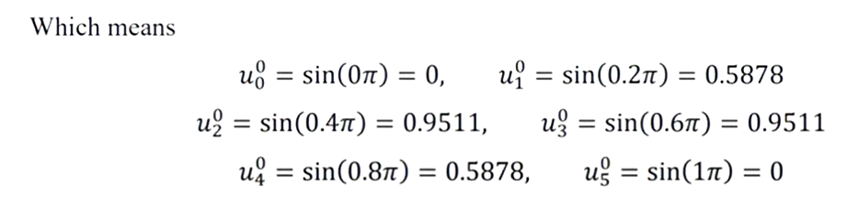

Now to calculate the values at inner nodes we will use the FTCS scheme. The discretized FTCS equation of given equation will be:

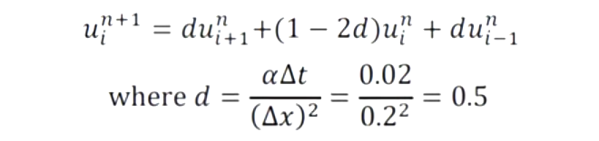

Stability condition meets

Now there will be 4 equations for each n since at each n there are 4 interior unknowns

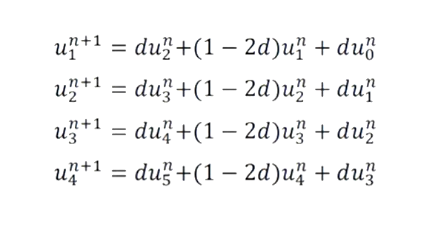

Iteration #1 (n = 0):

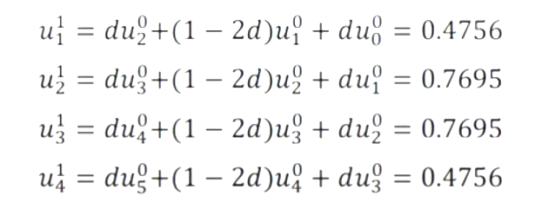

Iteration #2 (n = 1):

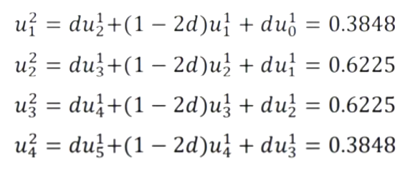

Iteration #2 (n = 1):

