|  |
| --- |
| Photo displaying partial image of two pie charts on a canvas-textured page |
| PO3_DGW  Hardware Software Interface Document |
|  |

Status table

|  |  |
| --- | --- |
| PO3_DGW_HSI | |
| Version | V0.1 |
| Status | Draft |
| Author | Bassem Ezzat (Architect)  Mohammed Elsayed (Developer) |
| Last updated | February 4, 2020 |
| Reviewer |  |

Table of history

|  |  |  |  |
| --- | --- | --- | --- |
| Version | Author(s) | Date | Changes |
| 0.0 | - Bassem Ezzat  - Moahmmed Elsayed | January 31, 2020 | Create HIS document |
| 0.1 | - Bassem Ezzat  - Moahmmed Elsayed | February 4, 2020 | Add pinout of the components |

**Content**

Status table 1

Table of history 1

1. Hardware requirements 3

1.1. Block Diagram 3

1.2. Components 4

1.2.1. Display device 4

1.2.2. Sound device 4

1.2.3. User interacting device 4

1.2.4. Control device 4

1.2.5. Power source 4

1.2.6. Casing and packaging 4

1.3. Hardware connections 5

1. Hardware requirements

The hardware that system required illustrated in the following list:

* Display Device
* Sound device
* User interacting device
* Control device
* Power source
* Casing and packaging
  1. Block Diagram



Figure 1. block Diagram of Hardware requirements

* 1. Components

This section lists the requirements in details.

* + 1. Display device

A 16x2 Dot Matrix Liquid Crystal Display Controller will be used as display device.

* + 1. Sound device

A 5V buzzer will be used as sound drive for alarm mode.

* + 1. User interacting device

A three push buttons will be used to allow user to interact with the system.

* + 1. Control device

A microcontroller ATmega32 will be used as controller device of the system.

* + 1. Power source

A 9V battery will be used to power the system up.

* + 1. Casing and packaging

Not specified

* 1. Hardware connections

This section provides a detailed pin connection for each hardware component.

* + 1. Display device

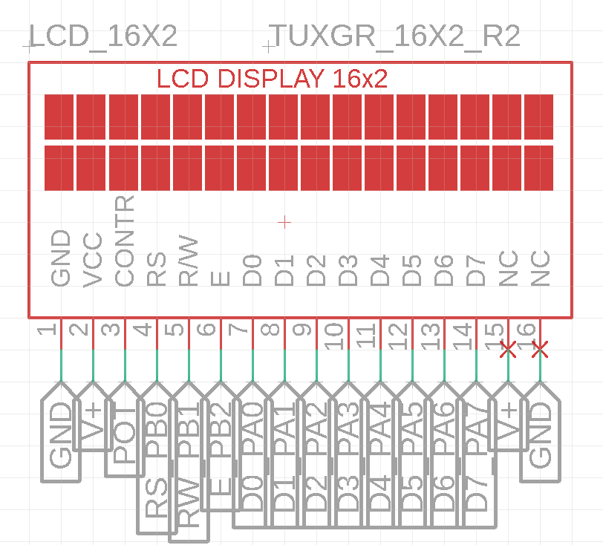

* + 1. Sound device

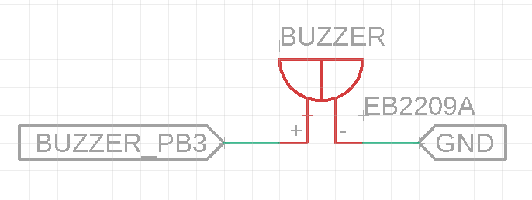

* + 1. User interacting device

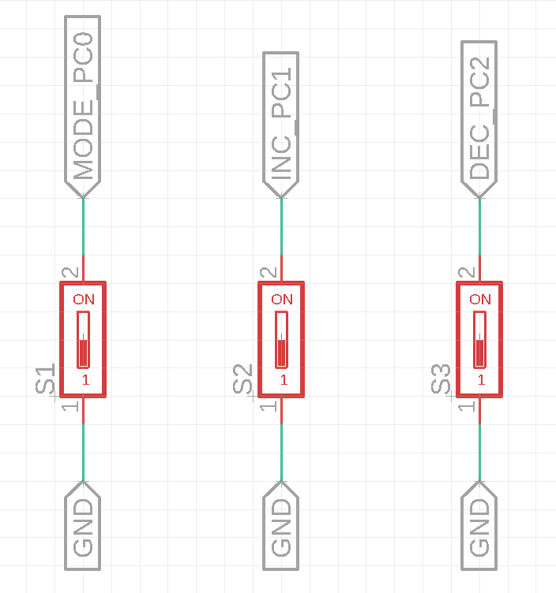

* + 1. Control device

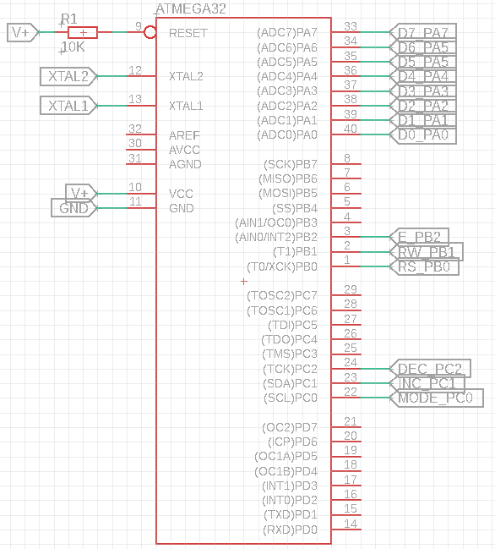

* + 1. Power source

