API : Application Programming Interface
Endpoint : the point of route handling
Client (Javascript) sends a Request to the Server ( API ) to get back with Response
HTTP (Hyper Text Transfer Protocol) is a protocol between front end and back end, it can send any type of data that both front and back argue with.
Request

RESTfull APIs Representational State Transfer
- Uniform Interface: standardized way of accessing and processing data resources : unique resource identifiers (URLs)
- Stateless: Every client request is self-contained (dose not depend on anything) There is no dependency between successive requests (Request2 dose not depend on Request1)
- Cacheable & Layered System: Caching and layering increases networking efficiency
- Connectionless like UDP connection is open @ request and get closed @ response
- Not Sessionless: Utilizing headers and cookies, sessions can be created to allow each HTTP request to share the same context.
  - Session is a section that contains data to be shared with requests (like your account user name and password when navigating pages @ facebook )
- Media Independent: Any type of data can be sent over HTTP as long as both the client and server know how to handle the data format, JSON , HTML, Text, Byte Array

URI is a Uniform Source Identifier
- URL identify the Location or route to the endpoint
- URN identify the Name of the endpoint, the endpoint can be accessed by it also
- https://webmasters.stackexchange.com/questions/19101/what-is-the-difference-between-a-uri-and-a-url

Request :
Method:Defines the operation to be performed
Path:The URL of the resource to be fetched, excluding the scheme and host
HTTP Version
Headers:optional information, success as Accept-Language
Body:optional information, usually for methods such as POST and PATCH, which contain the resource being sent to the server

Request Methods
Different request methods indicate different operations to be performed. It's essential to attend to this to correctly format your requests and properly structure an API.
GET:ONLY retrieves information for the requested resource of the given URI
POST:Send data to the server to create a new resource.
PUT:Replaces all of the representation of the target resource with the request data
PATCH:Partially modifies the representation of the target resource with the request data
DELETE:Removes all of the representation of the resource specified by the URI
OPTIONS:Sends the communication options for the requested resource

Response

Elements:
Status Code & Status Message
HTTP Version
Headers: similar to the request headers, provides information about the response and resource representation. Some common headers include:
Date
Content-Type: the media type of the body of the request
Body:optional data containing the requested resource

Status Codes:
As an API developer, it's important to send the correct status code. As a developer using an API, the status codes—particularly the error codes—are important for understanding what caused an error and how to proceed.

Codes fall into five categories:
1xx Informational (ex: approved)
2xx Success
3xx Redirection
4xx Client Error
5xx Server Error

Common Codes:
200: OK
201: Created
304: Not Modified
400: Bad Request
401: Unauthorized
404: Not Found405: Method Not Allowed
500: Internal Server Error

Curl is tool for testing APIs or endpoints

ex : curl -X POST http://www.example.com/tasks/

-X or --request COMMAND
-d or --data DATA
-F or --form CONTENT
-u or --user USER[:PASSWORD]
-H or --header LINE

CORS (Cross Origin Resource Sharing) Origin mean URL Domain (Website URL or name)
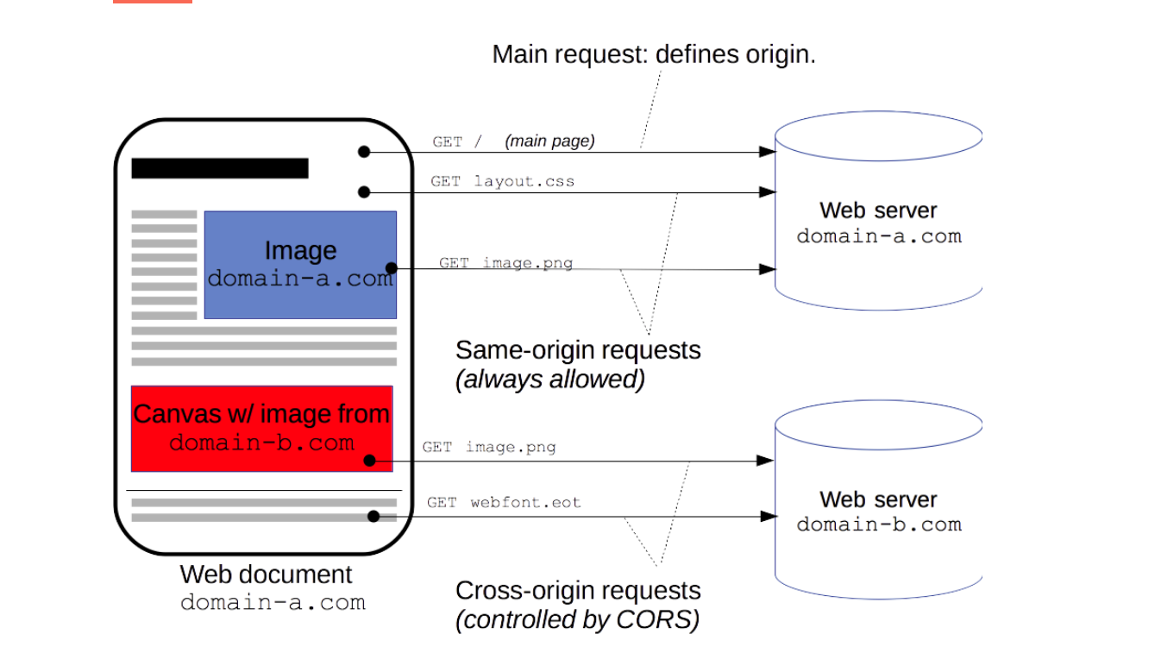
https://developer.mozilla.org/en-US/docs/Web/HTTP/CORS
https://en.wikipedia.org/wiki/Cross-origin_resource_sharing
Cross-Origin Resource Sharing (CORS) is a mechanism that uses additional HTTP headers to tell browsers to give a web application running at one origin, access to selected resources from a different origin. A web application executes a cross-origin HTTP request when it requests a resource that has a different origin (domain, protocol, or port) from its own.
An example of a cross-origin request: the front-end JavaScript code served from https://domain-a.com uses XMLHttpRequest to make a request for https://domain-b.com/data.json.
For security reasons, browsers restrict cross-origin HTTP requests initiated from scripts. For example, XMLHttpRequest and the Fetch API follow the same-origin policy. This means that a web application using those APIs can only request resources from the same origin the application was loaded from, unless the response from other origins includes the right CORS headers.

An example of a cross-origin request: the front-end JavaScript code served from https://domain-a.com uses XMLHttpRequest to make a request for https://domain-b.com/data.json
The same-origin policy is a concept of web security that allows scripts in Web-page 1 to access data from Web-page 2 only if they share the same domain. This means that the above error will be raised in the following cases:
- Different domains
- Different subdomains (example.com and api.example.com)
- Different ports (example.com and example.com:1234)
- Different protocols (http://example.com and https://example.com)

CORS failures or errors, but for security reasons, are not available to JavaScript. The only way to see the errors is to look at the browser's console for details.

