Process itself is a (text & stack & heap & data)

Process Control Block PCB
is the information of the process ( pid , program counter , state , cpu registers values , memory limits (where the process is ) , list of open files )

Allocating in memory
- Process is loaded in memory ( in any place the operating system choose)
- PCB of the process is loaded in OS’s stack( operating system stack memory )
  - easier to OS to load PCB, it is faster than memory
  - more protection
- ( running , waiting , ready ) is a ways that PCB s get stored not process itself, process itself is stored in RAM whatever its state.

Swapping & Context Switching
- Swapping (Memory)
  - is for RAM & Virtual Memory & cache
  - transfer data between cache memory & RAM
- Context Switching (Processor)
  - when switching between processes execution, saving its states and all information.
  - CPU Scheduling

Process Scheduling ( handling many processes ) ( running , waiting , ready .. etc)
- ready queue
- waiting queue
- job queue

Short term scheduler
- selects from ready queue which processes will be executed
- it is ‘short’ because process in the running state takes short time
Long term scheduler
- usually operating systems don’t have long term
- selects which processes should be brought into ready queue
Medium term scheduler
- schedule the processes in the virtual memory when there is no space in the ram for additional process
- swapping
- if you have big ram , then there is no need for swapping
System Calls
- Operating System is a set of services and programs that handles
- Processes Scheduling
- Processes Communication
- Memory Management
- IO Management & Synchronization with process
- Security
- these services is abstracted into some sort of APIs called system calls.
- This system calls are complex so it is abstracted again into libraries to use it as a functions.
Process Creation
- fork()
- process created in another process. ( tree of processes )
  - the very first process is created on boot ( init process with pid 1 )
- when you fork(), the child process take a copy of every thing in the parent process
- you must call exec() to make the child take another program or its own instructions.

- Cascading Termination
  - Parent process must call wait() at its end, to wait all child process to get terminated before its termination
  - if the parent terminated before its childs, when the childs terminates, its PCB will remain in the OS in a Zombie way

Processes Intercommunication.
- Processes must communicate with each other to send & receive information
- Communication Categories
  - Physical
    - Shared Memory: Processes share a memory locations to produce & consume memory (see the assignment)
    - Message Passing: using sockets via process names not (ip,port) or using shared memory technique but we used that memory in a different way using data structures to pass messages.
    - Network : Message passing through ip & port , valid for different devices
    - Hardware Bus between processes (not seen used)
  - Logic
    - Direct – Indirect
      - direct: processes communicate directly without any interface or port, processes send – receive directly , send(process_Receiver,data); , receive(process_Sender,data);
      - Indirect: through a port interface
    - synchronous & asynchronous or Blocking & non blocking : blocks until the job is done or not(search for blocking & non blocking sockets)
    - Automatic & explicit buffering ( I don’t know )
- Shared Memory : See the folders of Processes Communication in the same repo @ Github
- Sockets Message Passing : https://www.geeksforgeeks.org/socket-programming-cc/

Threads (Light Weight Processes)
- Threads are internal small processes that exist inside a process and all threads share the memory of that process, used to run some programs in parallel
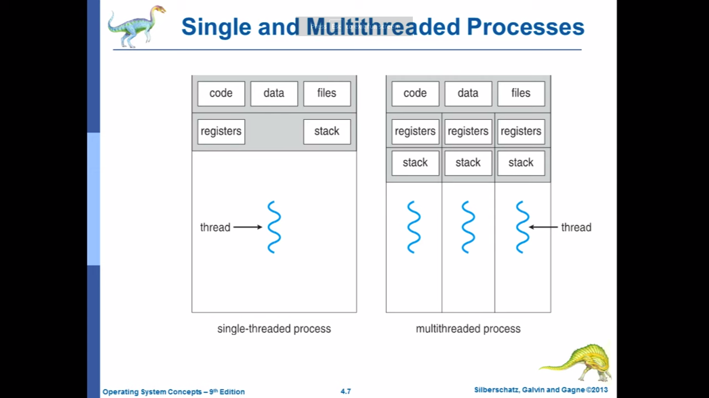
- Each thread has its program counter & a piece of stack memory.

- ex: word program, has thread for words correction & another threads for handling user’s input .. etc, all in the same process ( the word program)
- Why not creating multi processes instead of multi threads?
  - Processes Creation & Processes Communication via shared memory or messages passing are difficult to do and it is a hard efforts

- Benefits :
  - Higher responsive ( needed especially in user interface ) , as moving from states as a processes is harder than threads.
  - Resource Sharing : how they will communicate, they don’t need a special algorithms like processes communication by message passing or shared memory
  - Economy : low cost in creating threads that creating process, also context switching between them when its states change, it is faster in threads as data is shared.
  - Scalability

Threads
- dividing process into threads that can run in parallel, with a balance in code size of each.
- Data dividing of the threads & data dependency:if output of thread is input to another.
- Testing & Debugging
- Concurrency : time slice multi running processes or threading on single core
- Parallelism : actual threading on multi ALUs
  - task parallelism
  - data parallelism : used in task parallelism but to split the data itself to be used in the threads.
    - لو عايز تعمل برنامج يجمع ارراي مثلا . ف بتقسم الارراي نفسه علي كذا ثريد وكل واحد يجمع حتة ف كدة هسرع العملية
- User threads & Kernel threads
  - Used threads is creating in code
  - Kernel threads is creating and get handled by OS
  - we convert the user threads to kernel threads using Multi-threading model [(1,1) (1-n) (n-n)]
    - many to one : (not used) map any number of user thread to 1 kernel thread . OS take action on the whole process that contains the threads.
    - one to one : map each user thread to kernel thread (windows & Linux)
      - overhead on system
    - many to many, consider the process that contains many threads as many pieces, each piece can be one thread ore many threads
    - 2 level model ( I don’t understand it )

- User threads :Posix Pthreads , Windows threads , Java threads
- Threading Library :
  - User Level Library: functions is implemented directly in the library
  - Kernel Level Library: functions use the APIs of the kernel

Threading Programming Linux .. pthread.h
- global variables are shared between threads
- see the Threading folder

