A close up of a logo

Description generated with very high confidence



Scope Document

Tassnief Platform

|  |  |
| --- | --- |
| Saudi AZM | Issued by |
| 14/06/2022 | Issuing date |
| V1.2 | Document Version |

# Table of Content

Table of Content 2

Table of modifications: 4

Document Approvals: 4

Glossary of Terms: 5

1. Introduction 6

1.1 Document Purpose 6

1.2 Project Overview 6

1.3 Stakeholders 6

2. System Structure 7

2.1 System Modules 7

1. Client Management Module 7

2. Service Management Module 7

3. Service Flow Module 7

4. Billing Module 7

5. Document Viewer 7

2.2 System Integration Points 7

6. Notifications Center 7

7. SMS Gateway 8

8. Payment Gateway 8

3. Business Process Workflow 8

**3** 8

3.1 Tassnief Platform Full Journey 8

3.2 Request Service 11

3.3 Allocate Task 14

3.4 Register Client 16

3.5 Prepare Agreement Package 18

3.6 Agreement Package Approval 19

3.7 Issue Bill 22

3.8 Receive Payment 24

3.9 Service Initiation 25

3.10 Client Meeting 27

3.11 Internal Rating Committee Meeting 28

3.12 External Rating Committee Meeting 30

3.13 Draft Report 32

3.14 Receive Draft Report 33

3.15 Final Report 34

3.16 Client Appeal 35

4. Roles and Users 37

5. Services Catalog 38

5.1 System Modules 38

6. Assumptions 38

6.1 Client Engagement 38

6.2 Documents 38

6.3 Billing 38

Table of Figures

[Figure 1: Full Journey Workflow 8](https://azimco-my.sharepoint.com/personal/halromi_azm_sa/Documents/Projects/Tassneif/Scope/Tassnief%20-%20Workflows%20BRD.docx#_Toc105692687)

[Figure 2: Request Service 11](https://azimco-my.sharepoint.com/personal/halromi_azm_sa/Documents/Projects/Tassneif/Scope/Tassnief%20-%20Workflows%20BRD.docx#_Toc105692688)

[Figure 3: Allocate Task 14](https://azimco-my.sharepoint.com/personal/halromi_azm_sa/Documents/Projects/Tassneif/Scope/Tassnief%20-%20Workflows%20BRD.docx#_Toc105692689)

[Figure 4: Register Client 16](https://azimco-my.sharepoint.com/personal/halromi_azm_sa/Documents/Projects/Tassneif/Scope/Tassnief%20-%20Workflows%20BRD.docx#_Toc105692690)

[Figure 5: Prepare Agreement Package 18](https://azimco-my.sharepoint.com/personal/halromi_azm_sa/Documents/Projects/Tassneif/Scope/Tassnief%20-%20Workflows%20BRD.docx#_Toc105692691)

[Figure 6: Agreement Package Approval 19](https://azimco-my.sharepoint.com/personal/halromi_azm_sa/Documents/Projects/Tassneif/Scope/Tassnief%20-%20Workflows%20BRD.docx#_Toc105692692)

[Figure 7: Issue Bill 22](https://azimco-my.sharepoint.com/personal/halromi_azm_sa/Documents/Projects/Tassneif/Scope/Tassnief%20-%20Workflows%20BRD.docx#_Toc105692693)

[Figure 8: Receive Payment 24](https://azimco-my.sharepoint.com/personal/halromi_azm_sa/Documents/Projects/Tassneif/Scope/Tassnief%20-%20Workflows%20BRD.docx#_Toc105692694)

[Figure 9: Service Initiation 25](https://azimco-my.sharepoint.com/personal/halromi_azm_sa/Documents/Projects/Tassneif/Scope/Tassnief%20-%20Workflows%20BRD.docx#_Toc105692695)

[Figure 10: Client Meeting 27](https://azimco-my.sharepoint.com/personal/halromi_azm_sa/Documents/Projects/Tassneif/Scope/Tassnief%20-%20Workflows%20BRD.docx#_Toc105692696)

[Figure 11: IRC Meeting 28](https://azimco-my.sharepoint.com/personal/halromi_azm_sa/Documents/Projects/Tassneif/Scope/Tassnief%20-%20Workflows%20BRD.docx#_Toc105692697)

[Figure 12: ERC Meeting 30](https://azimco-my.sharepoint.com/personal/halromi_azm_sa/Documents/Projects/Tassneif/Scope/Tassnief%20-%20Workflows%20BRD.docx#_Toc105692698)

[Figure 13: Draft Report 32](https://azimco-my.sharepoint.com/personal/halromi_azm_sa/Documents/Projects/Tassneif/Scope/Tassnief%20-%20Workflows%20BRD.docx#_Toc105692699)

Figure 14: Receive Draft Report 33

Figure 15: Final Report 34

[Figure 16: Client Appeal 35](https://azimco-my.sharepoint.com/personal/halromi_azm_sa/Documents/Projects/Tassneif/Scope/Tassnief%20-%20Workflows%20BRD.docx#_Toc105692702)

# Table of modifications:

|  |  |  |  |
| --- | --- | --- | --- |
| Description | Version | Name | Date |
| Initial version |  | Hessah AlRomi | 9-6-2022 |
|  |  |  |  |
|  |  |  |  |
|  |  |  |  |

# Document Approvals:

|  |  |  |  |
| --- | --- | --- | --- |
| Signature | Project Role | Approver Name | Date |
|  |  |  |  |
|  |  |  |  |
|  |  |  |  |
|  |  |  |  |

# Glossary of Terms:

|  |  |  |
| --- | --- | --- |
| No. | Term/Acronym | Definition |
|  | Rating | A service provided by Tassnief to their clients to conduct an analysis and rate the status of the client |
|  | IRC | Internal Rating Committee. A committee from within Tassnief employees. |
|  | ERC | External Rating Committee. A committee from outside of Tassnief |
|  | Client | The client of Tassnief. Any entity that requests a service from Tassnief rating |
|  | BA | Business analyst |
|  | RA | Rating analyst |

# Introduction

## Document Purpose

This document aims to clarify the business scope of the project, what will be included in the platform business process and what won’t in regards of the business aspect of the project. It will also clarify the integration points with external systems and how the system modules will interact with them.

## Project Overview

The project will be created to digitalize Tasnief internal system in regards of personal or processing of any service request/ client. It will govern the service processing by automating the approvals and documenting the delivery of the service.

## Stakeholders

This section includes all the stakeholders that will be participating in this project and a description of them.

| **No.** | **Stakeholder** | **Description** |
| --- | --- | --- |
| 1. | AZM | AZM Tech company |
| 2. | Tassnief | Tassnief is a SIMAH agency concerned with rating |
| 3. | SIMAH | SIMAH credit bureau IT department |
| 4. | Client | Clients of Tassnief wither they were participating through the platform or outside the platform |



# System Structure

Tassnief platform contains 5 modules and integrate with 3 systems to operate in order to allow the platform to preform it’s intended functions. The below figure represents the system architecture and how each module and integration point will interact in the system.

## System Modules

Tassnief platform contains the 5 modules grouped by business logic for each module to preform a group of related functions.

### Employee Management Module

This module is a responsible for managing the employees of Tassnief and allocating tasks for them. It handles the allocation approach, task delegation and escalations.

### Client Management Module

This module is a responsible for managing client registration and confirmation with compliance regulations to avoid any conflict of interest with clients. In addition to storing and maintaining clients’ data and information.

### Service Management Module

This module will handle the configuration and settings of service attributes which will affect the service flow.

### Service Flow Module

This module will handle the flow of services provided by Tassnief platform and all actions to be performed on the service request. This module will also include a sub module to preform the tasks.

* Document viewer:

The system will include a document viewer system to govern the security of documents and give permissions to users according to their role.

### Billing Module

This module is a financial consolidation system that will be part of Tassnief platform to handle all financial transactions by generating bills, processing the payments and installments.

### Supporting Service Module

This handles all supporting services such as, reports and tasks logs.

## System Integration Points

Tassnief platform will integrate with the following systems to preform part of the functions.

### Notifications Center

The system will integrate with a notification center to send platform and Email notifications to the users of the system, clients and external rating committee members.

### SMS Gateway

The system will integrate with SMS service to send SMS messages to the users of the system, clients and external rating committee members for the purpose of double factor authentication and delivering notifications.

### Payment Gateway

The system will integrate with a payment gateway to process the invoice payment.

# Business Process Workflow

This section shows the business process workflow of Tassnief platform.

1. 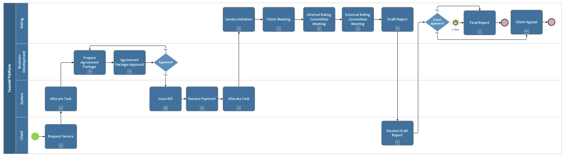

Figure : Full Journey Workflow

## Tassnief Platform Full Journey

|  |  |  |  |  |
| --- | --- | --- | --- | --- |
| No. | Actor | Step Name | Step Description | Notes |
|  | Client | Request Service | This step is a sub-process that describes how the client requests a service through the platform or other channels | Refer to Request Service |
|  | System | Allocate Task | System allocate preparing the agreement package task based on the approach. | Allocation approach is either “Push” or “Drag and Drop” Refer to Allocate Task |
|  | BD | Prepare Agreement Package | BD department prepare the agreement package after allocation or if a package has been through the approval cycle and was rejected. | Refer to Prepare Agreement Package |
|  | BD | Agreement Package Approval | This step is a sub-process that describes how BD department prepares the agreement package and approves it to be sent to the client. | Refer to Agreement Package Approval |
|  | System | Issue Bill | System issues bill after agreement package approval | Refer to Issue Bill |
|  | System | Receive Payment | Receives payment from client through the payment gateway. | Refer to Receive Payment |
|  | System | Allocate Task | System allocates service initiation task based on the approach. | Allocation approach is either “Push” or “Drag and Drop” Refer to Allocate Task |
|  | Rating | Service Initiation | This step is a sub-process that describes how the rating department starts with the service initiation. | Refer to Service Initiation |
|  | Rating | Client Meeting | This step is a sub-process that describes how the rating department prepares and conducts the client meeting. | Refer to Client Meeting |
|  | Rating | IRC Meeting | This step is a sub-process that describes how the rating department prepares and conducts IRC meeting. | Refer to IRC Meeting |
|  | Rating | ERC Meeting | This step is a sub-process that describes how the rating department prepares and conducts ERC meeting. | Refer to ERC Meeting |
|  | Rating | Draft Report | This step is a sub-process that describes how the rating department prepares the draft report to be delivered to the client. | Refer to Draft Report |
|  | Client | Receive Draft Report | This step is a sub-process that describes how the client receives the draft report through email. | Refer to Receive Draft Report |
|  | Rating | Final Report | This step is a sub-process that describes how the rating department prepares the final report after client approval or after 5 days with no response from client. | Client approval is captured through email and uploaded to the system by rating. Refer to  Final Report |
|  | Rating | Client Appeal | This step is a sub-process that describes how the rating department goes through the client appeal process after client rejection. | Client appeal is captured through email and uploaded to the system by rating. Refer to Client Appeal |

## Request Service

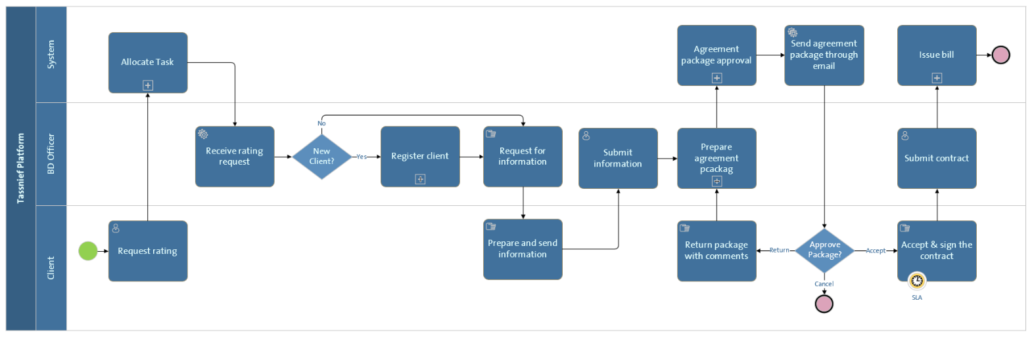

Figure : Request Service

|  |  |  |  |  |
| --- | --- | --- | --- | --- |
| NO. | Actor | Step Name | Step Description | Notes |
|  | Client | Request rating | Client requests for a rating service through the platform. | The client can request a service through other channels such as(email- phone). |
|  | System | Allocate task | System allocate preparing the agreement package task based on the approach. | Allocation approach is either “Push” or “Drag and Drop” Refer to Allocate Task |
|  | BD Officer | Receive rating request | BD officer receives rating request from client and checks whether the client is registered or not. |  |
|  | BD Officer | Register client | Register client if the client is a new client | Refer to Register Client |
|  | BD Officer | Request for information | Request for service needed information through email. | The email body is written by the BD officer and sent through the system to the client email. |
|  | Client | Prepare and send information | Sends requested information to the BD officer through email |  |
|  | BD Officer | Submit information | After receiving information from client through email, the BD officer submits the information as request information in the platform |  |
|  | BD Officer | Prepare agreement package | Prepare agreement package after receiving all request and client information. | Refer to Prepare Agreement Package |
|  | System | Agreement package approval | Go through agreement package approval cycle |  |
|  | System | Send agreement package | Send agreement package to client through email automatically |  |
|  | Client | Return package with comments | After receiving the agreement package, client return agreement package with comments to the BD officer through email. BD officer goes back to preparing the agreement package again |  |
|  | Client | Accept and sign the contract | After receiving the agreement package, client accepts and signs the contract and inform BD officer through email. |  |
|  | BD Officer | Submit contract | Submit the received contract through email to the platform. |  |
|  | System | Issue bill | System will issue bill. | Refer to Issue Bill |

## Allocate Task

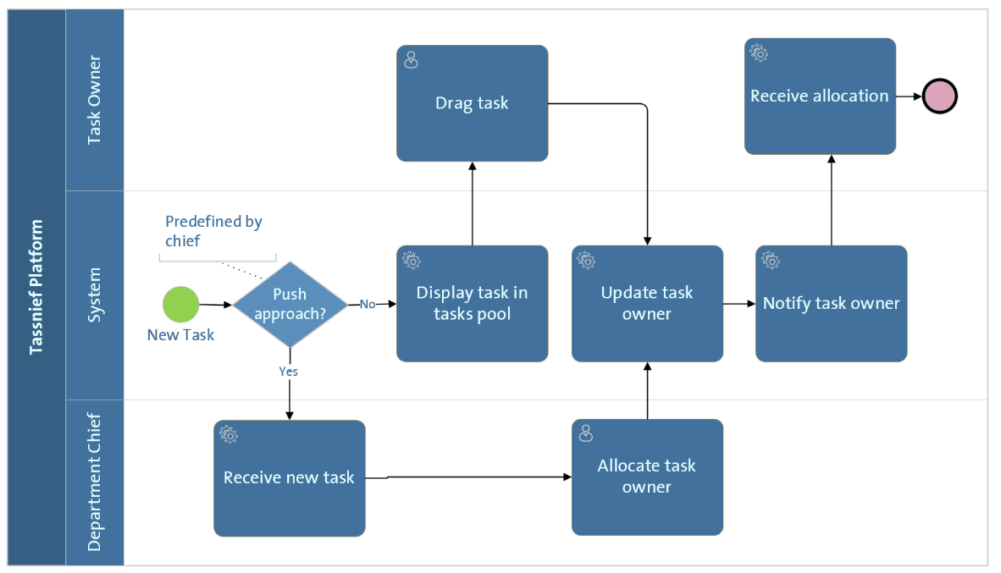

Figure : Allocate Task

|  |  |  |  |  |
| --- | --- | --- | --- | --- |
| NO. | Actor | Step Name | Step Description | Notes |
|  | System | Display task in tasks pool | System displays the task in tasks pool if the allocation approach was drag and drop. | Allocation approach is predefined by the department chief |
|  | Task Owner | Drag Task | A task owner drags a task from the pool that is in status for someone with task owner role to own it. | Pool depends on task status thus; the task is displayed for a specific role |
|  | Department Chief | Receive new task | Receive new task by the system if the approach of allocation was push approach | Allocation approach is predefined by the department chief |
|  | Department Chief | Allocate task owner | Department chief allocates task owner with the same role that the task status needs action on. |  |
|  | System | Update task owner | System updates task owner whither it was allocated by the chief or the task dragged by the owner. |  |
|  | System | Notify task owner | System notifies that the allocation was done successfully and that the new owner of the task is them |  |
|  | Task Owner | Receive allocation | Task owner receives allocation of the task. |  |

## Register Client

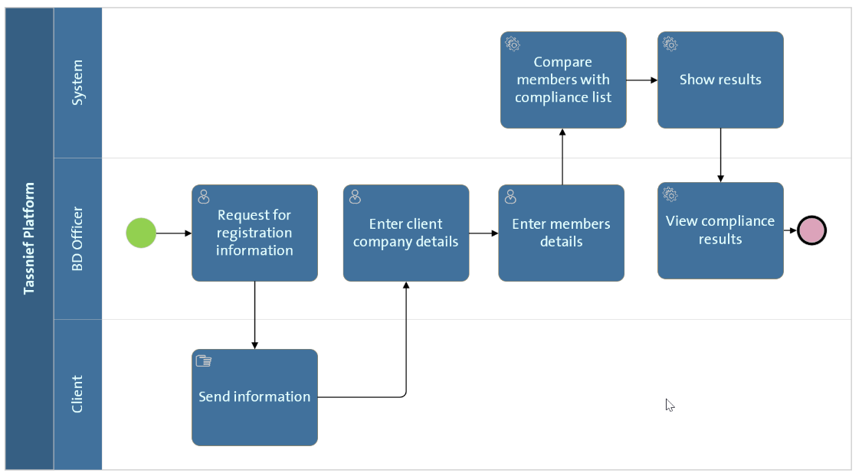

Figure : Register Client

|  |  |  |  |  |
| --- | --- | --- | --- | --- |
| No. | Actor | Step Name | Step Description | Notes |
|  | BD Officer | Request for registration information | Request for client registration information (client company information and members information) through email | The email body is written by the BD officer and sent through the system to the client email. |
|  | Client | Request rating | Send information through email to the BD officer. |  |
|  | BD Officer | Enter client company details | Enter client company details in the system after receiving the email from client | Ex. Register type- CRN – Sector |
|  | BD Officer | Enter members’ details | Enter client members’ details in the system | Ex. Name – Position – Email – phone number |
|  | System | Compare with compliance list | In earlier stages, the compliance department fills a list of restricted clients both based on companies and personal | The list is part of the management and configuration module. |
|  | System | Show results | Show if the client information matches a restricted client information. |  |
|  | BD Officer | View Compliance results | View if the client information matches a restricted client information. | This information helps in deciding the team allocation for the client from Taasnief. |

## Prepare Agreement Package

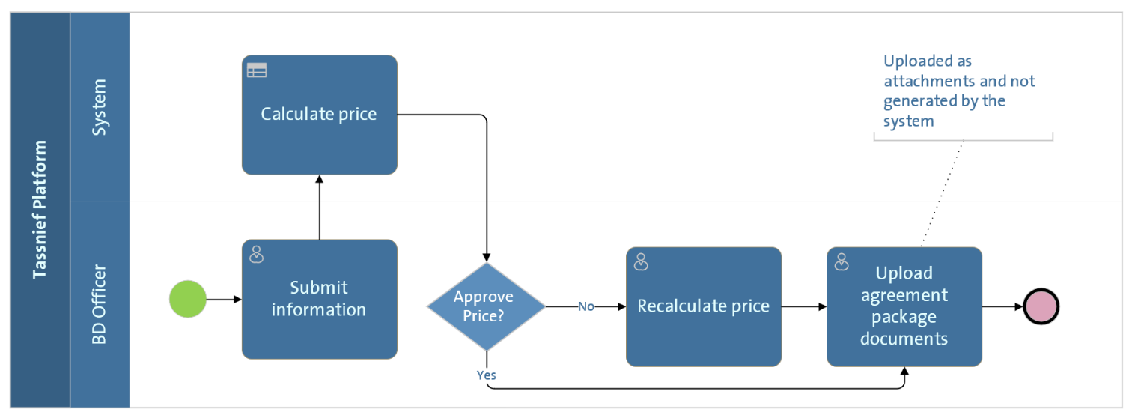

Figure : Prepare Agreement Package

|  |  |  |  |  |
| --- | --- | --- | --- | --- |
| No. | Actor | Step Name | Step Description | Notes |
|  | BD Officer | Submit information | Submit request information to the system | Ex. (new- renewal)- request type. |
|  | System | Calculate price | Calculate price automatically | Based on pricing formulas defined by BD chief |
|  | BD Officer | Recalculate price | Renter a price if the price generated by the system if it needs changing | The BD officer have a limited pricing range |
|  | BD Officer | Upload agreement package | Upload agreement package documents information as attachments it to the system | Documents are only attached not generated by the system.  Attached documents name and format such as: contract |

## Agreement Package Approval

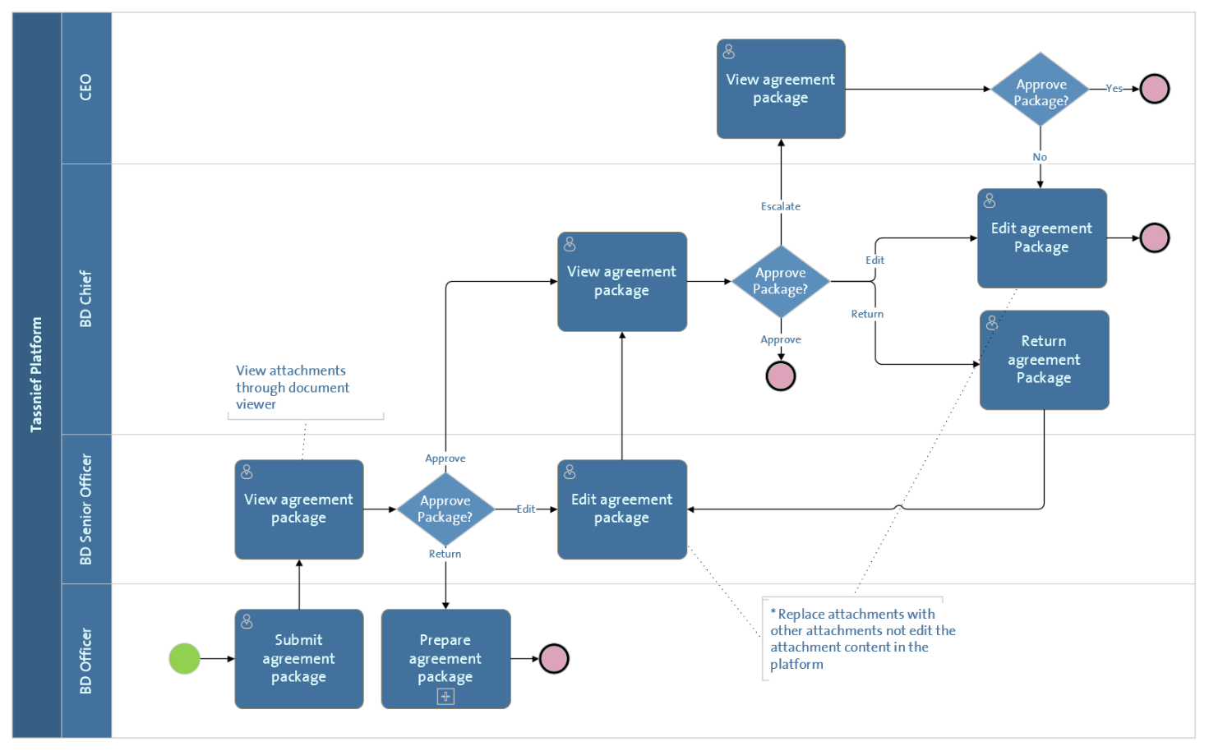

Figure : Agreement Package Approval

|  |  |  |  |  |
| --- | --- | --- | --- | --- |
| No. | Actor | Step Name | Step Description | Notes |
|  | BD Officer | Submit agreement package | Submit agreement package after preparing it to the system. |  |
|  | BD Senior Officer | View agreement package | View agreement package after submission. | Through document viewer |
|  | BD Senior Officer | Edit Package | Edit agreement package if the BD senior officer decides to. | Agreement package fields are editable to the senior officer (pricing is within limited change)- *attachments can be replaced but not edited through the system. |
|  | BD Senior Officer | Return package | Return agreement package to the BD officer with comments. | A comment filed will be showed to the senior officer. |
|  | BD Senior Officer | Approve package | Approve the agreement package if the senior officer has no comments. |  |
|  | BD Chief | View agreement package | View agreement package after senior officer approval |  |
|  | BD Chief | Edit Package | Edit agreement package if the BD Chief decides to. | Agreement package fields are editable to the chief. * attachments can be replaced but not edited through the system. |
|  | BD Chief | Return package | Return agreement package to the senior officer with comments. | A comment filed will be showed to the chief. |
|  | BD Chief | Approve package | Approve the agreement package if the BD chief has no comments which is the final approval. |  |
|  | BD Chief | Escalate Agreement package | Escalate the agreement package if the BD chief has no comments which is the final approval. |  |
|  | CEO | View agreement package | CEO views the agreement package if the BD chief escalates it to the CEO. |  |
|  | CEO | Return package | CEO returns the agreement package with comments to the BD chief. |  |
|  | CEO | Approve agreement package | CEO approves agreement which is the final approval. |  |

## Issue Bill

Figure : Issue Bill

|  |  |  |  |  |
| --- | --- | --- | --- | --- |
| No. | Actor | Step Name | Step Description | Notes |
|  | BD Officer | Enter bill amount | Enter bill amount |  |
|  | BD Officer | Enter bill duo date | Enter bill duo date |  |
|  | System | Create bill | Create a bill in the system with a generated reference number | Ex. (new- renewal)- request type. |
|  | System | Notify Payment Gateway | System will notify the integrated payment gateway with bill details. |  |
|  | Payment Gateway system | Create bill | Payment gateway creates a bill with the specified amount |  |
|  | Payment Gateway system | Send payment gateway bill details | Payment gateway send bill details with the specified amount to Tassnief platform |  |
|  | System | Receive payment gateway bill details | Receive Payment gateway bill details | Link payment gateway bill with Tassnief bill |
|  | System | Notify finance with bill details | Notify finance with bill details |  |
|  | Finance | Receive bill notification | Receive bill details |  |
|  | System | Notify client | Notify client with bill issuance and bill details through notification channel |  |

## Receive Payment

Figure : Receive Payment

|  |  |  |  |  |
| --- | --- | --- | --- | --- |
| No. | Actor | Step Name | Step Description | Notes |
|  | Payment Gateway system | Update bill status | Update bill status after receiving payment |  |
|  | Payment Gateway system | Notify Tassnief finance | Payment gateway notifies Tassnief finance with bill payment by client |  |
|  | Finance | Receive notification | Receive payment notification from payment gateway |  |
|  | Finance | Confirm payment | Finance confirms payment in Tassnief platform |  |
|  | System | Update bill status | System updates bill status to” Paid” after finance confirmation. |  |
|  | System | Notify rating | Notify rating with payment confirmation to start the process |  |

## Service Initiation

Figure : Service Initiation

|  |  |  |  |  |
| --- | --- | --- | --- | --- |
| No. | Actor | Step Name | Step Description | Notes |
|  | system | Allocate task | System allocate preparing the agreement package task based on the approach. | Allocation approach is either “Push” or “Drag and Drop”  Refer to |
|  | Business Analyst | Draft initiation email/RFI | Draft initiation email/RFI body |  |
|  | Business Analyst | Send initiation email/RFI | Send initiation email/RFI through the system to the client email to get the needed information from client or if client didn’t send the full information | The email body is written by the BA and sent through the system to the client email. |
|  | Client | Receive email | Client receives initiation email/RFI |  |
|  | Client | Send information | Client sends the needed information to the BA through email |  |
|  | Business Analyst | Upload information to the system | BA uploads the information to the system after receiving it from the client through email | The information can be either attachments or comments in a text filed |
|  | Business Analyst | Allocate rating/senior rating analyst | BA allocates the RA and senior RA to the task if the allocation was “push” approach. | *if the allocation approach was “Drag and drop”, the RA and senior RA can drag the tasks whenever the tasks status allows it. |
|  | Rating Chief | View Allocation | Rating chief views allocation of RA and senior RA chosen by the BA if the allocation was “push” approach. And decides whether they approve it or return it to BA to reallocate them. |  |
|  | Rating Chief | Allocate IRC members | Allocate IRC members to the case. |  |

## Client Meeting

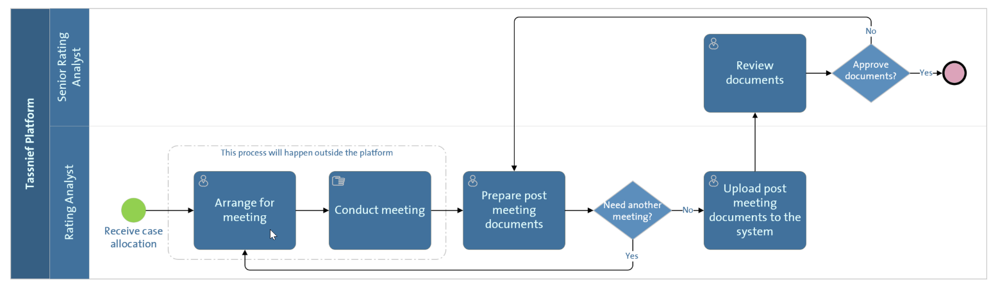

Figure : Client Meeting

|  |  |  |  |  |
| --- | --- | --- | --- | --- |
| No. | Actor | Step Name | Step Description | Notes |
|  | Rating Analyst | Arrange for meeting | Arrange for the client meeting by communicating with client outside the platform. | The platform is not a part of this process. |
|  | Rating Analyst | Conduct Meeting | Conduct client meeting outside the platform. | Whither the meeting was onsite or online the platform is not included in the process. |
|  | Rating Analyst | Prepare post meeting documents | Prepare post meeting documents and decides if another meeting is needed and if it was the rating analyst conducts another to make sure documents are sufficient. | The decision of wither another meeting is required is outside the platform. |
|  | Rating Analyst | Upload post meeting documents | Uploads post meeting minutes to the system | Meeting documents are attached such as meeting minutes |
|  | Senior Rating Analyst | Review documents | Senior views post meeting documents through document viewer |  |
|  | Senior Rating Analyst | Approve documents | Senior approves post meeting documents |  |
|  | Senior Rating Analyst | Return documents | Senior returns post meeting documents |  |

## Internal Rating Committee Meeting

Figure : IRC Meeting

|  |  |  |  |  |
| --- | --- | --- | --- | --- |
| NO. | Actor | Step Name | Step Description | Notes |
|  | Rating Analyst | Prepare pre-committee documents | Prepare pre-committee documents. Rating analyst’s case is not qualified to go to the committee until these documents are submitted: RC Draft Report/ RC PPT/ SIMAH/ Commercial Report/ Rating Result |  |
|  | Rating Analyst | Submit pre-committee documents | Submit pre-committee documents | Documents are attached and the rating result is an input |
|  | Senior Rating Analyst | Review documents | Review pre-committee documents and decide whither they approve it or not. If not, it’s returned to rating analyst with comment | Through document viewer |
|  | IRC members | Call for committee meeting | Call for committee meeting if members receive a case outside the platform. |  |
|  | IRC members | Conduct committee meeting | Conduct IRC meeting outside the platform |  |
|  | Rating Analyst | Prepare IRC MM & updated documents | Prepare the updated documents and meeting minutes after the IRC meeting is conducted outside the platform |  |
|  | Rating Analyst | Submit IRC MM & updated documents | Submit the updated documents and meeting minutes after the IRC meeting is conducted outside the platform |  |
|  | IRC members | View MM & updated documents | View the updated documents and meeting minutes after through documents viewer for the documents and decide wither they approve it or return it to rating analyst |  |

## External Rating Committee Meeting

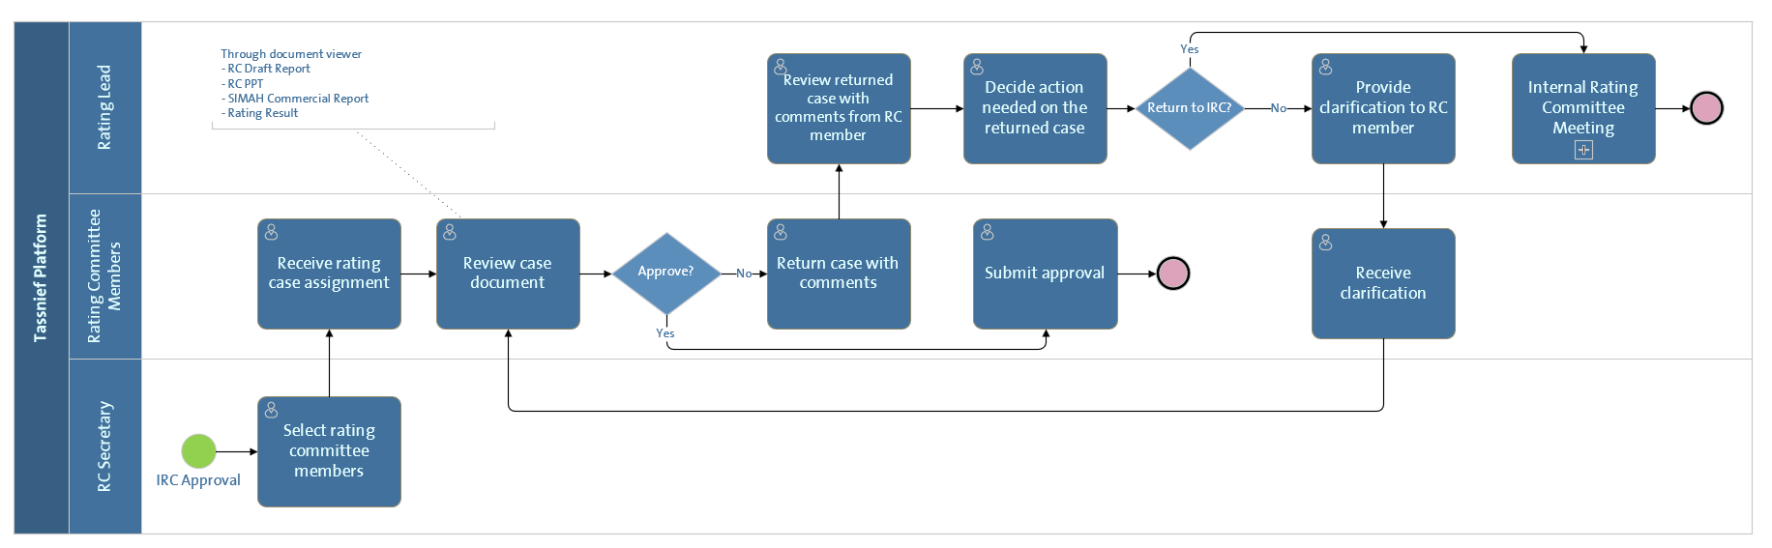

Figure : ERC Meeting

|  |  |  |  |  |
| --- | --- | --- | --- | --- |
| NO. | Actor | Step Name | Step Description | Notes |
|  | ERC secretary | Select ERC members | Secretary selects ERC members after IRC approval | Secretary can view compliance list thus, can choose members based on it |
|  | ERC members | Review rating case assignment | ERC review rating case assignment |  |
|  | ERC members | Review case documents | ERC review rating case assignment through document viewer | Through document viewer |
|  | IRC members | Submit approval | Submit approval in the platform | Case is only approved it all members approval is captured |
|  | IRC members | Return case with comments | Return case with comments |  |
|  | Rating Lead | View returned case | View returned case with comments |  |
|  | Rating Lead | Decide the needed action to the returned case | Decide the needed action to the returned case |  |
|  | Rating Lead | Return to IRC | Lead returns the case to IRC if they decide that it need more analysis |  |
|  | Rating Lead | Provide clarification to ERC member | Provide clarification to ERC member if they decide that it needs more explanation |  |
|  | IRC members | Receive clarification | IRC member receives clarification from rating lead and gets to decide wither they approve or not | Approved members do not need to approve again |

## Draft Report

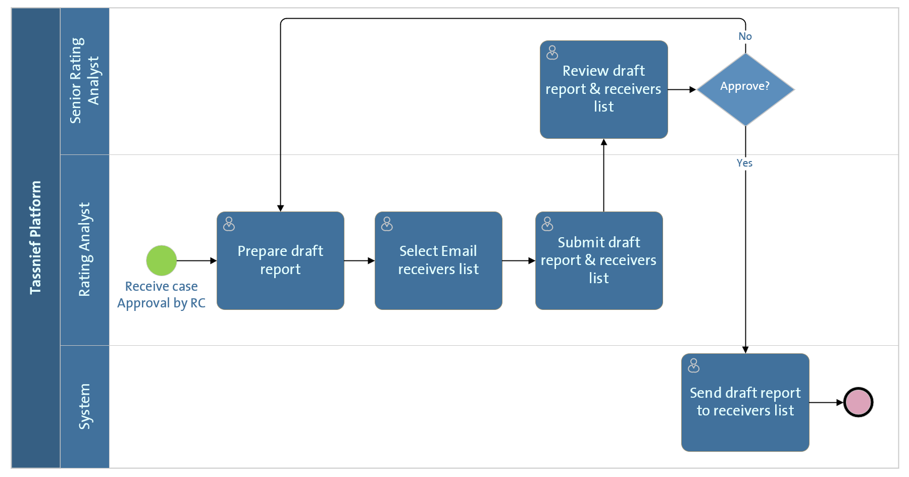

Figure : Draft Report

|  |  |  |  |  |
| --- | --- | --- | --- | --- |
| NO. | Actor | Step Name | Step Description | Notes |
|  | Rating Analyst | Prepare draft report | Prepare draft report outside the platform | No report is generated by the platform |
|  | Rating Analyst | Select Email receives list | Select the receivers list form the client members defined by BD |  |
|  | Rating Analyst | Submit draft report and receives list | Submit the draft report as an attachment and receivers list to be sent to |  |
|  | Senior Rating Analyst | Review draft report and receives list | Reviews the report through a document viewer and the receivers list and decide wither to approve or return it to the RA |  |
|  | System | Send draft report and receives list | Sends the draft report to the receivers list after the senior rating analyst approves it |  |

## Receive Draft Report

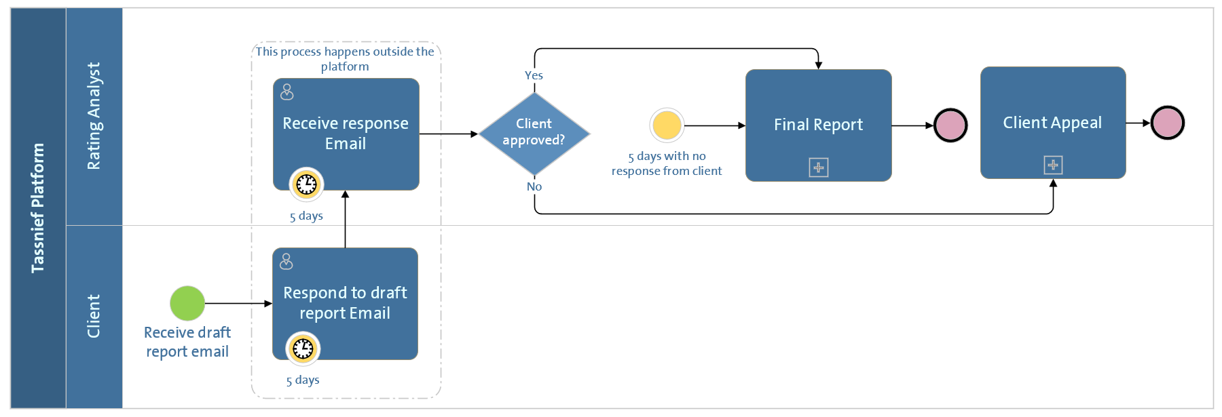

Figure 14: Receive Draft Report

|  |  |  |  |  |
| --- | --- | --- | --- | --- |
| NO. | Actor | Step Name | Step Description | Notes |
|  | Client | Respond to draft report | Responds to draft report outside the platform through email within 5 days |  |
|  | Rating Analyst | Receive Response to draft report | Receives response to draft report outside the platform through email within 5 days | No response is captured by the platform |
|  | Rating Analyst | Final report | The rating analyst goes to the final repost if the client has approved to the draft report or it 5 days have passed with no response. |  |
|  | Rating Analyst | Client appeal | The rating analyst goes to the client appeal if the client hasn’t approved to the draft report. |  |

## Final Report

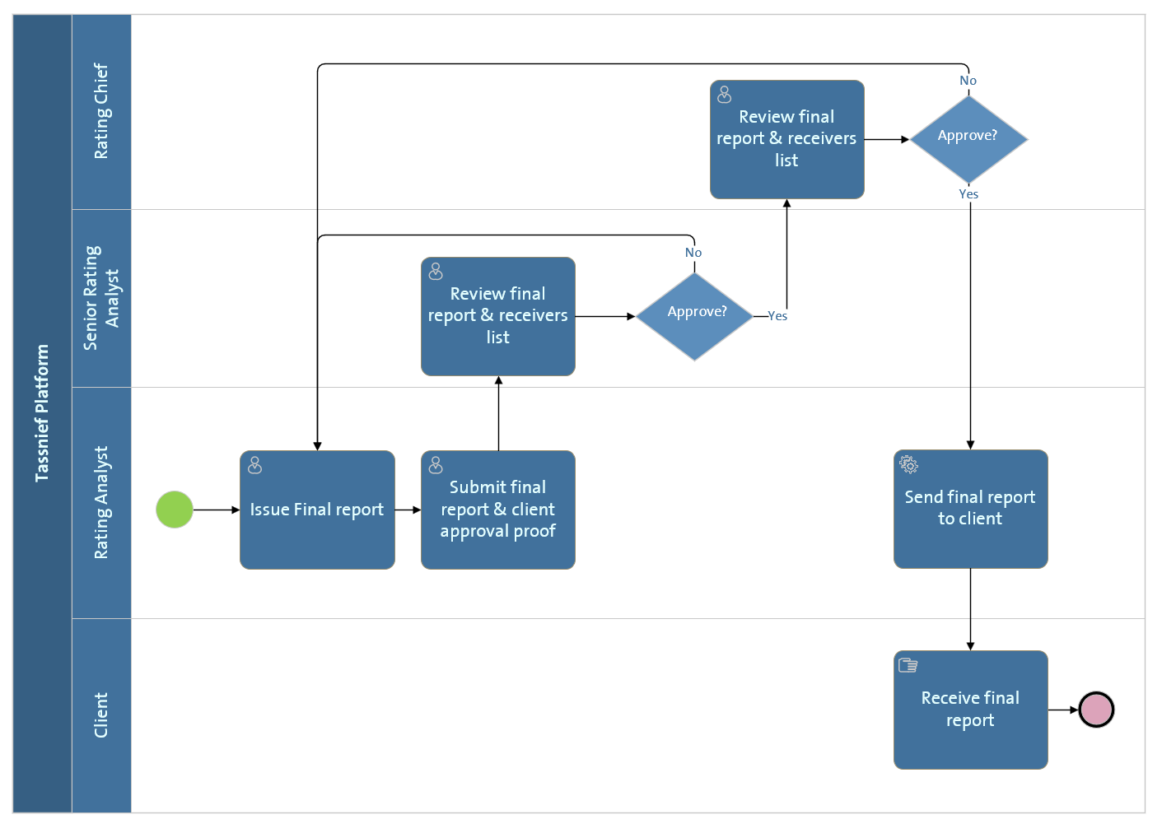

Figure 15: Final Report

|  |  |  |  |  |
| --- | --- | --- | --- | --- |
| NO. | Actor | Step Name | Step Description | Notes |
|  | Rating Analyst | Issue Final report | Prepare final report outside the platform | No report is generated by the platform |
|  | Rating Analyst | Submit Final report & client approval proof | Submit final report & client approval proof with receivers list |  |
|  | Senior Rating Analyst | Review final report and receivers list | Review final report & client approval proof with receivers list and decides wither they approve it or not. If not, it’s returned to the analyst |  |
|  | Rating Chief | Review final report and receivers list | Review final report & client approval proof with receivers list after Senior analyst approval and decides wither they approve it or not. If not, it’s returned to the analyst. |  |
|  | Rating Analyst | Send final report | Send final report to client |  |
|  | Client | Receive final report | Receive final report through email |  |

## Client Appeal

Figure : Client Appeal

|  |  |  |  |  |
| --- | --- | --- | --- | --- |
| NO. | Actor | Step Name | Step Description | Notes |
|  | Rating Analyst | Prepare appeal document | Prepare appeal document platform | No report is generated by the platform |
|  | Rating Analyst | Submit appeal proof | Submit appeal proof received by client to the platform | Proof is attached as an attachment |
|  | Senior Rating Analyst | Review client appeal document | Review client appeal document and proof through the document viewer |  |
|  | Senior Rating Analyst | Prepare appeal response email | Prepare appeal response email if the appeal is not approved |  |
|  | Senior Rating Analyst | Send appeal response email | Send client appeal response to the client email | The email body is written by the senior rating analyst and sent through the system to the client email. |
|  | Client | Receive appeal response email | Receive appeal response email and decides wither they approve of the response or not. If not, the rating analyst have to resubmit the appeal again through the platform | The client response is not captured by the system and only through the RA engagement with the system |
|  | Senior Rating Analyst | Final report | The final report is issued if the client accepts the appeal response and the acceptance is captured by the senior rating analyst |  |
|  | Rating Chief | Review client appeal document | Review client appeal document and proof through the document viewer and decides wither they approve it or not |  |
|  | Rating chief | Client meeting | Call for client meeting if the appeal is approved by the rating chief and the whole rating process begins again |  |
|  | Rating Analyst | Inform client of appeal rejection | Inform client of appeal rejection if the rating chief rejects the appeal |  |

# Roles and Users

|  |  |  |  |
| --- | --- | --- | --- |
| NO. | Role | Department | Description |
|  | Admin | - | Manages all the platform users and platform functions |
|  | CEO | Organization | CEO of Tassnief organization (only one user) |
|  | IRC member | Organization | Internal rating committee member from a specified list of members from inside Tassnief organization |
|  | ERC member | Organization | External rating committee member from a specified list of members from outside Tassnief organization |
|  | ERC secretary | Organization | External rating committee secretary responsible for facilitating ERC meeting and capturing approvals |
|  | Rating Chief | Rating | Rating department chief responsible for higher level of approvals and authorities in rating tasks |
|  | BD Chief | BD | BD department chief responsible for higher level of approvals and authorities in BD tasks |
|  | Compliance officer | Compliance | Responsible for creating and maintaining compliance list |
|  | Rating Lead | Rating | Responsible for leading and governing the rating process |
|  | Senior rating analyst | Rating | Responsible for approving and governing the rating analyst activities |

|  |  |  |  |
| --- | --- | --- | --- |
|  | Business analyst | Rating | Responsible for initiating the rating process |
|  | Rating analyst | Rating | Responsible for the rating activities |
|  | BD Senior Officer | BD | Responsible for approving agreement packages and monitoring BD officer activities. |
|  | BD Officer | BD | Responsible for register clients and services |
|  | Finance | SIMAH finance | Responsible for validating the payment after receiving payment confirmation from payment gateway. |
|  | Client |  | Requests service the platform. |

# Services Catalog

The service catalog is grouped by system modules and users, in a way that describes what each user is able to do in a module.



## Employee Management

|  |  |  |  |
| --- | --- | --- | --- |
| Role No. | Role | Feature No. | Feature |
|  | BD chief | 1.1 | Pick task allocation approach. (push – drag and drop) for department employees. |
| 1.2 | Assign BD officers to BD senior officers to report to. |
| 1.3 | Assign employee delegations to other employees. |
|  | Rating Chief | 2.1 | Pick task allocation approach. (push – drag and drop) for department employees (within rating department). |
| 2.2 | Assign rating analysts to senior rating analysts to report to. |
| 2.3 | Assign employee delegations to other employees (within rating department). |
| 2.4 | Create IRC members list. |
| 2.5 | Create ERC members list. |

## Client Management

|  |  |  |  |
| --- | --- | --- | --- |
| Role No. | Role | Feature No. | Feature |
|  | Compliance officer | 1.1 | Create compliance list (a list of client’s members and companies that Tassnief is restricted in regards of providing the service to them.) |
| 1.2 | Maintain compliance list (edit – add - delete). |
| 1.3 | View compliance list. |
| 1.4 | View registered clients. |
| 1.5 | View compliance list matching results of a request. |
|  | BD Officer | 2.1 | View compliance list. |
| 2.2 | View compliance list matching results of a request. |
| 2.3 | Register clients (company and members details) |
| 2.4 | View registered clients list. |
| 2.5 | Maintain registered clients list (edit – add delete). |
| 2.5 | View update request to registered clients. |
|  | BD Chief | 3.1 | View compliance list. |
| 3.2 | View compliance list matching results of a request. |
| 3.3 | Register clients. |
| 3.4 | View registered clients list. |
| 3.5 | Maintain registered clients list (edit – add delete). |

|  |  |  |  |
| --- | --- | --- | --- |
|  | Business Analyst | 4.1 | View compliance list matching results of a request. |
| 4.2 | View registered client details of an assigned case. |
|  | Rating Chief | 5.1 | View compliance list. |
| 5.2 | View compliance list matching results of a request. |
| 5.3 | View registered client details of an assigned case. |
| 5.4 | View registered clients list. |
| 5.4 | Request update on a registered client from BD. |
|  | Rating Analyst | 6.1 | View compliance list matching results of a request. |
| 6.2 | View registered client details of an assigned case. |
|  | CEO | 7.1 | View compliance list. |
| 7.2 | View compliance list matching results of a request. |
| 7.3 | Register clients. |
| 7.5 | View registered clients list. |
|  | System | 8.1 | Compare registered clients with compliance list. |

## Service Management

|  |  |  |  |
| --- | --- | --- | --- |
| Role No. | Role | Feature No. | Feature |
|  | BD Chief | 1.1 | Create pricing limitations for BD department users. |
| 1.2 | Maintain pricing limitations for BD department users. |
| 1.3 | Create payment installments packages. |
| 1.4 | Maintain payment installments packages. |
|  | System | 2.1 | Calculate pricing limitations for BD department users. |
| 2.2 | Calculate payment installments duo date. |

## Service Flow

|  |  |  |  |
| --- | --- | --- | --- |
| Role No. | Role | Feature No. | Feature |
|  | BD Chief | 1.1 | Allocate new service requests to BD officer (if allocation approach was “Push”). |
| 1.2 | View Allocation of BD officer for tasks (if allocation approach was” Drag and Drop”). |
| 1.3 | View all new service requests. |
| 1.4 | View service status. |
| 1.5 | View agreement package. |
| 1.4 | Approve agreement package. |
| 1.6 | Escalate agreement package. |
| 1.7 | Return agreement package to BD senior officer with comments. |
| 1.8 | Edit agreement package. |
| 1.9 | Assign permissions in document viewer to department employees. |

|  |  |  |  |
| --- | --- | --- | --- |
|  | BD Senior Officer | 2.1 | View service status. |
| 2.2 | View agreement package. |
| 2.3 | Approve agreement package. |
| 2.4 | Return agreement package to BD officer with comments. |
| 2.5 | Edit agreement package. |
|  | BD Officer | 3.1 | View assigned services. (if allocation approach was “Push”). |
| 3.2 | Drag a service (if allocation approach was” Drag and Drop”). |
| 3.3 | View service status. |
| 3.4 | Draft service RFI email to client. |
| 3.5 | Upload service request documents obtained by client to the system. |
| 3.6 | Enter price for an agreement package. |
| 3.7 | Upload agreement package documents. |
| 3.8 | View agreement package status. |
| 3.9 | View returned agreement package comments. |
| 3.10 | Edit agreement package after return. |
| 3.11 | Submit signed contract by the client to the system. |
|  | CEO | 4.1 | View agreement package. |
| 4.2 | Approve Agreement package. |
| 4.3 | Return agreement package to BD chief with comments. |
|  | Rating Chief | 5.1 | Allocate new service requests to BA (if allocation approach was “Push”). |
| 5.2 | View allocation of BA for tasks (if allocation approach was” Drag and Drop”). |
| 5.3 | View allocation of rating analyst and senior rating analyst by BA. |
| 5.4 | Approve allocation of rating analyst and senior rating analyst by BA. |
| 5.5 | Return allocation of rating analyst and senior rating analyst by BA. |
| 5.6 | Allocate IRC members. |
| 5.7 | Assign permissions in document viewer to department employees. |
| 5.8 | View final report and receivers list. |
| 5.9 | Approve final report and receivers list. |
| 5.10 | Return final report and receivers list. |
| 5.11 | View client appeal document. |
| 5.12 | Approve client appeal document. |
| 5.13 | Call for a client meeting if appeal document was approved. |
| 5.14 | Reject client appeal document. |
|  | Rating Lead | 6.1 | View returned case by ERC with comments. |
| 6.2 | Return case to IRC if the lead decide that it need more analysis |
| 6.3 | Provide clarification to ERC member if the lead decide that it needs more explanation |
|  | Senior rating analyst | 7.1 | View assigned services. (if allocation approach was “Push”). |
| 7.2 | Drag a service (if allocation approach was” Drag and Drop”). |
| 7.3 | View post meeting documents through document viewer |
| 7.4 | Approve post meeting documents |
| 7.5 | Return post meeting documents |
| 7.6 | Review pre-committee documents |
| 7.7 | Approve pre-committee documents |
| 7.8 | Return pre-committee documents to rating analyst with comment |
| 7.9 | View draft report and receivers list. |
| 7.10 | Approve draft report and receivers list. |
| 7.11 | Return draft report and receivers list. |
| 7.12 | View final report and receivers list. |
| 7.13 | Approve final report and receivers list. |
| 7.14 | Return final report and receivers list. |
| 7.15 | View client appeal document. |
| 7.16 | Approve client appeal document. |
| 7.17 | Reject client appeal document. |
| 7.18 | Draft appeal response to client. |
| 7.19 | Send appeal response to rating analyst. |
| 7.20 | Call for final report if client approves client response. |
|  | Rating Analyst | 8.1 | View assigned services. (if allocation approach was “Push”). |
| 8.2 | Drag a service (if allocation approach was” Drag and Drop”). |
| 8.3 | Prepare post client meeting documents. |
| 8.4 | Submit post client meeting documents. |
| 8.5 | Prepare pre- IRC documents. |
| 8.6 | Submit pre-IRC documents. |
| 8.7 | Prepare IRC MM and updated documents. |
| 8.8 | Submit IRC MM and updated documents. |
| 8.9 | Prepare draft report. |
| 8.10 | Select draft report receivers list. |
| 8.11 | Submit draft report and receivers list. |
| 8.12 | Submit client response to draft report. |
| 8.13 | Prepare final report. |
| 8.14 | Select final report receivers list. |
| 8.15 | Submit final report and receivers list. |
| 8.16 | Prepare client appeal proof. |
| 8.17 | Submit client appeal proof. |
| 8.18 | Send client appeal email. |
| 8.19 | Submit client appeal email response. |
|  | IRC member | 9.1 | Call for committee meeting. |
| 9.2 | View pre-IRC meeting documents through document viewer. |
| 9.3 | Approve IRC meeting minutes and updated documents. |
| 9.4 | Return IRC meeting minutes and updated documents. |
|  | ERC member | 10.1 | Review rating case assignment. |
| 10.2 | View ERC case documents through document viewer. |
| 10.3 | Approve ERC case documents. |
| 10.4 | Return ERC case documents. |
| 10.5 | Review clarification for returned case documents. |
|  | ERC secretary | 11.1 | Select ERC members. |
|  | System | 12.1 | Send Initiation email created by BA. |
| 12.2 | Send draft report email to receivers list. |
| 12.3 | Send final report email to receivers list. |
| 12.4 | Send client appeal response email to receivers list. |
|  | Compliance | 13.1 | View cases allocation. |
| 13.2 | Raise a flag for a case that doesn’t confirm to compliance rules |

## Billing

|  |  |  |  |
| --- | --- | --- | --- |
| Role No. | Role | Feature No. | Feature |
|  | BD officer | 1.1 | Enter bill amount. |
| 1.2 | Enter bill duo date |
|  | Finance | 2.1 | Receive payment confirmation for payment gateway. |
| 2.2 | Confirm payment. |
|  | System | 3.1 | Create bill with reference number. |
| 3.2 | Notify payment gateway with bill details. |
| 3.3 | Receive payment gateway bill details. |
| 3.4 | Notify finance with bill details. |
| 3.5 | Notify client with bill details. |
| 3.6 | Update bill status. |
| 3.7 | Notify rating chief. |
|  | Finance | 4.1 | Receive notification of payment from payment gateway. |
| 4.2 | Confirm payment. |

## Supporting Services

|  |  |  |  |
| --- | --- | --- | --- |
| Role No. | Role | Feature No. | Feature |
|  | System | 1.1 | Generate reports for the tasks in the platform. |
| 1.2 | Generate real time system transactions audit log |
| 1.3 | Generate 360° rating service process dashboard |
| 1.4 | Generate ad-hoc reports & queries |
| 1.5 | Generate real time system transactions audit log |
|  | Admin | 2.1 | Manage user permissions and privileges (edit – add -delete). |
| 2.2 | Authenticate and authorize user access. |
| 2.3 | View real time system transactions audit log |
| 2.4 | View 360° rating service process dashboard |
| 2.5 | View ad-hoc reports & queries |

# Assumptions



## Client Engagement

1. Client can only submit a request through the platform and other than that will only receive email for the rest on engagement.
2. Client can submit the request through t]other channels than the platform such as: email- phone
3. The employee that manages the client task is one responsible for capturing the client response and submitting proof as an attachment to the task in the platform.

## Documents

1. No documents or reports are generated by the system.
2. No editable documents on the system. Attachments can be downloaded and deleted or replace only.

## Billing

1. Billing will be inside Tassnief platform while payment will be through a payment gateway that is to be decide.