Lab2
Name : Amr Ahmed Gomaa

1-Create a ReplicaSet using the below yaml

apiVersion: apps/v1
kind: ReplicaSet
metadata:
name: new-replica-set
namespace: default
spec:
replicas: 4
selector:
matchLabels:
name: busybox-pod
template:
metadata:
labels:
name: busybox-pod
spec:
containers:
- command:
- sh
- -c
- echo Hello Kubernetes! && sleep 3600
image: busybox777
imagePullPolicy: Always
name: busybox-container

create a new yaml file
copy the yaml code to the yaml file
kubectl apply -f <filename.yml>
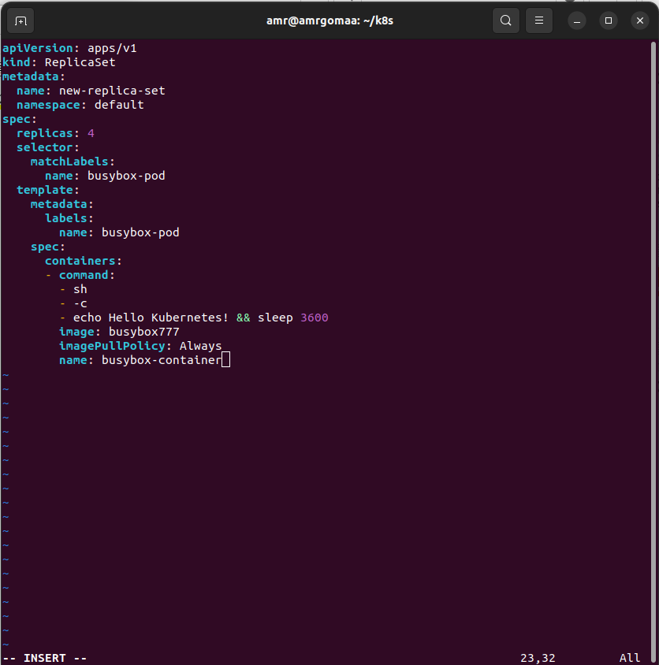
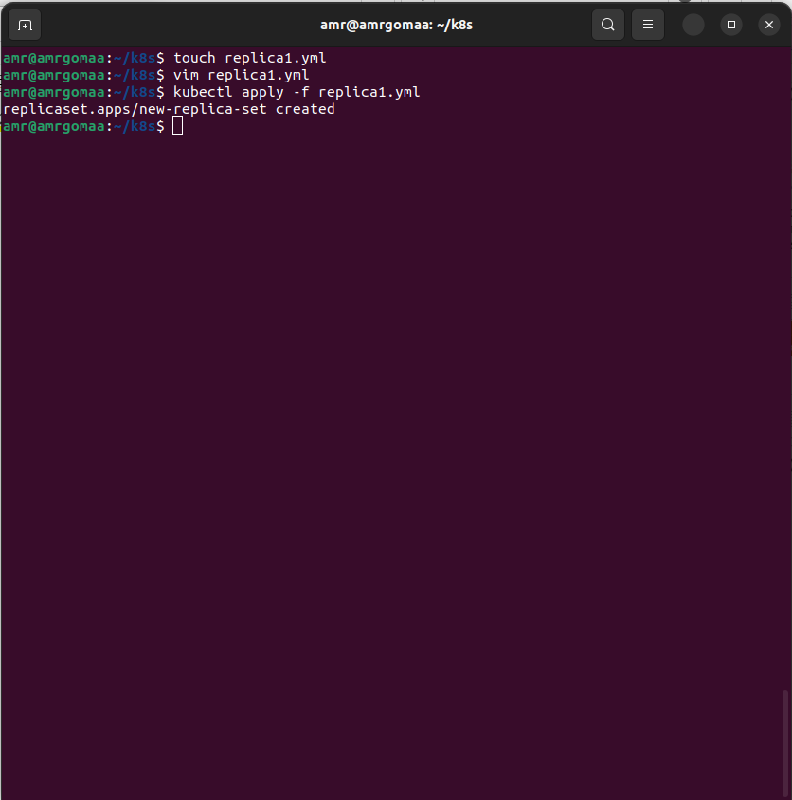

--------------------
2-How many PODs are DESIRED in the new-replica-set?
Desired from the yaml file are 4 pods
or get it from the command kubectl get replicaset

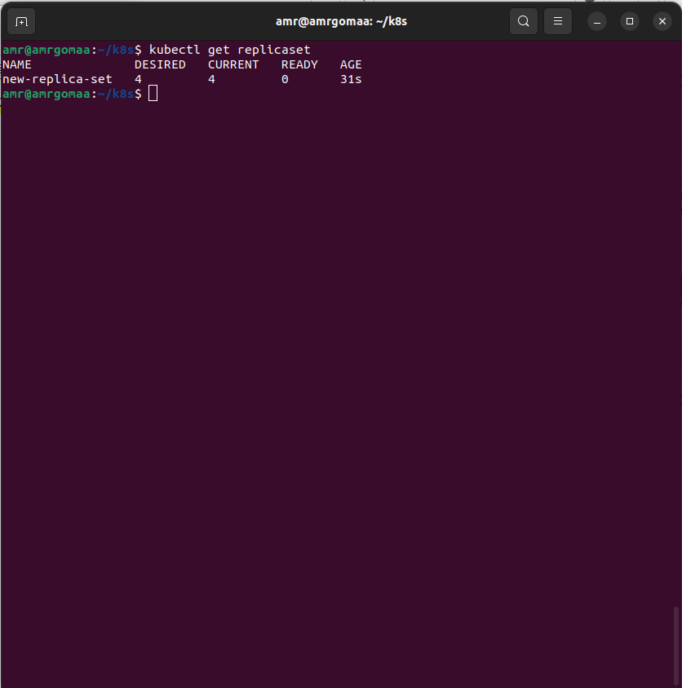

----------------------
3-What is the image used to create the pods in the new-replica-set?
Image used from the yaml file is busybox777

---------------------
4-How many PODs are READY in the new-replica-set?
All the pods arent ready – (the pods are waiting if we inspect using descripe the pod)
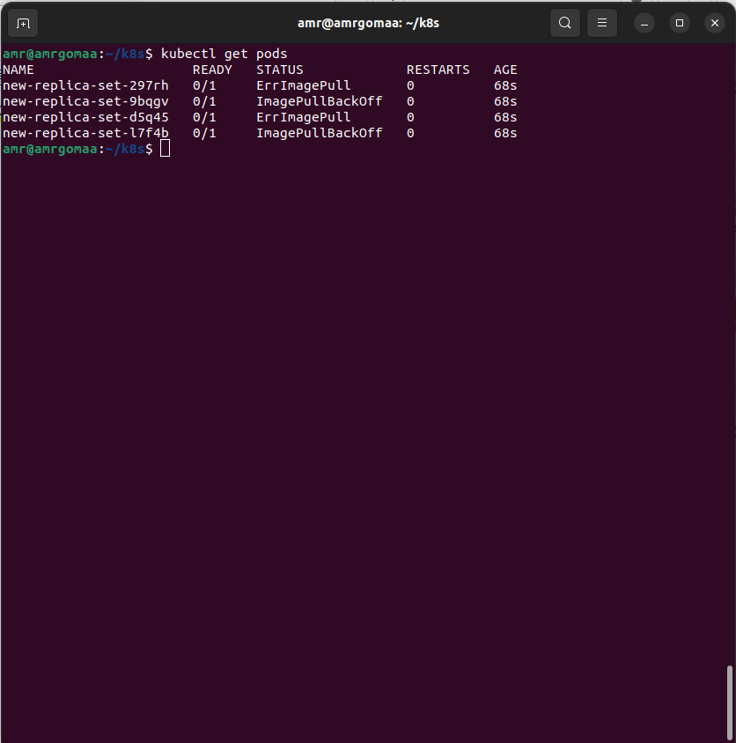

---------------------
5-Why do you think the PODs are not ready?
After running kubectl describe pod <any pod name>
there is an error in pulling the image
There is no image called busybox777
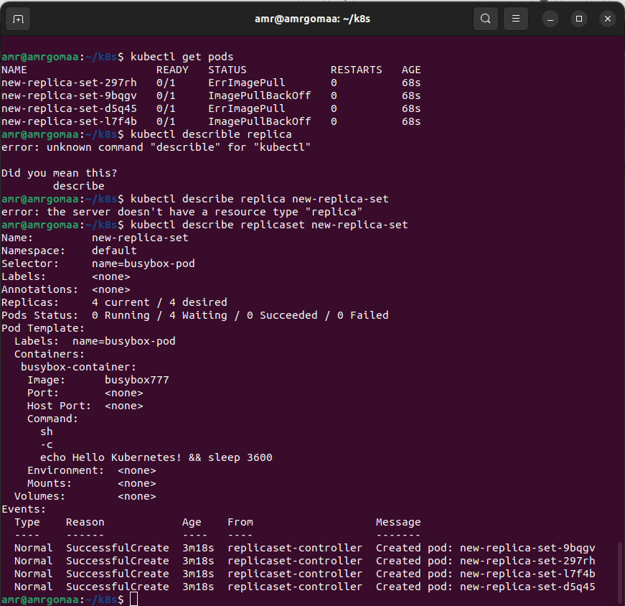

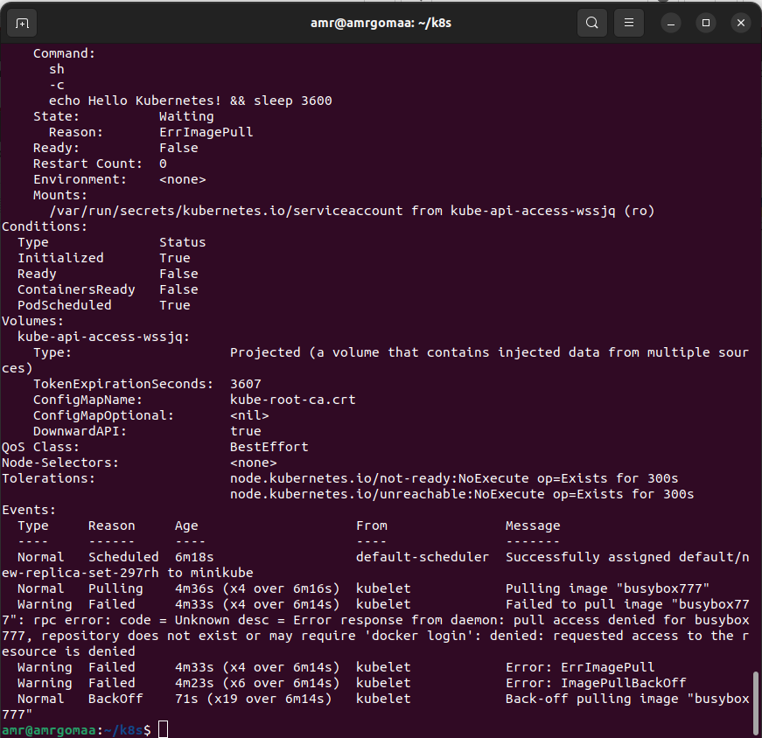
------------------------

6-Delete any one of the 4 PODs.
How many pods now
still 4 pods ,
kubectl get delete pod <pod name>
still 4 pods

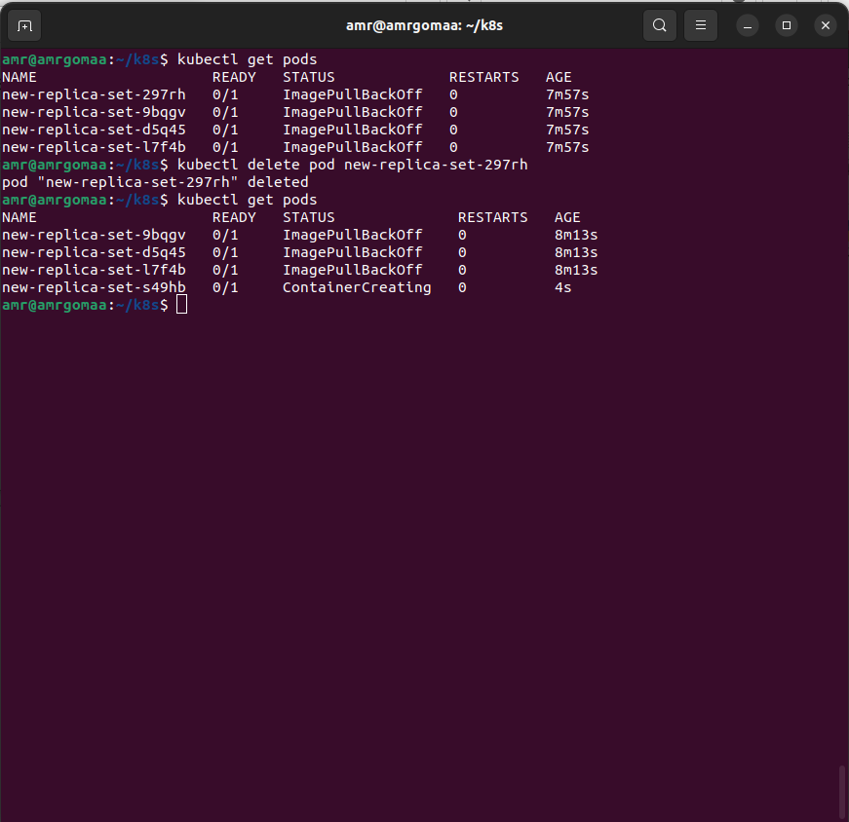

---------------------
7-Why are there still 4 PODs, even after you deleted one?

as the relicas= 4 in the yml file so it will automatically recover and run another pod to be 4 again
-----------------
8-Create a ReplicaSet using the below yaml

There is an issue with the file, so try to fix it.

apiVersion: v1
kind: ReplicaSet
metadata:
name: replicaset-1
spec:
replicas: 2
selector:
matchLabels:
tier: frontend
template:
metadata:
labels:
tier: frontend
spec:
containers:
- name: nginx
image: nginx

in apiVersion the value should be = apps/v1
The ApiVersion supports the resource ReplicaSet. Every API supports certain resources and together with Kind we can unequivocally define them

below there are screenshots for the solution after modifying the yml file

