Students Affairs

BRD

Introduced by: Team 22

**Introduction**

**Executive Summary**

**Students Affairs** Website is a tool that will accelerate the workflow of SA department and offer great deal of comfort for both applicants and employees. SA website is an online platform where students can apply for any type of official document, and employees can manage and oversee any type of requests. Online student affairs offer answers for all student’s enquiries and FAQs, easy & quick access to any document procedures, student can manage all his\her requests supported with online payment as well as mail notifications.

**Document Overview**

This document introduces **Students Affairs** product study plan. It introduces general description, technical description, development plan, operation plan, cost analysis and marketing study.

**Business Objectives**

* Offers easy and effective online student affairs service.
* Offers recorded answers for frequently asked questions and inquiries about any document procedures.
* Offers effective way of students/affairs office interaction, document follow up and final reception.
* Offers organized and secure way of certification and official documentation with online fees payment.
* Offers free and self-growing service to everyone.

**Background**

**Introduction**

**Education** has always played an essential role in human life and it has been conducted in various ways depending on the culture and location. During the past centuries, men have traveled from country to country for business, migration, war and education. Desire to avoid traditional education was always tremendous and invention of Internet brought this idea closer to reality (Marsap and Narin, 2009).

**Internet** interconnects the computer networks and enables them to communicate directly with each other throughout the world. This global interconnection of governments, education and businesses led to computer networks becoming more accessible to the public to provide quality information, education and entertainment for humanity. In early 1995, the Internet interconnected more than 2 million hosts and nearly 25 million users worldwide and it kept growing. (Hefley and Morris, 1995), Internet revolutionized the world of education. In education the existence of internet and World Wide Web are changing the instructions, researches, administrations, and public services (Katz and Oblinger, 2000). According to Winstion et al (2001), in any higher institution the student affairs is used to describe the organizational structure or unit within an institution responsible for students’ out-of-class life and learning.

**Student affairs** department has many divisions that provide services to students. Advanced technologies such as World Wide Web, email, and more have also facilitated the student affairs, administration and services. Today’s many institutions have placed a variety of student affairs services online (example, financial aid registration, admission, and career services). Online services allowed students to be served “better, quicker, easier, cheaper, and at times and places more convenient for students” (Winstion et al, 2001). This system emphasizes on online student affairs administration for students and can be also used to facilitate student affairs administration in traditional system.

**Survey**

Many different college websites have served students [users] by various ways, these ways can be represented as the following:

**College Navigator:**This federal website contains more data on the nation's colleges and universities than any place else on the Internet. Using the College Navigator's school search engine, you can scour the country for schools based on your criteria, which is handy if you aren't sure where to hunt for schools beyond the obvious name brands and your own state institutions.

**College Results Online:**Families assume that their children will graduate from college in four years, but that's sadly not true for most. This great website provides four, five, and six-year graduation rates of schools across the country. What I also like about College Results Online is that it breaks down graduation rates by gender and ethnicity.

**Zinch and Cappex:**These websites are online matchmakers that have borrowed features from Facebook that should appeal to teenagers. On both sites, for instance, a student can create a profile that goes well beyond test scores and grade-point averages that they can share with schools. Using these sites is a great way to discover intriguing schools that you didn't know exist. Through Cappex, you can access [Meritaid.com](http://meritaid.com/), which provides a valuable directory of scholarships that thousands of schools offer.

**College Insight:**College Insight, which is the brainchild of the Institute for College Access and Success, has gathered detailed information on thousands of colleges. You can find statistics for any school on such topics as college affordability, graduation rates, and college diversity, including the racial and ethnic breakdown of students and professors.

**Project on Student Debt:**This website is devoted to helping families make the best economic choices when tackling college costs. You will find tons of information about college debt and student loans. The site also has a list of schools that have pledged to limit or eliminate the use of student loans in their financial aid packages.

**Unigo:**This site, which has teamed up with the Wall Street Journal, serves up the unvarnished scoop on schools from the students themselves. You won't find spin from admission offices here. Unigo urges college students to share their take on their own schools through comments, photos, and videos.

**The Choice (New York Times):**This college blog will keep you up to date on the latest trends on college admission, testing, and financial aid. The blog also features a lot of question-and-answer.

**Service Types**

A quick overview of all possible services offered by Students Affairs Department.

**Office of Student Affairs**

The Office of Student Affairs is the administration unit of counseling work. It emphasizes the counseling of the student’s professional know-how and carry through the college motto of Diligence, Betterment and Practice with which the students can be educated to become high tech personnel with humanistic concern and technological know-how. Also, it is responsible for:

* Enrolling new students.
* Army forms needed.
* Students’ books.
* Personal students’ documents: health insurance, drop out (expel) forms.
* Memos required for faculty board of staff.
* Related jobs for exams

**Student Guidance Section**

Purpose of Student Guidance Section: By offering counseling services to the students regarding their lives, we aim to enhance students’ perception of education on life, conduct, and democracy, in order to cultivate the students into responsible and cooperative people that obey law and order and behave with accurate view of life. Student can direct message affairs expert employees or review recorded answers for frequently asked questions to inquire about any document procedures and counsel employees.

**Extracurricular Activities Section**

Through participation in the extracurricular activities, students can learn how to think independently, practice their leadership capability and cooperative skills, and express their youthfulness and energy fully. It is believed that the students will have good memories for their college lives. The mission of the Extracurricular Activities Section is to provide consultations for the students to pursue the college lives of truthfulness, goodness, and beauty. As a result, the Extracurricular Activities Section is one of the administrative units that have closest relationship with the students.

Major Services:

* Providing consultations to the student clubs and promoting extracurricular activities
* Application of all kinds of scholarships
* Sponsor or co-sponsor large-scale activities
* Promoting the concept of community service

**Health Service Section**

The Health Service Section is formed under the Office of Students Affairs to fulfill the above mission. Under the administration of the Health Service Section, there is a healthcare center to offer the following services: health and nutrition consultation, first-aid and medical care information, health insurance, medical equipment and books loaning, health education, prevention of causalities, food hygiene education and recorded speeches, offering of healthcare information medical consultation bonus package offered through integration of community healthcare resources, etc.

**Housing Service Section**

It aims to promptly solve students’ living problems and satisfy their requirements.

Specific practices are as follows:

* It establishes a platform of rental information, constructs a safe environment and perfect facilities for students and provides a convenient location as well as reasonable prices for students who want to rent a house.

**Office of Military Instruction**

Consolidate the goals of military, national defense education, student counseling and campus security. There are three major works of military training instruction. Through the accomplishment of goal, we aim to elevate the consciousness of national defense for the people through cultivation in subtle manners. In addition, we are responsible to assist carrying out the works of the maintenance of campus security and offering life counseling services to the students to establish a secure learning environment.

**E-Services and Management Section**

When a student wants to acquire a certificate of registration, the process will take the following steps:

* The student will enter the Faculty website using his registered account.
* He/she will fill an online form of the required fields in the certificate.
* He/she will then pay the required fees and submit the paycheck code online.
* A SA employee will receive a notification of a new request.
* He/she will then proceed with the standard protocol, finish the requested certificate and notify the applicant for receipt.
* The student will finally pickup his certificate.

**System Description**

**What is Student Affairs**

Over the past couple of years, Faculty of Engineering, Ain Shams University has witnessed a great deal of renovation. Still, Students Affairs (SA) office has not yet seen any remarkable change.

The Traditional system forces the student to waste his time standing in a huge queue just to make a request or ask a little question, also employees waste time on receiving documents and inquiries from students and make great efforts managing and organizing forms.

Students Affairs Website is a tool that will accelerate the workflow of SA department and offer great deal of comfort for both applicants and employees.

**Student Side**

Through this website student can apply for his needs in a v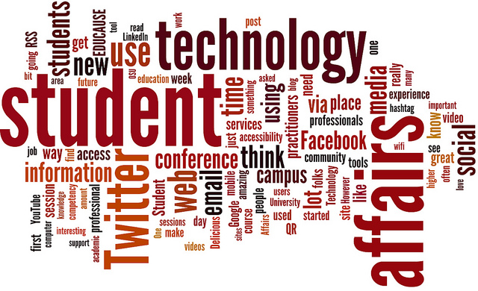ery comfortable environment, with one click the student will be able to:

* make most of his requests easily.
* Receive a list of required files for his specific request.
* Pay onlinefor the request if needed.
* Know when his document will be ready through a mail notification.
* Know information he needs throughFAQs.

The website will also make it easier for making inquiries and receiving specific answers from employees, saving time and avoiding any problems.

**Employee Side**

On The other side for the employee it enables them reaching the information they need as admins just by hitting a button, instead of going through many boxes and pages. Thus this will save time, efforts, avoiding any kind of missing data, and make all their jobs done easily. The employees will receive the student request with student information so they can prepare the required document and send the student a notification when his paper is finished.

**System Features**

**Enquiries and FAQs**

Our system provides answers for all student’s questions either through direct messaging connection with affairs expert employees or recorded answers for frequently asked questions. Students can find the answer of the question by searching about it.

**Extract Papers**

Our system provides easy way to create a request with the required papers by applying his/her information in a form for this specific paper.

**Requests Management**

All requests are managed online as students can easily fill all required data fields in specially prepared forms to record all needed requests.

**Online Payment**

If the request needs some fees students can pay it online through Fawry service or bank credits. No more need to cash money.

**Document Progress**

Student can easily track and follow the request step by step through all the procedures to get frequent feedback and updated time estimation.

**Mail Notification**

To save more time and effort, student will receive a mail notification informs you the exact time to receive your request from student affairs office or even if there is any missing information or data needed.

***User Management***

Users must register to the system before they can order any paper from the site. Students can order any number of papers they want. Employees can request additional identification from participants like student id or army information. Those identifiers are important to map users to their real identity inside the organization.

**User Profile**

Users are either employees or student. Employees contribute to the system by adding the forms of required information to each document and answering the student’s questions. Students participate in ordering their papers and ask questions. Users profile show all his/her own requests or activities and their private information. Employee can view all requests and student information’s.

**Complains**

If the student faces any delaying in required request (without mentioning a reason), Through complains section communicate with the chiefs to solve this situation.

**System Architecture**

Student affairs system introduces huge amount of student information and many student service. The system offer the contents and service to both mobile and desktop users via web-based.

The system consists of following modules: (1) Storage, (2) Data Processing, (3) Student Area, (4) Employee Area, (5) System Administration Area, (6) Supervisors Area, (7) Security.

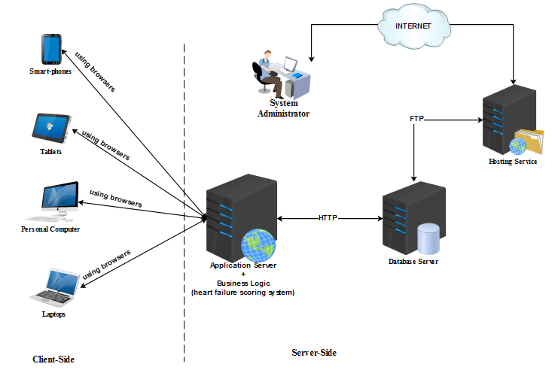

**Storage**

Student affairs uses traditional structured database which provide better queries and data processing over structured contents. MySQL is the world’s most popular open source database. With its proven performance, reliability, and ease-of-use, MySQL [1] has become the leading database choice for web-based applications, used by high profile web properties including Facebook, Twitter, YouTube, and all five of the top five websites. Additionally, it is an extremely popular choice as embedded database, distributed by thousands of ISVs and OEMs.

**Data Processing**

Data processing module is responsible on providing all data related services like data modeling and correction, data transformation, data classifier and multimedia processing. Data modeling and correction is required to understand the textual material based on the related language model. Data transformation is required to allow import and export of different data format. The system supports common data formats supported by common data processors applications. Multimedia processing is required to enhance the quality of multimedia contents like images. It converts multimedia contents to unified format.

**Student Area**

This module provides all student needs in a very comfortable environment. The student can request the document he wants and fill all the required information and pay online for the documents that require some fees. The student will be notified when his document is finished. The student can send his enquiries to student affairs department and get notification when they answer it.

**Employee Area**

This module provides employee all the tools required to manage student affairs department. The employee will receive the student’s request with student information. The employee can notify the student when his is paper is finished. The employee can answer students’ questions online.

**System Administration Area**

This module is dedicated for system administrators. System administrators responsible on system management, configuration, backup and solving technical issues. System administrator can view system status, data status, online sessions, logs and other system status and measures.

**Supervisors Area**

This module is dedicated for system operators. System operators are responsible on managing the system operation and contents. System operator can access all system contents, view statistical reports and provide direct support to users.

**Security**

Security module is responsible on user authentication and communications security. User can register/login using internal accounts. The portal access is made using https protocol in order to secure the communication. Security module also, responsible on managing the permissions and roles. Users are either students or employees. Security module also, responsible on detecting the threats and preventing data theft. The system is tested against common attacks using known penetration testing tools. Data theft is prevented using various data protection techniques.

**System Development**

**Development Plan**

|  |  |  |  |  |  |  |  |  |  |  |  |  |  |
| --- | --- | --- | --- | --- | --- | --- | --- | --- | --- | --- | --- | --- | --- |
|  | 1 | 2 | 3 | 4 | 5 | 6 | 7 | 8 | 9 | 10 | 11 | 12 | 13 |
| Study Requirements |  |  |  |  |  |  |  |  |  |  |  |  |  |
| Management Planning |  |  |  |  |  |  |  |  |  |  |  |  |  |
| Preparation |  |  |  |  |  |  |  |  |  |  |  |  |  |
| Test Planning |  |  |  |  |  |  |  |  |  |  |  |  |  |
| Implementation |  |  |  |  |  |  |  |  |  |  |  |  |  |
| Testing |  |  |  |  |  |  |  |  |  |  |  |  |  |
| System Testing |  |  |  |  |  |  |  |  |  |  |  |  |  |
| Final Release |  |  |  |  |  |  |  |  |  |  |  |  |  |

**Tools**

Student affairs will be developed using open source tools, languages and servers. This will decrease the cost especially for long term operation. While development only online tools will be used for management, tracking, testing and source control. This will increase the collaboration between team members even they are not located at the same place. Also, this will allow external teams and members to participate.

|  |  |
| --- | --- |
| Operation |  |
| Version Control | GitHub/Git |
| Tasks and Issues Tracking | GitHub/issues |
| Structured Database | MySQL |
| Programming Languages | PHP |
| Operating Systems | Linux (Ubuntu), Windows |
| Documents | Google Docs |
| Software SRS/SDA/SDD | Visio |