**System Description**

**What is Student Affairs**

Over the past couple of years, Faculty of Engineering, Ain Shams University has witnessed a great deal of renovation. Still, Students Affairs (SA) office has not yet seen any remarkable change.

The Traditional system forces the student to waste his time standing in a huge queue just to make a request or ask a little question, also employees waste time on receiving documents and inquiries from students and make great efforts managing and organizing forms.

Students Affairs Website is a tool that will accelerate the workflow of SA department and offer great deal of comfort for both applicants and employees.

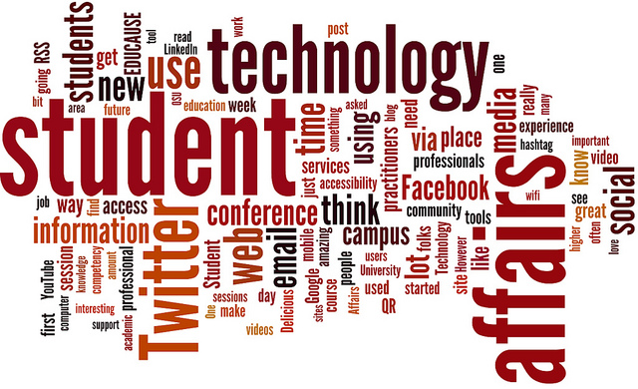**Student Side**

Through this website student can apply for his needs in a very comfortable environment, with one click the student will be able to:

* make most of his requests easily.
* Receive a list of required files for his specific request.
* Pay onlinefor the request if needed.
* Know when his document will be ready through a mail notification.
* Know information he needs throughFAQs.

The website will also make it easier for making inquiries and receiving specific answers from employees, saving time and avoiding any problems.

**Employee Side**

On The other side for the employee it enables them reaching the information they need as admins just by hitting a button, instead of going through many boxes and pages. Thus this will save time, efforts, avoiding any kind of missing data, and make all their jobs done easily. The employees will receive the student request with student information so they can prepare the required document and send the student a notification when his paper is finished.

**Employee Area**

This module provides employee all the tools required to manage student affairs department. The employee will receive the student’s request with student information. The employee can notify the student when his is paper is finished, The employee can answer students’ questions online.