Article
Encoders, Decision Models or LLMs? Cross-Dialect Arabic Banking Intent Detection with a Confidence Cascade
Amr Abdelkhalik ^{1,}, Yara Ibrahim², Ahmed Hassanein^{3,4}*, and Sarah Khamis^{5,6}
¹ Independent Researcher, Saudi Arabia; amr.khalil.abdelkhalik@gmail.com,
² Investment and Finance Department, Faculty of International Business and Humanities, Egypt–Japan University of Science and Technology, Alexandria 21934, Egypt
³ Accounting and MIS Department, College of Business Administration, Gulf University for Science and Technology, Mubarak Al-Abdullah 32093, Kuwait
⁴ Department of Accounting, Faculty of Commerce, Mansoura University, Mansoura 35516, Egypt
⁵ Accounting and Information Systems Department, Faculty of International Business and Humanities, Egypt–Japan University of Science and Technology, Alexandria 21934, Egypt
⁶ Department of Accounting, Alexandria Academy for Management and Accounting (EIA), Alexandria 21648, Egypt
Abstract
Banking contact centers in the Arab world receive customer messages in many dialects, but labeled intent data usually exists only for Modern Standard Arabic (MSA) and one or two dialects. We compare how fine-tuned Arabic encoders, a multilingual single-pass decision model (Laya), and a 9-billion-parameter large language model (LLM) prompted with retrieved examples transfer to unseen dialects on the 77-intent ArBanking77 benchmark. All trained systems use only MSA and Palestinian training data and are evaluated on the official MSA, Palestinian, Saudi, Moroccan, and Tunisian test sets, with three seeds and analyses of calibration, selective prediction, cost, and error. The best encoder, MARBERTv2, reaches 91.8% accuracy on MSA and 85.7% on Saudi but only 57.8% on Tunisian, where the LLM is clearly better; the decision model trails the encoders everywhere. A confidence cascade, in which the encoder answers when its confidence exceeds a threshold chosen on validation data and the LLM answers otherwise, is never significantly worse than the better component while sending only 4.5–33.0% of messages to the LLM. The dialect gap tracks the share of unseen words, and calibration learned on in-domain data does not transfer to unseen dialects.
Keywords: Arabic dialects; intent detection; banking; large language models; model cascades; calibration; selective prediction

1. Introduction
Intent detection maps a short customer message to one of a fixed set of service intents. It is the first step of most contact-centre automation, deciding which self-service flow, form or human queue receives the request. For Arabic, dialectal variation complicates the task. Customers write in their own dialect, yet the labeled data that banks and researchers collect are typically in Modern Standard Arabic (MSA) and, at best, one or two dialects. A model deployed across the region must therefore transfer to dialects it was never trained on.
The size of this transfer problem is easy to underestimate. Arabic dialects differ from MSA and from each other in vocabulary, morphology and spelling conventions, and written dialectal Arabic has no standard orthography [1,2]. The words that carry the intent of a banking message, such as verbs for “send”, “arrive”, and “withdraw” or nouns for a card or a transfer, are exactly the words that vary most between Gulf, Levantine, and Maghrebi speech. Language technology is known to degrade on dialects that are under-represented in training data [3], and a bank cannot simply collect labeled data for every dialect its customers use.
ArBanking77 [4] made this question measurable. It translates the 77 English banking intents of Banking77 [5] into MSA and Palestinian Arabic. The AraFinNLP 2024 shared task [6] used an updated release with parallel queries in MSA and four dialects, and its official test sets include dialects absent from the training data. Most shared-task systems were ensembles of fine-tuned Arabic encoders [7,8]. A separate Moroccan resource, DarijaBanking [9], showed that dialect-specific data matter. Since then, two other kinds of models have become practical for this problem. Instruction-tuned large language models (LLMs) can classify intents from a list of labels and a few examples, without task-specific training [10], but at a much higher cost per message. Single-pass decision models such as Laya [11,12] score a set of natural-language options in one forward pass and are trained for this kind of choice directly. How these three families compare across dialects, and what a deployment should do with that comparison, has not been measured on the same data under the same protocol.
This paper addresses four research questions:
- RQ1. How well do fine-tuned Arabic encoders, a decision model and a retrieval-augmented LLM transfer from MSA and Palestinian training data to Saudi, Moroccan and Tunisian test data?
- RQ2. Are the encoder and the LLM wrong on the same messages, or are their errors complementary?
- RQ3. Can a simple confidence cascade, tuned only on in-domain data, combine the strengths of both at a fraction of the LLM’s cost?
- RQ4. Do the confidence scores that such a cascade relies on remain trustworthy under dialect shift?
The contributions are:
1. A controlled comparison of four fine-tuned encoders, a nearest-neighbor baseline, the Laya decision model (with its own training recipe, with the encoders’ recipe, and trained directly on 12 routing categories), and a 9-billion-parameter LLM with and without retrieved examples, on the five official ArBanking77 test sets, with three seeds and paired bootstrap confidence intervals.
2. Evidence that the ranking flips with dialect distance: fine-tuned encoders win on MSA and the dialects close to the training data, while the retrieval-augmented LLM wins on Moroccan and Tunisian, and the two make largely different errors.
3. A confidence cascade, with its threshold chosen on validation data only, that is never significantly worse than the better component on any test set while routing 4.5–33.0% of traffic to the LLM and costing 6–35% of the LLM’s latency.
4. Deployment-oriented measurements that accuracy alone hides: calibration under dialect shift, the share of traffic that can be automated at a fixed accuracy, accuracy at the level of 12 routing categories, latency, and an analysis of the errors that remain.
The remainder of the paper is organized as follows. Section 1.1 reviews related work. Section 2 defines the task, the data, the systems, the cascade and the evaluation protocol. Section 3 reports the results, Section 4 discusses their implications and the threats to validity, and Section 5 concludes. The appendices give hyperparameters, the LLM prompt, per-seed results and the category mapping.

1.1. Related Work

1.1.1. Intent detection benchmarks
Intent detection is usually framed as single-label classification of a user utterance. CLINC150 [13] and HWU64 [14] cover many domains with few examples per intent, while Banking77 [5] concentrates 77 fine-grained intents in one domain, which makes neighbouring intents hard to separate. Strong results on these benchmarks come from fine-tuned sentence encoders, including efficient few-shot methods such as SetFit [15]. ArBanking77 [4] provides the Arabic counterpart of Banking77 in MSA and Palestinian Arabic and reports fine-tuned encoder baselines. The AraFinNLP 2024 shared task [6] evaluated cross-dialect intent detection on this label set; strong submissions combined several fine-tuned encoders [7] or added contrastive objectives [8]. DarijaBanking [9] built a Moroccan banking intent corpus and compared fine-tuned encoders with zero-shot, retrieval-based and LLM-prompting approaches, finding a fine-tuned encoder best when in-dialect training data are available. Table 1 positions the present study against this work.
Table 1. Positioning against prior work on Arabic banking intent detection. ✓: covered; –: not covered.
Study | Unseen-dialect test | Encoders | LLM | Decision model | Calibration / selective | Cascade
ArBanking77 [4] | – | ✓ | – | – | – | –
AraFinNLP 2024 systems [6–8] | ✓ | ✓ | – | – | – | –
DarijaBanking [9] | – | ✓ | ✓ | – | – | –
This study | ✓ | ✓ | ✓ | ✓ | ✓ | ✓

1.1.2. Arabic financial NLP
Banking intent detection belongs to a broader and growing body of Arabic financial NLP. Recent resources cover financial named-entity recognition in news (AMWAL [16]), summarisation of Arabic financial news with domain-adapted LLMs (AraFinNews [17]), LLM-based sentiment analysis of Saudi market text [18], and SAHM [19], a benchmark of Arabic financial and Shari’ah-compliant reasoning that finds Arabic fluency does not imply financial reasoning ability. These studies evaluate LLMs against fine-tuned models on financial understanding, but none of them examines transfer to unseen dialects, calibration under that shift, or how to combine a cheap classifier with an LLM in production, which is the focus of the present work.

1.1.3. Arabic dialects and pre-trained encoders
Dialect identification shared tasks such as NADI [2,20] and resources such as the MADAR corpus [1] document how strongly Arabic varieties differ at the word level. Arabic pre-trained encoders reflect different choices of training text: MARBERT [21] was pre-trained on large amounts of dialectal social-media text, AraBERT [22] mainly on MSA, QARiB [23] on tweets, and CAMeLBERT [24] released variants trained on MSA, dialectal, classical and mixed data. XLM-R [25] serves as a multilingual baseline. All follow the BERT architecture [26]. Recent encoder designs such as ModernBERT [27] focus on efficiency and long context, but they do not yet have Arabic-specific releases. Multilingual sentence embedders such as bge-m3 [28] support retrieval across Arabic varieties without task-specific training. Benchmarks such as ALUE [29] and ORCA [30] compare Arabic encoders across many understanding tasks, including dialectal ones; toolkits such as CAMeL Tools [31] provide the morphological analysis and dialect identification used in many Arabic pipelines.

1.1.4. Large language models and decision models
Instruction-tuned LLMs can perform classification by generation, guided by a list of labels and a few demonstrations [10]. Choosing demonstrations that are similar to the input improves in-context learning substantially [32]. Arabic-centric LLMs such as Jais [33] and ALLaM [34], and multilingual models such as Qwen3.5 [35], now make this practical for Arabic, but systematic comparisons on classification tasks often find that small fine-tuned models remain competitive at a fraction of the cost [36]. Laya [11] is a multilingual non-autoregressive model. Given an input and a set of natural-language options, it returns a distribution over the options in a single pass. Related work on single-pass decision encoders studies when such models should ask for more information [12].

1.1.5. Cascades, selective prediction and calibration
Routing easy inputs to a cheap model and hard inputs to an expensive one is an established way to reduce inference cost [37,38]. Its effectiveness depends on whether the cheap model’s confidence ranks its errors well, which is the subject of selective classification [39,40]. Recent work learns the deferral rule online [41] or lets a cascade abstain early when even the expensive model is unlikely to help [42], and conformal prediction offers distribution-free guarantees for such decisions under exchangeability [43], an assumption that dialect shift violates. The maximum softmax probability is a simple and strong confidence signal [44], and selective prediction has been studied for question answering under domain shift [45] and for NLP more broadly [46]. Pre-trained transformers are reasonably calibrated in-domain [47], and temperature scaling [48] is the usual post-hoc calibration method. However, predictive uncertainty is known to degrade under dataset shift [49]. Dialects unseen in training are a natural instance of such a shift, and we measure it directly.

2. Materials and Methods
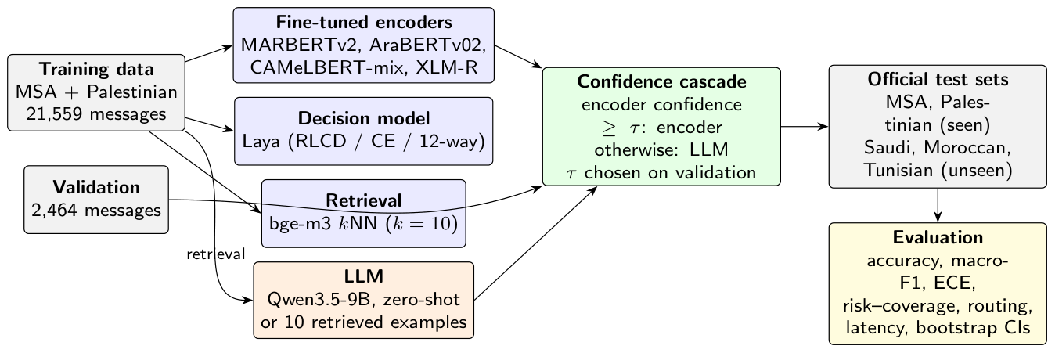
Figure 1. Study design. All trained systems learn from the MSA and Palestinian training split only. Every system is evaluated on the five official test sets; the LLM and the cascade on a fixed 400-message subsample of each. The cascade sends a message to the LLM only when the encoder’s confidence is below a threshold chosen on validation data.

2.1. Task definition
Let $Y$ be the set of $K=77$ intents and $x$ a customer message. A classifier $f$ returns a probability vector $p(⋅∣x)$ over $Y$, a prediction $\hat{y}=arg\max_{y}p(y∣x)$ and a confidence $c(x)=\max_{y}p(y∣x)$. Training uses labelled messages from a source distribution (MSA and Palestinian); evaluation uses test sets from the source varieties and from three target dialects (Saudi, Moroccan, Tunisian) whose distributions differ from the source. Figure 1 summarizes the design, and Table 2 lists the notation.
Table 2. Notation.
Symbol | Meaning
$Y$, $K$ | set of intents, $K=|Y|=77$
$x$, $y$ | customer message and its gold intent
$$p(⋅∣x)$$ | predicted probability vector of a system
$\overset{‾}{p}(⋅∣x)$, $\overset{‾}{c}(x)$ | seed-averaged encoder probabilities and confidence
$\hat{y}$, ${\hat{y}}_{LLM}$ | predicted intent of a system and of the LLM
$$τ$$ | cascade threshold
$$T$$ | temperature used for calibration
$B$, $B_{b}$ | number of confidence bins and the $b$-th bin
$${Cov}_{90}$$ | largest coverage with accuracy $≥90\%$
$t_{E}$, $t_{L}$ | per-message latency of encoder and LLM

2.2. Data
We use the official ArBanking77 release (commit 2e3a563 of the authors’ repository, CC BY-SA 4.0). Table 3 lists the splits. The Tunisian set covers 27 of the 77 intents. Some lines of the released CSV files contain unescaped quotation marks; a standard CSV parser silently drops them, so we split each line at the first field separator instead, which recovers every message.
Table 3. Official ArBanking77 splits used in this study: number of messages, intents covered, and mean / median message length in words.
Split | Messages | Intents | Mean | Median
Train | 21,559 | 77 | 9.1 | 7
Validation | 2,464 | 77 | 9.2 | 7
MSA | 3,574 | 77 | 9.3 | 8
Pal. | 3,807 | 77 | 7.8 | 7
Saudi | 3,580 | 77 | 7.8 | 7
Moroccan | 3,574 | 77 | 8.6 | 7
Tunisian | 999 | 27 | 7.8 | 7
Saudi, Moroccan and Tunisian are unseen at training time. Because the dialect sets were produced from the same intent inventory as the training data, we checked for leakage with multilingual sentence embeddings [28]. The Palestinian test set, which is in-domain by design, serves as a reference. Of the Palestinian test messages, 352 have a training message with cosine similarity of at least 0.95; for Saudi the count is 251 of 3580, for Moroccan 47 and for Tunisian 0. The unseen dialects are therefore no closer to the training data than the in-domain test set, and we use the official splits unchanged. Appendix E gives the full statistics of this check.

2.3. Systems
Fine-tuned encoders. MARBERTv2 [21], AraBERTv02 [22], CAMeLBERT-mix [24] and XLM-R base [25] are fine-tuned with a linear classification head for 5 epochs. The learning rate is $3×{10}^{-5}$, the batch size is 32, and the maximum length is 64 tokens. We keep the epoch with the best validation macro-F1. Each model is trained with three seeds (Appendix A).
Nearest neighbours. Messages are embedded with bge-m3 [28], using a normalised first-token representation $e(x)$. With $N_{k}(x)$ the $k=10$ training messages most similar to $x$, the score of intent $y$ is
s(y∣x)=(xi,yi)∈Nk(x)​1[yi=y] e(x)⊤e(xi).
This baseline needs no training and shows how far retrieval alone goes.
Decision model. We fine-tune the 322-million-parameter multilingual Laya model [11]. Each message is paired with the 77 intent names as options. We use English names so that all 77 fit within the model’s 1,024-token input, and the model returns one score per option. We train it in three ways. Laya (RLCD) uses the training recipe released with the model: a policy-gradient objective over Gaussian-perturbed option scores, rewarded by proper scoring rules, plus a soft cross-entropy term, for 3 epochs. Laya (CE) follows the same protocol as the encoders, with cross-entropy only, 5 epochs, and the best epoch chosen on validation. Laya (12-way) uses the released recipe on the 12 routing categories of Section 3.10 instead of the 77 intents, with option descriptions written for each category. The training script includes a check that no training message is silently dropped for exceeding the input length.
LLM. We use Qwen3.5-9B [35], served locally with its reasoning mode disabled, greedy decoding and at most 8 output tokens. The system prompt lists the 77 intents with their English and Arabic names and asks for the intent number only (Appendix B). In the zero-shot setting the message follows directly. In the retrieval setting, the 10 most similar training messages (by bge-m3) are inserted as user–assistant example turns before it, following the observation that similar demonstrations help in-context learning [32]. Each LLM call costs far more than an encoder pass, so the LLM is evaluated on a fixed random subsample of 400 messages per test set and 400 validation messages, drawn with a fixed seed. Every comparison involving the LLM uses the other systems’ predictions on exactly the same items.

2.4. Confidence cascade
The cascade uses MARBERTv2, averaging the softmax outputs of its three seeds into $\overset{‾}{p}(⋅∣x)$ with confidence $\overset{‾}{c}(x)$. For a threshold $τ$ it returns
$${\hat{y}}_{τ}(x)=\left\{\begin{matrix}arg\max_{y}\overset{‾}{p}(y∣x) & \text{if }\overset{‾}{c}(x)≥τ, \\ {\hat{y}}_{LLM}(x) & \text{otherwise.}\end{matrix}\right.$$
The threshold is chosen on the validation subsample only, by Algorithm 1: it is the largest $τ$ in $\{0.30,0.31,…,0.99\}$ for which, among the validation messages routed to the LLM, the LLM is at least as accurate as the encoder. This gives $τ=0.60$, which is then applied unchanged to every test set. The rule needs no labelled data from the target dialects; it only asks whether, on in-domain messages where the encoder is unsure, the LLM is the better choice.
The accuracy of the cascade on a test set decomposes into the part kept by the encoder and the part routed to the LLM:
$${Acc}_{τ}=Pr[\overset{‾}{c}≥τ] {Acc}_{E}(\overset{‾}{c}≥τ)+Pr[\overset{‾}{c}<τ] {Acc}_{L}(\overset{‾}{c}<τ),$$
where ${Acc}_{E}(⋅)$ and ${Acc}_{L}(⋅)$ are the accuracies of the encoder and of the LLM on the indicated messages. The cascade improves on the encoder exactly when the LLM is more accurate than the encoder on the routed messages, ${Acc}_{L}(\overset{‾}{c}<τ)>{Acc}_{E}(\overset{‾}{c}<τ)$, and the gain is that difference weighted by the routed share. Its expected latency is $t_{E}+Pr[\overset{‾}{c}<τ] t_{L}$, where $t_{E}$ and $t_{L}$ are the per-message latencies of the two stages.
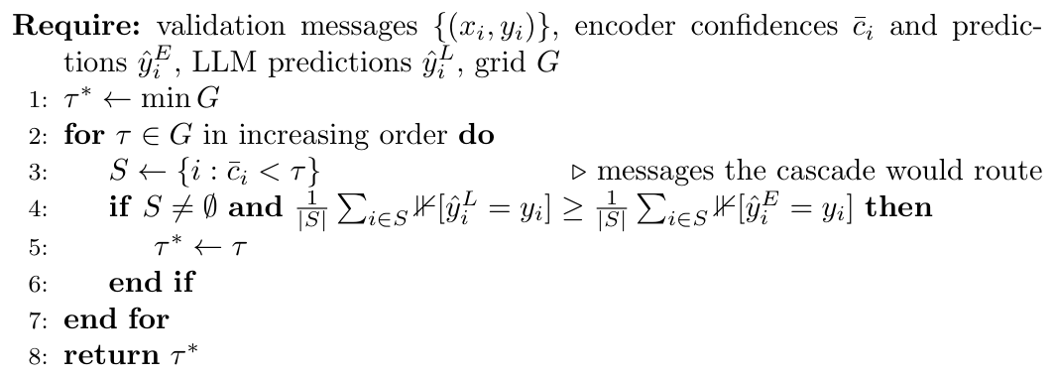
Algorithm 1. Choosing the cascade threshold on validation data

2.5. Calibration
For each run we fit a single temperature $T>0$ on the in-domain validation split by minimising the negative log-likelihood of $softmax(z/T)$, where $z$ are the logits [48], and apply it unchanged to every test set. We report calibration both before and after this step.

2.6. Metrics
We report accuracy and macro-F1, the latter averaged over the intents present in each test set. Calibration is measured by the expected calibration error [50]. With messages grouped into $B=15$ equal-width confidence bins $B_{b}$ over $n$ messages,
$$ECE=\sum_{b=1}^{B}{\frac{|B_{b}|}{n}} |acc(B_{b})-conf(B_{b})|.$$
For selective prediction [40], messages are sorted by decreasing confidence; answering the first $m$ gives coverage $m/n$ and risk equal to the error rate among them. We report the area under this risk–coverage curve (AURC) and the largest coverage at which accuracy is at least 90%:
Cov90=maxmn:1mj≤m​1[y(j)=y(j)]≥0.9.
For routing, we map the 77 intents to 12 contact-centre categories (for example cards, transfers, top-ups and account security; Appendix D). We sum the predicted probabilities within each category and report category accuracy and the share of errors that stay inside the correct category. Latency is the median time for a single message on one GPU (NVIDIA RTX 6000, 24 GB) and, for the encoders, on 8 CPU threads.

2.7. Statistical testing
Differences between two systems $A$ and $B$ on the same test items are tested with paired bootstrap resampling [51]. For $R=10,000$ resamples $I_{r}$ of the $n$ items drawn with replacement, we compute
Δr=1ni∈Ir​1[yiA=yi]-1[yiB=yi],
and report the 2.5th and 97.5th percentiles as a 95% confidence interval. A difference is called significant when this interval excludes zero. For multi-seed systems, the comparison uses the seed-averaged predictions.

2.8. Use of Generative AI
Claude (Anthropic, Claude Opus 5.5) assisted the authors with study design, with programming the experimental and analysis pipeline, with interpreting the results, and with drafting and editing the manuscript text. No generative model was used to create data or results: every number, table and figure is computed by the released code from the released data, and all code and text were reviewed by the authors. Separately, the large language model Qwen3.5-9B is one of the evaluated systems (Section 2.3); it is used without fine-tuning as a baseline classifier and as the second stage of the cascade.

3. Results
Table 4. Accuracy (%) on the official test sets, mean $±$ standard deviation over three seeds. All systems are trained on (or, for $k$NN, retrieve from) the MSA and Palestinian training split only; Saudi, Moroccan and Tunisian are unseen dialects.
System | MSA | Pal. | Saudi | Moroccan | Tunisian
MARBERTv2 | 91.8 $±$0.2 | 89.7 $±$0.4 | 85.7 $±$0.2 | 76.7 $±$0.4 | 57.8 $±$0.1
AraBERTv02 | 91.8 $±$0.2 | 90.1 $±$0.1 | 83.2 $±$0.1 | 78.0 $±$0.2 | 57.0 $±$1.3
CAMeLBERT-mix | 91.2 $±$0.4 | 88.8 $±$0.4 | 79.7 $±$0.3 | 72.6 $±$0.6 | 42.9 $±$2.2
XLM-R base | 90.3 $±$0.1 | 86.7 $±$0.1 | 78.6 $±$0.8 | 69.2 $±$0.1 | 50.9 $±$0.4
bge-m3 $k$NN | 88.4 | 81.1 | 75.9 | 67.0 | 53.1
Laya (RLCD) | 83.2 $±$4.1 | 78.8 $±$5.5 | 70.9 $±$4.9 | 64.1 $±$3.7 | 37.6 $±$0.6
Laya (CE) | 89.5 $±$0.1 | 86.2 $±$0.2 | 78.9 $±$0.5 | 69.6 $±$0.8 | 41.9 $±$0.8

3.1. Encoders transfer well to near dialects only
Table 4 gives accuracy on the five test sets, and macro-F1 in Table 6 follows the same pattern. MARBERTv2 and AraBERTv02 are the strongest trained systems. MARBERTv2 reaches 91.8% on MSA and 89.7% on Palestinian, and still 85.7% on the unseen Saudi set. It drops to only 76.7% on Moroccan and 57.8% on Tunisian, even though the Tunisian set contains only 27 intents. The drop follows the expected linguistic distance from the MSA and Levantine training data. MARBERTv2, pre-trained on dialectal text, is ahead of AraBERTv02 on Saudi (85.7 vs 83.2%), while AraBERTv02 is slightly ahead on Moroccan. CAMeLBERT-mix and XLM-R lose most on the unseen dialects. Nearest-neighbour retrieval with bge-m3, which involves no training, reaches 75.9% on Saudi, roughly ten points below the best encoder. Seed variation is small for the encoders (Appendix C), so the differences between dialects are not an artefact of a lucky run.
Table 5. Accuracy difference (percentage points) of each system against MARBERTv2 on the full test sets, both seed-averaged. †: the 95% paired bootstrap interval excludes zero.
System | MSA | Pal. | Saudi | Moroccan | Tunisian
AraBERTv02 | -0.1 | +0.2 | -2.1† | +1.8† | +1.2
CAMeLBERT-mix | -0.5 | -1.1† | -5.7† | -2.7† | -14.6†
XLM-R base | -1.4† | -3.3† | -5.9† | -6.1† | -5.8†
bge-m3 $k$NN | -4.2† | -9.6† | -10.6† | -10.4† | -5.8†
Laya (RLCD) | -5.3† | -7.0† | -10.3† | -7.9† | -17.0†
Laya (CE) | -1.8† | -3.0† | -5.3† | -4.8† | -13.9†
Table 5 tests every system against MARBERTv2 on the full test sets. 26 of the 30 differences are significant. AraBERTv02 is the only system that is never clearly worse: it is significantly behind on Saudi and significantly ahead on Moroccan, and the two are statistically tied elsewhere. All other systems, including both decision-model variants, are significantly worse than MARBERTv2 on every test set, with the single exception of CAMeLBERT-mix on MSA.
Table 6. Macro-F1 (%), averaged over the intents present in each test set (Tunisian covers 27 of 77).
System | MSA | Pal. | Saudi | Moroccan | Tunisian
MARBERTv2 | 91.7 $±$0.2 | 89.3 $±$0.4 | 85.5 $±$0.2 | 75.9 $±$0.4 | 61.5 $±$0.7
AraBERTv02 | 91.7 $±$0.2 | 89.6 $±$0.1 | 83.0 $±$0.1 | 77.1 $±$0.1 | 60.7 $±$1.1
CAMeLBERT-mix | 91.2 $±$0.3 | 88.5 $±$0.4 | 79.4 $±$0.2 | 71.6 $±$0.7 | 46.4 $±$3.6
XLM-R base | 90.3 $±$0.1 | 86.3 $±$0.1 | 78.0 $±$0.8 | 68.3 $±$0.2 | 56.5 $±$0.8
bge-m3 $k$NN | 88.3 | 80.7 | 75.7 | 65.9 | 59.5
Laya (RLCD) | 83.1 $±$4.1 | 78.1 $±$5.7 | 70.5 $±$4.9 | 63.2 $±$3.8 | 43.5 $±$1.8
Laya (CE) | 89.4 $±$0.1 | 86.0 $±$0.1 | 78.7 $±$0.6 | 68.7 $±$1.0 | 47.1 $±$2.2

3.2. Lexical distance explains the dialect gap
Table 7. Lexical shift from the training data: share of Arabic word tokens never seen in the training split (after removing diacritics and normalising alif, ta marbuta and alif maqsura), share of messages with at least one such word, and accuracy (%) of the seed-averaged MARBERTv2.
Test | Unseen tokens | Messages affected | Accuracy
MSA | 2.3 | 17.1 | 92.5
Pal. | 4.6 | 26.5 | 90.7
Saudi | 15.0 | 65.7 | 86.5
Moroccan | 43.1 | 98.6 | 77.4
Tunisian | 53.5 | 98.5 | 58.9
Why does accuracy fall so steeply from Saudi to Tunisian? Table 7 measures how much of each test set’s vocabulary never occurs in the training split, after removing diacritics and normalising common spelling variants. Only 2.3% of MSA word tokens are unseen, against 15.0% for Saudi, 43.1% for Moroccan and 53.5% for Tunisian; almost every Moroccan and Tunisian message contains at least one unseen word. Across the five test sets, the unseen-token rate and the encoder’s accuracy are almost perfectly anti-correlated (Pearson $r=-0.94$). Figure 2 shows that the same relation holds within each dialect: messages with no unseen words are classified within a few points of MSA (for example 87.8% on Saudi and 92.2% on Moroccan, against 93.2% on MSA), while messages in which at least 40% of the words are unseen fall to 70.8% on Moroccan and 53.9% on Tunisian. The dialect gap is therefore largely a vocabulary gap: when a dialectal message happens to use words that the training data contain, the encoder handles it almost as well as MSA.
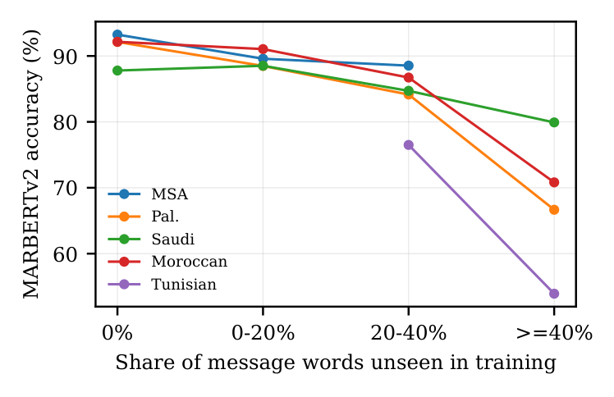
Figure 2. Accuracy of the seed-averaged MARBERTv2 as a function of the share of a message’s words that never occur in the training data. Points are shown for groups with at least 30 messages.
Message length plays a smaller role (Figure 3). For MSA, Palestinian, Saudi and Moroccan, longer messages are slightly easier, because they contain more cues to the intent. Tunisian is the exception: its longer messages contain more unseen dialectal words, and accuracy falls with length.
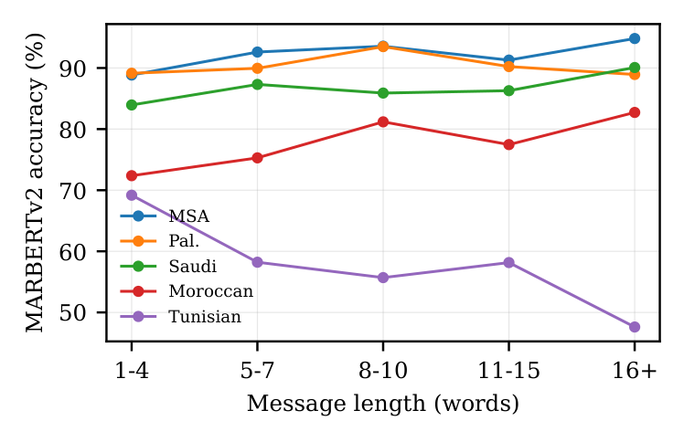
Figure 3. Accuracy of the seed-averaged MARBERTv2 by message length (groups with at least 30 messages).

3.3. The decision model trails the encoders
With its released recipe, Laya is 10.7 points below the best encoder on Saudi (95% CI 9.5 to 12.0) and 17.6 points below on Tunisian, with a large variance across seeds. Training it with the encoders’ protocol (cross-entropy and validation-based epoch selection) removes most of the variance and raises Saudi accuracy to 78.9%, but it remains below MARBERTv2 on every test set and is about four times slower per message (27.2 ms vs 7.2 ms on the GPU). The likely reason is input length: every message has to be read together with all 77 option names, so the model spends most of its capacity on the options rather than on the short message, and its multilingual pre-training has seen far less dialectal Arabic than MARBERT. For a fixed label set with thousands of training examples, a classification head on a dialect-aware encoder remains the better choice; a decision model is more attractive when the option set changes at run time.

3.4. The LLM is better on far dialects
Table 8. Qwen3.5-9B on the 400-message subsamples: accuracy (%), share of answers that are not a valid intent number (%), and median latency (ms), without and with 10 retrieved examples.
 | Zero-shot |  |  | 10 retrieved
Test | Acc. | Invalid | ms | Acc. | Invalid | ms
MSA | 68.8 | 0.5 | 219 | 92.8 | 0.0 | 406
Pal. | 60.8 | 0.2 | 220 | 86.5 | 0.0 | 405
Saudi | 62.0 | 0.5 | 220 | 82.2 | 0.0 | 404
Moroccan | 58.0 | 0.2 | 218 | 80.0 | 0.0 | 406
Tunisian | 54.2 | 1.8 | 212 | 69.2 | 0.0 | 394
Without examples the LLM is weak, reaching 68.8% on MSA and 54.2% on Tunisian on the 400-message subsamples (Table 8). Many intents differ only in a detail, such as a card that has not arrived versus a card that has been lost, and the intent names alone do not define that boundary. With 10 retrieved examples, accuracy rises to 92.8% on MSA, 80.0% on Moroccan and 69.2% on Tunisian, and almost every answer is a valid intent number. On the same items (Table 10), the seed-averaged MARBERTv2 is ahead on MSA, Palestinian and Saudi. The LLM, however, is ahead by 74.5$→$80.0% on Moroccan and 59.2$→$69.2% on Tunisian. The ranking of the two families therefore depends on how far the target dialect is from the training data. The price is latency: a retrieval-augmented LLM call takes about 404.0 ms on the GPU, compared with 7.2 ms for MARBERTv2 (25.4 ms on 8 CPU threads).

3.5. The encoder and the LLM make different errors
Table 9. Complementarity of MARBERTv2 (seed-averaged) and the retrieval-augmented LLM on the same 400 messages per test set (% of messages). The last column is the accuracy of an oracle that always picks the correct system when one of them is right.
Test | Both | Encoder only | LLM only | Neither | Oracle
MSA | 90.8 | 2.2 | 2.0 | 5.0 | 95.0
Pal. | 84.0 | 7.0 | 2.5 | 6.5 | 93.5
Saudi | 76.8 | 9.2 | 5.5 | 8.5 | 91.5
Moroccan | 68.0 | 6.5 | 12.0 | 13.5 | 86.5
Tunisian | 51.0 | 8.2 | 18.2 | 22.5 | 77.5
Table 9 splits each subsample by which system is right. The two systems are far from redundant. On Moroccan, 12.0% of messages are answered correctly by the LLM alone and 6.5% by the encoder alone; on Tunisian the LLM alone is right on 18.2% of messages. An oracle that always picks the right system would reach 86.5% on Moroccan and 77.5% on Tunisian, well above either system. The practical question is whether a deployable rule, without access to the gold label, can recover part of this gap.
The encoders, in contrast, largely agree with each other. Figure 4 shows Cohen’s $κ$ between the predictions of the trained systems. On Saudi, MARBERTv2 and AraBERTv02 agree strongly ($κ=0.89$); on Tunisian their agreement drops to 0.58, and agreement with the retrieval baseline to 0.50. On far dialects the trained systems are not only less accurate but also less consistent, which is a further reason to bring in a model of a different kind rather than another encoder.
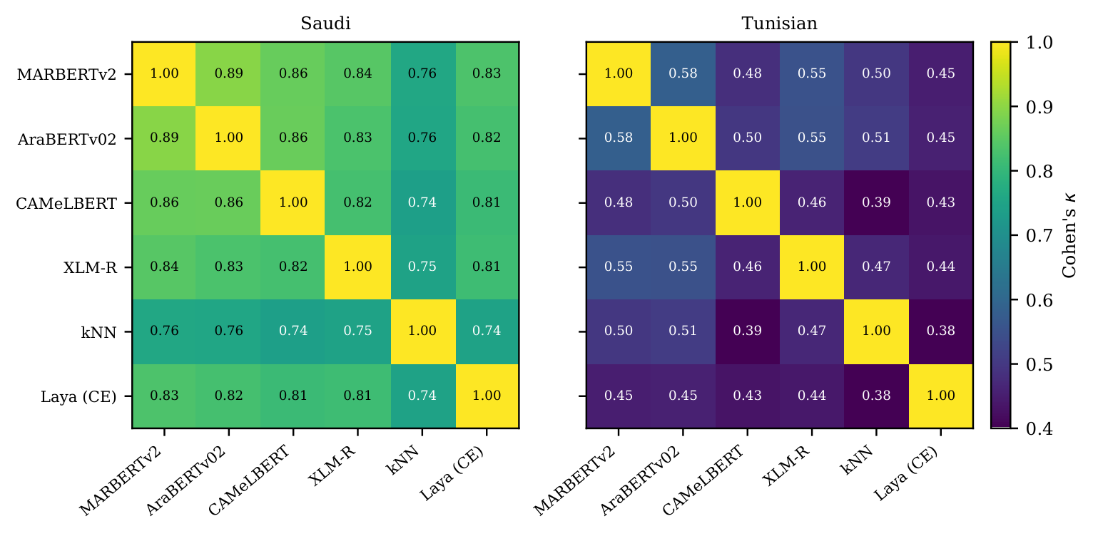
Figure 4. Agreement (Cohen’s $κ$) between the seed-averaged predictions of the trained systems on the full Saudi and Tunisian test sets.

3.6. A confidence cascade gets the better of both
Table 10. Confidence cascade on the LLM subsample (400 items per test set): MARBERTv2 answers when its confidence is at least $τ=0.60$ (chosen on validation), otherwise the retrieval-augmented LLM answers. Accuracy (%) and share of traffic routed to the LLM.
Test | Encoder | LLM | Cascade | Routed (%)
MSA | 93.0 | 92.8 | 93.2 | 4.5
Pal. | 91.0 | 86.5 | 90.8 | 7.0
Saudi | 86.0 | 82.2 | 86.0 | 11.0
Moroccan | 74.5 | 80.0 | 79.2 | 20.2
Tunisian | 59.2 | 69.2 | 67.5 | 33.0
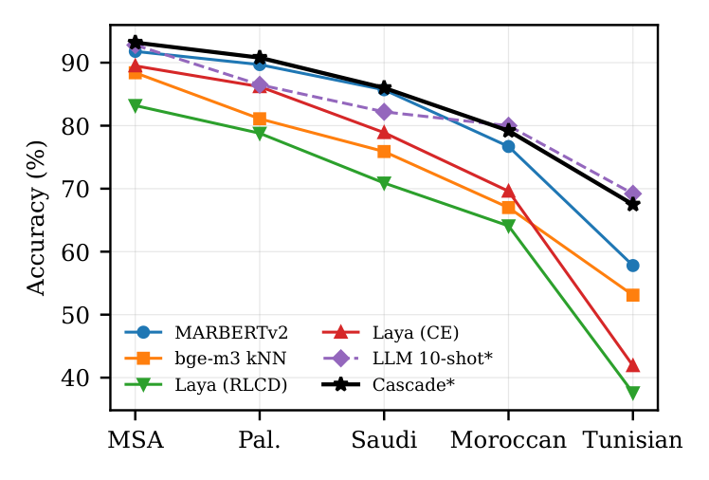
Figure 5. Accuracy by test set. Systems marked * are evaluated on the 400-message subsamples; the others on the full test sets. The encoder leads on MSA and the near dialects, the LLM on Moroccan and Tunisian, and the cascade follows the better of the two.
The cascade (Table 10, Figure 5) reaches 93.2% on MSA, 86.0% on Saudi, 79.2% on Moroccan and 67.5% on Tunisian. On Moroccan and Tunisian it is significantly better than the encoder (95% CI of the difference 2.0 to 7.8 and 5.0 to 11.5 points), recovering 85% and 83% of the gap to the LLM. Its difference from the LLM is not significant (-5.5 to 2.0 on Tunisian). On Palestinian and Saudi it is significantly better than the LLM and not different from the encoder. On no test set is the cascade significantly worse than the better component.
Table 11. Decomposition of the cascade (Eq. (3)) on the 400-message subsamples: share of messages kept by the encoder and its accuracy on them, share routed to the LLM, and accuracy of the encoder and of the LLM on the routed messages (%).
 | Kept ($\overset{‾}{c}≥τ$) |  | Routed ($\overset{‾}{c}<τ$)
Test | Share | Encoder | Share | Encoder | LLM
MSA | 95.5 | 94.5 | 4.5 | 61.1 | 66.7
Pal. | 93.0 | 94.1 | 7.0 | 50.0 | 46.4
Saudi | 89.0 | 90.4 | 11.0 | 50.0 | 50.0
Moroccan | 79.8 | 86.8 | 20.2 | 25.9 | 49.4
Tunisian | 67.0 | 79.9 | 33.0 | 17.4 | 42.4
Table 11 decomposes the result according to Eq. (3). The messages the encoder keeps are answered well on every dialect (90.4% on Saudi, 79.9% on Tunisian). The routed messages are hard for both systems, but on the far dialects the LLM is much better on them: on Moroccan it answers 49.4% of the routed messages correctly against 25.9% for the encoder, and on Tunisian 42.4% against 17.4%. On Saudi the two are tied on the routed messages (50.0% each), so routing neither helps nor hurts, which is why the cascade equals the encoder there. Figure 6 shows typical messages of both kinds: dialectal phrasings that the encoder misreads with low confidence and the LLM, guided by similar training examples, resolves; and, less often on the far dialects, cases where routing replaces a correct but unsure encoder answer with a wrong LLM answer.
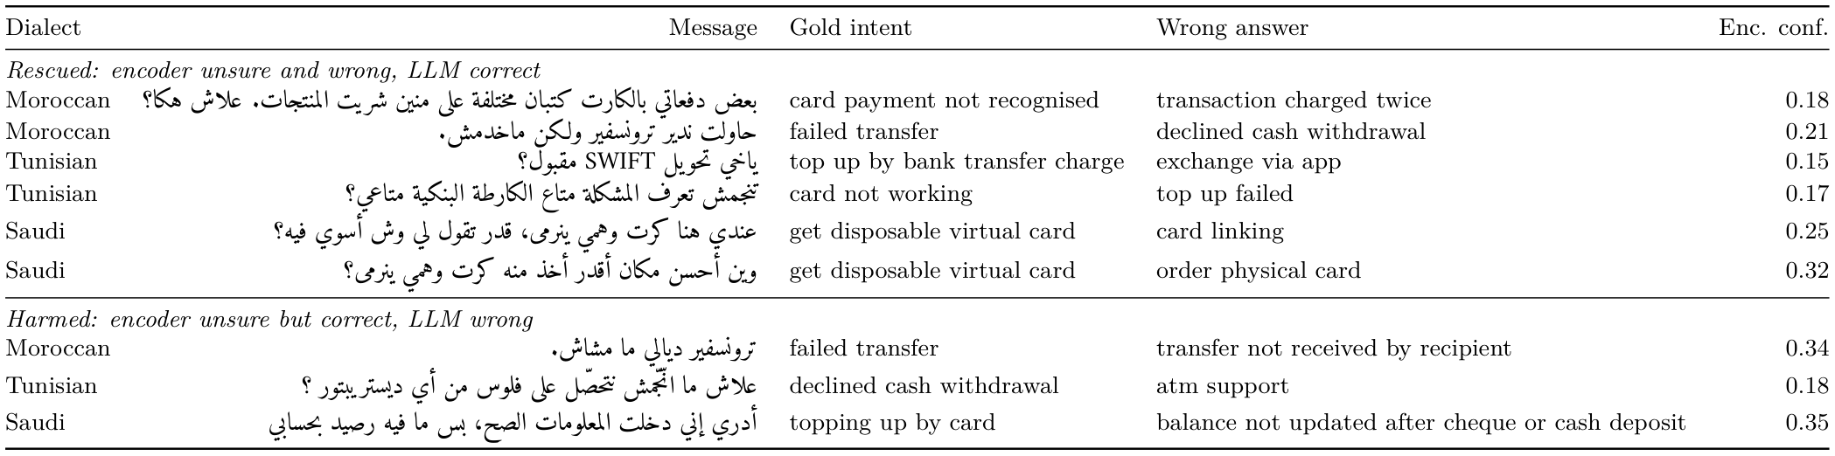
Figure 6. Examples of messages routed by the cascade ($\overset{‾}{c}<τ$) from the 400-message subsamples. Upper part: the encoder is wrong and the LLM is right. Lower part: the encoder is right and the LLM is wrong. Messages are reproduced from the ArBanking77 test sets (CC BY-SA 4.0).
The share of traffic sent to the LLM adapts to the dialect without any dialect identification: 4.5% of MSA messages, 11.0% of Saudi, 20.2% of Moroccan and 33.0% of Tunisian messages fall below the threshold. Figure 7 shows why: the encoder’s confidence distribution shifts towards lower values as the dialect moves away from the training data, so its confidence works as an implicit detector of messages it cannot handle.
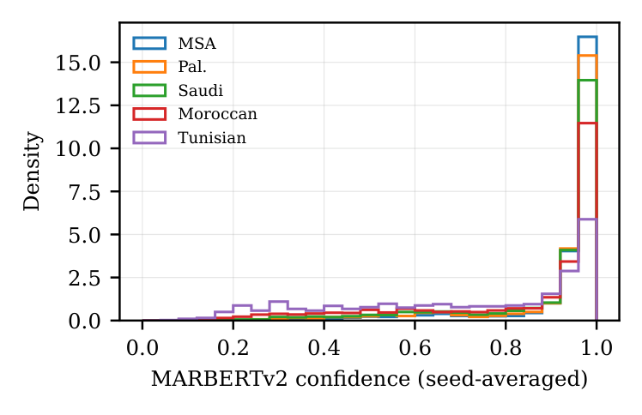
Figure 7. Distribution of MARBERTv2’s seed-averaged confidence on each full test set. Low-confidence mass grows with dialect distance, which is what lets the cascade route more far-dialect traffic to the LLM.

3.7. Threshold sensitivity and cost
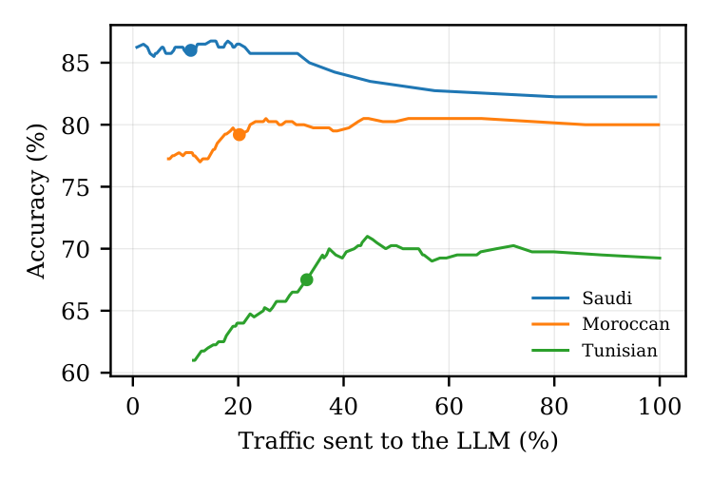
Figure 8. Accuracy of the cascade as the threshold varies, plotted against the share of traffic sent to the LLM (400 messages per test set). Dots mark the threshold chosen on validation ($τ=0.60$).
Table 12. Sensitivity of the cascade to the threshold $τ$: accuracy (%) and share routed to the LLM (%) on the 400-message subsamples. $​^{*}$ marks the value chosen on validation.
 | Saudi |  | Moroccan |  | Tunisian
$$τ$$ | Acc. | LLM | Acc. | LLM | Acc. | LLM
0.4 | 85.8 | 4.5 | 77.8 | 10.8 | 62.5 | 17.2
0.5 | 86.0 | 7.8 | 78.0 | 15.2 | 65.2 | 25.0
0.6$​^{*}$ | 86.0 | 11.0 | 79.2 | 20.2 | 67.5 | 33.0
0.7 | 86.2 | 16.2 | 80.2 | 27.2 | 70.2 | 43.2
0.8 | 86.2 | 21.2 | 80.0 | 32.5 | 70.0 | 51.2
0.9 | 85.8 | 28.0 | 80.2 | 42.8 | 69.5 | 61.5
Figure 8 and Table 12 show how the cascade responds to the threshold. On Saudi, accuracy is flat for low thresholds and starts to fall once too much traffic is routed, because the LLM is weaker than the encoder on this dialect. On Moroccan and Tunisian, accuracy rises with the routed share and then levels off. The validation-chosen threshold sits near the point where further routing stops paying off on Saudi and Moroccan; on Tunisian a higher threshold would have helped slightly more, which a deployment could exploit with a small amount of labelled target-dialect data.
Table 13. Expected GPU latency per message (ms): encoder only, retrieval-augmented LLM only, and the cascade (encoder for every message plus the LLM for the routed share), and the cascade’s latency as a percentage of the LLM-only system.
Test | Encoder | LLM | Cascade | % of LLM
MSA | 7.2 | 403 | 25 | 6
Pal. | 7.2 | 403 | 35 | 9
Saudi | 7.2 | 403 | 52 | 13
Moroccan | 7.2 | 403 | 89 | 22
Tunisian | 7.2 | 403 | 140 | 35
Because the LLM is called only for the routed share, the expected latency per message is far below that of an LLM-only system (Table 13): 25 ms on MSA and 140 ms on Tunisian, against 403 ms when every message goes to the LLM. On the near dialects the cascade therefore costs about a tenth of the LLM while being more accurate than it, and even on the most distant dialect it costs about a third.
Table 14. Model size (millions of parameters), mean training time per run (minutes, one GPU), and median latency for one message (ms) on the GPU and, for the encoders, on 8 CPU threads.
System | Params | Train | GPU | CPU
MARBERTv2 | 163 | 5 | 7.2 | 25.4
AraBERTv02 | 135 | 5 | 8.5 | 26.6
CAMeLBERT-mix | 109 | 5 | 7.0 | 23.9
XLM-R base | 278 | 7 | 6.6 | 31.3
Laya (RLCD) | 322 | 70 | 29.9 | –
Laya (CE) | 322 | 118 | 27.2 | –
Laya (12-way) | 322 | 45 | 24.2 | –
Qwen3.5-9B, zero-shot | $≈$9,000 | – | 218 | –
Qwen3.5-9B, 10 retrieved | $≈$9,000 | – | 403 | –
Table 14 puts these numbers in the context of the full system. The encoders train in about 5 minutes per run on one GPU and answer a message in under 10 ms on the GPU and about 25 ms on eight CPU threads, so the first stage can run on commodity servers. The decision model needs between 45 and 118 minutes per run because every training example carries all the options, and it is three to four times slower at inference. The LLM needs no training but dominates the cost of every message it sees. Figure 9 shows the validation curves: the encoders converge within the five epochs, and the validation accuracy of Laya (CE) levels off after about three of its five epochs, so a longer schedule is unlikely to close its gap.
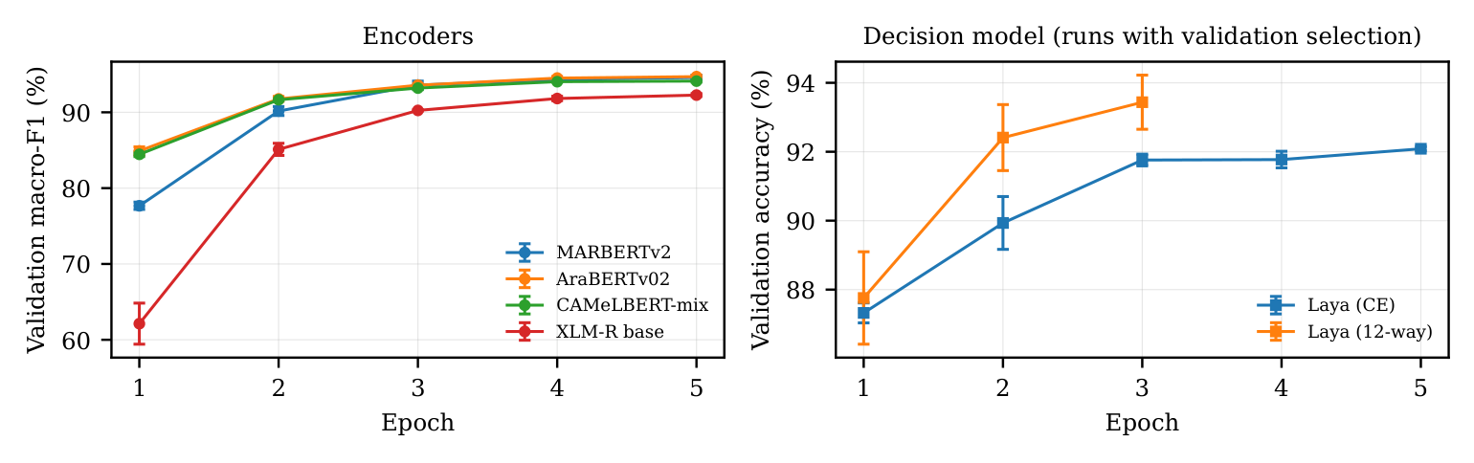
Figure 9. Validation curves (mean and standard deviation over three seeds). Left: macro-F1 of the encoders. Right: accuracy of the decision-model runs that use validation-based epoch selection.

3.8. Robustness of the cascade to its components
Table 15. Cascades built from other components, each with its threshold chosen on validation by Algorithm 1: accuracy (%) on the 400-message subsamples and share of Tunisian traffic sent to the second stage. The first row is the cascade of Table 10.
First stage $→$ second stage | $$τ$$ | MSA | Pal. | Saudi | Moroccan | Tunisian | Routed (Tun.)
MARBERTv2 $→$ LLM (10 retrieved) | 0.60 | 93.2 | 90.8 | 86.0 | 79.2 | 67.5 | 33.0
AraBERTv02 $→$ LLM (10 retrieved) | 0.81 | 92.5 | 90.5 | 84.0 | 80.2 | 69.2 | 53.2
MARBERTv2+AraBERTv02 $→$ LLM (10 retrieved) | 0.70 | 92.5 | 90.5 | 84.2 | 80.0 | 69.8 | 53.0
MARBERTv2 $→$ LLM (zero-shot) | 0.45 | 91.8 | 90.8 | 84.8 | 75.0 | 63.7 | 20.5
MARBERTv2 $→$ bge-m3 $k$NN | 0.45 | 92.2 | 90.2 | 86.2 | 76.0 | 60.0 | 20.5
MARBERTv2+AraBERTv02 ensemble (no LLM) | – | 92.8 | 92.8 | 86.0 | 77.5 | 62.5 | 0.0
The cascade is a recipe rather than a particular pair of models, so Table 15 rebuilds it from other components, always choosing the threshold on validation data with Algorithm 1. With AraBERTv02 or an average of MARBERTv2 and AraBERTv02 as the first stage, the cascade reaches the LLM’s accuracy on the far dialects (69.2% and 69.8% on Tunisian) but gives up about two points to the encoder on Palestinian. For these first stages the validation rule picks a higher threshold and routes more traffic, which helps far dialects and costs a little on near ones; with MARBERTv2 as the first stage the cascade gives the best balance between the two. The choice of second stage matters more. A zero-shot LLM adds only a few points on the far dialects (63.7% on Tunisian), and the retrieval baseline adds almost nothing (60.0%), because both are weaker than the encoder on most of the routed messages. An ensemble of the two encoders without any LLM reaches 62.5% on Tunisian, well below the cascade’s 67.5%. The gain on distant dialects therefore comes from the retrieval-augmented LLM, not from combining models as such, while the confidence rule is what keeps that gain from costing accuracy on the near dialects.

3.9. In-domain calibration does not transfer
Table 16. Expected calibration error (%, 15 bins) before / after temperature scaling fitted on the in-domain validation split.
System | MSA | Pal. | Saudi | Moroccan | Tunisian
MARBERTv2 | 2.1/3.1 | 2.9/3.9 | 5.1/6.4 | 9.1/10.8 | 18.0/20.4
AraBERTv02 | 3.0/3.0 | 3.4/3.4 | 6.3/6.2 | 7.4/7.4 | 13.0/12.9
bge-m3 $k$NN | 10.7/5.8 | 16.5/7.0 | 21.6/10.0 | 29.2/9.6 | 40.7/7.5
Laya (RLCD) | 10.6/5.1 | 12.8/7.1 | 18.0/10.1 | 21.0/11.3 | 35.6/18.3
Laya (CE) | 9.0/4.0 | 11.8/4.9 | 18.1/8.6 | 26.0/14.0 | 47.8/24.9
Table 16 shows calibration error before and after temperature scaling, and Figure 10 shows the corresponding reliability diagrams for MARBERTv2. For the fine-tuned encoders, raw calibration error grows steadily with dialect distance (MARBERTv2: 2.1% on MSA, 18.0% on Tunisian). Temperature scaling, fitted on the in-domain validation split, does not fix this and makes MARBERTv2 worse on every test set, for example 5.1$→$6.4% on Saudi and 18.0$→$20.4% on Tunisian: the encoder is slightly under-confident in-domain, the fitted temperature is below one ($T=0.96$ for the first seed) and sharpens its outputs, and on unseen dialects, where it is already over-confident, this adds to the error. The fitted temperatures of all runs are listed in Appendix F. For the nearest-neighbour and decision models, whose raw scores are not probabilities, temperature scaling is essential and helps on every set. The practical consequence is that confidence thresholds and calibration must be checked on data from the target dialect, not inherited from the training data. The cascade is robust to this problem because it only needs the ranking of confidences, not their absolute values, and its threshold was chosen by comparing the two components rather than by trusting a probability.
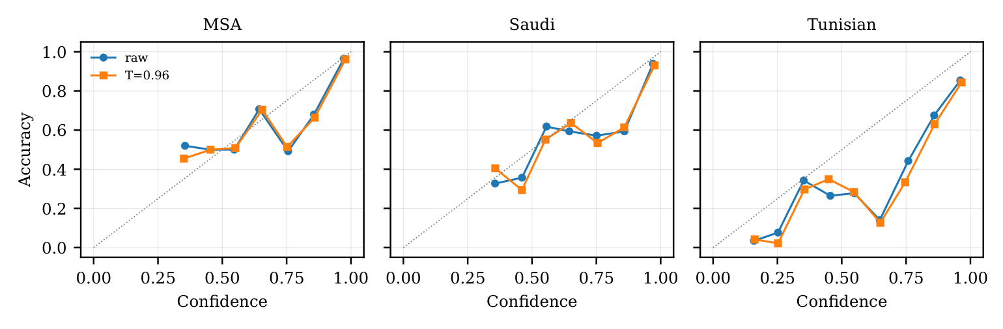
Figure 10. Reliability diagrams for MARBERTv2 (first seed) on MSA, Saudi and Tunisian, before (raw) and after temperature scaling fitted on in-domain validation data. Points below the diagonal indicate over-confidence; bins with fewer than 15 messages are omitted.

3.10. Routing view and selective prediction
Table 17. Routing view. Left: accuracy (%) at the level of 12 contact-centre categories (77-way predictions summed per category; Laya (12-way) is trained directly on the categories). Right: share of traffic (%) that can be answered automatically at $≥$90% accuracy (selective prediction by confidence).
 | 12-category accuracy |  |  |  |  | Coverage at 90% accuracy
System | MSA | Pal. | Saudi | Moroccan | Tunisian | MSA | Pal. | Saudi | Moroccan | Tunisian
MARBERTv2 | 96.1 | 94.7 | 93.2 | 86.6 | 69.8 | 100 | 99 | 90 | 74 | 32
AraBERTv02 | 96.1 | 95.1 | 91.8 | 87.8 | 70.3 | 100 | 100 | 87 | 78 | 37
bge-m3 $k$NN | 94.3 | 89.8 | 86.3 | 80.2 | 64.3 | 96 | 80 | 68 | 55 | 39
Laya (RLCD) | 90.6 | 88.0 | 83.1 | 79.0 | 58.7 | 86 | 77 | 58 | 49 | 6
Laya (CE) | 94.7 | 92.6 | 88.9 | 81.9 | 57.8 | 99 | 94 | 75 | 57 | 3
Laya (12-way) | 91.5 | 89.2 | 85.5 | 80.0 | 57.3 | 100 | 98 | 90 | 81 | 16
For contact-centre routing, the 77 intents are often more detail than necessary. Summing MARBERTv2’s predicted probabilities within 12 routing categories (Table 17) gives 93.2% category accuracy on Saudi and 86.6% on Moroccan. About half of its intent errors on MSA, Palestinian and Saudi stay inside the correct category (52.2% on Saudi), so the message would still reach the right team. On Tunisian, where the encoder fails most, this share falls to 27.7% and the errors are no longer near misses. Training the decision model directly on the 12 categories does not close the gap: it reaches 85.5% on Saudi and 80.0% on Moroccan, below the category accuracy obtained by grouping MARBERTv2’s 77-intent predictions, so a fine-grained classifier is the better route even when only the category is needed.
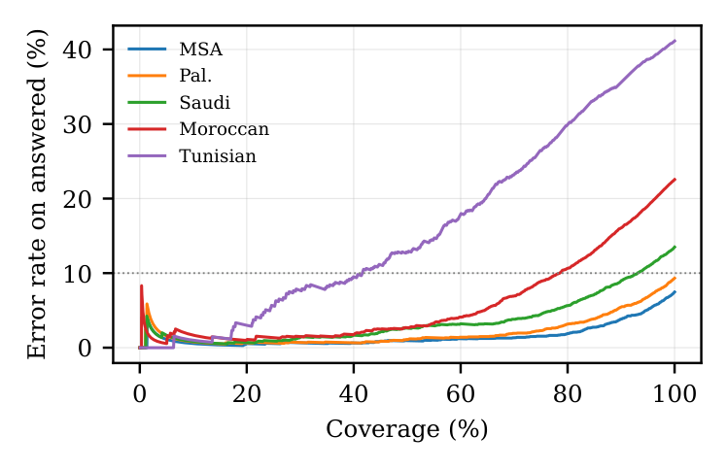
Figure 11. Risk–coverage curves of MARBERTv2 (seed-averaged): error rate among the messages answered automatically, as more low-confidence messages are included. The dotted line marks a 10% error rate.
Figure 13 breaks category accuracy down by dialect. Most categories remain above 90% on Saudi, but on Tunisian several fall sharply; the weakest is pin security at 42.4%. Such a breakdown tells a bank which self-service flows can be offered automatically in which market. Figure 12 shows where the Tunisian category errors go. They are concentrated in a few neighbouring pairs: about a quarter of payment-dispute messages are routed to top-ups, a fifth of card-problem messages to card management, and PIN-security messages are spread over the two card categories. Identity, account and currency-exchange messages are almost always routed correctly.
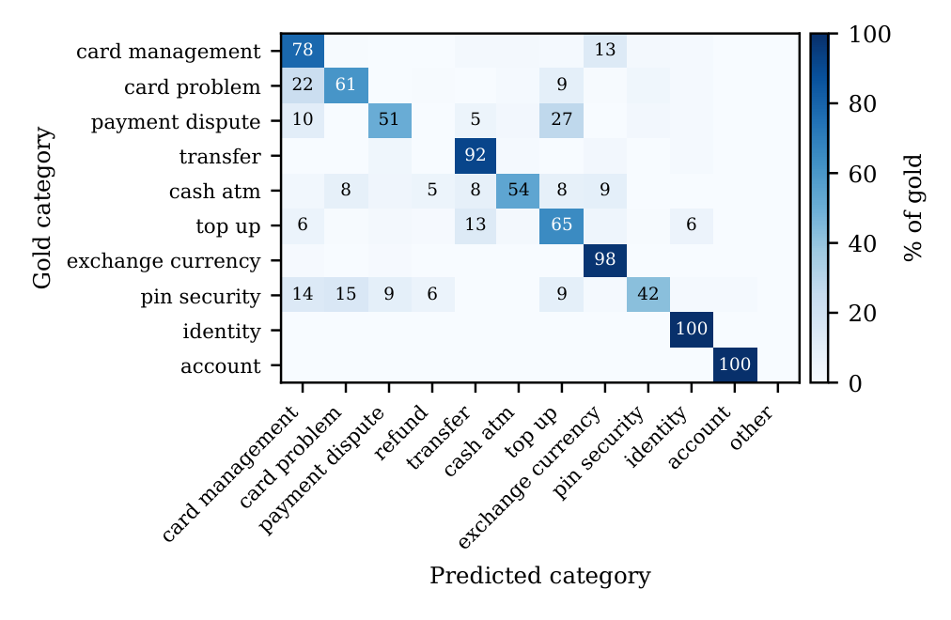
Figure 12. Category-level confusion matrix of MARBERTv2 on the Tunisian test set (row-normalized, %; values below 5% not printed).
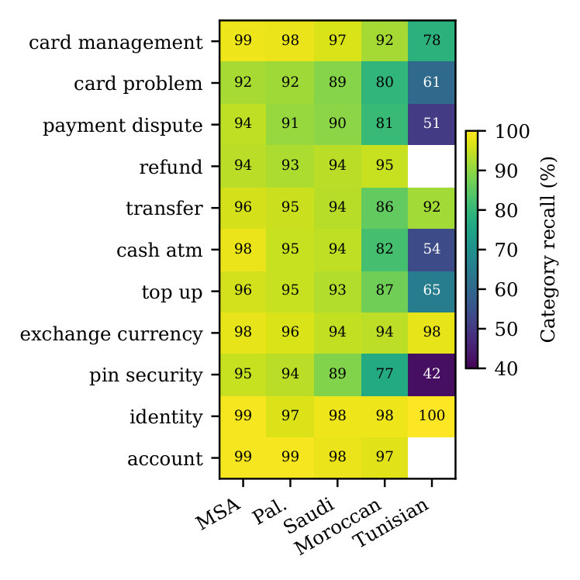
Figure 13. Category-level recall (%) of the seed-averaged MARBERTv2 when its 77-intent probabilities are summed per routing category. Cells with fewer than 20 messages are left blank; the “other” category is omitted.
Selective prediction gives the same picture (Figure 11, Table 18). MARBERTv2 can answer 90.0% of Saudi messages automatically at 90% accuracy and 74.5% of Moroccan messages, but only 32.3% of Tunisian messages. For a deployment that must keep automatic answers above a fixed accuracy, the far dialects therefore need either more human handling or a second model, which is precisely the role the LLM plays in the cascade. Table 18 compares all systems. MARBERTv2 and AraBERTv02 have the lowest risk–coverage area on the four nearer test sets, and the decision model is clearly the weakest everywhere. On Tunisian, however, the retrieval baseline ranks its errors as well as the best encoders and can answer a larger share of messages at 95% accuracy, even though its overall accuracy is lower: when a Tunisian message is close to a training message, nearest-neighbour similarity is a reliable signal.
Table 18. Selective prediction for every system. Left: area under the risk–coverage curve (AURC, %; lower is better). Right: share of traffic (%) that can be answered automatically at $≥$95% accuracy.
 | AURC |  |  |  |  | Coverage at 95% accuracy
System | MSA | Pal. | Saudi | Moroccan | Tunisian | MSA | Pal. | Saudi | Moroccan | Tunisian
MARBERTv2 | 1.9 | 2.6 | 4.2 | 6.8 | 18.4 | 92 | 87 | 74 | 58 | 21
AraBERTv02 | 1.4 | 1.9 | 4.1 | 5.5 | 18.3 | 94 | 90 | 71 | 63 | 20
CAMeLBERT-mix | 1.6 | 2.2 | 5.7 | 8.3 | 30.3 | 92 | 86 | 61 | 51 | 13
XLM-R base | 1.7 | 2.7 | 6.0 | 10.1 | 22.9 | 90 | 81 | 59 | 44 | 13
bge-m3 $k$NN | 2.3 | 5.1 | 8.0 | 11.6 | 18.3 | 84 | 65 | 48 | 41 | 34
Laya (RLCD) | 4.3 | 6.6 | 10.9 | 13.8 | 39.7 | 72 | 58 | 30 | 29 | 4
Laya (CE) | 2.0 | 3.0 | 6.8 | 10.9 | 38.4 | 89 | 80 | 51 | 34 | 1

3.11. Error analysis
Table 19. The twelve most frequent confusions of MARBERTv2 (seed-averaged) on the three unseen dialects pooled, with whether both intents fall in the same routing category.
Gold intent | Predicted intent | Errors | Same category
change pin | passcode forgotten | 29 | yes
supported cards and currencies | fiat currency support | 27 | no
pin blocked | passcode forgotten | 23 | yes
contactless not working | apple pay or google pay | 19 | no
exchange rate | exchange charge | 17 | yes
get disposable virtual card | disposable card limits | 16 | yes
top up by bank transfer charge | transfer fee charged | 15 | no
top up limits | age limit | 15 | no
card payment fee charged | transaction charged twice | 15 | yes
contactless not working | top up failed | 14 | no
card acceptance | supported cards and currencies | 14 | yes
contactless not working | card not working | 13 | yes
Table 19 lists the most frequent confusions of MARBERTv2 on the unseen dialects. They account for 12.8% of all errors, and 7 of the twelve pairs fall in the same routing category. Most are genuinely close intents in the Banking77 inventory: changing a PIN versus a forgotten passcode, an exchange rate versus an exchange charge, a disposable virtual card versus its limits. Others reflect dialectal wording, such as questions about supported cards and currencies that are read as questions about fiat currency support. Table 20 lists the intents with the lowest recall; most are members of such near-synonymous pairs. Appendix G gives the recall of every intent on the Tunisian test set. Figure 14 compares per-intent F1 on the unseen dialects. MARBERTv2 has a higher F1 than the decision model on 86% of the intents and than the retrieval baseline on 86%, so its advantage is spread across the label set rather than concentrated in a few intents.
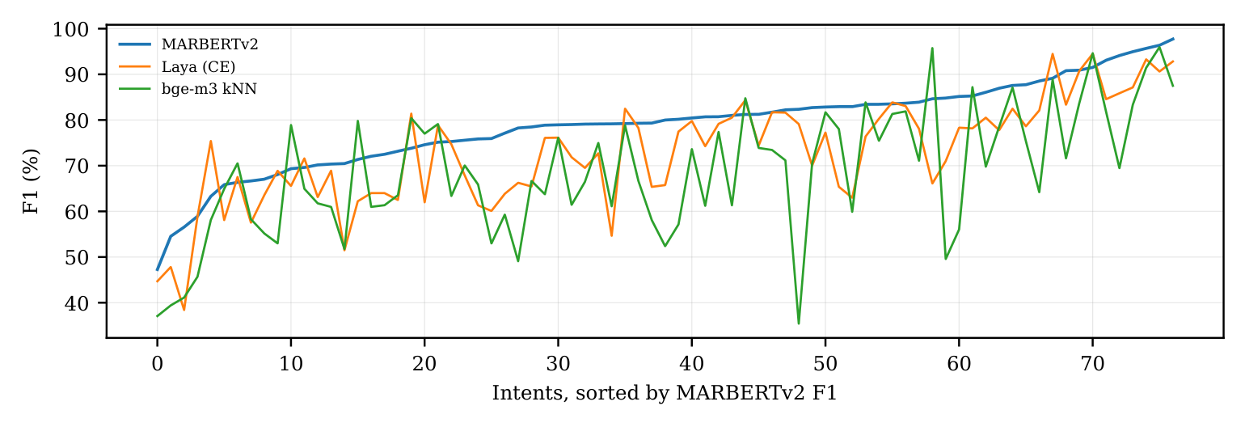
Figure 14. Per-intent F1 (%) on the three unseen dialects pooled, with intents sorted by the F1 of MARBERTv2 (all systems seed-averaged where applicable).
Table 20. The ten intents with the lowest recall for MARBERTv2 on the unseen dialects pooled (intents with at least 40 test messages).
Intent | Category | $$n$$ | Recall (%)
pin blocked | pin security | 120 | 32.5
contactless not working | card problem | 141 | 48.9
card payment not recognised | payment dispute | 80 | 52.5
card payment fee charged | payment dispute | 184 | 58.7
get physical card | card management | 80 | 58.8
top up reverted | top up | 94 | 59.6
change pin | pin security | 100 | 62.0
top up by bank transfer charge | top up | 159 | 62.9
card acceptance | card management | 118 | 64.4
direct debit payment not recognised | payment dispute | 102 | 67.6
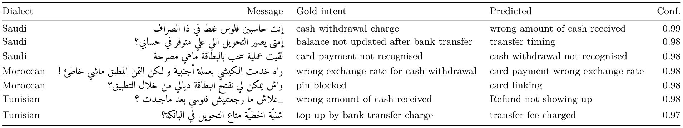
Figure 15. High-confidence errors of MARBERTv2 (seed-averaged confidence $≥0.97$) on the unseen dialects. Messages are reproduced from the ArBanking77 test sets (CC BY-SA 4.0); intent names are the dataset’s English labels.
Figure 15 shows errors that the encoder makes with high confidence, which the cascade cannot catch because they are never routed. Several of them are not clear model failures. A Saudi message complaining that the ATM “calculated the money wrongly” is labelled as a cash-withdrawal charge but predicted as a wrong amount of cash received, and a Moroccan message about opening the card “through the application” is labelled as a blocked PIN but predicted as card linking. Such cases point to label ambiguity in fine-grained intent inventories, which no amount of model capacity can remove and which argues for evaluating routing at the category level as well.

4. Discussion

4.1. Implications for deployment
The results suggest a simple recipe for multi-dialect banking assistants. A fine-tuned dialect-aware encoder should be the first stage: it is the most accurate system on MSA and the near dialects and costs a few milliseconds per message, even on a CPU. A retrieval-augmented LLM is worth adding as a second stage when the customer base includes dialects that are distant from the training data, and a confidence threshold chosen on in-domain validation data is enough to decide when to use it. The threshold transfers because it relies on the ranking of confidences, while the absolute probabilities do not transfer; any rule that relies on a calibrated probability, such as an automatic-answer threshold expressed as “at least 90% sure”, should be re-validated on target-dialect samples. Grouping fine-grained predictions into routing categories is a cheap way to make errors less harmful.

4.2. Checklist for practitioners
The findings translate into a short checklist for teams building multi-dialect Arabic assistants:
1. Start from a dialect-aware encoder fine-tuned on the available labelled data, and measure it on a held-out sample of each target dialect rather than on an in-domain split.
2. Measure the lexical distance of each target dialect from the training data; the unseen-word rate is a cheap early warning of where accuracy will drop.
3. Add a retrieval-augmented LLM as a second stage only behind a confidence threshold, and choose the threshold with a rule that compares the two stages on validation data.
4. Do not trust absolute confidence values on new dialects; re-check calibration and any “automatic answer” threshold on target-dialect samples.
5. Report results at the routing-category level as well as the intent level, and inspect high-confidence errors for label ambiguity before blaming the model.

4.3. Why the decision model lags
Decision models are attractive because one model can serve many classification tasks with options written in natural language. On a fixed 77-intent inventory with more than twenty thousand training messages, however, the encoders’ dedicated classification head has a clear advantage. Each Laya input must contain all 77 options, so the message itself is a small part of a long input, and the model’s multilingual pre-training covers dialectal Arabic less densely than MARBERT’s. The coarse-category experiment shows that the gap is not caused by the number of options alone: with only 12 options, Laya is still below the grouped encoder predictions. Decision models remain a reasonable choice when the label set changes frequently or labelled data are scarce, which this study does not test.

4.4. Threats to validity
Internal validity. All trained systems use the same data, epochs and model selection protocol, except where the Laya recipe prescribes otherwise, and every comparison with the LLM uses the same 400 items per test set. The cascade threshold is chosen on validation data only, so no test information leaks into the reported cascade results. External validity. The dialect test sets were produced by translating a common intent inventory and may be more regular than spontaneous customer messages; real traffic also contains code-switching and Arabizi, which ArBanking77 does not cover. Construct validity. Accuracy treats all confusions as equally harmful; the category-level analysis and the error examples show that many errors are near misses that a deployment would tolerate.

4.5. Ethical considerations
Dialect gaps are also a fairness issue: customers who write in dialects far from the training data receive worse automatic service, as the drop from MSA to Tunisian accuracy shows. A deployment should monitor accuracy separately for each dialect group and route uncertain messages to human agents or stronger models rather than answering them automatically. The study uses a public benchmark of constructed messages and involves no personal data. A production system that sends customer messages to an LLM must respect banking confidentiality, which favours locally hosted models such as the one used here.

4.6. Limitations and future work
The LLM results come from 400 messages per test set, so their confidence intervals are wider than those of the trained systems. We also tested only one LLM, at one size; a larger model would likely raise far-dialect accuracy and, with it, the cascade’s. The Tunisian set covers only 27 intents. By design, all trained systems use the same MSA and Palestinian data, and adding even a small amount of target-dialect data would change the absolute numbers. Finally, the decision model was run with English option names to fit its input length, and Arabic option descriptions might suit it better. Future work should evaluate the cascade on real multi-dialect contact-centre traffic, combine it with a small amount of target-dialect fine-tuning, and replace the single confidence threshold with a learned deferral rule.

5. Conclusions
On cross-dialect Arabic banking intent detection, no single model family is best everywhere. A fine-tuned dialect-aware encoder is the most accurate and by far the cheapest option on MSA and the dialects close to its training data; a retrieval-augmented LLM is better on distant dialects, and the two make largely different errors; a single-pass decision model does not reach either on a fixed 77-intent label set. A confidence cascade with a threshold chosen on in-domain validation data combines the first two: it is never significantly worse than the better component, sends the LLM only the messages the encoder is unsure about, routes more traffic to the LLM automatically as the dialect moves further from the training data, and costs a fraction of an LLM-only system. Because calibration fitted on in-domain data degrades on unseen dialects, deployments should validate confidence thresholds on target-dialect samples. All code, predictions and per-item results are released to support such checks.
Author Contributions: Conceptualization, A.A.; methodology, A.A.; software, A.A.; formal analysis, A.A.; investigation, A.A.; data curation, A.A.; visualization, A.A.; validation, A.H., S.K. and Y.I.; writing—original draft preparation, A.A.; writing—review and editing, A.A., A.H., S.K. and Y.I. All authors have read and agreed to the published version of the manuscript.
Funding: This research received no external funding.
Institutional Review Board Statement: Not applicable.
Informed Consent Statement: Not applicable.
Data Availability Statement: ArBanking77 is publicly available from its authors under the CC BY-SA 4.0 licence. All code, per-item predictions and results supporting the reported findings are available at https://github.com/AmrKhalil9/arabic-banking-intent-dialects.
Acknowledgments: Qwen3.5-9B is part of the method and is used, without fine-tuning, as a baseline classifier and as the second stage of the cascade. During the preparation of this manuscript, the authors used Claude (Anthropic, Claude Opus 5.5) for the purposes of programming assistance and drafting and editing the text. The authors have reviewed and edited the output and take full responsibility for the content of this publication.
Conflicts of Interest: The authors declare no conflicts of interest.

Abbreviations
The following abbreviations are used in this manuscript:
AURC | area under the risk–coverage curve
CE | cross-entropy
ECE | expected calibration error
kNN | k-nearest neighbours
LLM | large language model
MSA | Modern Standard Arabic
RLCD | the training recipe released with the Laya model
RQ | research question

Appendix A. Hyperparameters
Table A1 lists the settings of every trained system. All runs use the same official training and validation splits, three seeds (1, 2, 3), mixed-precision training on one NVIDIA RTX 6000 (24 GB), and model selection on the validation split where stated.
Table A1. Training and inference settings.
System | Settings
Encoders | AdamW, learning rate $3×{10}^{-5}$, weight decay 0.01, linear schedule with 6% warm-up, batch size 32, maximum length 64 tokens, 5 epochs, best epoch by validation macro-F1, fp16 mixed precision.
Laya (RLCD) | Released multilingual checkpoint (322M parameters); AdamW with learning rates $2.5×{10}^{-5}$ (encoder) and ${10}^{-4}$ (head), cosine schedule, micro-batch 4 with 8 accumulation steps (effective batch 32), 3 epochs; policy-gradient objective with 4 Gaussian perturbations of the option scores per item (standard deviation annealed from 0.4 to 0.1), reward from a weighted spherical (0.75) and ranked-probability (1.0) score, plus soft cross-entropy; input length 1,024 tokens with the 77 English intent names as options.
Laya (CE) | As above but cross-entropy only, 5 epochs, best epoch by validation accuracy.
Laya (12-way) | As Laya (RLCD) with the 12 routing categories and their descriptions as options, best epoch by validation accuracy.
bge-m3 $k$NN | Normalised first-token embeddings, maximum length 128, $k=10$, cosine similarity, class score = sum of similarities.
Qwen3.5-9B | Local inference, reasoning disabled, temperature 0, at most 8 output tokens; retrieval setting uses the 10 nearest training messages by bge-m3 as example turns; 400 messages per split sampled with seed 0.
Calibration | One temperature per run, fitted by L-BFGS on validation negative log-likelihood.
Cascade | Seed-averaged MARBERTv2 probabilities; threshold grid 0.30–0.99 in steps of 0.01 (Algorithm 1).
Statistics | Paired bootstrap, 10,000 resamples, 95% percentile intervals.

Appendix B. LLM prompt
The system prompt is shown below; the list continues for all 77 intents, ordered by their Arabic labels, each with its English name and the Arabic label from ArBanking77. In the retrieval setting, each of the 10 retrieved training messages is added as a user turn followed by an assistant turn containing its intent number, before the test message.
You classify Arabic banking customer messages (any dialect) into exactly one of 77 intents. Reply with only the intent number.
Intents:
0: apple pay or google pay (Arabic label)
1: reverted card payment? (Arabic label)
…
76: card arrival (Arabic label)

Appendix C. Results of individual runs
Table C1 gives the accuracy of every training run. The encoders vary by less than a point between seeds; Laya trained with its released recipe varies by several points, which motivated the additional cross-entropy runs.
Table C1. Accuracy (%) of every individual training run (seed) on each test set, and the epoch selected on validation. Laya (12-way) is scored on the 12 routing categories.
System | Seed | MSA | Pal. | Saudi | Moroccan | Tunisian | Epoch
MARBERTv2 | 1 | 91.9 | 89.4 | 85.8 | 77.2 | 57.9 | 5
 | 2 | 92.0 | 90.3 | 85.4 | 76.2 | 58.0 | 5
 | 3 | 91.5 | 89.3 | 85.7 | 76.7 | 57.7 | 4
AraBERTv02 | 1 | 91.6 | 90.2 | 83.1 | 78.2 | 58.9 | 5
 | 2 | 91.8 | 90.1 | 83.3 | 78.0 | 56.1 | 5
 | 3 | 92.0 | 89.9 | 83.2 | 77.8 | 56.1 | 5
CAMeLBERT-mix | 1 | 91.6 | 88.9 | 80.0 | 73.1 | 44.1 | 5
 | 2 | 91.3 | 89.3 | 79.9 | 72.9 | 44.6 | 5
 | 3 | 90.7 | 88.3 | 79.2 | 71.7 | 39.8 | 4
XLM-R base | 1 | 90.4 | 86.6 | 79.2 | 69.3 | 50.6 | 5
 | 2 | 90.5 | 86.8 | 79.1 | 69.2 | 50.7 | 5
 | 3 | 90.2 | 86.6 | 77.5 | 69.1 | 51.5 | 5
Laya (RLCD) | 1 | 77.4 | 71.1 | 64.0 | 58.9 | 36.9 | –
 | 2 | 85.7 | 82.5 | 73.5 | 66.0 | 38.4 | –
 | 3 | 86.3 | 82.8 | 75.1 | 67.3 | 37.3 | –
Laya (CE) | 1 | 89.6 | 86.3 | 78.9 | 68.9 | 40.8 | 5
 | 2 | 89.4 | 85.9 | 78.3 | 69.1 | 41.9 | 5
 | 3 | 89.6 | 86.3 | 79.6 | 70.7 | 42.8 | 5
Laya (12-way) | 1 | 92.5 | 90.1 | 86.4 | 80.7 | 59.5 | 3
 | 2 | 90.4 | 87.8 | 84.2 | 79.5 | 56.6 | 3
 | 3 | 91.7 | 89.5 | 85.8 | 79.7 | 55.9 | 3

Appendix D. Intent-to-category mapping
Table D1 lists the mapping from the 77 intents to the 12 routing categories used in Section 3.10. The mapping was fixed before any results were computed and is applied identically to every system.
Table D1. Mapping of the 77 ArBanking77 intents (English names) to the 12 contact-centre routing categories used in Section 3.10.
Category | $$n$$ | Intents
card management | 15 | activate my card, apple pay or google pay, card about to expire, card acceptance, card arrival, card delivery estimate, card linking, disposable card limits, get disposable virtual card, get physical card, getting spare card, getting virtual card, order physical card, supported cards and currencies, visa or mastercard
payment dispute | 7 | card payment fee charged, card payment not recognised, direct debit payment not recognised, extra charge on statement, pending card payment, reverted card payment?, transaction charged twice
top up | 8 | automatic top up, pending top up, top up by bank transfer charge, top up by card charge, top up by cash or cheque, top up failed, top up limits, top up reverted
transfer | 11 | balance not updated after bank transfer, beneficiary not allowed, cancel transfer, declined transfer, failed transfer, pending transfer, receiving money, transfer fee charged, transfer into account, transfer not received by recipient, transfer timing
card problem | 7 | card not working, card swallowed, compromised card, contactless not working, declined card payment, lost or stolen card, virtual card not working
refund | 2 | Refund not showing up, request refund
identity | 6 | age limit, unable to verify identity, verify my identity, verify source of funds, verify top up, why verify identity
pin security | 5 | change pin, lost or stolen phone, passcode forgotten, pin blocked, topping up by card
cash atm | 7 | atm support, balance not updated after cheque or cash deposit, cash withdrawal charge, cash withdrawal not recognised, declined cash withdrawal, pending cash withdrawal, wrong amount of cash received
exchange currency | 7 | card payment wrong exchange rate, country support, exchange charge, exchange rate, exchange via app, fiat currency support, wrong exchange rate for cash withdrawal
account | 2 | edit personal details, terminate account

Appendix E. Leakage check
Table E1 gives the full results of the leakage check of Section 2.2. The unseen dialects are no closer to the training data than the in-domain Palestinian test set, and the two most distant dialects have almost no near-duplicates of training messages. Saudi messages often have an MSA test message as their nearest neighbour, which is expected because the dialect test sets are parallel versions of the same test queries; this concerns similarity among test sets, not leakage from training.
Table E1. Leakage check with bge-m3 embeddings: median cosine similarity of each test message to its nearest training message, number and share of test messages with a training message at similarity $≥0.95$, and share whose nearest neighbour among training and MSA-test messages is an MSA-test message.
Test | $$n$$ | Median sim. | $$≥0.95$$ | % | NN in MSA test
Pal. (in-domain) | 3,807 | 0.86 | 352 | 9.2 | 0.35
Saudi | 3,580 | 0.85 | 251 | 7.0 | 0.56
Moroccan | 3,574 | 0.77 | 47 | 1.3 | 0.38
Tunisian | 999 | 0.71 | 0 | 0.0 | 0.32

Appendix F. Fitted temperatures
Table F1 lists the temperature fitted for each run. MARBERTv2 and XLM-R receive temperatures below one, which sharpen their predictions and explain why temperature scaling increases their calibration error on unseen dialects. The retrieval baseline and the decision model receive large temperatures because their raw scores are not probabilities.
Table F1. Temperatures fitted on the validation split for each run (one value per seed). Values below one sharpen the predicted distribution, values above one soften it.
System | Fitted temperature(s)
MARBERTv2 | 0.96, 0.95, 0.91
AraBERTv02 | 1.01, 1.01, 0.99
CAMeLBERT-mix | 1.03, 1.00, 1.00
XLM-R base | 0.88, 0.87, 0.88
bge-m3 $k$NN | 7.83
Laya (RLCD) | 1.43, 3.04, 3.08
Laya (CE) | 2.85, 2.85, 2.60
Laya (12-way) | 3.66, 3.84, 3.65

Appendix G. Per-intent results on Tunisian
Table G1 lists recall for each of the 27 intents in the Tunisian test set, sorted from hardest to easiest for the encoder. The LLM column is based on few messages per intent and should be read as indicative only.
Table G1. Per-intent recall (%) on the Tunisian test set: seed-averaged MARBERTv2 on all messages, and the retrieval-augmented LLM on the subsampled messages of that intent (number in parentheses).
Intent | $$n$$ | MARBERTv2 | LLM
card payment fee charged | 60 | 3.3 | 5 (22)
pin blocked | 40 | 10.0 | 50 (16)
top up reverted | 10 | 10.0 | 0 (3)
contactless not working | 47 | 12.8 | 93 (15)
passcode forgotten | 26 | 15.4 | 50 (12)
card acceptance | 38 | 36.8 | 94 (16)
top up by bank transfer charge | 53 | 41.5 | 44 (18)
supported cards and currencies | 43 | 46.5 | 76 (17)
declined cash withdrawal | 47 | 46.8 | 38 (24)
top up limits | 46 | 47.8 | 69 (13)
pending card payment | 17 | 52.9 | 62 (8)
card arrival | 34 | 55.9 | 50 (14)
wrong amount of cash received | 50 | 64.0 | 70 (23)
exchange rate | 40 | 65.0 | 85 (13)
card linking | 54 | 70.4 | 86 (22)
automatic top up | 4 | 75.0 | 100 (1)
lost or stolen card | 53 | 77.4 | 84 (19)
card not working | 40 | 82.5 | 82 (17)
pending top up | 65 | 84.6 | 44 (25)
card payment wrong exchange rate | 7 | 85.7 | 50 (2)
transfer not received by recipient | 45 | 86.7 | 95 (21)
getting virtual card | 46 | 87.0 | 96 (25)
cancel transfer | 40 | 92.5 | 90 (20)
exchange via app | 40 | 97.5 | 82 (17)
age limit | 45 | 100.0 | 100 (13)
card delivery estimate | 3 | 100.0 | 100 (1)
edit personal details | 6 | 100.0 | 100 (3)

References
- Bouamor, H.; Habash, N.; Salameh, M.; Zaghouani, W.; Rambow, O.; Abdulrahim, D.; Obeid, O.; Khalifa, S.; Eryani, F.; Erdmann, A.; et al. The MADAR Arabic Dialect Corpus and Lexicon. In Proceedings of the Proceedings of the eleventh international conference on language resources and evaluation (LREC 2018); Calzolari, N., Choukri, K., Cieri, C., Declerck, T., Goggi, S., Hasida, K., Isahara, H., Maegaard, B., Mariani, J., Mazo, H., Moreno, A., Odijk, J., Piperidis, S., Tokunaga, T., Eds.; European Language Resources Association (ELRA): Miyazaki, Japan, May 2018.
- Abdul-Mageed, M.; Zhang, C.; Bouamor, H.; Habash, N. NADI 2020: The First Nuanced Arabic Dialect Identification Shared Task. In Proceedings of the Proceedings of the fifth arabic natural language processing workshop; Zitouni, I., Abdul-Mageed, M., Bouamor, H., Bougares, F., El-Haj, M., Tomeh, N., Zaghouani, W., Eds.; Association for Computational Linguistics: Barcelona, Spain (Online), December 2020; pp. 97–110.
- Kantharuban, A.; Vulić, I.; Korhonen, A. Quantifying the Dialect Gap and Its Correlates Across Languages. In Proceedings of the Findings of the association for computational linguistics: EMNLP 2023; Bouamor, H., Pino, J., Bali, K., Eds.; Association for Computational Linguistics: Singapore, December 2023; pp. 7226–7245.
- Jarrar, M.; Birim, A.; Khalilia, M.; Erden, M.; Ghanem, S. ArBanking77: Intent Detection Neural Model and a New Dataset in Modern and Dialectical Arabic. In Proceedings of the Proceedings of ArabicNLP 2023; Sawaf, H., El-Beltagy, S., Zaghouani, W., Magdy, W., Abdelali, A., Tomeh, N., Abu Farha, I., Habash, N., Khalifa, S., Keleg, A., Haddad, H., Zitouni, I., Mrini, K., Almatham, R., Eds.; Association for Computational Linguistics: Singapore (Hybrid), December 2023; pp. 276–287.
- Casanueva, I.; Temčinas, T.; Gerz, D.; Henderson, M.; Vulić, I. Efficient Intent Detection with Dual Sentence Encoders. In Proceedings of the Proceedings of the 2nd workshop on natural language processing for conversational AI; Wen, T.-H., Celikyilmaz, A., Yu, Z., Papangelis, A., Eric, M., Kumar, A., Casanueva, I., Shah, R., Eds.; Association for Computational Linguistics: Online, July 2020; pp. 38–45.
- Malaysha, S.; El-Haj, M.; Ezzini, S.; Khalilia, M.; Jarrar, M.; Almujaiwel, S.; Berrada, I.; Bouamor, H. AraFinNLP 2024: The First Arabic Financial NLP Shared Task. In Proceedings of the Proceedings of the second arabic natural language processing conference; Habash, N., Bouamor, H., Eskander, R., Tomeh, N., Abu Farha, I., Abdelali, A., Touileb, S., Hamed, I., Onaizan, Y., Alhafni, B., Antoun, W., Khalifa, S., Haddad, H., Zitouni, I., AlKhamissi, B., Almatham, R., Mrini, K., Eds.; Association for Computational Linguistics: Bangkok, Thailand, August 2024; pp. 393–402.
- Ramadan, A.; Amr, M.; Torki, M.; El-Makky, N. MA at AraFinNLP2024: BERT-Based Ensemble for Cross-Dialectal Arabic Intent Detection. In Proceedings of the Proceedings of the second arabic natural language processing conference; Habash, N., Bouamor, H., Eskander, R., Tomeh, N., Abu Farha, I., Abdelali, A., Touileb, S., Hamed, I., Onaizan, Y., Alhafni, B., Antoun, W., Khalifa, S., Haddad, H., Zitouni, I., AlKhamissi, B., Almatham, R., Mrini, K., Eds.; Association for Computational Linguistics: Bangkok, Thailand, August 2024; pp. 441–445.
- Elkordi, H.; Sakr, A.; Torki, M.; El-Makky, N. AlexuNLP24 at AraFinNLP2024: Multi-Dialect Arabic Intent Detection with Contrastive Learning in Banking Domain. In Proceedings of the Proceedings of the second arabic natural language processing conference; Habash, N., Bouamor, H., Eskander, R., Tomeh, N., Abu Farha, I., Abdelali, A., Touileb, S., Hamed, I., Onaizan, Y., Alhafni, B., Antoun, W., Khalifa, S., Haddad, H., Zitouni, I., AlKhamissi, B., Almatham, R., Mrini, K., Eds.; Association for Computational Linguistics: Bangkok, Thailand, August 2024; pp. 415–421.
- Skiredj, A.; Azhari, F.; Berrada, I.; Ezzini, S. DarijaBanking: A New Resource for Overcoming Language Barriers in Banking Intent Detection for Moroccan Arabic Speakers. Natural Language Processing 2024, 31, 1234–1264, doi:10.1017/nlp.2024.55.
- Brown, T.; Mann, B.; Ryder, N.; Subbiah, M.; Kaplan, J.D.; Dhariwal, P.; Neelakantan, A.; Shyam, P.; Sastry, G.; Askell, A.; et al. Language Models Are Few-Shot Learners. In Proceedings of the Advances in neural information processing systems; Larochelle, H., Ranzato, M., Hadsell, R., Balcan, M.F., Lin, H., Eds.; Curran Associates, Inc., 2020; Vol. 33, pp. 1877–1901.
- convaiinnovations Laya: Multilingual, Non-Autoregressive System 1 Decision Model 2026.
- Yilmaz, F.; Tasdemir, H.A.; Gozay, M.F. LAVOIR: Teaching a Single-Pass Decision Encoder When and What to Ask with Amortized Value of Information 2026.
- Larson, S.; Mahendran, A.; Peper, J.J.; Clarke, C.; Lee, A.; Hill, P.; Kummerfeld, J.K.; Leach, K.; Laurenzano, M.A.; Tang, L.; et al. An Evaluation Dataset for Intent Classification and Out-of-Scope Prediction. In Proceedings of the Proceedings of the 2019 conference on empirical methods in natural language processing and the 9th international joint conference on natural language processing (EMNLP-IJCNLP); Inui, K., Jiang, J., Ng, V., Wan, X., Eds.; Association for Computational Linguistics: Hong Kong, China, November 2019; pp. 1311–1316.
- Liu, X.; Eshghi, A.; Swietojanski, P.; Rieser, V. Benchmarking Natural Language Understanding Services for Building Conversational Agents. In Increasing naturalness and flexibility in spoken dialogue interaction; Springer Singapore, 2021; pp. 165–183 ISBN 9789811593239.
- Tunstall, L.; Reimers, N.; Jo, U.E.S.; Bates, L.; Korat, D.; Wasserblat, M.; Pereg, O. Efficient Few-Shot Learning Without Prompts 2022.
- Abdo, M.S.; Hatekar, Y.A.; Cavar, D. AMWAL: Named Entity Recognition for Arabic Financial News. In Proceedings of the Proceedings of the joint workshop of the 9th financial technology and natural language processing (FinNLP), the 6th financial narrative processing (FNP), and the 1st workshop on large language models for finance and legal (LLMFinLegal); Chen, C.-C., Moreno-Sandoval, A., Huang, J., Xie, Q., Ananiadou, S., Chen, H.-H., Eds.; Association for Computational Linguistics: Abu Dhabi, UAE, January 2025; pp. 207–213.
- El-Haj, M.; Rayson, P. AraFinNews: Arabic Financial Summarisation with Domain-Adapted LLMs. In Proceedings of the 2025 IEEE international conference on big data (BigData); IEEE, December 2025; pp. 5428–5436.
- Albaqawi, M.H.; Albalkhi, E.M.; Albaiti, J.A.; Lopedoto, E. LLM-Based Financial Sentiment Analysis in Arabic: Evidence from Saudi Markets. In Proceedings of the The 7th workshop on open-source Arabic corpora and processing tools (OSACT7) with 5 shared tasks; Al-Khalifa, H., El-Haj, M., Ezzini, S., Eds.; Association for Computational Linguistics: Palma, Mallorca (Spain), May 2026; pp. 14–24.
- Elbadry, R.; Ahmad, S.; Heakl, A.; Bouch, D.; Ahsan, M.; AlMahri, M.; Khalil, M.E.; Wang, Y.; Lahlou, S.; Ananiadou, S.; et al. SAHM: A Benchmark for Arabic Financial and Shari’ah-Compliant Reasoning. In Proceedings of the Proceedings of the 64th annual meeting of the Association for Computational Linguistics (volume 1: Long papers); Liakata, M., Moreira, V.P., Zhang, J., Jurgens, D., Eds.; Association for Computational Linguistics: San Diego, California, United States, July 2026; pp. 34509–34536.
- Abdul-Mageed, M.; Elmadany, A.; Zhang, C.; Nagoudi, E.M.B.; Bouamor, H.; Habash, N. NADI 2023: The Fourth Nuanced Arabic Dialect Identification Shared Task. In Proceedings of the Proceedings of ArabicNLP 2023; Sawaf, H., El-Beltagy, S., Zaghouani, W., Magdy, W., Abdelali, A., Tomeh, N., Abu Farha, I., Habash, N., Khalifa, S., Keleg, A., Haddad, H., Zitouni, I., Mrini, K., Almatham, R., Eds.; Association for Computational Linguistics: Singapore (Hybrid), December 2023; pp. 600–613.
- 21. Abdul-Mageed, M.; Elmadany, A.; Nagoudi, E.M.B. ARBERT & MARBERT: Deep Bidirectional Transformers for Arabic. In Proceedings of the Proceedings of the 59th annual meeting of the association for computational linguistics and the 11th international joint conference on natural language processing (volume 1: Long papers); Zong, C., Xia, F., Li, W., Navigli, R., Eds.; Association for Computational Linguistics: Online, August 2021; pp. 7088–7105.
- Antoun, W.; Baly, F.; Hajj, H. AraBERT: Transformer-Based Model for Arabic Language Understanding. In Proceedings of the Proceedings of the 4th workshop on open-source arabic corpora and processing tools, with a shared task on offensive language detection; Al-Khalifa, H., Magdy, W., Darwish, K., Elsayed, T., Mubarak, H., Eds.; European Language Resources Association: Marseille, France, May 2020; pp. 9–15.
- Abdelali, A.; Hassan, S.; Mubarak, H.; Darwish, K.; Samih, Y. Pre-Training BERT on Arabic Tweets: Practical Considerations 2021.
- Inoue, G.; Alhafni, B.; Baimukan, N.; Bouamor, H.; Habash, N. The Interplay of Variant, Size, and Task Type in Arabic Pre-Trained Language Models. In Proceedings of the Proceedings of the sixth arabic natural language processing workshop; Habash, N., Bouamor, H., Hajj, H., Magdy, W., Zaghouani, W., Bougares, F., Tomeh, N., Abu Farha, I., Touileb, S., Eds.; Association for Computational Linguistics: Kyiv, Ukraine (Virtual), April 2021; pp. 92–104.
- Conneau, A.; Khandelwal, K.; Goyal, N.; Chaudhary, V.; Wenzek, G.; Guzmán, F.; Grave, E.; Ott, M.; Zettlemoyer, L.; Stoyanov, V. Unsupervised Cross-Lingual Representation Learning at Scale. In Proceedings of the Proceedings of the 58th annual meeting of the association for computational linguistics; Jurafsky, D., Chai, J., Schluter, N., Tetreault, J., Eds.; Association for Computational Linguistics: Online, July 2020; pp. 8440–8451.
- Devlin, J.; Chang, M.-W.; Lee, K.; Toutanova, K. BERT: Pre-Training of Deep Bidirectional Transformers for Language Understanding. In Proceedings of the Proceedings of the 2019 conference of the north American chapter of the association for computational linguistics: Human language technologies, volume 1 (long and short papers); Burstein, J., Doran, C., Solorio, T., Eds.; Association for Computational Linguistics: Minneapolis, Minnesota, June 2019; pp. 4171–4186.
- Warner, B.; Chaffin, A.; Clavié, B.; Weller, O.; Hallström, O.; Taghadouini, S.; Gallagher, A.; Biswas, R.; Ladhak, F.; Aarsen, T.; et al. Smarter, Better, Faster, Longer: A Modern Bidirectional Encoder for Fast, Memory Efficient, and Long Context Finetuning and Inference. In Proceedings of the Proceedings of the 63rd annual meeting of the association for computational linguistics (volume 1: Long papers); Che, W., Nabende, J., Shutova, E., Pilehvar, M.T., Eds.; Association for Computational Linguistics: Vienna, Austria, July 2025; pp. 2526–2547.
- Chen, J.; Xiao, S.; Zhang, P.; Luo, K.; Lian, D.; Liu, Z. M3-Embedding: Multi-Linguality, Multi-Functionality, Multi-Granularity Text Embeddings Through Self-Knowledge Distillation. In Proceedings of the Findings of the association for computational linguistics: ACL 2024; Ku, L.-W., Martins, A., Srikumar, V., Eds.; Association for Computational Linguistics: Bangkok, Thailand, August 2024; pp. 2318–2335.
- Seelawi, H.; Tuffaha, I.; Gzawi, M.; Farhan, W.; Talafha, B.; Badawi, R.; Sober, Z.; Al-Dweik, O.; Freihat, A.A.; Al-Natsheh, H. ALUE: Arabic Language Understanding Evaluation. In Proceedings of the Proceedings of the sixth arabic natural language processing workshop; Habash, N., Bouamor, H., Hajj, H., Magdy, W., Zaghouani, W., Bougares, F., Tomeh, N., Abu Farha, I., Touileb, S., Eds.; Association for Computational Linguistics: Kyiv, Ukraine (Virtual), April 2021; pp. 173–184.
- Elmadany, A.; Nagoudi, E.B.; Abdul-Mageed, M. ORCA: A Challenging Benchmark for Arabic Language Understanding. In Proceedings of the Findings of the association for computational linguistics: ACL 2023; Rogers, A., Boyd-Graber, J., Okazaki, N., Eds.; Association for Computational Linguistics: Toronto, Canada, July 2023; pp. 9559–9586.
- Obeid, O.; Zalmout, N.; Khalifa, S.; Taji, D.; Oudah, M.; Alhafni, B.; Inoue, G.; Eryani, F.; Erdmann, A.; Habash, N. CAMeL Tools: An Open Source Python Toolkit for Arabic Natural Language Processing. In Proceedings of the Proceedings of the twelfth language resources and evaluation conference; Calzolari, N., Béchet, F., Blache, P., Choukri, K., Cieri, C., Declerck, T., Goggi, S., Isahara, H., Maegaard, B., Mariani, J., Mazo, H., Moreno, A., Odijk, J., Piperidis, S., Eds.; European Language Resources Association: Marseille, France, May 2020; pp. 7022–7032.
- Liu, J.; Shen, D.; Zhang, Y.; Dolan, B.; Carin, L.; Chen, W. What Makes Good in-Context Examples for GPT-3? In Proceedings of the Proceedings of deep learning inside out (DeeLIO 2022): The 3rd workshop on knowledge extraction and integration for deep learning architectures; Agirre, E., Apidianaki, M., Vulić, I., Eds.; Association for Computational Linguistics: Dublin, Ireland; Online, May 2022; pp. 100–114.
- Sengupta, N.; Sahu, S.K.; Jia, B.; Katipomu, S.; Li, H.; Koto, F.; Marshall, W.; Gosal, G.; Liu, C.; Chen, Z.; et al. Jais and Jais-Chat: Arabic-Centric Foundation and Instruction-Tuned Open Generative Large Language Models 2023.
- Bari, M.S.; Alnumay, Y.; Alzahrani, N.A.; Alotaibi, N.M.; Alyahya, H.A.; AlRashed, S.; Mirza, F.A.; Alsubaie, S.Z.; Alahmed, H.A.; Alabduljabbar, G.; et al. ALLaM: Large Language Models for Arabic and English. In Proceedings of the The thirteenth international conference on learning representations; 2025.
- Qwen Team Qwen3.5: Towards Native Multimodal Agents 2026.
- Zhang, W.; Deng, Y.; Liu, B.; Pan, S.; Bing, L. Sentiment Analysis in the Era of Large Language Models: A Reality Check. In Proceedings of the Findings of the association for computational linguistics: NAACL 2024; Duh, K., Gomez, H., Bethard, S., Eds.; Association for Computational Linguistics: Mexico City, Mexico, June 2024; pp. 3881–3906.
- Varshney, N.; Baral, C. Model Cascading: Towards Jointly Improving Efficiency and Accuracy of NLP Systems. In Proceedings of the Proceedings of the 2022 conference on empirical methods in natural language processing; Goldberg, Y., Kozareva, Z., Zhang, Y., Eds.; Association for Computational Linguistics: Abu Dhabi, United Arab Emirates, December 2022; pp. 11007–11021.
- Chen, L.; Zaharia, M.; Zou, J. FrugalGPT: How to Use Large Language Models While Reducing Cost and Improving Performance. Transactions on Machine Learning Research 2024.
- El-Yaniv, R.; Wiener, Y. On the Foundations of Noise-Free Selective Classification. Journal of Machine Learning Research 2010, 11, 1605–1641.
- Geifman, Y.; El-Yaniv, R. Selective Classification for Deep Neural Networks. In Proceedings of the Advances in neural information processing systems; Guyon, I., Luxburg, U.V., Bengio, S., Wallach, H., Fergus, R., Vishwanathan, S., Garnett, R., Eds.; Curran Associates, Inc.: Red Hook, NY, USA, 2017; Vol. 30.
- Nie, L.; Ding, Z.; Hu, E.; Jermaine, C.; Chaudhuri, S. Online Cascade Learning for Efficient Inference over Streams. In Proceedings of the Proceedings of the 41st international conference on machine learning; Salakhutdinov, R., Kolter, Z., Heller, K., Weller, A., Oliver, N., Scarlett, J., Berkenkamp, F., Eds.; PMLR, 2024; Vol. 235, pp. 38071–38090.
- Zellinger, M.J.; Liu, R.; Thomson, M. Cost-Saving LLM Cascades with Early Abstention 2025.
- Angelopoulos, A.N.; Bates, S. Conformal Prediction: A Gentle Introduction. Foundations and Trends in Machine Learning 2023, 16, 494–591, doi:10.1561/2200000101.
- Hendrycks, D.; Gimpel, K. A Baseline for Detecting Misclassified and Out-of-Distribution Examples in Neural Networks. In Proceedings of the International conference on learning representations; 2017.
- Kamath, A.; Jia, R.; Liang, P. Selective Question Answering Under Domain Shift. In Proceedings of the Proceedings of the 58th annual meeting of the association for computational linguistics; Jurafsky, D., Chai, J., Schluter, N., Tetreault, J., Eds.; Association for Computational Linguistics: Online, July 2020; pp. 5684–5696.
- Xin, J.; Tang, R.; Yu, Y.; Lin, J. The Art of Abstention: Selective Prediction and Error Regularization for Natural Language Processing. In Proceedings of the Proceedings of the 59th annual meeting of the association for computational linguistics and the 11th international joint conference on natural language processing (volume 1: Long papers); Zong, C., Xia, F., Li, W., Navigli, R., Eds.; Association for Computational Linguistics: Online, August 2021; pp. 1040–1051.
- Desai, S.; Durrett, G. Calibration of Pre-Trained Transformers. In Proceedings of the Proceedings of the 2020 conference on empirical methods in natural language processing (EMNLP); Webber, B., Cohn, T., He, Y., Liu, Y., Eds.; Association for Computational Linguistics: Online, November 2020; pp. 295–302.
- Guo, C.; Pleiss, G.; Sun, Y.; Weinberger, K.Q. On Calibration of Modern Neural Networks. In Proceedings of the Proceedings of the 34th international conference on machine learning; Precup, D., Teh, Y.W., Eds.; PMLR: Sydney, Australia, 2017; Vol. 70, pp. 1321–1330.
- Ovadia, Y.; Fertig, E.; Ren, J.; Nado, Z.; Sculley, D.; Nowozin, S.; Dillon, J.; Lakshminarayanan, B.; Snoek, J. Can You Trust Your Models Uncertainty? Evaluating Predictive Uncertainty Under Dataset Shift. In Proceedings of the Advances in neural information processing systems; Wallach, H., Larochelle, H., Beygelzimer, A., dAlché-Buc, F., Fox, E., Garnett, R., Eds.; Curran Associates, Inc.: Red Hook, NY, USA, 2019; Vol. 32.
- Pakdaman Naeini, M.; Cooper, G.; Hauskrecht, M. Obtaining Well Calibrated Probabilities Using Bayesian Binning. Proceedings of the AAAI Conference on Artificial Intelligence 2015, 29, doi:10.1609/aaai.v29i1.9602.
- Efron, B.; Tibshirani, R.J. An Introduction to the Bootstrap; Springer US: Boston, MA, 1993; ISBN 9780412042317.

