Article
Prediction Is Not Profit: Machine-Learning Trading Signals, Transaction Costs and the Break-Even Fee in Crypto Spot Markets
Amr Abdelkhalik ¹, Yara Ibrahim ^{2,}*, Ahmed Hassanein ^{3,4,}* and Sarah Khamis ^{5,6}
Academic Editor: Firstname Lastname
Received: date
Revised: date
Accepted: date
Published: date
Copyright: © 2026 by the authors. Submitted for possible open access publication under the terms and conditions of the Creative Commons Attribution (CC BY) license.
¹ Arab Academy for Science, Technology & Maritime Transport, Alexandria, Egypt; amr.khalil.abdelkhalik@gmail.com (A.A.)
² Investment and Finance Department, Faculty of International Business and Humanities, Egypt–Japan University of Science and Technology, Alexandria 21934, Egypt; (Y.I.)
³ Accounting and MIS Department, College of Business Administration, Gulf University for Science and Technology, Mubarak Al-Abdullah 32093, Kuwait; Hassanein.a@gust.edu.kw (A.H.)
⁴ Department of Accounting, Faculty of Commerce, Mansoura University, Mansoura 35516, Egypt
⁵ Accounting and Information Systems Department, Faculty of International Business and Humanities, Egypt–Japan University of Science and Technology, Alexandria 21934, Egypt; sarah.eid@ejust.edu.eg (S.K.)
⁶ Department of Accounting, Alexandria Academy for Management and Accounting (EIA), Alexandria 21648, Egypt
* Correspondence: yara.magdy@ejust.edu.eg
Abstract
Machine-learning (ML) studies of cryptocurrency returns usually report classification accuracy or back-tested profits but seldom ask whether the measured edge exceeds the cost of trading on it. Under a protocol fixed in advance, we evaluate gradient-boosted trees, a regularized logistic regression, and two technical-rule benchmarks on 30 liquid USDT spot pairs over 33 monthly walk-forward test folds and four holding periods from six hours to twenty days. The models rank outcomes better than chance (pooled test AUC up to 0.606), but this does not translate into trading skill: the primary models’ gross excess return over count-matched random entries is insignificant at every horizon. After a standard 10 bps taker fee, every model and rule loses money on average at every holding period, and the break-even fee is zero for all but one model–holding-period pair. Against cash, Hansen’s superior predictive ability test pooled over 80 strategy–fee–holding-period combinations yields p = 0.914, and no deflated Sharpe ratio is distinguishable from zero. Additional analyses, including CatBoost, a recurrent network, and a survivorship-free universe, leave these conclusions unchanged. The measurable signal is small relative to the cost of trading it; a precisely measured negative result and a reusable evaluation design are the paper’s contribution.
Keywords: cryptocurrency; machine learning; transaction costs; break-even cost; data snooping; deflated Sharpe ratio; walk-forward backtesting
JEL Classification: G11; G14; G17; C12; C53

1. Introduction
Cryptocurrency markets trade around the clock, publish their complete trade and candle histories, and are populated largely by retail traders who act on rule-based or learned signals. A large and growing literature reports that machine-learning (ML) models can predict short-horizon cryptocurrency returns [1–5]. The broader finance literature, however, offers three reasons to treat such reports with caution. First, most published equity anomalies disappear once trading costs are paid [6]. Second, testing many variants on a single history produces false discoveries unless the specification search is explicitly accounted for [7–10]. Third, statistical and economic success are distinct: a classifier whose area under the receiver operating characteristic curve (AUC) exceeds one-half ranks outcomes better than chance, but this does not by itself pay for a round trip, and a strategy that is profitable at one fee level may be unprofitable at the fee that most traders actually pay.
The gap between prediction and profit is especially relevant in cryptocurrency spot markets, where trading costs are explicit, public, and tiered. Retail accounts pay the standard taker fee, whereas high-volume accounts, maker orders, and fees settled in an exchange’s native token are charged less, and some promotional pairs have at times traded without fees. A signal that is profitable only at the lowest tier is therefore unavailable to most of the traders who rely on such signals, and a study that reports profitability at a single fee level effectively answers a different question for each reader. We instead report results across the entire fee grid and solve for the fee at which each strategy breaks even.
This paper addresses a deliberately narrow question under a protocol fixed before any walk-forward run: once the search over models, thresholds, fees, and holding periods is accounted for, does an ML signal on liquid cryptocurrency spot pairs generate an edge that survives realistic fees?

1.1. Research Questions and Hypotheses
We decompose this question into four research questions (RQs) and state, for each, the null hypothesis that the evidence must reject. The research questions, the survival criteria, and the list of models were fixed in the protocol before the first walk-forward run, with two exceptions disclosed in Section 8.5; the null hypotheses below restate them in testable form and add nothing to them.
RQ1 (gross edge). Do the models predict barrier outcomes at all, and do the trades they select outperform count-matched random entries before fees? H1: The scores carry no information (test AUC = 0.5), and the selected trades earn no gross excess return over random entries with the same per-pair count, barriers, and slippage.
RQ2 (break-even cost). At what per-side fee does each model’s mean net return per trade reach zero, and how does that fee compare with actual exchange fee tiers? H2: At the standard taker fee of 10 bps per side, no model achieves a positive mean net return, so every break-even fee lies below the standard tier.
RQ3 (model class). Does the model class matter? We compare gradient-boosted trees, a regularized logistic regression, and two rule-based benchmarks and, in additional analyses, CatBoost, a recurrent neural network, and a 30-configuration tree search. H3: no learner improves on the others, or on the rule benchmarks, after costs.
RQ4 (snooping-robust inference). After accounting for the variants tried, does any strategy outperform cash or random entry? H4: no strategy has a superior predictive ability (SPA) or Reality Check p-value below 0.05 against its benchmark, and none has a deflated Sharpe ratio above 0.95.
A strategy counts as a positive finding only if it jointly rejects the nulls of RQ1, RQ2, and RQ4 at the standard taker cost. If none does, the protocol commits us to reporting a well-measured negative result, whose substance lies in the size of the gross edge and of the break-even fee relative to actual costs.
The answers are negative, and they are precisely measured. The models rank outcomes better than chance at holding periods of up to four days, with pooled test AUCs between 0.544 and 0.606; the first part of H1 is therefore rejected at these horizons, whereas at twenty days the AUC is statistically indistinguishable from one-half. The trades that the models select, however, do not outperform random entries to a statistically detectable degree, so the second part of H1 is not rejected. At the 24 h primary hold, the gradient-boosted model underperforms random entry (gross excess of −0.0515% per trade; SPA p = 1), and the logistic regression slightly outperforms it (0.0411%; p = 0.192). After a 10 bps per-side fee and 5 bps slippage, the mean net return per trade at the primary hold is −0.451% for the trees and −0.403% for the logistic model. H2 is not rejected anywhere, and the break-even fee is zero for all but one model–hold pair. Neither the model class nor the rule benchmarks alter this conclusion (H3), and against cash the pooled SPA p-value is 0.914 (H4). No strategy jointly satisfies the three survival criteria. The longest hold comes closest, because fees least erode its gross returns, but even there the gross edge is not significant.
The paper makes five contributions. First, it proposes a pre-specified, leakage-tested walk-forward design that reports skill against count-matched random entries separately from profitability against cash. Second, it derives an analytic break-even fee with a bootstrap confidence interval and maps it onto real exchange fee tiers. Third, it applies snooping-aware inference to the validation-selected strategies. Fourth, it offers a fair comparison of linear, boosted, recurrent, and rule-based models on identical inputs and costs, keeping additional analyses separate from the primary results. Fifth, it provides a reproducible package from which every reported number is generated. More broadly, the study speaks to a central concern of the FinTech literature: whether data-driven trading tools that are widely available to retail investors deliver economic value once realistic frictions are taken into account.
The remainder of the paper is organized as follows. Section 2 reviews the related literature. Section 3 describes the data, and Section 4 sets out the methodology. Section 5 presents the results for each research question, Section 6 assesses economic significance with an investable portfolio, and Section 7 reports robustness analyses. Section 8 discusses the findings, implications, and limitations, and Section 9 concludes.

2. Related Literature
Our question lies at the intersection of four literatures: the predictability of cryptocurrency returns, technical and ML trading rules, transaction costs, and inference after a specification search.

2.1. Market Efficiency and the Predictability of Cryptocurrency Returns
Market efficiency is defined net of costs: no rule based on public information should earn returns in excess of its risk and cost [11,12]. A market can therefore contain detectable structure and still be efficient. Cryptocurrency markets are young, fragmented, open around the clock, and dominated by retail order flow, which makes them a natural setting in which to look for departures from efficiency. Early Bitcoin prices failed standard efficiency tests [13]. Cryptocurrency returns load on cryptocurrency-specific momentum and investor-attention factors [14], and a small set of cryptocurrency factors prices the cross-section [15]. Returns on one coin predict those on others [16], which motivates our inclusion of BTC and ETH context features, and limits to arbitrage sustain persistent cross-exchange price gaps [17]. Collectively, these studies show that cryptocurrency prices contain structure; they do not show that exploiting it pays at retail trading frequencies.

2.2. Technical Trading Rules
Brock et al. [18] documented predictive power in moving-average rules for the Dow Jones index, but Sullivan et al. [7] showed that the best of several thousand rules did not persist once the search was accounted for. In cryptocurrency markets, technical rules display predictive ability for several coins [19] and excess returns for Bitcoin in some periods [20], yet moving-average profits largely vanish once Bitcoin is excluded [21]. Detzel et al. [22] explain why technical signals can matter for assets with hard-to-value fundamentals. Two lessons shape our design: the search over rules must be counted, and a simple rule is an essential benchmark. We therefore include time-series momentum [23] and an exponential moving average (EMA) crossover rule with a relative strength index (RSI) filter, both run through the same execution engine as the models.

2.3. Machine Learning for Return Prediction and Trading
Tree ensembles and neural networks improve equity return forecasts by capturing non-linear interactions [24]. Daily statistical arbitrage with deep networks and boosted trees earns high returns before costs but considerably less after costs [25,26]. In cryptocurrency markets, classifiers predict the direction of major coins above chance at daily and intraday horizons [1], and recurrent networks and gradient boosting predict minute-level Bitcoin price movements [2]. ML has also been combined with momentum filters [3]. Recent surveys [4,5] note, however, that most studies report accuracy or back-tests with simplified costs and rarely correct for the number of strategies tried. Among learners, boosted trees [27] dominate tabular prediction tasks; CatBoost [28] reduces prediction shift on categorical features such as our pair identifier, and gated recurrent networks [29] exploit the sequence of past states directly. Because thresholds convert scores into trades, calibration matters for interpretation [30], and tree-based attributions [31] reveal which inputs a model relies on. Leippold et al. [32] illustrate how a signal can be judged on economic rather than purely statistical criteria.

2.4. Transaction Costs and Liquidity
Most high-turnover equity anomalies do not survive realistic trading costs [6]. Cryptocurrency fees are public, but effective costs also include the bid–ask spread and price impact. Quoted Bitcoin spreads are small for retail-sized trades on large exchanges [33], and low-frequency liquidity measures can be validated against high-frequency benchmarks [34]. Costs also differ across venues [17]. We therefore treat cost as a design dimension rather than a fixed assumption: a grid of per-side fees from zero to the standard taker tier, fixed and volatility-scaled slippage, and the fee at which each strategy breaks even.

2.5. Data Snooping and Backtest Overfitting
White’s Reality Check [8] tests whether the best of a family of strategies outperforms a benchmark using the stationary bootstrap [35]; data-driven block lengths were developed later [36], and Hansen’s SPA test [37] gains power by recentering poorly performing strategies. Sullivan et al. [7] applied the Reality Check to technical rules, and Harvey et al. [9] argue for substantially higher significance thresholds given the number of factors already tested. A specification search can manufacture high in-sample Sharpe ratios [10]; the probability of backtest overfitting [38] and the deflated Sharpe ratio [39], built on the sampling theory of Sharpe ratios [40,41], quantify this effect [42]. Many published anomalies fail stricter replication [43,44], and walk-forward schemes differ in the protection they afford [45,46].
Taken together, these literatures imply that evidence of ML predictability in cryptocurrency markets should be evaluated jointly against a skill benchmark that controls for market drift and trade count, against realistic and tiered costs, and against the size of the specification search. To the best of our knowledge, no prior study combines all three elements within a single pre-specified protocol; this is the gap that the present paper addresses.

3. Data

3.1. Universe and Sample
The sample comprises 30 USDT-quoted spot pairs traded on a single large exchange. The pairs were selected by quote volume in October 2022, the first month of the data and fifteen months before the first test month. The candidate set included every symbol that has ever had a public archive on the exchange’s data portal, not only symbols listed today. Coins that were subsequently delisted therefore remain in the sample up to their last bar, so the universe is not conditioned on survival; three pairs in the universe were delisted during the sample period. The fixed universe has one known weakness: a coin that became liquid only after October 2022 cannot enter it. A point-in-time rolling universe, which re-ranks all archived pairs each month on trailing volume, addresses this concern and is reported as a robustness check (Section 7).

3.2. Price Bars
We use hourly open–high–low–close–volume (OHLCV) candles from October 2022 to September 2026, totaling 993,458 bars, constructed from the exchange’s public monthly archives. Every archive is verified against its published checksum before use, and the hourly series contain no gaps longer than two hours. Because the archives changed their timestamp unit from milliseconds to microseconds during the period, the loader detects the unit file by file. Five-minute bars for a subset of the pairs are used solely to resolve hourly bars in which both barriers are touched (Section 7); they are never used as model inputs.

3.3. Features
Every decision is made at the close of an hourly bar using features computed on that bar and earlier bars only. The 34 features fall into seven groups:
- Returns over 1, 4, 24, 72 and 168 h;
- Volatility: the average true range (ATR) as a share of price and the standard deviation of hourly returns over 24 h;
- Volume: the z-score of volume and the change in quote volume;
- Oscillators and trend: the 14-period RSI, the moving average convergence divergence (MACD) histogram, distances from the 20-, 50- and 200-period EMAs, and the position within the Bollinger band;
- Range and candle shape: distances from the 24 h and 7-day highs and lows, and the body and wick ratios of the bar;
- Market context: the 1 h returns of BTC and ETH as of the decision time, the rolling correlation with BTC, and the Crypto Fear & Greed Index lagged by one day;
- Calendar and flags: hour of day, day of week, an EMA-crossover state, RSI oversold/overbought flags, breakout flags, and a volume-spike flag.
The pair identity enters as an additional categorical input. The feature code was frozen before the walk-forward runs, and an allow-list, checked by the test suite, keeps labels, timestamps and split columns out of the inputs (Section 4.9).

3.4. Trading Costs
A round trip carries an explicit cost, namely the exchange fee on each side, and an implicit cost, namely the gap between the decision price and the fill price. Spot fees are public and tiered by trading volume and by maker or taker status, with discounts for fees paid in the exchange’s token and occasional zero-fee promotions. The standard retail taker fee is 10 bps per side, and our grid (0, 2, 5, 7.5, and 10 bps) spans every tier down to zero. Because signals are computed at the close of an hour and filled at the next open, we model the implicit cost as 5 bps of slippage per side—a conservative assumption for liquid pairs with small quoted spreads [33,34]—and test a volatility-scaled alternative in Section 7. A standard round trip therefore costs 30 bps, and even a zero-fee round trip costs 10 bps.

3.5. Descriptive Statistics
Table 1 summarizes the sample used for each model and holding period, reporting the number of pairs traded, the scored test rows, the labeled rows and the executed trades. Every test-month row is scored regardless of whether its label is available, so the number of scored rows is identical across models at a given hold. The number of trades differs because each model selects its own threshold.
Table 1. Sample composition: hourly bars, scored rows, labeled rows, and executed trades by holding period and model.
Hold | Model | Pairs traded | Bars/scored rows | Labeled rows | Trades
All | Raw hourly sample | 30 | 993,458 | – | –
6 h | LightGBM | 30 | 664,881 | 664,701 | 34,020
 | Logistic | 29 | 664,881 | 664,701 | 62,285
24 h | LightGBM | 30 | 664,881 | 664,161 | 7,971
 | Logistic | 29 | 664,881 | 664,161 | 11,956
96 h | LightGBM | 30 | 664,881 | 662,001 | 2,103
 | Logistic | 28 | 664,881 | 662,001 | 3,708
480 h | LightGBM | 29 | 664,881 | 650,481 | 980
 | Logistic | 26 | 664,881 | 650,481 | 1,049
Note: The raw hourly rows are not pooled prediction rows; all holding periods share the same hourly decision grid. LightGBM = gradient-boosted decision trees; Logistic = L2-regularized logistic regression.

4. Methodology
Figure 1 summarizes the research design. The protocol that fixes these choices was written before any walk-forward run. Amendment A1 (holding periods) was added before any non-primary run; Amendment A2 records implementation details that the protocol text left open (including the 30-configuration LightGBM search); and Amendment A3 adds the EMA/RSI rule. CatBoost and the gated recurrent unit (GRU) network were added later as additional analyses that no amendment pre-specified, and they are labeled as additional throughout. The Supplementary Materials list the implementation details. Each element of the design is described below.
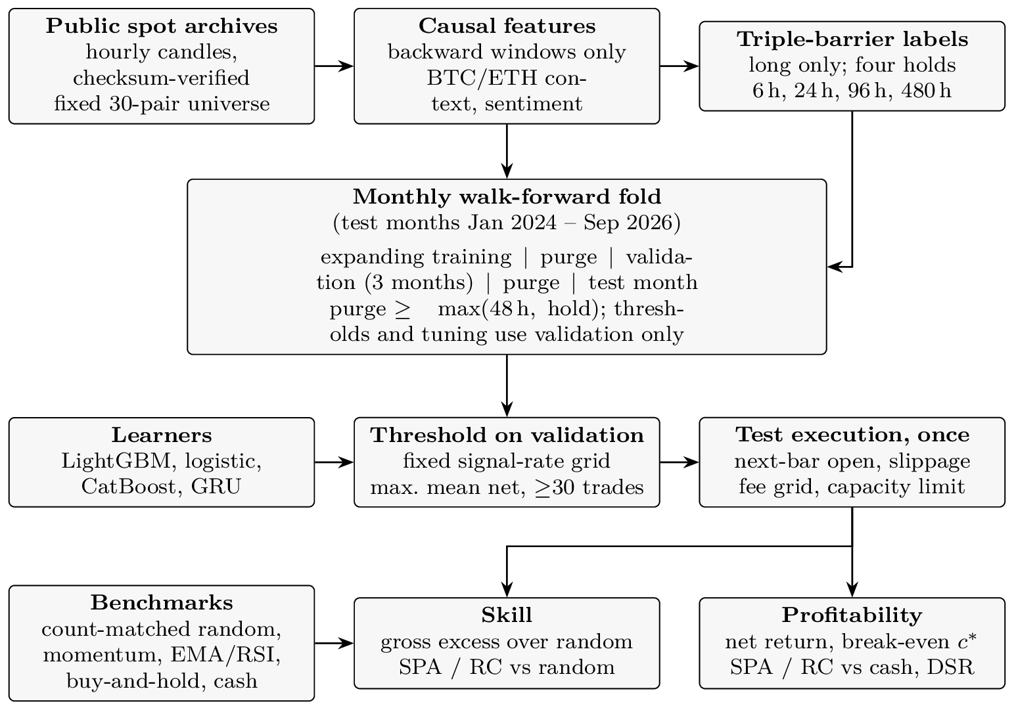
Figure 1. Research design. Features and labels are constructed once; each monthly fold fits the learners on its training window, selects a threshold on its validation window, and executes the test month once. Skill is measured against count-matched random entries and profitability against cash.

4.1. Labels and Holding Periods
Each hourly decision is labeled using a long-only triple barrier. A long position opened at the next bar’s open is labeled WIN if the price touches the take-profit level before the stop-loss level within the maximum holding time; otherwise, including when neither level is touched (a time-out), it is labeled LOSS. The primary setting is +3%/−2%/24 h. Amendment A1 varies the holding period on the same hourly decision grid, scaling the barriers approximately with the square root of the hold: +1.5%/−1%/6 h, +6%/−4%/96 h and +15%/−10%/480 h. Because features, decision times, and data are identical across holds, the comparison isolates the effect of the holding period: a longer hold allows a move to grow while the round-trip cost remains fixed.
Why triple-barrier labels? A label that records whether the take-profit is reached before the stop-loss matches the decision faced by a trader who uses a bracket order, and it makes the label and the execution rule nearly identical (execution adds only slippage, gap fills, and a close-out at the horizon): the same barriers that define WIN and LOSS close the back-tested trades. Labels based on a fixed-horizon return would instead reward a model for predicting moves that a stop-loss would have cut short. The cost of this choice is that the label mixes direction and volatility, because a volatile hour makes both barriers easier to reach. Section 7.3 shows that the models exploit precisely this feature.

4.2. Walk-Forward Design
Test months run from January 2024 to September 2026, yielding 33 folds. For each test month, the models are trained on an expanding window that starts in October 2022, and the threshold (and, for the tuned variants, the hyperparameters) is selected on the three months preceding the test month. A purge separates training from validation and validation from test. Its length is the larger of 48 h and the label horizon, and it removes every row whose label window would cross the boundary; label windows are measured in actual candles so that data gaps are not mistaken for elapsed hours. The protocol text specified 48 h plus the horizon; at the 24 h hold the implemented purge is therefore 48 h rather than 72 h, and a seven-day purge yields the same conclusion (Section 7.4). Each test month is scored once, by a model that has never seen it. A fold whose validation window yields no threshold with at least 30 trades does not trade.

4.3. Learners
All learners receive the same features and labels and are subject to the same threshold rule.
LightGBM. Gradient-boosted decision trees [47] are estimated with a single fixed configuration in the primary runs: 31 leaves, a learning rate of 0.05, at least 50 rows per leaf, up to 2,000 boosting rounds with early stopping on validation log-loss, and class weights balanced through the ratio of negatives to positives. Signals are ranked on the raw booster score, and calibration metrics are computed on these raw scores. The isotonic calibrator fitted inside the training routine does not enter any reported number (Amendment A2).
Logistic regression. The model is L2-regularized, with balanced class weights. Numeric features are median-imputed (infinite ratio values are first set to missing) and standardized on the training rows, and the pair enters as one-hot dummies.
CatBoost (additional). Ordered boosting [28] uses 1,000 iterations of depth 6, a learning rate of 0.05, balanced class weights, the pair as a native categorical feature, and early stopping on the validation window.
GRU (additional). A small gated recurrent network [29] runs over the last 48 hourly feature vectors of a pair, with 16 hidden units and a four-dimensional pair embedding. Training runs for five epochs on at most 50,000 sequences with a class-balanced loss. Sequences never cross a gap in the hourly data, and training, validation, and test rows all follow the same availability rule.
Rule benchmarks. Time-series momentum [23] enters whenever the past 24 h return is positive. The EMA/RSI rule enters when the 50-period EMA is above the 200-period EMA and the 14-period RSI is below 35—a trend-following entry on a short-term dip in the spirit of the moving-average rules of Brock et al. [18]. Both rules use past prices only and are executed exactly like the models.

4.4. Threshold Selection
A model’s score becomes a trade only when it clears a threshold. Thresholds are set as signal rates rather than probabilities, so that every learner faces the same search. Each candidate threshold is the score quantile at which 0.5, 1, 2, 3, 5, 7.5, 10, 15, 20, or 30% of validation rows fire. For each candidate, the validation window is back-tested under the same execution rules as the test month, and the candidate with the highest mean net return per executed trade—at a 10 bps fee and 5 bps slippage, subject to at least 30 executed trades—is selected; ties go to the lower threshold. The ten candidates per fold are the threshold trials counted by the deflated Sharpe ratio. Because signal rates are independent of the score scale, each learner faces at most ten candidate trade sets (fewer in folds where tied scores make neighboring quantiles coincide), and the size of the search is fixed in advance.

4.5. Count-Matched Random Entries
A model that trades in a rising market makes money even without skill, and a model that trades rarely has a noisier mean. The random benchmark removes both effects. In each test month, it draws, without replacement, the same number of entries per pair as the model executed, from all hourly bars of that pair in that month, and executes each entry under the same barriers, slippage and fees. This procedure is repeated 1,000 times. Unlike the model’s trades, the random entries are not subject to the capacity limit; the benchmark therefore measures the mean return per trade rather than an executable portfolio. The model’s excess over the mean of these repeats is its timing skill, net of market drift and of the trade count. Because the random entries pay the same fees, the excess is identical at every fee level, which is why we report it gross. The repeat distribution also yields a percentile for every month, revealing whether any excess is persistent or concentrated in a few months. A second, volatility-matched benchmark draws random entries only from bars in the same ATR% decile mix as the executed entries (Table 3); it yields the same conclusion at every hold.

4.6. Execution and Costs
Signals generated at the close of hour t are executed at the open of hour t + 1. A position in a pair whose data end before its exit is closed at the pair’s last close, and entries whose holding window would extend beyond the end of the sample are skipped as administratively censored. Each trade carries 5 bps of slippage per side and a fee of 0, 2, 5, 7.5, or 10 bps per side. The grid spans zero-fee promotional pairs, high-volume maker and VIP tiers, taker fees discounted by an exchange token, and the standard taker fee. At most ten positions can be open simultaneously, with at most one per pair; signals that arrive while the pair is already open or capacity is full are skipped and counted. These limits apply continuously across months: all months’ signals are replayed in chronological order through a single position book, so a position still open at month-end blocks its pair and occupies a slot in the following month (independent monthly books are retained only as a secondary check). A stop-loss fills at the bar open if the bar gaps through it. If a single hourly bar touches both barriers, the stop-loss is conservatively assumed to be hit first; Section 7 resolves these bars using five-minute data. Each test month’s candle window extends past the month-end by the holding period, so a trade entered near the end of a month reaches its normal exit instead of being closed at the fold boundary.

4.7. Performance Metrics
Prediction. The AUC [48], the Brier score, and the expected calibration error (ECE) are computed on all labeled test rows, not only on traded ones. They are pooled across folds, and the distribution of monthly AUCs is reported alongside.
Skill. Skill is the gross mean return per trade (after slippage, before fees) minus the mean of the count-matched random repeats in the same fold. We also report it on mid-price returns, with slippage removed, as a cost-free version.
Profitability. Profitability is measured by the mean net return per trade, the win rate, the profit factor, and the additive drawdown of unit-stake daily profit and loss (P&L). Because positions overlap, P&L is additive in unit stakes; a compounded, capital-constrained portfolio is reported separately in Section 6.
Break-even fee. For a gross mean return ḡ, the per-side fee c* that sets the mean net return to zero solves
$$\frac{(1 - c^{*})(1 + \overline{g})}{1 + c^{*}} = 1,$$ | (1)
which gives
$$c^{*} = \frac{\overline{g}}{2 + \overline{g}}.$$ | (2)
When ḡ ≤ 0, there is no positive root, and the model is reported as unprofitable at any fee. Confidence intervals are obtained from a stationary day-block bootstrap that keeps trades entered on the same day together.

4.8. Inference and Hypothesis Tests
Daily series. Daily P&L is the sum of the net returns of the trades entered on each UTC day, with zero on days without trades. The daily skill series is the sum, over the day’s trades, of each trade’s gross return minus its fold’s random mean.
Superior predictive ability. For profitability, the SPA test [37] and the Reality Check [8] compare each strategy–fee column with cash (zero), per holding period and pooled across all holds. For skill, they compare each model’s daily skill series with zero, per model and per holding period. The bootstraps use 2,000 replications of the stationary bootstrap [35] with a mean block length of ten days and propagate the sampling uncertainty of the random benchmark. We report the consistent, lower, and upper versions of the SPA p-value; a fixed benchmark and a data-driven block length [36,49] yield the same conclusions.
Deflated Sharpe ratio. We use the estimator of Bailey and López de Prado [39] with an explicit trial count of 440: two models × ten thresholds × five fees × four holds, plus the two rule benchmarks at five fees and four holds. The cross-trial Sharpe-ratio variance, 0.0522, is the variance of the daily Sharpe ratios of all computed strategy–fee–hold columns. Additional analysis variants add their own trials to a separate, larger count.
Survival. The protocol declares a strategy successful only if, at the standard taker cost, its excess over random entries is positive, its SPA p-value is below 0.05, and its deflated Sharpe ratio exceeds 0.95. Table 2 maps each hypothesis to its test.
Table 2. Null hypotheses and the evidence required to reject each. All tests use the walk-forward test months only.
Hypothesis | Null hypothesis | Evidence against the null
H1 | Model scores carry no information about barrier outcomes, and the selected trades are no better than count-matched random entries before fees. | Pooled test AUC above 0.5; gross excess over random with SPA p < 0.05 (per model and per hold).
H2 | At the standard taker fee, no model’s mean net return per trade is positive (break-even fee below 10 bps). | Positive mean net return at 10 bps; break-even fee c* with a bootstrap interval above the fee tier.
H3 | Model class does not matter: no learner improves on the others or on the rule benchmarks after costs. | A learner with a higher net return and skill than the rules and the other learners, robust across holds.
H4 | After the search is accounted for, no strategy beats cash or random entries. | SPA or Reality Check p < 0.05 over the family; deflated Sharpe ratio above 0.95.

4.9. Leakage Controls
Features use bars up to and including the decision bar, and trades enter at the next bar’s open. Splits are chronological, with the purge described above. The test suite checks the main threats directly. It (i) plants a feature that encodes the future label and verifies that the fixed allow-list keeps it out of the model inputs; (ii) perturbs future prices and verifies that the momentum and EMA/RSI signals before the perturbation are unchanged; (iii) verifies that the random benchmark draws exactly the executed per-pair trade count without replacement; (iv) verifies that test-month rows are scored whether or not their labels exist; and (v) verifies that a changed parameter or input file cannot silently resume an earlier run. Replaying the stored test scores through the execution engine reproduces every executed trade in every fold (Section 7).

4.10. Use of Generative Artificial Intelligence
Generative AI assistants were used under the authors’ direction to write and revise the analysis code and to draft and edit the text. One assistant acted as a simulated referee whose report was triaged by the authors. The authors designed the study, fixed the protocol, and reviewed the code, the results, and the text. A script from saved result files generates every reported number.

5. Results
We address the four research questions in turn. Each subsection first reports the evidence and then offers an economic interpretation. Unless otherwise stated, “net” denotes returns after the standard 10 bps per-side fee and 5 bps per-side slippage, and returns are means per trade in percent.

5.1. RQ1: Prediction and Skill
Prediction. Table 3 reports prediction quality on all labeled test rows. The pooled test AUC declines with the holding period, from 0.600 (trees) and 0.606 (logistic) at 6 h to 0.575 and 0.593 at 24 h, 0.544 and 0.565 at 96 h, and 0.522 and 0.521 at 480 h (Figure 2). A day-block bootstrap of the pooled AUC (mean block length of ten days) places every AUC at 6, 24, and 96 h above one-half, whereas at 480 h the share of bootstrap AUCs at or below one-half is 0.193 for the trees and 0.158 for the logistic model. The first part of H1—that the scores carry no information—is therefore rejected at the three shorter holds but not at twenty days. The logistic model is less well calibrated (ECE of 19.8% versus 3.1% at 24 h) because of its balanced class weights; since thresholds are set by rank, this does not affect which trades are taken.
Table 3. Prediction quality and gross skill relative to count-matched random entries, by holding period and model.
Hold | Model | Pooled AUC | Mean monthly AUC | SD (monthly AUC) | Brier | ECE (%) | Val. AUC | Gross excess (%) | Folds ≥ p95 | Vol-matched excess (%) | Vol-matched folds ≥ p95
6 h | LightGBM | 0.6 | 0.601 | 0.0333 | 0.198 | 3.14 | 0.605 | −0.00972 | 5 | 0.0108 | 9
 | Logistic | 0.606 | 0.6 | 0.0301 | 0.243 | 21.7 | 0.605 | −0.0106 | 5 | −0.00447 | 4
24 h | LightGBM | 0.575 | 0.581 | 0.0394 | 0.208 | 3.1 | 0.591 | −0.0515 | 5 | −0.0285 | 4
 | Logistic | 0.593 | 0.587 | 0.0347 | 0.245 | 19.8 | 0.589 | 0.0411 | 8 | 0.0329 | 5
96 h | LightGBM | 0.544 | 0.552 | 0.0445 | 0.216 | 3.55 | 0.578 | 0.246 | 9 | 0.223 | 9
 | Logistic | 0.565 | 0.569 | 0.0398 | 0.245 | 17.6 | 0.559 | 0.0978 | 5 | 0.0719 | 2
480 h | LightGBM | 0.522 | 0.554 | 0.0644 | 0.228 | 7.58 | 0.603 | 0.8 | 8 | 0.0815 | 5
 | Logistic | 0.521 | 0.57 | 0.0699 | 0.251 | 16.6 | 0.527 | 0.997 | 8 | 0.325 | 4
Note: AUC is computed on every labeled scored row, not only on executed trades. Validation windows overlap across folds. Gross excess is measured relative to the count-matched random benchmark and to the ATR-decile-matched (volatility-matched) random benchmark; “Folds ≥ p95” counts the test months (out of 33) in which the model’s mean gross return is at or above the 95th percentile of its random distribution. ECE = expected calibration error.
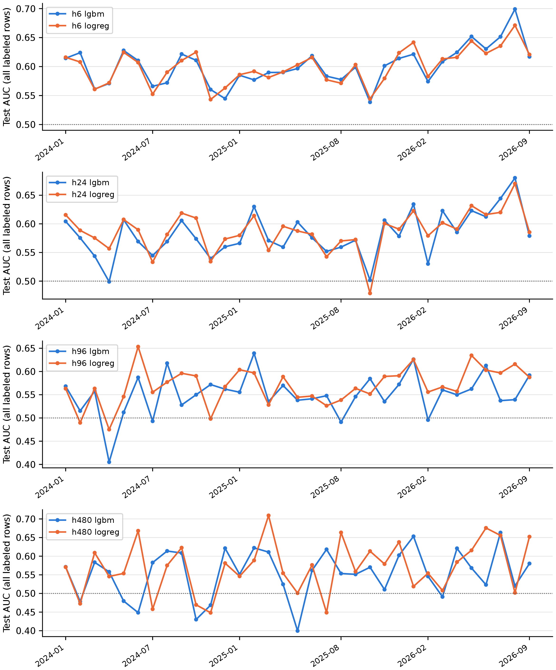
Figure 2. Monthly test AUC on all labeled rows, by holding period and model.
Skill. Ranking ability does not carry over to the selected trades. At 6 h, both models’ trades are slightly worse than random entries with the same per-pair counts (−0.00972% and −0.0106% per trade). At 24 h, the trees underperform random entry (−0.0515%), whereas the logistic model slightly outperforms it (0.0411%, with 8 of 33 folds at or above the 95th percentile of the random distribution). This exceeds the roughly 1.7 such months expected if each month were an independent 5% draw, but weak months offset the strong ones, so pooled skill is not significant. At 96 and 480 h, both models have positive point estimates of up to 0.997% per trade, none of which is significant: the single-model SPA p-values are 1 and 0.192 at 24 h, 0.133 and 0.273 at 96 h, and 0.138 and 0.0965 at 480 h. Treating the two models as one family, the SPA p-values are 1, 0.329, 0.254, and 0.178 for the four holds. The mid-price version of the excess, with slippage removed, is practically identical (e.g., 0.0411% for the logistic model at 24 h), because model and random trades pay the same slippage. Figure 3 shows the fold-by-fold percentiles: months above the 95th percentile are scattered rather than persistent. The second part of H1—that the selected trades are no better than random—is therefore not rejected for either primary model at any hold.
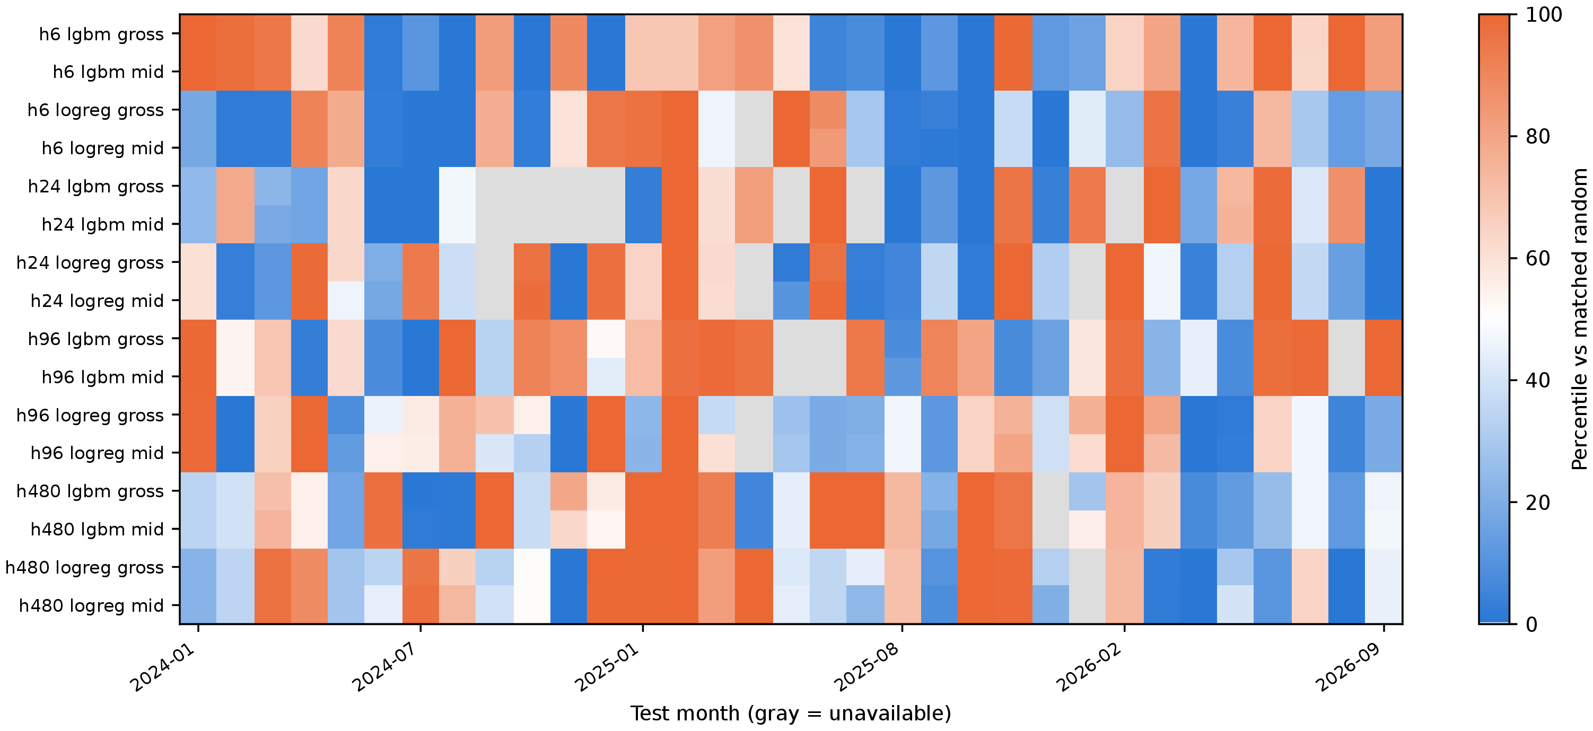
Figure 3. Percentile of each model’s monthly gross mean return within its 1,000 count-matched random repeats (gross and mid-price returns).
Economic interpretation. The AUC rewards ranking across the entire score distribution, whereas a strategy uses only the top of that distribution—precisely where the models concentrate on volatile hours in which both barriers become reachable. The positive point estimates at long holds mainly reflect a heavily losing random benchmark (−1.17% per trade at 480 h for the trees’ pairs and months). With roughly one thousand overlapping trades, they lie within sampling error.

5.2. RQ2: Fees and the Break-Even Cost
Figure 4 and Table A1 (Appendix A) show the mean net return per trade along the fee grid. Even at a zero fee, slippage alone leaves every model with a negative mean at 6, 24, and 96 h; at 24 h, the gross means (after slippage, before fees) are −0.251% and −0.204%. At the standard 10 bps fee, the 24 h means fall to −0.451% and −0.403%, with win rates of 36.4% and 36.9%, profit factors of 0.680 and 0.713, and only 4 and 3 positive months out of 33, respectively. The 6 h hold, with the narrowest barriers, generates the most trades (34,020 and 62,285) and loses 0.346% and 0.359% per trade.
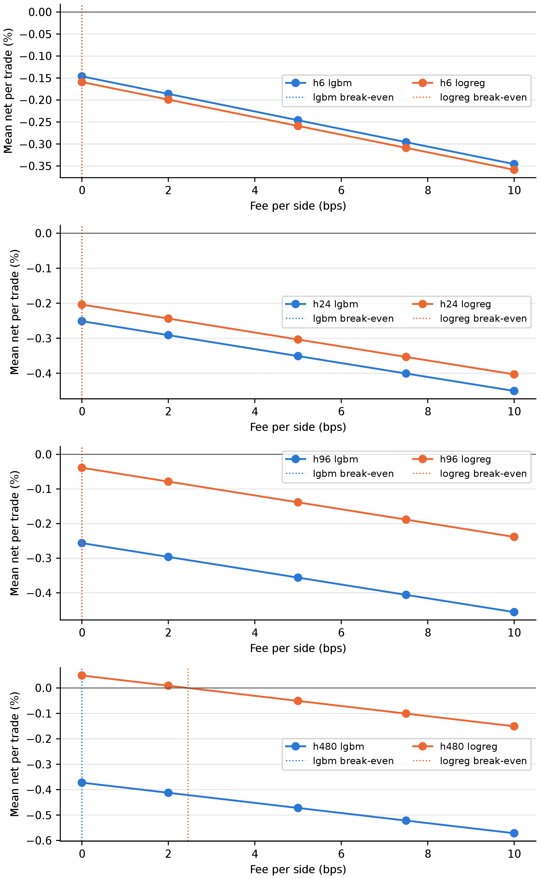
Figure 4. Mean net return per trade against the per-side fee, by holding period and model.
The fee grid maps onto actual tiers: zero (promotional pairs), 2 bps (high-volume maker), 5 bps, 7.5 bps (taker with an exchange-token discount) and 10 bps (standard taker). Moving down the tiers improves every strategy by the same amount per trade, but no tier turns a negative gross mean into a profit.
Table 4 reports the break-even fee. Because the gross mean is negative, the break-even fee is zero for every model except the logistic model at 480 h, whose gross mean is 0.0491%. Its break-even fee is c* = 0.0246% per side, with a day-block bootstrap interval from 0% to 0.649%. This is about 2.5 bps per side—a quarter of the standard taker fee and below every paid tier except the cheapest maker rates—and the interval, which starts at zero, is too wide to be informative. The rule benchmarks behave in the same way: momentum and the EMA/RSI rule have negative gross means and a zero break-even fee at every hold, with net means at 24 h of −0.380% and −0.454%. Equal-weight buy-and-hold has a positive gross mean over the period at every hold, so its break-even fee is positive. It is, however, a descriptive benchmark that makes no timing decision and holds each pair for the whole month; it remains profitable after a 10 bps fee, whereas a random long entry in the same pairs loses money on average. H2 is not rejected for any model or rule at any hold.
Table 4. Break-even per-side fee c* (with day-block bootstrap interval), daily Sharpe ratio, and probabilistic and deflated Sharpe ratios at 10 bps.
Hold | Strategy | c* (bps/side) | CI low | CI high | Daily SR | PSR | DSR | Status
6 h | LightGBM | 0 | 0 | 0 | −0.53 | 3.76×10⁻¹⁴¹ | 0 | Not profitable
 | Logistic | 0 | 0 | 0 | −0.784 | 5.38×10⁻²⁰⁷ | 0 | Not profitable
 | Buy-and-hold | 42.2 | 0 | 399 | 0.00535 | 0.569 | – | Positive c*
 | EMA/RSI | 0 | 0 | 0 | −0.327 | 6.22×10⁻⁶⁸ | 0 | Not profitable
 | Momentum | 0 | 0 | 0 | −1.04 | 1.41×10⁻¹⁶⁵ | 0 | Not profitable
24 h | LightGBM | 0 | 0 | 0 | −0.221 | 1.67×10⁻¹⁹ | 7.48×10⁻²⁹⁷ | Not profitable
 | Logistic | 0 | 0 | 0 | −0.237 | 3.31×10⁻²⁵ | 0 | Not profitable
 | Buy-and-hold | 42.2 | 0 | 410 | 0.00535 | 0.569 | – | Positive c*
 | EMA/RSI | 0 | 0 | 0 | −0.184 | 2.87×10⁻¹⁴ | 2.66×10⁻²⁷⁸ | Not profitable
 | Momentum | 0 | 0 | 0 | −0.354 | 5.00×10⁻²⁷ | 2.06×10⁻²¹⁸ | Not profitable
96 h | LightGBM | 0 | 0 | 9.03 | −0.068 | 0.0119 | 4.44×10⁻¹⁴⁰ | Not profitable
 | Logistic | 0 | 0 | 11.5 | −0.0545 | 0.0344 | 5.50×10⁻¹³⁶ | Not profitable
 | Buy-and-hold | 42.2 | 0 | 428 | 0.00535 | 0.569 | – | Positive c*
 | EMA/RSI | 0 | 0 | 1.67 | −0.0933 | 0.000759 | 9.14×10⁻¹⁵⁶ | Not profitable
 | Momentum | 0 | 0 | 0 | −0.135 | 1.51×10⁻⁵ | 7.62×10⁻¹⁴⁴ | Not profitable
480 h | LightGBM | 0 | 0 | 43.6 | −0.0308 | 0.165 | 8.67×10⁻¹¹⁵ | Not profitable
 | Logistic | 2.46 | 0 | 64.9 | −0.00838 | 0.395 | 3.48×10⁻¹⁰⁸ | Positive c*
 | Buy-and-hold | 42.2 | 0 | 418 | 0.00535 | 0.569 | – | Positive c*
 | EMA/RSI | 0 | 0 | 26.5 | −0.0587 | 0.0342 | 3.81×10⁻¹¹⁹ | Not profitable
 | Momentum | 0 | 0 | 39.7 | −0.0306 | 0.17 | 8.32×10⁻¹¹² | Not profitable
Note: Break-even fees measure absolute profitability after slippage. The DSR uses the protocol estimator with the declared number of trials and the computed variance of daily Sharpe ratios. The count-matched and volatility-matched random benchmarks have negative gross means and therefore c* = 0 at every hold; no day-block interval is computed for them, and they are omitted. CI = confidence interval; SR = Sharpe ratio; PSR = probabilistic Sharpe ratio; DSR = deflated Sharpe ratio.
Figure 5 shows the cumulative unit-stake P&L of each model against the random-entry band.
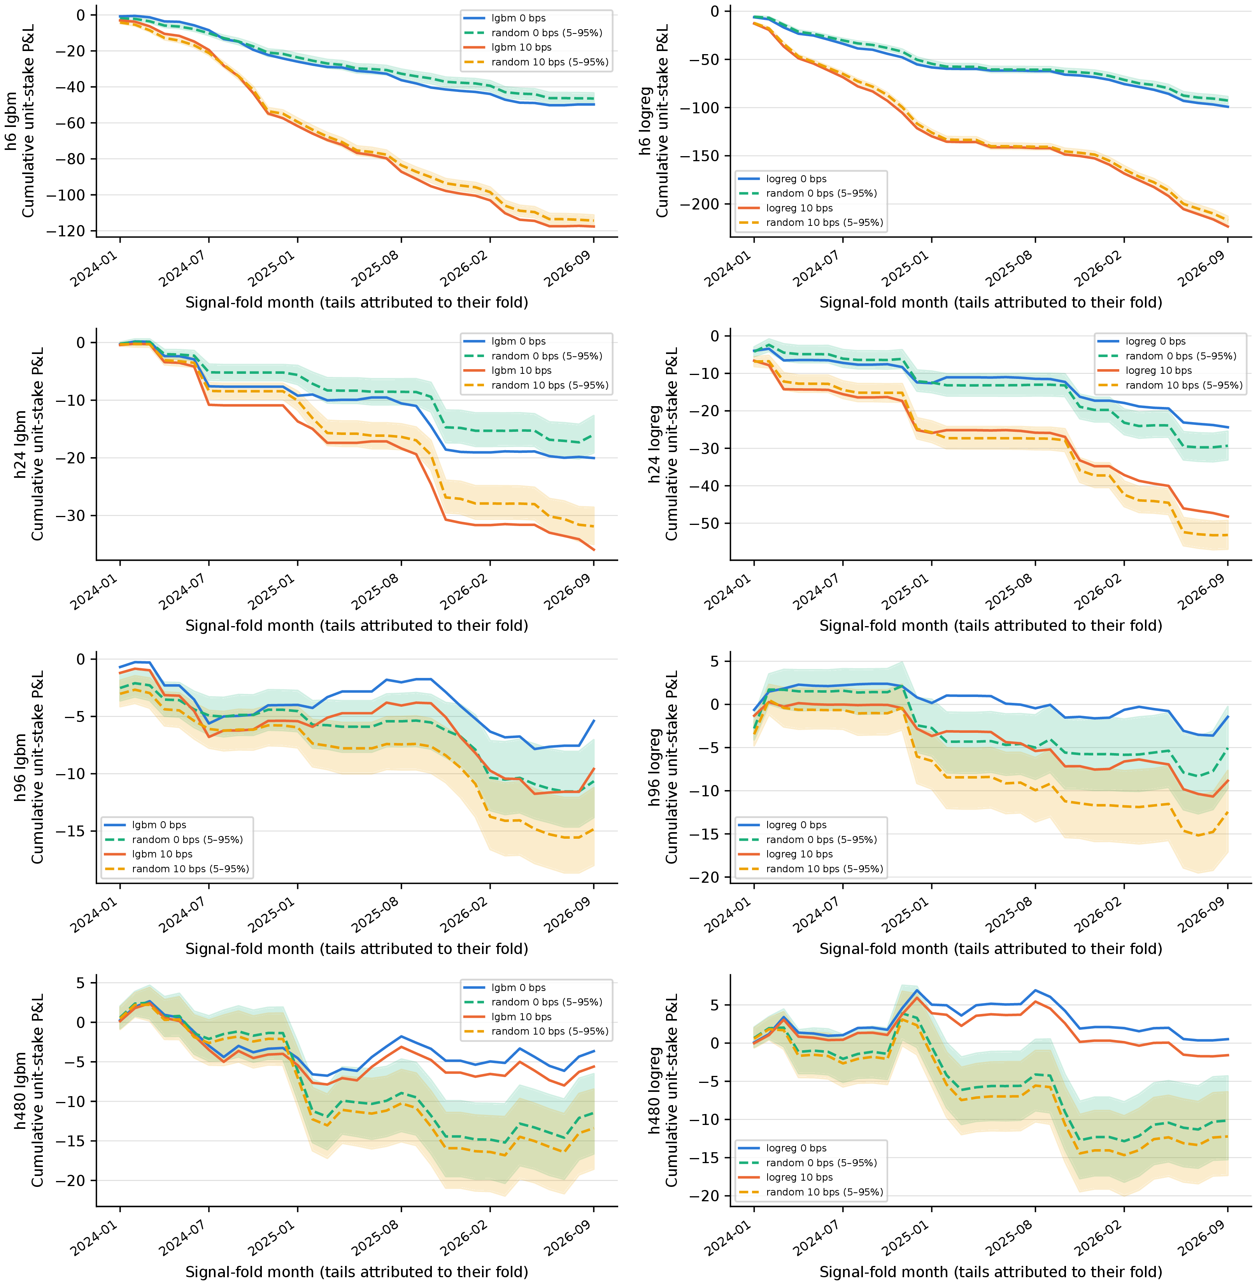
Figure 5. Cumulative unit-stake P&L of each model by fold, at zero and 10 bps fees, against the 5th, 50th and 95th percentiles of the random-entry paths.
Economic interpretation. At the primary hold, a round trip at the standard taker tier costs 30 bps. Because the models’ gross means are negative before any fee, the binding constraint is not the fee level but the absence of a positive gross edge. A trader who moves to a lower fee tier loses less per trade but still loses, with one exception: the logistic model at 480 h is marginally positive at the zero and 2 bps tiers, which is not significant against cash.

5.3. RQ3: Model Class
Primary models and rules. The holding period matters more than the model class. The trees and the logistic regression have similar AUCs and net losses (Tables 3 and 4); the logistic model loses less at 24, 96, and 480 h, and the trees lose less at 6 h. At 24 h, momentum trades 23,101 times and loses 0.380% per trade—slightly less than either primary model—while the EMA/RSI rule (4,911 trades; −0.454%) loses about as much as the trees. At 96 and 480 h, the logistic model loses less than momentum. No model or rule turns a net loss into a profit.
More flexible learners (additional). Three further learners were run on the 24 h protocol as additional analyses (Section 7.4, Table 9). A random search over 30 LightGBM configurations, selected on validation data only, does not produce positive skill: its gross excess over random entries is −0.00786%, and its net mean is −0.409%. CatBoost and the GRU behave differently: both select trades that outperform count-matched random entries, with a gross excess of 0.208% per trade for CatBoost (single-model SPA p = 0.023) and 0.121% for the GRU (p = 0.0415). These are the largest—and the only nominally significant—skill estimates at the primary hold, but they do not make the strategies profitable. The gross means remain negative (−0.0411% and −0.119%), the net means are −0.241% and −0.318%, and both cash SPA p-values equal 1. Moreover, the single-model p-values do not account for the number of learners tried. When pooled into one family with the two primary models and every other 24 h variant and learner (11 daily skill series), the SPA p-value is 0.179, and the Reality Check p-value is 0.259.
Economic interpretation. More flexible learners can select somewhat better entries than random ones, but the improvement is a fraction of the round-trip cost, and the selected trades still lose money before fees. H3 is not rejected in its economic form: no learner improves on the others or on the rules by enough to change the sign of the net return. In its statistical form, the evidence is weak: CatBoost and the GRU are each nominally significant on their own, but the family test over all learners is far from the 5% level, so their timing skill is suggestive rather than established.

5.4. RQ4: Data-Snooping-Robust Inference
Table 5 reports the SPA and Reality Check p-values. Against cash, each per-hold family contains 20 columns (the two models and the two rules at five fees). Its SPA p-value is 1 at 6, 24, and 96 h, where every column has a negative mean daily P&L. At 480 h, the logistic model at zero fee has a mean daily P&L of 5.13 × 10⁻⁴, close to zero, and the family p-value is 0.745. Pooled over all 80 columns, the SPA p-values are 0.914 (consistent), 0.732 (lower), and 0.989 (upper), and the Reality Check p-value is 0.989.
Table 5. SPA (consistent, lower and upper recentering) and Reality Check p-values. “Cash”: strategy–fee columns tested against zero; “Random”: daily skill tested against count-matched random entries.
Hold | Benchmark family | Candidates | SPA (consistent) | SPA (lower) | SPA (upper) | RC
6 h | Cash | 20 | 1 | 1 | 1 | 1
 | Random (gross) | 2 | 1 | 1 | 1 | 1
 | Random (mid-price) | 2 | 1 | 1 | 1 | 1
 | Vol-matched random (gross) | 2 | 0.33 | 0.261 | 0.33 | 0.377
 | Vol-matched random (mid-price) | 2 | 0.33 | 0.261 | 0.33 | 0.377
24 h | Cash | 20 | 1 | 1 | 1 | 1
 | Random (gross) | 2 | 0.329 | 0.221 | 0.329 | 0.285
 | Random (mid-price) | 2 | 0.329 | 0.221 | 0.329 | 0.285
 | Vol-matched random (gross) | 2 | 0.364 | 0.275 | 0.364 | 0.338
 | Vol-matched random (mid-price) | 2 | 0.364 | 0.275 | 0.364 | 0.338
96 h | Cash | 20 | 1 | 1 | 1 | 1
 | Random (gross) | 2 | 0.254 | 0.254 | 0.254 | 0.301
 | Random (mid-price) | 2 | 0.254 | 0.254 | 0.254 | 0.301
 | Vol-matched random (gross) | 2 | 0.278 | 0.278 | 0.278 | 0.303
 | Vol-matched random (mid-price) | 2 | 0.278 | 0.278 | 0.278 | 0.303
480 h | Cash | 20 | 0.745 | 0.598 | 0.745 | 0.747
 | Random (gross) | 2 | 0.178 | 0.178 | 0.178 | 0.162
 | Random (mid-price) | 2 | 0.178 | 0.178 | 0.178 | 0.162
 | Vol-matched random (gross) | 2 | 0.485 | 0.485 | 0.485 | 0.487
 | Vol-matched random (mid-price) | 2 | 0.485 | 0.485 | 0.485 | 0.487
All holds | Cash | 80 | 0.914 | 0.732 | 0.989 | 0.989
Note: Each test uses 1,004 daily observations. Cash tests use the daily P&L of the validation-selected threshold strategies; random tests use the daily summed excess return on entry dates. The full family of unselected thresholds is unavailable (Section 8.5). RC = Reality Check.
The deflated Sharpe ratio corroborates this result. Every daily Sharpe ratio of the models and rule benchmarks at 10 bps is negative (only buy-and-hold is positive, at 0.00535)—for example, −0.221 and −0.237 at 24 h (annualized −4.23 and −4.54). With 440 trials, the largest deflated Sharpe ratio among the primary models is 3.48 × 10⁻¹⁰⁸. When the additional variants are also counted (2,340 trials), no variant’s deflated Sharpe ratio exceeds zero after rounding. H4 is therefore not rejected: no strategy beats cash, and no learner beats random entries at the 5% level once the family of learners is accounted for.
Survival. No strategy jointly satisfies the protocol’s three survival criteria at the standard taker cost. The closest candidates fail in different ways: the long-hold models have positive but insignificant skill; CatBoost and the GRU have nominally significant skill but negative returns before fees; and every deflated Sharpe ratio is close to zero.

5.5. Summary of the Hypothesis Tests
Table 6 collects the verdicts. The pattern is consistent across holds: the scores are informative up to four days (the first part of H1 is rejected there, but not at twenty days), yet this information does not translate into selection skill, profit, or a strategy that survives the search (the second part of H1, H2, H3, and H4 are not rejected). The closest approaches to a positive finding are the long-hold primary models, whose point estimates of skill are positive but insignificant, and the additional CatBoost and GRU learners, whose skill is nominally significant individually but not as a family, and whose trades lose money before fees.
Table 6. Verdicts on the four null hypotheses (Section 1.1) at the standard taker cost.
Hypothesis | Verdict | Main evidence
H1a | Rejected (6–96 h) | Pooled test AUC between 0.544 and 0.606 (6–96 h); day-block bootstrap: above one half up to 96 h, not at 480 h.
H1b | Not rejected | Two-model skill SPA p of 1 (6 h) to 0.178 (480 h); pooled 24 h learner family p = 0.179.
H2 | Not rejected | Negative mean net return at 10 bps for every model and rule at every hold; largest model break-even fee 0.0246% per side.
H3 | Not rejected | Learners and rules all lose after costs; flexible learners improve skill but not the sign of the gross return.
H4 | Not rejected | Pooled cash SPA p = 0.914 over 80 columns; deflated Sharpe ratios near zero.
Note: H1a and H1b denote the first (information) and second (selection skill) parts of H1.

6. Economic Significance: An Investable Portfolio
Because the per-trade results use unit stakes and overlapping positions, we also simulate a compounded, capital-constrained portfolio (additional analysis). Each new position receives 1/N of current equity, with at most N ∈ {5, 10, 20} open positions, the remainder held in cash, hourly marking-to-market, and no borrowing; the signals and exits are the same as before. Every configuration loses capital (Table 7). At 24 h with N = 10 and a 10 bps fee, the compound annual growth rate (CAGR) is −74.1% for the trees and −83.7% for the logistic model, with maximum drawdowns of 97.7% and 99.3%. The smallest zero-fee loss—the logistic model at 96 h with N = 20—is −1.92% per year, and the same portfolio loses 18.0% per year at 10 bps. At 10 bps, the smallest loss is −10.2% per year (the logistic model at 480 h with N = 20).
Table 7. Additional analysis: compounded, capital-constrained portfolio (equity/N per position, cash otherwise) by holding period, model, N, and fee.
Hold | Model | N | Fee (bps/side) | CAGR (%) | Annualized SR | MDD (%) | DSR
6 h | LightGBM | 5 | 0 | −91.5 | −5.86 | 99.9 | 0
 |  |  | 10 | −99.7 | −11.3 | 100 | 0
 |  | 10 | 0 | −84.3 | −5.4 | 99.5 | 0
 |  |  | 10 | −98.7 | −10.2 | 100 | 0
 |  | 20 | 0 | −71.3 | −4.85 | 97 | 0
 |  |  | 10 | −94.7 | −8.89 | 100 | 0
 | Logistic | 5 | 0 | −99.1 | −9.15 | 100 | 0
 |  |  | 10 | −100 | −16.5 | 100 | 0
 |  | 10 | 0 | −97.5 | −8.46 | 100 | 0
 |  |  | 10 | −100 | −15.1 | 100 | 0
 |  | 20 | 0 | −91.9 | −7.5 | 99.9 | 0
 |  |  | 10 | −99.7 | −13 | 100 | 0
24 h | LightGBM | 5 | 0 | −60.9 | −2.48 | 94 | 1.40×10⁻²⁰⁵
 |  |  | 10 | −81.1 | −4.24 | 99.1 | 0
 |  | 10 | 0 | −53.7 | −2.52 | 89.6 | 3.69×10⁻²¹³
 |  |  | 10 | −74.1 | −4.17 | 97.7 | 0
 |  | 20 | 0 | −39 | −2.07 | 76.7 | 6.01×10⁻¹⁸⁸
 |  |  | 10 | −59.7 | −3.6 | 92.1 | 5.16×10⁻²⁹⁷
 | Logistic | 5 | 0 | −73 | −2.94 | 97.4 | 1.29×10⁻²⁴³
 |  |  | 10 | −91.2 | −5.16 | 99.9 | 0
 |  | 10 | 0 | −61.2 | −2.49 | 92.9 | 1.95×10⁻²³¹
 |  |  | 10 | −83.7 | −4.54 | 99.3 | 0
 |  | 20 | 0 | −41.4 | −1.84 | 77.8 | 2.38×10⁻²⁰²
 |  |  | 10 | −68.3 | −3.81 | 95.9 | 0
96 h | LightGBM | 5 | 0 | −23.9 | −0.587 | 66.2 | 2.07×10⁻¹⁴⁶
 |  |  | 10 | −37.5 | −1.13 | 79.6 | 2.38×10⁻¹⁶⁰
 |  | 10 | 0 | −21 | −0.667 | 60 | 1.75×10⁻¹⁴⁹
 |  |  | 10 | −32.2 | −1.18 | 73 | 9.67×10⁻¹⁶⁵
 |  | 20 | 0 | −19.7 | −0.999 | 52.4 | 1.72×10⁻¹⁶³
 |  |  | 10 | −27.4 | −1.47 | 63.3 | 9.43×10⁻¹⁸⁵
 | Logistic | 5 | 0 | −20.4 | −0.279 | 75 | 7.04×10⁻¹⁴¹
 |  |  | 10 | −44.2 | −1.05 | 86.6 | 6.82×10⁻¹⁶³
 |  | 10 | 0 | −11.7 | −0.159 | 58.9 | 4.47×10⁻¹³⁸
 |  |  | 10 | −32.5 | −0.887 | 75.2 | 4.58×10⁻¹⁵⁹
 |  | 20 | 0 | −1.92 | 0.0567 | 41.8 | 4.47×10⁻¹³³
 |  |  | 10 | −18 | −0.626 | 55.5 | 1.73×10⁻¹⁵⁰
480 h | LightGBM | 5 | 0 | −29.7 | −0.332 | 80.3 | 3.35×10⁻¹⁴⁰
 |  |  | 10 | −35.1 | −0.468 | 83.5 | 8.04×10⁻¹⁴³
 |  | 10 | 0 | −23.4 | −0.272 | 72 | 7.25×10⁻¹³⁹
 |  |  | 10 | −28.6 | −0.409 | 75.1 | 2.41×10⁻¹⁴¹
 |  | 20 | 0 | −17.8 | −0.321 | 62.6 | 9.43×10⁻¹⁴⁰
 |  |  | 10 | −21.9 | −0.454 | 65 | 3.54×10⁻¹⁴²
 | Logistic | 5 | 0 | −3.57 | 0.24 | 70.3 | 4.61×10⁻¹²⁹
 |  |  | 10 | −12.7 | 0.075 | 74.2 | 1.35×10⁻¹³²
 |  | 10 | 0 | −11.6 | −0.00393 | 63.5 | 2.32×10⁻¹³⁴
 |  |  | 10 | −18.1 | −0.156 | 67.1 | 7.19×10⁻¹³⁸
 |  | 20 | 0 | −5.63 | 0.00721 | 46.8 | 3.89×10⁻¹³⁴
 |  |  | 10 | −10.2 | −0.134 | 50.8 | 6.31×10⁻¹³⁷
Note: Cash-funded, compounded mark-to-market net asset value with an equity/N stake and no borrowing. CAGR = compound annual growth rate; SR = Sharpe ratio; MDD = maximum drawdown; DSR = deflated Sharpe ratio.
A regression of daily P&L on daily BTC returns (Table 8), with Newey–West standard errors [50], reveals long market exposure combined with negative intercepts. At 24 h, the trees’ BTC beta is 2.04 with a daily alpha of −0.038 (p = 3.91 × 10⁻⁸), and the logistic model’s beta and alpha are 2.96 and −0.0512, respectively (in unit-stake P&L units). Entering during volatile hours brings market exposure, and what remains after removing that exposure is negative.
Table 8. Additional analysis: regression of daily unit-stake P&L on daily BTC returns with Newey–West (10 lags) standard errors.
Hold | Model | Daily alpha | BTC beta | Alpha p-value | Beta p-value | Days
6 h | LightGBM | −0.122 | 3.64 | 3.34×10⁻²⁷ | 6.52×10⁻²³ | 998
 | Logistic | −0.229 | 4.65 | 2.70×10⁻³⁷ | 2.02×10⁻¹⁵ | 998
24 h | LightGBM | −0.038 | 2.04 | 3.91×10⁻⁸ | 2.44×10⁻⁶ | 998
 | Logistic | −0.0512 | 2.96 | 2.80×10⁻⁸ | 2.04×10⁻⁶ | 998
96 h | LightGBM | −0.0113 | 1.63 | 0.0359 | 0.00293 | 998
 | Logistic | −0.0104 | 1.91 | 0.0552 | 4.91×10⁻⁷ | 998
480 h | LightGBM | −0.00656 | 0.812 | 0.377 | 0.0166 | 998
 | Logistic | −0.00268 | 0.658 | 0.696 | 0.133 | 998
Note: The dependent variable is unit-stake P&L, not a capital-normalized return.

7. Robustness
This section has two parts. The subsample analyses in Section 7.1 were specified in the protocol, whereas Sections 7.2–7.4 report analyses that go beyond it; the latter are labeled additional and do not replace the pre-specified primary results.

7.1. Subsamples (Protocol)
Table A2 (Appendix A) splits the trades by BTC regime, defined as terciles of the trailing 30-day BTC return over the study period (a descriptive split, not a model input), by liquidity tercile of the October 2022 ranking, and by whether the three delisted pairs are excluded. At 24 h, every regime, liquidity, and delisting subsample has a negative mean net return; only a few individual pairs, each with few trades, are positive. The negative result is therefore driven neither by a single market phase nor by the least liquid pairs or delistings.

7.2. Execution, Capacity and Ambiguous Bars (Additional)
Execution and capacity. At 480 h, the two models executed similar numbers of trades (980 for the trees and 1,049 for the logistic model), and both saturated capacity. For the trees, 73,334 signals were rejected because the pair was already open and 31,201 because ten positions were open; for the logistic model, the corresponding counts—taken from the independent monthly books, which the continuous book follows closely—were 32,374 and 11,968 (Table A3, Appendix A). With a saturated book, the signals are executed depending on their arrival order—a further reason why long-hold results are noisy.
Ambiguous bars. At 24 h, 93 of the trees’ 7,974 trades in the independent monthly books exit on an hourly bar that touches both barriers. Five-minute data, which cover only part of the universe, resolve some of these bars, while the remainder (85) stay unresolved. The resolution changes two outcomes and moves the mean net return from −0.450% to −0.449%. At 6 h, where the barriers are closest, 3,384 of the logistic model’s trades are ambiguous and 190 change. The conservative stop-loss-first rule therefore does not drive the result.
Volatility-scaled slippage. Replacing the fixed 5 bps slippage with k × ATR%, where k is calibrated on validation data so that median slippage is 5 bps, yields mean net returns at 24 h of −0.533% for the trees and −0.563% for the logistic model at 10 bps. Doubling k gives −0.720% and −0.835%. Because signals cluster in volatile hours, slippage that scales with volatility costs the models more than the fixed assumption does.

7.3. Calibration, Ranking and Attributions (Additional)
Reliability diagrams (Figure 6) show that the trees’ scores fall within a narrow probability range, where they are approximately calibrated, whereas the logistic model’s probabilities exceed observed frequencies over most of their range, as its class weighting implies. Averaged over months, the cross-sectional rank correlation between scores and the barrier outcome at each hour is 0.153 for the trees and 0.162 for the logistic model at 24 h, and it is positive in all 33 months for both models. This is a correlation with the binary outcome (take-profit first), not with the return, and it restates the AUC result in cross-sectional form: at a given hour, the models rank which pairs are likely to reach take-profit, and that ranking is largely a ranking by volatility.
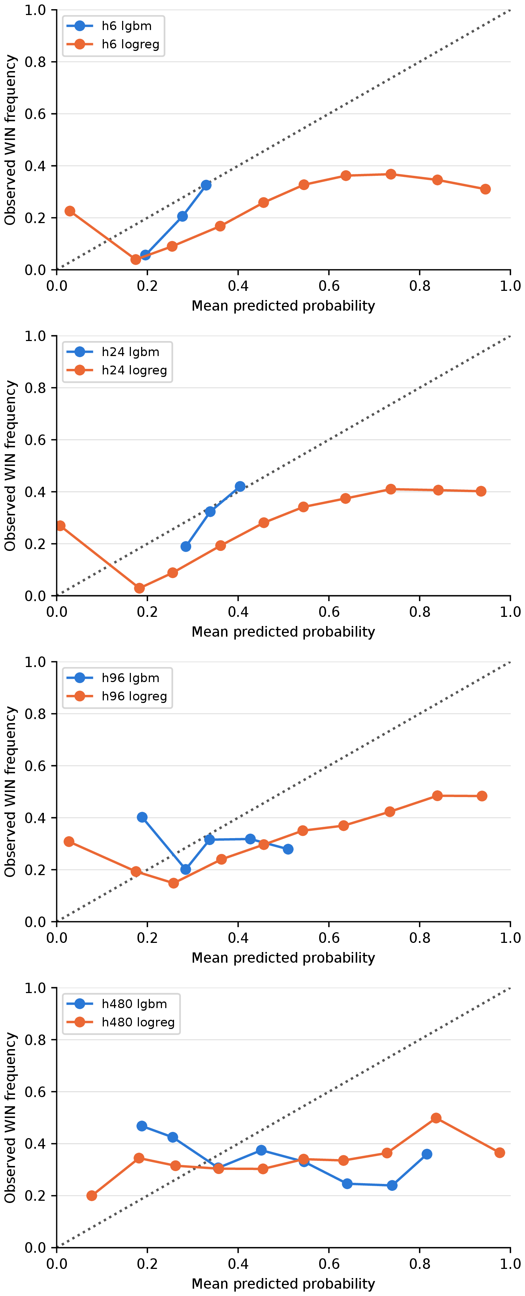
Figure 6. Additional analysis: reliability diagrams of test predictions, by holding period and model.
Tree attributions based on SHapley Additive exPlanations (SHAP) [31] for the 24 h model are led by volatility (ATR%), the distance from the seven-day low and the Fear & Greed Index (Figure 7; Table A4, Appendix A). The models thus mostly learn when large moves are likely. This helps a classifier of barrier outcomes but not a long-only trader who pays a round-trip fee.
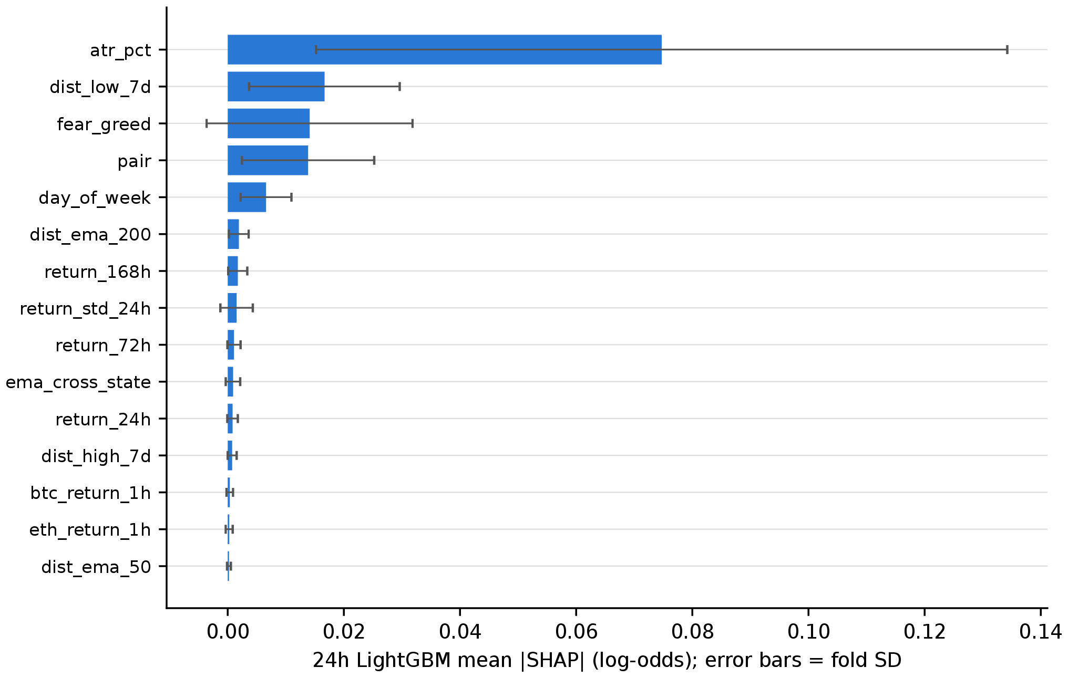
Figure 7. Mean absolute SHAP value of the 24 h LightGBM model across folds (error bars: standard deviation across folds). Attributions are computed from boosters re-fitted on the same folds because the original boosters were not saved.

7.4. Alternative Designs and Learners (Additional)
Table 9 reports complete re-runs of the 24 h walk-forward under alternative designs and learners. With symmetric barriers (±2.5%), the mean net returns are −0.428% for the trees and −0.389% for the logistic regression. A seven-day purge yields −0.410% and −0.383%. Because the autocorrelations of level-type features decay slowly (Table A5, Appendix A), the purge length was varied explicitly; the result does not depend on it. The tuned trees, CatBoost and the GRU, are discussed under RQ3 (Section 5.3). Every variant’s cash SPA p-value is 1, and, counting all 2,340 trials, no variant’s deflated Sharpe ratio exceeds zero after rounding.
The point-in-time rolling universe re-ranks, at the start of each month, all archived USDT pairs by their quote volume over the previous 30 days (requiring at least 25 daily bars) and trades the top 30. Selection for a month uses only data from before that month, so a coin’s own activity during the month cannot determine whether it is traded. Coins that became liquid after October 2022 can therefore enter the universe, and coins that faded leave it. The result is unchanged: the trees trade 8,281 times in 92 pairs and the logistic model 16,881 times in 132 pairs, with mean gross returns of −0.185% for both and mean net returns at 10 bps of −0.384% and −0.385%, close to the fixed-universe values of −0.451% and −0.403%. The excess over count-matched random entries is −0.00704% and 0.00939% per trade (skill SPA p = 1 and 0.381), and both cash SPA p-values equal 1. A survivorship-free, point-in-time universe thus leaves the negative result intact; the fixed universe is not what makes the strategies lose.
Table 9. Additional analysis: walk-forward variants at the 24 h hold.
Variant | Model | Trades | AUC | Gross (%) | Net10 (%) | Excess (%) | Skill SPA p | Cash SPA p | DSR
Alternative learner | CatBoost | 4,000 | 0.595 | −0.0411 | −0.241 | 0.208 | 0.023 | 1 | 5.47×10⁻¹⁶³
 | GRU | 7,830 | 0.59 | −0.119 | −0.318 | 0.121 | 0.0415 | 1 | 2.40×10⁻²⁰⁹
Tuned trees | LightGBM (30-config. search) | 3,161 | 0.574 | −0.21 | −0.409 | −0.00786 | 1 | 1 | 4.99×10⁻²⁵⁰
Seven-day purge | LightGBM | 8,759 | 0.575 | −0.21 | −0.41 | −0.0138 | 1 | 1 | 1.70×10⁻²³⁷
 | Logistic | 13,490 | 0.593 | −0.184 | −0.383 | 0.0425 | 0.179 | 1 | 1.84×10⁻³⁰³
Rolling universe | LightGBM | 8,281 | 0.587 | −0.185 | −0.384 | −0.00704 | 1 | 1 | 8.73×10⁻²²¹
 | Logistic | 16,881 | 0.598 | −0.185 | −0.385 | 0.00939 | 0.381 | 1 | 0
Symmetric barriers (±2.5%) | LightGBM | 7,324 | 0.589 | −0.229 | −0.428 | 0.0107 | 0.437 | 1 | 7.23×10⁻²⁵¹
 | Logistic | 16,275 | 0.595 | −0.19 | −0.389 | −0.0197 | 1 | 1 | 0
Note: Skill SPA p-values are per model. Overall, for 11 complete 24 h learners (primary and variants), the skill family has an SPA p-value of 0.179 (Reality Check: 0.259). Net10 = mean net return per trade at a 10 bps fee; Excess = gross excess over count-matched random entries; Rolling universe = point-in-time universe re-ranked monthly on trailing volume; DSR = deflated Sharpe ratio.

8. Discussion

8.1. What the Models Learn and Why It Does Not Pay
The models detect genuine structure—monthly AUCs exceed one-half in most months at every hold—but three gaps separate this structure from profit. First, ranking is not selection. A threshold strategy trades only the top of the score distribution, which the attributions suggest is dominated by volatile hours (ATR% leads the attribution ranking). The models therefore learn mainly when a large move is likely rather than its direction, and a long-only trader is exposed to the downside as much as to the upside. Second, the edge is smaller than the cost. A standard round trip costs 30 bps, while the gross mean is negative for most model–hold pairs, and a cheaper fee tier shifts every net return equally without turning a negative gross mean into a profit. Third, the positive point estimates, mainly at long holds, are indistinguishable from chance once the search is counted.

8.2. Longer Holds and Model Class
Costs are paid once per round trip, whereas price moves grow with the hold, so longer holds reduce the cost share (Amendment A1). Net losses shrink relative to the barrier widths, and the gross excess over random entries turns positive. Long holds, however, produce fewer and overlapping trades and saturate position capacity, and none of the resulting excesses survives the search. Across learners trained on identical inputs, greater model capacity buys a little timing skill (Section 5.3), but this skill does not survive the family test and amounts to a fraction of the round-trip cost. The binding constraint is the signal-to-cost ratio, not model expressiveness.

8.3. What Would a Profitable Signal Require?
A long-only strategy at the standard tier needs a mean gross return (after slippage) of about 20 bps per round trip—the two 10 bps fees—to break even; relative to mid prices, the all-in cost is 30 bps. That gross mean equals the return of a random entry in the same pairs and months, which is itself negative here (e.g., about −0.2% at 24 h), plus the model’s timing skill. A profitable model would therefore need skill on the order of the round-trip cost plus this drift deficit. Even the largest skill measured at the primary hold—CatBoost’s 0.208% per trade—falls short of the drift deficit of its own random benchmark (about −0.25%), let alone the fees. Cheaper fees leave the deficit untouched, and longer holds lower the cost share but reduce the number of independent trades, so each lever trades one problem for another.

8.4. Relation to Prior Work and Implications
The above-chance intraday accuracy reported for cryptocurrency direction [1,2] is consistent with our AUCs. We add that this accuracy does not concentrate in the trades that a long-only threshold strategy takes, and that it is small relative to costs. This finding matches equity evidence on trading costs [6], fragile anomalies [43,44] and weakening cryptocurrency rule profits [21]. Accuracy should therefore be reported alongside a count-matched random benchmark and a break-even fee, with the search explicitly counted. A signal that does not beat random entries before fees cannot be rescued by a cheaper tier, a longer hold or a more complex model.
These results have practical implications. For retail investors and the trading platforms that serve them, headline accuracy figures for ML trading tools are not evidence of after-cost value, and access to a lower fee tier cannot compensate for the absence of a gross edge. For researchers, editors and reviewers, the design used here—separating skill from profitability, reporting the break-even fee and counting the search—offers a practical checklist for evaluating claims that a predictive signal is a profitable one. For regulators concerned with the promotion of algorithmic trading products to retail clients, the gap between statistical and economic performance documented here suggests that performance claims should rest on after-cost, snooping-adjusted evidence.

8.5. Limitations and Boundary Conditions
The results describe a single exchange’s spot market from October 2022 to September 2026 (with test months from January 2024). Other venues, periods, and less liquid coins may behave differently, although a point-in-time rolling universe yields the same conclusion (Section 7.4). Only long spot positions are considered, because shorting through perpetual futures would introduce funding costs. Costs are modeled as a fee grid with fixed or volatility-scaled slippage and no order-book depth; modeling depth would only worsen the results for larger accounts. Bars touching both barriers are resolved conservatively, partly using five-minute data. The threshold grid and the fixed learner settings bound the search. The SPA and Reality Check families contain the validation-selected threshold per fold rather than every threshold tried, because return paths were not saved for unselected thresholds; the deflated Sharpe ratio, which counts all trials, therefore serves as an approximate sensitivity check.
Two departures from the protocol’s model list are disclosed here. A pre-registered, fine-tuned text-encoder classifier was not run to completion under the walk-forward design and is not reported, and the protocol’s four-configuration LightGBM grid was replaced by one fixed configuration plus the 30-configuration search of Amendment A2. In addition, three items listed in the protocol are not reported: the outcome of its pre-specified go/no-go gate, the variant that exits long positions on a sell signal, and a separate maker-versus-taker analysis, which the fee grid from zero to the taker tier covers only through the fee level.

8.6. Future Research
Natural extensions include a long–short design on perpetual futures after funding costs, SPA families over the full threshold search, and an order-book cost model that maps the break-even fee to account size. Applying the same protocol to other venues and asset classes, and to signals derived from alternative data such as on-chain activity or text, would further test the generality of the gap between prediction and profit.

9. Conclusions
Under a protocol fixed in advance, ML signals on liquid cryptocurrency spot pairs rank outcomes better than chance at holding periods of up to four days. They do not, however, select trades that outperform random entries, and no strategy beats cash after fees once the specification search is accounted for. The break-even fee is zero almost everywhere. More flexible learners and rule-based benchmarks do not change this picture, and the conclusion survives a range of additional robustness analyses. The measurable signal is small relative to the cost of trading it. The design that establishes this—separate measurement of skill and profitability, an analytic break-even fee and snooping-aware inference—applies to any claim that a predictive signal is a profitable one.

Author Contributions: Conceptualization, A.A.,; methodology, A.A.,; software, A.A.; validation, A.A., Y.I., A.H., and S.K.; formal analysis, A.A., Y.I., A.H., and S.K.; investigation, A.A., Y.I., A.H., and S.K.; data curation, A.A., Y.I., A.H., and S.K.; writing—original draft preparation, A.A., Y.I., A.H., and S.K.; writing—review and editing, A.A., Y.I., A.H., and S.K.; visualization, A.A., Y.I., A.H., and S.K.; supervision, Y.I.; project administration, A.H. [Authors to complete using the CRediT taxonomy and initials A.A., Y.I., A.H. and S.K.] All authors have read and agreed to the published version of the manuscript.
Funding: This research received no external funding.
Institutional Review Board Statement: Not applicable.
Informed Consent Statement: Not applicable.
Data Availability Statement: Data will be available from the corresponding author upon reasonable request.
Acknowledgments: The authors used ChatGPT (GPT-5.5) to assist with language editing, including grammar, spelling, clarity, and readability, and the generation of Figure 1. The authors independently reviewed, verified, and approved all AI-assisted text and remain fully responsible for the accuracy, originality, interpretation, and final content of the article. The authors have reviewed and edited the output and take full responsibility for the content of this publication.
Conflicts of Interest: The authors declare no conflicts of interest.

Abbreviations
The following abbreviations are used in this manuscript:
ATR | Average true range
AUC | Area under the receiver operating characteristic curve
bps | Basis points
BTC | Bitcoin
CAGR | Compound annual growth rate
DSR | Deflated Sharpe ratio
ECE | Expected calibration error
EMA | Exponential moving average
ETH | Ether
GRU | Gated recurrent unit
MACD | Moving average convergence divergence
MDD | Maximum drawdown
ML | Machine learning
OHLCV | Open–high–low–close–volume
P&L | Profit and loss
PSR | Probabilistic Sharpe ratio
RC | Reality Check
RQ | Research question
RSI | Relative strength index
SHAP | SHapley Additive exPlanations
SPA | Superior predictive ability
SR | Sharpe ratio
USDT | Tether (USD-pegged stablecoin)

Appendix A. Additional Tables
This appendix reports the detailed tables referred to in the main text: mean net returns along the fee grid (Table A1), descriptive subsamples (Table A2), signals rejected by the position limits (Table A3), SHAP attributions (Table A4) and feature autocorrelations (Table A5).
Table A1. Mean net return per trade, win rate, profit factor, and additive drawdown at every fee level.
Hold | Strategy | Fee (bps/side) | Trades | Mean net (%) | Win rate (%) | PF | Additive MDD
6 h | LightGBM | 0 | 34,020 | −0.146 | 36.6 | 0.777 | 50.9
 |  | 2 | 34,020 | −0.186 | 36.5 | 0.727 | 64.2
 |  | 5 | 34,020 | −0.246 | 36.4 | 0.658 | 84.1
 |  | 7.5 | 34,020 | −0.296 | 36.3 | 0.606 | 101
 |  | 10 | 34,020 | −0.346 | 36.2 | 0.558 | 118
 | Logistic | 0 | 62,285 | −0.159 | 36.2 | 0.758 | 99.8
 |  | 2 | 62,285 | −0.199 | 36.1 | 0.709 | 125
 |  | 5 | 62,285 | −0.259 | 35.8 | 0.641 | 162
 |  | 7.5 | 62,285 | −0.309 | 35.7 | 0.59 | 193
 |  | 10 | 62,285 | −0.359 | 35.6 | 0.543 | 224
 | Buy-and-hold | 0 | 917 | 0.848 | 42.6 | 1.09 | 31.5
 |  | 2 | 917 | 0.807 | 42.5 | 1.09 | 31.7
 |  | 5 | 917 | 0.747 | 42.4 | 1.08 | 32
 |  | 7.5 | 917 | 0.696 | 42.3 | 1.08 | 32.2
 |  | 10 | 917 | 0.646 | 42.3 | 1.07 | 32.5
 | EMA/RSI | 0 | 8,950 | −0.168 | 38 | 0.722 | 15.3
 |  | 2 | 8,950 | −0.208 | 37.3 | 0.67 | 18.9
 |  | 5 | 8,950 | −0.268 | 36.5 | 0.599 | 24.2
 |  | 7.5 | 8,950 | −0.318 | 35.9 | 0.545 | 28.6
 |  | 10 | 8,950 | −0.368 | 35.4 | 0.497 | 33.1
 | Momentum | 0 | 65,319 | −0.152 | 37.4 | 0.749 | 99.9
 |  | 2 | 65,319 | −0.192 | 36.9 | 0.696 | 126
 |  | 5 | 65,319 | −0.252 | 36.2 | 0.624 | 165
 |  | 7.5 | 65,319 | −0.302 | 35.6 | 0.57 | 197
 |  | 10 | 65,319 | −0.352 | 35.1 | 0.521 | 230
 | Random (LightGBM) | 0 | 34,020 | −0.136 | – | – | –
 |  | 2 | 34,020 | −0.176 | – | – | –
 |  | 5 | 34,020 | −0.236 | – | – | –
 |  | 7.5 | 34,020 | −0.286 | – | – | –
 |  | 10 | 34,020 | −0.336 | – | – | –
 | Random (Logistic) | 0 | 62,285 | −0.149 | – | – | –
 |  | 2 | 62,285 | −0.189 | – | – | –
 |  | 5 | 62,285 | −0.248 | – | – | –
 |  | 7.5 | 62,285 | −0.298 | – | – | –
 |  | 10 | 62,285 | −0.348 | – | – | –
 | Vol-matched random (LightGBM) | 0 | 34,020 | −0.157 | – | – | –
 |  | 2 | 34,020 | −0.197 | – | – | –
 |  | 5 | 34,020 | −0.257 | – | – | –
 |  | 7.5 | 34,020 | −0.307 | – | – | –
 |  | 10 | 34,020 | −0.357 | – | – | –
 | Vol-matched random (Logistic) | 0 | 62,285 | −0.155 | – | – | –
 |  | 2 | 62,285 | −0.195 | – | – | –
 |  | 5 | 62,285 | −0.254 | – | – | –
 |  | 7.5 | 62,285 | −0.304 | – | – | –
 |  | 10 | 62,285 | −0.354 | – | – | –
24 h | LightGBM | 0 | 7,971 | −0.251 | 36.6 | 0.804 | 21.6
 |  | 2 | 7,971 | −0.291 | 36.5 | 0.777 | 24.6
 |  | 5 | 7,971 | −0.351 | 36.5 | 0.739 | 29.1
 |  | 7.5 | 7,971 | −0.401 | 36.4 | 0.709 | 32.9
 |  | 10 | 7,971 | −0.451 | 36.4 | 0.68 | 36.6
 | Logistic | 0 | 11,956 | −0.204 | 37.1 | 0.841 | 24.9
 |  | 2 | 11,956 | −0.244 | 37 | 0.813 | 29.6
 |  | 5 | 11,956 | −0.304 | 37 | 0.774 | 36.8
 |  | 7.5 | 11,956 | −0.354 | 37 | 0.743 | 42.7
 |  | 10 | 11,956 | −0.403 | 36.9 | 0.713 | 48.6
 | Buy-and-hold | 0 | 917 | 0.848 | 42.6 | 1.09 | 31.5
 |  | 2 | 917 | 0.807 | 42.5 | 1.09 | 31.7
 |  | 5 | 917 | 0.747 | 42.4 | 1.08 | 32
 |  | 7.5 | 917 | 0.696 | 42.3 | 1.08 | 32.2
 |  | 10 | 917 | 0.646 | 42.3 | 1.07 | 32.5
 | EMA/RSI | 0 | 4,911 | −0.255 | 38.3 | 0.787 | 12.9
 |  | 2 | 4,911 | −0.294 | 38 | 0.759 | 14.8
 |  | 5 | 4,911 | −0.354 | 37.5 | 0.718 | 17.7
 |  | 7.5 | 4,911 | −0.404 | 37.2 | 0.686 | 20.1
 |  | 10 | 4,911 | −0.454 | 37 | 0.656 | 22.6
 | Momentum | 0 | 23,101 | −0.181 | 38.8 | 0.848 | 43.4
 |  | 2 | 23,101 | −0.221 | 38.6 | 0.818 | 52.5
 |  | 5 | 23,101 | −0.28 | 38.3 | 0.775 | 66.2
 |  | 7.5 | 23,101 | −0.33 | 38.1 | 0.742 | 77.6
 |  | 10 | 23,101 | −0.38 | 37.9 | 0.71 | 88.9
 | Random (LightGBM) | 0 | 7,971 | −0.2 | – | – | –
 |  | 2 | 7,971 | −0.24 | – | – | –
 |  | 5 | 7,971 | −0.3 | – | – | –
 |  | 7.5 | 7,971 | −0.349 | – | – | –
 |  | 10 | 7,971 | −0.399 | – | – | –
 | Random (Logistic) | 0 | 11,956 | −0.245 | – | – | –
 |  | 2 | 11,956 | −0.285 | – | – | –
 |  | 5 | 11,956 | −0.345 | – | – | –
 |  | 7.5 | 11,956 | −0.395 | – | – | –
 |  | 10 | 11,956 | −0.444 | – | – | –
 | Vol-matched random (LightGBM) | 0 | 7,971 | −0.223 | – | – | –
 |  | 2 | 7,971 | −0.263 | – | – | –
 |  | 5 | 7,971 | −0.323 | – | – | –
 |  | 7.5 | 7,971 | −0.372 | – | – | –
 |  | 10 | 7,971 | −0.422 | – | – | –
 | Vol-matched random (Logistic) | 0 | 11,956 | −0.237 | – | – | –
 |  | 2 | 11,956 | −0.277 | – | – | –
 |  | 5 | 11,956 | −0.337 | – | – | –
 |  | 7.5 | 11,956 | −0.386 | – | – | –
 |  | 10 | 11,956 | −0.436 | – | – | –
96 h | LightGBM | 0 | 2,103 | −0.256 | 38.8 | 0.893 | 8.14
 |  | 2 | 2,103 | −0.296 | 38.5 | 0.877 | 8.91
 |  | 5 | 2,103 | −0.356 | 38.5 | 0.855 | 10.1
 |  | 7.5 | 2,103 | −0.406 | 38.5 | 0.836 | 11.1
 |  | 10 | 2,103 | −0.456 | 38.5 | 0.818 | 12
 | Logistic | 0 | 3,708 | −0.0387 | 40.5 | 0.984 | 7.45
 |  | 2 | 3,708 | −0.0787 | 40.5 | 0.967 | 8.28
 |  | 5 | 3,708 | −0.139 | 40.5 | 0.943 | 9.72
 |  | 7.5 | 3,708 | −0.189 | 40.5 | 0.924 | 11.1
 |  | 10 | 3,708 | −0.238 | 40.5 | 0.905 | 12.5
 | Buy-and-hold | 0 | 917 | 0.848 | 42.6 | 1.09 | 31.5
 |  | 2 | 917 | 0.807 | 42.5 | 1.09 | 31.7
 |  | 5 | 917 | 0.747 | 42.4 | 1.08 | 32
 |  | 7.5 | 917 | 0.696 | 42.3 | 1.08 | 32.2
 |  | 10 | 917 | 0.646 | 42.3 | 1.07 | 32.5
 | EMA/RSI | 0 | 2,689 | −0.358 | 38.9 | 0.847 | 12.7
 |  | 2 | 2,689 | −0.398 | 38.9 | 0.831 | 13.5
 |  | 5 | 2,689 | −0.458 | 38.8 | 0.809 | 14.9
 |  | 7.5 | 2,689 | −0.508 | 38.7 | 0.791 | 16
 |  | 10 | 2,689 | −0.557 | 38.5 | 0.773 | 17.2
 | Momentum | 0 | 7,008 | −0.24 | 39.3 | 0.898 | 21.7
 |  | 2 | 7,008 | −0.28 | 39.3 | 0.882 | 24.1
 |  | 5 | 7,008 | −0.339 | 39.2 | 0.859 | 27.8
 |  | 7.5 | 7,008 | −0.389 | 39.1 | 0.84 | 30.9
 |  | 10 | 7,008 | −0.439 | 39 | 0.822 | 34
 | Random (LightGBM) | 0 | 2,103 | −0.502 | – | – | –
 |  | 2 | 2,103 | −0.542 | – | – | –
 |  | 5 | 2,103 | −0.602 | – | – | –
 |  | 7.5 | 2,103 | −0.651 | – | – | –
 |  | 10 | 2,103 | −0.701 | – | – | –
 | Random (Logistic) | 0 | 3,708 | −0.137 | – | – | –
 |  | 2 | 3,708 | −0.176 | – | – | –
 |  | 5 | 3,708 | −0.236 | – | – | –
 |  | 7.5 | 3,708 | −0.286 | – | – | –
 |  | 10 | 3,708 | −0.336 | – | – | –
 | Vol-matched random (LightGBM) | 0 | 2,103 | −0.48 | – | – | –
 |  | 2 | 2,103 | −0.52 | – | – | –
 |  | 5 | 2,103 | −0.579 | – | – | –
 |  | 7.5 | 2,103 | −0.629 | – | – | –
 |  | 10 | 2,103 | −0.679 | – | – | –
 | Vol-matched random (Logistic) | 0 | 3,708 | −0.111 | – | – | –
 |  | 2 | 3,708 | −0.151 | – | – | –
 |  | 5 | 3,708 | −0.21 | – | – | –
 |  | 7.5 | 3,708 | −0.26 | – | – | –
 |  | 10 | 3,708 | −0.31 | – | – | –
480 h | LightGBM | 0 | 980 | −0.373 | 39.8 | 0.936 | 10.7
 |  | 2 | 980 | −0.412 | 39.8 | 0.93 | 10.9
 |  | 5 | 980 | −0.472 | 39.6 | 0.92 | 11.2
 |  | 7.5 | 980 | −0.522 | 39.6 | 0.912 | 11.4
 |  | 10 | 980 | −0.572 | 39.6 | 0.904 | 11.6
 | Logistic | 0 | 1,049 | 0.0491 | 40.7 | 1.01 | 7.32
 |  | 2 | 1,049 | 0.00913 | 40.7 | 1 | 7.43
 |  | 5 | 1,049 | −0.0509 | 40.6 | 0.991 | 7.61
 |  | 7.5 | 1,049 | −0.101 | 40.6 | 0.983 | 7.82
 |  | 10 | 1,049 | −0.151 | 40.6 | 0.975 | 8.08
 | Buy-and-hold | 0 | 917 | 0.848 | 42.6 | 1.09 | 31.5
 |  | 2 | 917 | 0.807 | 42.5 | 1.09 | 31.7
 |  | 5 | 917 | 0.747 | 42.4 | 1.08 | 32
 |  | 7.5 | 917 | 0.696 | 42.3 | 1.08 | 32.2
 |  | 10 | 917 | 0.646 | 42.3 | 1.07 | 32.5
 | EMA/RSI | 0 | 884 | −0.906 | 38.7 | 0.844 | 13.2
 |  | 2 | 884 | −0.946 | 38.6 | 0.838 | 13.5
 |  | 5 | 884 | −1.01 | 38.6 | 0.829 | 14
 |  | 7.5 | 884 | −1.05 | 38.6 | 0.822 | 14.4
 |  | 10 | 884 | −1.1 | 38.6 | 0.814 | 14.8
 | Momentum | 0 | 1,318 | −0.26 | 40.4 | 0.954 | 11.4
 |  | 2 | 1,318 | −0.3 | 40.4 | 0.947 | 11.7
 |  | 5 | 1,318 | −0.359 | 40.1 | 0.937 | 12.2
 |  | 7.5 | 1,318 | −0.409 | 40.1 | 0.928 | 12.5
 |  | 10 | 1,318 | −0.459 | 40.1 | 0.92 | 12.9
 | Random (LightGBM) | 0 | 980 | −1.17 | – | – | –
 |  | 2 | 980 | −1.21 | – | – | –
 |  | 5 | 980 | −1.27 | – | – | –
 |  | 7.5 | 980 | −1.32 | – | – | –
 |  | 10 | 980 | −1.37 | – | – | –
 | Random (Logistic) | 0 | 1,049 | −0.948 | – | – | –
 |  | 2 | 1,049 | −0.987 | – | – | –
 |  | 5 | 1,049 | −1.05 | – | – | –
 |  | 7.5 | 1,049 | −1.1 | – | – | –
 |  | 10 | 1,049 | −1.15 | – | – | –
 | Vol-matched random (LightGBM) | 0 | 980 | −0.454 | – | – | –
 |  | 2 | 980 | −0.494 | – | – | –
 |  | 5 | 980 | −0.553 | – | – | –
 |  | 7.5 | 980 | −0.603 | – | – | –
 |  | 10 | 980 | −0.653 | – | – | –
 | Vol-matched random (Logistic) | 0 | 1,049 | −0.276 | – | – | –
 |  | 2 | 1,049 | −0.315 | – | – | –
 |  | 5 | 1,049 | −0.375 | – | – | –
 |  | 7.5 | 1,049 | −0.425 | – | – | –
 |  | 10 | 1,049 | −0.475 | – | – | –
Note: Drawdown is measured in unit-stake P&L, not as a percentage of net asset value. Profit factor and daily drawdown cannot be identified from the means of the random repeats (–). PF = profit factor; MDD = maximum drawdown.
Table A2. Descriptive subsamples: BTC regime, liquidity tercile, delisted pairs and per-pair extremes.
Hold | Strategy | Subset | Trades | Gross (%) | Mid-price (%) | Net10 (%)
6 h | LightGBM | BTC regime: bear | 11,600 | −0.133 | −0.0327 | −0.332
 |  | BTC regime: bull | 12,729 | −0.133 | −0.0334 | −0.333
 |  | BTC regime: side | 9,691 | −0.179 | −0.0795 | −0.379
 |  | Liquidity tercile: high | 8,004 | −0.157 | −0.0566 | −0.356
 |  | Liquidity tercile: low | 13,105 | −0.147 | −0.0466 | −0.346
 |  | Liquidity tercile: middle | 12,911 | −0.139 | −0.0396 | −0.339
 |  | Including delisted pairs | 34,020 | −0.146 | −0.0463 | −0.346
 |  | Excluding delisted pairs | 33,271 | −0.145 | −0.0447 | −0.344
 |  | Best pair: TRXUSDT | 13 | 0.316 | 0.416 | 0.115
 |  | Best pair: QNTUSDT | 456 | −0.0577 | 0.0423 | −0.257
 |  | Best pair: BNBUSDT | 324 | −0.077 | 0.0229 | −0.277
 |  | Worst pair: MDXUSDT | 375 | −0.265 | −0.166 | −0.465
 |  | Worst pair: MATICUSDT | 120 | −0.218 | −0.118 | −0.417
 |  | Worst pair: BTCUSDT | 181 | −0.176 | −0.076 | −0.375
 | Logistic | BTC regime: bear | 17,528 | −0.176 | −0.0764 | −0.376
 |  | BTC regime: bull | 27,925 | −0.154 | −0.0545 | −0.354
 |  | BTC regime: side | 16,832 | −0.149 | −0.0494 | −0.349
 |  | Liquidity tercile: high | 12,627 | −0.169 | −0.0696 | −0.369
 |  | Liquidity tercile: low | 26,329 | −0.165 | −0.0646 | −0.364
 |  | Liquidity tercile: middle | 23,329 | −0.148 | −0.0477 | −0.347
 |  | Including delisted pairs | 62,285 | −0.159 | −0.0593 | −0.359
 |  | Excluding delisted pairs | 60,613 | −0.159 | −0.0589 | −0.358
 |  | Best pair: BNBUSDT | 56 | −0.0232 | 0.0768 | −0.223
 |  | Best pair: ATOMUSDT | 2,131 | −0.0996 | 0.000347 | −0.299
 |  | Best pair: BTCUSDT | 164 | −0.105 | −0.00481 | −0.304
 |  | Worst pair: LTCUSDT | 183 | −0.277 | −0.177 | −0.476
 |  | Worst pair: SHIBUSDT | 394 | −0.274 | −0.174 | −0.473
 |  | Worst pair: XRPUSDT | 26 | −0.251 | −0.152 | −0.451
 | Buy-and-hold | BTC regime: bear | 389 | −1.33 | −1.23 | −1.53
 |  | BTC regime: bull | 364 | 3.89 | 3.99 | 3.68
 |  | BTC regime: side | 164 | −0.741 | −0.642 | −0.939
 |  | Liquidity tercile: high | 306 | 2.26 | 2.36 | 2.05
 |  | Liquidity tercile: low | 281 | 0.432 | 0.532 | 0.231
 |  | Liquidity tercile: middle | 330 | −0.107 | −0.00679 | −0.306
 |  | Including delisted pairs | 917 | 0.848 | 0.948 | 0.646
 |  | Excluding delisted pairs | 891 | 1.08 | 1.18 | 0.879
 |  | Best pair: XRPUSDT | 33 | 8.5 | 8.61 | 8.29
 |  | Best pair: NEARUSDT | 33 | 5.77 | 5.87 | 5.56
 |  | Best pair: DOGEUSDT | 33 | 5.02 | 5.12 | 4.81
 |  | Worst pair: MDXUSDT | 7 | −9.47 | −9.38 | −9.65
 |  | Worst pair: MATICUSDT | 9 | −8.62 | −8.53 | −8.8
 |  | Worst pair: LUNAUSDT | 33 | −4.63 | −4.54 | −4.82
 | EMA/RSI | BTC regime: bear | 2,347 | −0.168 | −0.0684 | −0.368
 |  | BTC regime: bull | 3,580 | −0.138 | −0.038 | −0.337
 |  | BTC regime: side | 3,023 | −0.205 | −0.105 | −0.404
 |  | Liquidity tercile: high | 2,819 | −0.174 | −0.0743 | −0.374
 |  | Liquidity tercile: low | 2,665 | −0.15 | −0.0497 | −0.349
 |  | Liquidity tercile: middle | 3,466 | −0.178 | −0.0783 | −0.378
 |  | Including delisted pairs | 8,950 | −0.168 | −0.0685 | −0.368
 |  | Excluding delisted pairs | 8,705 | −0.168 | −0.0676 | −0.367
 |  | Best pair: LUNAUSDT | 242 | −0.0503 | 0.0497 | −0.25
 |  | Best pair: QNTUSDT | 264 | −0.0543 | 0.0457 | −0.254
 |  | Best pair: UNIUSDT | 251 | −0.0635 | 0.0365 | −0.263
 |  | Worst pair: MATICUSDT | 72 | −0.333 | −0.233 | −0.532
 |  | Worst pair: ATOMUSDT | 334 | −0.296 | −0.196 | −0.495
 |  | Worst pair: CHZUSDT | 407 | −0.287 | −0.188 | −0.487
 | Momentum | BTC regime: bear | 20,079 | −0.149 | −0.0493 | −0.349
 |  | BTC regime: bull | 25,660 | −0.156 | −0.0559 | −0.355
 |  | BTC regime: side | 19,580 | −0.152 | −0.0516 | −0.351
 |  | Liquidity tercile: high | 20,924 | −0.142 | −0.042 | −0.341
 |  | Liquidity tercile: low | 15,906 | −0.172 | −0.0723 | −0.372
 |  | Liquidity tercile: middle | 28,489 | −0.149 | −0.0493 | −0.349
 |  | Including delisted pairs | 65,319 | −0.152 | −0.0526 | −0.352
 |  | Excluding delisted pairs | 64,472 | −0.152 | −0.0525 | −0.352
 |  | Best pair: TRXUSDT | 1,027 | −0.0649 | 0.0351 | −0.265
 |  | Best pair: BNBUSDT | 3,256 | −0.0934 | 0.00657 | −0.293
 |  | Best pair: QNTUSDT | 1,013 | −0.103 | −0.00311 | −0.303
 |  | Worst pair: LUNAUSDT | 1,252 | −0.322 | −0.222 | −0.521
 |  | Worst pair: LUNCUSDT | 1,364 | −0.242 | −0.143 | −0.442
 |  | Worst pair: PHAUSDT | 1,553 | −0.24 | −0.14 | −0.439
24 h | LightGBM | BTC regime: bear | 3,918 | −0.258 | −0.158 | −0.457
 |  | BTC regime: bull | 1,849 | −0.21 | −0.11 | −0.409
 |  | BTC regime: side | 2,204 | −0.274 | −0.174 | −0.473
 |  | Liquidity tercile: high | 1,826 | −0.196 | −0.0966 | −0.396
 |  | Liquidity tercile: low | 3,054 | −0.29 | −0.19 | −0.489
 |  | Liquidity tercile: middle | 3,091 | −0.246 | −0.146 | −0.445
 |  | Including delisted pairs | 7,971 | −0.251 | −0.152 | −0.451
 |  | Excluding delisted pairs | 7,701 | −0.24 | −0.14 | −0.439
 |  | Best pair: TRXUSDT | 5 | 0.871 | 0.972 | 0.669
 |  | Best pair: BTCUSDT | 37 | 0.316 | 0.416 | 0.115
 |  | Best pair: QNTUSDT | 94 | 0.153 | 0.253 | −0.0472
 |  | Worst pair: KLAYUSDT | 57 | −0.78 | −0.681 | −0.979
 |  | Worst pair: MDXUSDT | 187 | −0.579 | −0.48 | −0.778
 |  | Worst pair: LTCUSDT | 134 | −0.544 | −0.445 | −0.743
 | Logistic | BTC regime: bear | 4,984 | −0.189 | −0.0892 | −0.388
 |  | BTC regime: bull | 4,711 | −0.191 | −0.0916 | −0.391
 |  | BTC regime: side | 2,261 | −0.263 | −0.163 | −0.462
 |  | Liquidity tercile: high | 2,436 | −0.199 | −0.0992 | −0.398
 |  | Liquidity tercile: low | 5,345 | −0.218 | −0.118 | −0.418
 |  | Liquidity tercile: middle | 4,175 | −0.188 | −0.0886 | −0.388
 |  | Including delisted pairs | 11,956 | −0.204 | −0.104 | −0.403
 |  | Excluding delisted pairs | 11,446 | −0.204 | −0.105 | −0.404
 |  | Best pair: BNBUSDT | 2 | 2.95 | 3.05 | 2.74
 |  | Best pair: QNTUSDT | 58 | 0.132 | 0.232 | −0.0684
 |  | Best pair: KLAYUSDT | 88 | 0.0302 | 0.13 | −0.17
 |  | Worst pair: LTCUSDT | 40 | −1.28 | −1.18 | −1.47
 |  | Worst pair: SHIBUSDT | 135 | −0.494 | −0.395 | −0.693
 |  | Worst pair: XRPUSDT | 16 | −0.428 | −0.328 | −0.627
 | Buy-and-hold | BTC regime: bear | 389 | −1.33 | −1.23 | −1.53
 |  | BTC regime: bull | 364 | 3.89 | 3.99 | 3.68
 |  | BTC regime: side | 164 | −0.741 | −0.642 | −0.939
 |  | Liquidity tercile: high | 306 | 2.26 | 2.36 | 2.05
 |  | Liquidity tercile: low | 281 | 0.432 | 0.532 | 0.231
 |  | Liquidity tercile: middle | 330 | −0.107 | −0.00679 | −0.306
 |  | Including delisted pairs | 917 | 0.848 | 0.948 | 0.646
 |  | Excluding delisted pairs | 891 | 1.08 | 1.18 | 0.879
 |  | Best pair: XRPUSDT | 33 | 8.5 | 8.61 | 8.29
 |  | Best pair: NEARUSDT | 33 | 5.77 | 5.87 | 5.56
 |  | Best pair: DOGEUSDT | 33 | 5.02 | 5.12 | 4.81
 |  | Worst pair: MDXUSDT | 7 | −9.47 | −9.38 | −9.65
 |  | Worst pair: MATICUSDT | 9 | −8.62 | −8.53 | −8.8
 |  | Worst pair: LUNAUSDT | 33 | −4.63 | −4.54 | −4.82
 | EMA/RSI | BTC regime: bear | 1,255 | −0.271 | −0.171 | −0.47
 |  | BTC regime: bull | 2,064 | −0.228 | −0.128 | −0.428
 |  | BTC regime: side | 1,592 | −0.276 | −0.176 | −0.475
 |  | Liquidity tercile: high | 1,552 | −0.213 | −0.114 | −0.413
 |  | Liquidity tercile: low | 1,413 | −0.225 | −0.125 | −0.424
 |  | Liquidity tercile: middle | 1,946 | −0.309 | −0.209 | −0.508
 |  | Including delisted pairs | 4,911 | −0.255 | −0.155 | −0.454
 |  | Excluding delisted pairs | 4,768 | −0.253 | −0.153 | −0.452
 |  | Best pair: LUNAUSDT | 139 | 0.284 | 0.384 | 0.0832
 |  | Best pair: PHAUSDT | 163 | 0.0576 | 0.158 | −0.142
 |  | Best pair: KLAYUSDT | 65 | −0.0334 | 0.0666 | −0.233
 |  | Worst pair: MATICUSDT | 36 | −0.757 | −0.658 | −0.956
 |  | Worst pair: AVAXUSDT | 231 | −0.641 | −0.542 | −0.84
 |  | Worst pair: GALAUSDT | 162 | −0.594 | −0.495 | −0.793
 | Momentum | BTC regime: bear | 7,249 | −0.209 | −0.109 | −0.409
 |  | BTC regime: bull | 9,410 | −0.15 | −0.0503 | −0.35
 |  | BTC regime: side | 6,442 | −0.193 | −0.0933 | −0.393
 |  | Liquidity tercile: high | 7,166 | −0.165 | −0.0648 | −0.364
 |  | Liquidity tercile: low | 6,105 | −0.205 | −0.105 | −0.404
 |  | Liquidity tercile: middle | 9,830 | −0.178 | −0.0777 | −0.377
 |  | Including delisted pairs | 23,101 | −0.181 | −0.0808 | −0.38
 |  | Excluding delisted pairs | 22,772 | −0.181 | −0.0814 | −0.381
 |  | Best pair: UNIUSDT | 343 | −0.00199 | 0.0981 | −0.202
 |  | Best pair: TRXUSDT | 357 | −0.00332 | 0.0967 | −0.203
 |  | Best pair: ETHUSDT | 484 | −0.0234 | 0.0766 | −0.223
 |  | Worst pair: XRPUSDT | 281 | −0.351 | −0.251 | −0.55
 |  | Worst pair: LUNAUSDT | 549 | −0.334 | −0.235 | −0.533
 |  | Worst pair: LUNCUSDT | 558 | −0.296 | −0.196 | −0.495
96 h | LightGBM | BTC regime: bear | 1,029 | −0.391 | −0.292 | −0.59
 |  | BTC regime: bull | 418 | −0.0486 | 0.0514 | −0.248
 |  | BTC regime: side | 656 | −0.177 | −0.0771 | −0.376
 |  | Liquidity tercile: high | 618 | −0.601 | −0.501 | −0.799
 |  | Liquidity tercile: low | 685 | −0.211 | −0.111 | −0.41
 |  | Liquidity tercile: middle | 800 | −0.0297 | 0.0703 | −0.229
 |  | Including delisted pairs | 2,103 | −0.256 | −0.157 | −0.456
 |  | Excluding delisted pairs | 2,037 | −0.217 | −0.118 | −0.417
 |  | Best pair: TRXUSDT | 6 | 1.55 | 1.65 | 1.34
 |  | Best pair: UNIUSDT | 32 | 0.325 | 0.425 | 0.124
 |  | Best pair: SUSHIUSDT | 66 | 0.317 | 0.417 | 0.117
 |  | Worst pair: MATICUSDT | 10 | −3.44 | −3.35 | −3.64
 |  | Worst pair: LTCUSDT | 18 | −1.57 | −1.47 | −1.77
 |  | Worst pair: MDXUSDT | 20 | −1.57 | −1.47 | −1.76
 | Logistic | BTC regime: bear | 1,176 | 0.267 | 0.368 | 0.0672
 |  | BTC regime: bull | 1,516 | −0.0304 | 0.0696 | −0.23
 |  | BTC regime: side | 1,016 | −0.405 | −0.306 | −0.604
 |  | Liquidity tercile: high | 754 | −0.0877 | 0.0123 | −0.287
 |  | Liquidity tercile: low | 1,845 | −0.0667 | 0.0333 | −0.266
 |  | Liquidity tercile: middle | 1,109 | 0.0412 | 0.141 | −0.159
 |  | Including delisted pairs | 3,708 | −0.0387 | 0.0613 | −0.238
 |  | Excluding delisted pairs | 3,597 | −0.0354 | 0.0646 | −0.235
 |  | Best pair: ATOMUSDT | 33 | 0.962 | 1.06 | 0.76
 |  | Best pair: MATICUSDT | 4 | 0.95 | 1.05 | 0.748
 |  | Best pair: ETCUSDT | 43 | 0.833 | 0.934 | 0.632
 |  | Worst pair: XRPUSDT | 4 | −4.05 | −3.95 | −4.24
 |  | Worst pair: LTCUSDT | 36 | −1.19 | −1.09 | −1.38
 |  | Worst pair: KLAYUSDT | 15 | −1.04 | −0.939 | −1.24
 | Buy-and-hold | BTC regime: bear | 389 | −1.33 | −1.23 | −1.53
 |  | BTC regime: bull | 364 | 3.89 | 3.99 | 3.68
 |  | BTC regime: side | 164 | −0.741 | −0.642 | −0.939
 |  | Liquidity tercile: high | 306 | 2.26 | 2.36 | 2.05
 |  | Liquidity tercile: low | 281 | 0.432 | 0.532 | 0.231
 |  | Liquidity tercile: middle | 330 | −0.107 | −0.00679 | −0.306
 |  | Including delisted pairs | 917 | 0.848 | 0.948 | 0.646
 |  | Excluding delisted pairs | 891 | 1.08 | 1.18 | 0.879
 |  | Best pair: XRPUSDT | 33 | 8.5 | 8.61 | 8.29
 |  | Best pair: NEARUSDT | 33 | 5.77 | 5.87 | 5.56
 |  | Best pair: DOGEUSDT | 33 | 5.02 | 5.12 | 4.81
 |  | Worst pair: MDXUSDT | 7 | −9.47 | −9.38 | −9.65
 |  | Worst pair: MATICUSDT | 9 | −8.62 | −8.53 | −8.8
 |  | Worst pair: LUNAUSDT | 33 | −4.63 | −4.54 | −4.82
 | EMA/RSI | BTC regime: bear | 713 | −0.853 | −0.753 | −1.05
 |  | BTC regime: bull | 1,121 | −0.186 | −0.0861 | −0.385
 |  | BTC regime: side | 855 | −0.172 | −0.0719 | −0.371
 |  | Liquidity tercile: high | 870 | −0.161 | −0.0614 | −0.361
 |  | Liquidity tercile: low | 767 | −0.331 | −0.232 | −0.53
 |  | Liquidity tercile: middle | 1,052 | −0.541 | −0.441 | −0.739
 |  | Including delisted pairs | 2,689 | −0.358 | −0.258 | −0.557
 |  | Excluding delisted pairs | 2,616 | −0.352 | −0.252 | −0.551
 |  | Best pair: SUSHIUSDT | 63 | 0.723 | 0.824 | 0.522
 |  | Best pair: SHIBUSDT | 57 | 0.582 | 0.683 | 0.381
 |  | Best pair: MATICUSDT | 21 | 0.463 | 0.563 | 0.262
 |  | Worst pair: KLAYUSDT | 31 | −1.52 | −1.42 | −1.71
 |  | Worst pair: AVAXUSDT | 126 | −1.11 | −1.01 | −1.31
 |  | Worst pair: CHZUSDT | 124 | −0.983 | −0.884 | −1.18
 | Momentum | BTC regime: bear | 2,267 | −0.326 | −0.226 | −0.525
 |  | BTC regime: bull | 2,781 | −0.0987 | 0.00124 | −0.298
 |  | BTC regime: side | 1,960 | −0.34 | −0.24 | −0.539
 |  | Liquidity tercile: high | 2,188 | −0.117 | −0.017 | −0.316
 |  | Liquidity tercile: low | 1,897 | −0.396 | −0.296 | −0.595
 |  | Liquidity tercile: middle | 2,923 | −0.23 | −0.13 | −0.43
 |  | Including delisted pairs | 7,008 | −0.24 | −0.14 | −0.439
 |  | Excluding delisted pairs | 6,898 | −0.245 | −0.145 | −0.444
 |  | Best pair: MDXUSDT | 42 | 0.873 | 0.974 | 0.672
 |  | Best pair: SOLUSDT | 98 | 0.449 | 0.549 | 0.248
 |  | Best pair: NEARUSDT | 138 | 0.43 | 0.531 | 0.229
 |  | Worst pair: MATICUSDT | 26 | −1.53 | −1.43 | −1.72
 |  | Worst pair: QNTUSDT | 155 | −1.15 | −1.05 | −1.35
 |  | Worst pair: GALAUSDT | 130 | −0.987 | −0.888 | −1.18
480 h | LightGBM | BTC regime: bear | 397 | 0.828 | 0.929 | 0.627
 |  | BTC regime: bull | 238 | −0.775 | −0.676 | −0.973
 |  | BTC regime: side | 345 | −1.48 | −1.38 | −1.67
 |  | Liquidity tercile: high | 230 | −0.0738 | 0.0262 | −0.273
 |  | Liquidity tercile: low | 353 | −0.604 | −0.505 | −0.803
 |  | Liquidity tercile: middle | 397 | −0.339 | −0.24 | −0.539
 |  | Including delisted pairs | 980 | −0.373 | −0.273 | −0.572
 |  | Excluding delisted pairs | 935 | −0.385 | −0.285 | −0.584
 |  | Best pair: BTCUSDT | 1 | 14.9 | 15.1 | 14.7
 |  | Best pair: XRPUSDT | 3 | 6.61 | 6.72 | 6.4
 |  | Best pair: QNTUSDT | 8 | 3.73 | 3.83 | 3.52
 |  | Worst pair: ETHUSDT | 11 | −6.24 | −6.14 | −6.42
 |  | Worst pair: GALAUSDT | 64 | −3.02 | −2.92 | −3.21
 |  | Worst pair: AVAXUSDT | 58 | −2.49 | −2.39 | −2.68
 | Logistic | BTC regime: bear | 477 | 0.22 | 0.321 | 0.0201
 |  | BTC regime: bull | 300 | 1.44 | 1.54 | 1.23
 |  | BTC regime: side | 272 | −1.78 | −1.68 | −1.98
 |  | Liquidity tercile: high | 205 | −0.00547 | 0.0946 | −0.205
 |  | Liquidity tercile: low | 474 | 0.0831 | 0.183 | −0.117
 |  | Liquidity tercile: middle | 370 | 0.0359 | 0.136 | −0.164
 |  | Including delisted pairs | 1,049 | 0.0491 | 0.149 | −0.151
 |  | Excluding delisted pairs | 979 | 0.0473 | 0.147 | −0.153
 |  | Best pair: BNBUSDT | 1 | 14.9 | 15.1 | 14.7
 |  | Best pair: ETCUSDT | 6 | 8.3 | 8.4 | 8.08
 |  | Best pair: LTCUSDT | 5 | 3.96 | 4.07 | 3.75
 |  | Worst pair: XRPUSDT | 1 | −10 | −9.96 | −10.2
 |  | Worst pair: GALAUSDT | 76 | −3.05 | −2.96 | −3.25
 |  | Worst pair: APTUSDT | 43 | −2.3 | −2.2 | −2.49
 | Buy-and-hold | BTC regime: bear | 389 | −1.33 | −1.23 | −1.53
 |  | BTC regime: bull | 364 | 3.89 | 3.99 | 3.68
 |  | BTC regime: side | 164 | −0.741 | −0.642 | −0.939
 |  | Liquidity tercile: high | 306 | 2.26 | 2.36 | 2.05
 |  | Liquidity tercile: low | 281 | 0.432 | 0.532 | 0.231
 |  | Liquidity tercile: middle | 330 | −0.107 | −0.00679 | −0.306
 |  | Including delisted pairs | 917 | 0.848 | 0.948 | 0.646
 |  | Excluding delisted pairs | 891 | 1.08 | 1.18 | 0.879
 |  | Best pair: XRPUSDT | 33 | 8.5 | 8.61 | 8.29
 |  | Best pair: NEARUSDT | 33 | 5.77 | 5.87 | 5.56
 |  | Best pair: DOGEUSDT | 33 | 5.02 | 5.12 | 4.81
 |  | Worst pair: MDXUSDT | 7 | −9.47 | −9.38 | −9.65
 |  | Worst pair: MATICUSDT | 9 | −8.62 | −8.53 | −8.8
 |  | Worst pair: LUNAUSDT | 33 | −4.63 | −4.54 | −4.82
 | EMA/RSI | BTC regime: bear | 249 | −2.88 | −2.78 | −3.07
 |  | BTC regime: bull | 351 | 0.53 | 0.63 | 0.329
 |  | BTC regime: side | 284 | −0.953 | −0.854 | −1.15
 |  | Liquidity tercile: high | 278 | −0.851 | −0.752 | −1.05
 |  | Liquidity tercile: low | 272 | −0.621 | −0.522 | −0.82
 |  | Liquidity tercile: middle | 334 | −1.18 | −1.09 | −1.38
 |  | Including delisted pairs | 884 | −0.906 | −0.807 | −1.1
 |  | Excluding delisted pairs | 859 | −0.915 | −0.816 | −1.11
 |  | Best pair: PHAUSDT | 28 | 1.56 | 1.66 | 1.35
 |  | Best pair: TRXUSDT | 38 | 1.49 | 1.6 | 1.29
 |  | Best pair: KLAYUSDT | 11 | 1.31 | 1.41 | 1.11
 |  | Worst pair: MDXUSDT | 6 | −5.88 | −5.79 | −6.07
 |  | Worst pair: XRPUSDT | 24 | −3.81 | −3.71 | −4
 |  | Worst pair: GALAUSDT | 22 | −3.23 | −3.13 | −3.42
 | Momentum | BTC regime: bear | 482 | −0.276 | −0.176 | −0.475
 |  | BTC regime: bull | 488 | 0.558 | 0.659 | 0.357
 |  | BTC regime: side | 348 | −1.38 | −1.29 | −1.58
 |  | Liquidity tercile: high | 406 | −0.447 | −0.347 | −0.646
 |  | Liquidity tercile: low | 373 | 0.518 | 0.618 | 0.317
 |  | Liquidity tercile: middle | 539 | −0.657 | −0.557 | −0.855
 |  | Including delisted pairs | 1,318 | −0.26 | −0.16 | −0.459
 |  | Excluding delisted pairs | 1,295 | −0.23 | −0.13 | −0.429
 |  | Best pair: SUSHIUSDT | 17 | 3.64 | 3.74 | 3.43
 |  | Best pair: UNIUSDT | 21 | 3.04 | 3.15 | 2.84
 |  | Best pair: ENSUSDT | 39 | 1.94 | 2.04 | 1.73
 |  | Worst pair: KLAYUSDT | 12 | −3.33 | −3.23 | −3.52
 |  | Worst pair: LINKUSDT | 21 | −2.91 | −2.81 | −3.1
 |  | Worst pair: DOTUSDT | 44 | −2.09 | −1.99 | −2.29
Note: BTC regimes are descriptive terciles of the trailing 30-day BTC return; liquidity terciles are frozen at the October 2022 ranking. Best and worst pairs are the three pairs with the highest and lowest gross mean return. Results for all pairs are available in the replication package. Net10 = mean net return at a 10 bps fee.
Table A3. Additional analysis: signals rejected because the pair was already open or capacity was full (identity-verified replay).
Hold | Model | Pair already open | Capacity full
6 h | LightGBM | 16,400 | 21,821
 | Logistic | 35,225 | 45,572
24 h | LightGBM | 25,040 | 17,599
 | Logistic | 20,845 | 17,002
96 h | LightGBM | 28,140 | 9,539
 | Logistic | 21,440 | 9,808
480 h | LightGBM | 73,334 | 31,201
 | Logistic | 32,374 | 11,968
Note: Earlier runs replay float32 scores; counts are reported only when the executed signal identities match, which holds for every hold and model.
Table A4. SHAP attributions of the 24 h LightGBM model across folds (boosters re-fitted on the same folds; the originals were not saved).
Feature | Mean |SHAP| | Fold SD | Mean rank | Top-15 folds (%)
atr_pct | 0.0747 | 0.0595 | 1 | 100
dist_low_7d | 0.0166 | 0.013 | 2.67 | 100
fear_greed | 0.0141 | 0.0177 | 4.17 | 100
pair | 0.0138 | 0.0114 | 3 | 100
day_of_week | 0.00659 | 0.00437 | 4.83 | 100
dist_ema_200 | 0.0019 | 0.0017 | 9.92 | 83.3
return_168h | 0.00172 | 0.00165 | 9.75 | 83.3
return_std_24h | 0.00152 | 0.00279 | 17.8 | 33.3
return_72h | 0.00108 | 0.00113 | 11.6 | 83.3
ema_cross_state | 0.0009 | 0.00124 | 16.1 | 50
return_24h | 0.000826 | 0.000907 | 15.7 | 50
dist_high_7d | 0.000756 | 0.000769 | 14.1 | 66.7
btc_return_1h | 0.000344 | 0.000565 | 19.1 | 33.3
eth_return_1h | 0.000247 | 0.000605 | 20.6 | 16.7
dist_ema_50 | 0.000211 | 0.000327 | 19.2 | 33.3
Note: Raw log-odds; SHAP values are computed on 6 folds × 512 rows (2024-01, 2024-07, 2025-01, 2025-08, 2026-02 and 2026-09). Feature names are the variable identifiers used in the code.
Table A5. Additional analysis: feature autocorrelation by lag (training period, mean over pairs).
Feature | Lag 1 h | Lag 6 h | Lag 24 h | Lag 48 h | Lag 168 h
atr_pct | 0.981 | 0.878 | 0.619 | 0.485 | 0.322
body_ratio | −0.00275 | 0.00968 | 0.00944 | 0.00685 | 0.0082
bollinger_pos | 0.846 | 0.388 | −0.0516 | −0.0093 | 0.00629
breakout_down | 0.174 | 0.018 | −0.00792 | −0.00344 | 0.0147
breakout_up | 0.233 | 0.0292 | −0.00323 | 0.00233 | 0.00428
btc_return_1h | −0.0371 | 0.00419 | −0.032 | −0.00501 | 0.00558
corr_btc | 0.964 | 0.788 | 0.219 | 0.165 | 0.116
day_of_week | 0.969 | 0.814 | 0.252 | −0.25 | 1
dist_ema_20 | 0.894 | 0.526 | 0.053 | −0.00211 | 0.0203
dist_ema_200 | 0.988 | 0.933 | 0.764 | 0.601 | 0.182
dist_ema_50 | 0.955 | 0.769 | 0.348 | 0.136 | 0.0164
dist_high_24h | 0.952 | 0.746 | 0.202 | 0.159 | 0.124
dist_high_7d | 0.991 | 0.952 | 0.822 | 0.66 | 0.0559
dist_low_24h | 0.949 | 0.756 | 0.191 | 0.15 | 0.103
dist_low_7d | 0.99 | 0.957 | 0.837 | 0.691 | 0.134
ema_cross_state | 0.96 | 0.792 | 0.395 | 0.159 | −0.00908
eth_return_1h | −0.013 | 0.00912 | −0.035 | −0.0122 | 0.00832
fear_greed | 0.999 | 0.992 | 0.967 | 0.949 | 0.883
hour_of_day | 0.76 | −0.126 | 1 | 1 | 1
lower_wick_ratio | 0.0281 | 0.00846 | 0.000414 | 0.0054 | 0.0141
macd_hist | 0.965 | 0.453 | −0.252 | −0.0655 | 0.0256
quote_volume_change | −0.115 | −0.00103 | 0.0301 | 0.0273 | 0.019
return_168h | 0.993 | 0.962 | 0.854 | 0.714 | 0.0199
return_1h | −0.0144 | −0.00619 | −0.0325 | −0.00283 | 0.0162
return_24h | 0.953 | 0.732 | −0.0245 | −0.00223 | 0.026
return_4h | 0.74 | −0.0173 | −0.0439 | −0.0132 | 0.0197
return_72h | 0.984 | 0.911 | 0.654 | 0.338 | 0.014
return_std_24h | 0.986 | 0.897 | 0.511 | 0.395 | 0.247
rsi_14 | 0.9 | 0.52 | −0.0492 | −0.00376 | 0.00695
rsi_overbought | 0.682 | 0.262 | −0.00869 | −0.00306 | 0.00563
rsi_oversold | 0.68 | 0.288 | −0.0192 | 0.00679 | 0.0276
upper_wick_ratio | 0.0403 | 0.0151 | −0.000181 | 0.0061 | 0.00746
volume_spike | 0.154 | −0.0123 | 0.0226 | 0.018 | 0.0302
volume_zscore | 0.404 | 0.0132 | 0.106 | 0.0944 | 0.13
Note: Autocorrelations are computed over the training period before the first test month and averaged over pairs.

References
- Akyildirim, E.; Goncu, A.; Sensoy, A. Prediction of cryptocurrency returns using machine learning. Ann. Oper. Res. 2021, 297, 3–36. https://doi.org/10.1007/s10479-020-03575-y
- Jaquart, P.; Dann, D.; Weinhardt, C. Short-term bitcoin market prediction via machine learning. J. Financ. Data Sci. 2021, 7, 45–66. https://doi.org/10.1016/j.jfds.2021.03.001
- Bellocca, G.P.; Attanasio, G.; Cagliero, L.; Fior, J. Leveraging the momentum effect in machine learning-based cryptocurrency trading. Mach. Learn. Appl. 2022, 8, 100310. https://doi.org/10.1016/j.mlwa.2022.100310
- Fang, F.; Ventre, C.; Basios, M.; Kanthan, L.; Martinez-Rego, D.; Wu, F.; Li, L. Cryptocurrency trading: A comprehensive survey. Financ. Innov. 2022, 8, 13. https://doi.org/10.1186/s40854-021-00321-6
- Otabek, S.; Choi, J. From prediction to profit: A comprehensive review of cryptocurrency trading strategies and price forecasting techniques. IEEE Access 2024, 12, 87039–87064. https://doi.org/10.1109/ACCESS.2024.3417449
- Novy-Marx, R.; Velikov, M. A taxonomy of anomalies and their trading costs. Rev. Financ. Stud. 2016, 29, 104–147. https://doi.org/10.1093/rfs/hhv063
- Sullivan, R.; Timmermann, A.; White, H. Data-snooping, technical trading rule performance, and the bootstrap. J. Financ. 1999, 54, 1647–1691. https://doi.org/10.1111/0022-1082.00163
- White, H. A reality check for data snooping. Econometrica 2000, 68, 1097–1126. https://doi.org/10.1111/1468-0262.00152
- Harvey, C.R.; Liu, Y.; Zhu, H. … and the cross-section of expected returns. Rev. Financ. Stud. 2016, 29, 5–68. https://doi.org/10.1093/rfs/hhv059
- Bailey, D.H.; Borwein, J.M.; López de Prado, M.; Zhu, Q.J. Pseudo-mathematics and financial charlatanism: The effects of backtest overfitting on out-of-sample performance. Not. Am. Math. Soc. 2014, 61, 458–471. https://doi.org/10.1090/noti1105
- Fama, E.F. Efficient capital markets: A review of theory and empirical work. J. Financ. 1970, 25, 383–417. https://doi.org/10.2307/2325486
- Jensen, M.C. Some anomalous evidence regarding market efficiency. J. Financ. Econ. 1978, 6, 95–101. https://doi.org/10.1016/0304-405X(78)90025-9
- Urquhart, A. The inefficiency of Bitcoin. Econ. Lett. 2016, 148, 80–82. https://doi.org/10.1016/j.econlet.2016.09.019
- Liu, Y.; Tsyvinski, A. Risks and returns of cryptocurrency. Rev. Financ. Stud. 2021, 34, 2689–2727. https://doi.org/10.1093/rfs/hhaa113
- Liu, Y.; Tsyvinski, A.; Wu, X. Common risk factors in cryptocurrency. J. Financ. 2022, 77, 1133–1177. https://doi.org/10.1111/jofi.13119
- Guo, L.; Sang, B.; Tu, J.; Wang, Y. Cross-cryptocurrency return predictability. J. Econ. Dyn. Control 2024, 163, 104863. https://doi.org/10.1016/j.jedc.2024.104863
- Makarov, I.; Schoar, A. Trading and arbitrage in cryptocurrency markets. J. Financ. Econ. 2020, 135, 293–319. https://doi.org/10.1016/j.jfineco.2019.07.001
- Brock, W.; Lakonishok, J.; LeBaron, B. Simple technical trading rules and the stochastic properties of stock returns. J. Financ. 1992, 47, 1731–1764. https://doi.org/10.1111/j.1540-6261.1992.tb04681.x
- Hudson, R.; Urquhart, A. Technical trading and cryptocurrencies. Ann. Oper. Res. 2021, 297, 191–220. https://doi.org/10.1007/s10479-019-03357-1
- Corbet, S.; Eraslan, V.; Lucey, B.; Sensoy, A. The effectiveness of technical trading rules in cryptocurrency markets. Financ. Res. Lett. 2019, 31, 32–37. https://doi.org/10.1016/j.frl.2019.04.027
- Grobys, K.; Ahmed, S.; Sapkota, N. Technical trading rules in the cryptocurrency market. Financ. Res. Lett. 2020, 32, 101396. https://doi.org/10.1016/j.frl.2019.101396
- Detzel, A.; Liu, H.; Strauss, J.; Zhou, G.; Zhu, Y. Learning and predictability via technical analysis: Evidence from bitcoin and stocks with hard-to-value fundamentals. Financ. Manag. 2021, 50, 107–137. https://doi.org/10.1111/fima.12310
- Moskowitz, T.J.; Ooi, Y.H.; Pedersen, L.H. Time series momentum. J. Financ. Econ. 2012, 104, 228–250. https://doi.org/10.1016/j.jfineco.2011.11.003
- Gu, S.; Kelly, B.; Xiu, D. Empirical asset pricing via machine learning. Rev. Financ. Stud. 2020, 33, 2223–2273. https://doi.org/10.1093/rfs/hhaa009
- Krauss, C.; Do, X.A.; Huck, N. Deep neural networks, gradient-boosted trees, random forests: Statistical arbitrage on the S&P 500. Eur. J. Oper. Res. 2017, 259, 689–702. https://doi.org/10.1016/j.ejor.2016.10.031
- Fischer, T.; Krauss, C. Deep learning with long short-term memory networks for financial market predictions. Eur. J. Oper. Res. 2018, 270, 654–669. https://doi.org/10.1016/j.ejor.2017.11.054
- Chen, T.; Guestrin, C. XGBoost: A scalable tree boosting system. In Proceedings of the 22nd ACM SIGKDD International Conference on Knowledge Discovery and Data Mining, San Francisco, CA, USA, 13–17 August 2016; ACM: New York, NY, USA, 2016; pp. 785–794. https://doi.org/10.1145/2939672.2939785
- Prokhorenkova, L.; Gusev, G.; Vorobev, A.; Dorogush, A.V.; Gulin, A. CatBoost: Unbiased boosting with categorical features. arXiv 2017, arXiv:1706.09516.
- Cho, K.; van Merriënboer, B.; Gulcehre, C.; Bahdanau, D.; Bougares, F.; Schwenk, H.; Bengio, Y. Learning phrase representations using RNN encoder–decoder for statistical machine translation. In Proceedings of the 2014 Conference on Empirical Methods in Natural Language Processing (EMNLP), Doha, Qatar, 25–29 October 2014; Association for Computational Linguistics: Stroudsburg, PA, USA, 2014; pp. 1724–1734. https://doi.org/10.3115/v1/D14-1179
- Niculescu-Mizil, A.; Caruana, R. Predicting good probabilities with supervised learning. In Proceedings of the 22nd International Conference on Machine Learning (ICML ’05), Bonn, Germany, 7–11 August 2005; ACM: New York, NY, USA, 2005; pp. 625–632. https://doi.org/10.1145/1102351.1102430
- Lundberg, S.M.; Erion, G.; Chen, H.; DeGrave, A.; Prutkin, J.M.; Nair, B.; Katz, R.; Himmelfarb, J.; Bansal, N.; Lee, S.-I. From local explanations to global understanding with explainable AI for trees. Nat. Mach. Intell. 2020, 2, 56–67. https://doi.org/10.1038/s42256-019-0138-9
- Leippold, M.; Wang, Q.; Yang, M. Technical patterns and news sentiment in stock markets. J. Financ. Data Sci. 2024, 10, 100145. https://doi.org/10.1016/j.jfds.2024.100145
- Dyhrberg, A.H.; Foley, S.; Svec, J. How investible is Bitcoin? Analyzing the liquidity and transaction costs of Bitcoin markets. Econ. Lett. 2018, 171, 140–143. https://doi.org/10.1016/j.econlet.2018.07.032
- Brauneis, A.; Mestel, R.; Riordan, R.; Theissen, E. How to measure the liquidity of cryptocurrency markets? J. Bank. Financ. 2021, 124, 106041. https://doi.org/10.1016/j.jbankfin.2020.106041
- Politis, D.N.; Romano, J.P. The stationary bootstrap. J. Am. Stat. Assoc. 1994, 89, 1303–1313. https://doi.org/10.1080/01621459.1994.10476870
- Politis, D.N.; White, H. Automatic block-length selection for the dependent bootstrap. Econom. Rev. 2004, 23, 53–70. https://doi.org/10.1081/ETC-120028836
- Hansen, P.R. A test for superior predictive ability. J. Bus. Econ. Stat. 2005, 23, 365–380. https://doi.org/10.1198/073500105000000063
- Bailey, D.H.; Borwein, J.M.; López de Prado, M.; Zhu, Q.J. The probability of backtest overfitting. J. Comput. Financ. 2017, 20, 39–69. https://doi.org/10.21314/JCF.2016.322
- Bailey, D.H.; López de Prado, M. The deflated Sharpe ratio: Correcting for selection bias, backtest overfitting, and non-normality. J. Portf. Manag. 2014, 40, 94–107. https://doi.org/10.3905/jpm.2014.40.5.094
- Lo, A.W. The statistics of Sharpe ratios. Financ. Anal. J. 2002, 58, 36–52. https://doi.org/10.2469/faj.v58.n4.2453
- Bailey, D.H.; López de Prado, M. The Sharpe ratio efficient frontier. J. Risk 2012, 15, 3–44. https://doi.org/10.21314/JOR.2012.255
- Bailey, D.H.; López de Prado, M. How “backtest overfitting” in finance leads to false discoveries. Significance 2021, 18, 22–25. https://doi.org/10.1111/1740-9713.01588
- Hou, K.; Xue, C.; Zhang, L. Replicating anomalies. Rev. Financ. Stud. 2020, 33, 2019–2133. https://doi.org/10.1093/rfs/hhy131
- Chordia, T.; Goyal, A.; Saretto, A. Anomalies and false rejections. Rev. Financ. Stud. 2020, 33, 2134–2179. https://doi.org/10.1093/rfs/hhaa018
- Arian, H.; Norouzi Mobarekeh, D.; Seco, L. Backtest overfitting in the machine learning era: A comparison of out-of-sample testing methods in a synthetic controlled environment. Knowl.-Based Syst. 2024, 305, 112477. https://doi.org/10.1016/j.knosys.2024.112477
- Yae, J.; Luo, Y. Robust monitoring machine: A machine learning solution for out-of-sample R²-hacking in return predictability monitoring. Financ. Innov. 2023, 9. https://doi.org/10.1186/s40854-023-00497-z
- Ke, G.; Meng, Q.; Finley, T.; Wang, T.; Chen, W.; Ma, W.; Ye, Q.; Liu, T.-Y. LightGBM: A highly efficient gradient boosting decision tree. In Advances in Neural Information Processing Systems 30 (NIPS 2017); Curran Associates: Red Hook, NY, USA, 2017; pp. 3146–3154.
- Hanley, J.A.; McNeil, B.J. The meaning and use of the area under a receiver operating characteristic (ROC) curve. Radiology 1982, 143, 29–36. https://doi.org/10.1148/radiology.143.1.7063747
- Patton, A.; Politis, D.N.; White, H. Correction to “Automatic block-length selection for the dependent bootstrap” by D. Politis and H. White. Econom. Rev. 2009, 28, 372–375. https://doi.org/10.1080/07474930802459016
- Newey, W.K.; West, K.D. A simple, positive semi-definite, heteroskedasticity and autocorrelation consistent covariance matrix. Econometrica 1987, 55, 703–708. https://doi.org/10.2307/1913610
Disclaimer/Publisher’s Note: The statements, opinions and data contained in all publications are solely those of the individual author(s) and contributor(s) and not of MDPI and/or the editor(s). MDPI and/or the editor(s) disclaim responsibility for any injury to people or property resulting from any ideas, methods, instructions or products referred to in the content.

