Universe Selection:

<https://investresolve.com/blog/dynamic-asset-allocation-for-practitioners-part-1-universe-selection/>

Data Sources:

Yahoo Finance for historical returns of ETFs

Bloomberg Terminal (Rotman Trading Lab) index returns, that can be used as proxies for ETF allowing for longer backtesting period

Factor Models no good:

<https://alphaarchitect.com/2018/01/04/predict-stock-returns-using-various-firm-characteristics/>

<https://www.osam.com/Commentary/dimensions-of-return>

<https://riskparity.ca/>

-Series of Articles on Portfolio Optimization:

1) <https://t.co/oQ4BcdCLAA?amp=1>

2) <https://t.co/TKh9kHSTLW?amp=1>

3) <https://investresolve.com/blog/portfolio-optimization-case-study-managed-futures/>

Tweets on Portfolio Optimization (by Adam Butler):

<https://twitter.com/GestaltU/status/1044952829818032128>

- TL; DR: Portfolio Construction/Optimization may increase performance without active views on relative returns

- Standard model is MVO (investors want highest return with minimal vol), CAPM mean variance optimal with market beta only compensated risk (risk premium), here assets weights in proportional to mkt beta

- KEY: MARKET BETA HAS NO RELATIONSHIP WITH STOCK RETURNS (Verified????), CAPM has not empirical merit, and this is well known

- Evidence (for above): from Fama French “The Cross Section of Stock Returns” (1992), after controlling for size, returns are independent of beta decile

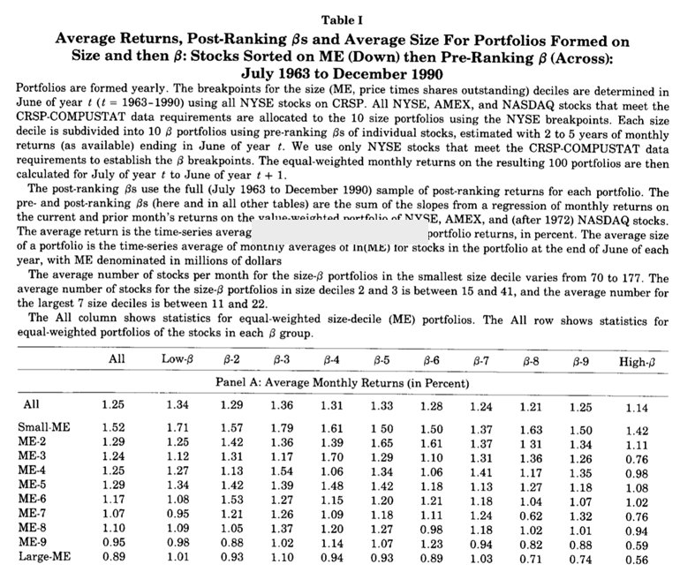

* Market Cap weighted is optimal if stock returns are proportional to beta, if not true, not optimal
* If this is the case what is the best method
* Expressing relative returns is very difficult, want model that links expected returns to risk (like CAPM) or simply minimizes risk