SYSTEM DESIGN DOCUMENT
Cyber-Physical Smart Building Access Control System
Phase 1 Deliverable — Architecture, Firmware, Database, API, and UI Design

1. System Block Diagram
The System is organized into three layers: the edge (door node hardware), the network (hybrid RS-485 backbone with Wi-Fi fallback), and the application layer (backend, database, dashboard). This mirrors the layered architecture established in the revised proposal.
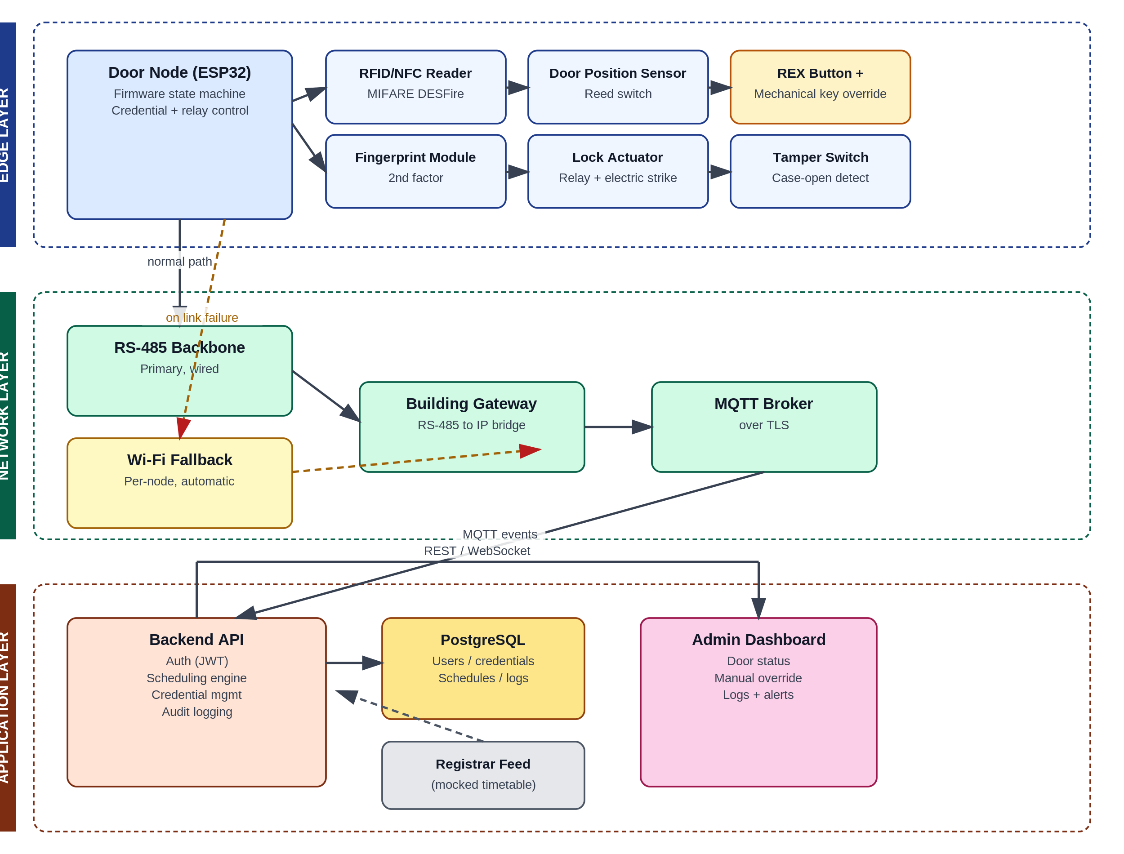
Figure 1 — Three-layer system architecture and data flow.

2. Door Node Wiring & Connection Diagram
Each door node centers on an ESP32 driving all peripherals through the interfaces below. This is a functional wiring diagram, not a fabrication-ready schematic — resistor values, connector pinouts, and PCB layout are produced in the next design pass once this topology is confirmed.
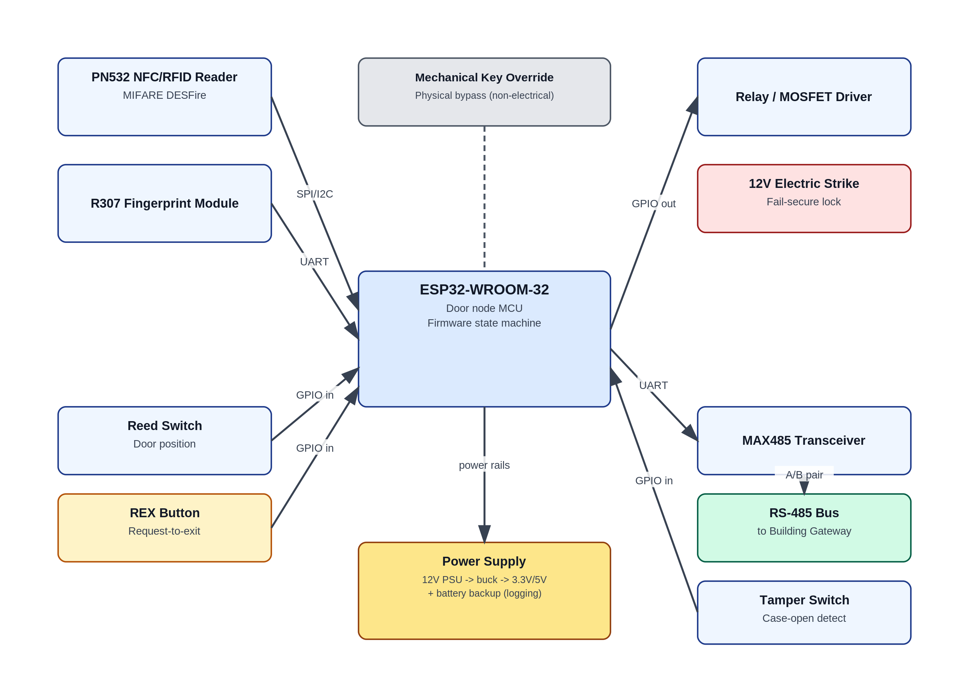
Figure 2 — ESP32 peripheral connections and protocols.
- SPI/I2C: PN532 NFC/RFID reader (configurable per hardware revision).
- UART: R307 fingerprint module and MAX485 RS-485 transceiver (separate UART peripherals on the ESP32).
- GPIO in: reed switch (door position), REX button, tamper switch.
- GPIO out: relay/MOSFET driver firing the electric strike.
- Mechanical key override is a physical bypass with no electrical tie to the ESP32 — it must work even if the node is fully powered down.

3. Firmware State Machine
The door node firmware runs a primary access state machine plus two independent background tasks: a network watchdog (handles RS-485/Wi-Fi failover) and a tamper interrupt that can fire from any state.
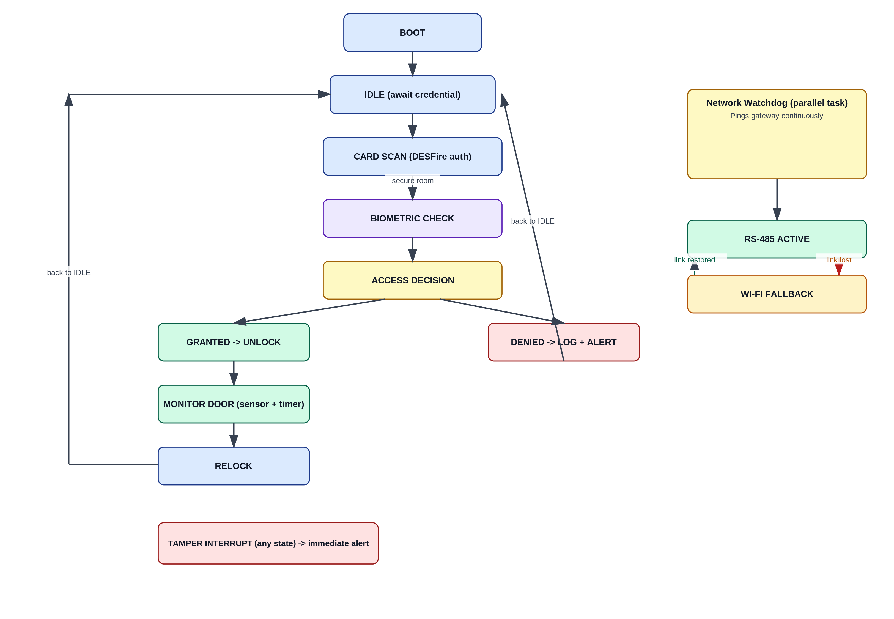
Figure 3 — Door node firmware states and transitions.
- IDLE waits for a card or fingerprint read; BIOMETRIC CHECK only runs for doors flagged as higher-security.
- MONITOR DOOR compares the commanded lock state against the reed switch reading, so a propped-open or forced door is detected independently of the lock's own status.
- The network watchdog runs continuously in parallel; a lost RS-485 link switches the node to its Wi-Fi radio without interrupting the access flow.

4. Database Schema
Six core tables cover users, credentials, doors, schedules, access events, and alerts. Foreign keys tie access events and alerts back to both the door and the credential involved, which is what the dashboard's history and audit views query against.
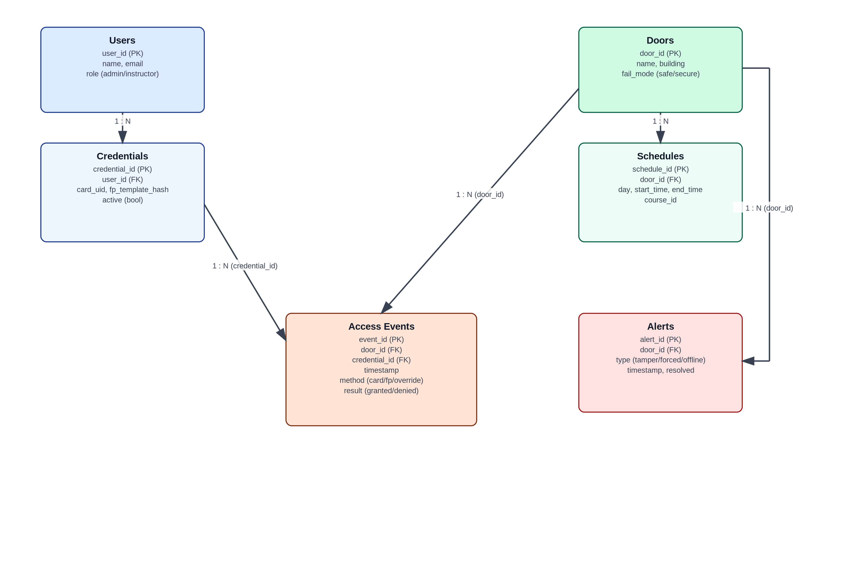
Figure 4 — Entity-relationship diagram.
CREATE TABLE users (
user_id SERIAL PRIMARY KEY,
name VARCHAR(120) NOT NULL,
email VARCHAR(160) UNIQUE NOT NULL,
role VARCHAR(20) NOT NULL CHECK (role IN ('admin','instructor')),
created_at TIMESTAMP NOT NULL DEFAULT now()
);
CREATE TABLE credentials (
credential_id SERIAL PRIMARY KEY,
user_id INTEGER REFERENCES users(user_id),
card_uid VARCHAR(64),
fp_template_hash VARCHAR(256),
active BOOLEAN NOT NULL DEFAULT true,
issued_at TIMESTAMP NOT NULL DEFAULT now()
);
CREATE TABLE doors (
door_id SERIAL PRIMARY KEY,
name VARCHAR(80) NOT NULL,
building VARCHAR(80) NOT NULL,
fail_mode VARCHAR(10) NOT NULL CHECK (fail_mode IN ('safe','secure'))
);
CREATE TABLE schedules (
schedule_id SERIAL PRIMARY KEY,
door_id INTEGER REFERENCES doors(door_id),
day_of_week SMALLINT NOT NULL,
start_time TIME NOT NULL,
end_time TIME NOT NULL,
course_id VARCHAR(40)
);
CREATE TABLE access_events (
event_id BIGSERIAL PRIMARY KEY,
door_id INTEGER REFERENCES doors(door_id),
credential_id INTEGER REFERENCES credentials(credential_id),
event_time TIMESTAMP NOT NULL DEFAULT now(),
method VARCHAR(20) NOT NULL,
result VARCHAR(20) NOT NULL
);
CREATE TABLE alerts (
alert_id SERIAL PRIMARY KEY,
door_id INTEGER REFERENCES doors(door_id),
type VARCHAR(20) NOT NULL,
alert_time TIMESTAMP NOT NULL DEFAULT now(),
resolved BOOLEAN NOT NULL DEFAULT false
);

5. REST API Specification
Method | Endpoint | Description
POST | /api/auth/login | Authenticate admin/instructor; returns a JWT
POST | /api/auth/refresh | Refresh an expiring JWT
GET | /api/doors | List all doors with current status
GET | /api/doors/{door_id} | Get detail for a single door
POST | /api/doors/{door_id}/override | Manual unlock/lock override
GET | /api/doors/{door_id}/logs | Access event history for a door
GET | /api/schedules | List schedules
POST | /api/schedules | Create or import a schedule entry
PUT | /api/schedules/{schedule_id} | Update a schedule entry
GET | /api/credentials | List credentials (admin only)
POST | /api/credentials | Issue a new credential
DELETE | /api/credentials/{credential_id} | Revoke a credential
GET | /api/alerts | List active/resolved alerts
PUT | /api/alerts/{alert_id}/resolve | Mark an alert resolved
GET | /api/users | List users (admin only)

6. MQTT Topic Structure
Topic | Direction | Payload
site/{door_id}/status | Door → Backend | Retained online/offline heartbeat
site/{door_id}/event | Door → Backend | JSON access event (credential, method, result, timestamp)
site/{door_id}/alert | Door → Backend | Tamper / forced-entry / sensor-mismatch alert
site/{door_id}/cmd | Backend → Door | Override command (lock / unlock)
site/{door_id}/cmd/ack | Door → Backend | Command execution acknowledgment
site/gateway/health | Gateway → Backend | Building gateway heartbeat
All topics are published over MQTT with TLS enabled on the broker connection; door nodes authenticate to the broker with per-device credentials rather than a shared password.

7. Dashboard Wireframe
Low-fidelity layout for the admin dashboard's main screen: door status grid with per-door override/history actions, an alert banner for anything needing immediate attention, and a recent access events table.
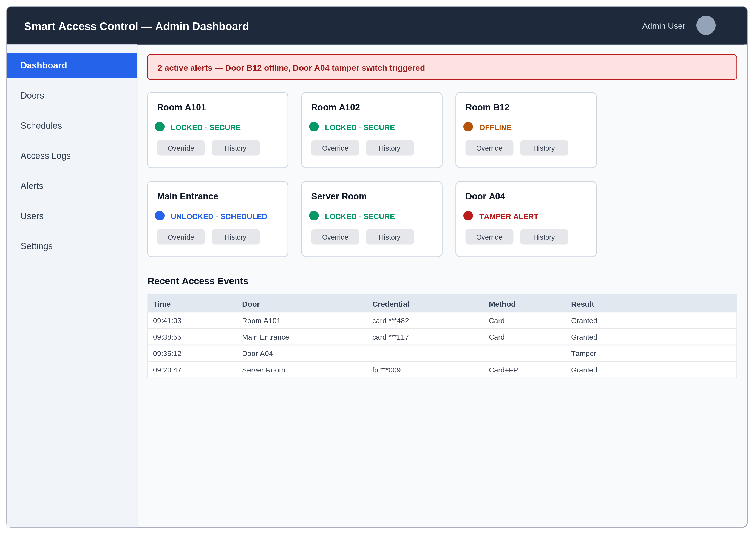
Figure 5 — Admin dashboard wireframe (Dashboard view).

8. Open Questions for Design Review
- Confirm PoE vs. RS-485-only for the backbone — affects gateway hardware and per-node cost.
- Confirm which rooms require the biometric second factor vs. card-only (drives fingerprint module BOM quantity).
- Confirm registrar timetable data format/access — determines whether Phase 3's scheduling import is a real integration or a structured mock.
- Confirm campus IT's stance on new devices on the network (VLAN, firewall rules for MQTT broker and gateway).
- Confirm fire-safety-mandated egress doors with campus facilities before finalizing which doors are fail-safe vs. fail-secure.

