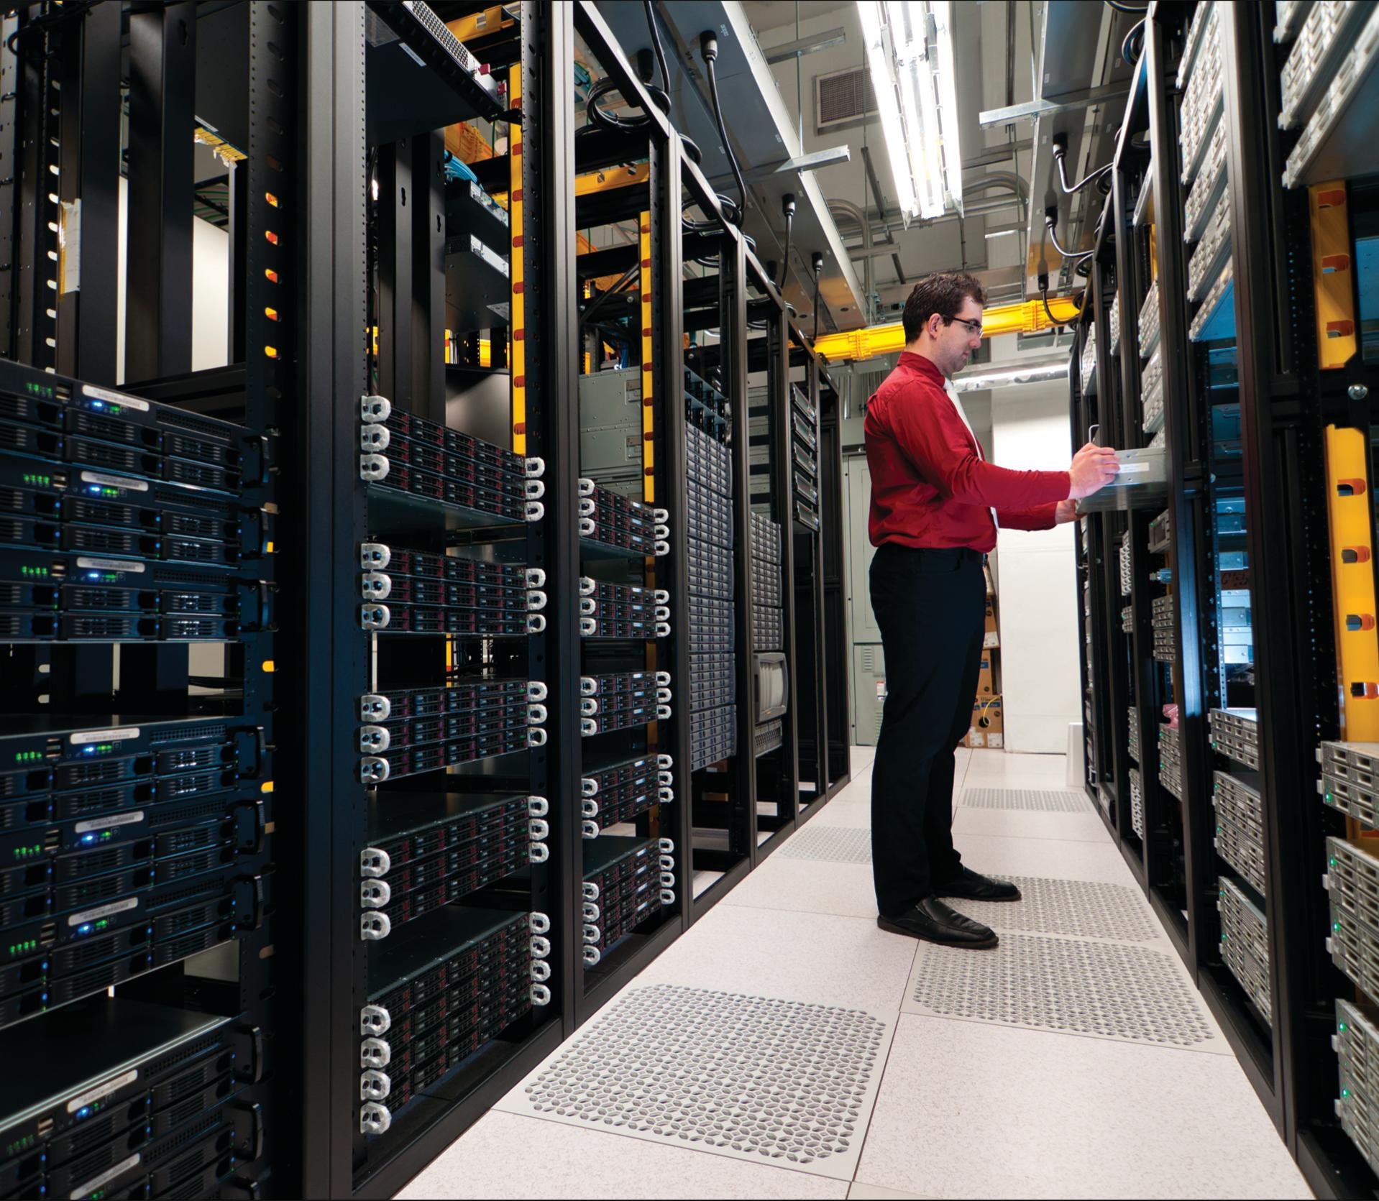

Course Title

CCNA

CCNA TASK Documentation

**Student’s Name: Amr Mohamed**

**Teacher’s Name: Mina Maher**

* First, what is required

1-Make basic configurations for all routers.

2-Make basic configurations for all switches.

3-Follow up the flowchart.

Request

1. Check spanning tree at network 17.0.0.0 and write:
2. Name of the root switch.
3. Name of designated ports on non-root switch.
4. Name of root ports on non-root switch.
5. Name of blocked ports.
6. Switch Aswan is server VTP switch, it has 3 VLANs.
7. VLAN 2 named IT.
8. VLAN 3 named HR.
9. VLAN 10 named Server.
10. Switch Aswan Client
11. VLAN 2 Interface 0/2 - 10.
12. VLAN 3 Interface 0/12 - 20.
13. VLAN 10 Interface 0/21 - 24.
14. All PCs ping together on all networks.
15. Backup all configurations and IOSs for all routers on TFTP server 21.0.0.2.
16. Configure all routers and switches remotely throw SSH only.
17. Deny all network 16.0.0.0 to access HTTp server 21.0.0.2.

* Secondly, we will implement what is required

1-Make basic configurations for all routers.

To implement this step we will do the following

ena

conf t

hostname amr-1

enable secret 111

line console 0

password 111

login

Exit

We will apply this code to all routers with a different name and possibly a different password.

2-Make basic configurations for all switches.

To implement this step we will do the following

ena

conf t

hostname amr-s1

enable secret 111

line console 0

password 111

login

Exit

We will apply this code to all switches with a different name and possibly a different password.

1. Follow up the flowchart.

After we followed the flowchart, our view became like this

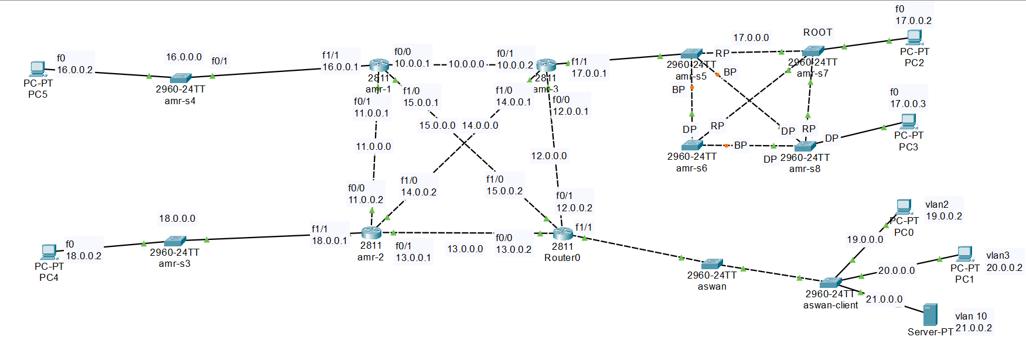

1-Check spanning tree at network 17.0.0.0 and write:

A-Name of the root switch.

B-Name of designated ports on non-root switch.

C-Name of root ports on non-root switch.

D-Name of blocked ports.

To implement this step we will do the following

1. Name of the root switch.

We go to switch amr-s7 and write the following code:

ena

Show spanning-tree

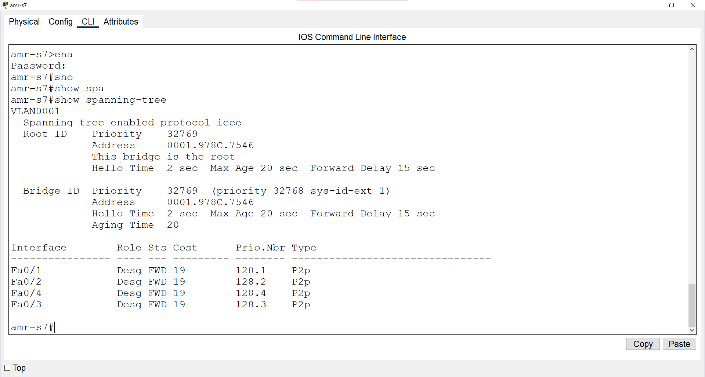

We will notice that in the root id it is written (this bridge is the root). We will also notice that the address in both the root id and the bridge id is similar.So this switch amr-s7 is the root switch.

B-Name of designated ports on non-root switch.

We will go to the switches (amr-s5 / amr-s6 / amr-s8)

We will write the following code:

ena

Show spanning-tree

It will appear to us as follows:

In switch amr-s5

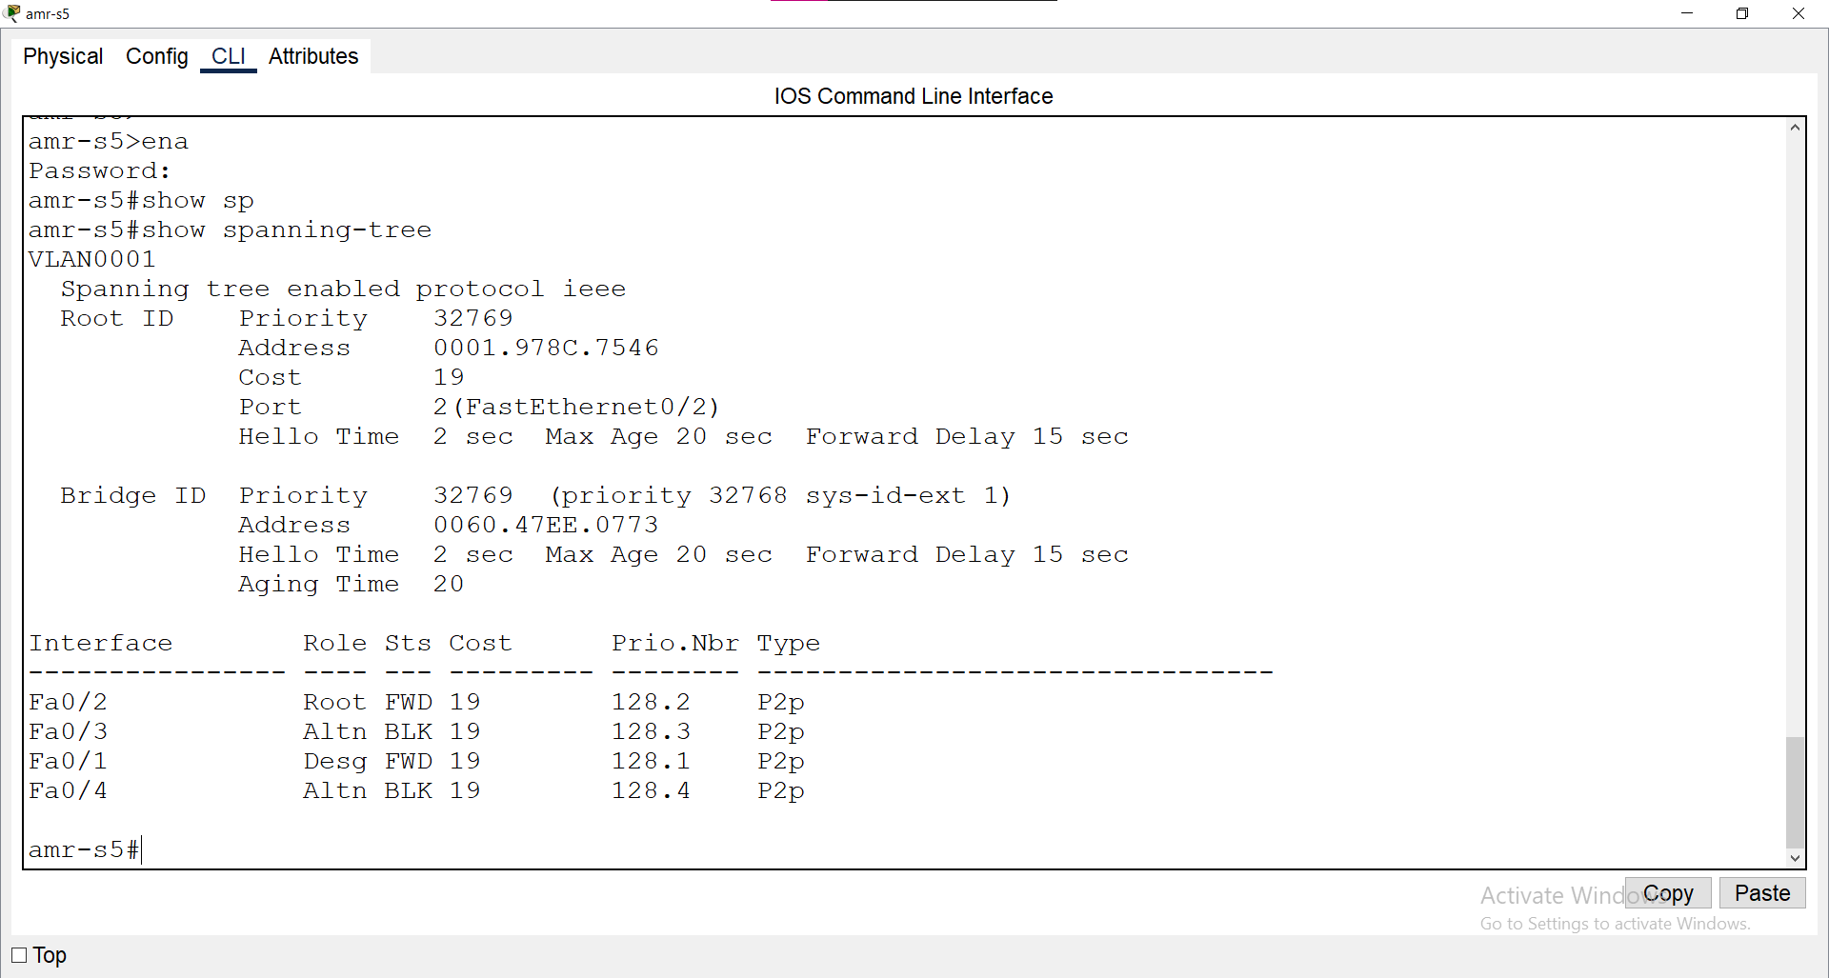

In switch amr-s6

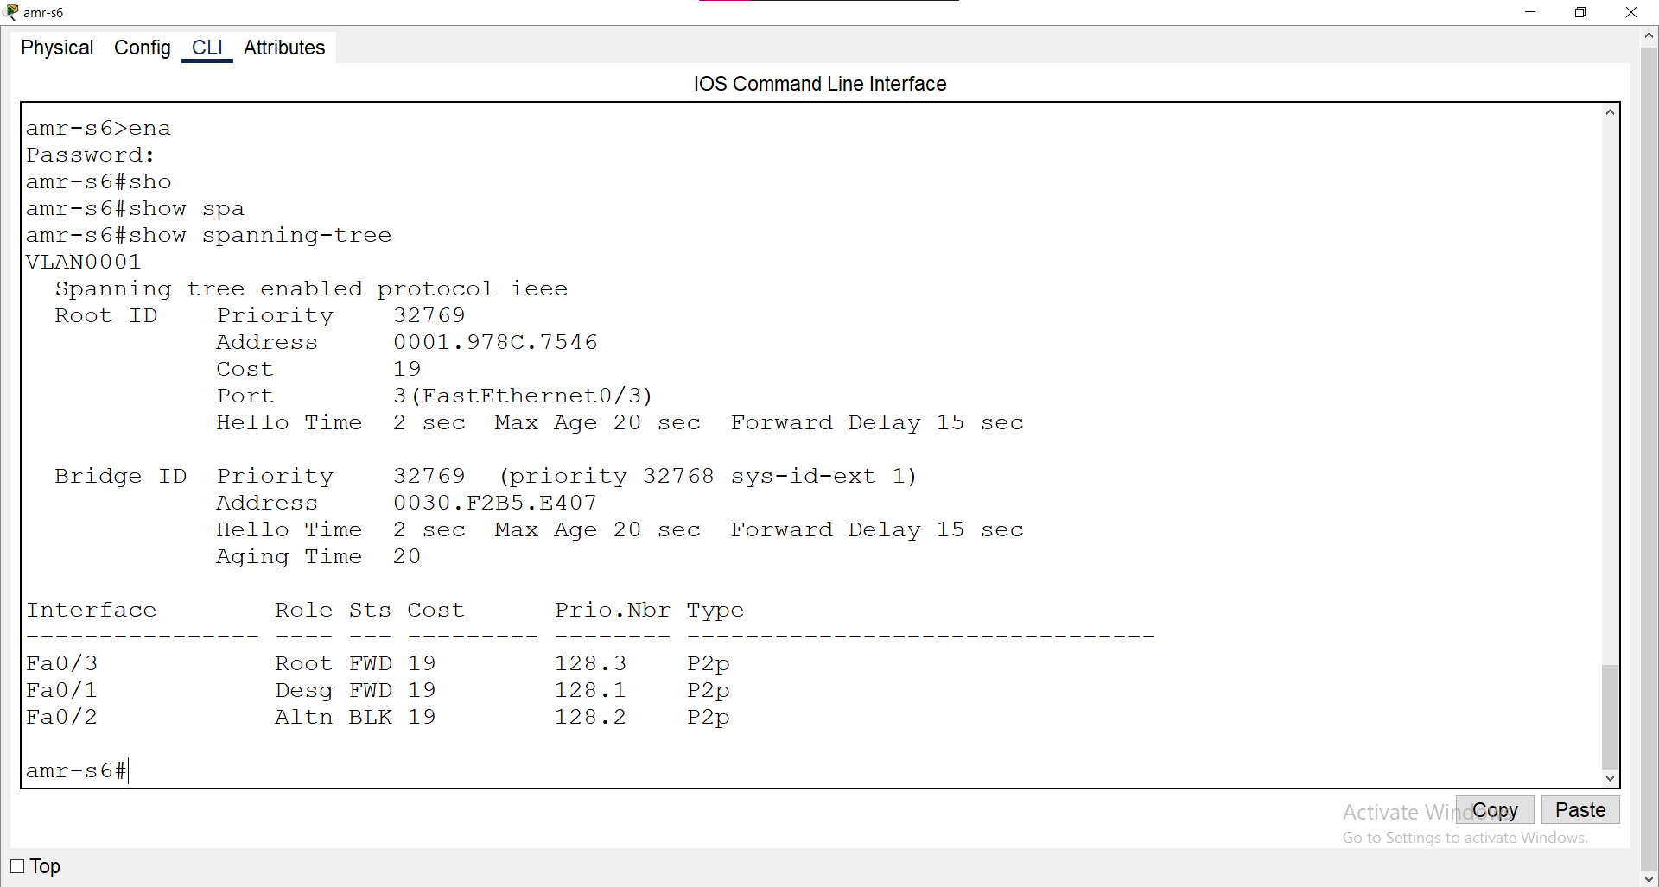

In switch amr-s8

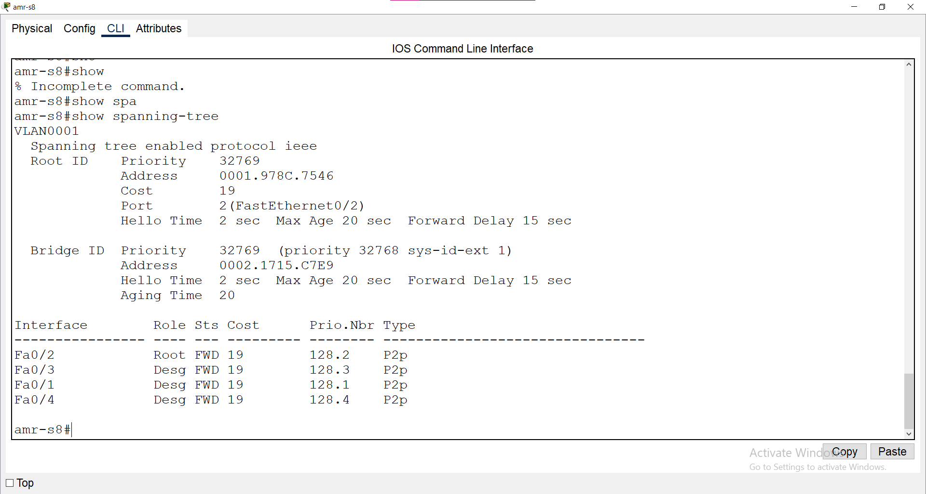

From the above we can deduce the following

In switch amr-s5 we note that the designated ports are:

Fa 0/1 only.

In switch amr-s6 we note that the designated ports are:

Fa 0/1 only.

In switch amr-s8 we note that the designated ports are:

Fa 0/1

Fa 0/3

Fa 0/4.

C-Name of root ports on non-root switch.

We will apply the same previous step and we will conclude that

In switch amr-s5 we note that the root ports are:

Fa 0/2 only.

In switch amr-s6 we note that the root ports are:

Fa 0/3 only.

In switch amr-s8 we note that the root ports are:

Fa 0/2 only.

D-Name of blocked ports.

We will apply the same previous step and we will conclude that

In switch amr-s5 we note that the blocked ports are:

Fa 0/3

Fa 0/4.

In switch amr-s6 we note that the blocked ports are:

Fa 0/2 only.

In switch amr-s8 there are no blocked ports.

2-Switch Aswan is server VTP switch, it has 3 VLANs.

A-VLAN 2 named IT.

B-VLAN 3 named HR.

C-VLAN 10 named Server.

To implement this step we will do the following

We will go to switch aswan and then do the following:

We will write the following code:

ena

show vlan brief

The following will be shown to us:

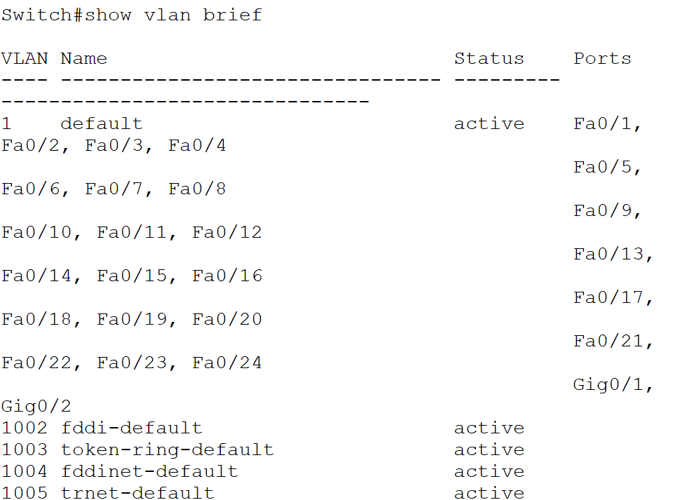

We will notice that there are only default VLANs.

So, we will add new VLANs as required. To do this, we will write the following code:

ena

conf t

vtp mode server

vtp domain aswan

vlan 2

name IT

vlan 3

name HR

vlan 10

name Server

After that we will write the following code:

ena

show vlan brief

The following will be shown to us:

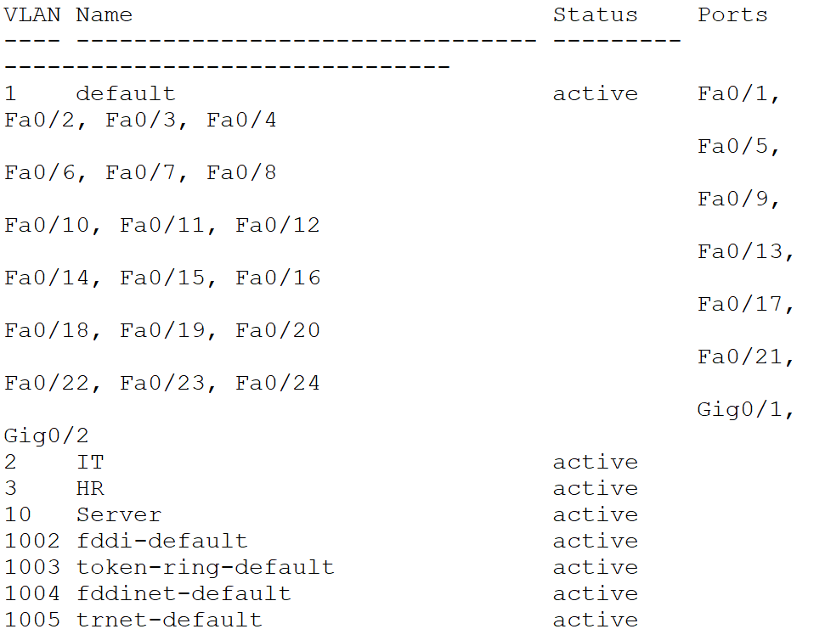

We will notice that the VLANs have been added successfully.

3-Switch Aswan Client

A-VLAN 2 Interface 0/2 - 10.

B-VLAN 3 Interface 0/12 - 20.

C-VLAN 10 Interface 0/21 - 24.

To implement this step we will do the following

We will write the following codes:

ena

conf t

Interface range fastethernet 0/2 - 10

switchport access vlan 2

Exit

B-

ena

conf t

Interface range fastethernet 0/12 - 20

switchport access vlan 3

Exit

C-

ena

conf t

Interface range fastethernet 0/21 - 24

switchport access vlan 10

Exit

After that we will write the following code:

ena

show vlan brief

The following will be shown to us:

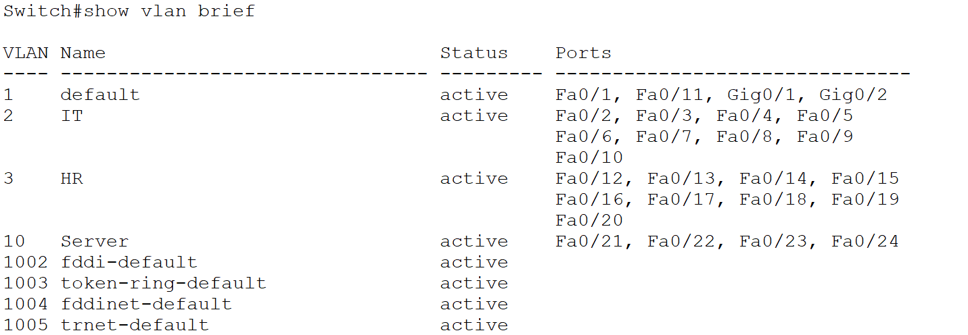

1. All PCs ping together on all networks.

After we have applied all the previous steps, we will be able to ping all existing PCs from any device.

If we need to ping PC0, whose IP is 19.0.0.2, to PC5, whose IP is 16.0.0.2, the result will be as follows:

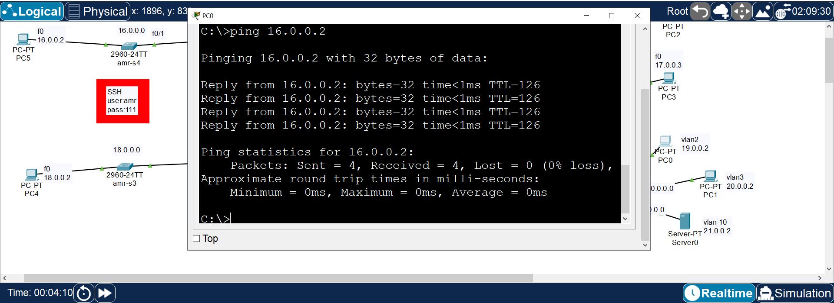

5-Backup all configurations and IOSs for all routers on TFTP server 21.0.0.2.

To implement this step we will do the following

We will write the following codes for all routers:

copy startup-config tftp

21.0.0.2

Click enter

copy running-config tftp

21.0.0.2

show flash

Copy this :2800nm-advipservicesk9-mz.151-4.M4.bin

copy flash tftp

And put it in this step: 2800nm-advipservicesk9-mz.151-4.M4.bin

6-Configure all routers and switches remotely throw SSH only.

To implement this step we will do the following

We will write the following codes for all routers:

ip domain-name amr

crypto key generate rsa

ip ssh version 2

line vty 0 4

transport input ssh

exit

username amr secret 111

enable secret 111

line vty 0 4

login local

7-Deny all network 16.0.0.0 to access HTTp server 21.0.0.2.

To implement this step we will do the following

We will write the following codes:

ena

conf t

access-list 100 deny tcp host 16.0.0.0 host 21.0.0.2 eq 80