Style

Luke Zappia

2017-08-23

# Introduction

**Lorem ipsum** dolor *sit amet*.

* Single asterisks italicize text *like this*.
* Double asterisks embolden text **like this**.

Start a new paragraph with a blank line separating paragraphs.

* This will start an unordered list environment, and this will be the first item.
* This will be a second item.
* A third item.
  + Four spaces and a dash create a sublist and this item in it.
* The fourth item.

1. This starts a numerical list.
2. This is no. 2 in the numerical list.

# This Starts A New Section

## This is a Subsection

### This is a Subsubsection

#### This starts a Paragraph Block.

This will create a block quote, if you want one.

Want a table? This will create one.

|  |  |
| --- | --- |
| Table Header | Second Header |
| Table Cell | Cell 2 |
| Cell 3 | Cell 4 |

Note that the separators *do not* have to be aligned.

Want an image? This will do it.

par(mar = c(4, 4, 0.1, 0.1))  
plot(pressure, pch = 19, type = "b")

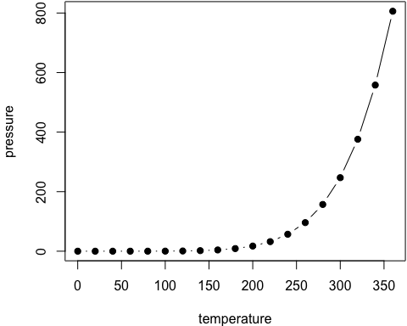

Figure 1 An example figure

A normal paragraph.

And here is a cross reference to Figure 1.

Almost forgot about creating a footnote.[1] This will do it again.[2]

Want to cite something?

* Find your biblatexkey in your bib file.
* Put an @ before it, like R Core Team (2016), or whatever it is.
* R Core Team (2016) creates an in-text citation (e.g. Smith (1984) says...)
* (R Core Team 2016) creates a parenthetical citation (Smith, 1984)

That'll also automatically create a reference list at the end of the document.

[In-text link to Google](http://google.com) as well.

R Core Team. 2016. *R: A Language and Environment for Statistical Computing*. Vienna, Austria: R Foundation for Statistical Computing. <https://www.R-project.org/>.

1. The first footnote
2. The second footnote