Facial Landmarks

Face landmark detection is the process of finding regions (points) of interest (ROI) in an image of a human face, those landmarks are used after wards as input features for our model.
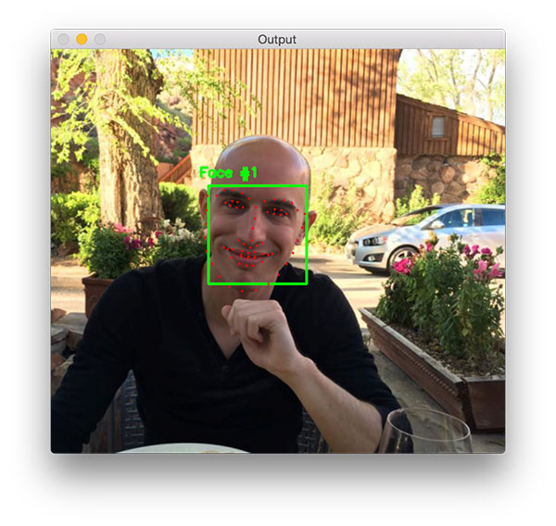

how it works:
we first detect the face, then mark the regions of interest (landmarks) in it, such as Mouth, Right eyebrow, Left eyebrow, Right eye, Left eye, Nose and Jaw.
A pre-trained facial landmark detector inside the Dlib library can be used to estimate the location of 68 (x, y)-coordinates that map to facial structures on the face.
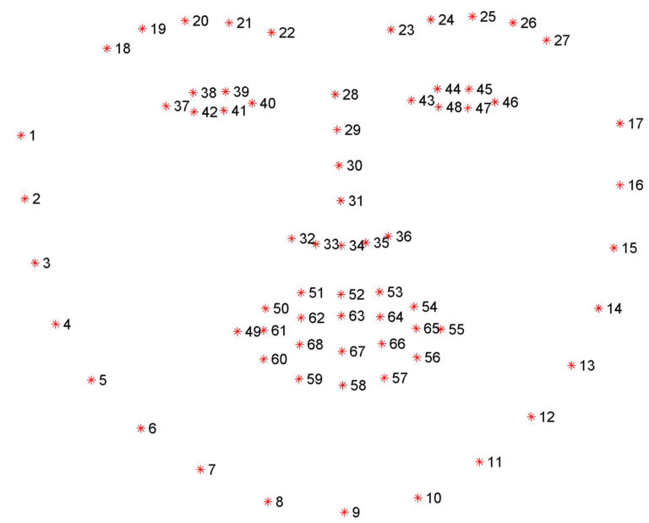
(Optional)

The facial landmark detector included in the dlib library is an implementation of the One Millisecond Face Alignment with an Ensemble of Regression Trees paper by Kazemi and Sullivan (2014).
This method starts by using:
- A training set of labeled facial landmarks on an image. These images are manually labeled,specifying specific (x, y)-coordinates of regions surrounding each facial structure.
- Priors, of more specifically, the probability on distance between pairs of input pixels.
Given this training data, an ensemble of regression trees are trained to estimate the facial landmark positions directly from the pixel intensities themselves (i.e., no “feature extraction” is taking place).
The end result is a facial landmark detector that can be used to detect facial landmarks in real-time with high quality predictions.
Effect on Performance:
It has a great effect on performance because it is a very valuable feature in expression detection as performance (accuracy) highly increases after we used it.

