Database

1St week notes

* Database is an organized collection of related data.
* By making two CSV files, one for artists and the other for albums made by the artists … we can come up with some problems as :

1. Data Integrity: Data is not connected and related to each other in both files.
2. Implementation: Searching algorithms can take place which will increase space and time complexity if the file has a large capacity, we can rewrite a code for the database access in a different programing language for a different app that uses the same database or what if two threads wrote to same database at the same time.
3. Durability: machine can crash while the program is updating a record.

* A database management system (DBMS) is a software for solving the pervious problems (define, create, query, update and administrate).
* SQL lite is a database management system.
* Data model is a collection of concepts for describing the data in a database.
* Schema is a description for a particular collection of data, using a given data model.

- Types of database models:

1. Relational 🡪 most DBMSs
2. Key/Value
3. Graph 🡪 No SQL used for large capacity and
4. Document fast performance data retrieve.
5. Column-family
6. Array/Matrix 🡪 Machine Learning
7. Hierarchical
8. Network 🡪Obsolete/Legacy/Rare
9. Multi-value

-----------------------------------------------------------------------

Relational Database Model

* Is a collection of relations. A relation is nothing but a table of values.
* S**tructure**: definition of the database data connections and relations.
* **Integrity:** ensures the database’s contents satisfying some constrains.
* **Manipulation:** programing interface for accessing and modifying a database’s content.
* Artist (name, year, country). Relation

Attributes that represent entities.

* Tuple, Row, Entity or Domain is a set of attributes values in the relation (table).
* A table also can be an entity.
* Values are atomic or scalar.
* The special value NULL is a member of every domain.
* N-ary Relation = table of n columns.
* For SQL naming conventions all letters are capital and spaces are underscores.

Primary Keys: identifies a single tuple.

Foreign key: maps a tuple from a relation into another relation.

* Some DBMSs automatically create an internal primary key if a table doesn’t define one.
* Atomic value is one piece variable
* Joint relation is a relation that maps two related primary keys in two different relations.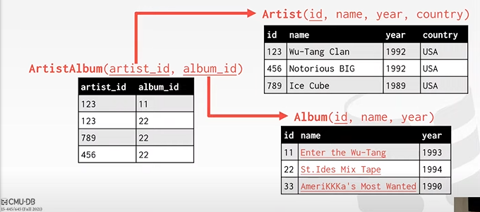

**Data Manipulation Languages (DML)**

* Methods to store and retrieve desired data from a database.
* A query can either be **a request for data results from your database or for action on the data, or for both.**
* How you want to retrieve the data?

1. **Procedural**: the query specifies the strategy the DBMSs should use to find the desired result.
2. **Non-procedural (Declarative):** the query specifies only the desired data and not how to find it, Example…SQL LITE.

Relational Algebra

* Operations to retrieve and manipulate tuples in a relation.
* Each operator takes one or more relation as an input and outputs a new relation.
* 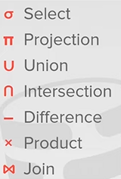predicate works as an if statement.

**************

* Entity is a group of attributes.
* One to one relationship: two pieces of data related to each other in a unique way.
* One to many relationships: one parent data related to multiple data like a user having multiple comments.
* Many to Many relationships: two or more relations each have multiple relationships.
* Queries are requests made by the DBMSs for a specific information.
* We can make a foreign key from the same relation.
* A relation can have more than one primary key (composite key) each two or more combination of primary keys must be unique.
* Any primary key must be unique.
* SQL is four in one language:

1. Data query language
2. Data definition language
3. Data control language
4. Data manipulation language