In the EDA we explored the data problems , and since I run on my pc I used lights model to achieve the task.

# **Approach:**

In the code I tried up sampling, down sampling, loss weights for unbalance issue the best approach yield results was, loss weights in favor of efficientnetv2

**Matrices:**

I used **F1 score** to chose best model and save it is weights , while also using accuracy and confusion matrix.

# **Efficient NET:**

**Accuracy**: 0.964, **Error**:0.0358

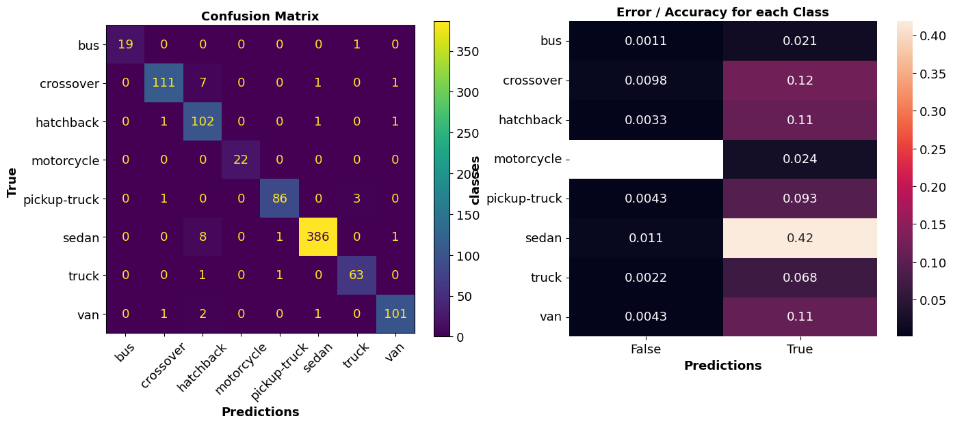

# **inception:**

**Accuracy: 0.91 ,Error:0.089**

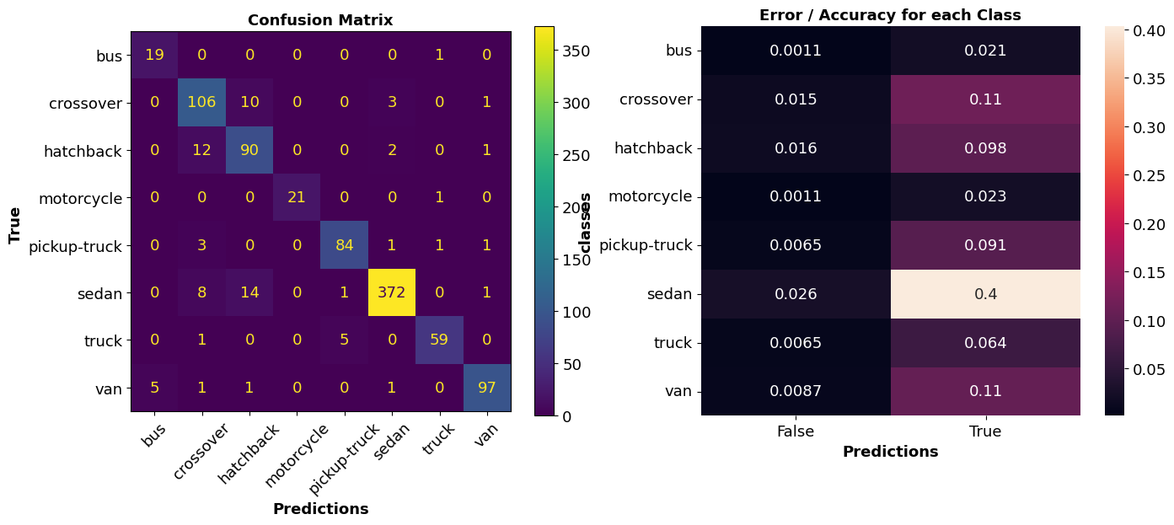

# **resnext50d:**

**Accuracy : 0.94 ,Error:0.06**

