**Vietnam General Confederation of Labor**

**TON DUC THANG UNIVERSITY**

**FACULTY OF INFORMATION TECHNOLOGY**



**FINAL REPORT**

**DISCRETE STRUCTURES**

*Instructor*: **Mr. MAI DUY TAN**

*Student*: **Duong Trong Tai – 518H0434**

*Class* **: 18H50303**

*Year* **: 22**

**HO CHI MINH CITY, 2022**

Vietnam General Confederation of Labor

**TON DUC THANG UNIVERSITY**

**FACULTY OF INFORMATION TECHNOLOGY**



**FINAL REPORT**

**DISCRETE STRUTURES**

*Instructor*: **Mr. MAI DUY TAN**

*Student*: **Duong Trong Tai – 518H0434**

*Class* **: 18H50303**

*Year* **: 22**

**HO CHI MINH CITY, 2022**

ACKNOWLEDGEMENT

The first sincere thanks I want to give to Mr. Mai Duy Tan, who enthusiastically taught and worked tirelessly to give me enough tools and skills to complete this report. He played an important role in improving my mathematical logic and knowledge. The second thanks I would like to give to the teachers of the Department of Information Technology of Ton Duc Thang University for giving me the opportunity to do this report.

Because the impact of the epidemic is too great, my report will have some errors, I am very open to receiving feedback from teachers so that I can improve my report writing skills.

Finally, I wish you good health and success in your noble career.

*Ho Chi Minh city, 7th January, 2022*

*Author*

*(Sign and write full name)*

*Duong Trong Tai*

**THIS PROJECT WAS COMPLETED AT**

**TON DUC THANG UNIVERSIY**

I fully declare that this is my own project and is guided by Mr. Mai Duy Tan; The research contents and results in this topic are honest and have not been published in any form before. The data in the tables for analysis, comments and evaluation are collected by the author himself from different sources, clearly stated in the reference section.

Besides that, the project also uses a number of comments, assessments as well as data from other authors, other agencies and organizations, with citations and source annotations.

**Should any frauds were found, I will take full responsibility for the content of my report.** Ton Duc Thang University is not related to copyright and copyright violations caused by me during the implementation process (if any).

*Ho Chi Minh city, 8th January, 2022*

*Author*

*(Sign and write full name)*

*Duong Trong Tai*

CONFIRMATION AND ASSESSMENT SECTION

**Instructor confirmation section**

_______________________________________________________________________________________________________________________________________________________________________________________________________________________________________________________________________________________________________________________________________________________________________________________________________________

*Ho Chi Minh January, 2022*

*(Sign and write full name)*

**Evaluation section for grading instructor**

_______________________________________________________________________________________________________________________________________________________________________________________________________________________________________________________________________________________________________________________________________________________________________________________________________________

*Ho Chi Minh January 2022*

*(Sign and write full name)*

SUMMARY

This is a report on Discrete Strutures by Faculty of Information Technology of Ton Duc Thang University. By the help of Mr. Mai Duy Tan. This report was finish at 8:30AM on 7th January, 2022. If it weren’t for Mr. Mai Duy Tan lessons, I could not perfectly finish this report. Sometimes this article of mine has many errors, I am very open to receive the constructive contributions of teachers and will use it as a lesson for the final articles.

INDEX

ACKNOWLEDGEMENT i

CONFIRMATION AND ASSESSMENT SECTION iii

SUMMARY iv

INDEX 1

CHAPTER 1 – INTRODUCTION 1

Introduce the report 1

CHAPTER 2 2

CHAPTER 3 – REFERENCES 3

CHAPTER 4 – SELF -EVALUATION FORM 4

CHAPTER 1 – INTRODUCTION

1. Purpose and scope

1.1 Purpose

This document provides a comprehensive overview of the architecture of the sales management software we designed, including the use of technology models. For the purpose of capturing and communicating the important architectural decisions that have been made about the modules, the document serves as a bridge between the software requirements and the detailed design of the application. It also helps programmers easily grasp the requirements of users and customers, avoiding unnecessary omissions.

1.2 Scope

This document defining software architecture that addresses project requirements in the following areas: functionality, usability, reliability, scalability, maintainability, manageability, and evolution of software.

1. Product Overview

The product is designed after a lot of planning and execution, constantly changing and tweaking to build on the goodness of existing applications. The application still ensures the required functions such as importing and exporting goods, paying bills, viewing order status and goods management statistics.

1. Structure of the Document

The structure of the document consists of 6 parts including: introduction, project plan, requirements specifications, architecture, design and testing. Each part plays an equally important role to be able to create a complete application in the final design and testing part.

1. Terms, Acronyms, and Abbreviations

CHAPTER 2 - Project Management Plan

1. Project Organization
2. Lifecycle model used

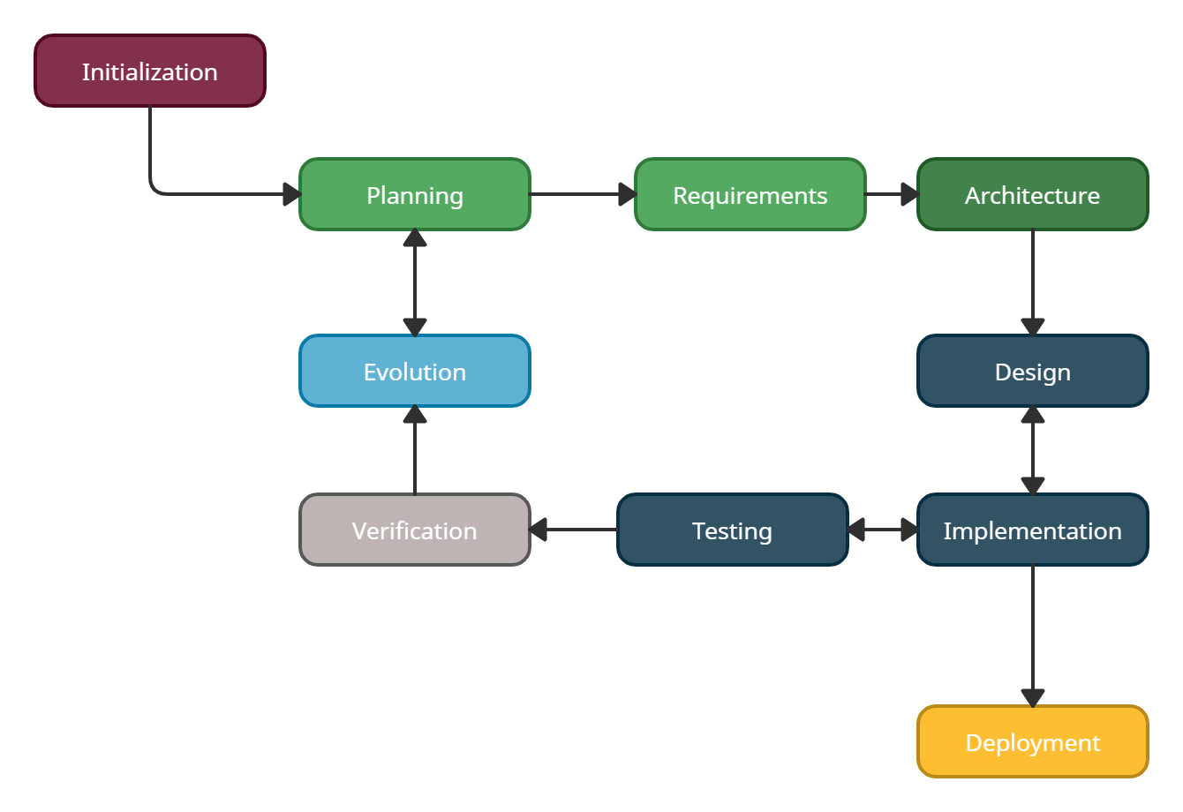

Reason: It is easier for us to use the iterative model when we have identified the requirements from the beginning and are suitable for small processes that are divided for each of us to facilitate learning other subjects, Above all, the design and testing need to be constantly changing so it is very convenient to use the iterative model.

1. Risk analysis

CHAPTER 3 – REFERENCES

1. <http://www-math.ucdenver.edu/~wcherowi/courses/m5410/exeucalg.html>
2. <https://www.algotree.org/algorithms/tree_graph_traversal/depth_first_search/cycle_detection_in_undirected_graphs/>
3. IDP Project of Mark J. Becker at Chair M9 of Technische Universität München. 2015 <https://algorithms.discrete.ma.tum.de/graph-algorithms/hierholzer/index_en.html>
4. Join Brilliant <https://brilliant.org/wiki/extended-euclidean-algorithm/>

CHAPTER 4 – SELF -EVALUATION FORM

|  |  |  |
| --- | --- | --- |
| Question | Description | Score |
| Question 1 | Correct calculation, detailed explanation. | 1 |
| Question 2 | Correct calculation, detailed explanation. | 1 |
| Question 3 | Correct calculation, detailed explanation. | 1 |
| Question 4 | Right results, detailed  explanation. | 1 |
| Question 5 | Good study, right calculation, detailed explanation. | 1 |
| Question 6 | Reasonable detailed proposion with illustration. | 0.5 |
| Question 7 | a-Correct recognition, right explanation. b,c-Good study, right calculation, detailed  explanation. | 2 |
| Question 8 | Correct modeling, right coloring. | 2 |
| **Total** |  | 9,5 |