1. **Use case diagram**

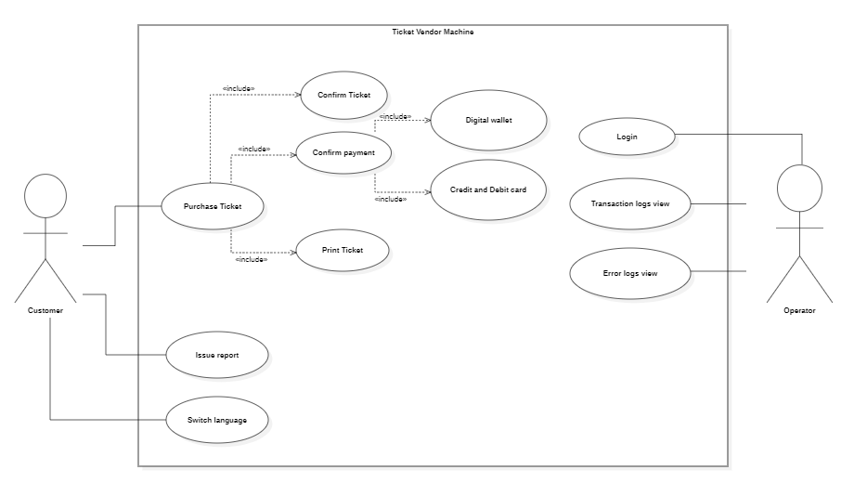

* 1. **Purchase Ticket description**

|  |  |  |
| --- | --- | --- |
| **Use case name:** | Purchase Ticket | |
| **Trigger event:** | Customer hits the start button on the screen | |
| **Brief description:** | Customer purchases ticket for the selected destinations using available payment methods and receives a printed ticket with a barcod | |
| **Actors:** | Customer | |
| **Preconditions:** | TVM is connected to MRT system and payment system | |
| **Post conditions:** | _The TVM issues a ticket with a bar code  _The TVM logs the transaction | |
| **Flow of activities:** | Actor | System |
| 1. Customer selects destination from the TVM menu  2. Customer selects mode of payment, confirms payment and pays | 1.1 TVM displays available routes calculates ticket price and display it on screen  1.2 TVM prompts customer to select ticket quantity and mode of payment  2.1 Charged customer bank account or display QR code base on selected payment method and wait for transaction processed  2.2 TVM issues tickets with barcode and logs the transaction after the transaction is complete |
| **Alternative flow:** | _ Go back to previous step if customer want to change destination or payment method  _ Customer can cancel the transaction before confirmation | |
| **Exception conditions:** | The TVM displays an error message and logs the error in the error logs if there is an error during the transaction process | |

* 1. **Feedback description**

|  |  |  |
| --- | --- | --- |
| **Use case name:** | Feedback | |
| **Trigger event:** | Customer hit the feedback button | |
| **Brief description:** | Customer provide feedback on the TVM experiences | |
| **Actors:** | Customer | |
| **Preconditions:** | None | |
| **Post conditions:** | Customer feedback is logged in the feedback logs for further action | |
| **Flow of activities:** | Actor | System |
| 1. Customer select the feedback option on the menu  2. Customer input their experiences and submit the feedback report | 1.1 TVM prompts the customer to describe their experiences on the TVM  2.1 TVM records their feedback in the feedback logs |
| **Alternative flow:** | The TVM menu display a list of common issues in case of they want to report the issues. | |
| **Exception conditions:** | None | |

* 1. **Switch language description**

|  |  |  |
| --- | --- | --- |
| **Use case name:** | Switch language | |
| **Trigger event:** | Customer select a language | |
| **Brief description:** | The TVM displays information on selected language | |
| **Actors:** | Customer | |
| **Preconditions:** | None | |
| **Post conditions:** | Information displayed in selected language on the TVM menu | |
| **Flow of activities:** | Actor | System |
| 1. Customer select switch language option  2. Customer select their desired language | 1.1 The TVM display a list of available language  2.1 The TVM reload the menu with infomatin displayed in selected language |
| **Alternative flows:** | _ TVM switch back to defaut language after one minute of no interaction | |
| **Exception conditions:** | The TVM displays error message and logs the error in the error logs if there is an error during switching language. | |

* 1. **Login as administrator description**

|  |  |  |
| --- | --- | --- |
| **Use case name:** | Purchase Ticket | |
| **Trigger event:** | After hit the start button on the screen | |
| **Brief description:** | Customer purchase ticket for the selected destinations using available payment methods and print the tickets after the transaction completed | |
| **Actors:** | Customer, TVM | |
| **Preconditions:** | _The TVM is functional  _The TVM is connected to MRT system | |
| **Post conditions:** | _The TVM issue a ticket with a bar code  _The TVM logs the transaction | |
| **Flow of activities:** | Actor | **Flow of activities:** |
|  |  |
| **Alternative flows:** |  | |
| **Exception conditions:** |  | |

* 1. **Transaction logs view description**

|  |  |  |
| --- | --- | --- |
| **Use case name:** | Purchase Ticket | |
| **Trigger event:** | After hit the start button on the screen | |
| **Brief description:** | Customer purchase ticket for the selected destinations using available payment methods and print the tickets after the transaction completed | |
| **Actors:** | Customer, TVM | |
| **Preconditions:** | _The TVM is functional  _The TVM is connected to MRT system | |
| **Post conditions:** | _The TVM issue a ticket with a bar code  _The TVM logs the transaction | |
| **Flow of activities:** | Actor | **Flow of activities:** |
|  |  |
| **Alternative flows:** |  | |
| **Exception conditions:** |  | |

* 1. **Error logs view description**

|  |  |  |
| --- | --- | --- |
| **Use case name:** | Purchase Ticket | |
| **Trigger event:** | After hit the start button on the screen | |
| **Brief description:** | Customer purchase ticket for the selected destinations using available payment methods and print the tickets after the transaction completed | |
| **Actors:** | Customer, TVM | |
| **Preconditions:** | _The TVM is functional  _The TVM is connected to MRT system | |
| **Post conditions:** | _The TVM issue a ticket with a bar code  _The TVM logs the transaction | |
| **Flow of activities:** | Actor | **Flow of activities:** |
|  |  |
| **Alternative flows:** |  | |
| **Exception conditions:** |  | |

1. **Activity diagram**
2. **Sequence diagram**
3. **State chart diagram**
4. **Class diagram**
5. **MVC model**
6. **Deployment diagram**
7. **Demo**