AJIT ELECTRICALS

**HOW TO LOGIN APPLICATION**

1. First page displayed on opening app.

* Without login we can’t purchase products.
* Firstly, we have to click on login highlighted with blue colour.

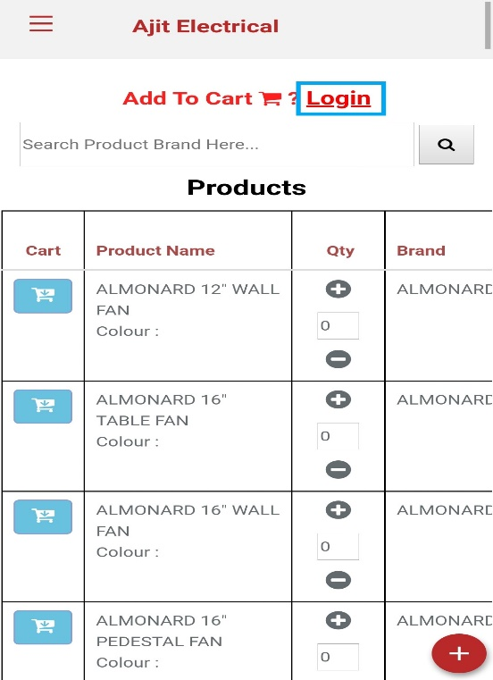

* Then register your self by clicking on sign up button.

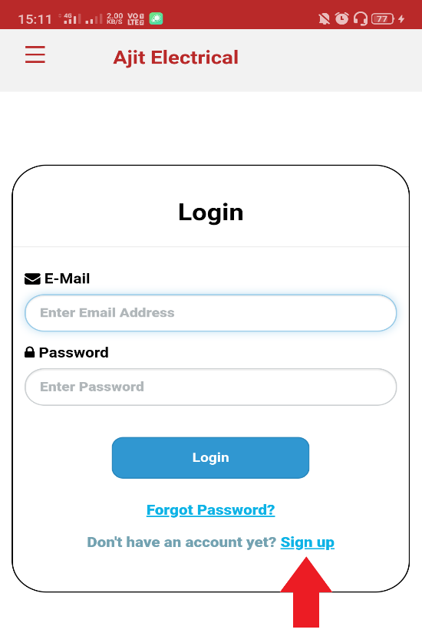

2. Register by filling all the credentials.

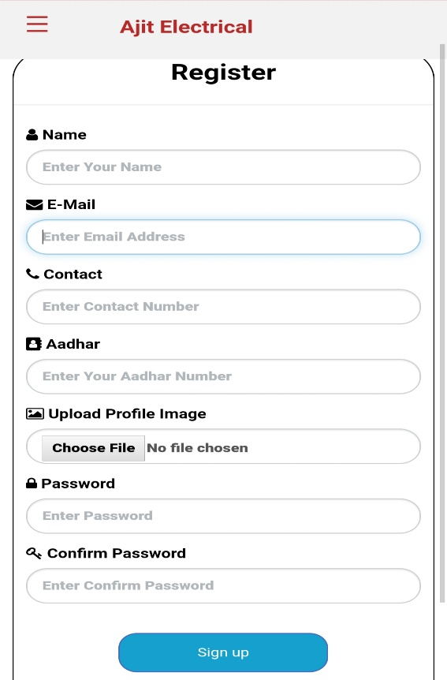

3. After successful registration you will get mail from Ajit Electricals, your registration will be pending for two days. User Status will be updated soon by admin.

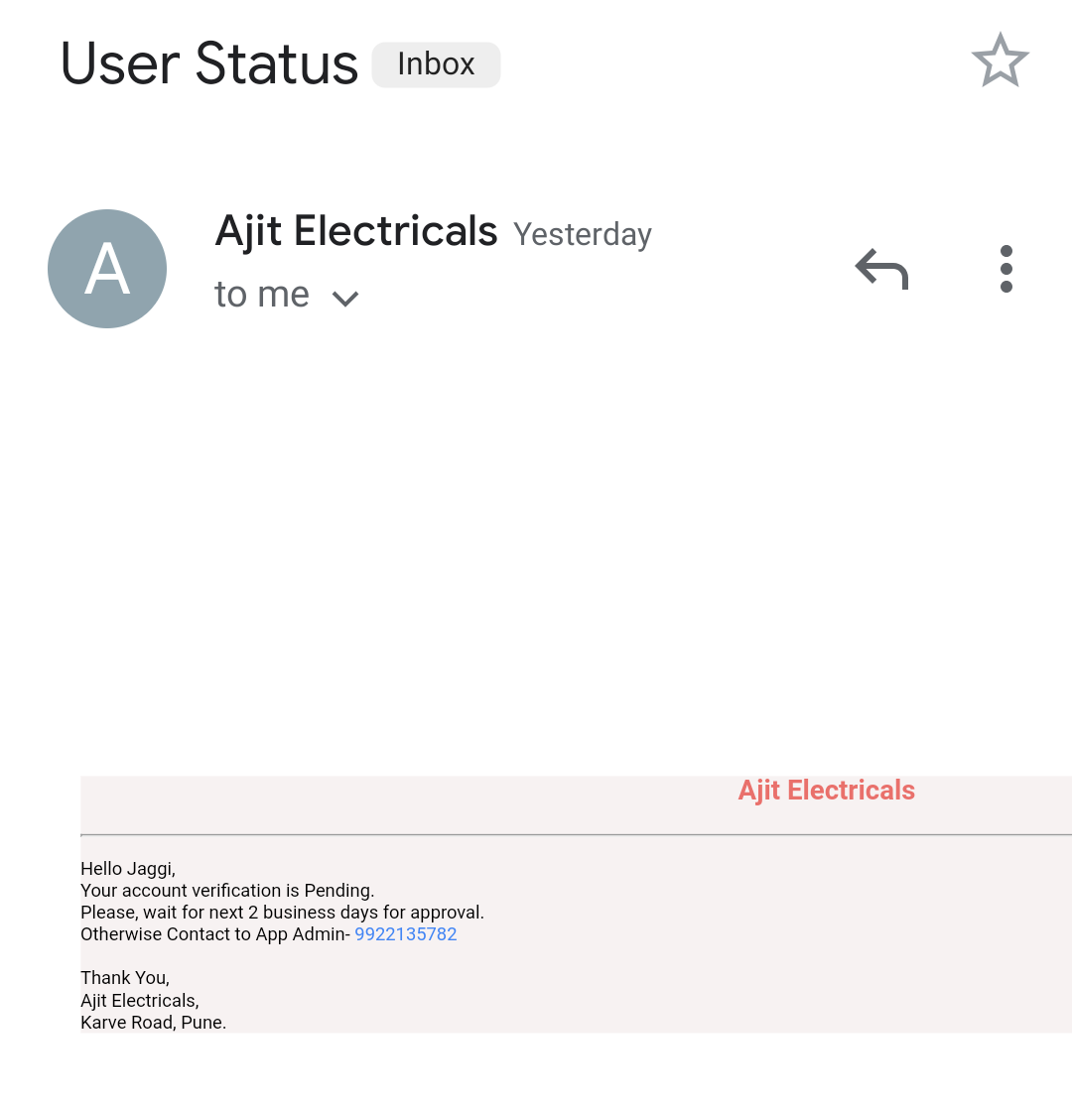

4. After two days you will get mail from ajit admin accepted your account request.

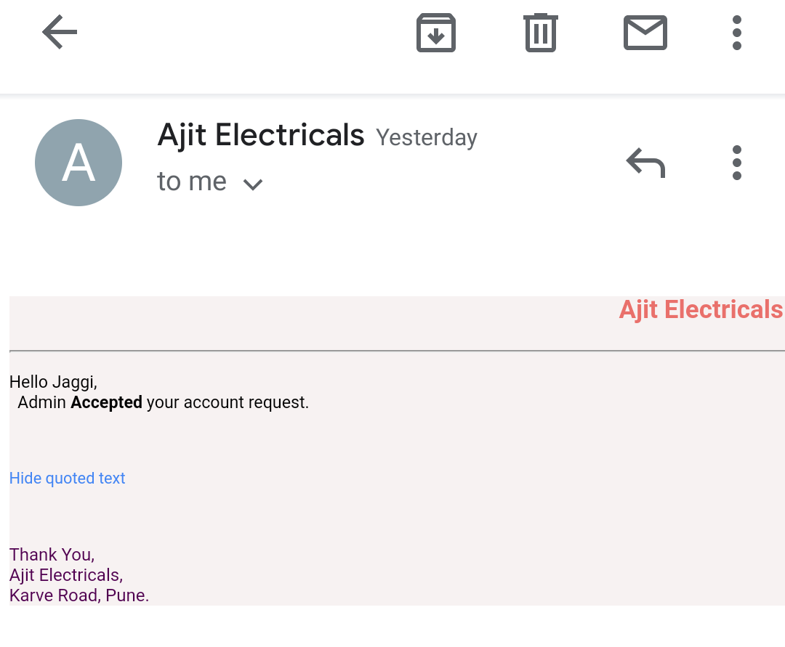

5. Sign in credentials.

* User can sign in in three ways.
  + In House
  + Out House
  + Dealer
* User role is specified by the admin only and status is updated by admin.

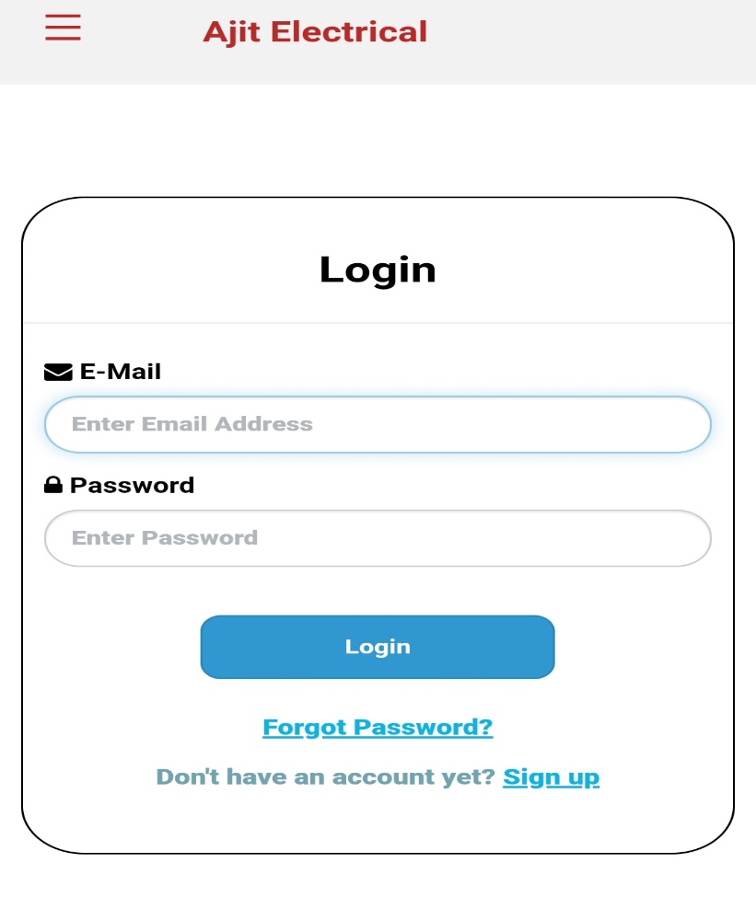

**ROLE OF IN HOUSE:**

In house user have these functionalities.

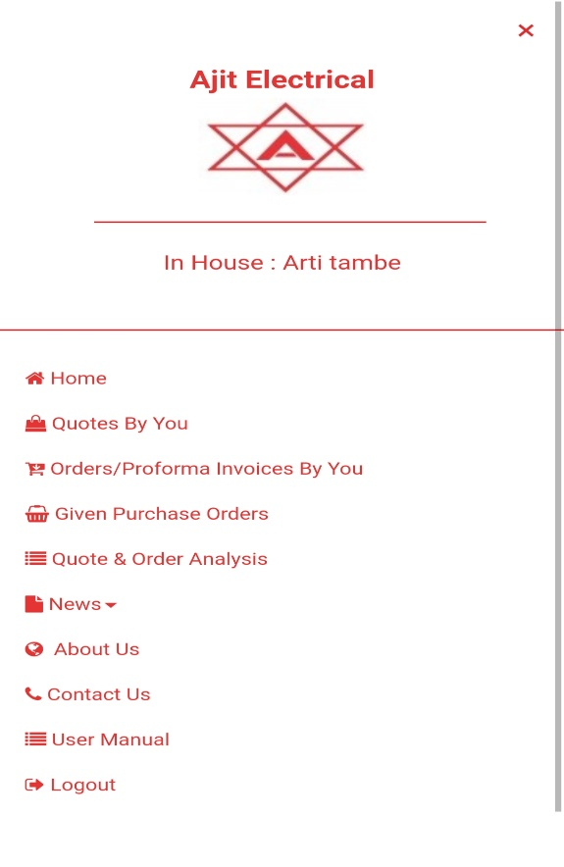

In House is provided with MOP (Minimum operational Price)

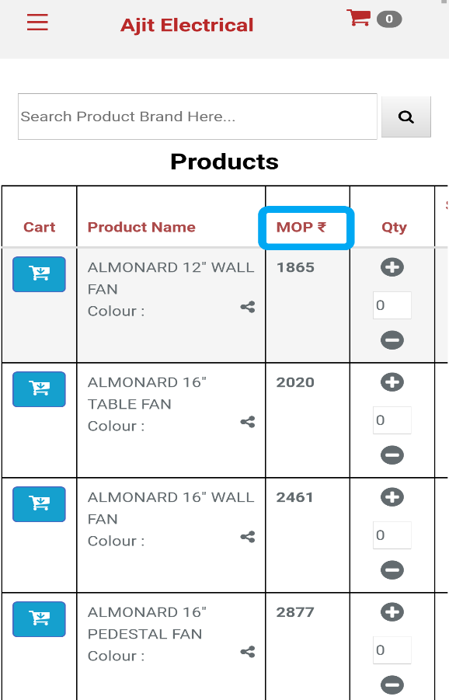

**ROLE OF OUT HOUSE:**

Out House is provided with following functionalities.

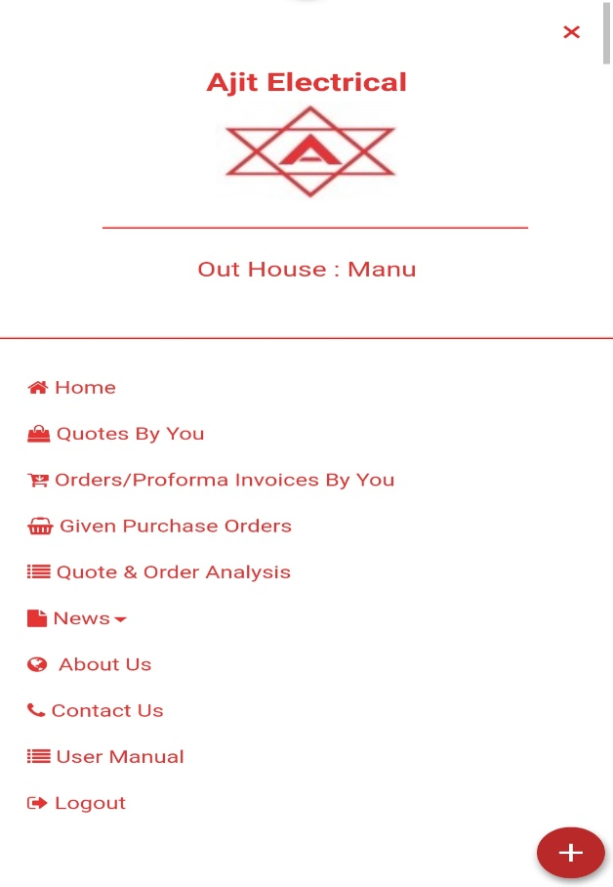

Out House is provided with DP (Dealer Price)

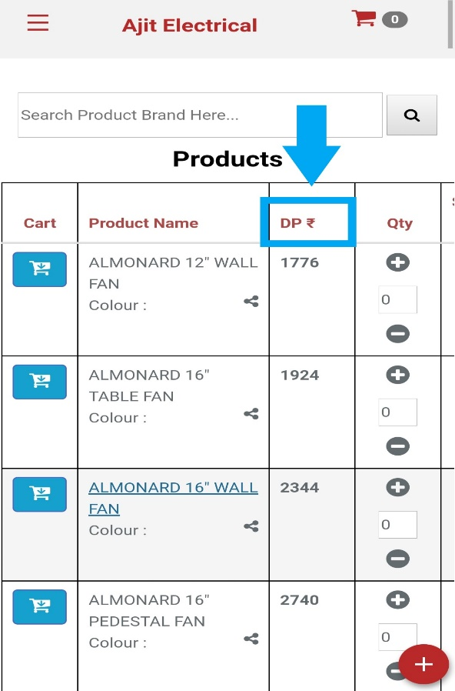

**ROLE OF DEALER:**

Dealer is provided with following functionalities.

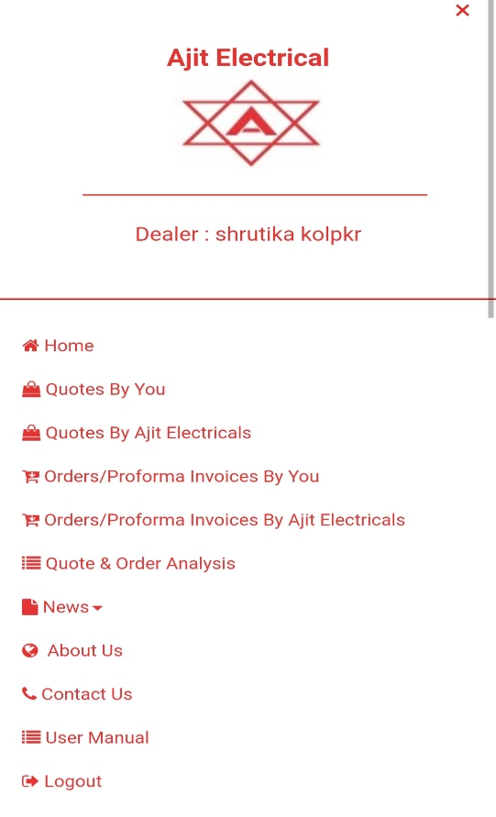

Dealer is provided with DP (Dealer price)



**HOW TO GENERATE QUOTE & ORDER:**

* Firstly, you have to select the quantity (1).
* Proceed to step two (2) to save product into cart.
* Then proceed to step (3) to generate order & quote.

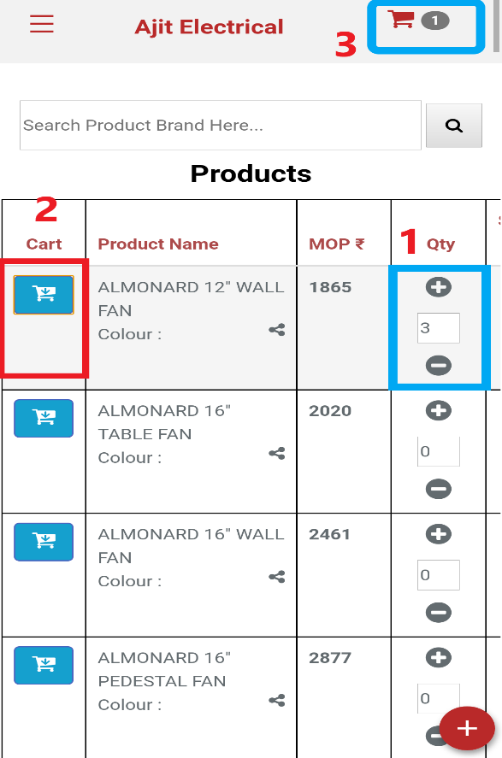

* After clicking step (3) you can see your cart with products for which you can make a quote / order.
* You can also increase quantity from point (1) and can also remove or delete product from point (2) as described in below figure.

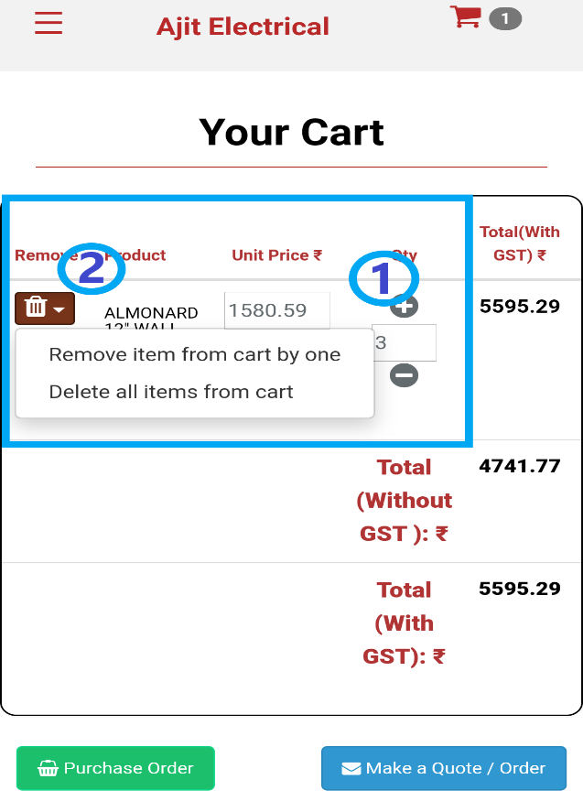

* Click on Make a quote/ order button pointed with red arrow to generate quote or order.

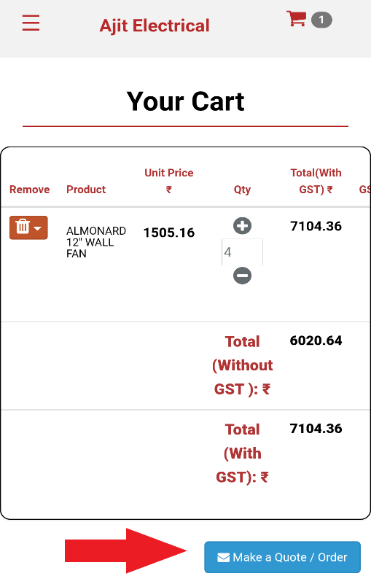

**Generate order**

Click on generate order button to generate your product order.

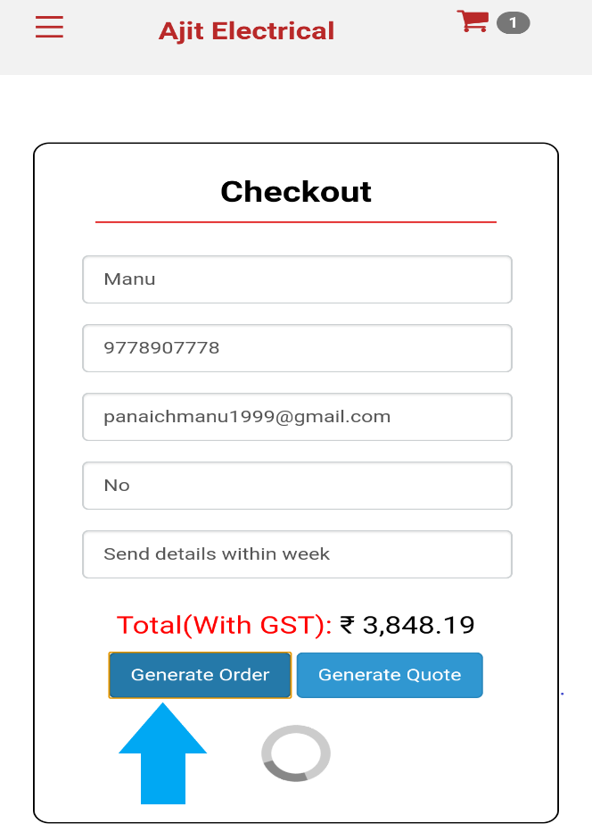

After pressing button, you will get mail from Ajit Electricals regarding your order as shown below:

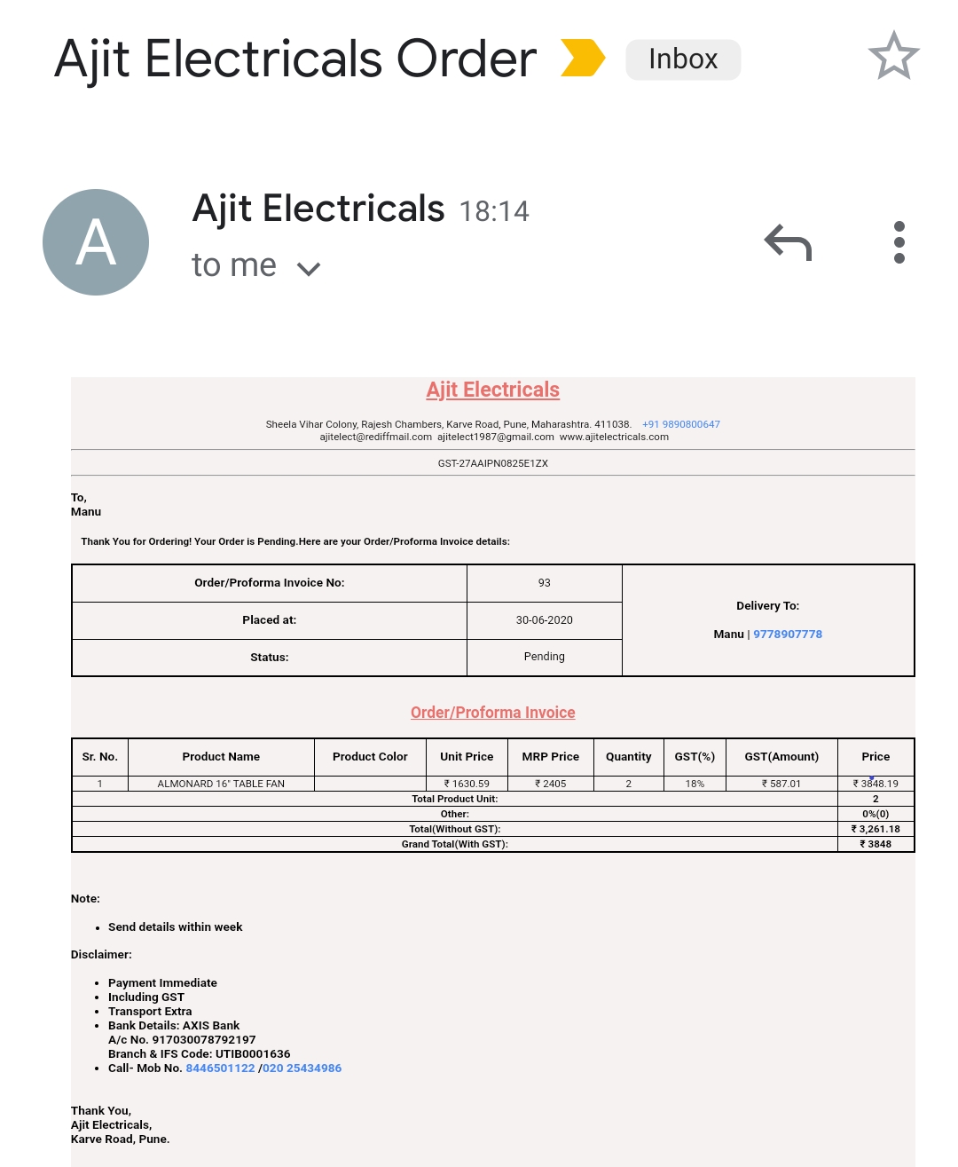

**Generate Quote**

To generate quote, click on generate quote button as pointed in below figure.

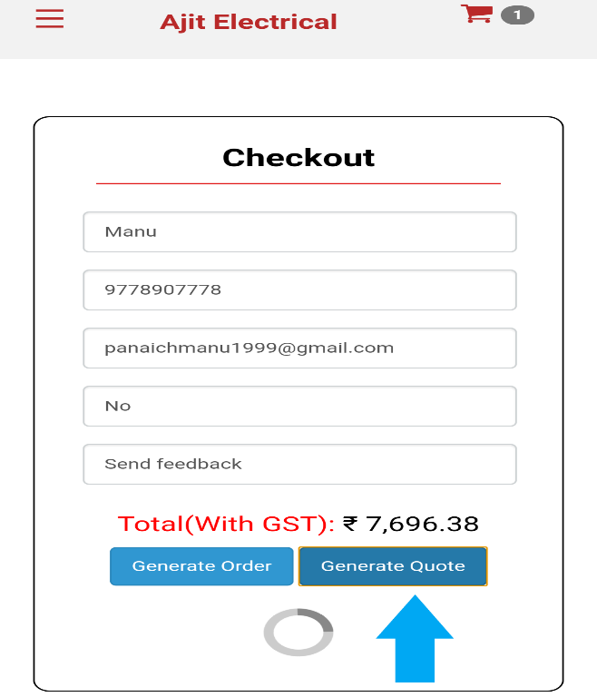

And you will receive mail from Ajit Electricals regarding your quote as shown below:

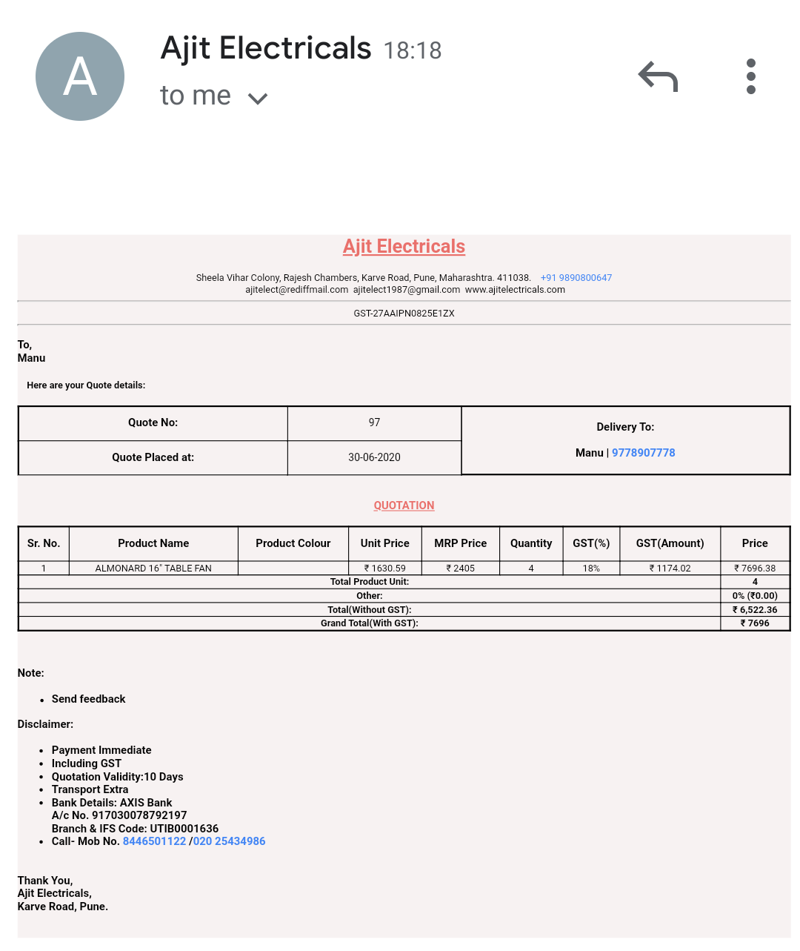

**HOW TO DOWNLOAD, UPDATE & DELETE QUOTE OR ORDER:**

DOWNLOAD: On clicking on download tab (pointed in figure with blue arrow) you can download your order and quote.

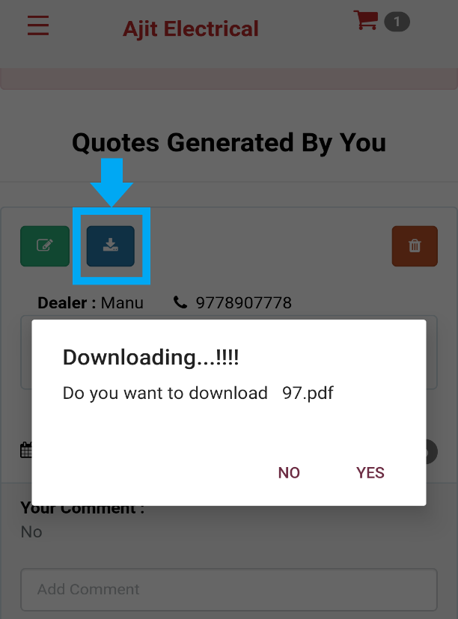

DELETE: Click on delete button (pointed in figure with blue arrow) to delete your quote or order, but you can only delete after 45 days. As shown in below figure.

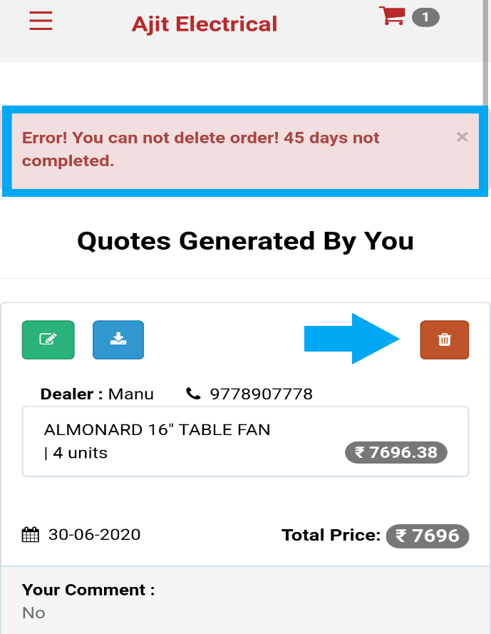

UPDATE: You can also update you order or quote whenever you want from update tab (pointed in figure with blue arrow).

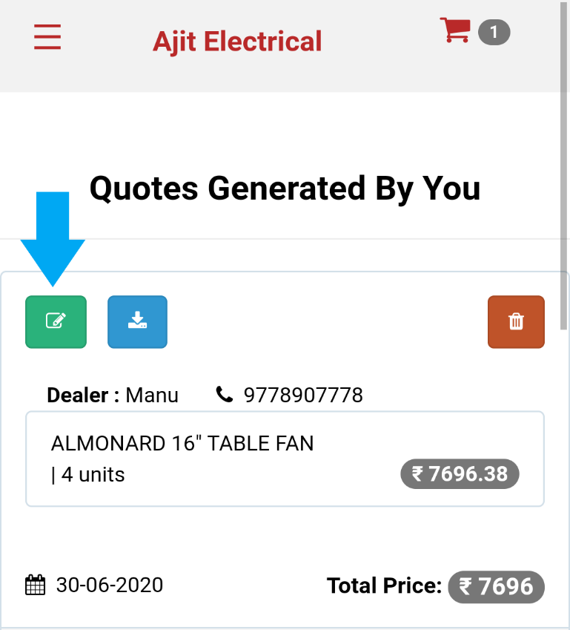

* After clicking on update tab, you will get below screen from where you can make all changes.

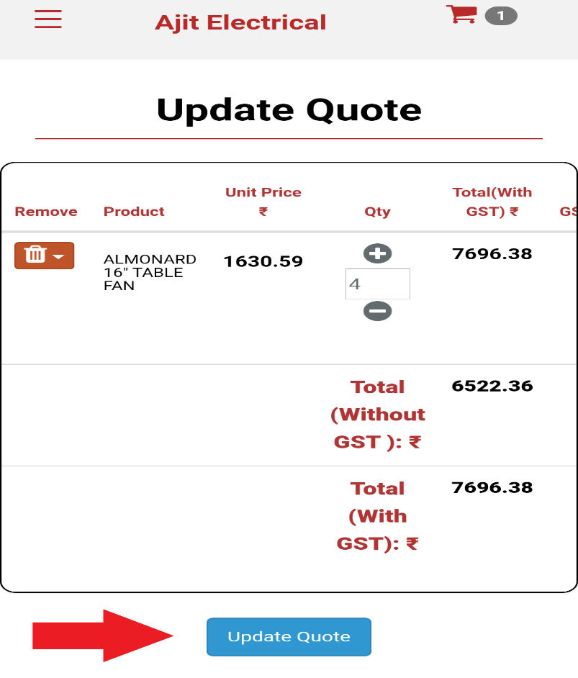

You can also add comment in your order or quote by clicking on submit comment (marked as 1) and can also convert your quote into order from convert button (marked 2).

