* **DIRECTOR MESSAGE – DOD Doctors on Door Lifeline**

It gives me immense pleasure in representing DOD Lifeline to the corporate world as the Director. Right through our journey, DOD Lifeline has focused on building leaders who deliver true value to the organizations that they work for – not just in terms of work-related competence, but also the strong ethics and value system that guides them as individuals and corporate citizens. We selects individuals with high leadership potential.

We are the providers of comprehensive, seamless and integrated services of creating a link between Doctors and Patients, fixing their appointments, meeting the needs of both in real time. We understand seeking medical treatment outside your home can be physically and mentally difficult. So at DOD Lifeline, we are eager to get you the best medical facility.

* **CORPORATE SALES MANAGER:- Er. Kirtesh Jagtap, Aeronautical**

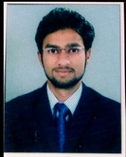Sales people are the people who brings business to the organization. For every deal you close, you likely face countless unanswered calls and emails -- not to mention uninterested or even hostile prospects. It can be hard to power through all the "*No's*" on the road to a "*Yes.*" But you know who else has encountered rejection? Some of the greatest thinkers, leaders, and businesspeople of our time and they didn't just persevere through the hard times -- failure is what made them succeed.

So, the next time you feel your obstacles are overwhelming, just remember that "Our greatest weakness lies in giving up. The most certain way to succeed is always to try just one more time."

* **RESEARCH AND DEVELOPMENT EXPERT: Miss. Namrata Valvi, M.sc**

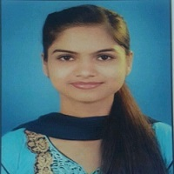Although pharmaceutical industry is quite old, starting from the age of Ayurveda to the today’s age of telemedicine but the main motive remains the same i.e., to meet the constant health issues that need to be conquered for the endurance of human life. As a team it’s our priority to continuously improve ourselves by engaging in the research and development work. There is a saying that “Yesterday is experience, today is experiment and tomorrow is expectation”

Therefore we should use our experience in our experiment, to achieve our expectation. We all should know that Research is not about finding new things it is simply about finding out the solution or making the present better.

* 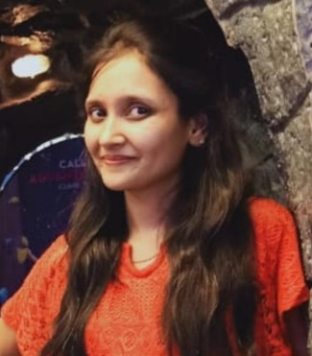**EMPLOYEE RELATIONS MANAGER: Miss. Prachi Bhakkad, MBA HR**

Our ideology is that employees are asset for an organization, they are the driving wheels which helps any organization to achieve its goals. We believe that a stronger employee relationship leads to better employee morale and job satisfaction.

Open communication as we believe communication is the key to remove any misunderstanding. Showing recognition by appreciating the employee. Investing in employees as by that they feel belonging to the organization.

* **COMPANY LEGAL ADVISOR:- Mr. Shripal Jethekar Exp. 4 year**

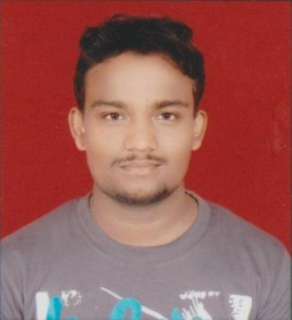The organization works in a society and for the society as well in governed by various policies and programmes of the law. It is required by the organization to work in a set framework as prescribed by the law. But not every business is not very much aware about the legal rules and regulations therefore here comes the role of company’s legal advisor. A legal advisor is one who provides legal advice and services in a specific area of law to the organizations.

There are several duties performed by the legal advisor such as draft and negotiate contracts, ensure compliance with corporate law, Provide counsel for employee and management conflicts. Hence it is important for the organization to have legal advisor to work on various law related matters.

* **WHAT DO WE DO?**
* DOD is an appointment booking system which allows patients to view real-time availability of doctors and practices, and book instant appointments using smartphone apps.
* Using DOD, instant appointments are booked by patients and are automatically added to the DOD Ray scheduler.
* DOD sends automated notifications to patients and to the doctor with whom the appointment is booked, making the process entirely seamless and automatic. They also get notification through booking system which is provide to the doctors.
* DOD also gives emergency service to patients through call, free of cost.
* We have expert doctors available 24/7 for your health.
* We also take care of your medicine which is prescribed by doctors. On time home delivery is also done.
* **OUR PROMISE TO DOCTORS AND PATIENTS:**
* Well maintained clinics and hospitals.
* Authorised Doctors with medicine facility.
* Email Campaigns to our regular family doctors and patients.
* Maintain professional attitude and ethical standards.
* Website to the doctors in our support of Digital India campaign.
* Online payment management system and booking system.
* Great offers to our patients.
* Free medical check up in our hospitals.
* Bulk SMS Campaigns.
* Expert guidance to the patients in case of emergency.
* Connections to different villages, tehsils, districts, and states.

