**INTRUDER DETECTION SYSTEM**

A PROJECT REPORT

submitted by

M Priyadharshan 15BCE0679

Komal Gulati 17BCE0596

Sakshi Gupta 17BCE0477

Amreeta Koner 17BCE2033

Nikita Nandankar 17BCB0108

*in partial fulfilment for the award*

of the

**B.Tech**

degreein

**Computer Science and Engineering**

**School of Computing Science and Engineering**



**CONTENTS**

|  |  |  |
| --- | --- | --- |
| **Chapter Title** | **Page** |  |
| Title Page  Declaration |  | i  ii |
| Certificate |  | iii |
| Table of Contents |  | v |
| List of figures |  | vi |
| Abstract |  | vii |

1. **Introduction**
   1. Back ground of theproblem
   2. Motivation of the proposedwork
   3. Focus of the proposedwork
   4. Proposed workcontribution

### LiteraturesSurvey

* 1. Existing work in the context of proposedwork
  2. Limitations of the existingwork
  3. Research gaps from existingwork
  4. Objectives of the proposedwork

### Overview of the ProposedSystem

* 1. Method andapproaches
  2. Metrics andmeasurements
  3. Overview organization of the proposed work (ContextDiagram)
  4. Data Analysismethods

### Proposed System Analysis and Design(As Per IEEEStandard)

* 1. ArchitectureDiagram
  2. ProposedModel
  3. WorkingPrinciple:
  4. Algorithms of the proposedwork
  5. Description of the proposedwork
  6. NON-FUNCTIONALREQUIREMENTS
     1. Reliability
     2. Availability
     3. Security
     4. Maintainability
     5. Portability
  7. Engineering StandardRequirements
  8. Hardwarerequirements:
  9. SoftwareRequirements:

1. Results andDiscussion
   1. Implementation:
   2. Testing andDebugging:
   3. EvaluationCriteria
   4. Application interface & Experimental setup
   5. Results obtained through proposedapproach
   6. Description of the results obtained through proposed approach 6.5. Comparison with existing studies and methods (Plot graphs and suitableevidence)
2. Conclusion, limitation and future scope ofwork
3. References:

**LIST OF FIGURES**

|  |  |  |
| --- | --- | --- |
| **Figure NO.** | **TITLE** | **PAGE NO.** |
| **1.** | IDS ARCHITECTURE | 11 |
| **2.** | CIRCUIT DIAGRAM | 12 |
| **3.** | PROPOSED MODEL | 17 |
| **4.** | ARCHITECTURE DIAGRAM | 18 |
| **5.** | CIRCUIT OF BURGLAR ALARM SYSTEM | 19 |
| **6.** | BLOCK DIAGRAM | 19 |
| **7.** | WORKING OF PIR SENSOR | 20 |
| **8.** | ARDUINO UNO BOARD | 23 |
| **9.** | PIR SENSOR | 23 |
| **10.** | BUZZER | 24 |
| **11.** | GSM MODULE | 24 |
| **12.** | IMPLEMENTATION | 25 |
| **13.** | SERIAL MONITOR VALUES | 26 |

**ABSTRACT:**

The most vital issues in data security application space is Intruder DetectionSystem. IDS is a cautious forceful framework to ensure data, checking and reacting to happening assaults on PC frameworks and systems. This paper gives the review ofthe best in class in interruption location investigate. Interruption recognition frameworks are programming or potentially equipment segments that screen PC frameworks and examine occasions happening in them for indications of interruptions. Because of far reaching decent variety and multifaceted nature of PC frameworks, it is hard to give a totally secure PC framework. In this way, there are various security frameworks and interruption discoveryframeworks that address distinctive parts of PC security. In this we are using the wireless home security which deserves very less amount of power. Now-a-days the home is not safe in security purposes, to protect with good security purposes, we providing some ideas through this paper based on GSM based wireless home security which keeps home safe fromintruder.

Expected outcome: The GSM based home security system will be designed and tested with the mobile network. The user can get alerts anywhere through the GSM technologythusmakingthesystemlocationindependent.Aflexiblewaytocontroland explore the services of the mobile, AT commands is used in the system. The communication of home is only through the SMS which has been tested with the mobile networks and will work on any mobilenetwork.

## Introduction to intruder detection:

The major history and goal of intruder detection is to check whether the network assets to identify odd behavior and abuse in network . Intruder detection plan was presented in mid 1980's after the advancement of internet with observation end checking the danger. From that point forward, a few occasions in IDS innovation have propelled interruption identification to its present state. James Anderson's composed a paper for an administration association and imported an approach that review trails contained essential data that could be profitable in following abuse and comprehension of client conduct and understanding of user behavior. At that point the discovery showed up and review information and its

significance prompted fabulous upgrades in the subsystems of each working framework . IDS and Host Based Interruption Location Framework (HIDS) were first characterized. In 1983,SRIWorldwideandDorothyDenningstartedtakingashotatanadministrationventure thatpropelledanotherexertionintointerruptiondiscoveryframeworkimprovement.Around 1990s the incomes are produced and interruption recognition showcase has been raised. Genuine secure is an interruption identification organize created byISS.

# Introduction

### Background of the problem:

An intruder detection system (IDS) screens system or framework exercises for malignantexercisesorstrategyinfringementandproducesreportstoanadministration station. Intrusion Location Frameworks (IDS) are essentially centred around recognizing possible incidents, recognizing data about them, tries to stop them, and sends a message or redirect a call that that tells about your home update or predefined message which is embedded in micro controller. An IDS is referred as burglaralarm.

For example: Burglar alarm is the kind of lock system in the home, and it protects from intruder. If someone enters the house and try to break the lock system, the alarm whichislocatedinthehousedetectsthatthelockhasbeenbrokenandalertstheowner by raising analarm.

Moreover, though the system is a wireless home security which consumes very less amount of power. Moreover PIR sensor is used at the entry point to a precedence for producingasignalthroughpublictelecomnetworkandsendthecallormessagetothe owner through real time application, it immediately alerts the owner fromintruder.

Wireless sensor network(WSN) are connected to different fields of science and innovation: To assemble data with respect to human exercises and conduct, for example, social insurance, etc. Then again, security in WSNs is an essential issue, particularly on the off chance that they have missionbasic errands. For example, a

private patient wellbeing record ought not be discharged to outsiders in a heath mind application.

Intruder detection system is needed for convenience and safety. This systeminvented to keep home safe from intruder. In this work, we present the design and implementationofaGSMbasedwirelesshomesecuritywhichtakeaverylesspower. The system is a wireless home network which contains a GSM modem. The system can response rapidly as intruder detect and GSM module will do alert home owner. This security system for alerting a house owner wherever he will. In this system a PIR(Passive Infrared Sensor) installed at entry point to a precedence produce a signal through a public telecom network and sends a message or redirect a call that that tells aboutyourhomeupdateorpredefinedmessagewhichisembeddedinmicrocontroller. Suspected activities are conveyed to remote user through SMS or Call using GSM technology.

Fromlastfewyearhomesecurityisanessentialrequirementofhouseholdstokeep home safe from intruders to get rob. So we try to implement an algorithms and make some gradates that keep your home safe from intruders. This leads to advance technologythatmake yourhomeintelligentormodernthiscalledashomeautomation system also. With this technology house owner can control other appliances as well like lighting system, dimming, electrical appliances and many more. Now a day's wireless technology is used to control home appliances instead of wired topological connection. GSM(Global System for Mobile Communication) technology makesused tocommunicateinputsignalfromappliancestooutputmessageondevice.Thatmeans after detection of any intrusion GSM Modem sends the appropriate message to house owner's phone. The signals or data which is comes from sensors or other equipment digitize it by GSM module and send it toreceiver.

### Motivation of the proposedwork:

In the recent years the home security is a main part of problem faced by the human. The main problem is to keep home safe from intruders to get theft.

Sowetrytoimplementanalgorithmsandmakesomegradatesthatkeepyourhomesafe fromintruders.Thisleadstoadvancefuturetechnologythatmakeyourhousesafefrom intruder this called as home automation system. By using this technology house owner can control other appliances as well as healthcare, military surveillance and

reconnaissance, highway traffic; to monitor physical and environmental phenomena, such as ocean and wildlife, earthquake, pollution, wild fire, water quality; to monitor industrial sites, such as building safety, manufacturing machinery performance. Now a day's wireless technology is used to control home appliances instead of wired topological connection. GSM(Global System for Mobile Communication) technology makes used to communicate input signal from appliances to output message on device. ThatmeansafterdetectionofanyintrusionGSMModemsendstheappropriatemessage to house owner's phone. The signals or data which is comes from sensors or other equipment digitize it by GSM module and send it toreceiver.

This interruption identification framework screens singular frameworks upon the system. For this situation, the sensor of the IDS is situated within the specific host to screen framework level conduct. This kind of interruption discovery is particularly helpful for checking possibly hazardous client action inside the system. A report by System Partners makes a decent contention for have based interruption identification, expressing, and any veiling methods, for example, inclusion, cushioning, fracture, or out-of-succession conveyance, which would sidestep a system based IDS can be effortlessly gotten by a host based IDS." Moreover, have based IDSs can be very powerful in exchanged conditions, while arrange based IDS frameworks are less powerful in that condition. A change has a tendency to segregate interchanges on the system, making it troublesome for arrange based IDS to screen all activity. Be that as it may, if the frameworks on the exchanged system have based IDSs introduced, potential assaults might be impeded.

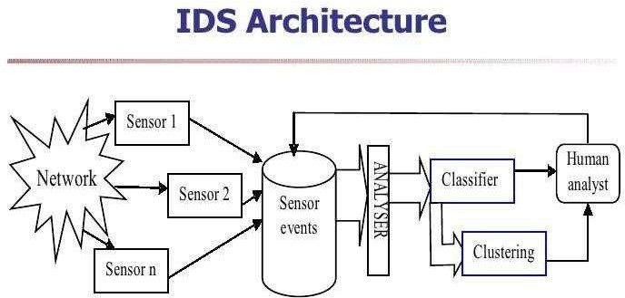

### Figure 1:IDS ARCHITECTURE

* 1. **Focus on the proposedwork:**

This system construct with Arduino which contains a piece of

code for a specific action. The action will be taken by the GSM modem to alert an owner about intruder or danger to house. That device should be installed on the door, as the intruder opens the door and someone walk in PIR sensor will detect them and theappropriateactionwillbetakenbyGSMmodemandthebuzzerattachedtocircuit will be turnedon.

Algorithm:

Step1: Initialize Arduino, buzzer, PIR sensor, GSM module with connection.

Step2: Switch on the circuit and keep it on .

Step3: If PIR sensor couldn’t detect any movement of the body then keep as it is.

Step4: Else if PIR sensor detect the movement of the body then GSM module will send SMS to owner and buzzer will be turned on.

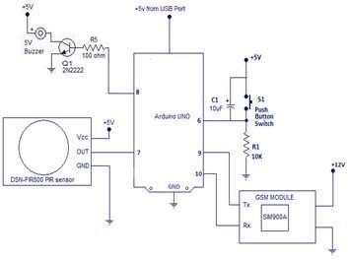

### Figure 2:CIRCUIT DIAGRAM

* 1. **Proposed workcontribution:**

*NAME: Revanthan U REG NO: 15BCE0135*

*Contribution: intruder detection system program code. NAME: Sudharshan*

*REG NO: 15BCE0310*

*Contribution: intruder detection system design.*

# Literatures Survey

### Existing work in the context of proposedwork

**LINK:**

[**http://research.ijcaonline.org/volume65/number23/pxc3886273.pdf**](http://research.ijcaonline.org/volume65/number23/pxc3886273.pdf)

The basic idea for the project came from this website. This website simply explained the usage of Intruder detection system. This paper titled "Proposed Interruption

Discovery Framework" is an interruption recognition framework (IDS) proposed by investigating the rule of the interruption location framework in view of host and system. Here we are thinking and breaking down general execution and additionally security of the proposed IDS. In addition the proposed IDS affirm the adequacy of the proposedstrategy,andexhibitedcomesaboutshowspreferencesofhostbasedandalso organize based security. The proposed model of half and half IDSs offers a few focal pointsoveroptionframeworks.Aboveallelseitgavehighersecurity,itbolsteredhigh accessibility and versatility, and most essential thing it created great outcomes as far as would be expected and strange practices of caught bundle. The proposed demonstrateincorporatesreconciliationofindividualsegmentstocreatedplayercomes about.

LINK: [https://www.ijircce.com/upload/2014/november/38H_A%20Survey.pdfT](https://www.ijircce.com/upload/2014/november/38H_A%20Survey.pdf)his research paper is about the Survey of Intrusion Detection System

Using Different Data Mining Techniques written by Trupti Phutane, ApashabiPathan. This Paper examine about the way toward finding the obscure example from given arrangement of examples. If there should arise an occurrence of interruption recognition framework, we utilize the idea of information mining we will discoverthe example which will track all clients action to discover the gatecrashers. In existing frameworkweareconcentratingonlearningdesigningproceduresinwhichthechoices are gone up against the premise of some settled run the show. For the most part interruption discovery framework is isolated in two general classifications i.e. interruption identification framework utilizing affiliation administer mining and interruption recognition framework utilizing occasion connection informationmining.

LINK: <https://www.hindawi.com/journals/tswj/2015/314601/>

**This is a advanced version of the intruder detection system.** The topic is Fusion of Heterogeneous Intrusion Detection Systems for Network Attack Detection written by jayakumarkaliappan.Aninterruptionidentificationframework(IDS)recognizesdiversesorts of assaults by and large, and the discovery rate will be higher for some particular class of assaults. This paper is planned on the possibility that every id is proficient in identifying a particularsortofassault.InproposedNumerousIDSUnit(MIU),therearefiveIDSunits,and everyidtakesafteraoneofakindcalculationtorecognizeassaults.Thecomponentchoiceis

finished with the assistance of hereditary calculation. The chose highlights of the info movementarepassedontotheMIUforhandling.Thechoicefromeveryidisnamedasnearby choice. The combination unit inside the MIU forms all the neighborhood choices with the assistance of larger part voting principle and settles on a ultimate conclusion. The proposed framework demonstrates a decent change in recognition rate and lessens the false alertrate.

### LIMITATIONS OF THE EXISTINGWORK:

This interference revelation structure screens particular systems upon the framework. For this circumstance, the sensor of the IDS is Overall Journal of PC Applications (0975–8887)Volume65–No.23,Walk201347arrangedinsidetheparticularhostto screen system level direct. This sort of intrusion area is especially useful for checking conceivably perilous customer development inside the framework. Clearly there are two sorts of host-based interference area programming: have wrappers (or individual firewalls) and administrator based programming. Here delineate the host wrappers as contraptions that can be intended to look at all framework bundles, affiliation tries, or loginattemptstothecheckedmachine.Themasterbasedprogramminghasanunclear limit from the host wrappers, yet can moreover perceive changes in structure records andchangesincustomerbenefits.AreportbyFrameworkAccomplicesmakesabetter thanaveragedisputeforhavebasedinterferencedistinguishingproof,communicating, and any veiling techniques, for instance, incorporation, padding, irregularity, or out- of-course of action movement, which would evade a framework based IDS can be easily gotten by a host based IDS." In addition, have based IDSs can be extremely effective in traded circumstances, however sort out based IDS structures are less convincing in that condition. A change tends to separate exchanges on theframework, makingittroublesomefororchestratebasedIDStoscreenalldevelopment.Regardless, if the structures on the traded framework have based IDSs presented, potential ambushes may bedisturbed.

### RESEARCH GAPS FROM EXISTINGWORKS:

The research gaps in the intruder detection system lies has different scopes in fields like data mining,neural networks and learning patterns from Unix process execution tracesetc.Atechniqueispresentedforrecognizinginterruptionsattheleveloffavored

procedures. Proof is given that short arrangements of framework calls executed by runningproceduresareadecentdiscriminatoramongsttypicalandanomalousworking attributes of a few basic UNIX programs. Ordinary conduct is gathered in two routes: Artificially, by practicing however many typical methods of utilization of a program ascouldreasonablybeexpected,andinaliveclientconditionbyfollowingthegenuine execution of the program. In the previous case a few sorts of nosy conduct were examined; in the last case, comes about were investigated for false positives.and the another scope in the intruder detection system is the circulated and open structure of distributed computing and administrations turns into an alluring focus for potential digital assaults by gatecrashers. The customary Interruption Discovery and Counteractive action Frameworks (IDPS) are to a great extent wasteful to be sent in distributed computing conditions because of their receptiveness and particular quintessence. This overviews, investigates and advises analysts about the most recent created IDPSs and alert administration strategies by giving a thorough scientific classificationandexploringconceivableanswersforrecognizeandavoidinterruptions in distributed computing frameworks. Considering the coveted attributes of IDPS and distributed computing frameworks, a rundown of relevant prerequisites is distinguishedandfourideasofautonomicregisteringself-administration,metaphysics, hazard administration, and fluffy hypothesis are utilized to fulfil thesenecessities.

### OBJECTIVES OF THE PROPOSEDWORK:

InthisprojectforHumanComputerInteractions,wewillbemakingansysteminvented to keep home safe from intruder. In this work, we present the design and implementation of a GSM based wireless home security which take a very lesspower. The system is a wireless home network which contains a GSM modem. The system can response rapidly as intruder detect and GSM module will do alert home owner. This security system for alerting a house owner wherever he will. In this system a PIR(Passive Infrared Sensor) installed at entry point to a precedence produce a signal through a public telecom network and sends a message or redirect a call that that tells aboutyourhomeupdateorpredefinedmessagewhichisembeddedinmicrocontroller. Suspected activities are conveyed to remote user through SMS or Call using GSM technology.

# Overview of the ProposedSystem

### Method andapproaches

By using this Intruder Detection System we can secure industry or home very easily. This system consists of a sensor which monitors the area and gives an output whenever a person is moving at the premises. The output of the sensor is given to the control unit, when the control unit gets an input from the sensor then itproducesanalarmalsosendsacommandtotheGSMmodemsothatthemodem sends an SMS to corresponding number which is preloaded in the control unit. This system continuously monitors the status of sensors connected to it. If any of the sensor gives the output indication, then microcontroller based system automatically sends the SMS alerts to the user. After completion of the command implementation this system sends the confirmation messages back to the calling user.

The basic components in such a system are:

* + 1. PIRSensor
    2. Arduinoboard
    3. Arduino unocable
    4. Gsm module 800 SIMA
    5. A simcard
    6. A mobiledevice
    7. Jumperwires

### Metrics andmeasurements

|  |  |  |
| --- | --- | --- |
| **Item** | **Quantity** | **Cost** |
| Arduino | 1 | 500 |
| Arduino uno cable | 1 | 150 |

|  |  |  |
| --- | --- | --- |
| Gsm module 800 SIM A | 1 | 1150 |
| Jumper wire | 10 | 3.5 |
| PIR sensor | 1 | 150 |
| A mobile device | 1 |  |
| A SIM card | 1 |  |

* 1. **Overview organization of the proposed work (ContextDiagram)**

The proposed model is given in the circuit below

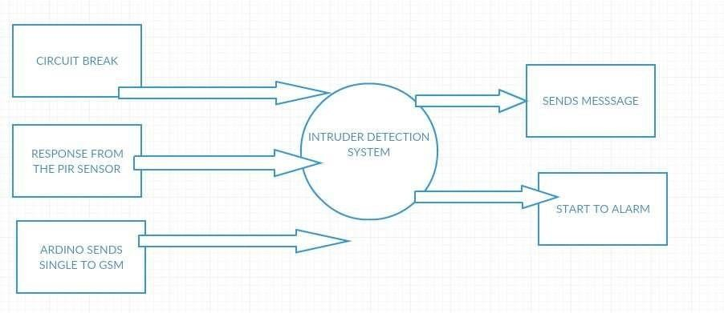

### Figure 3:PROPOSED MODEL

This is our model which consists of an Arduino UNO board, GSM Module, PIR Sensor, a 5V Buzzer. We would like to connect our circuit as given in the diagram aboveandthenprogramwithArduinosuchthatifPIRSensorvalueishighthebuzzer beeps, the LED blinks and the SMS is sent.

### DATA ANALYSIS METHOD

AsuccessfulburglaralarmsystemutilizingArduinoUNOboardandaGSMModule has been made. Future enhancements could be added in order to improve the product. We plan on implementing a keypad which stores information about which modeof

operationtobeoperatingonalongwithakeypadsecuritysystemwhichmeansthatthe alarmwouldbetriggeredwithin15secondsofdetectionunlessthepasswordsavedby the home owner is typed and the alarm once triggered will last for half an hour unless the password is typed. A Burglar alarm system which was aimed at the middle class population has been successfully implemented using Arduino Board which is a Free OpenSourceSoftware(FOSS)alongwithaPIRSensor,BuzzerandGSMmodulehas been successfully implemented and on testing works perfectly. We plan on implementing our future enhancements as soon as possible to make this product more marketworthy.

# Proposed System Analysis and Design(As Per IEEEStandard)

### ArchitectureDiagram

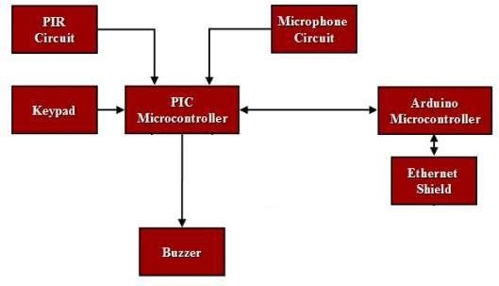

**Figure 4:ARCHITECTURE DIAGRAM**

* 1. **ProposedModel**

The proposed model is given in the circuit below

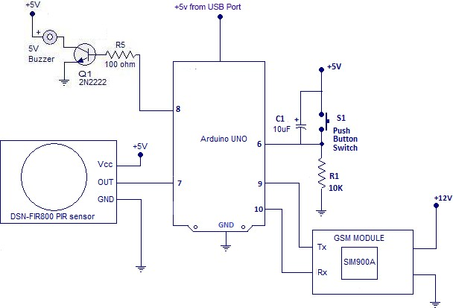

### Fig 5: Circuit of Burglar Alarm System

This is our model which consists of an Arduino UNO board, GSM Module, PIR Sensor, a5V Buzzer.Wewouldliketoconnectourcircuitasgiveninthediagramaboveandthenprogram with Arduino such that if PIR Sensor value is high the buzzer beeps, the LED blinks and the SMS issent.

### Block Diagram:

**Fig 6: Block Diagram**

* 1. **WorkingPrinciple:**

TheprincipleofthisprojectismainlybasedontheworkingofthePIRSensor.ThePIRsensor itselfhastwoslotsinit,eachslotismadeofaspecialmaterialthatissensitivetoIR.Thelens used here is not really doing much and so we see that the two slots can 'see' out past some distance (basically the sensitivity of the sensor). When the sensor is idle, both slots detect the same amount of IR, the ambient amount radiated from the room or walls or outdoors. When an intruder crosses the PIR sensor, it first intercepts one half of the PIR sensor, which causes *apositivedifferential*changebetweenthetwohalves.Whenthewarmbodyleavesthesensing area, the reverse happens, whereby the sensor generates a negative differential change. These change pulses are what is detected.

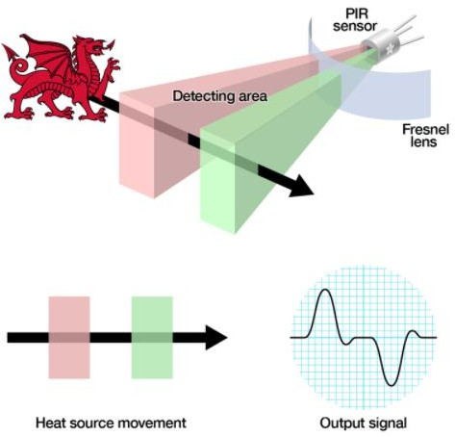

### Fig 7: Working of PIR Sensor

This is then written into the Arduino board as the PIR was set as a Pin Input. The microcontroller which is then programmed to set the pin containing buzzer HIGH and also to send signal to GSM Module to send a message to the home owner.

### Algorithm of the proposed workAlgorithm:

Step1: Initialize Arduino, buzzer, PIR sensor, GSM module with connection. Step2: Switch on the circuit and keep it on .

Step3: If PIR sensor couldn’t detect any movement of the body then keep as it is.

Step4: Else if PIR sensor detect the movement of the body then GSM module will send SMS to owner and buzzer will be turned on.

### Description of the proposed work

Byutilizingthis IntruderDetectionSystemwecansecureindustryorhomeeffectively.This frameworkcomprisesofasensorwhichscreenstherangeandgivesayieldatwhateverpoint amanismovingatthepremises.Theyieldofthesensorisgiventothecontrolunit,whenthe control unit gets a contribution from the sensor then it delivers an alert additionally sends a charge to the GSM modem with the goal that the modem sends a SMS to comparing number whichispreloadedinthecontrolunit.Thisframeworkconstantlyscreensthestatusofsensors associated with it. On the off chance that any of the sensor gives the yield sign, at that point microcontroller based framework consequently sends the SMS alarms to the client. After fruition of the summon execution this framework sends the affirmation messages back to the callingclient.

### REQUIREMENTS

* 1. **NON-FUNCTIONALREQUIREMENTS**
     1. Reliability

Burglar Alarm runs 24 hours a day and 356 days a year with the fault rate less than 1/10000.But the user can witch it off when ever required

* + 1. Availability

Burglar Alarm supports normal electronic equipments.

* + 1. Security

It is full secured and no one can surpass it .

* + 1. Maintainability

Burglar Alarm home has a backup system. When the main system is out of order, the backup will continue to work and send message to call Maintainer.

* + 1. Portability Easilyprotable.

### Engineering StandardRequirements

For evaluation of the system we have to consider those below

* Correctness – whether it satisfies the needs in smart home visiondocument.
* Efficiency - amount of computing resources and code required to performfunction
* Flexibility – how much we can expend the functions of smarthome.
* Integrity/Security-factorsthatprotectthesoftwarefromaccidentalormaliciousaccess,use, modification, destruction, ordisclosure
* Interoperability - effort needed to couple software and thehardware
* Maintainability - ease of maintenance for disabilities and oldpeople
* Reliability - factors required to establish the required reliability of thesystem
* Reusability - extent to which it can be reused for otherpeople
* Testability - effort needed to test to ensure performs asintended
* Usability - effort required to learn, operate, prepare input, interpretoutput
* Availability - factors required to guarantee a defined availability level for thesystem.

### Hardwarerequirements:

* + - **ARDINO UNO:** Ardino Uno is used to connect output of PIR sensor, buzzer and gsm module. USB cable is used to connect the computer code to the hardware. Ardino IDE uses C++ language and makes it simple for the user tounderstand.

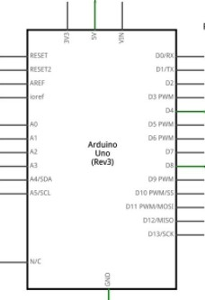

**Fig 8:** Arduino UNO board pin diagram

* + - 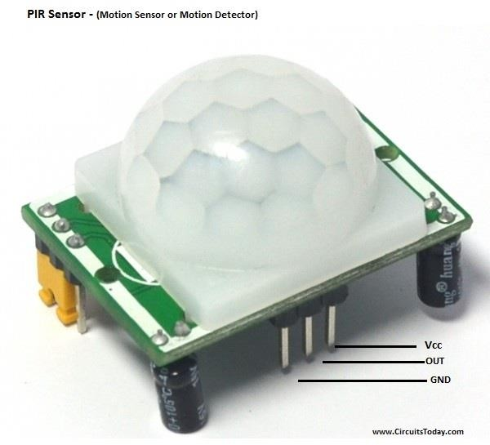**PIR SENSOR:** This sensor is used to detect the motion of the intruder in our project. Itmeasurestheinfraredlightradiatedbyobjectswithinthedistanceof5to12m.Since allobjectswithtemperatureaboveabsolutezeroemitradiationsininfraredwavelength, PIR sensor is used to detect object and its motion by detecting itsenergy.

**Fig 9:** PIR Sensor

* + - **Buzzer:** Buzzer is used to signal when someone has entered the house. It creates an alarm when the output from the PIR sensor is high (when PIR sensor identifies movement of aobject).

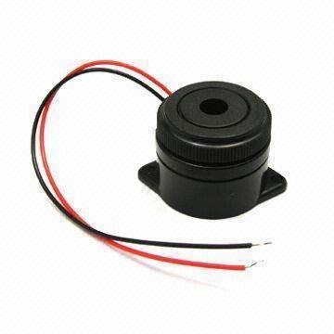

**Fig 10:** Buzzer

* + - **Switch:**Switchisrequiredforthisprojecttoresetthewholesystemafteritisactivated.
    - **GSM module:** Global system for mobile communication is used in our project tosend amessagetotheownerwhensomeonetriedtoenterthehouse.WhenPIRsensorgives output as high then GSM module is activated and sends message with the use of asim.

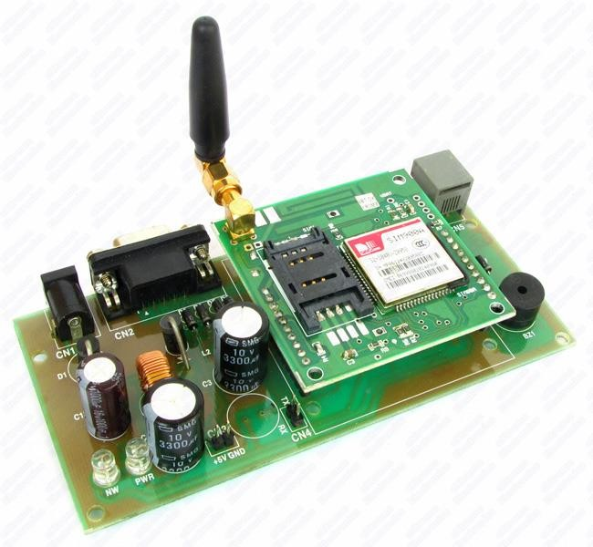

**Fig 11:** GSM Module

* + - **Sim:** A 2g sim is required to connect to the network and send message to theowner.

### SoftwareRequirements:

Os:Windows 8 or Windows 8.1 or Windows 10 Software:Arduino Ide

### Implementation:

1. **Results and Discussion**

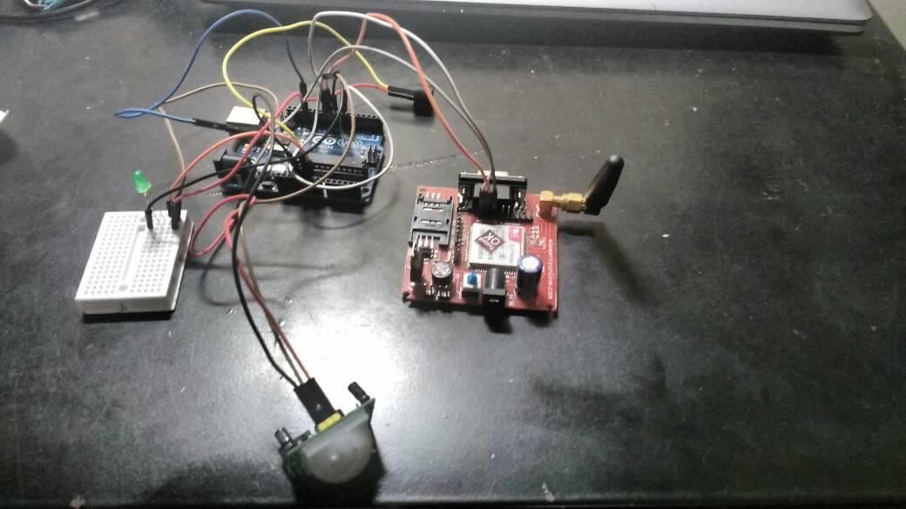

**Fig 12:** Implementation of Project

### Testing andDebugging:

|  |  |  |  |  |
| --- | --- | --- | --- | --- |
| **S**  **No.** | **Test Case** | **Expected Output** | **Obtained Output** | **Comment** |
| 1 | PIR Sensor Value is 0 | No Buzzer beep or SMS sent | No Buzzer beep or SMS sent | Pass |
| 2 | PIR Sensor Value is 1 | Buzzer beepsand SMSSent | Buzzer beeps and SMSSent | Pass |



**Fig 13:** Serial Monitor Values

### EvaluationCriteria

The IDS is requesting recommendations from qualified merchants inspired by this venture as determined in this. The IDS saves the privilege not to grant any agreement for the venture. The Vendor might give the Owner a one week see preceding work starting at the proposedareas.Utilities,ifrequired,mightbehadfromoffices,andshouldbeutilizedjustas coordinatedbytheProprietorupontheVendor'sask.Everysellerisurgedtovisiteachsiteto end up plainly completely familiar with the offices, extent of the undertaking, administration and challenges of giving this administration or finishing this task. Neither extra pay nor help from any commitments will be conceded on account of an absence of learning of the site(s) ortheconditionsunderwhichtheworkwillbeexpert.MerchantsmightinstantlytelltheIDS of any equivocalness, irregularity or blunder which they may endless supply of the Request forProposals.Understanding,revisionandchangestotheDemandforProposalswillbemade by composed addendum and sent to every single enrolledmerchant.

Understanding,amendmentsorchangesmadeinsomeotherwaywon'ttie.Anyagdendamust be recognized in theProposal.

### Application interface & Experimentalsetup

This framework build with Arduino which contains a bit of code for a particular activity. The move will be made by the GSM modem to alarm a proprietor about interloper or peril to house. That gadget ought to be introduced on the entryway, as the gate-crasher opens the entryway and somebody stroll in PIR sensor will recognize them and the fitting move will be made by GSM modem and the signal connected to circuit will be turned on.

### Description of the results obtained through proposedapproach

The IDS may lead exchanges with any Vendor that presents a proposition. Amidthe course of such dialogs, the IDS should not uncover any data stamped private inside any proposition and may talk about relative estimating with at least one Vendors. The IDS may likewisetalkwithVendorsamidtheassessmentprocedure.ChosenSellersmightbeaskedfor to give oral introductions. Those Vendors will be told to organize particular circumstances. The IDS won't be in charge of any cost of the Vendor's introduction. The IDS maintains whateverauthorityisneededtoarrangedetails,termsandconditionswhichmightbeessential or suitable to the achievement of the reason for this RFP. After a survey of the recommendations, and conceivable oral introductions, the IDS expects to go into an concurrence with the chose Vendor. On the off chance that an assention isn't finished in a sensible measure of time as dictated by the IDS in its sole caution, at that point the IDS maintains whatever authority is needed to consult with different Vendors as may best serve the interests of the IDS. TheIDS holds the comfortable time and for any motivation to cross out this Request for Proposals or any part thereof, to dismiss any or all proposition, or to acknowledge a substitute proposition. The IDS claims all authority to postpone any unimportant deformity in any proposition. Unless generally indicated by the Seller, the IDS hasninety(90)days fromthedistributedaccommodationdatetogointoanconcurrencewith a Vendor. The IDS may look for elucidation from a Vendor whenever and disappointment to react expeditiously is cause for dismissal. Stop IDS of Highland won't be at risk, under any condition, for any expenses brought about by Merchants in answering to thisRFP.

### Comparison with existing studies and methods (Plot graphs and suitableevidence)

The fundamental thought for the undertaking originated from this site. This site just clarifiedtheuseofIntruderidentificationframework.Thispapertitled"ProposedInterruption Discovery Framework" is an interference acknowledgment structure (IDS) proposed by researching the manage of the intrusion area structure in perspective of host andframework.

Here we are considering and separating general execution and also security of the proposed IDS. What's more the proposed IDS insist the sufficiency of the proposed system, and displayed comes to fruition demonstrates inclinations of host based and furthermore sort out based security. The proposed model of cream IDSs offers a couple of central focuses over choice structures. To the exclusion of everything else it gave higher security, it reinforced high availability and flexibility, and most fundamental thing it made awesome results similarly as would be normal and odd practices of got package. The proposed show joins compromise of individual portions to made player comes to fruition.

This exploration paper is about the Survey of Intrusion Detection System Utilizing Different Data Mining Techniques composed by Trupti Phutane, Apashabi Pathan. This Paper look at about the path toward finding the dark case from given course of action of illustrations. On the off chance that there ought to emerge an event of intrusion acknowledgment system, we use the possibility of data mining we will find the illustration which will track all customers activity to find the interlopers. In existing structure we are focusing on getting the hang of outlining systems in which the decisions are gone up against the commence of some settled run the show. Generally intrusion revelation structure is detached in two general characterizations i.e. intrusion recognizable proof structure using association oversee mining and interference acknowledgment system using event association data mining.

Thisisapropelledadaptationofthegatecrasheridentificationframework.Thesubject isCombinationofHeterogeneousIntrusionDetectionSystemsforNetworkAttackDetection composed by jayakumar kaliappan. An interference distinguishing proof structure (IDS) perceives various sorts of attacks all around, and the disclosure rate will be higher for some specific class of ambushes. This paper is moved toward the likelihood that each id is capable in recognizing a specific kind of ambush. In proposed Numerous IDS Unit (MIU), there are fiveIDSunits,andeachidtakesafterastand-outestimationtoperceiveattacks.Thesegment decision is done with the help of innate count. The picked features of the data development are passed on to the MIU for taking care of. The decision from each id is named as close-by decision. The blend unit inside the MIU frames all the area decisions with the help of bigger partvotingruleandsettlesonanextremeconclusion.Theproposedstructureexhibitsabetter than average change in acknowledgment rate and reduces the false readyrate.

# Conclusion, Limitations and Scope for futureWork

Taking everything into account, the undertaking prerequisite has been effectively accomplished.BothPIRandMicrophonecircuithasbeenplanandexpandonPCB.Sincethe yield of these circuit was little, the required to intensification and separating stages. With a specificendgoaltogivethesesignstoamicrocontroller,someflagmouldingtechniqueshave been connected. In the PIR circuit, a comparator has been use to give a computerized yield 0V or 5V. While in the receiver circuit a technique has been taken after to give an simple yield from 0V to 5V. PIR and Microphone PCBs have been utilized together with PIC microcontroller, Arduino Uno board, Ethernet shield, keypad, to make a gatecrasher caution framework.Theoverallframeworkcouldidentifyhumandevelopmentandvoiceandgivethe client numerous fates, for example, great client interface, simple guideline to take after anda web access to the framework. The result of this undertaking has created circuit plan and examination abilities. This task offers a phenomenal information about channel, intensification, and flag moulding stage. And in addition, increasing a few involvement with utilizing building programming instruments for re-enacting circuits and making PCBs. It too gives the chance to apply and build up the programming aptitudes for both PIC and Arduino microcontrollers.

This impedance disclosure structure screens specific frameworks upon the system. This kind of interruption territory is particularly valuable for checking possibly risky client advancement inside the structure. Plainly there are two sorts of host-based impedance range programming: have wrappers (or individual firewalls) and executive based programming. Here portray the host wrappers as contraptions that can be expected to take a gander at all system groups, connection tries, or login endeavors to the checked machine. The ace based programming has a misty point of confinement from the host wrappers, yet can additionally see changes in structure records and changes in client benefits. A report by Framework Accomplices improves a than normal debate for have based impedance recognizing confirmation,imparting,andanyveilingsystems,forexample,fuse,cushioning,abnormality, or out obviously of activity development, which would sidestep a structure based IDS canbe effortlessly gotten by a host based IDS." what's more, have based IDSs can be to a great degree compelling in exchanged conditions, however deal with based IDS structures areless

persuading in that condition. A change tends to isolate trades on the system, making it troublesomeforcoordinatebasedIDStoscreenalladvancement.Inanycase,ifthestructures on the exchanged system have based IDSs displayed, potential ambushes might bebothered.

ABurglaralarmsystemwhichwasaimedatthemiddleclasspopulationhasbeensuccessfully implemented using Arduino Board which is a Free Open Source Software (FOSS) alongwith a PIR Sensor, Buzzer and GSM module has been successfully implemented and on testing works perfectly. We plan on implementing our future enhancements as soon as possible to make this product more marketworthy.

# References:

1. Piyare, R. (2013). Internet of Things : Ubiquitous Home Control and MonitoringSystem using Android based Smart Phone, *2*(1), 5–11.https://doi.org/10.5923/j.ijit.20130201.02
2. Elshafee, A., & Hamed, K. A. (2012). Design and Implementation of a WiFi BasedHome Automation System, *6*(8), 1074–1080.
3. Javale,D.(2013).HomeAutomationandSecuritySystemUsingAndroidADK,*3*(2),382– 385.
4. Mishra, Y., Marwah, G. K., & Verma, S. (2015). Arduino Based Smart RFID Securityand Attendance System with Audio Acknowledgement, *4*(1),363–367.
5. Mowad,M.A.E.,Fathy,A.,&Hafez,A.(2014).SmartHomeAutomatedControlSystem Using Android Application and Microcontroller, *5*(5), 935–939.
6. Adriansyah, A. (2016). Design of Small Smart Home system based on Design of Small Smart Home System Based on Arduino, (August 2014). https://doi.org/10.1109/EECCIS.2014.7003731
7. Potts, J., & Sukittanon, S. (2012). Exploiting Bluetooth on Android Mobile Devices for Home Security Application,0–3.