Restaurant Administration Database Management System

CSE2004- DBMS PROJECT REPORT
(J Component )

submitted by

Amreeta Koner
17BCE2033

in partial fulfillment for the award of the degree of

B. Tech

in

School of Computer Science and Engineering(SCOPE)


Vellore-632014, Tamil Nadu, India
School of Computer Science and Engineering
November, 2018

ABSTRACT
The Database is designed in a way that both the Admin and the User can access the database management system and according to their needs and requirements, the functions have been designed.
The first database stores the information of the user where details like username, phone numbers, email id and address have been stored and a membership card is issued. The number written on this membership card is also stored in the same database. The data store hence helps the authority to contact their user and study them.
The second database that has been made is the employee database where details of the employee are stored.

The databases that can be accessed and are linked with the User Account are:
1. Database where the user can request for a certain food to be added to the Menu and ,after reviewing the request the authority can decide whether or not the request should be entertained.
2. The feedback database where the User can give feedback on his or her experience about the restaurant which the authority can use for publicizing their restaurant if needed.
3. Database where they can place their order ,from where the food that is to be served is processed.

The databases that can be accessed and are linked with the Admin Account are:
1. The Menu database where Admin can add items to the present menu of the restaurant.

2. The User database where the admin has the power to register a new user on the spot.

- INTRODUCTION
A database is an organized collection of data, stored and accessed electronically. Database designers typically organize the data to model aspects of reality in a way that supports processes requiring information, such as (for example) modelling the availability of rooms in hotels in a way that supports finding a hotel with vacancies.
The database management system (DBMS) is the software that interacts with end users, applications, and the database itself to capture and analyze data. A general-purpose DBMS allows the definition, creation, querying, update, and administration of databases. A database is generally stored in a DBMS-specific format which is not portable, but different DBMSs can share data by using standards such as SQL and ODBC or JDBC. The sum total of the database, the DBMS and its associated applications can be referred to as a "database system". Often the term "database" is used to loosely refer to any of the DBMS, the database system or an application associated with the database.
It is also generally to be expected the DBMS will provide a set of utilities for such purposes as may be necessary to administer the database effectively, including import, export, monitoring, defragmentation and analysis utilities. The core part of the DBMS interacting between the database and the application interface sometimes referred to as the database engine.
Often DBMSs will have configuration parameters that can be statically and dynamically tuned, for example the maximum amount of main memory on a server the database can use. The trend is to minimise the amount of manual configuration, and for cases such as embedded databases the need to target zero-administration is paramount.
The large major enterprise DBMSs have tended to increase in size and functionality and can have involved thousands of human years of development effort through their lifetime.
Early multi-user DBMS typically only allowed for the application to reside on the same computer with access via terminals or terminal emulation software. The client–server architecture was a development where the application resided on a client desktop and the database on a server allowing the processing to be distributed. This evolved into a multitier architecture incorporating application servers and web servers with the end user interface via a web browser with the database only directly connected to the adjacent tier.

- OVERVIEW OF THE PROPOSED SYSTEM
The proposed system consist of the following components-

2.1 SYSTEM ARCHITECTURE:
Software to be used for the completion of this project:-

1. Net Beans IDE
2. MySQL database
3. JDBC Drivers

For the database model Java programming language using NetbeansIDE will be done, as the frontend part. In the backend MySQL software is used and structured query language will be used to create a database. The frontend and backend will then be connected using JDBC drivers.

2.2 MODULE DECSCRPTION:

The project can be divided into two part in the initial phase:
Login (Main Class)-
a. User Login-
i. Login
ii. SignUp
iii. Forgot Password
b. Admin Login-
i. Login
ii. Forgot Password

The User Module has the following three components:
Request Food On The Menu: Requesting to add an item on the menu
Your Opinion On Our Loopholes: Feedback Page for Customers
Order Food: For Ordering Food Online
The Admin Module can be divided into two components:
Decide Menu: Add and amend the restaurant’s menu.
Enter Customer Details: For Registering Customers Details and opening an account on the spot

Main Class:
The main class of the project guides the person to enter the admin or the user account, whichever is appropriate for him/her.
According to the necessity, one of the button are clicked.
User Login:
The User Login helps the users to access their account
This has been made to keep the data of the user protected.
The User can access Signup, Forgot Password and Login from this page.
Forgot Password:
This page has been made to retrieve the password of the user
The password of the user is retrieved after entering few private details which only the user knows.
User signup:
User enters the details of himself/herself and signups to get this data stored into the database.
The details of the user stored helps them to create an account of their own and access it through back button.
Admin Login:
This is the page through which the admin logs in entering correct details that is provided to them during the time of joining.
Since detail is provided by the company, there is no need for the Admin to Signup.
Loading Page:
Loads the account of either the user or the admin.

User Account:
The User Home page has three components:
a. Request Food on the Menu
b. Your Opinion about Our Loopholes
c. Order Food

Request For Food Page:
Here the user can add orders they wish to see on the menu
If approved, the admin adds it on the menu database.
Order Placing Page:
Here the user places order for the items he or she wish to eat.
Feedback Page:
The user gives feedback about his or her experience on the restaurant and way it can improve
It also gives provision to the user to rate the restaurant.
Admin Account:
The Admin Home page has two components:
a. Decide Menu
b. Enter Customer Details

Decide Menu:
The Menu that is to be added is decided by the admin
It adds an order or a food item into the menu database.

Entering Customer Details:
The admin can make a new account for the new users on the spot.

- RESULTS AND DISCUSSION:
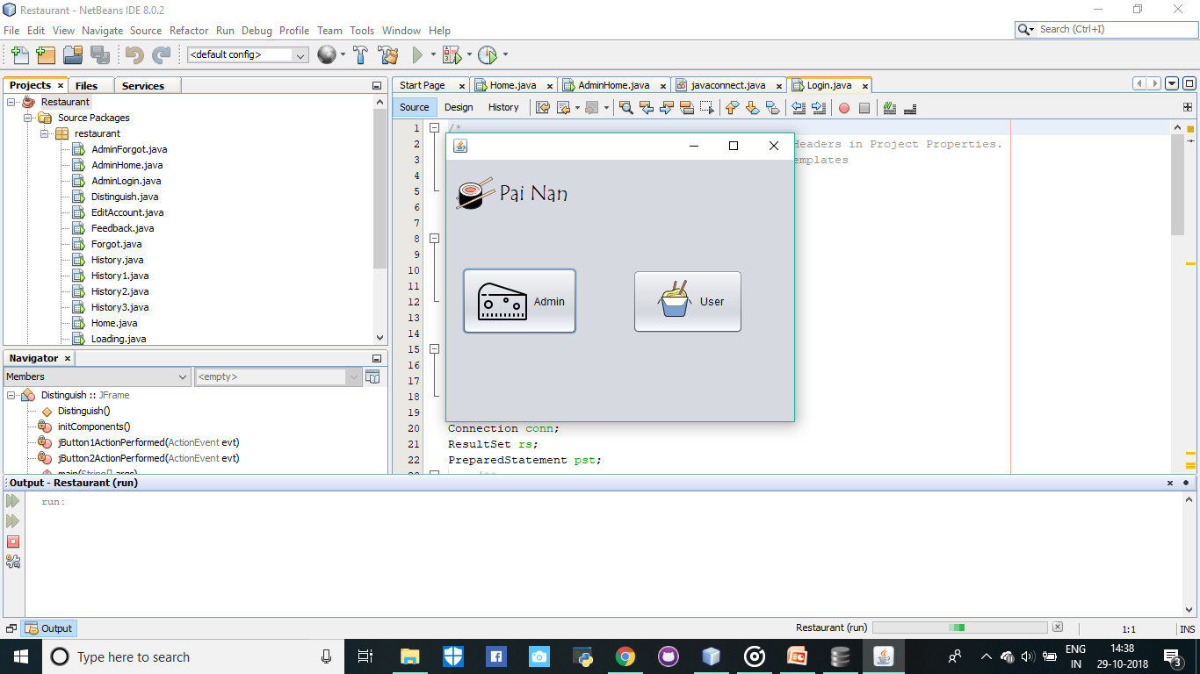
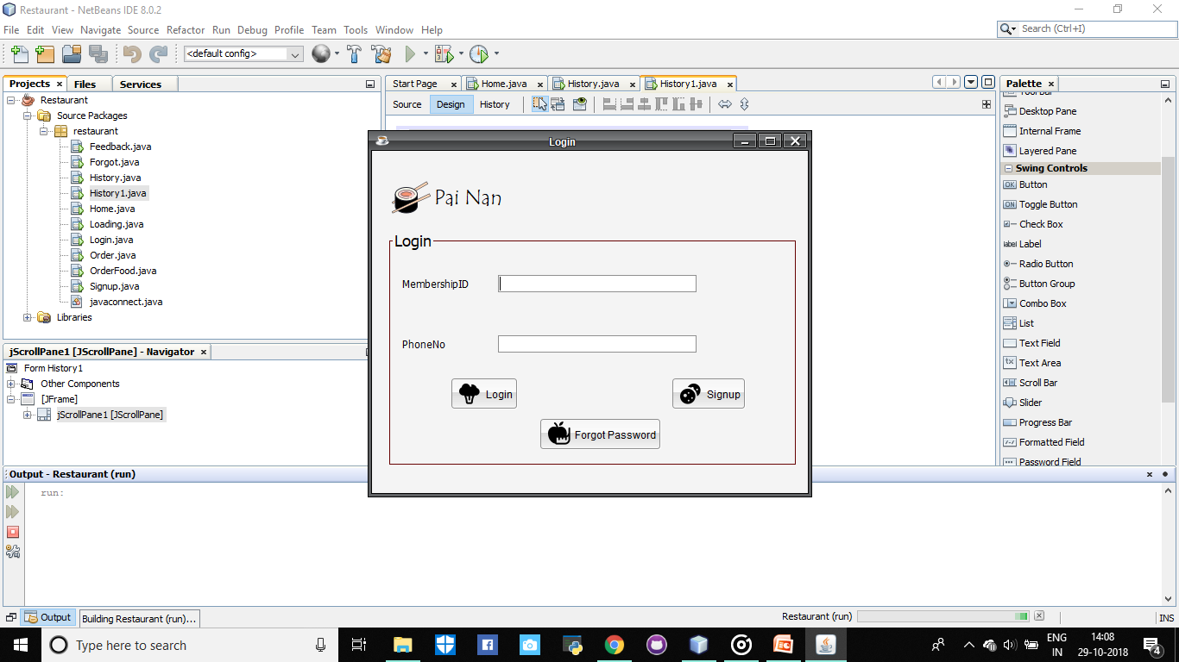
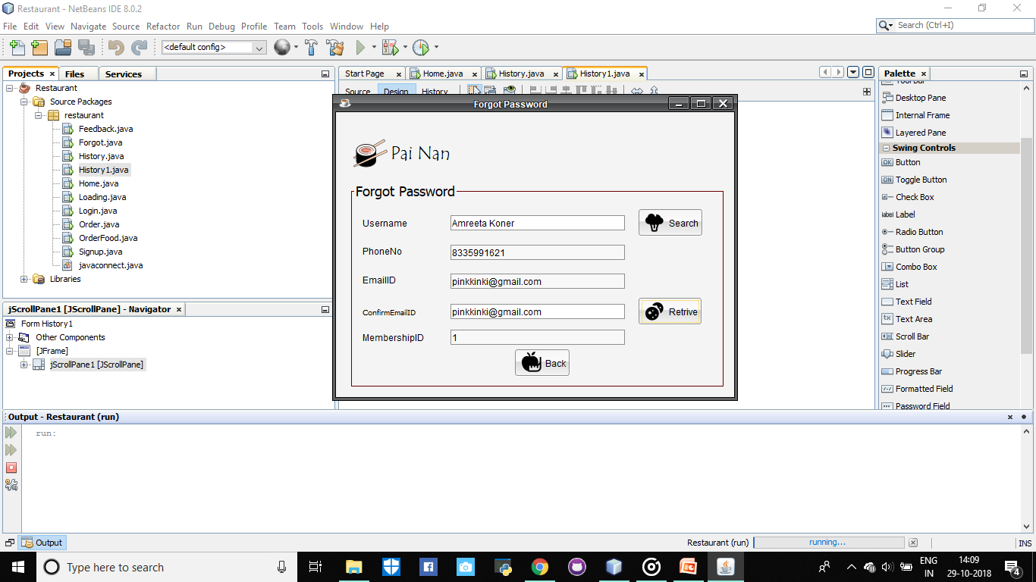
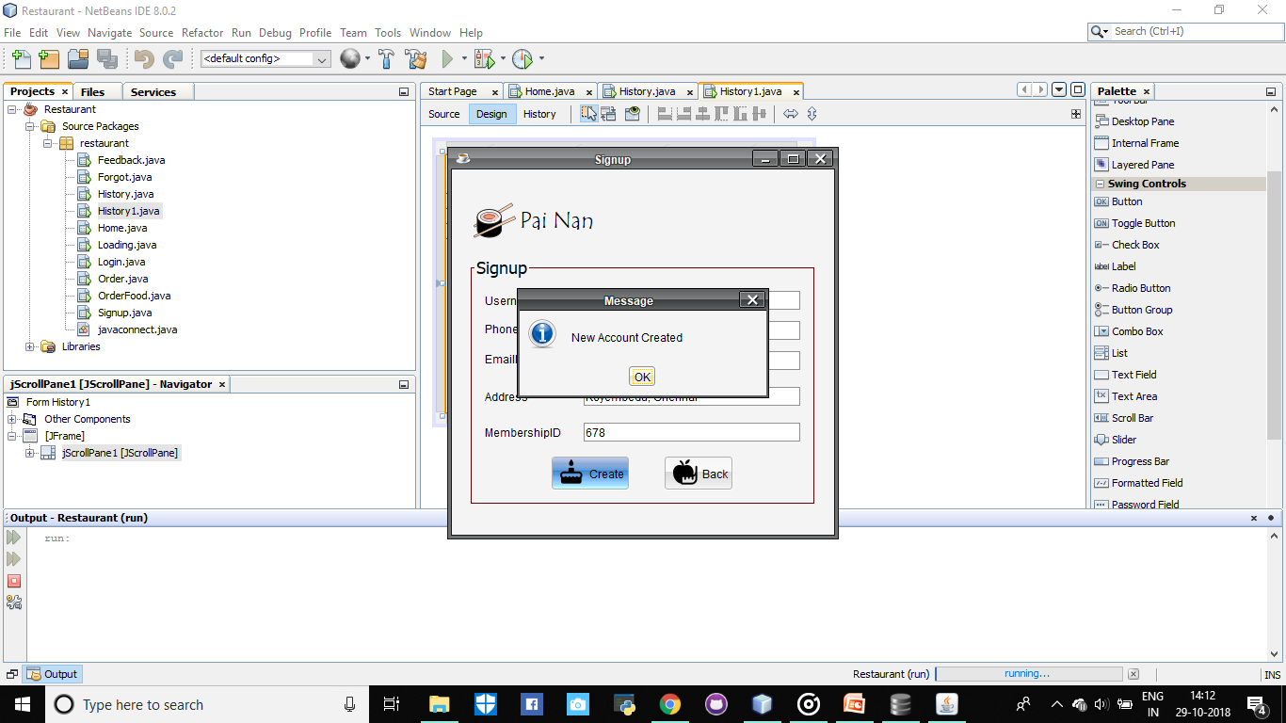
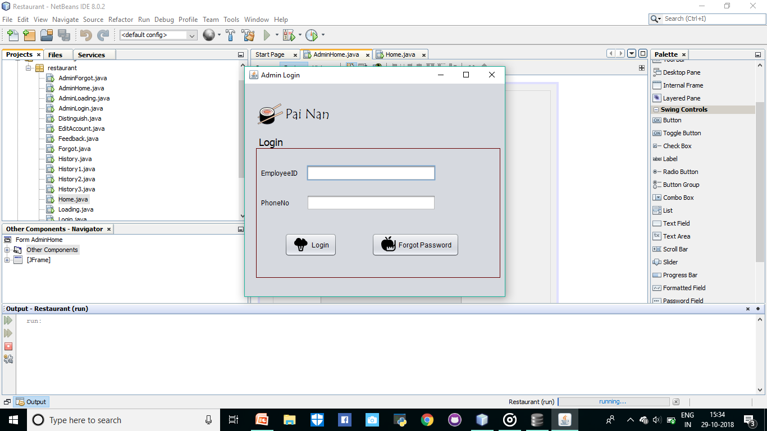
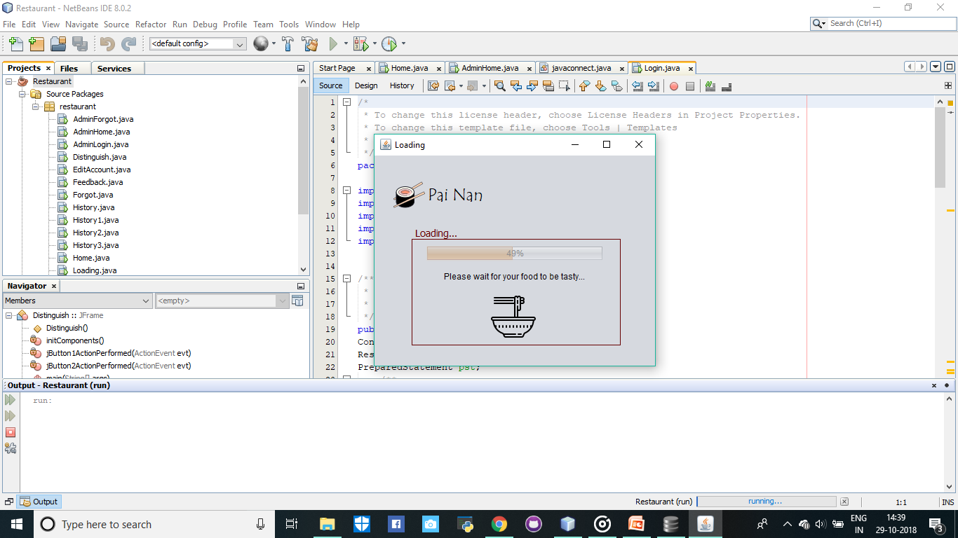
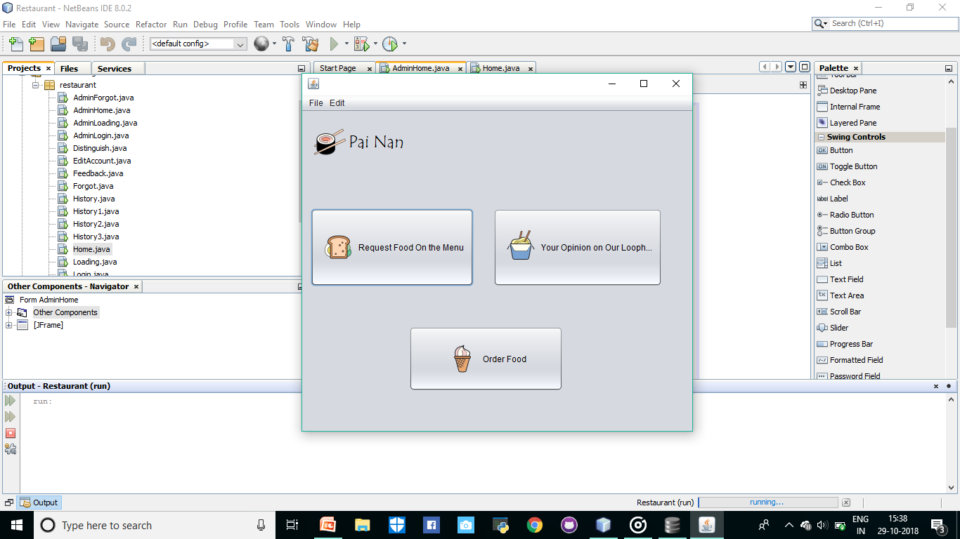
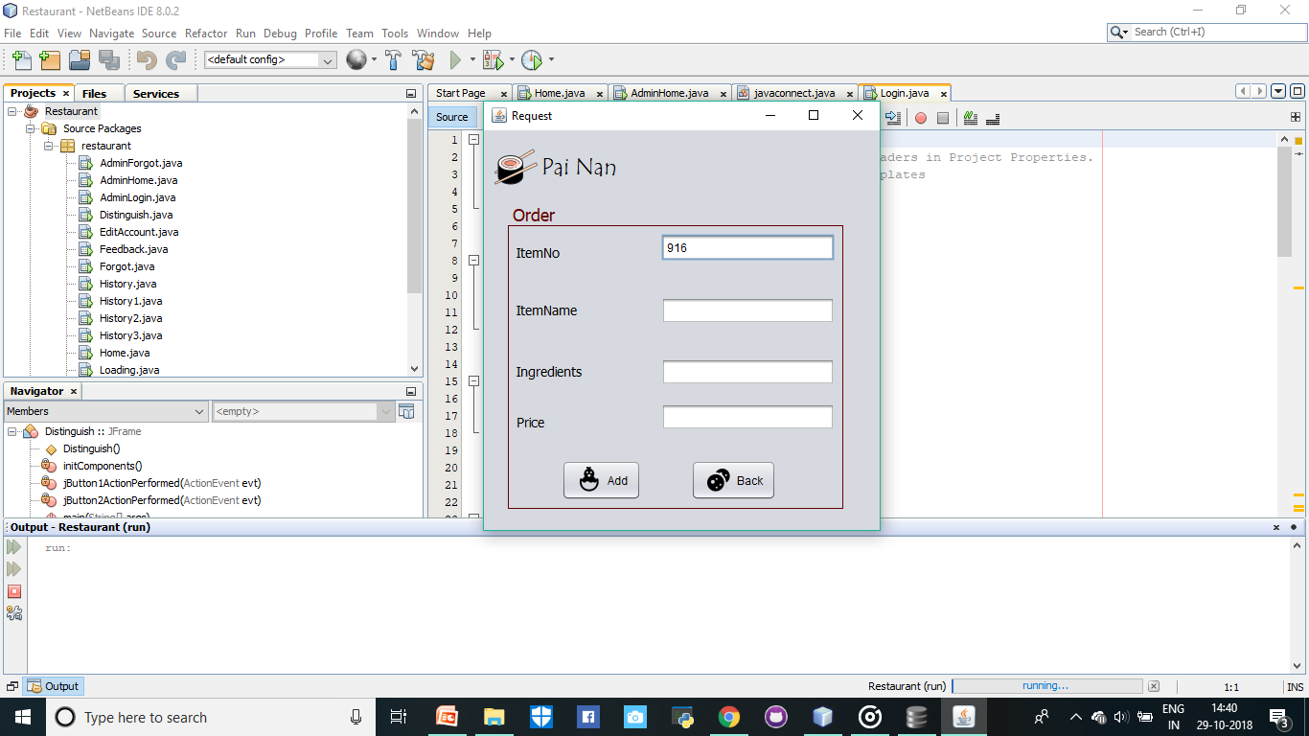
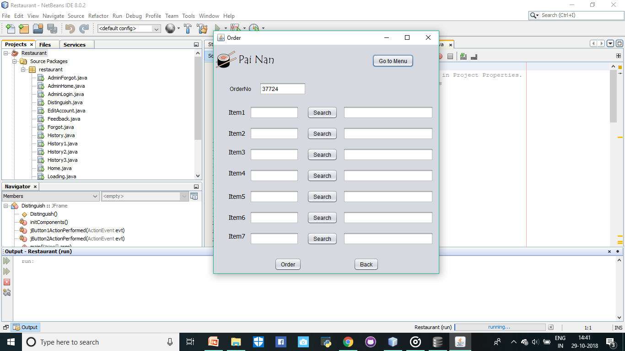
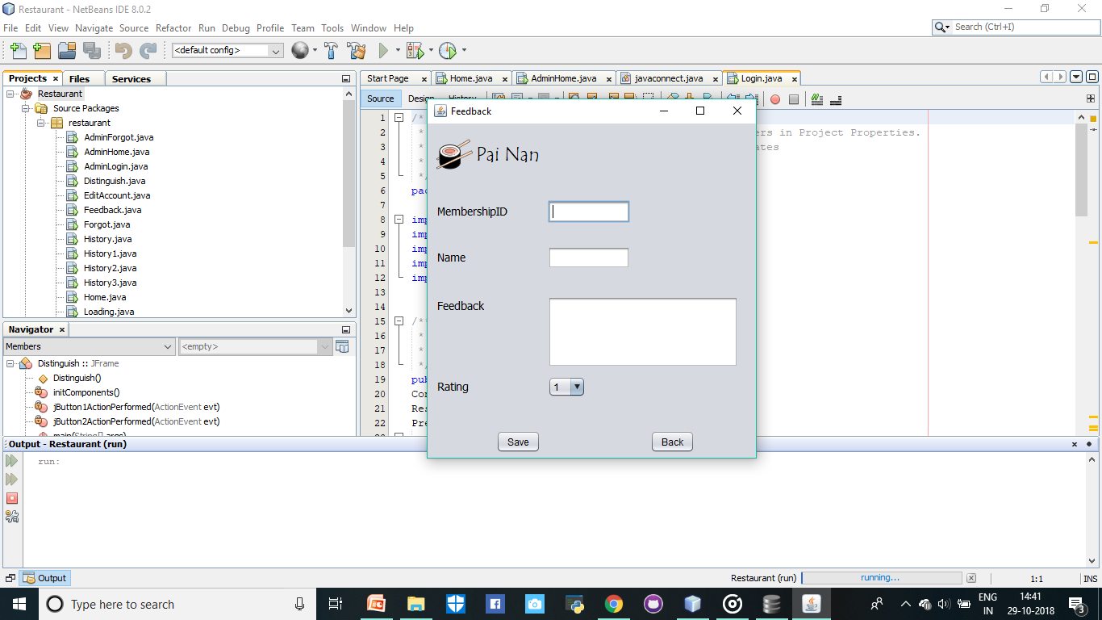
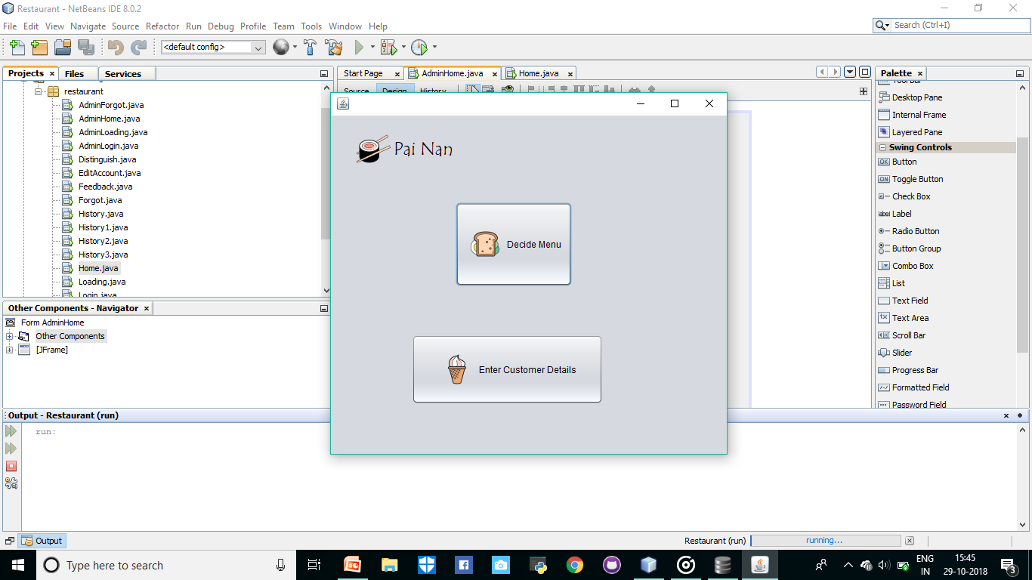
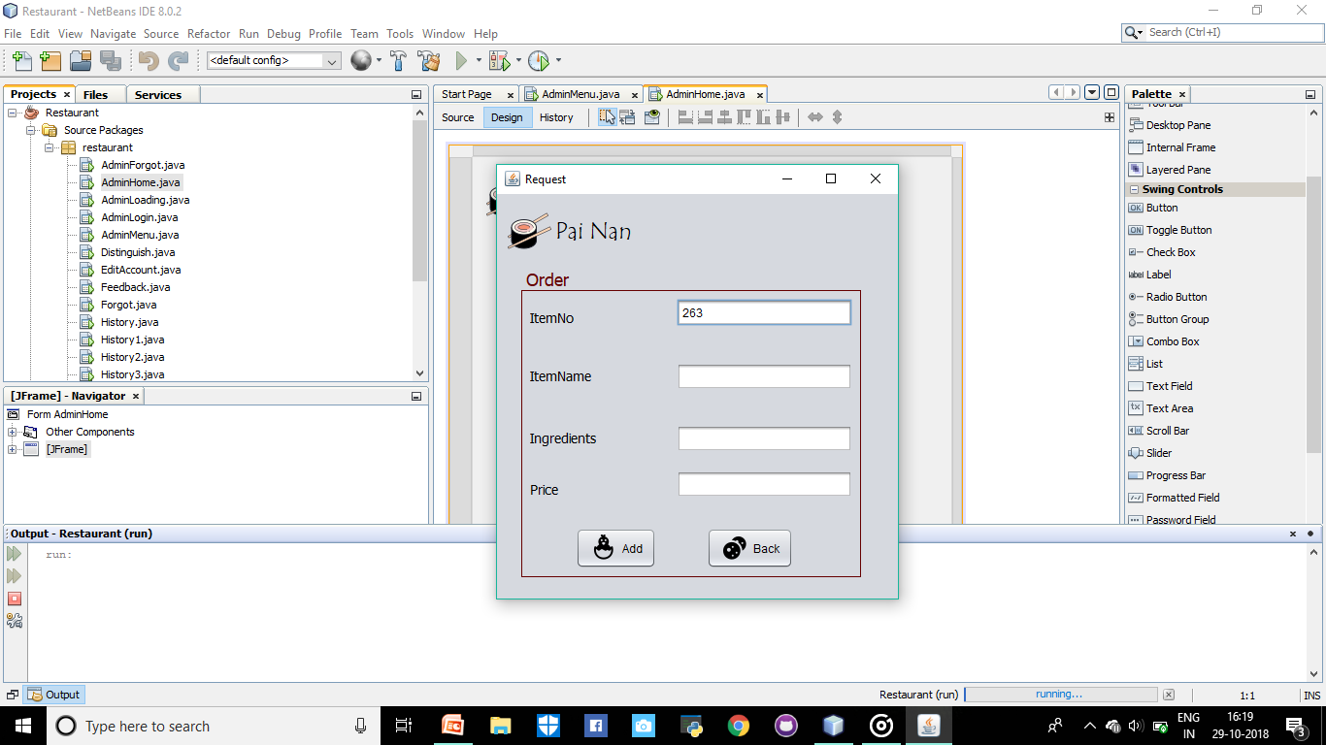
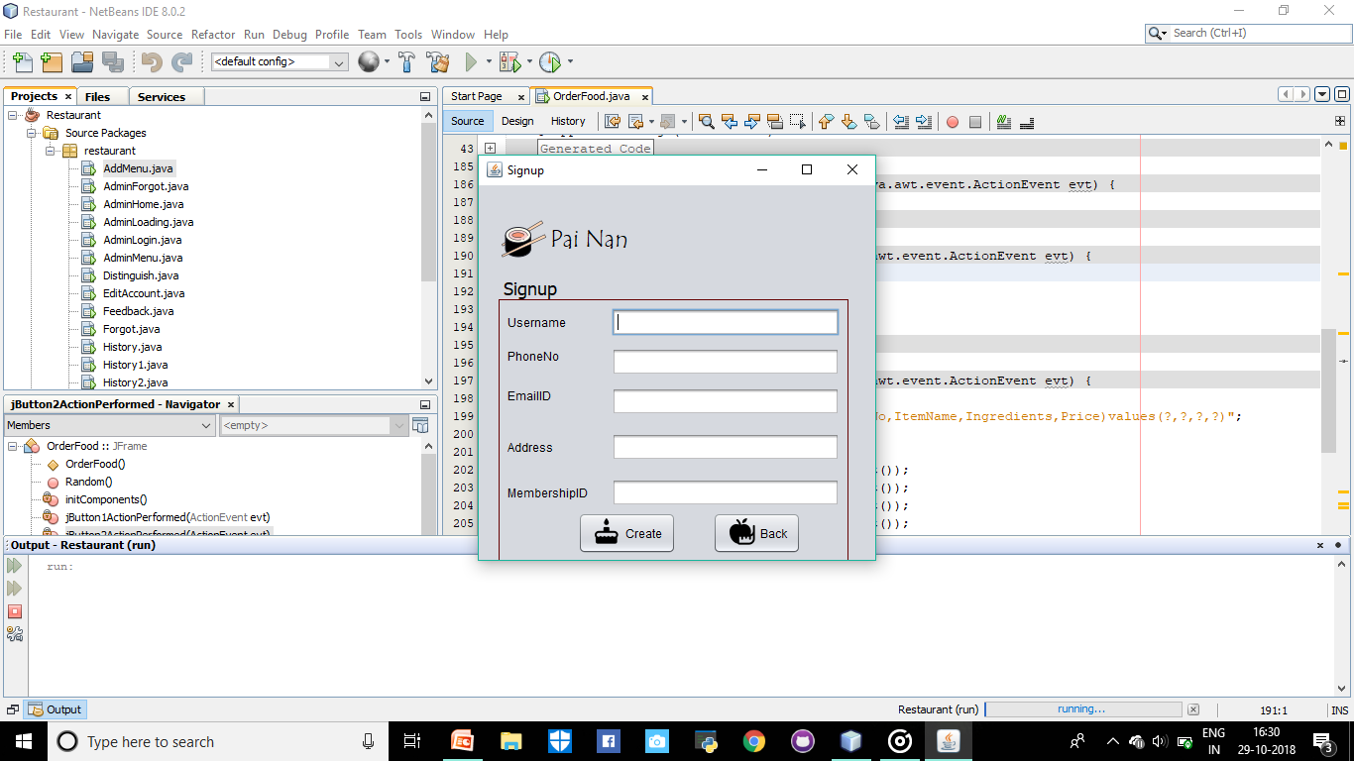
- CONCLUSION:
The motto of this project is to store and retrieve the data of the user, the employees, the orders and to ease the storage of data for the people operating the restaurant. This makes storage of data and its retrieval more easy and feasible. Working on this project many concepts of Database Management System has been applied and normalization of the table has been implemented.

REFERENCES:
www.youtube.com/Tech Entertaining
www.tutorialpoints.com

