PRACTICAL NO.1: 2D Graphs

NAME:-

ROLL NO:-

Q.1 write a python program to plot a 2D graph of the function f(x)=x in interval [10,10]

from matplotlib.pyplot import\*

from numpy import\*

x=(10,10,1)

y=x

plot(x,y)

show()

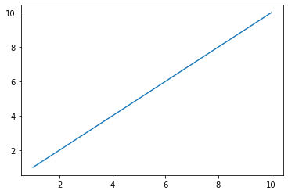

Q.2 write a python program to plot a 2D graph of the function f(x)=x^2+27 in interval [-5,5]

from matplotlib.pyplot import\*

from numpy import\*

x=np.arange(-5,5,0.1)

y=x\*\*2+27

plot(x,y)

show()

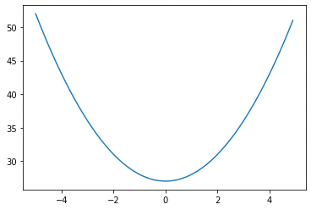

Q.3 write a python program to plot a 2D graph of the function f(x)=sin x in interval [-2π,2π]

from matplotlib.pyplot import\*

from numpy import\*

x=arange(-2\*pi,2\*pi,0.01)

y=sin(x)

plot(x,y)

show()

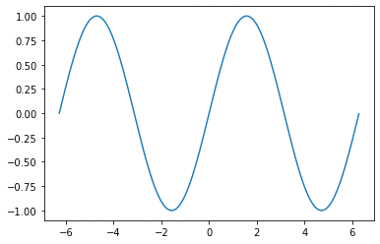

Q.4 write a python program to plot a 2D graph of the function f(x)=cos x in interval [-2π,2π]

from matplotlib.pyplot import\*

from numpy import\*

x=arange(-2\*pi,2\*pi,0.01)

y=cos(x)

plot(x,y)

show()

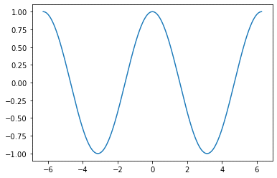

Q.5 write a python program to plot a 2D graph of the function f(x)=sin ^-1x in interval [-1,1]

from matplotlib.pyplot import\*

from numpy import\*

x=arange(-1,1,0.01)

y=arcsin(x)

plot(x,y)

show()

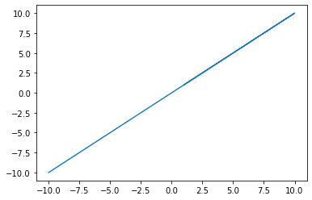

Q.6 write a python program to plot a 2D graph of the function f(x)=log10(x) in interval [1,10]

from matplotlib.pyplot import\*

from numpy import\*

x=arange(1,10,0.1)

y=log10(x)

plot(x,y)

show()

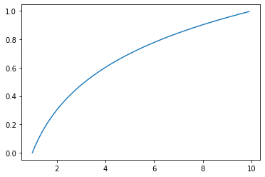

Q.7 write a python program to plot a 2D graph of the function f(x)=e^x in interval [0,3]

from matplotlib.pyplot import\*

from numpy import\*

x=arange(0,3,0.01)

y=e\*\*x

plot(x,y)

show()

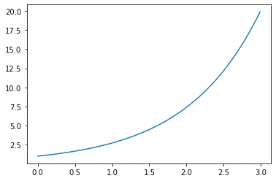

Q.8

from matplotlib.pyplot import\*

from numpy import\*

x=arange(-3,3,0.01)

y=abs(x\*\*2-1)

plot(x,y)

show()

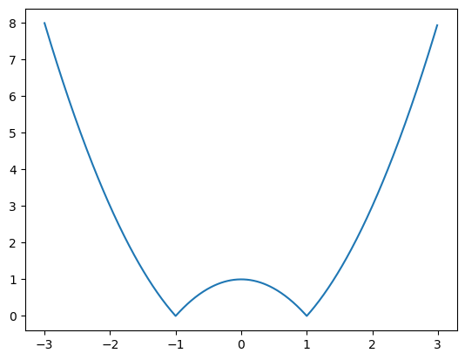

Q.9

from matplotlib.pyplot import\*

from numpy import\*

x=arange(-2\*pi,2\*pi,0.01)

y=sin(2\*\*x)

plot(x,y)

show()

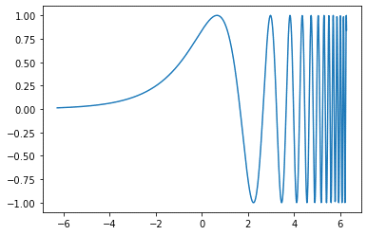

Q.10

pfrom matplotlib.pyplot import\*

from numpy import\*

x=arange(-3,3,0.01)

y=1+x+x\*\*2

plot(x,y)

show()

