Practical No.2: Line Graph, Bar Graph and Pie chart Graphs

Roll No:- Name:-

Q1.

from  matplotlib.pyplot import *

x1=[1920,1930,1940,1950,1960,1970,1980,1990,2000,2010]

y1=[9.8,12,8,7.2,6.9,7,6.5,6.2,5.5,6.3]

plot (x1,y1,label="line1")

xlabel('year')

ylabel('unemployment rate')

title('LINE GRAPH')

legend()

show()

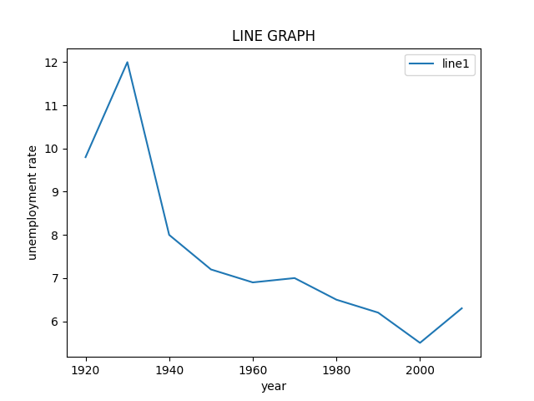

Q2.

from  matplotlib.pyplot import *

x1=[3,1,1,6]

y1=[1,6,3,1]

plot (x1,y1,label="line1")

x2=[1,8,1,3]

y2=[1,3,1,8]

plot (x2,y2,label='line2')

x3=[0,1,0,8]

y3=[0,8,0,1]

plot (x3,y3,label='line3')

xlabel('x-axis')

ylabel('y-axis')

title('LINE GRAPH')

legend()

show()

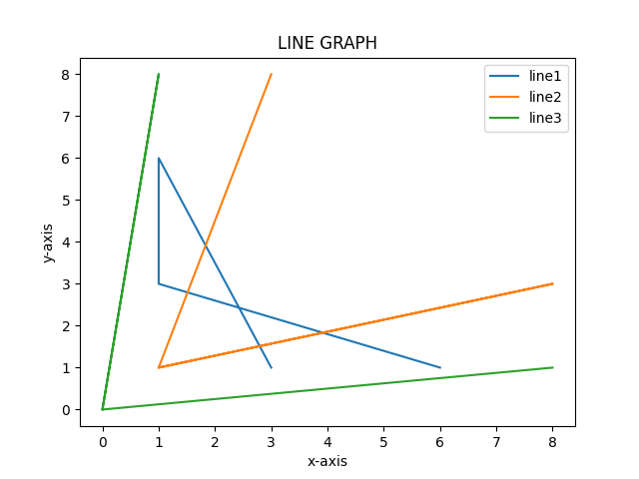

Q3.

from  matplotlib.pyplot import *

y=[1,2,3,4,5]

x=[600,850,700,300,900]

tick_label=['1st','2nd','3rd','4th','5th']

bar(y,x,tick_label=tick_label,width=0.5,color=['red','blue'])

xlabel('week')

ylabel('no. of bed shits')

title('BAR GRAPH')

legend()

show()

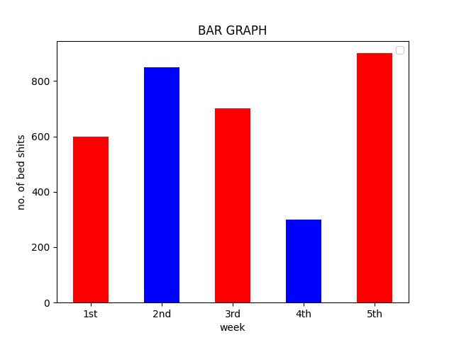

Q4.

from matplotlib.pyplot import *

x=[130,120,135,130,150,80,75]

y=[1,2,3,4,5,6,7]

tick_label=['6th','7th','8th','9th','10th','11th','12th']

bar(y,x,tick_label=tick_label,width=0.5,color=['red','green'])

xlabel("class")

ylabel("number of students")

title("student data")

legend()

show()

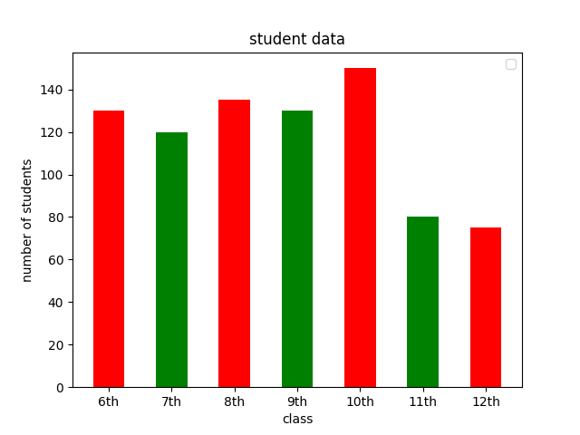

Q5.

from matplotlib.pyplot import *

x=[130,120,135,130,150,80]

y=[1,2,3,4,5,6]

tick_label=['mon','tue','wed','thur','fri','sat']

bar(y,x,tick_label=tick_label,width=0.5,color=['red','green'])

xlabel("days")

ylabel("number of Absentees")

title("Absentees")

legend()

show()

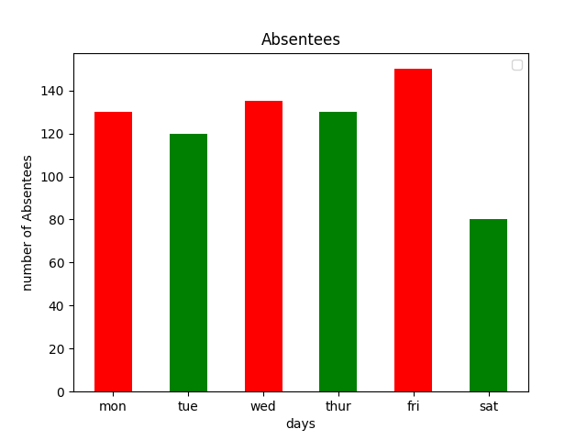

Q6.

from matplotlib.pyplot import *

x=[4000,5400,2800,1800,400]

tick_label=['A','B','C','D','E']

pie(x,labels=tick_label)

title("PI CHART")

show()

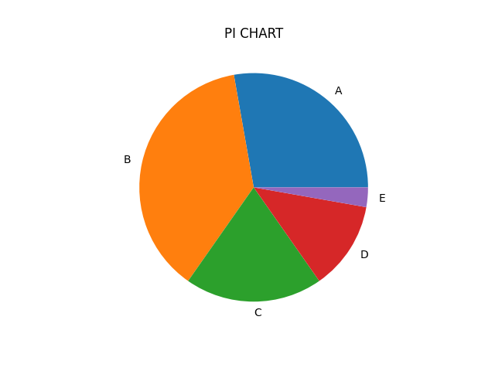

Q7.

from matplotlib.pyplot import *

x=[150,400,225,175,50]

tick_label=['beast animals','other land animals','birds','wateranimals','reptiles']

pie(x,labels=tick_label)

title("animals")

show()

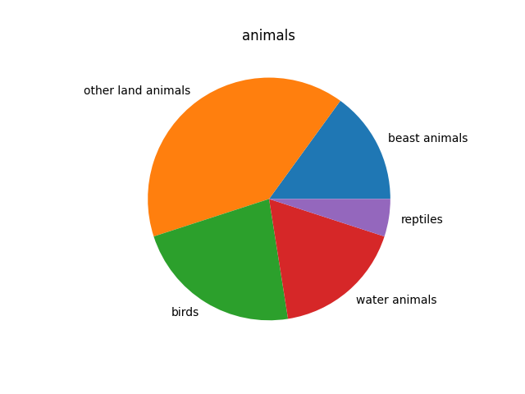

Q8.

from matplotlib.pyplot import *

x=[350,245,210,175,280]

tick_label=['school bus','privatebus','bicycle','rickshaw','on foot']

pie(x,labels=tick_label)

title("vechiles")

show()

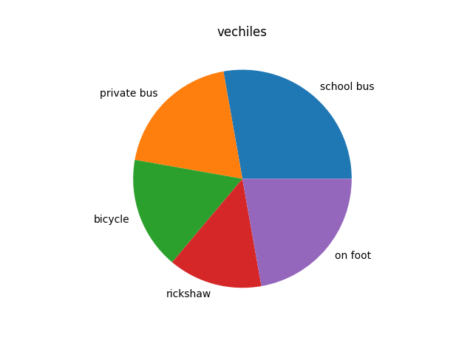

Q9. Draw the histogram of the following data:

from matplotlib.pyplot import *

x = [4,12,16,8]

range = (0,20)

intervals = 4

hist(x,intervals,range,width = 4.9,histtype='bar',)

xlabel("Height of Studens")

ylabel("No of students")

title("Height Vs No of students")

legend()

show()

