**Practical No.3: 3D Graphs**

**Name : Roll no :**

**1-> 3D box**

from matplotlib.pyplot import *

box = axes(projection='3d')

box.set_xlabel('X-axis')

box.set_ylabel('Y-axis')

box.set_zlabel('Z-axis')

box.set_title('3D-BOX')

show()

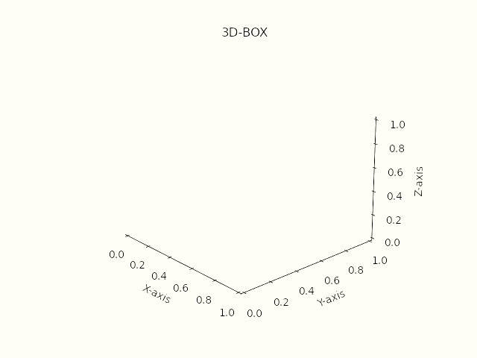

**2-> Helix**

from matplotlib.pyplot import *

from numpy import *

helix = axes(projection='3d')

z = linspace(-10,10,100)

x = sin(z)

y = cos(z)

helix.plot3D(x,y,z)

helix.set_title('3D Helix')

show()

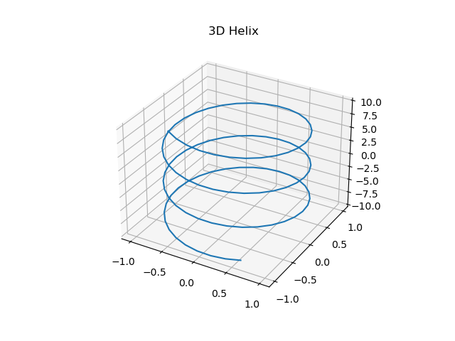

**3->Straight line**

1->

from matplotlib.pyplot import *

from numpy import *

line = axes(projection = '3d')

z = linspace(-5,5,100)

x = z

y = z

line.plot3D(x,y,z)

line.set_title('3D-Line')

show()

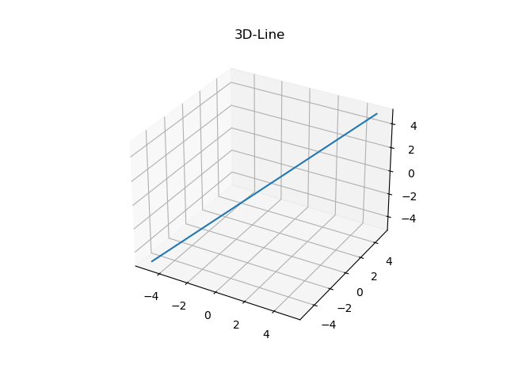

**4-> Point on helix**

from matplotlib.pyplot import *

from numpy import *

from mpl_toolkits import *

helix =axes(projection = '3d')

z = linspace(-10,10,200)

x = sin(z)

y = cos(z)

helix.scatter3D(x,y,z,c=z,cmap='Reds')

show()

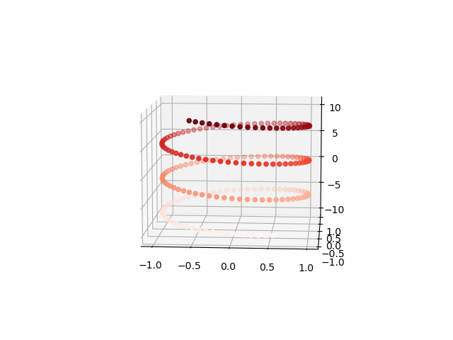

**5->Contour Graph**

from matplotlib.pyplot import *

from numpy import *

from math import *

from mpl_toolkits import *

ct = axes(projection='3d')

def f(x,y):

    return e**(-x**2 - y**2)

x = linspace(-2,2,100)

y = linspace(-2,2,100)

X,Y=meshgrid(x,y)

Z = f(X,Y)

ct.contour3D(X,Y,Z,50)

show()

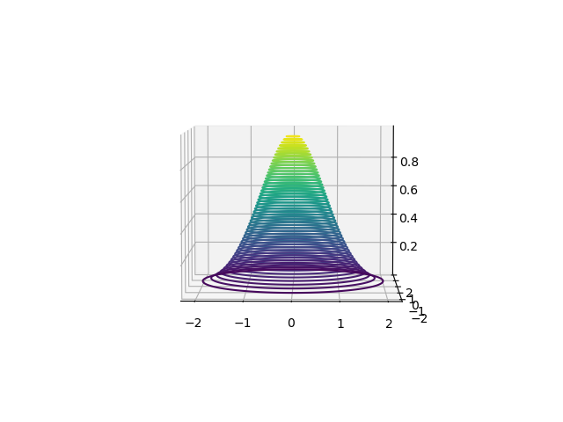

6->

from matplotlib.pyplot import *

from numpy import *

from mpl_toolkits import *

ax = axes(projection = '3d')

def f(x,y):

    return y-x

x = linspace(-3,3,100)

y = linspace(-3,3,100)

X,Y = meshgrid(x,y)

Z = f(X,Y)

ax.contour3D(X,Y,Z,50)

show()

­­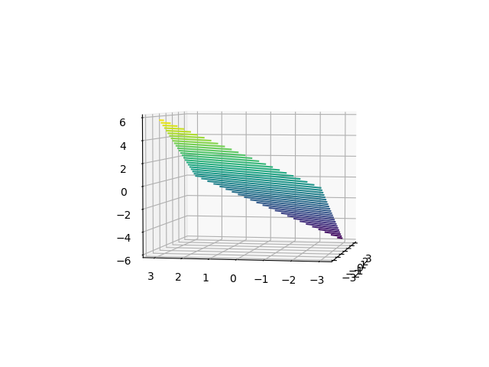

7->

from matplotlib.pyplot import *

from numpy import *

from mpl_toolkits import *

ax = axes(projection = '3d')

def f(x,y):

    return sqrt(y,x)

x = linspace(-3,3,100)

y = linspace(-3,3,100)

X,Y = meshgrid(x,y)

Z = f(X,Y)

ax.contour3D(X,Y,Z,50)

show()

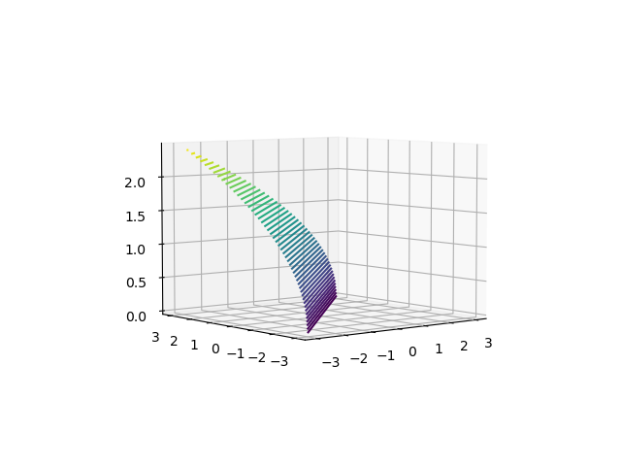

8->

from matplotlib.pyplot import *

from numpy import *

from mpl_toolkits import *

ax = axes(projection = '3d')

def f(x,y):

    return 3*x**2 + 5*y**2

x = linspace(-3,3,100)

y = linspace(-3,3,100)

X,Y = meshgrid(x,y)

Z = f(X,Y)

ax.contour3D(X,Y,Z,50)

show()

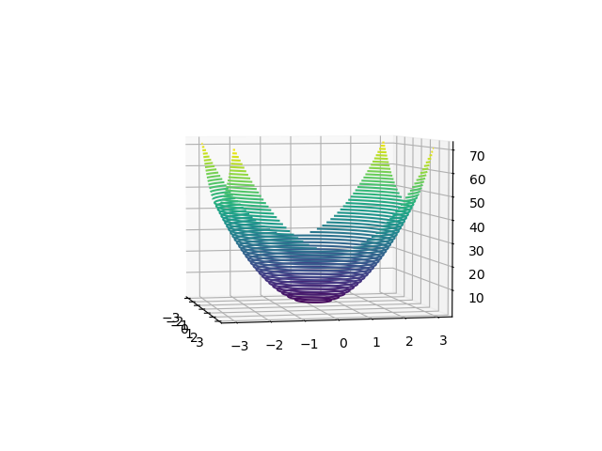

9->

from matplotlib.pyplot import *

from numpy import *

from mpl_toolkits import *

ax = axes(projection = '3d')

def f(x,y):

    return ((x-y)/(1+x**2+y**2))

x = linspace(1,6,100)

y = linspace(1,6,100)

X,Y = meshgrid(x,y)

Z = f(X,Y)

ax.contour3D(X,Y,Z,50)

show()

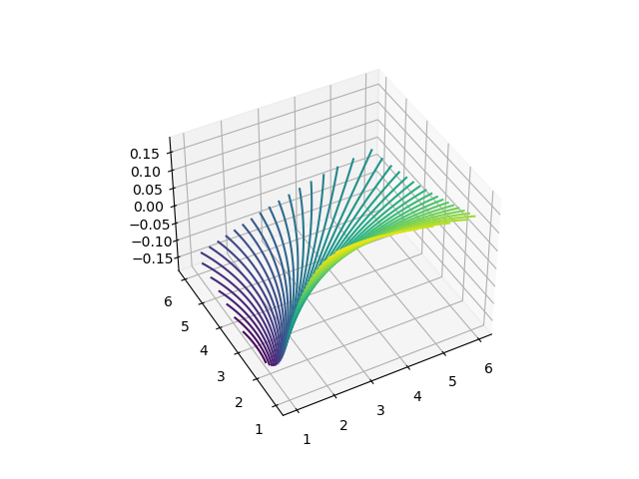

**10-> Wire Frame**

from matplotlib.pyplot import *

from numpy import *

from math import *

from mpl_toolkits import *

ct = axes(projection='3d')

def f(x,y):

    return e**(-x**2 - y**2)

x = linspace(-2,2,100)

y = linspace(-2,2,100)

X,Y=meshgrid(x,y)

Z = f(X,Y)

ct.plot_wireframe(X,Y,Z)

show()

