Issue Tracker Tool
(Created By- Amrin Mulani)

Date-30 July 2019 mulani.amrin09@gmail.com

Details of Project-
Created By: | Amrin Mulani
Frontend Technologies: | HTML5, CSS3, JS, Bootstrap and Angular
Backend Technologies: | NodeJS, ExpressJS and Socket.IO
Tools: | Visual Studio Code,Mongo Compass,GitHub,AWS EC2,Route 53
Database: | MongoDB
Url: | http://amiraissuetracker.ga
GitHub Repository for Code: | Frontend-https://github.com/AmrinMulani/IssueTracker-Frontend.git  Backend -https://github.com/AmrinMulani/IssueTracker-Backend.git

Login View
SignUp -

User can signup in the application by providing the below details
- First Name
- Last Name
- Email address
- Password
- Mobile number
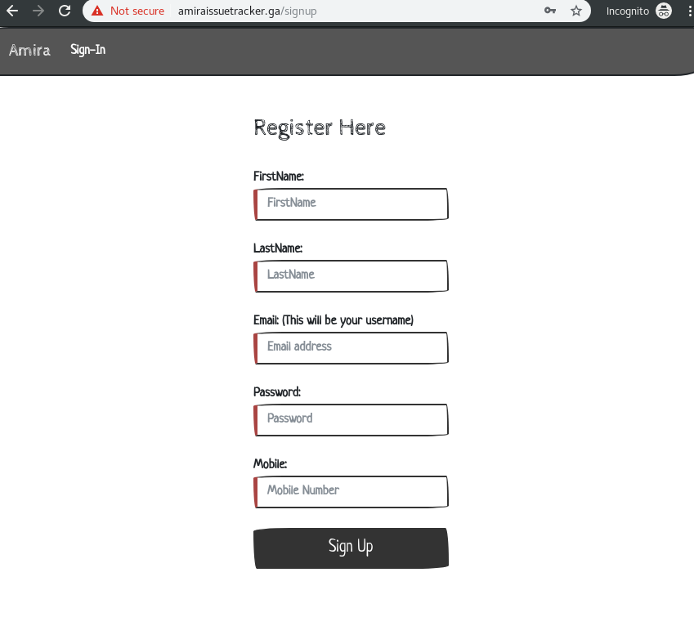

Login-
After succesfully signup user able to login by providing the email and password of user
And User also login using with his /her gmail account
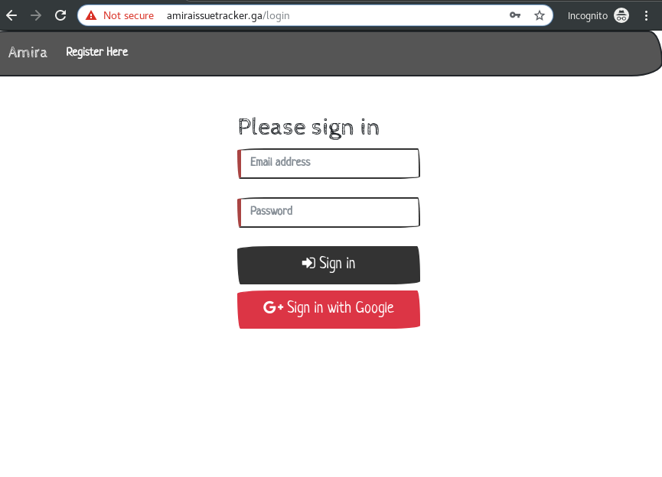
Dashboard-
After successfully login user can navigated to dashboard.
Where user can create the issue /bug and assign any user
User can view the list of issue which assigned to him/her in table paginated form where User can sort any column search a bug or issue and edit/view issue by clicking on row of table

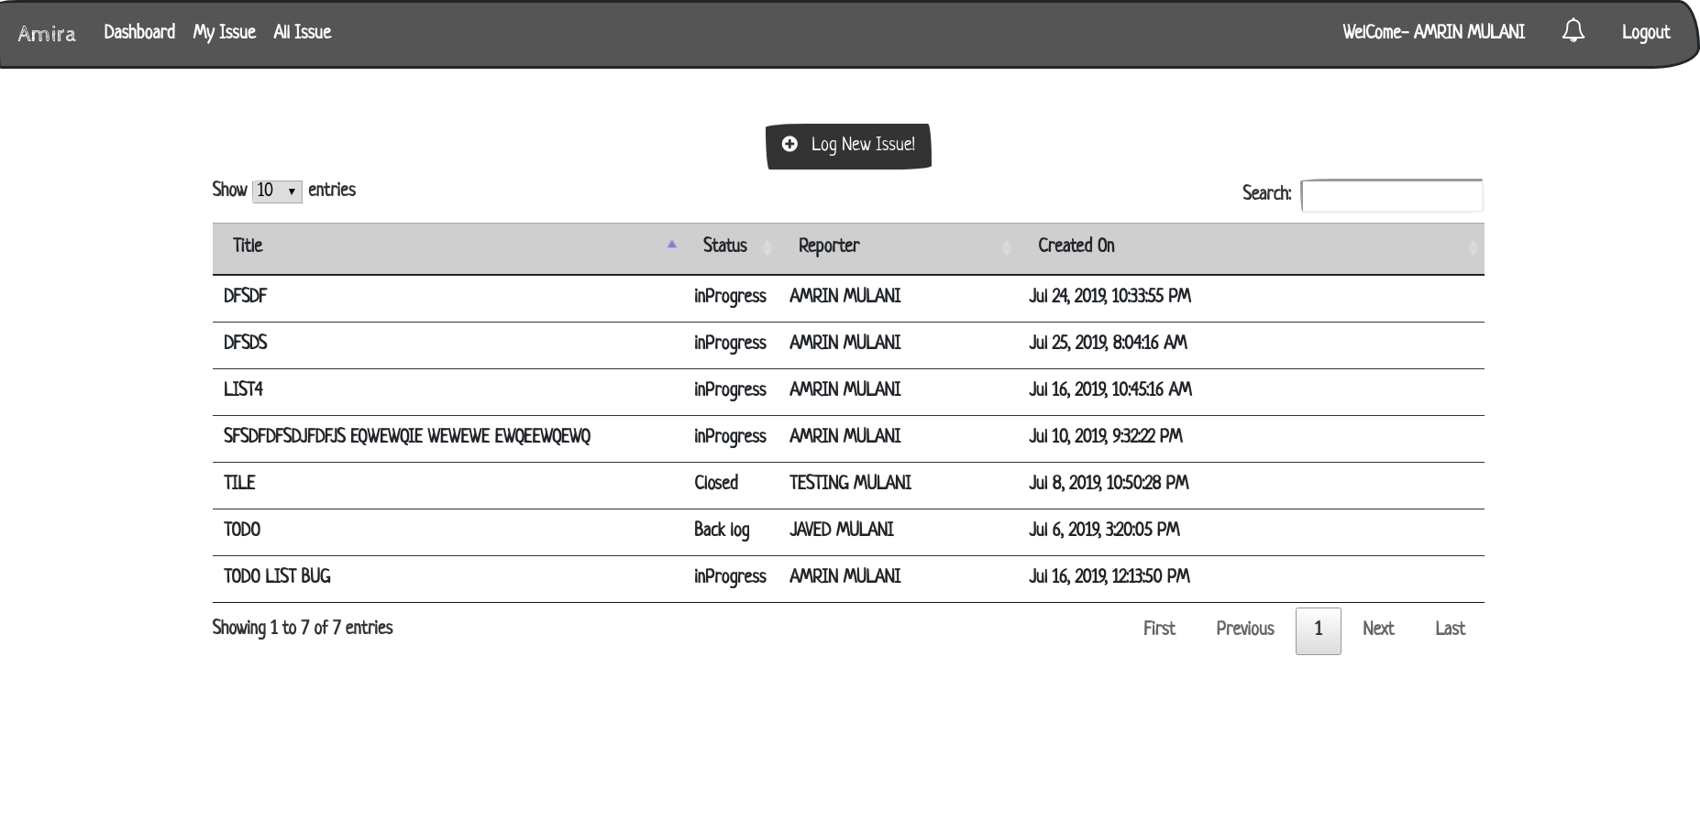

Create bug or issue-
There is button on dashboard page ,user can create the new bug or issue
User can create the bug or issue by providing the below details
- Title
- Description
- Assignee
- Attach a screen shot of error
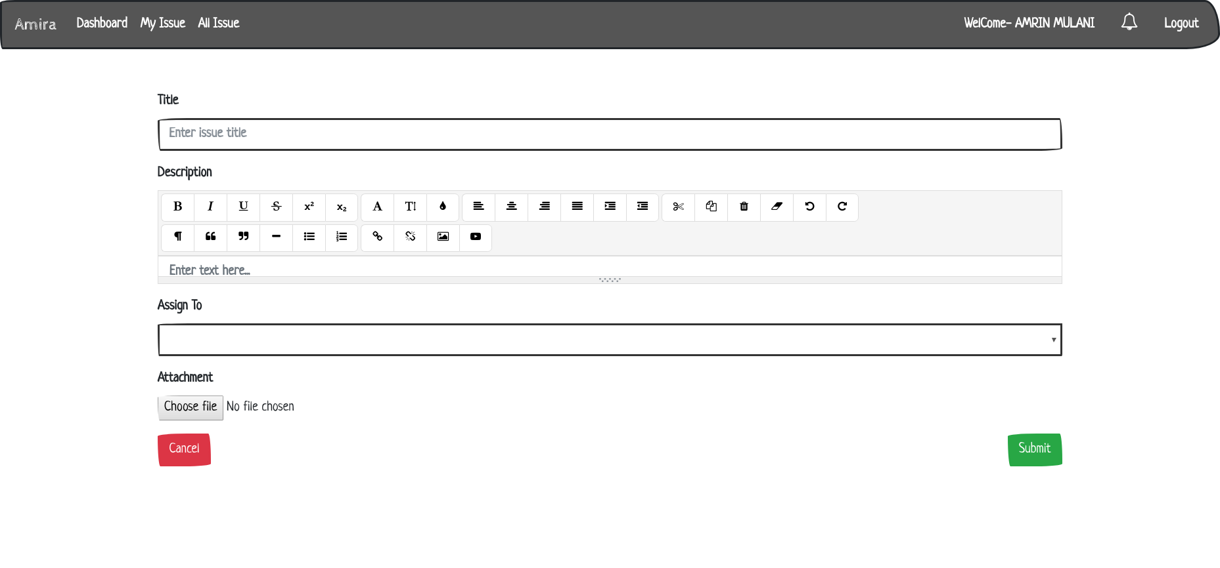
When the user create the issue and assign to another user .User will get notification if issue assigned to him/her 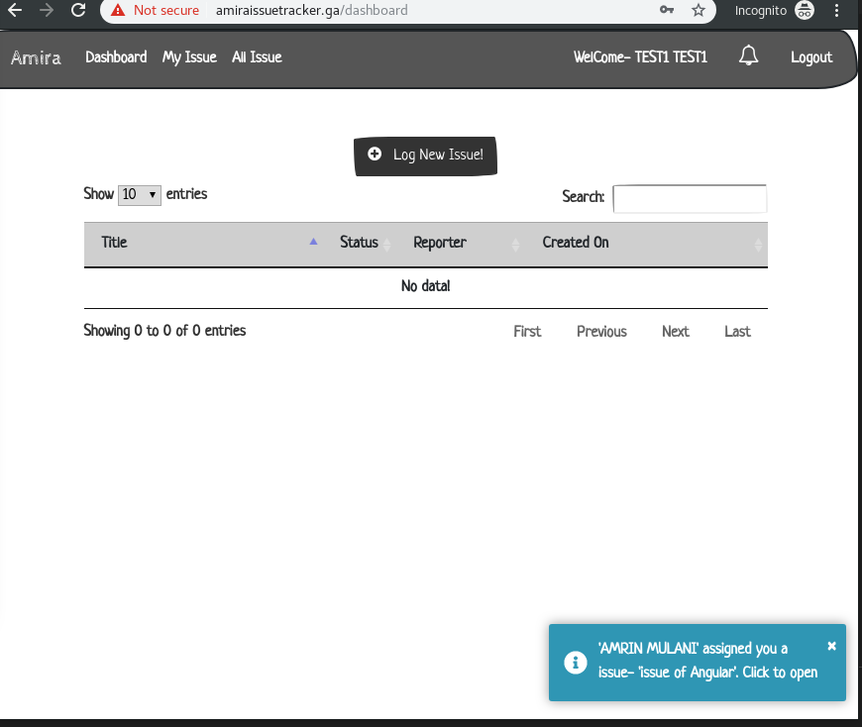

When user click on notification he /she will navigate to view/edit page of issue
User can edit issue and assigned to any user listed in user list
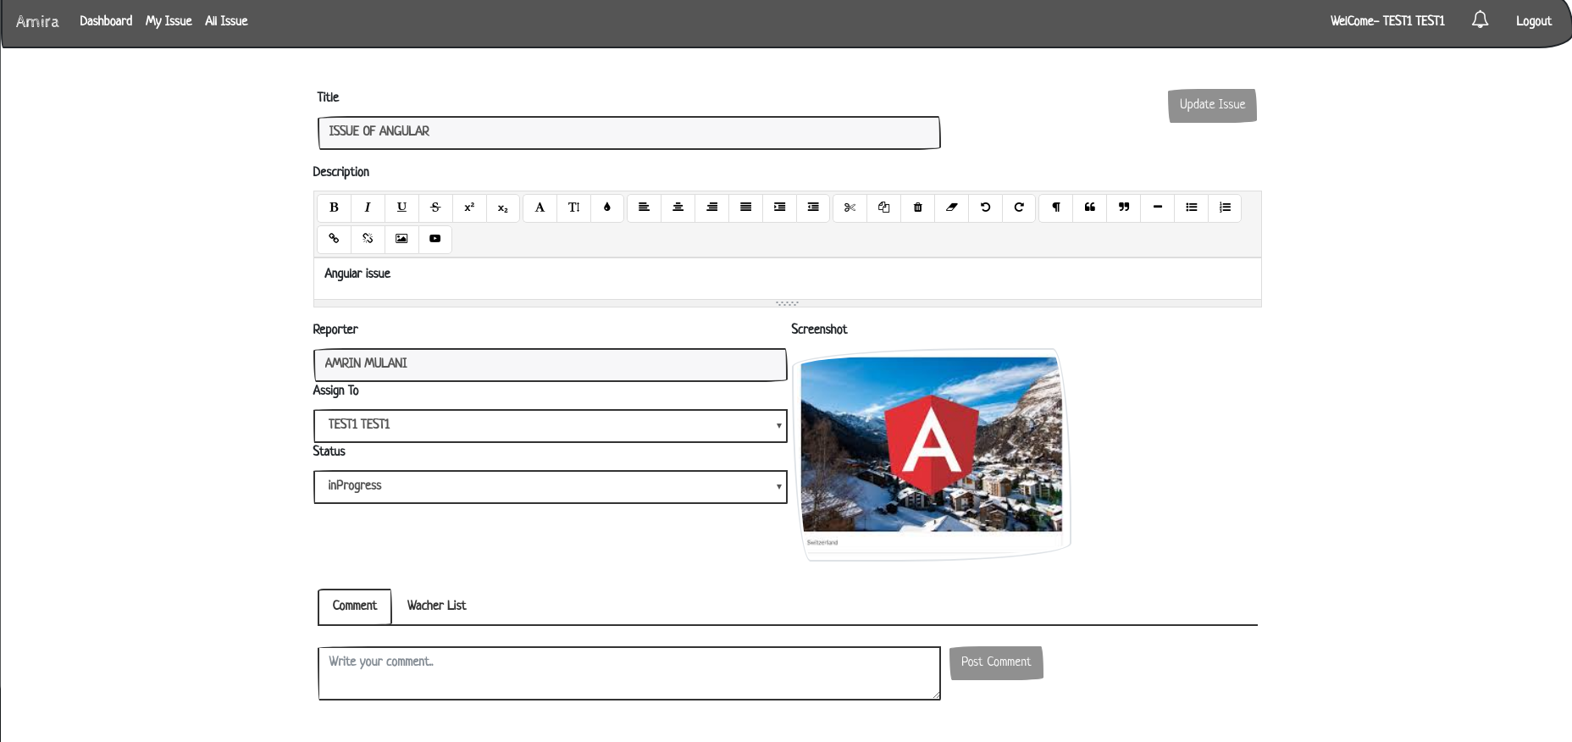

User can also search any field or issue title in search box and by click on the row of table user can navigate on edit /view page of issue
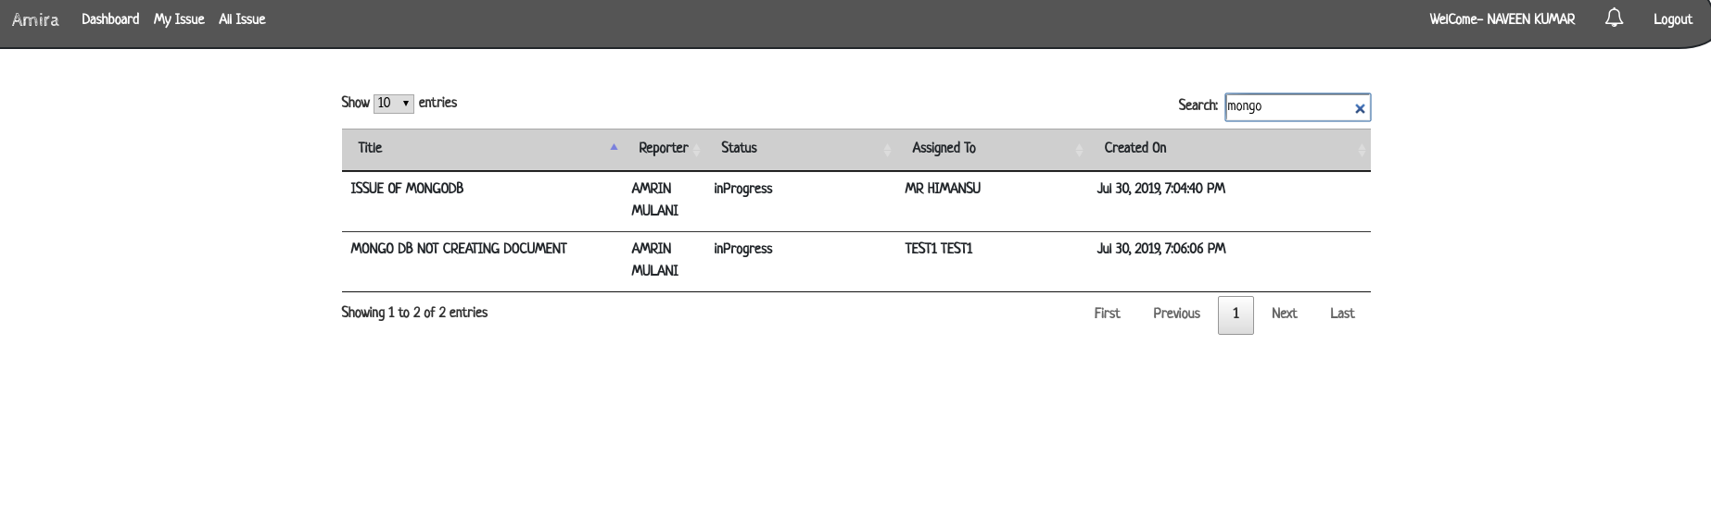
If the user is assignee ,reporter or watcher user will get the notification whenever there is update or add commenton issue 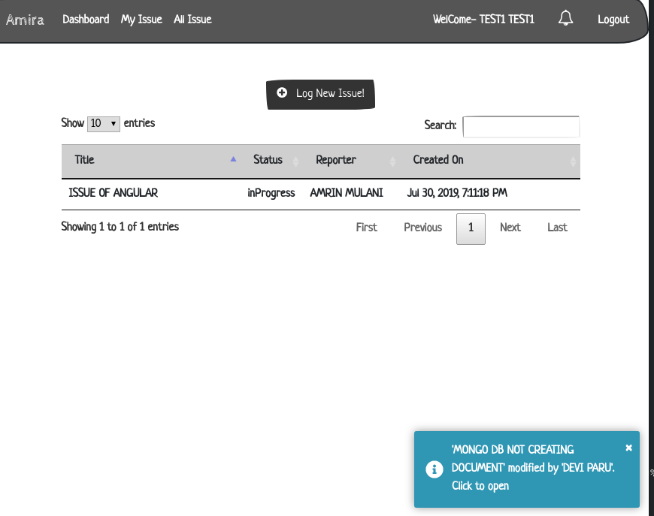

User can add a comment on any issue and user will get the notification when if user is assignee reporter or watcher

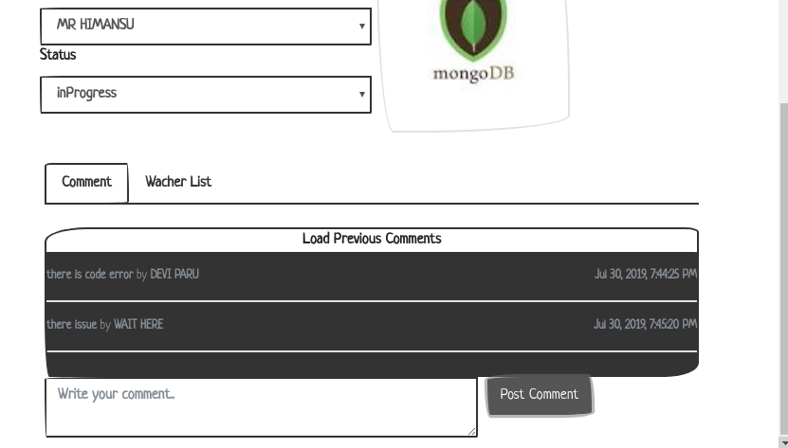

User can add himself as watcher to any issue
Not if user is reporter he/she can’t be added as watcher

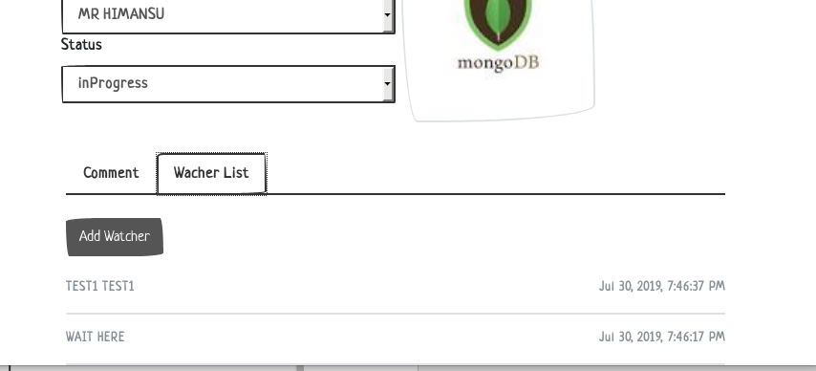

In Nav bar there is notification button user will receive the notification of issue update if user is watcher, assignee and reporter By click on the notification user can navigate on update page of issue
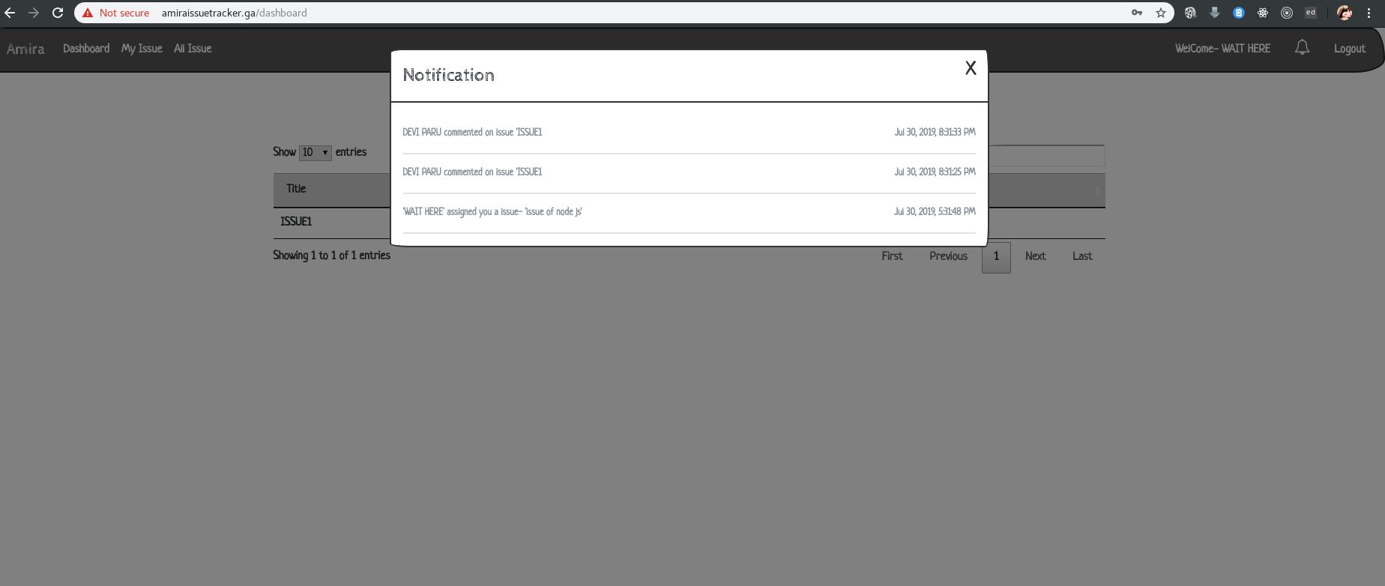

MyView-
User can view his/her reported issue in table paginated form where User can sort any column search a bug or issue and clicking on row user can update or add comment to the issue
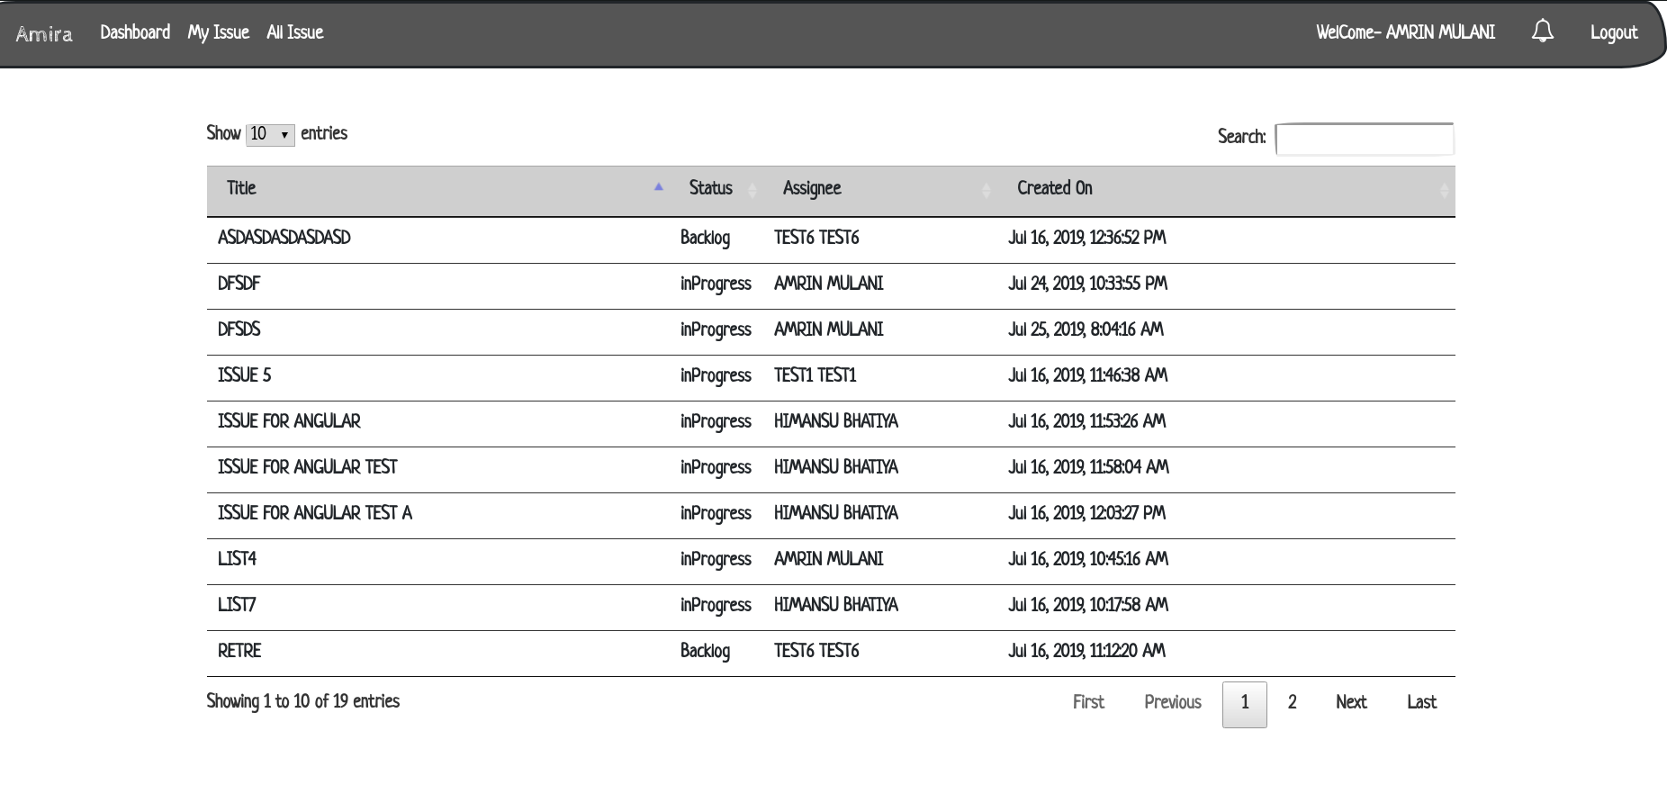

AllIssue-
User can view all issue in table paginated form where User can sort any column search a bug or issue and clicking on row user can update and add comment to issue
