HW 3 - Chapter 3: Joins
CSCI 331 Database Systems

Student Name | Amrina-Qayyum
Submission Date | 2026-02-16

Medium Articles (Join Topics)

Article 1 (Instructor-provided additional article)
Title: SQL: What is look like when LEFT JOIN twice? - fixing a bad query
Link: SQL: What is look like when LEFT JOIN twice? - fixing a bad query
Technique(s) used (Chapter 3): LEFT JOIN twice with aliases; avoid OR in join conditions; COALESCE to select the best match.
Why it matters: Reduces incorrect matches and improves query clarity and performance compared to OR inside JOIN.

Article 2 (Found on Medium)
Title: How To Write A Left Anti Join and Why
Link: How To Write A Left Anti Join and Why
Technique(s) used (Chapter 3): LEFT ANTI JOIN pattern = LEFT JOIN + WHERE right side key IS NULL (find missing records).
Why it matters: Quickly finds items that do not have related rows (e.g., customers with no orders).
In the video: open each article, show the title, and see the details

2. Chapter 3 Examples
We ran the Chapter 3 join examples using the Northwinds2024Student database. We executed different join types such as CROSS JOIN, INNER JOIN, LEFT JOIN, multi-table joins, and anti-joins, and show the outputs. All example queries, execution steps, and result outputs are also shown in our MP4 video to prove the queries work correctly in the required database.

3. Propositions and Queries (Northwinds2024Student)
We created problem propositions (real-life questions) based on two Medium join articles. For each proposition, we wrote SQL join queries in the Northwinds2024Student database, executed them, and checked the results. We demonstrated all propositions, queries, and outputs in our MP4 video, and we also included the full SQL work in the file Ch3_HW3_Amrina-Qayyum.sql. This shows we can apply Chapter 3 join concepts to solve practical business problems.

4. To-do List and Gantt Chart Evidence
In this section, we showed evidence of planning and tracking our work using the To-do list and Gantt chart. The to-do list shows who did which task and status, and the Gantt chart shows the timeline and deadlines. This proves we followed an organized workflow to complete HW3.

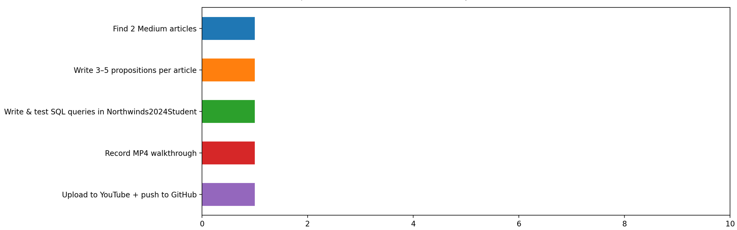
Fig 1. Gantt Chart of our work

