Assignment-1

Introduction to DBMS (Database Management System)

A DBMS is software that helps us store, manage, and retrieve data easily and safely.
Instead of saving data in files like text files or Excel sheets, we use a database controlled by a DBMS.
A database is a structured collection of data stored in a computer system for easy retrieval and management. Real-life example:
Student records in college
Bank accounts
Instagram users & their posts.

Need for DBMS
Before DBMS, people used file-based systems. They had many problems.
Problems with File System:
Data duplication:
Same data is stored multiple times in different files, wasting storage space.
No security:
Any user can access or modify data without proper authorization.
Difficult to search data:
Finding required data is slow and complex because there is no proper query system.
No backup & recovery:
If data is lost or the system crashes, there is no way to restore the data.
DBMS solves these problems.
Need of DBMS:
- Avoids Data Redundancy Same data is not stored again.
- Provides Data Security
Only authorized users can access data.
- Easy Data Access
We can easily fetch data using queries.
- Backup and Recovery
Data can be recovered if system crashes.
- Multi-user Access
Many users can use data at the same time.

DBMS Architecture
DBMS architecture shows how users, DBMS, and database interact.
Types of DBMS Architecture:
- 1-Tier Architecture
- 2-Tier Architecture
- 3-Tier Architecture

1-Tier Architecture
1-Tier architecture is the simplest DBMS architecture where the user, application, and database are all on the same system. There is no separate server and no network connection involved.
Example:
- Database stored on your computer
- No network involved

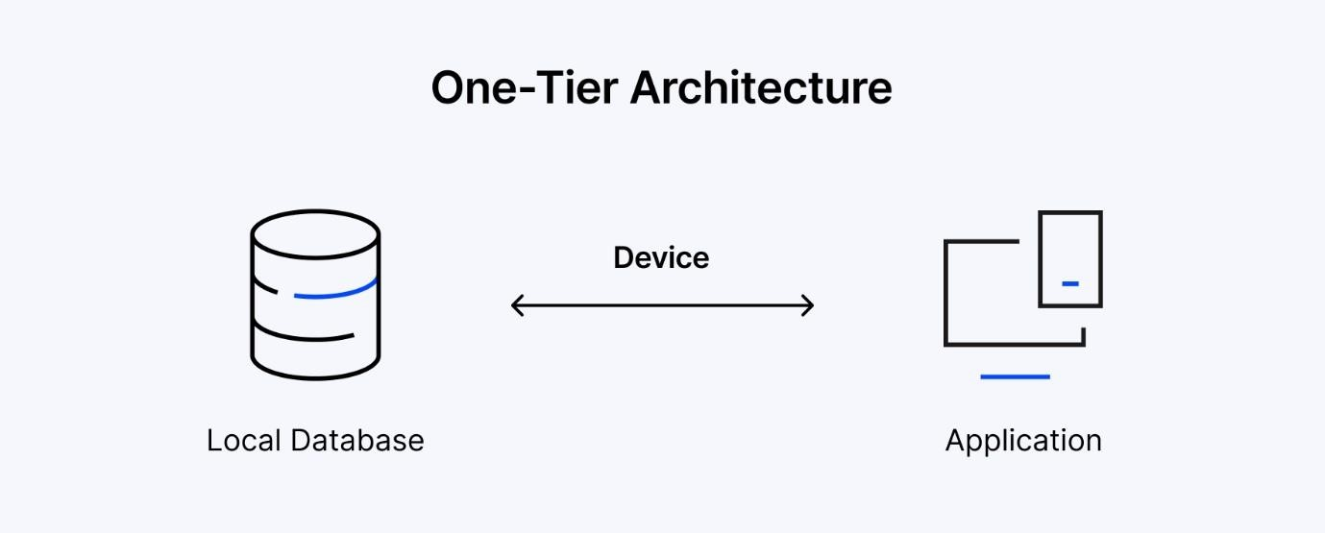

2-Tier Architecture
In 2-tier architecture, the user uses an application (client), and this application directly communicates with the database server to store or retrieve data.
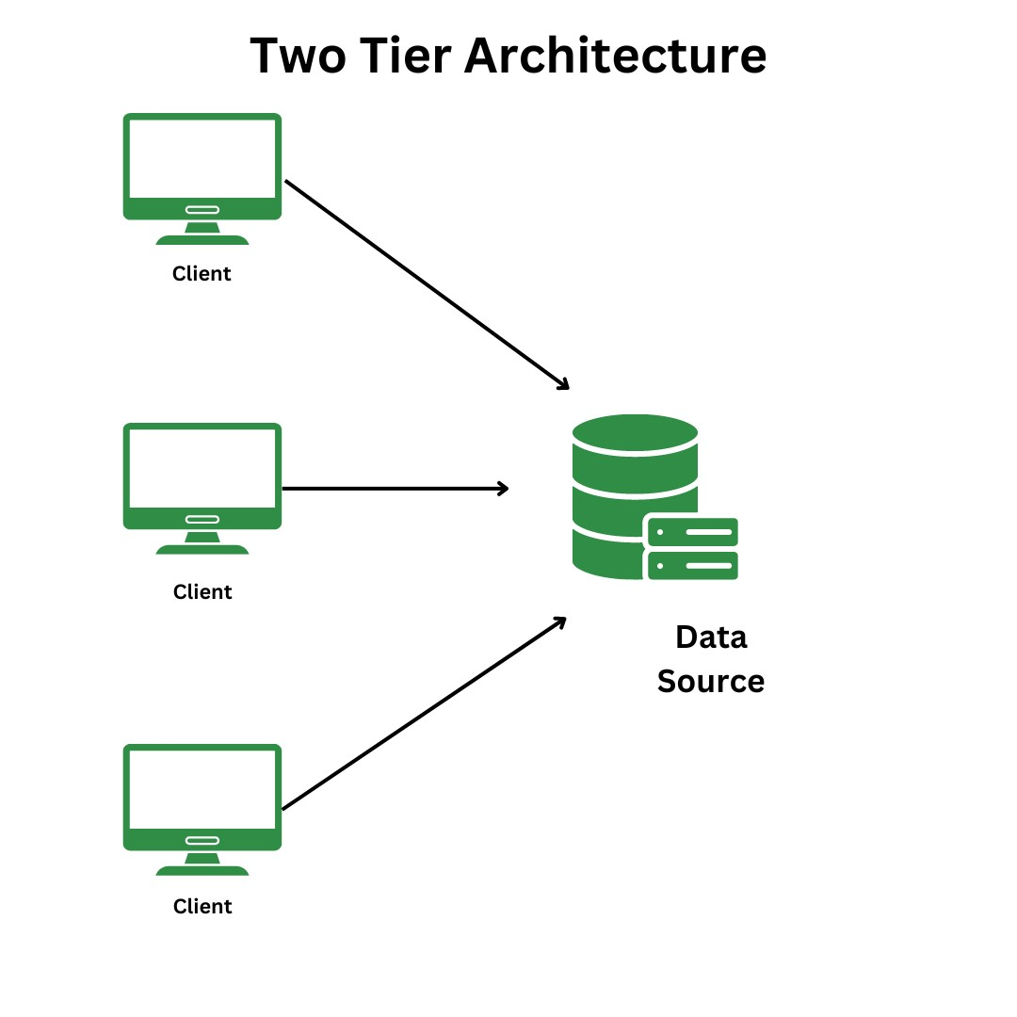
Faster but less secure

3-Tier Architecture
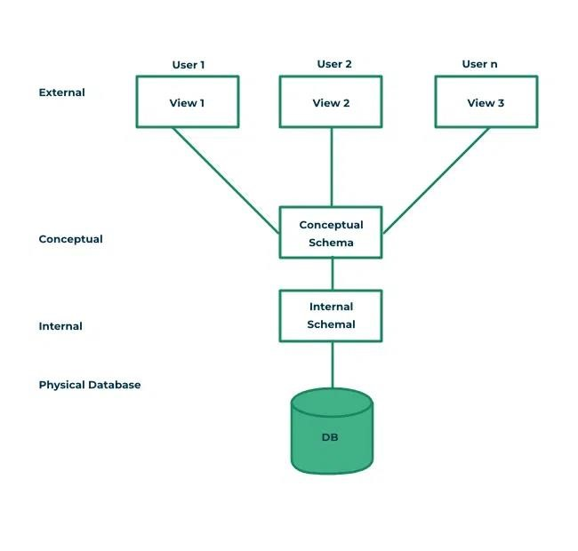

Presentation Layer (Client Layer)
- User interface (website / app)
- Takes input from user

Application Layer (Business Logic Layer)
- Processes user requests
- Applies rules and logic
- Acts as a bridge between user and database.

Database Layer
- Stores and manages actual data.
Example:
- Online banking system
- E-commerce websites
- Social media applications Why 3-tier is best?
- More secure
- Easy to manage
- Scalable

Database Languages in DBMS
Database languages are used to communicate with the database and perform different operations like creating tables, inserting data, and controlling access.

1. DDL (Data Definition Language)
- Used to define and modify the structure of the database
- It creates, changes, or deletes tables and databases
Operations:
- CREATE – Creates database objects like tables
- ALTER – Modifies the structure of existing tables
- DROP – Deletes tables or databases
- TRUNCATE – Removes all records from a table
- RENAME – Changes the name of a database object

2. DML (Data Manipulation Language)
- Used to insert, update, and delete data in tables
- Works on the actual data stored in the database
Operations:
- INSERT – Adds new data
- UPDATE – Modifies existing data
- DELETE – Removes data

3. DQL (Data Query Language)
- Used to retrieve or fetch data from the database
- Helps in viewing required data
Operations:
- SELECT – Fetches required data

4. DCL (Data Control Language)
- Used to control access and permissions
- Decides who can use or modify the database
Operations:
- GRANT – Gives permissions to users
- REVOKE – Removes permissions from users

5. TCL (Transaction Control Language)
Used to manage transactions in the database
Ensures data consistency during operations Operations:
- COMMIT – Saves changes permanently
- ROLLBACK – Undoes changes
- SAVEPOINT – Sets a point to roll back to

DBMS Software
DBMS software is a program that helps users create, store, manage, and retrieve data from a database easily and securely.
It acts as a middle layer between the user and the database, making sure data is organized, safe, and consistent.

MYSQL
MySQL is an open-source relational database management system widely used for web applications. It is fast, lightweight, and easy to learn, which makes it very popular among beginners and startups. MySQL works extremely well with web technologies and is commonly used in dynamic websites and content-driven applications. It is cost-effective, scalable for medium to large systems, and supported by a large developer community.

Oracle
Oracle Database is a commercial, enterprise-level relational database system designed for high performance, security, and reliability. It is commonly used by large organizations for mission-critical applications. Oracle supports advanced features such as high availability, strong transaction control, and complex data handling. It is highly scalable and robust but more complex to manage and significantly more expensive than open-source alternatives.

Assignment-2

Objective: To create and modify database tables using Data Definition Language (DDL) and manipulate data using Data Manipulation Language (DML) commands.

Data Definition Language (DDL):
DDL commands are used to define and manage the schema (structure) of a database. They operate at the table and database level, not on individual records.
- DDL is used to create, modify, and delete database objects such as tables, schemas, indexes, and constraints.
- Common commands include CREATE, ALTER, DROP, and TRUNCATE.
- These commands define attributes like column names, data types, primary keys, foreign keys, and constraints.
- DDL operations are usually auto-committed, meaning changes are permanent and cannot be rolled back easily.
- It is primarily used during database design and restructuring phases.

CREATE DATABASE school;
USE school;

CREATE TABLE Student_Amrinder (
RollNo INT PRIMARY KEY,
Name VARCHAR(50),
Age INT,
Marks INT
);

DESC Student_Amrinder;
ALTER TABLE Student_Amrinder ADD City VARCHAR(30);
ALTER TABLE Student_Amrinder MODIFY Marks FLOAT;
DESC Student_Amrinder;
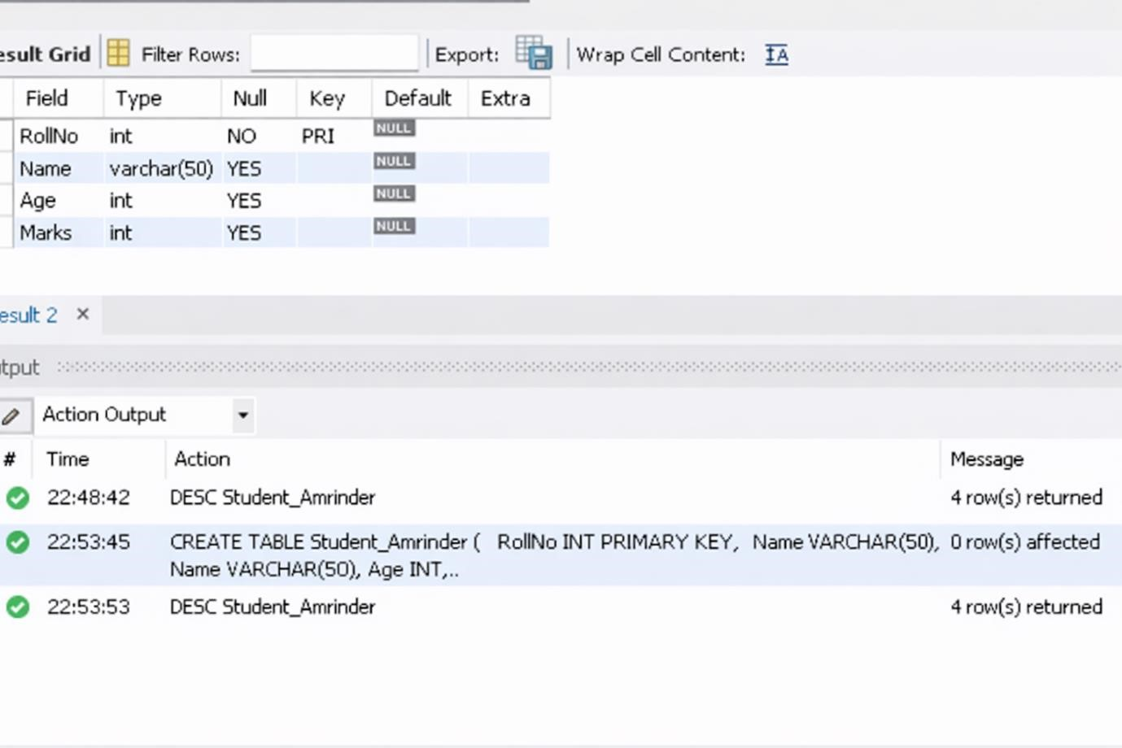

ALTER TABLE Student_Amrinder CHANGE City Address VARCHAR(40);
ALTER TABLE Student_Amrinder DROP Address;
DESC Student_Amrinder;

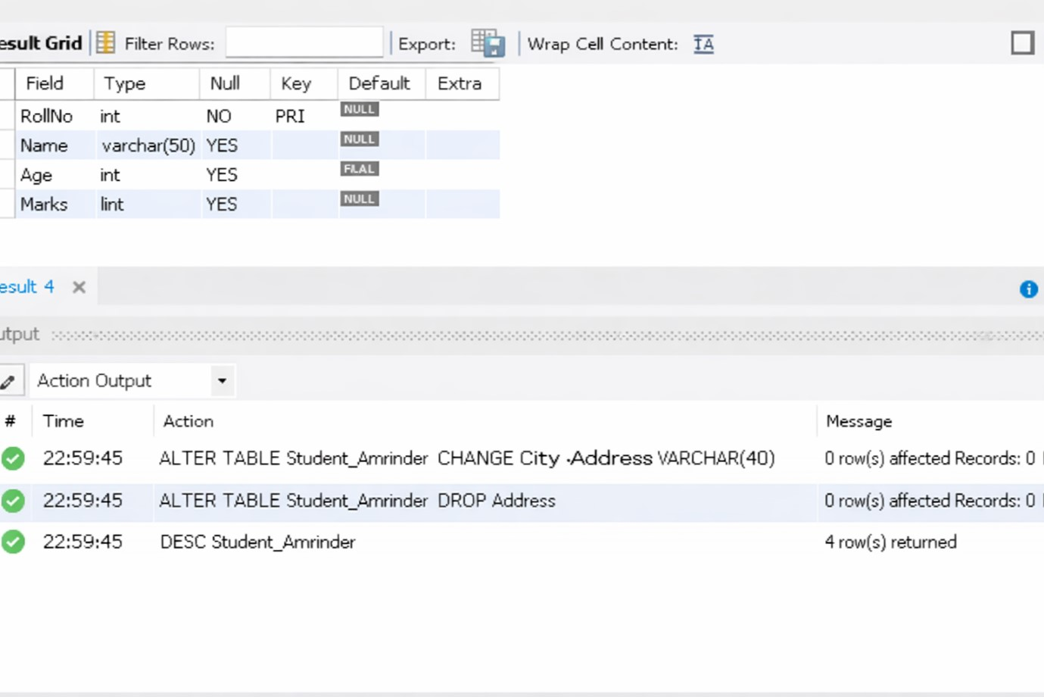
Data Manipulation Language (DML):
DML commands are used to manage and manipulate the data stored inside database tables.
- DML allows insertion, updating, deletion, and retrieval of records.
- Common commands include INSERT, UPDATE, DELETE, and SELECT.
- These operations work on rows (records) within tables rather than the structure.
- DML commands can be rolled back if transactions are used (using COMMIT and ROLLBACK).
- It is used in day-to-day operations where data needs to be modified or retrieved.

INSERT INTO Student_Amrinder VALUES (1, 'Priyanshu', 20, 85);
INSERT INTO Student_Amrinder VALUES (2, 'Amrinder', 19, 90);
INSERT INTO Student_Amrinder VALUES (3, 'Kumawat', 21, 78);
SELECT * FROM Student_Amrinder;

SELECT * FROM Student_Amrinder WHERE Marks > 85;

UPDATE Student_Amrinder
SET Marks = 95
WHERE RollNo = 2;
SELECT * FROM Student_Amrinder;
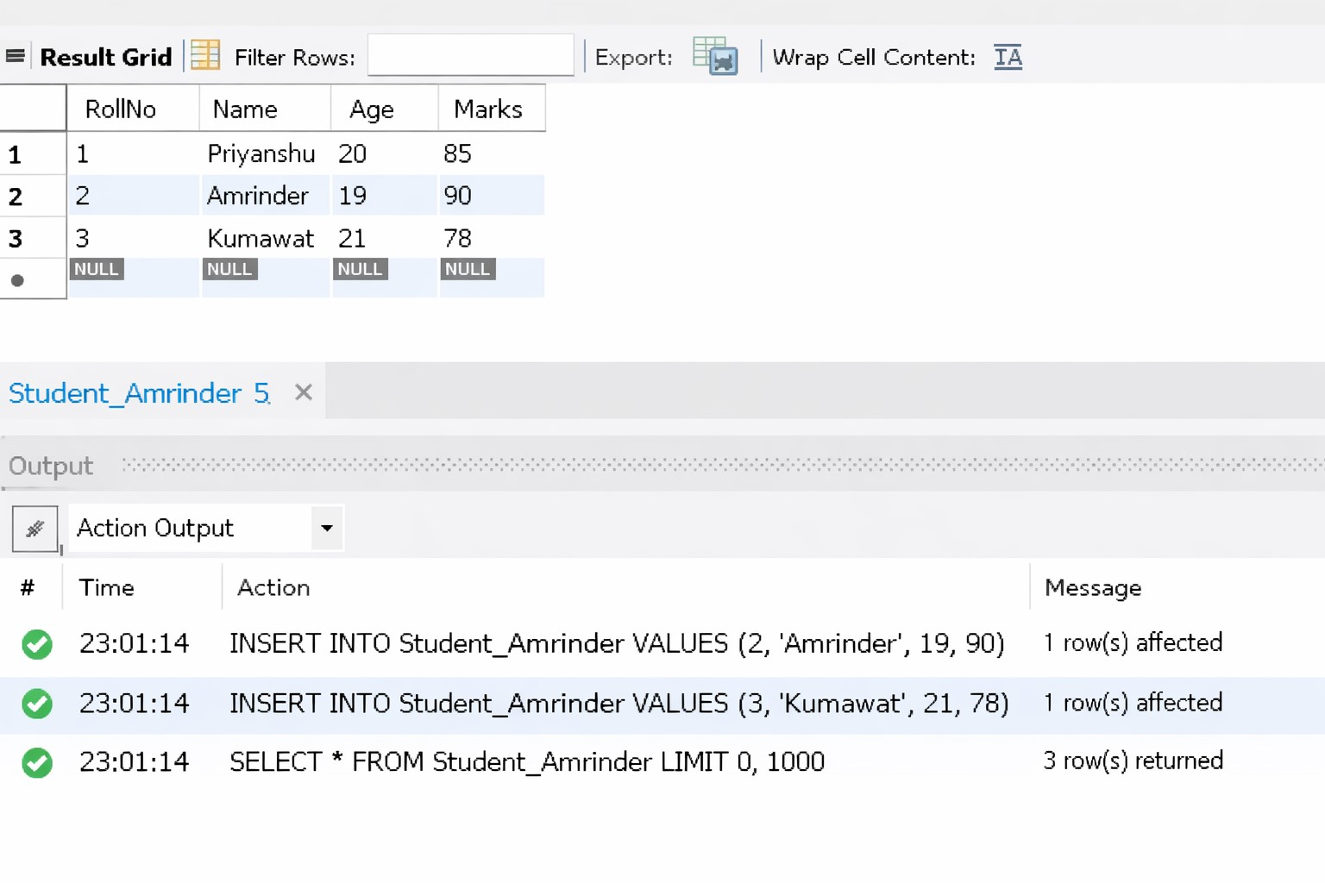

Assignment-3

