IRC Rover Cone Detection – Model Finalization Report
YOLOv8s vs YOLO11s vs YOLO26s Evaluation Framework
Three-Class Cone Detection: Blue, Red and Yellow

Executive Summary
The objective is to finalize an object-detection model for the IRC rover. The detector identifies Blue, Red and Yellow cones from rover-camera images and supplies bounding boxes and class information to the downstream perception pipeline. Model selection is therefore treated as a multi-criteria decision rather than a choice based on one accuracy number.
For this application, recall is the primary accuracy consideration because missed real cones are undesirable. mAP@50:95 is the main stricter measure of detection and localization quality. Precision is also important for false detections. Deployment efficiency—especially inference latency/FPS, GPU memory and computational complexity—is evaluated separately.
The completed YOLOv8s versus YOLO11s comparison currently favors YOLO11s. YOLO26s is being evaluated with the same three-class methodology and should not be declared the winner until its test-set results are available.

1. Project Objective
Develop a cone detector for the IRC rover that distinguishes Blue, Red and Yellow cones and localizes each cone with a bounding box. The final model should provide high detection coverage, accurate localization, acceptable false-positive behavior, and sufficiently fast onboard inference.

2. Model Finalization Criteria
Priority | Metric / factor | Why it matters
1 | Recall | Minimizes missed real cones (false negatives).
2 | mAP@50:95 | Strict measure of detection and bounding-box localization quality.
3 | Precision | Controls false-positive detections.
4 | Inference latency / FPS | Determines real-time capability.
5 | GPU memory / parameters / GFLOPs | Determines onboard resource requirements.
6 | mAP@50 | Useful overall detection measure, but less discriminating when scores are already very high.

3. Why Recall Is Most Important
Recall measures how many actual cones in the ground truth are successfully detected.
Recall = TP / (TP + FN)
TP is a correctly detected cone and FN is a real cone missed by the model. For rover perception, a missed cone removes useful environmental information. Therefore, high recall is particularly important.
A model should not be selected solely because it has the highest precision. A detector with slightly lower precision but substantially higher recall may be preferable when missing real objects is the more important failure mode.

4. Why mAP@50:95 Is Important
mAP@50:95 evaluates performance over IoU thresholds from 0.50 through 0.95, providing a stricter assessment of detection and bounding-box localization than mAP@50 alone.
For the rover, localization matters because the system needs more than an indication that a cone exists; it needs a reliable bounding box.
In the completed YOLOv8s versus YOLO11s comparison, mAP@50 values were already close to 100%, while mAP@50:95 provided a more discriminating comparison: 84.2% versus 84.8%.

5. Why Precision Still Matters
Precision measures how many positive detections are actually correct.
Precision = TP / (TP + FP)
FP represents false positives. Poor precision can create incorrect cone detections for downstream perception or decisions. Precision is therefore monitored even though recall has greater priority for this rover task.

6. Why Inference Speed Is a Deployment Requirement
Accuracy metrics do not establish real-time capability. A model can be highly accurate but unsuitable if inference latency is too high.
The final deployment evaluation should measure end-to-end camera-to-output latency and FPS on the actual Jetson. Tesla T4 measurements are useful for controlled model comparison but should not be assumed to equal Jetson performance.

7. Dataset Used
The three-class experiments use the letsgocone dataset converted to the required cone classes: Blue cone, Red cone and Yellow cone.
Split | Images | Labels
Train | 6,922 | 6,922
Validation | 1,993 | 1,993
Test | 1,022 | 1,022
Total | 9,937 | 9,937

The completed YOLOv8s and YOLO11s comparison used the same unseen test set containing 1,022 images and 2,610 cone instances.

8. Dataset Structure
YOLO-format structure:
letsgocone_3class/
├── train/
│ ├── images/
│ └── labels/
├── valid/
│ ├── images/
│ └── labels/
├── test/
│ ├── images/
│ └── labels/
└── data.yaml
Each image has a corresponding YOLO label file containing class ID and normalized bounding-box coordinates. The data.yaml defines dataset paths and class names.
- 0 → Blue cone
- 1 → Red cone
- 2 → Yellow cone

9. Training Method
Each model was initialized from its corresponding pretrained YOLO checkpoint and fine-tuned on the three-class cone dataset. The Ultralytics training interface performs the forward pass, loss calculation, backpropagation and weight updates.
Training flow:
Dataset → pretrained YOLO model → training images → predictions → compare with labels → calculate loss → update weights → repeat → validation → best.pt

10. Simple Training Code Structure
YOLOv8s:
from ultralytics import YOLO
model = YOLO("yolov8s.pt")
model.train(
data="/content/letsgocone_3class/data.yaml",
epochs=10,
imgsz=640,
batch=8,
device=0
)
YOLO11s:
from ultralytics import YOLO
model = YOLO("yolo11s.pt")
model.train(
data="/content/letsgocone_3class/data.yaml",
epochs=15,
imgsz=640,
batch=8,
device=0
)
YOLO26s current training structure:
from ultralytics import YOLO
model = YOLO("yolo26s.pt")
model.train(
data="/content/letsgocone_3class_v26/data.yaml",
epochs=10,
imgsz=640,
batch=8,
device=0,
workers=2,
amp=True
)

11. Main Training Parameters
Parameter | Value | Meaning
Epochs | YOLOv8s: 10; YOLO11s: 15; YOLO26s: 10 planned | Complete passes through training data.
Image size | 640 | Input size used for training/evaluation.
Batch size | 8 | Images processed per training batch.
Device | GPU 0 / Tesla T4 in Colab | Accelerated training/evaluation device.
Workers | 2 for YOLO26s | Data-loading worker processes.
AMP | True for YOLO26s | Automatic Mixed Precision for GPU efficiency.

12. Completed YOLOv8s vs YOLO11s Test-Set Results
Both completed models were evaluated on exactly the same unseen test set of 1,022 images and 2,610 cone instances.
Metric | YOLOv8s | YOLO11s | Better
Precision | 96.7% | 95.4% | YOLOv8s
Recall | 96.7% | 97.6% | YOLO11s
mAP@50 | 98.7% | 98.8% | YOLO11s
mAP@50:95 | 84.2% | 84.8% | YOLO11s
T4 inference | 10.4 ms/image | 9.4 ms/image | YOLO11s
Parameters | 11.13M | 9.41M | YOLO11s
GFLOPs | 28.4 | 21.4 | YOLO11s

13. Interpretation of Current Results
YOLOv8s has higher precision at 96.7% versus 95.4% for YOLO11s, indicating fewer false positives under these test conditions.
YOLO11s has higher recall at 97.6% versus 96.7%, meaning it detected a larger proportion of ground-truth cone instances.
YOLO11s also has slightly higher mAP@50 (98.8% versus 98.7%) and mAP@50:95 (84.8% versus 84.2%), giving it the stronger overall detection/localization result in the completed comparison.
YOLO11s has 9.41M parameters versus 11.13M for YOLOv8s and 21.4 GFLOPs versus 28.4 GFLOPs. Measured T4 inference was 9.4 ms/image versus 10.4 ms/image.

14. Current Leading Model: YOLO11s
- Higher recall: 97.6% vs 96.7%.
- Higher mAP@50: 98.8% vs 98.7%.
- Higher mAP@50:95: 84.8% vs 84.2%.
- Lower measured T4 inference latency: 9.4 ms vs 10.4 ms.
- 15.4% fewer parameters: 9.41M vs 11.13M.
- Approximately 24.6% fewer GFLOPs: 21.4 vs 28.4.
- Higher recall for Blue, Red and Yellow cones.
- Higher mAP@50:95 for Blue, Red and Yellow cones.
Therefore YOLO11s is currently the leading candidate because it provides the better overall accuracy–efficiency trade-off rather than winning every individual metric.

15. Why YOLOv8s Remains a Strong Alternative
YOLOv8s is not a poor model. It achieved 96.7% precision, 96.7% recall, 98.7% mAP@50 and 84.2% mAP@50:95. Its main advantage over YOLO11s is precision. The selection is therefore a trade-off decision.

16. YOLO26s Current Status
YOLO26s is being evaluated as an additional candidate. The newly downloaded Roboflow dataset initially contained 17 classes, so it was not used directly for the final three-class comparison. A three-class YOLO dataset was prepared so YOLO26s can be evaluated on the same Blue/Red/Yellow cone task and the same test-set methodology.
At the time of this report, the YOLO26s training run is in progress. Therefore, no final YOLO26s accuracy numbers should be claimed yet. After training, its best.pt checkpoint should be evaluated on the same 1,022-image test set.

17. Final Selection Procedure
- Train YOLO26s on the three-class dataset.
- Evaluate YOLO26s on the same 1,022-image test set.
- Record precision, recall, mAP@50 and mAP@50:95.
- Compare parameter count and GFLOPs.
- Measure inference latency and FPS on the actual Jetson.
- Check GPU memory and resource usage while other rover processes are running.
- Test real multi-frame rover-camera footage under motion, distance, lighting changes, blur and occlusion.
- Select the model with the best overall accuracy–efficiency trade-off that satisfies the rover's real-time requirement.

18. Dedicated GPU Consideration
A dedicated GPU does not automatically increase model accuracy. Accuracy comes from the trained weights and data. A dedicated GPU primarily improves inference speed and provides computational headroom.
A model designed for edge or integrated-graphics systems should not be rejected simply because the rover has a dedicated GPU. The correct question is whether it provides the required accuracy and runs efficiently on the actual deployment hardware.
The final benchmark must therefore be performed on the actual Jetson; Tesla T4 results are not a substitute for Jetson measurements.

19. Recommended Decision Rule
For this rover, prefer the model with high recall and high mAP@50:95 while maintaining acceptable precision and real-time performance. If two models have similar accuracy, prefer the one with lower latency, lower GPU memory usage and lower computational complexity.
In short: prioritize detection coverage and localization quality first, then verify that the model is fast and efficient enough for real rover operation.

20. Team Meeting Conclusion
Recommended statement: “For our IRC rover, we are not selecting the object-detection model using a single accuracy metric. Our primary accuracy consideration is recall because missing an actual cone is undesirable for the rover's perception system. We then consider mAP@50:95 because it provides a stricter evaluation of detection and bounding-box localization. Precision is also monitored to control false detections, while inference latency, FPS, GPU memory and computational complexity determine whether the model can operate efficiently on the rover hardware. In our completed YOLOv8s versus YOLO11s comparison, YOLO11s achieved 97.6% recall, 98.8% mAP@50 and 84.8% mAP@50:95, compared with 96.7%, 98.7% and 84.2% for YOLOv8s. YOLO11s also had fewer parameters, fewer GFLOPs and lower measured T4 inference latency. Therefore YOLO11s is currently our leading candidate. YOLO26s is being evaluated using the same three-class methodology before the final deployment model is declared.”

21. Current Finalization Status
Model | Status | Current evidence
YOLOv8s | Completed | Strong precision; complete test-set benchmark available.
YOLO11s | Completed | Currently leading based on recall, mAP@50:95 and efficiency.
YOLO26s | Training / evaluation in progress | Final test-set metrics not yet available.

Current leading candidate: YOLO11s — pending final YOLO26s test-set and Jetson deployment benchmark.
PART II – OBJECT DETECTION RESEARCH, EXPERIMENTAL STUDY AND YOLO26 RESULTS

PART III – INTEGRATED CONCLUSION AND FINALIZATION PLAN
The combined study establishes a clear progression: the initial research compared different object-detection families and identified the need to balance accuracy, localization, computational complexity and real-time speed; the later controlled three-class experiments then compared YOLOv8s and YOLO11s on the same unseen test set.
The earlier research document records a two-class experimental study involving Faster R-CNN, YOLOv8m and YOLO26m. Those results are useful as research evidence, but they were not a perfectly controlled head-to-head benchmark because the evaluated splits and instance counts differed. The later three-class YOLOv8s/YOLO11s benchmark is more directly comparable because both models were evaluated on the same 1,022-image test set containing 2,610 instances.
For the IRC rover, the practical finalization rule is to prioritize recall and strict localization quality, while maintaining acceptable precision and meeting the real-time requirements of the actual Jetson deployment. YOLO11s is the current leading candidate from the completed three-class benchmark, while YOLO26s must be evaluated on the same three-class test set before it can replace YOLO11s as the final model.
The final team decision should therefore be made only after the candidate models are benchmarked on the same dataset and then tested on the actual rover hardware using real camera footage. The final deployment test should include end-to-end FPS/latency, GPU memory, CPU/GPU utilization, power consumption, confidence-threshold behavior, object distance, lighting, occlusion, motion blur and camera vibration.
IRC Rover – Object Detection Model Research, Experimental Evaluation and Selection
1. Introduction
As part of the computer vision work for the IRC rover, I started working on object detection. The main aim was to identify an object detection model that can work effectively with the rover’s camera system.
Since the rover will be moving and continuously receiving images from its cameras, the model should not only detect objects accurately but should also be fast enough for real-time operation. It should also be possible to run the model on the rover’s onboard computer.
I did not want to directly select YOLO just because it is commonly used for real-time object detection. I first studied different object detection approaches and then narrowed them down based on the actual requirements of the rover.
2. Initial Study of Object Detection Models
I studied YOLO, Faster R-CNN, Mask R-CNN, SSD, MobileNet-SSD, RetinaNet, EfficientDet, DETR, RT-DETR and DINO/Grounding DINO. The purpose was to understand the difference between one-stage detectors, two-stage detectors, lightweight detectors and transformer-based approaches.
I found that different models make different trade-offs between accuracy, speed, computational requirements and additional capabilities such as segmentation or open-vocabulary detection.
3. Requirements for the IRC Rover
Detection accuracy and localization accuracy
Precision and recall
mAP@50 and mAP@50:95
Inference latency and FPS
Number of parameters and computational complexity
GPU memory, RAM, CPU and GPU utilization
Performance on small objects and objects at different distances
Robustness to lighting changes, shadows, occlusion, motion blur and camera vibration
Suitability for deployment on the rover’s onboard computer
4. Evaluation Metrics
Precision measures how many of the detections made by the model are correct. Recall measures how many of the actual objects are detected. IoU measures the overlap between the predicted bounding box and the ground-truth bounding box.
mAP@50 measures mean Average Precision at an IoU threshold of 0.50. mAP@50:95 is stricter because it evaluates multiple IoU thresholds from 0.50 to 0.95. FPS indicates how many frames can be processed per second, while inference latency is the time required to process one image.
Model parameters and GFLOPs were also considered. They provide information about model size and computational complexity, but they do not directly determine real-world latency on every hardware platform.
5. Model Shortlisting
Model | Reason for considering it
YOLO | Modern real-time one-stage detector and strong accuracy-speed trade-off
RT-DETR | Transformer-based real-time alternative
Faster R-CNN | Two-stage accuracy-oriented reference
MobileNet-SSD | Lightweight and low-computation reference
These four were selected because they represent different approaches rather than four models from the same family.
6. Dataset Preparation
For the practical experiment, I used a traffic-cone detection dataset obtained from Roboflow. The dataset contains two classes: blue cone and yellow cone.
During dataset inspection, some label files contained normal YOLO detection annotations while others contained segmentation polygon annotations. Some files contained both types. Since the experiment was for object detection, the annotations were cleaned so that the detection dataset contained valid bounding-box labels.
Fourteen blank label files were removed. After cleaning, the dataset was checked again and the training, validation and test annotations had zero invalid rows.
Split | Images | Labeled files
Train | 399 | 394
Valid | 295 | 288
Test | 174 | 172
7. Faster R-CNN Experiment
Faster R-CNN was used as a two-stage, accuracy-oriented reference. The recorded results were:
Metric | Faster R-CNN
mAP@50 | 96.11%
mAP@50:95 | 66.05%
mAP@75 | 70.17%
The model provided strong detection and localization performance, but a rover application also needs low latency and reasonable computational requirements.
8. YOLOv8m Experiment
YOLOv8m was evaluated as the main modern one-stage real-time detector.
Metric | YOLOv8m
Precision | 93.4%
Recall | 91.0%
mAP@50 | 96.4%
mAP@50:95 | 66.4%
Parameters | 25.84 million
GFLOPs | 78.7
Measured inference | 19.9 ms/image on Tesla T4
The class-wise results were 97.3% mAP@50 for blue cones and 95.4% for yellow cones. This showed a strong balance between detection accuracy and inference speed.
9. YOLO26m Experiment
I then evaluated YOLO26m as another modern real-time detector. The latest recorded run used Ultralytics 8.4.125, Python 3.12.13, PyTorch 2.11.0+cu128 and a Tesla T4 GPU with approximately 14.9 GB of GPU memory.
The training run completed 10 epochs. The final validation output reported 179 images and 1,594 object instances for the evaluated split.
Metric | YOLO26m – latest run
Precision | 93.0%
Recall | 89.5%
mAP@50 | 96.9%
mAP@50:95 | 66.7%
Parameters | 20,350,994
GFLOPs | 68.1
Preprocess | 0.4 ms/image
Inference | 8.2 ms/image
Postprocess | 0.5 ms/image
Class-wise results:
Class | Images | Instances | Precision | Recall | mAP@50 | mAP@50:95
Blue cone | 161 | 932 | 91.1% | 91.4% | 96.6% | 66.8%
Yellow cone | 143 | 662 | 94.9% | 87.5% | 97.3% | 66.6%
10. YOLO26m Training and Validation Graphs
The following figures are taken directly from the YOLO26m experiment results folder. They are included to show the training behaviour, detection performance and validation behaviour rather than presenting only the final numerical metrics.
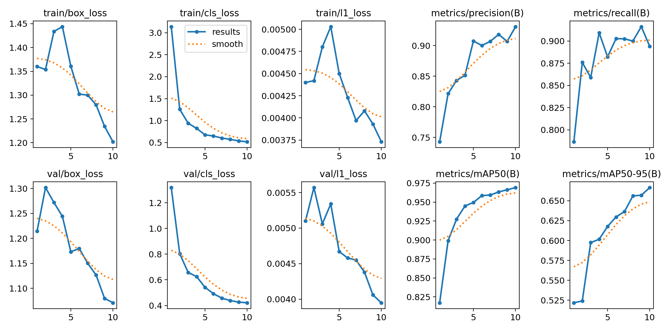
Figure 1. YOLO26m training and validation results across the training epochs.
The results graph summarizes how the training losses and validation metrics changed during training. The graph should be interpreted together with the final validation metrics rather than using a single curve alone.
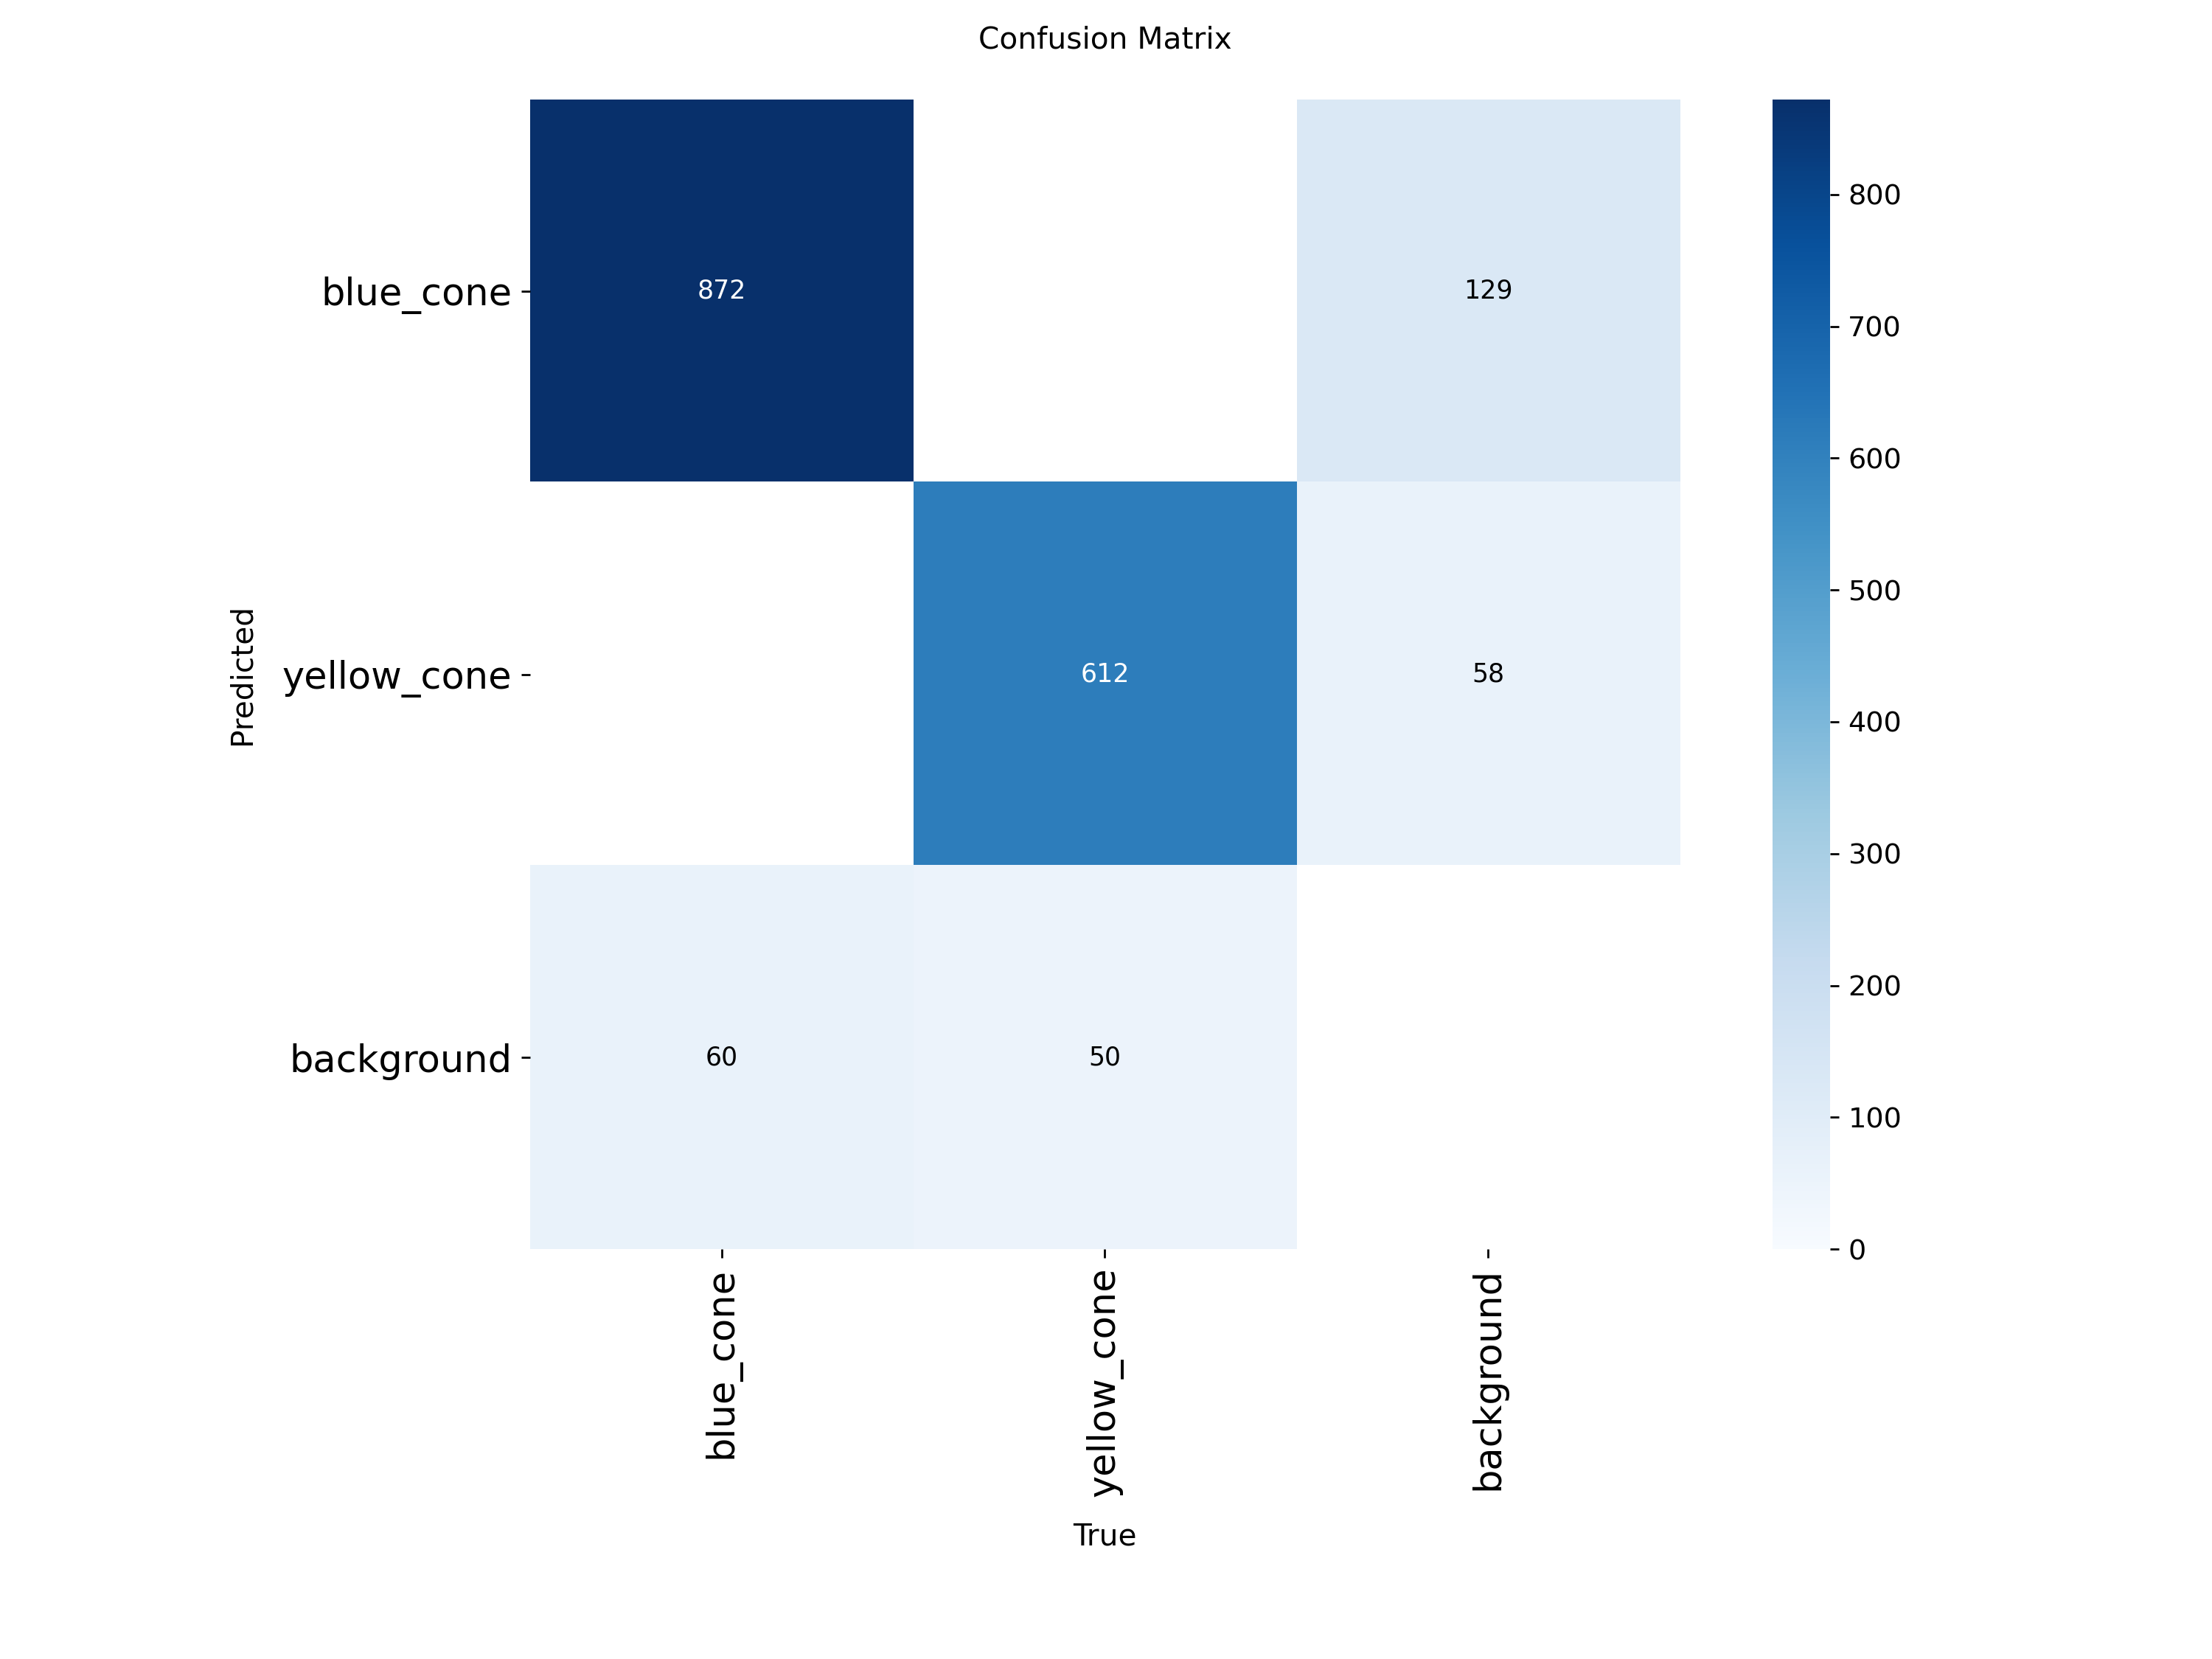
Figure 2. YOLO26m confusion matrix.
The confusion matrix shows the distribution of correct detections and classification errors between the blue-cone and yellow-cone classes. It helps identify whether one cone class is being confused with the other or with the background.
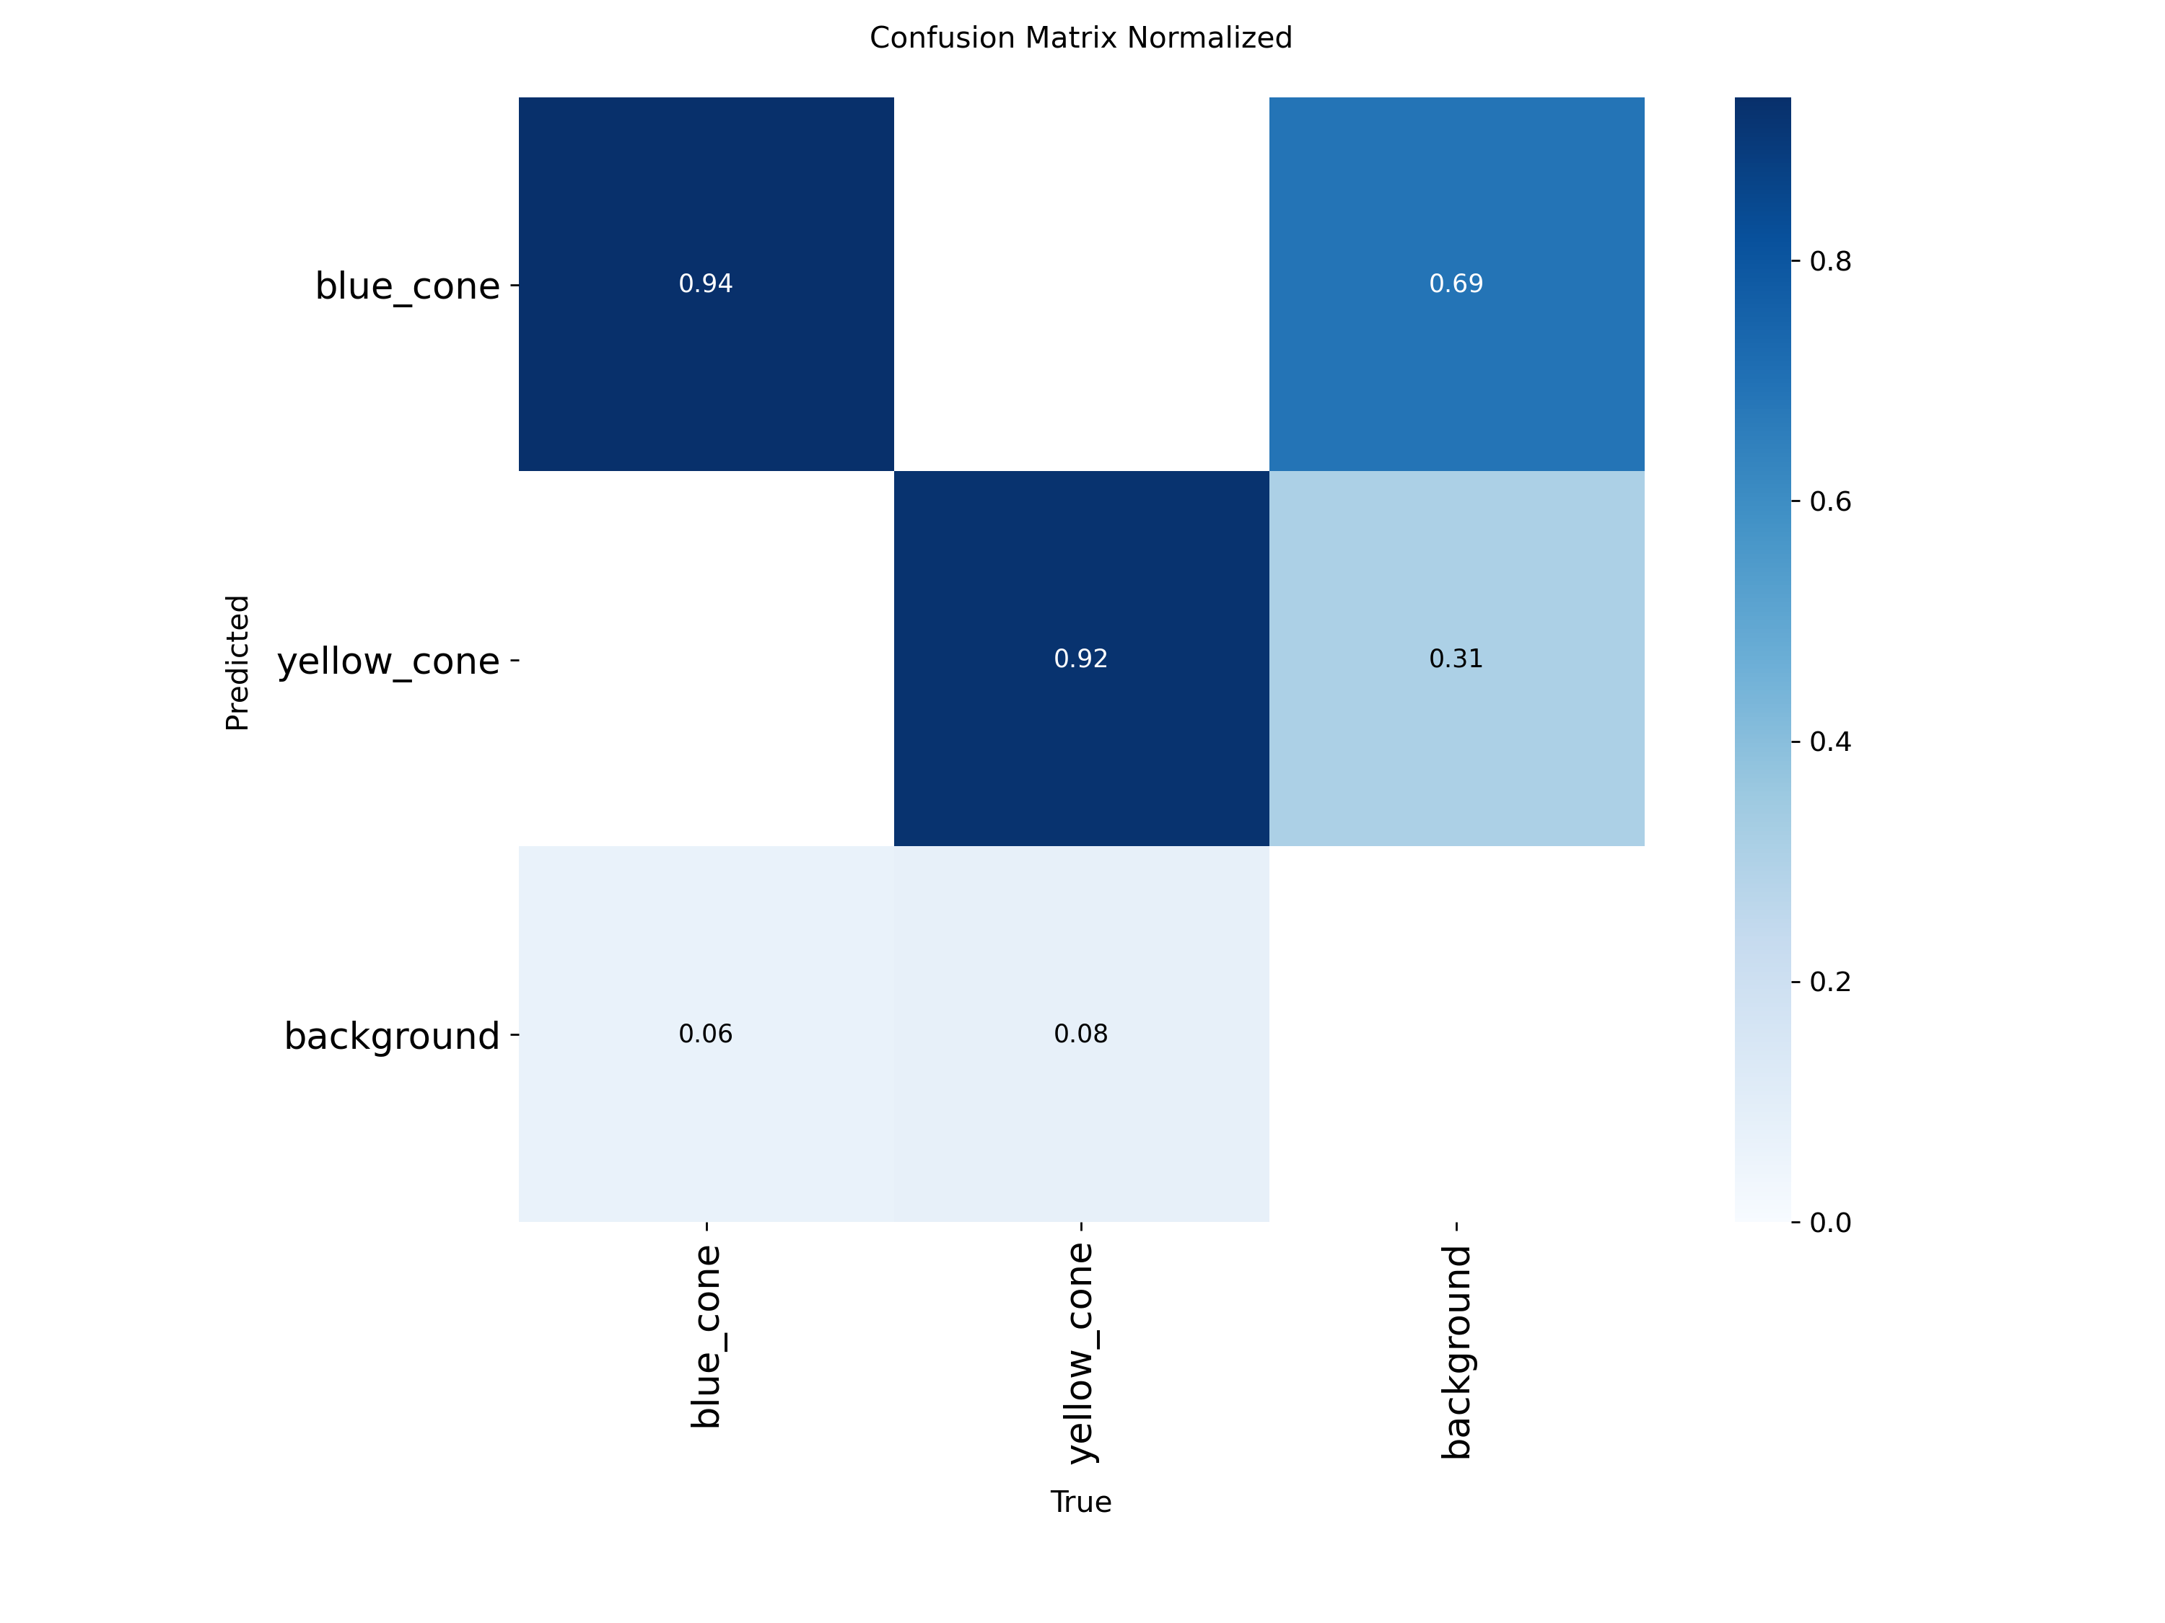
Figure 3. YOLO26m normalized confusion matrix.
The normalized confusion matrix presents the same classification behaviour in normalized form, making the relative performance of each class easier to interpret.
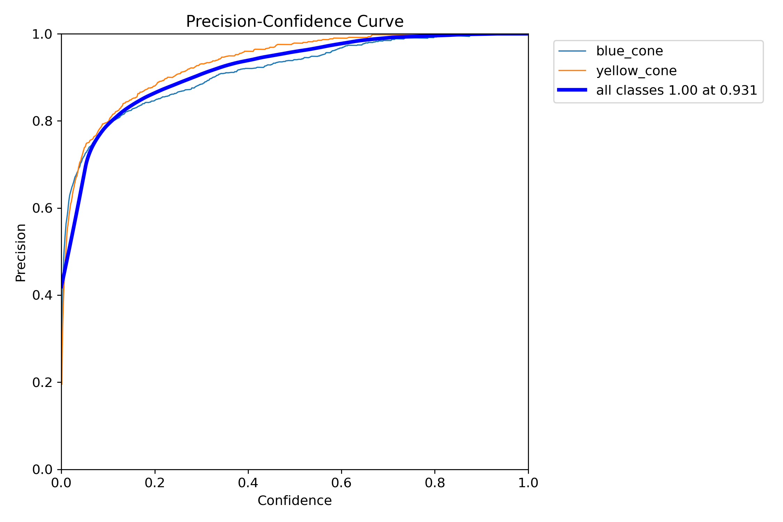
Figure 4. YOLO26m box precision curve.
The precision curve shows how detection precision changes with the confidence threshold. This is useful for choosing a confidence threshold that reduces false detections while retaining useful detections.
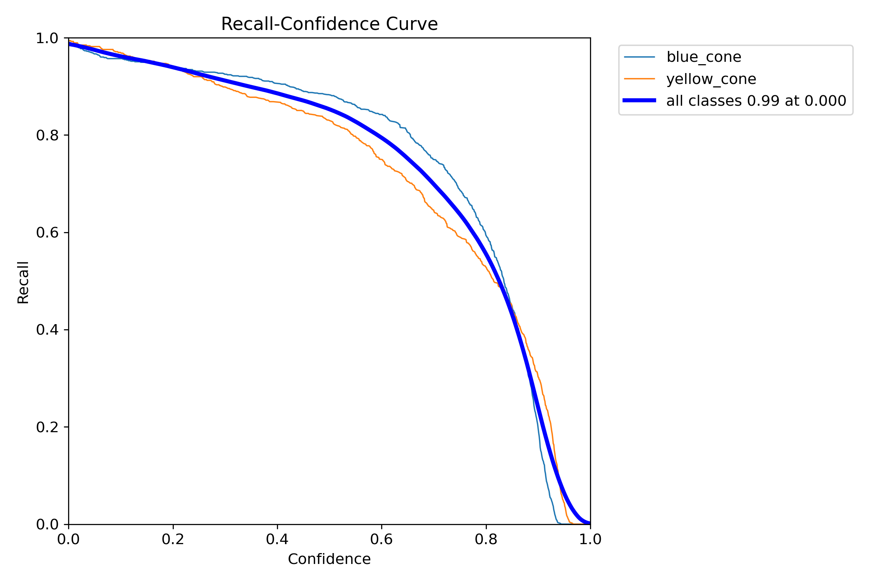
Figure 5. YOLO26m box recall curve.
The recall curve shows how the ability to detect ground-truth objects changes with the confidence threshold. For rover operation, recall is important because missed objects can affect perception and downstream decisions.
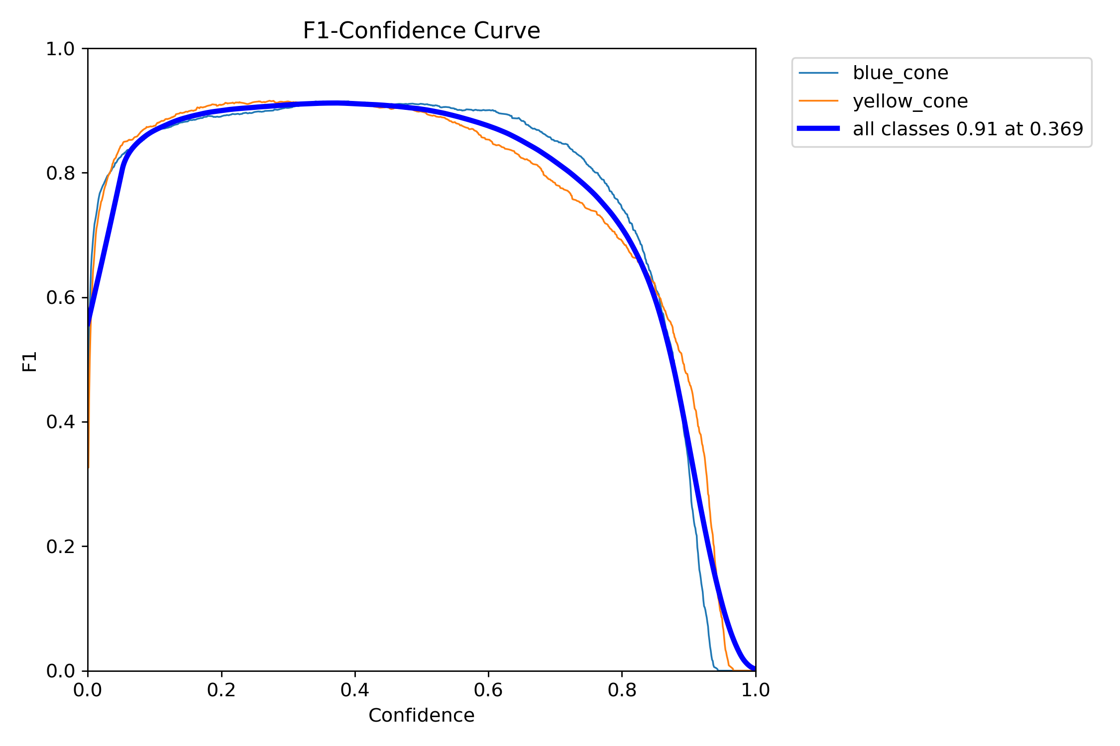
Figure 6. YOLO26m box F1 curve.
The F1 curve combines precision and recall. The peak region indicates a confidence threshold where the balance between false detections and missed detections is favourable.
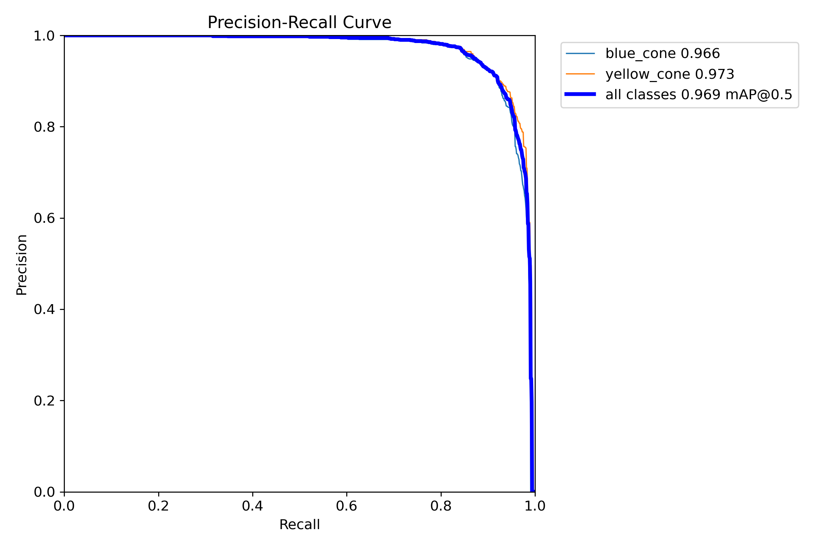
Figure 7. YOLO26m box precision-recall curve.
The precision-recall curve shows the trade-off between precision and recall over different confidence thresholds. The reported high mAP values indicate strong overall detection performance on the evaluated data.
11. YOLO26m Validation Prediction Examples
The validation prediction images are also useful for visually checking whether the predicted bounding boxes are placed correctly on the cones.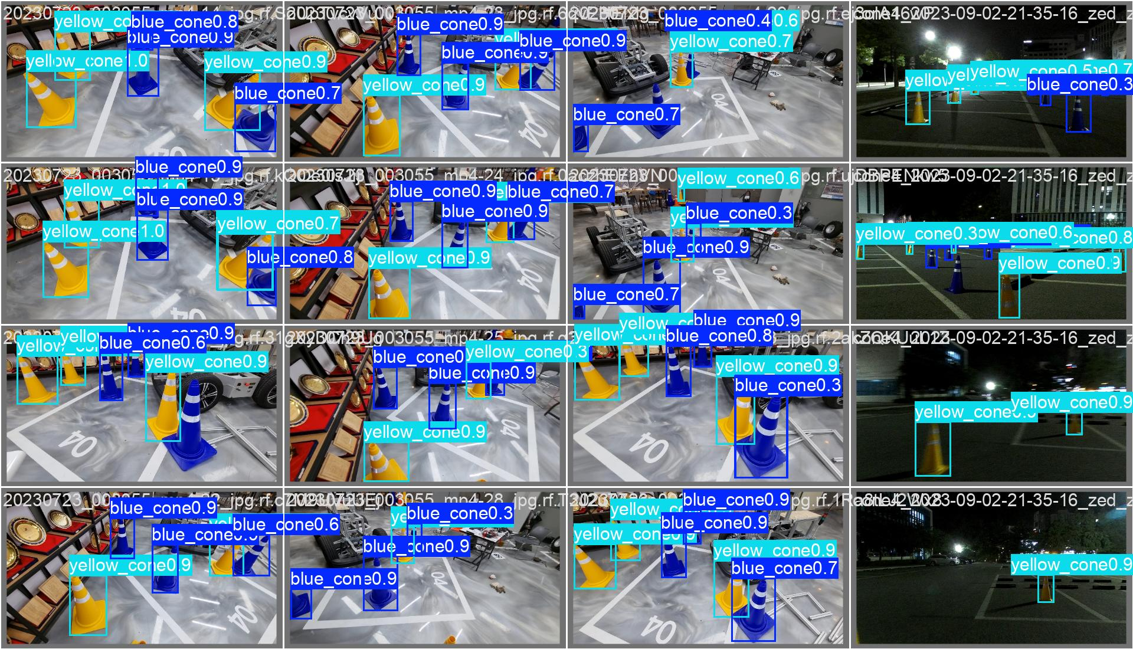
Figure 8. YOLO26m validation predictions for batch 0.
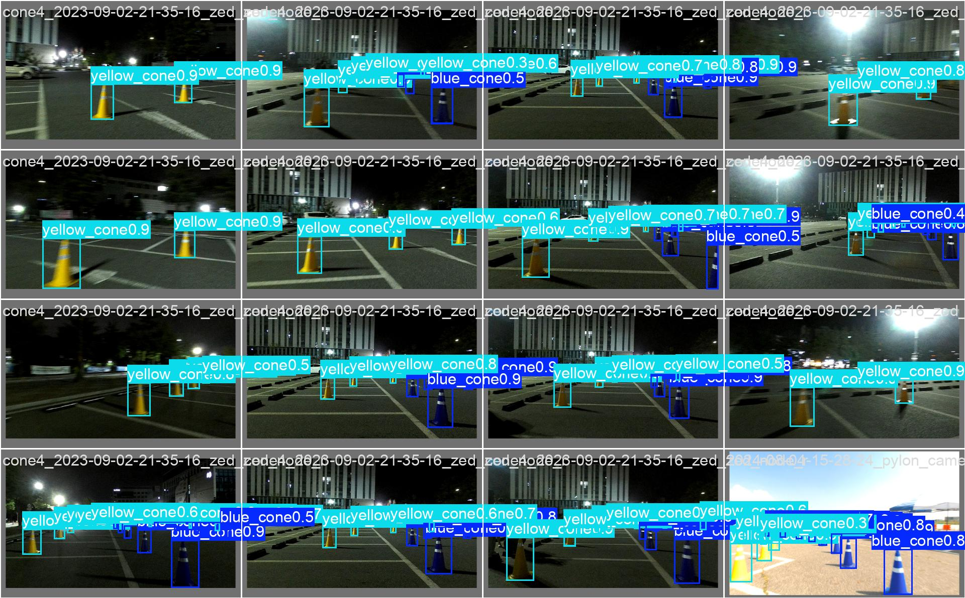
Figure 9. YOLO26m validation predictions for batch 1.
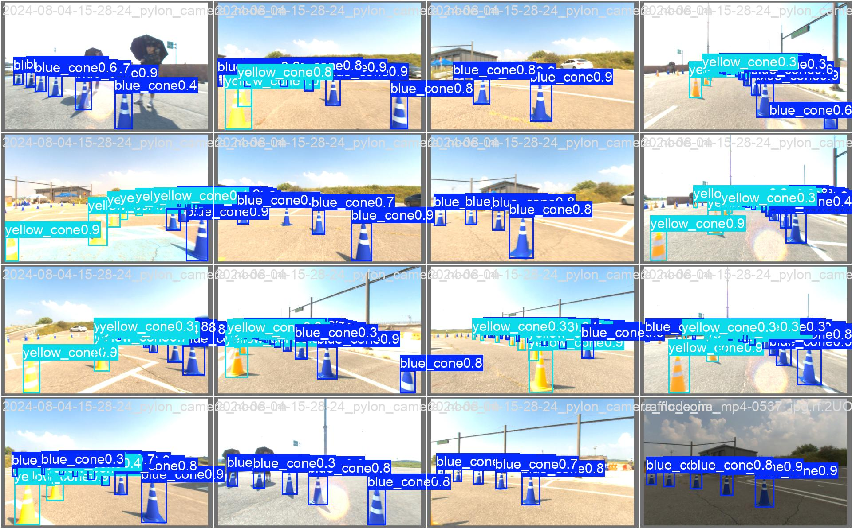
Figure 10. YOLO26m validation predictions for batch 2.
These images provide a qualitative check in addition to the numerical metrics. They are particularly useful for checking bounding-box placement, class assignment and cases where objects are close together.
12. Updated Model Comparison
The three main models considered in the current experimental study are Faster R-CNN, YOLOv8m, and YOLO26m. The purpose of this comparison is not to select a model based on a single accuracy metric, but to evaluate the overall balance between detection accuracy, localization performance, computational complexity, and inference speed.
Table 12.1. Comparison of the evaluated object-detection models
Metric | Faster R-CNN | YOLOv8m | YOLO26m – Latest Run
mAP@50 | 96.11% | 96.40% | 96.90%
mAP@50:95 | 66.05% | 66.40% | 66.70%
Precision | Not recorded in same format | 93.4% | 93.0%
Recall | Not recorded in same format | 91.0% | 89.5%
Parameters | Not recorded | 25.84 M | 20.35 M
GFLOPs | Not recorded | 78.7 | 68.1
Measured inference | Not benchmark equivalently | 19.9 ms/image | 8.2 ms/image
12.1 Detection Accuracy
mAP@50
mAP@50 represents the mean Average Precision of the detector when an Intersection over Union (IoU) threshold of 0.50 is used. It provides an overall measure of how accurately the model detects the target objects and places their bounding boxes.
The recorded results are:
- Faster R-CNN: 96.11%
- YOLOv8m: 96.40%
- YOLO26m: 96.90%
YOLO26m has the highest recorded mAP@50 among the three models. Its result is 0.50 percentage points higher than YOLOv8m and 0.79 percentage points higher than Faster R-CNN.
However, the difference is relatively small. Therefore, the result should not be interpreted as YOLO26m being significantly more accurate than the other models. Instead, it indicates that YOLO26m provides a comparable and slightly higher detection accuracy in the current experiments.
mAP@50:95
mAP@50:95 is a stricter evaluation metric because it evaluates detection performance across multiple IoU thresholds from 0.50 to 0.95. Therefore, it provides a better indication of bounding-box localization quality under stricter overlap requirements.
The recorded values are:
- Faster R-CNN: 66.05%
- YOLOv8m: 66.40%
- YOLO26m: 66.70%
YOLO26m again gives the highest recorded value. However, the difference between the models is small. This indicates that all three models provide reasonably strong localization performance on the evaluated dataset.
Therefore, accuracy alone does not provide a sufficient reason to select YOLO26m. The computational and real-time characteristics must also be considered.
12.2 Precision
Precision indicates how many of the detections produced by the model are actually correct.
The recorded precision values are:
- YOLOv8m: 93.4%
- YOLO26m: 93.0%

YOLOv8m has a slightly higher precision by 0.4 percentage points.
This means that, in the current recorded experiments, YOLOv8m produced slightly fewer false-positive detections than YOLO26m.
The Faster R-CNN precision value is not included in the same format in the current results, so a direct comparison cannot be made.
12.3 Recall
Recall represents the percentage of actual objects that were successfully detected by the model.
The recorded values are:
- YOLOv8m: 91.0%
- YOLO26m: 89.5%
YOLOv8m has a 1.5 percentage-point advantage in recall.
This indicates that YOLOv8m detected a slightly larger proportion of the objects present in its evaluated dataset.
Recall is particularly important for a rover because missed detections may affect subsequent perception or decision-making processes. Therefore, the lower recall of YOLO26m should be investigated further during controlled testing.
Again, a directly comparable Faster R-CNN recall value is not available in the current results.
12.4 Model Parameters
The number of parameters provides an indication of the size of the neural network.
The recorded values are:
- YOLOv8m: 25.84 million parameters
- YOLO26m: 20.35 million parameters
YOLO26m therefore has approximately 5.49 million fewer parameters than YOLOv8m.
This corresponds to approximately a 21% reduction in parameter count relative to YOLOv8m.
A lower parameter count can be beneficial for onboard deployment because it can reduce model storage and may reduce memory requirements. However, parameter count alone cannot be used to determine actual inference speed. Actual latency depends on the model architecture, hardware, implementation and other system factors.
12.5 Computational Complexity
GFLOPs represent an approximate measure of the floating-point computational operations required by a model.
The recorded values are:
- YOLOv8m: 78.7 GFLOPs
- YOLO26m: 68.1 GFLOPs
YOLO26m therefore has approximately 10.6 fewer GFLOPs than YOLOv8m, corresponding to roughly a 13.5% lower reported computational complexity.
This is relevant for the rover because the onboard computer must perform several tasks simultaneously. The available computing resources may also be required for camera processing, ROS, navigation, SLAM, sensor processing and communication.
Therefore, a detector that provides strong accuracy without unnecessarily high computational requirements is preferable.
12.6 Inference Latency
Inference latency represents the time taken by the object-detection model to process one image.
The recorded values are:
- YOLOv8m: 19.9 ms/image
- YOLO26m: 8.2 ms/image
The latest YOLO26m run therefore reports an inference time that is approximately 11.7 ms lower per image than the earlier YOLOv8m run.
This is an important result for a real-time rover system because lower inference latency allows the detector to process incoming camera frames more quickly.
However, the reported inference time should not be considered the complete rover-system latency. The actual perception pipeline will include camera capture, image transfer, preprocessing, neural-network inference, postprocessing and communication.
Therefore:
Model inference latency ≠ complete end-to-end rover latency.
The final system must be benchmarked as a complete pipeline.
12.7 Comparison of the Current Results
The current results show that YOLO26m provides the highest recorded mAP@50 and mAP@50:95 among the three models. It also has fewer parameters, lower reported GFLOPs and a lower measured inference time than the YOLOv8m experiment.
However, YOLO26m does not outperform YOLOv8m in every metric. YOLOv8m currently has slightly higher precision and recall.
Therefore, the decision cannot be based on accuracy alone.
For the IRC rover, the important consideration is the overall balance between:
- Detection accuracy
- Localization accuracy
- Precision
- Recall
- Inference latency
- FPS
- Computational complexity
- Memory requirements
- Hardware utilization
- Power consumption
- Robustness under real rover conditions
12.8 Limitation of the Current Comparison
Although the current results are useful for identifying the leading candidate, the comparison is not yet a perfectly controlled benchmark.
The latest YOLO26m evaluation used:
- 179 evaluated images
- 1,594 object instances
whereas the earlier YOLOv8m evaluation used:
- 174 test images
- 1,817 object instances
Therefore, the two models were not evaluated on exactly the same number of images and object instances.
This means that the difference in performance may be influenced not only by the model architecture but also by the evaluated data.
For this reason, it would not be scientifically appropriate to conclude that YOLO26m is definitively superior to YOLOv8m based only on these current results
13. Why the Other Models Were Not Prioritized
Mask R-CNN was not prioritized because the current requirement is bounding-box object detection rather than instance segmentation. RetinaNet was studied but did not add as much architectural diversity to the initial comparison as the selected models. EfficientDet was considered as an efficiency-oriented model, but a lightweight reference was already included. The original DETR was not prioritized because RT-DETR is more directly aligned with the real-time requirement. DINO/Grounding DINO was not prioritized because the current rover task uses predefined object classes rather than open-vocabulary detection.
14. Current Model Selection Status
Based on the latest experimental evidence, YOLO26m is currently the strongest candidate. It combines high detection accuracy with a smaller parameter count, lower GFLOPs and much lower measured inference time than the earlier YOLOv8m run.
However, I am not treating this as the final selection yet because the YOLOv8m and YOLO26m results were not produced on exactly the same evaluation set. The final selection will be made after a controlled head-to-head benchmark.
If YOLO26m maintains its current performance under the controlled benchmark and performs well on the actual Jetson rover hardware, it would be the preferred model for real-time onboard object detection.
15. Next Work
Evaluate YOLOv8m and YOLO26m on exactly the same test set.
Use the same image size, batch size and evaluation settings.
Measure FPS and end-to-end latency on the actual Jetson hardware.
Measure GPU memory, CPU usage, GPU usage and power consumption.
Test the model using the actual rover camera.
Test different object distances, lighting conditions, occlusion, motion blur and camera vibration.
Complete RT-DETR and MobileNet-SSD experiments if a full four-model benchmark is required.

