IRC Rover – Object Detection Model Research, Experimental Evaluation and Selection

1. Introduction
As part of the computer vision work for the IRC rover, I started working on object detection. The main aim was to identify an object detection model that can work effectively with the rover’s camera system.
Since the rover will be moving and continuously receiving images from its cameras, the model should not only detect objects accurately but should also be fast enough for real-time operation. It should also be possible to run the model on the rover’s onboard computer.
I did not want to directly select YOLO just because it is commonly used for real-time object detection. I first studied different object detection approaches and then narrowed them down based on the actual requirements of the rover.

2. Initial Study of Object Detection Models
I studied YOLO, Faster R-CNN, Mask R-CNN, SSD, MobileNet-SSD, RetinaNet, EfficientDet, DETR, RT-DETR and DINO/Grounding DINO. The purpose was to understand the difference between one-stage detectors, two-stage detectors, lightweight detectors and transformer-based approaches.
I found that different models make different trade-offs between accuracy, speed, computational requirements and additional capabilities such as segmentation or open-vocabulary detection.

3. Requirements for the IRC Rover
- Detection accuracy and localization accuracy
- Precision and recall
- mAP@50 and mAP@50:95
- Inference latency and FPS
- Number of parameters and computational complexity
- GPU memory, RAM, CPU and GPU utilization
- Performance on small objects and objects at different distances
- Robustness to lighting changes, shadows, occlusion, motion blur and camera vibration
- Suitability for deployment on the rover’s onboard computer

4. Evaluation Metrics
Precision measures how many of the detections made by the model are correct. Recall measures how many of the actual objects are detected. IoU measures the overlap between the predicted bounding box and the ground-truth bounding box.
mAP@50 measures mean Average Precision at an IoU threshold of 0.50. mAP@50:95 is stricter because it evaluates multiple IoU thresholds from 0.50 to 0.95. FPS indicates how many frames can be processed per second, while inference latency is the time required to process one image.
Model parameters and GFLOPs were also considered. They provide information about model size and computational complexity, but they do not directly determine real-world latency on every hardware platform.

5. Model Shortlisting
Model | Reason for considering it
YOLO | Modern real-time one-stage detector and strong accuracy-speed trade-off
RT-DETR | Transformer-based real-time alternative
Faster R-CNN | Two-stage accuracy-oriented reference
MobileNet-SSD | Lightweight and low-computation reference
These four were selected because they represent different approaches rather than four models from the same family.

6. Dataset Preparation
For the practical experiment, I used a traffic-cone detection dataset obtained from Roboflow. The dataset contains two classes: blue cone and yellow cone.
During dataset inspection, some label files contained normal YOLO detection annotations while others contained segmentation polygon annotations. Some files contained both types. Since the experiment was for object detection, the annotations were cleaned so that the detection dataset contained valid bounding-box labels.
Fourteen blank label files were removed. After cleaning, the dataset was checked again and the training, validation and test annotations had zero invalid rows.
Split | Images | Labeled files
Train | 399 | 394
Valid | 295 | 288
Test | 174 | 172

7. Faster R-CNN Experiment
Faster R-CNN was used as a two-stage, accuracy-oriented reference. The recorded results were:
Metric | Faster R-CNN
mAP@50 | 96.11%
mAP@50:95 | 66.05%
mAP@75 | 70.17%
The model provided strong detection and localization performance, but a rover application also needs low latency and reasonable computational requirements.

8. YOLOv8m Experiment
YOLOv8m was evaluated as the main modern one-stage real-time detector.
Metric | YOLOv8m
Precision | 93.4%
Recall | 91.0%
mAP@50 | 96.4%
mAP@50:95 | 66.4%
Parameters | 25.84 million
GFLOPs | 78.7
Measured inference | 19.9 ms/image on Tesla T4
The class-wise results were 97.3% mAP@50 for blue cones and 95.4% for yellow cones. This showed a strong balance between detection accuracy and inference speed.

9. YOLO26m Experiment
I then evaluated YOLO26m as another modern real-time detector. The latest recorded run used Ultralytics 8.4.125, Python 3.12.13, PyTorch 2.11.0+cu128 and a Tesla T4 GPU with approximately 14.9 GB of GPU memory.
The training run completed 10 epochs. The final validation output reported 179 images and 1,594 object instances for the evaluated split.
Metric | YOLO26m – latest run
Precision | 93.0%
Recall | 89.5%
mAP@50 | 96.9%
mAP@50:95 | 66.7%
Parameters | 20,350,994
GFLOPs | 68.1
Preprocess | 0.4 ms/image
Inference | 8.2 ms/image
Postprocess | 0.5 ms/image
Class-wise results:
Class | Images | Instances | Precision | Recall | mAP@50 | mAP@50:95
Blue cone | 161 | 932 | 91.1% | 91.4% | 96.6% | 66.8%
Yellow cone | 143 | 662 | 94.9% | 87.5% | 97.3% | 66.6%

10. YOLO26m Training and Validation Graphs
The following figures are taken directly from the YOLO26m experiment results folder. They are included to show the training behaviour, detection performance and validation behaviour rather than presenting only the final numerical metrics.
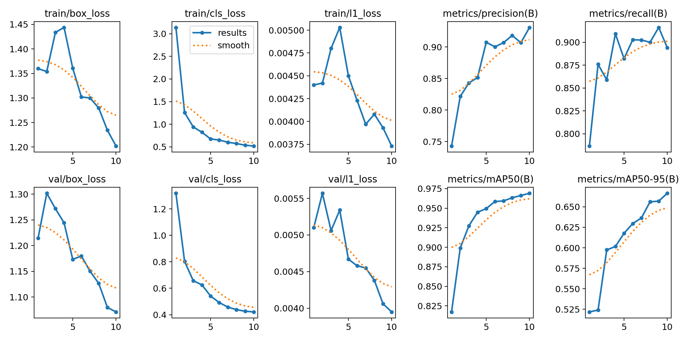
Figure 1. YOLO26m training and validation results across the training epochs.
The results graph summarizes how the training losses and validation metrics changed during training. The graph should be interpreted together with the final validation metrics rather than using a single curve alone.
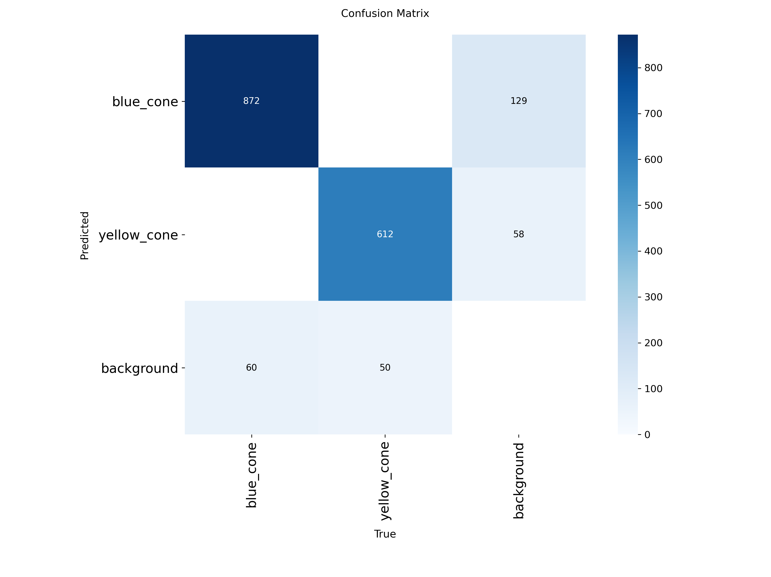
Figure 2. YOLO26m confusion matrix.
The confusion matrix shows the distribution of correct detections and classification errors between the blue-cone and yellow-cone classes. It helps identify whether one cone class is being confused with the other or with the background.
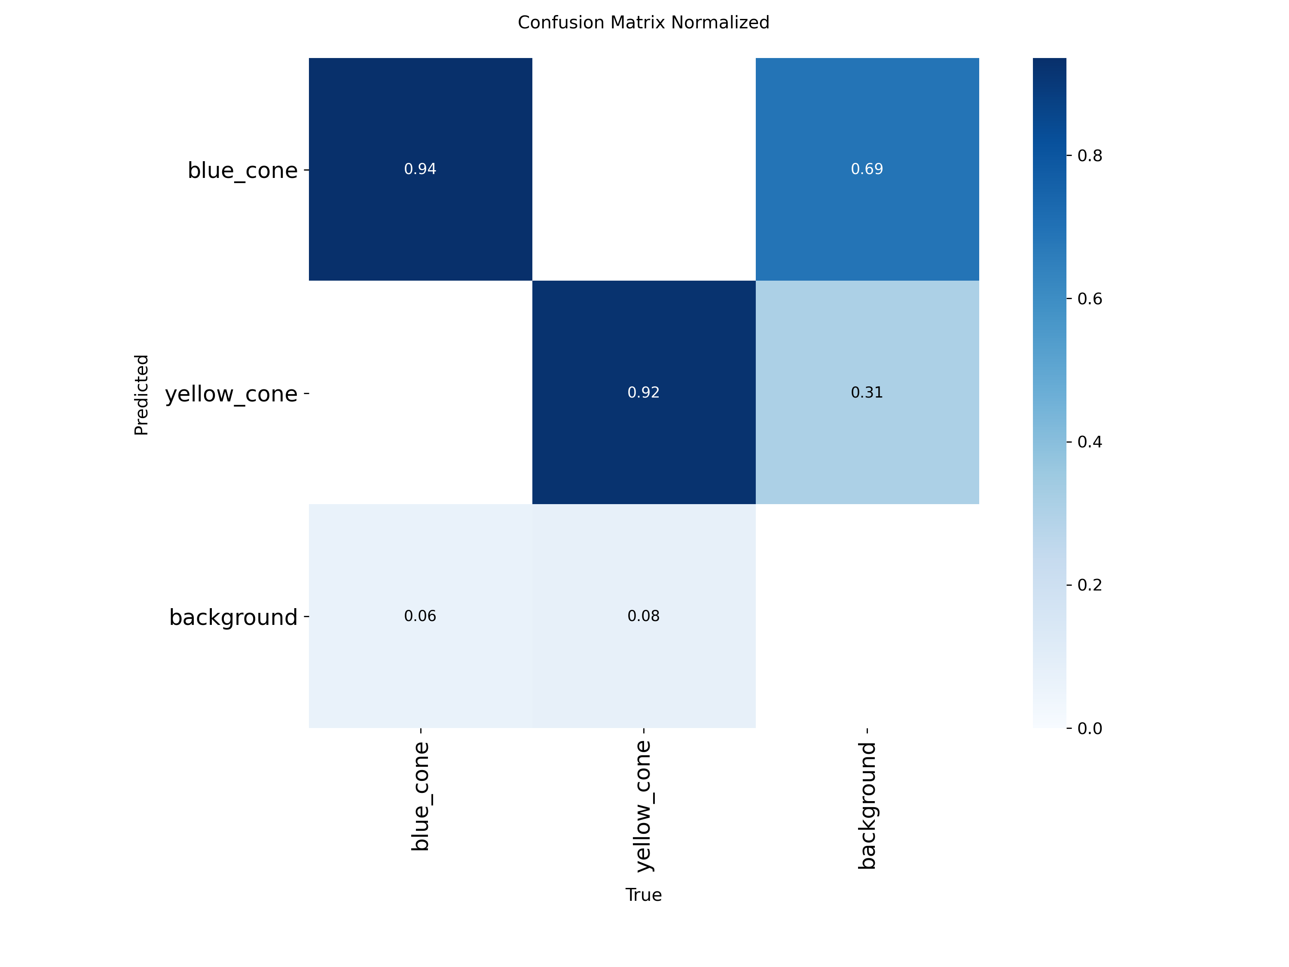
Figure 3. YOLO26m normalized confusion matrix.
The normalized confusion matrix presents the same classification behaviour in normalized form, making the relative performance of each class easier to interpret.
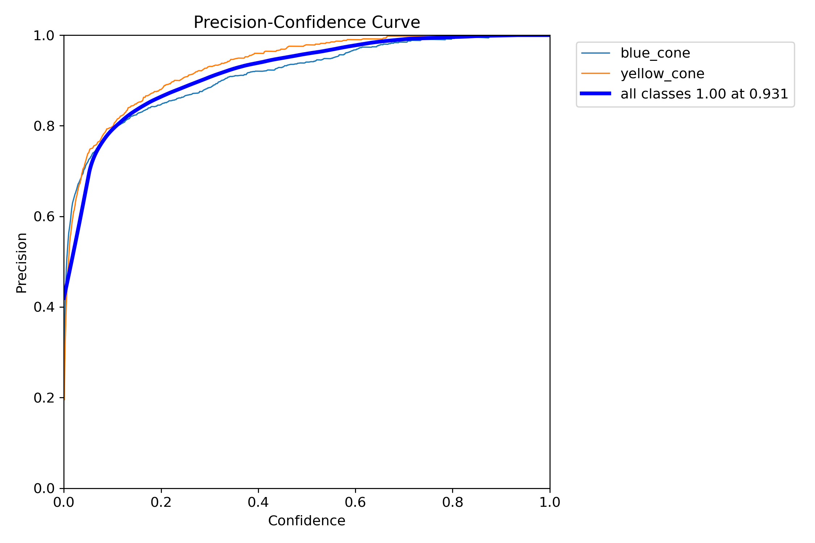
Figure 4. YOLO26m box precision curve.
The precision curve shows how detection precision changes with the confidence threshold. This is useful for choosing a confidence threshold that reduces false detections while retaining useful detections.
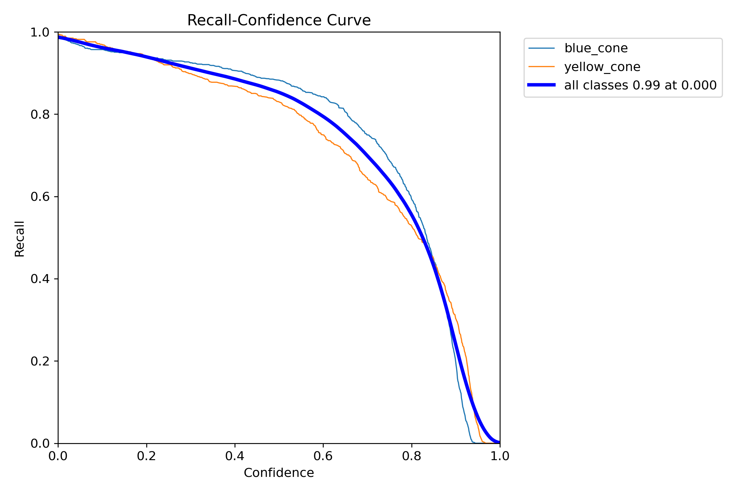
Figure 5. YOLO26m box recall curve.
The recall curve shows how the ability to detect ground-truth objects changes with the confidence threshold. For rover operation, recall is important because missed objects can affect perception and downstream decisions.
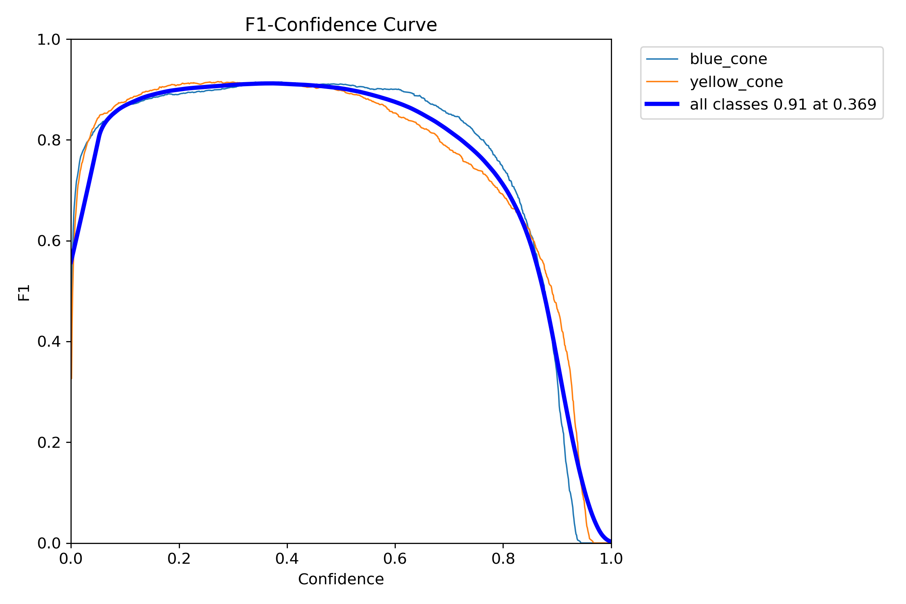
Figure 6. YOLO26m box F1 curve.
The F1 curve combines precision and recall. The peak region indicates a confidence threshold where the balance between false detections and missed detections is favourable.
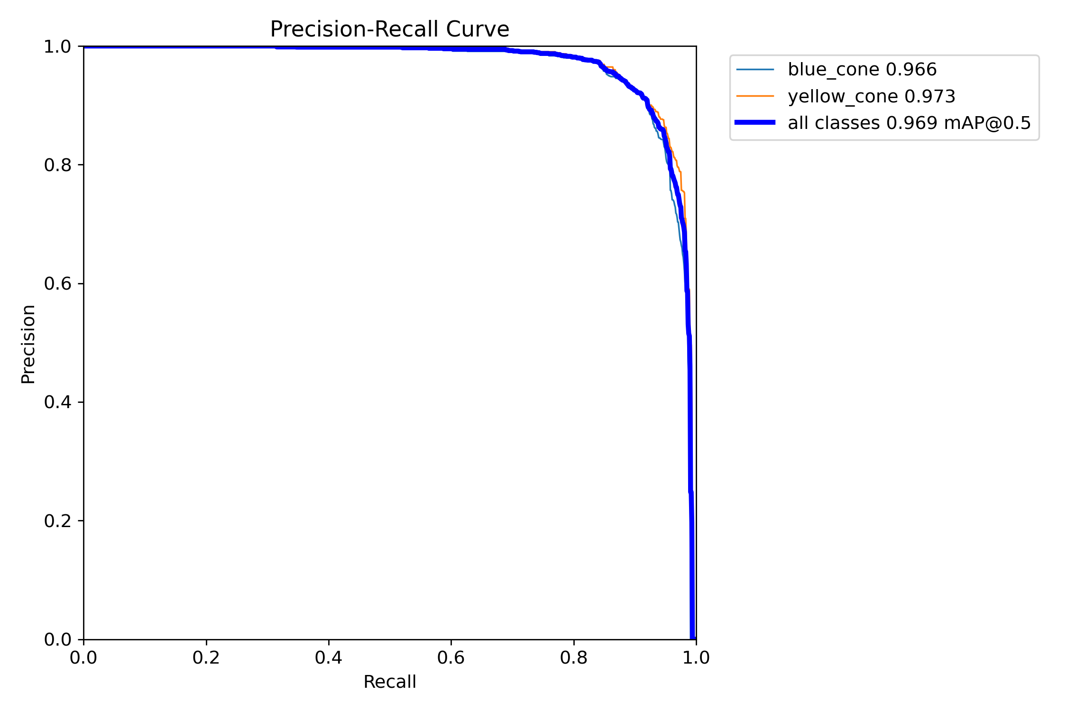
Figure 7. YOLO26m box precision-recall curve.
The precision-recall curve shows the trade-off between precision and recall over different confidence thresholds. The reported high mAP values indicate strong overall detection performance on the evaluated data.

11. YOLO26m Validation Prediction Examples
The validation prediction images are also useful for visually checking whether the predicted bounding boxes are placed correctly on the cones.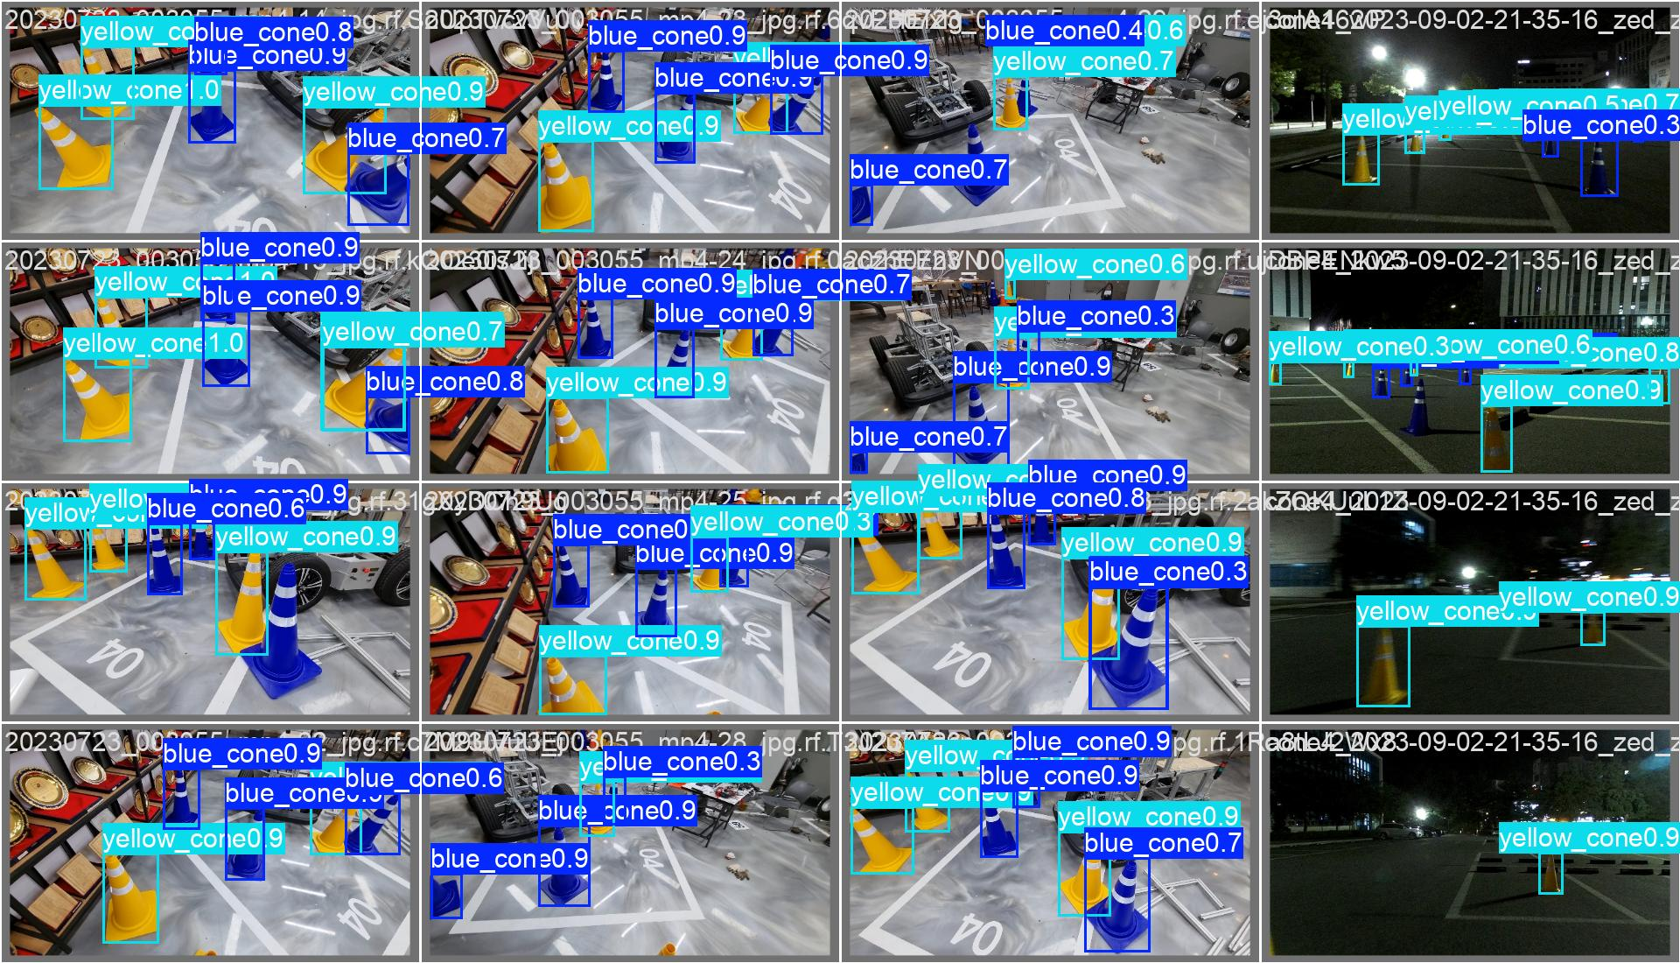
Figure 8. YOLO26m validation predictions for batch 0.
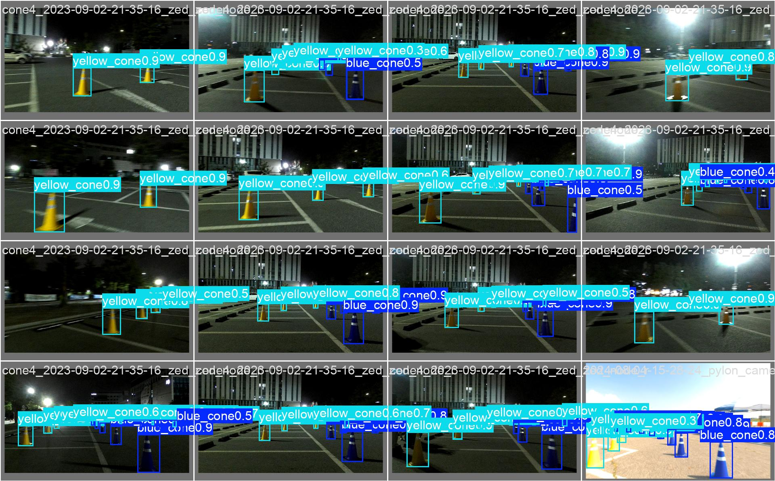
Figure 9. YOLO26m validation predictions for batch 1.
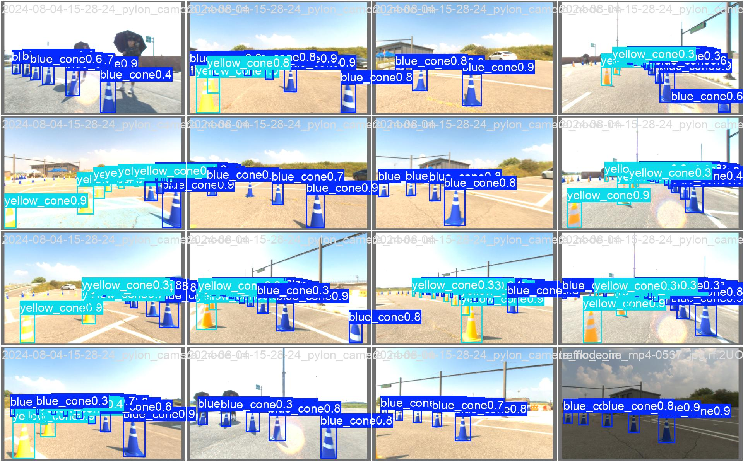
Figure 10. YOLO26m validation predictions for batch 2.
These images provide a qualitative check in addition to the numerical metrics. They are particularly useful for checking bounding-box placement, class assignment and cases where objects are close together.

12. Updated Model Comparison
The three main models considered in the current experimental study are Faster R-CNN, YOLOv8m, and YOLO26m. The purpose of this comparison is not to select a model based on a single accuracy metric, but to evaluate the overall balance between detection accuracy, localization performance, computational complexity, and inference speed.

Table 12.1. Comparison of the evaluated object-detection models
Metric | Faster R-CNN | YOLOv8m | YOLO26m – Latest Run
mAP@50 | 96.11% | 96.40% | 96.90%
mAP@50:95 | 66.05% | 66.40% | 66.70%
Precision | Not recorded in same format | 93.4% | 93.0%
Recall | Not recorded in same format | 91.0% | 89.5%
Parameters | Not recorded | 25.84 M | 20.35 M
GFLOPs | Not recorded | 78.7 | 68.1
Measured inference | Not benchmark equivalently | 19.9 ms/image | 8.2 ms/image

12.1 Detection Accuracy

mAP@50
mAP@50 represents the mean Average Precision of the detector when an Intersection over Union (IoU) threshold of 0.50 is used. It provides an overall measure of how accurately the model detects the target objects and places their bounding boxes.
The recorded results are:
- Faster R-CNN: 96.11%
- YOLOv8m: 96.40%
- YOLO26m: 96.90%
YOLO26m has the highest recorded mAP@50 among the three models. Its result is 0.50 percentage points higher than YOLOv8m and 0.79 percentage points higher than Faster R-CNN.
However, the difference is relatively small. Therefore, the result should not be interpreted as YOLO26m being significantly more accurate than the other models. Instead, it indicates that YOLO26m provides a comparable and slightly higher detection accuracy in the current experiments.

mAP@50:95
mAP@50:95 is a stricter evaluation metric because it evaluates detection performance across multiple IoU thresholds from 0.50 to 0.95. Therefore, it provides a better indication of bounding-box localization quality under stricter overlap requirements.
The recorded values are:
- Faster R-CNN: 66.05%
- YOLOv8m: 66.40%
- YOLO26m: 66.70%
YOLO26m again gives the highest recorded value. However, the difference between the models is small. This indicates that all three models provide reasonably strong localization performance on the evaluated dataset.
Therefore, accuracy alone does not provide a sufficient reason to select YOLO26m. The computational and real-time characteristics must also be considered.

12.2 Precision
Precision indicates how many of the detections produced by the model are actually correct.
The recorded precision values are:
- YOLOv8m: 93.4%
- YOLO26m: 93.0%

YOLOv8m has a slightly higher precision by 0.4 percentage points.
This means that, in the current recorded experiments, YOLOv8m produced slightly fewer false-positive detections than YOLO26m.
The Faster R-CNN precision value is not included in the same format in the current results, so a direct comparison cannot be made.

12.3 Recall
Recall represents the percentage of actual objects that were successfully detected by the model.
The recorded values are:
- YOLOv8m: 91.0%
- YOLO26m: 89.5%
YOLOv8m has a 1.5 percentage-point advantage in recall.
This indicates that YOLOv8m detected a slightly larger proportion of the objects present in its evaluated dataset.
Recall is particularly important for a rover because missed detections may affect subsequent perception or decision-making processes. Therefore, the lower recall of YOLO26m should be investigated further during controlled testing.
Again, a directly comparable Faster R-CNN recall value is not available in the current results.

12.4 Model Parameters
The number of parameters provides an indication of the size of the neural network.
The recorded values are:
- YOLOv8m: 25.84 million parameters
- YOLO26m: 20.35 million parameters
YOLO26m therefore has approximately 5.49 million fewer parameters than YOLOv8m.
This corresponds to approximately a 21% reduction in parameter count relative to YOLOv8m.
A lower parameter count can be beneficial for onboard deployment because it can reduce model storage and may reduce memory requirements. However, parameter count alone cannot be used to determine actual inference speed. Actual latency depends on the model architecture, hardware, implementation and other system factors.

12.5 Computational Complexity
GFLOPs represent an approximate measure of the floating-point computational operations required by a model.
The recorded values are:
- YOLOv8m: 78.7 GFLOPs
- YOLO26m: 68.1 GFLOPs
YOLO26m therefore has approximately 10.6 fewer GFLOPs than YOLOv8m, corresponding to roughly a 13.5% lower reported computational complexity.
This is relevant for the rover because the onboard computer must perform several tasks simultaneously. The available computing resources may also be required for camera processing, ROS, navigation, SLAM, sensor processing and communication.
Therefore, a detector that provides strong accuracy without unnecessarily high computational requirements is preferable.

12.6 Inference Latency
Inference latency represents the time taken by the object-detection model to process one image.
The recorded values are:
- YOLOv8m: 19.9 ms/image
- YOLO26m: 8.2 ms/image
The latest YOLO26m run therefore reports an inference time that is approximately 11.7 ms lower per image than the earlier YOLOv8m run.
This is an important result for a real-time rover system because lower inference latency allows the detector to process incoming camera frames more quickly.
However, the reported inference time should not be considered the complete rover-system latency. The actual perception pipeline will include camera capture, image transfer, preprocessing, neural-network inference, postprocessing and communication.
Therefore:
Model inference latency ≠ complete end-to-end rover latency.
The final system must be benchmarked as a complete pipeline.

12.7 Comparison of the Current Results
The current results show that YOLO26m provides the highest recorded mAP@50 and mAP@50:95 among the three models. It also has fewer parameters, lower reported GFLOPs and a lower measured inference time than the YOLOv8m experiment.
However, YOLO26m does not outperform YOLOv8m in every metric. YOLOv8m currently has slightly higher precision and recall.
Therefore, the decision cannot be based on accuracy alone.
For the IRC rover, the important consideration is the overall balance between:
- Detection accuracy
- Localization accuracy
- Precision
- Recall
- Inference latency
- FPS
- Computational complexity
- Memory requirements
- Hardware utilization
- Power consumption
- Robustness under real rover conditions

12.8 Limitation of the Current Comparison
Although the current results are useful for identifying the leading candidate, the comparison is not yet a perfectly controlled benchmark.
The latest YOLO26m evaluation used:
- 179 evaluated images
- 1,594 object instances
whereas the earlier YOLOv8m evaluation used:
- 174 test images
- 1,817 object instances
Therefore, the two models were not evaluated on exactly the same number of images and object instances.
This means that the difference in performance may be influenced not only by the model architecture but also by the evaluated data.
For this reason, it would not be scientifically appropriate to conclude that YOLO26m is definitively superior to YOLOv8m based only on these current results

13. Why the Other Models Were Not Prioritized
Mask R-CNN was not prioritized because the current requirement is bounding-box object detection rather than instance segmentation. RetinaNet was studied but did not add as much architectural diversity to the initial comparison as the selected models. EfficientDet was considered as an efficiency-oriented model, but a lightweight reference was already included. The original DETR was not prioritized because RT-DETR is more directly aligned with the real-time requirement. DINO/Grounding DINO was not prioritized because the current rover task uses predefined object classes rather than open-vocabulary detection.

14. Current Model Selection Status
Based on the latest experimental evidence, YOLO26m is currently the strongest candidate. It combines high detection accuracy with a smaller parameter count, lower GFLOPs and much lower measured inference time than the earlier YOLOv8m run.
However, I am not treating this as the final selection yet because the YOLOv8m and YOLO26m results were not produced on exactly the same evaluation set. The final selection will be made after a controlled head-to-head benchmark.
If YOLO26m maintains its current performance under the controlled benchmark and performs well on the actual Jetson rover hardware, it would be the preferred model for real-time onboard object detection.

15. Next Work
- Evaluate YOLOv8m and YOLO26m on exactly the same test set.
- Use the same image size, batch size and evaluation settings.
- Measure FPS and end-to-end latency on the actual Jetson hardware.
- Measure GPU memory, CPU usage, GPU usage and power consumption.
- Test the model using the actual rover camera.
- Test different object distances, lighting conditions, occlusion, motion blur and camera vibration.
- Complete RT-DETR and MobileNet-SSD experiments if a full four-model benchmark is required.

16. YOLOv8s vs YOLO11s – Detailed Model Comparison and Final Selection
IRC Rover – Three-Class Cone Detection
Important scope note: This section documents a separate, controlled three-class cone experiment performed after the earlier experiments in this report. It uses the letsgocone v4 three-class subset (Blue, Red and Yellow cones) and should therefore be read independently of the earlier two-class YOLO26m/YOLOv8m comparison.

16.1 Purpose
YOLOv8s and YOLO11s were trained for the same IRC rover cone-detection task. The objective of the final comparison was to select the model with the best overall balance of detection accuracy, localization quality, computational efficiency and inference speed for rover deployment.

16.2 Common Evaluation Setup
Both final checkpoints were evaluated on exactly the same unseen test split, making the comparison directly comparable. The test set contained 1,022 images and 2,610 cone instances.
Factor | Setting
Dataset | letsgocone v4, 3-class subset
Classes | Blue, Red, Yellow cone
Test images | 1,022
Test instances | 2,610
Input size | 640 × 640
Evaluation GPU | NVIDIA Tesla T4
Evaluation split | test

16.3 Models
YOLOv8s and YOLO11s were selected as lightweight YOLO models suitable for investigating the accuracy-versus-computation trade-off for rover deployment. YOLOv8s was trained for 10 epochs, while YOLO11s was trained for 15 epochs. Their final checkpoints were then evaluated under the same test conditions.
Parameter | YOLOv8s | YOLO11s
Training epochs | 10 | 15
Parameters | 11,126,745 | 9,413,961
GFLOPs | 28.4 | 21.4
Fused layers | 73 | 101

16.4 Overall Test-Set Results
Metric | YOLOv8s | YOLO11s | Better
Precision | 96.7% | 95.4% | YOLOv8s
Recall | 96.7% | 97.6% | YOLO11s
mAP@50 | 98.7% | 98.8% | YOLO11s
mAP@50:95 | 84.2% | 84.8% | YOLO11s
T4 inference | 10.4 ms/image | 9.4 ms/image | YOLO11s
Parameters | 11.13M | 9.41M | YOLO11s
GFLOPs | 28.4 | 21.4 | YOLO11s

16.5 Precision
YOLOv8s achieved 96.7% precision versus 95.4% for YOLO11s, a 1.3 percentage-point advantage. Thus, under these test conditions, YOLOv8s produced a slightly higher proportion of correct detections among its positive predictions. In practical terms, this indicates slightly fewer false-positive detections from YOLOv8s in this evaluation.
Precision alone was not used as the deciding criterion because the rover must also avoid missing actual cones. A model can have high precision while still failing to detect some real objects.

16.6 Recall
YOLO11s achieved 97.6% recall versus 96.7% for YOLOv8s, a 0.9 percentage-point advantage. Recall measures the proportion of actual cone instances that the detector successfully finds.
The higher recall of YOLO11s is important for rover perception because missed cones can remove useful environmental information from the perception pipeline and may affect subsequent perception or decision-making processes.

16.7 mAP Results
YOLO11s achieved 98.8% mAP@50 compared with 98.7% for YOLOv8s. The difference is small, but YOLO11s is slightly higher on this test set.
At the stricter mAP@50:95 metric, YOLO11s achieved 84.8% compared with 84.2% for YOLOv8s. Because this metric evaluates performance over IoU thresholds from 0.50 to 0.95, it gives a stricter indication of bounding-box localization quality. YOLO11s therefore had slightly better overall localization performance in the controlled test.

16.8 Class-Wise Results
Class | Model | Precision | Recall | mAP@50 | mAP@50:95
Blue | YOLO11s | 96.0% | 97.5% | 98.6% | 80.3%
Blue | YOLOv8s | 97.1% | 97.1% | 98.5% | 80.0%
Red | YOLO11s | 95.9% | 97.1% | 99.0% | 89.8%
Red | YOLOv8s | 96.9% | 96.4% | 98.8% | 88.7%
Yellow | YOLO11s | 94.4% | 98.0% | 98.8% | 84.2%
Yellow | YOLOv8s | 96.0% | 96.5% | 98.9% | 83.7%

YOLO11s had higher recall for all three classes and higher mAP@50:95 for all three classes. YOLOv8s had higher precision for all three classes. YOLO11s achieved its strongest class-level mAP@50:95 on Red cones at 89.8%.

16.9 Computational Efficiency
YOLO11s contains 9.41 million parameters compared with 11.13 million for YOLOv8s, corresponding to approximately 15.4% fewer parameters. It also requires 21.4 GFLOPs compared with 28.4 GFLOPs, corresponding to approximately 24.6% lower reported computational complexity.
Lower model complexity is advantageous for onboard rover computing because the perception system must share computing resources with other rover processes such as camera processing, ROS, navigation, SLAM, sensor processing and communication.

16.10 Inference Latency
On the Tesla T4 evaluation, YOLO11s reported 9.4 ms inference per image versus 10.4 ms for YOLOv8s. This is a 1.0 ms/image advantage for YOLO11s.
These measurements represent neural-network inference time and should not be treated as complete end-to-end rover FPS. The actual perception pipeline will also include camera capture, image transfer, preprocessing, neural-network inference, postprocessing and communication. Therefore, model inference latency is not the same as complete rover-system latency.

16.11 Why YOLO11s Was Selected
- Higher recall: 97.6% vs 96.7%.
- Higher mAP@50: 98.8% vs 98.7%.
- Higher mAP@50:95: 84.8% vs 84.2%.
- Lower measured T4 inference time: 9.4 ms vs 10.4 ms.
- 15.4% fewer parameters: 9.41M vs 11.13M.
- 24.6% fewer GFLOPs: 21.4 vs 28.4.
- Higher recall for Blue, Red and Yellow cones.
- Higher mAP@50:95 for Blue, Red and Yellow cones.
The selection is therefore not based on one metric. YOLO11s gives the better overall combination of detection coverage, localization quality and computational efficiency. For an IRC rover, this balance is more useful than selecting the model with the highest precision alone.

16.12 Why YOLOv8s Was Not Selected
YOLOv8s is also a strong detector and has the advantage in precision: 96.7% versus 95.4%. It also has a slightly higher Yellow-cone mAP@50. However, it has lower recall and mAP@50:95, more parameters, higher GFLOPs and slightly higher measured T4 inference time. Therefore, its overall trade-off was less favorable for this rover use case.

16.13 Final Decision
Decision factor | Selected result
Final model | YOLO11s
Checkpoint | YOLO11s best.pt
Test-set precision | 95.4%
Test-set recall | 97.6%
Test-set mAP@50 | 98.8%
Test-set mAP@50:95 | 84.8%
Parameters | 9.41M
GFLOPs | 21.4

Based on this controlled three-class test-set comparison, YOLO11s is selected as the current final cone-detection model for the IRC rover.

16.14 Limitations and Next Validation
The selection is based on the current unseen test-set comparison and Tesla T4 measurements. Before rover deployment, the selected model should be tested using real multi-frame rover-camera footage. The final evaluation should measure end-to-end FPS, latency, detection stability, confidence behaviour, GPU memory, CPU/GPU utilization and performance across object distance, lighting changes, occlusion, motion blur and camera vibration.
The current video test verified the inference pipeline, but the generated test video contained only one frame. Therefore, it should not be treated as a full real-time multi-frame benchmark.

16.15 Team Review Summary
We trained YOLOv8s and YOLO11s for three-class cone detection and evaluated both best checkpoints on the same unseen test set of 1,022 images. YOLOv8s achieved 96.7% precision, 96.7% recall, 98.7% mAP@50 and 84.2% mAP@50:95. YOLO11s achieved 95.4% precision, 97.6% recall, 98.8% mAP@50 and 84.8% mAP@50:95. YOLO11s also had fewer parameters, fewer GFLOPs and lower measured T4 inference time. Although YOLOv8s had higher precision, YOLO11s provided the better overall accuracy-efficiency trade-off, so YOLO11s was selected as the current final model for the IRC rover.

16.16 Final Model Selection Statement
Final selected model: YOLO11s. The decision is supported by the controlled test-set results: 97.6% recall, 98.8% mAP@50, 84.8% mAP@50:95, 9.41M parameters, 21.4 GFLOPs and 9.4 ms measured inference on the Tesla T4. YOLOv8s remains a strong alternative, particularly because of its 96.7% precision, but YOLO11s provides the more favorable overall balance for the rover's perception workload.

