1. Title Page
- Module: Machine Software Engineering (MOD003263)
- Student Name: Amrit Vaswani
- Student ID: 2319498
- Week: 3 – User Stories Refinement, Database Design & GitHub

REFINED USER STORIES

# | User | User Story | Acceptance Criteria
1 | Patient | As a patient, I want to view my live pressure heat map so that I can adjust my sitting posture to reduce high-pressure zones. | The dashboard displays a 32×32 grid updated every 5 seconds with color intensity showing pressure.
2 | Clinician | As a clinician, I want to filter patients by ID and view real-time alerts so that I can prioritise critical cases. | Clinician can search patients, click one to see their data and receive visual alert icons when thresholds are crossed.
3 | Admin | As an admin, I want to create, edit, and delete user accounts so that access is secure and organised. | Admin panel confirms each action with a message: “User added successfully” / “Account removed.”
4 | Clinician | As a clinician, I want to receive automated email alerts when pressure readings exceed safe limits so that I can respond quickly. | The system logs each high-pressure event and sends an email notification within 1 minute.
5 | Patient | As a patient, I want to submit comments on discomfort areas so that my clinician can review them later. | Comment box links each message to a specific timestamp and displays it under “Feedback History.”
REFINE WIREFRAME DIAGRAMS
Patient Dashboard
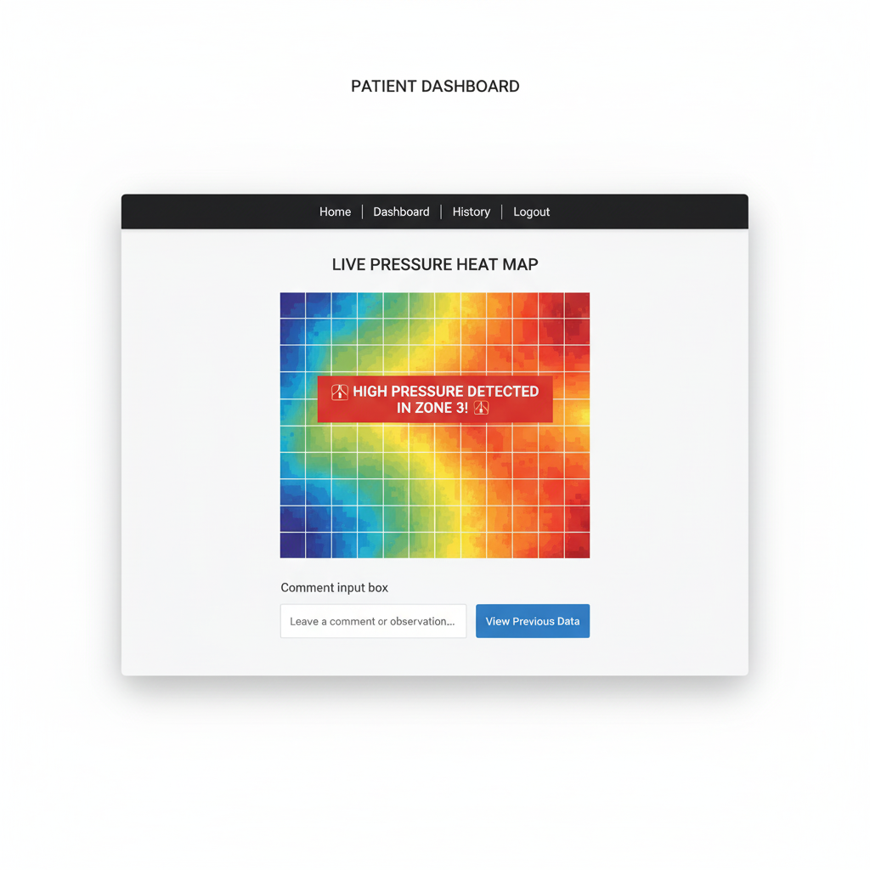

Clinician Dashboard

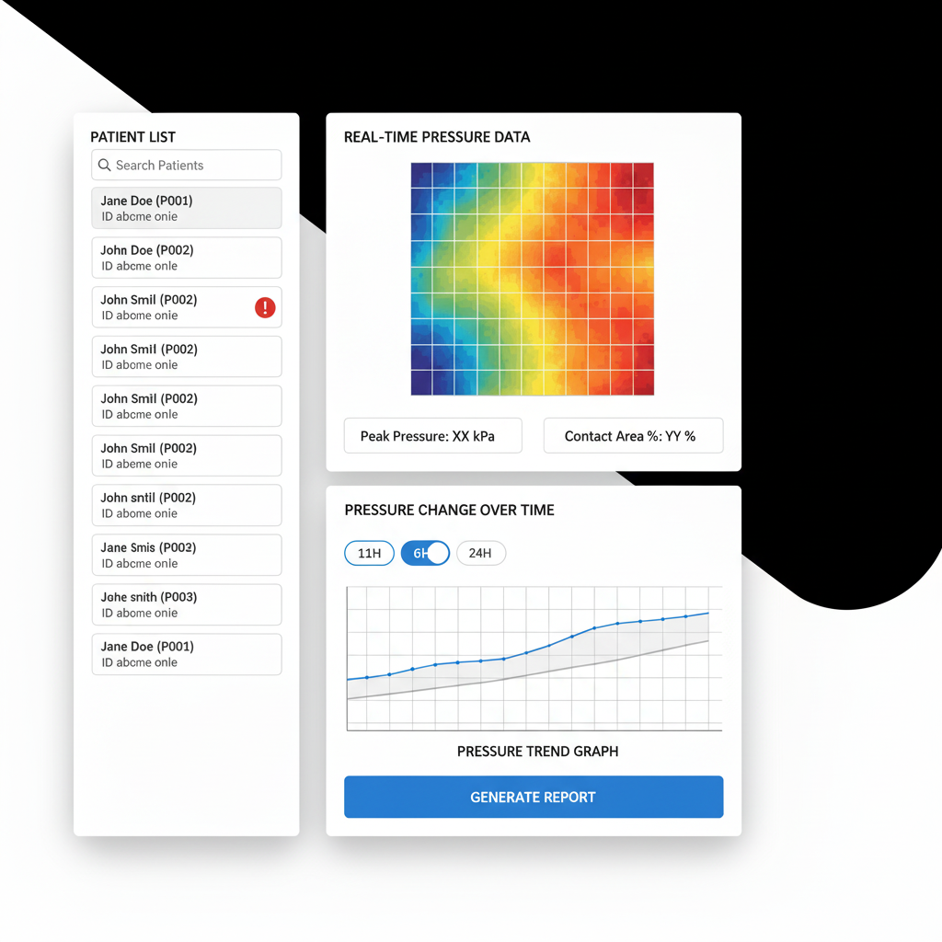

Admin Panel

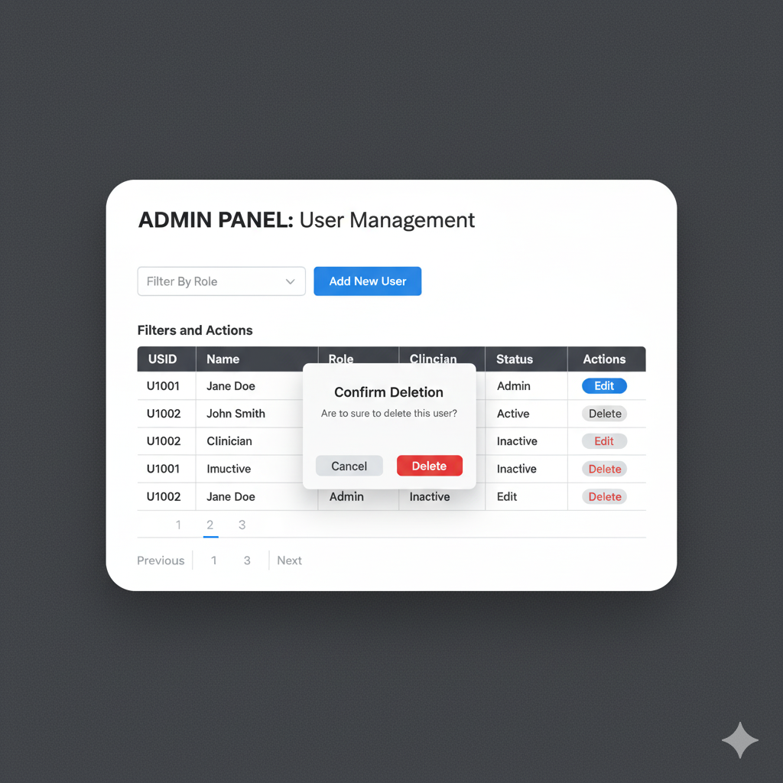
NET MVC Project and GitHub Integration

Database Design (Entity Relationship Diagram – ERD)

Table | Key Fields
Patient | PatientID (PK), Name, Email, Age
Clinician | ClinicianID (PK), Name, Email, Specialty
Admin | AdminID (PK), Name, Email
PressureData | DataID (PK), PatientID (FK), Timestamp, PeakPressure, ContactArea
Comment | CommentID (PK), PatientID (FK), ClinicianID (FK), Timestamp, Text
Alert | AlertID (PK), PatientID (FK), ClinicianID (FK), Time, Threshold, Status

Relationships
- One Patient → Many PressureData records
- One Clinician → Many Patients
- One Patient → Many Comments
- One Alert → Belongs to one Patient and one Clinician
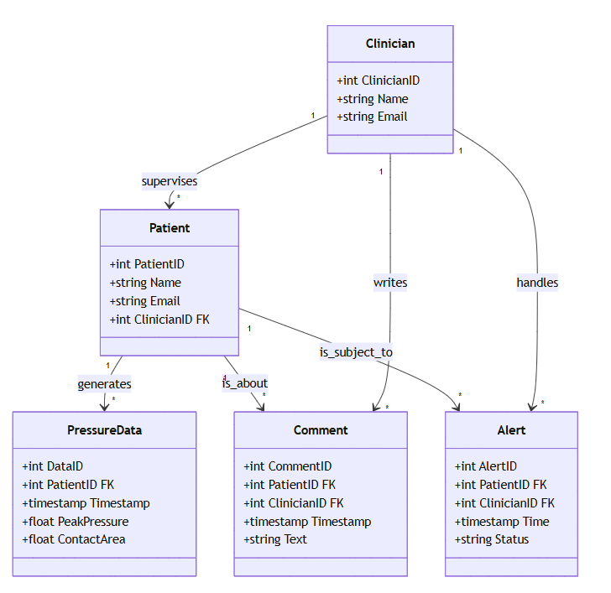

Reflection Logbook – Week 3
n Week 3, I improved the wireframes with improved navigation and added explicit acceptance criteria to my user stories. I created a new .NET MVC project using Visual Studio and connected it to GitHub with version control commands. In order to plan how the system will store and link patient, clinician, and alert data, I also created an Entity Relationship Diagram (ERD). This week, I gained a better understanding of the relationship between front-end user stories and back-end database design, as well as how Git facilitates project collaboration and progress monitoring.

