

**TRIBHUVAN UNIVERSITY**

Sagarmatha College Of Science And

Technology

1st SEMESTER PROJECT

ON

“PHONEBOOK SYSTEM”

In the partial fulfillment for the requirement of the 1st Semester Project-I (Subject Code-CSC 110) in the Completion of Bachelor of Computer Science and Information Technology (CSIT) 1st year 1st part at Sagarmatha College Of Science And Technology, affiliate to Tribhuvan University.

**Submitted By: Submitted To:**

CSIT Department

Sagarmatha College Of Science And Technology

* David Prakash Mukhiya
* Dipak Thapa Magar
* Ramesh Neupane
* Anish Rai
* Bishal Sunar
* Bijay Shrestha

**Acknowledgement**

We take this opportunity to express our profound appreciation and unfathomable regards to the Information Technology (IT) department for this commendable guidance, monitoring and constant encouragement throughout the course of this project. The help and guidance given by shall carry us a long way, in the journey on which we are about to embark.

We also take this opportunity to express a deep sense of gratefulness to our coordinator Ganga Subba for her amiable support, valuable information and guidance, which helped us in completing this task throughout its various stages. We are also indebted to all members of Sagarmatha College, for the valuable suggestions and help provided by them in their irrespective fields. We are grateful for their cooperation during the period of our project.

Finally, we would also like to express lots of thanks to TRIBHUVAN UNIVERSITY for designing such a wonderful course structure. It will help us to get more knowledge in the field of Information Technology & help us to have a bright future in the field of technology.

We hope this attempt will accept as a successful project.

**Student’s Declaration**

We following students, hereby declare that the Project Report titled

"**PHONEBOOK SYSTEM"** is a result of our own work and our indebtedness to other work publications, references, if any, have been dully acknowledged.

We further certify that this Project, submitted in partial fulfillment of the requirement for the C project for 1st year 1st part is our original work and names of students are listed below:

|  |  |  |  |  |
| --- | --- | --- | --- | --- |
| S.N | NAME | Regd.No | Symbol No. | Signature |
| 1 | David Prakash Mukhiya |  | 15754 |  |
| 2 | Dipak Thapa Magar |  | 15755 |  |
| 3 | Anish Rai |  |  |  |
| 4 | Ramesh Neupane |  |  |  |
| 5 | Bishal Sunar |  | 15753 |  |
| 6 | Bijay Shrestha |  | 15749 |  |



**TRIBHUVAN UNIVERSITY**

Kritipur

.

**Examiner’s Certification**

This is to certify that the project entitled “**Phonebook System**" has been successfully completed by David Prakash Mukhiya (Symbol no. 15754), Dipak Thapa Magar (Symbol no. 15755), Anish Rai (Symbol no. 157 ), Ramesh Neupane (Symbol no. 157 ), Bishal Sunar (Symbol no. 15753) and Bijay Shrestha (Symbol no. 15749) in partial fulfillment of Degree of Bachelor of Information Technology of Tribhuvan University during the academic year 2018 under the guidance of Mrs. Ganga Subba.

………………………………………………….

* Abstract of The Project

The “Phonebook System” undertaken as a project is based on relevant technologies. The main aim of this project is to develop software for keeping the details of people in simplest manner.

This project is developed using C programming language and is meant for storing the contact details. We have mainly focused on different types of problem that occur in normal recording system.

As we are beginners and have no practical experience in the field of software development and more over the phonebook system is very wide. So, we limit the scope of our project by computerizing the following fields of Phonebook System: -

* List
* Add
* Search
* Delete
* Count
* Quit
* **Introduction**

Phonebook software is a piece of computer program that manages the contacts. This software helps to store the contact information digitally. This is an efficient way to manage one’s contact.

This software ‘Phonebook’ provides various different functionalities like add, list, count, search, delete and exit of the contacts. Most of the times the recording of the contact is done in a physical piece of paper that can be lost or tore down. So, this software aims to solve that problem. With the use of this software, people don’t have to worry about losing the contacts of the people. The contacts can be stored instantly and also be retrieved when necessary. This software is easy to use and works efficiently even in older computer devices. So not only people can store contacts in smart phones but also their personal computers.

**Objective Of the project**

The major objectives of Phonebook System are:

* To store contact information.
* To store details like name, phone number, email and address.
* To save time and increase accuracy in work.
* To permanently save the contact information.
* To store the contact record and retrieve at any time.
* **Future Implementation For the project**

All these results of future of project are in high client-satisfaction. A future application of this system lies in the fact that the proposed system would remain relevant in the future. Though we haven’t included a full Phonebook System in this project but we will be trying to make it more advance by including all those materials required for a full Phonebook System. It is also necessary to see and visualizes the future scope. Future enhancement is necessary for the system as the limitations that cannot be denied today, can be overcome by better technologies. The project has a very vast scope in future.

**The following are the future scope for the project: -**

* Making the Software as a Web application such that the program can be used anywhere and anytime.
* The number of people handling the software can be made unlimited in future from the current status of handling up to N users.
* Efficiency can be further enhanced and boosted up to a great extent by introducing the database and provide security feature in the future.
* We can also make the project more attractive by introducing Graphical User Interface.
* Automatic and error free report generation with ease.
* With a fully automated solution, lesser staff, better space utilization and peaceful work environment, the company is bound to experience high turnover.

**SYSTEM RECOMMENDATION:**

The minimum requirements for the system are:

**HARDWARE:**

* PC with Pentium II Processor (260 MHz) or latest
* 32 MB of RAM or more
* Color Monitor (Preferably)
* Hard disk with at least 20 MB of free space

**SOFTWARE:**

* OS Windows (Windows XP, Windows 7, Windows 8, Windows 10)
* Turbo C/C++

**SYSTEM DESIGN**

**Algorithm:**

The system consists of different sets of algorithms.

**Algorithm for Main Menu**

Step 1: Start

Step 2: Declare variables

Step 3: Display main menu having option: -

1. List
2. Add
3. Search
4. Delete
5. Count
6. Exit

Step 4. Get integer value to choose the options

Step 5. If user choose 1-5 then call corresponding function, else if user choose 6 then goto Step 7 , else goto Step 6

Step 6. Print there are no other choices goto Step 3

Step 7: Stop

**Algorithm for Adding contact**

Step 1: Start

Step 2: Create a data file named **phbook.txt** in append mode

Step 3: Get Name, Number, Email and Address

Step 4: Store all value of variable in data file

Step 5: Stop

**Algorithm for Listing contact**

Step 1: Start

Step 2: Open the file **phbook.txt** in read mode

Step 3: Retrieve data from file and store them in Name, Number, Email and Address

Step 4: Is all records retrieved (if yes: goto step5)

Step 5: Stop

**Algorithm for Searching contact**

Step1: Start

Step2: Open the files **phbook.txt** in read mode

Step3: Read by Name or by phone number

Step4: Is name or number is matched then;

(Yes: display Name, Number, Email and Address)

(No: goto step 6)

Step5: If Not then Display message as records not found.

Step6: Stop

**Algorithm to delete a contact**

Step1: Start

Step2: Open the files **phbook.txt** in read mode

Step3: Read Name

Step4: Is Name is equal to Name from File

Step5: If yes then delete a record

Step6: Stop

**Algorithm to Count Number of Contact**

Step1: Start

Step2: Open the files **phbook.txt** in read mode

Step3: Initialize counter

Step4: Read info one by one and increment counter

Step5: If there is no info found then goto Step 6

Step6: Return Counter variable

Step7: Stop

**Source Code**

//header files used for program

#include <stdio.h>

#include <conio.h>

#include <stdlib.h>

#include <string.h>

#include <process.h>

#include <alloc.h>

//defining the structure phonebook

struct phonebook

{

char name [50];

long long int number;

char email [50];

char address [50];

};

//functions used for program

void add ();//to add the information in phonebook

void list ();//to list down the information of phonebook

void search ();//to search the information by name and number

void delet();//to delete the information

int count ();//to count the number of phonebook

typedef struct phonebook book;//defining the structure type phonebook

//declaring global variables so that we can access in each function

FILE *fp,*fpsrt;//using file pointers

char qt='n';

book phb,tmp,*temp,repl,hold;//using type defined phonebook book

char sname[30];//sname for search by name while delete and search

long long int num;//num for search by number while search

int i,j,counter=0,dec,ct;//i,j used in loop, counter for no of information, dec for decision char,ct to take return value from count function

//main program

int main ()

{

clrscr ();

printf ("\t\t\t\tPhonebook\n");//title

do

{

printf ("Choices:\n1.List\t\t\t2.Add\n3.Search\t\t4.Delete\n5.Count\t\t\t6.Quit\n Your Choice: ");

scanf ("%d",&dec);

if (dec==1)

list();//calling void list function

else if (dec==2)

add();//calling void add function

else if (dec==3)

search();//calling void search function

else if (dec==4)

{

delet();//calling void delete function

printf("The contact have been deleted.\n");

}

else if (dec==5)

{

clrscr();

printf("\n\t\t\t\tCount\n");//title count

ct=count();//calling function count which returns int value

printf("There are %d records.\n",counter);//printing no of records after count

}

else if (dec==6)

break;//quit the loop and comes out of loop

else

printf ("There are no other choices.\n");

}while (1);//for run loop until user choose to quit

return 0;

}

//to list the no of records

void list ()

{

clrscr();

printf("\t\t\tList\n");

fp = fopen("phbook.txt","r+"); //opening file in read write mode

if(fp==NULL) //check whether the file is empty or not

{

printf(" Couldn't open the file\n");//if empty print msg

}

//read from file and addressing to the defined struct book php

while(fread(&phb,sizeof(phb),1,fp)>0)

{ //print the records

printf("\n Name:%s\n Number:%lli\n Email:%s\n Address:%s\n\n",phb.name,phb.number,phb.email,phb.address);

}

fclose(fp);//closing the file

}

//to add records into the file

void add ()

{

clrscr();

printf ("\n\t\t\t\tAdd To Phonebook\n");//title add

fp=fopen("phbook.txt","a");//opening file in append mode

if (fp==NULL)

exit (0);//if file is null then exit through process

printf("\n Name:");

fflush(stdin); //flushing the previous value

gets(phb.name); //getting name

printf(" Number:");

fflush(stdin);

scanf("%lli",&phb.number); //getting number

printf(" Email:");

fflush(stdin);

scanf("%s",&phb.email);//getting email

printf(" Address:");

fflush(stdin);

scanf("%s",&phb.address);//getting address

fwrite(&phb,sizeof(phb),1,fp);

fclose(fp);//closing the file

fpsrt = fopen("phbook.txt","r");//opening file in read mode

counter=0; //initializing the counter variable

while(fread(&tmp,sizeof(tmp),1,fpsrt)>0){ //Find how many of the records are there for later use

counter++; //incrementing counter

}

fclose(fpsrt);//closing file

i=0; //initialization

//memory allocation of datatype book and no of counter

temp = (book *) calloc(counter,sizeof(book));

//opening file in read mode

fpsrt = fopen("phbook.txt","r");

//reading from file and addressing to tmp

while(fread(&tmp,sizeof(tmp),1,fpsrt)>0){ //Reads the records and stores into it's memory

temp[i] = tmp;//putting data into temp one by one

i++;//increment i by 1

}

fclose(fpsrt);//closing the file

for(i=0; i<counter; i++){ //To Sort the records by the name

for(j=i+1; j<counter; j++){

if(strcmp(temp[i].name,temp[j].name)>0)//comparing the string name

{

//using cyclic method to swap

repl = temp[i];

temp[i] = temp[j];

temp[j] = repl;

}

}

}

fp = fopen("phbook.txt","w");//opening the file in write mode

if(fp==NULL)

printf("Error while opening the phonebook");

//using loop to write the content of temp[i] into file one by one

for(i=0; i<counter; i++)

{

fwrite(&temp[i],sizeof(temp[i]),1,fp);

}

fclose(fp);//closing the file

free(temp);//to free the struct temp

//print msg

printf(" The contact has been successfully added\n\n");

//asking user to add more

printf ("Do you want to add more?y/n\n");

fflush(stdin);//flushing previous data

scanf("%c",&qt);//taking character

if (qt=='y')

add();//if the character is y then calling add function again

//in case of other character

else

printf ("\nOk then there you go.\n");

}

//to search the record

void search ()

{

clrscr();

printf("\t\t\tSearch\n");//title

fp = fopen("phbook.txt","r"); //opening the file

if(fp==NULL){

printf(" Error while opening phonebook\n");

}

//giving choice to search either by name or number

printf("\n 1:Search by name\n 2:Search by phone number\n Choose:");

fflush(stdin);//flush prev data

scanf("%d",&dec);

if(dec==1)//search by name if user choose 1

{

printf(" Enter the name:");

fflush(stdin);

gets(sname);//getting the name to search

while(fread(&hold,sizeof(hold),1,fp)>0)//reading records from file and address to hold

{

if(strcmp(hold.name,sname)==0)//matching the name

{ //if matched then print found

printf("\tContact Found:");

printf("\n Name:%s\n Number:%lli\n Email:%s\n Address:%s\n\n",hold.name,hold.number,hold.email,hold.address);

goto incase;

}

}

//if not found then

printf(" There is no contact named %s\n\n",sname);

}

else if(dec==2)//search by number if user choose 2

{

printf(" Enter the number:");

fflush(stdin);

scanf("%lli",&num);//get the number from user

while(fread(&hold,sizeof(hold),1,fp)>0)//read from file and address to hold

{

if(hold.number==num)//matching the number

{ //if matched then

printf("\nContact found:\n");

printf("\n Name:%s\n Number:%lli\n Email:%s\n Address:%s\n\n",hold.name,hold.number,hold.email,hold.address);

goto incase;//going to incase after found

}

}

//if not found then

printf(" There is no information of the number %lli\n\n",num);

}

else //if user choose rather than 1 and 2 then

{

printf(" Invalid choice, try again\n");

}

incase: //after finding the contact

fclose(fp);//closing the file

}

//delet function to delete contact

void delet(){

clrscr();

printf("\n\t\t\t\tDelete\n");//title delete

//asking the name

printf("\n Enter the name of the person you want to delete contact of: ");

fflush(stdin); //flusing the previous value

gets(sname);//getting searching name from user

fp=fopen("phbook.txt","r"); //opening file in read mode

if(fp==NULL){

printf(" Error while opening phonebook\n");

}

//using loop to read from file and store to hold

while(fread(&hold,sizeof(hold),1,fp)>0){

if(strcmp(hold.name,sname)==0)//checking the name are same or not

{

printf("\tContact Found:");//if same then found

//print info of the sname

printf("\n Name:%s\n Number:%lli\n Email:%s\n Address:%s\n\n",hold.name,hold.number,hold.email,hold.address);

goto incase;

}

}

//if not found

printf(" There is no contact named %s\n\n",sname);

//asking to search again

printf ("Do you want to search again? y/n\n");

fflush(stdin);

scanf("%c",&qt);//getting qt

if(qt=='y')

delet(); //recall own function delet()

else

exit(0); //if not then exit

//if found then

incase:

fclose(fp);//closing the file

ct=count(); //counting the no of records by calling count function

i=0; //initialize i

temp = (book *) calloc(ct,sizeof(book));//allocating memory

fpsrt = fopen("phbook.txt","r");//opening file in read mode

while(fread(&tmp,sizeof(tmp),1,fpsrt)>0){

//Reads the records and stores into it's memory

temp[i] = tmp;

i++; //increment i

}

fclose(fpsrt);//closing the file

//opening file in write mode

fp = fopen("phbook.txt","w");

if(fp==NULL){

printf(" Error while opening the file\n");

}

for(i=0; i<ct; i++)//using loop

{

if(strcmp(temp[i].name,sname)==0)

{

continue;

//when the name are same then the prosess of writing into file is skipped

}

//writing into the file

fwrite(&temp[i],sizeof(temp[i]),1,fp);

}

fclose(fp);//closing the file

free(temp);//to free the temp

}

//count function returns int value

int count ()

{

counter=0;//initializing the counter

fpsrt = fopen("phbook.txt","r");//opening file in read mode

while(fread(&tmp,sizeof(tmp),1,fpsrt)>0){ //Find how many of the records are there for later use

counter++; //counting incrementing counter variable

}

fclose(fpsrt);//closing the file

return counter;

}

**Snapshots of system :**

Snapshot of Main Menu

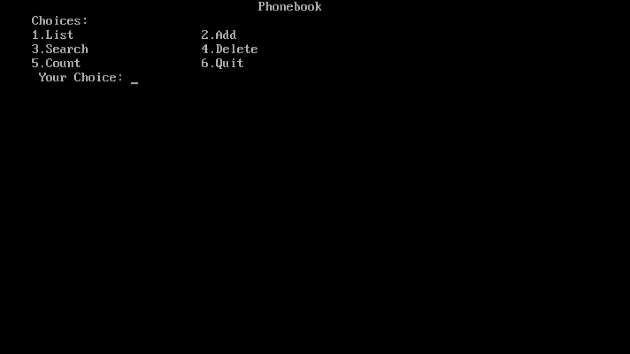

Snapshot of List:

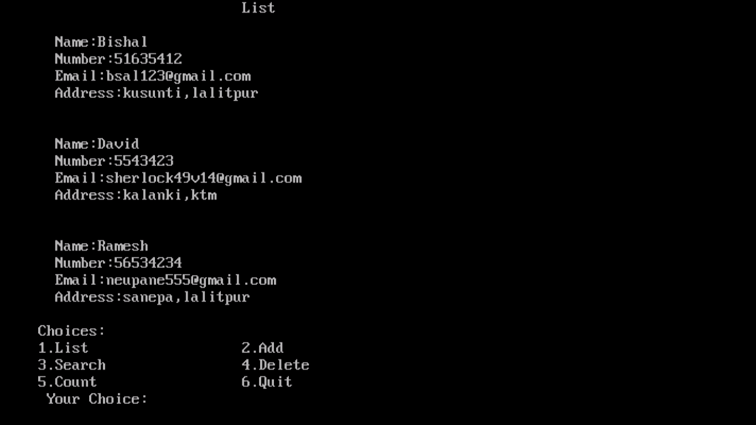

Snapshot of Add:

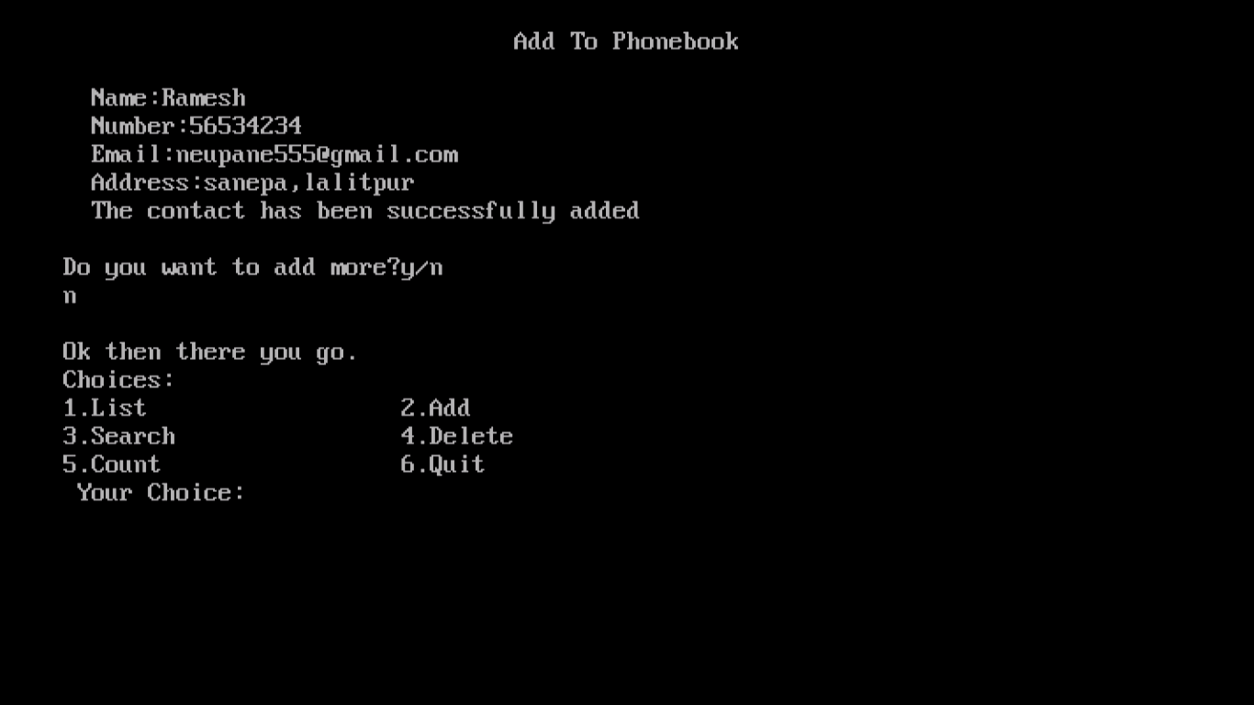

Snapshot of Search:

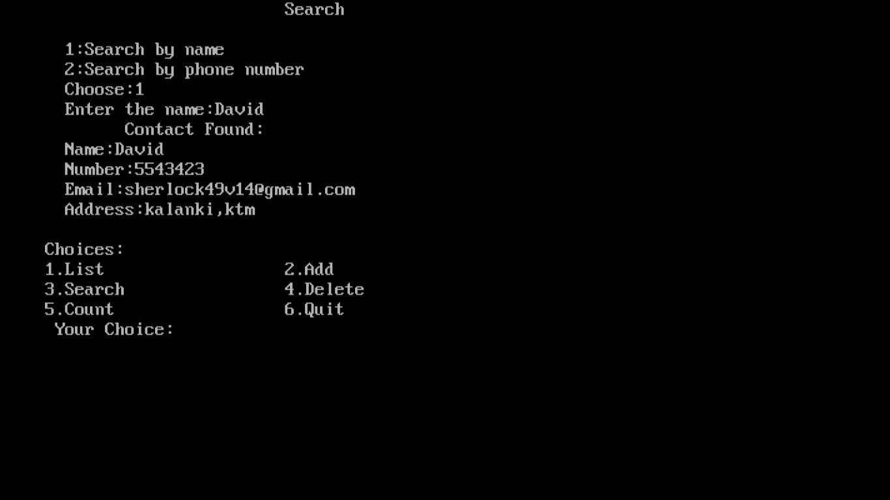

Snapshot of Delete:

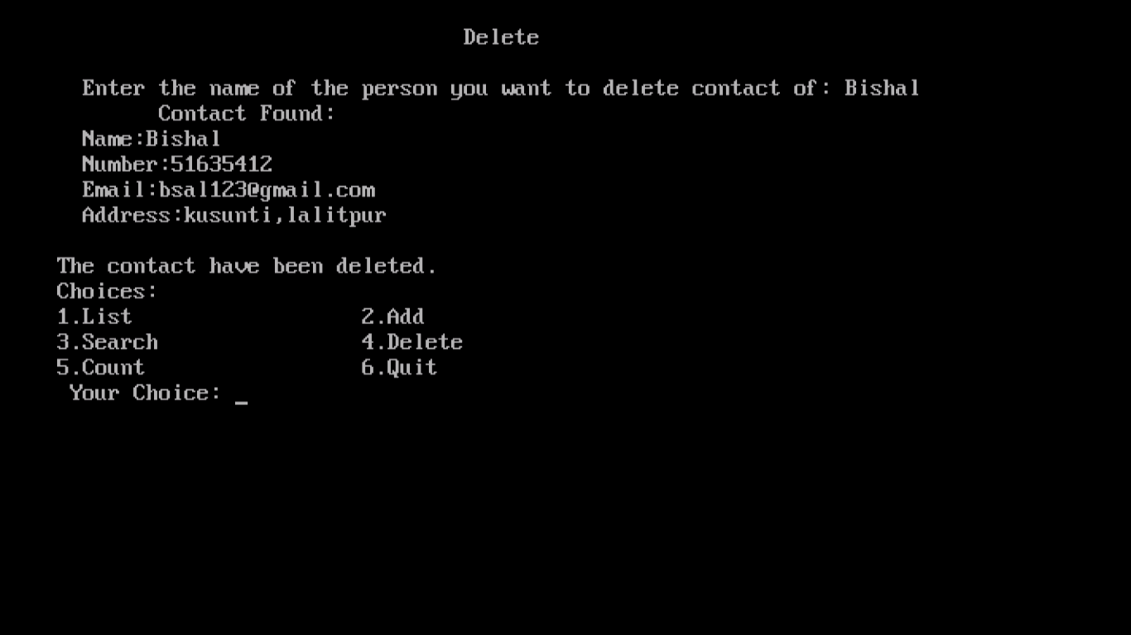

Snapshot of Count:

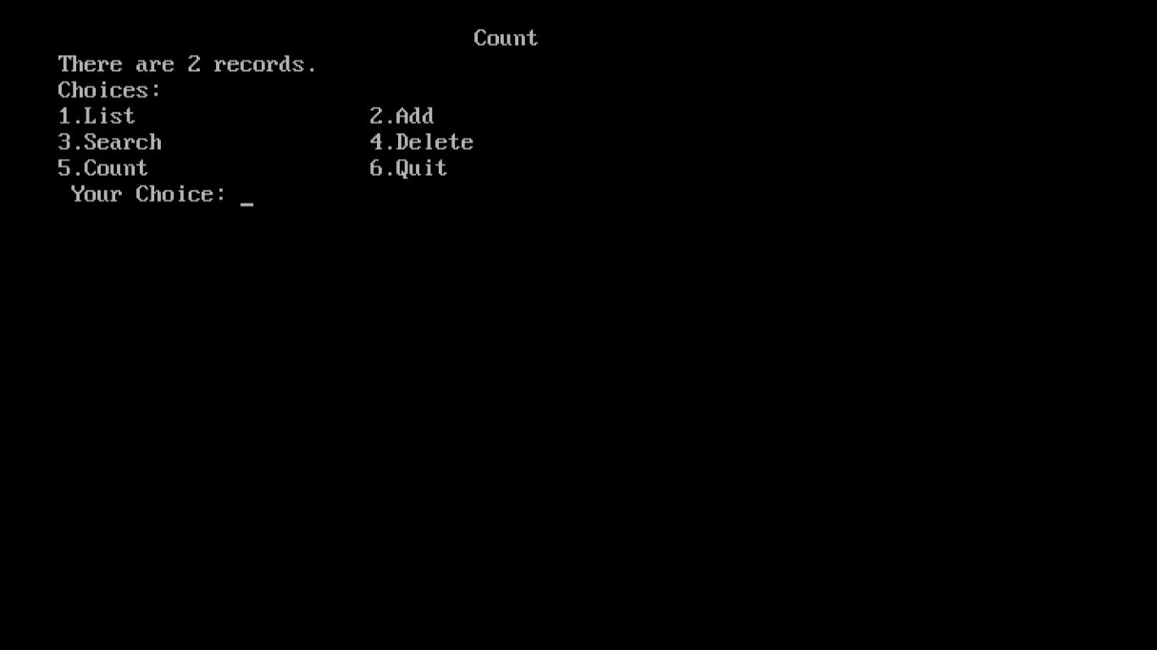

**LIMITATIONS**

The following are the Limitations for the project: -

* Printing not supported.
* Program might crash if invalid information is entered.
* No graphical User Interface.
* Online based application not supported.
* Lack of full security of data.
* Return of garbage value when excess of contact number tried to be add.
* Individual edit cannot be done in this program.

**CONCLUSION**

This project has been great opportunity for us to learn about C programming. It was a great time for us while making this project. We appreciate every individual that supported us.

Also, we have learnt much about handling programs which will help for our future profession and work. This basic teaching would help to work on our future and also for future more project that come during our studies.

With the use of this software the task of managing contact is made easy and efficient. The information of the contacts can be stored as long as the user wants. This is a lightweight software program so it is most likely run even in old computer devices.

**BIBLIOGRAPHY**

* E.Balagurusamy “Programming in ANSI C”, Tata McGraw-Hill Publishing.
* <https://www.tutorialspoint.com/cprogramming/>.
* [https://stackoverflow.com](https://stackoverflow.com/).
* CSIT coordinator Mrs. Ganga Subba