**LAB 2: COMPARE DIFFERENT PROPERTIES OF DIGITAL SIGNATURE ON DIFFERENT FILE FORMAT.**

**DIGITAL SIGNATURE:**

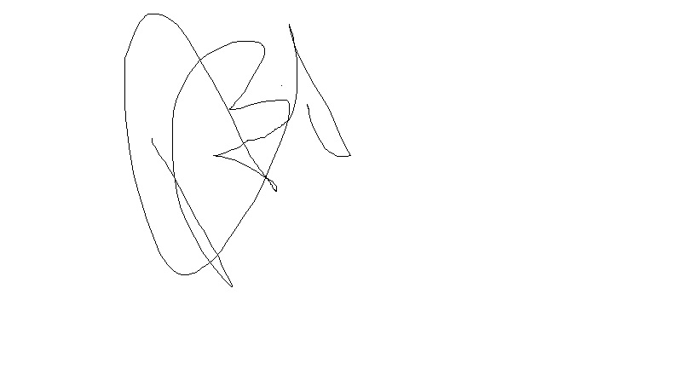

**PROPERTIES ON DIFFERENT FILE FORMAT:**

