**LAB 3: WRITE A PROGRAM TO IMPLEMENT RUN-LENGTH CODING.**

**SOURCE CODE:**

#include <bits/stdc++.h>

using namespace std;

int printRLE(string str)

{

int n = str.length(),count2=0;

for (int i = 0; i < n; i++)

{

int count = 1;

while (i < n - 1 && str[i] == str[i + 1]) {

count++;

i++;

}

cout << str[i]<< count;

count2=count2+2;

}

return count2;

}

return 0;

}

int main()

{

int a,i,p;

string str;

cout<<"Enter the string:";

cin>>str;

i=str.length();

cout<<"\nLength before compression:"<<i;

cout<<"\n\n";

a=printRLE(str);

cout<<"\n\nLength after compression:"<<a;

cout<<"\n";

**OUTPUT:**

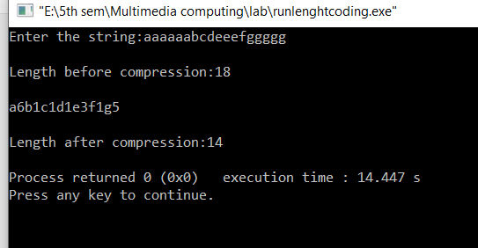

**Output:**