**Acknowledgment**

We would like to express our sincere and heartfelt gratitude and appreciation to all the individuals who helped us in successfully completing this project report on “Real Life Leadership & Team Management” within the limited time frame. We would like to thank our professor Dr. Savya Saachi sir, for giving us this golden opportunity to work on this wonderful assignment which taught us much more about the corporate industry and for his valuable guidance and support, his expertise and mentorship was greatly helpful in shaping our assignment & pushing us towards excellence. We would also like to thank our fellow group members for their hard work, dedication, and cooperation throughout this assignment. Each team member played a crucial role, bringing unique skills and perspectives, greatly enriching our work. We are also truly grateful for the collaboration, support, and resources provided by “Physics Wallah” who welcome us and let us observe and analyze their working environment to gain experience for our future growth & improvement. Thank you all for making this assignment a fulfilling and rewarding experience.

**Purpose**

The visit to **Physics Wallah** aimed to provide practical exposure to modern educational technologies, insights into ed-tech operations, and skill development in teaching methodologies, project management, and student engagement. The focus was on understanding how digital education platforms operate and deliver value to learners across India and beyond..

**Agenda**

The program included:

1. An introduction to Physics Wallah's core mission of providing affordable education to students preparing for JEE, NEET, and other competitive exams.
2. Practical sessions on online and hybrid learning models using the PW app and Pathshala centers.
3. Experience in interactive teaching tools, personalized learning, and data-driven strategies for student progress tracking.
4. Discussions with mentors and teachers about education quality, scalability, and leveraging technology to improve accessibility.

**Discussion**

We explored the following:

* **Innovative Learning Models**: Combining free resources like YouTube content with premium paid courses for enhanced learning.
* **Ed-Tech Challenges**: Strategies for overcoming market saturation and maintaining sustainable growth.
* **Engagement Strategies**: Techniques for personalized learning, including mock tests, quizzes, and one-on-one mentorship.
* **Technology in Education**: Leveraging AI-driven insights to refine teaching approaches and ensure high success rates for students.

**Key Takeaways**

1. **Inclusive Education**: Understanding Physics Wallah’s mission to offer high-quality education to students from diverse socio-economic backgrounds.
2. **Hands-On Experience**: Engaging with PW's platforms for live lectures, interactive quizzes, and academic resources.
3. **Teamwork and Problem-Solving**: Collaborating with peers and mentors to address student queries and improve the platform’s usability.
4. **Insight into Business Strategy**: Observing Physics Wallah’s unique blend of affordable education and financial growth, ensuring long-term sustainability.

**Behavior**

* Active listening during live and recorded sessions to improve content delivery.
* Clear and concise communication for responding to student queries.
* Adaptability to dynamic teaching requirements, both online and offline.
* Strategic thinking for curriculum development and resource management.

**Shaping the Future of Physics Wallah**

If I were a leader at Physics Wallah, my primary focus would be on driving innovation while preserving the company’s core mission of affordable, quality education. As an ed-tech leader, Physics Wallah has grown rapidly, but there is always room to refine processes, expand outreach, and enhance the overall learning experience. To ensure sustained growth and impact, I would focus on improving several key areas.

1. **Enhancing Teacher Training Programs**:  
   Focus on creating more structured and ongoing professional development for educators. Equip them with advanced teaching methodologies and training on innovative tools to make classes more interactive and effective. By emphasizing teacher upskilling, the platform can maintain a consistent quality of education across both online and offline channels.
2. **Improving Scalability and Accessibility**:  
   Work towards expanding Physics Wallah's reach to underserved regions by integrating more regional languages and leveraging partnerships with local organizations. This would ensure that quality education is accessible to students from all socio-economic backgrounds while maintaining the company’s affordability ethos.
3. **Strengthening Student Support Systems**:  
   Implement robust mechanisms for addressing student feedback and concerns. This includes introducing 24/7 support for academic and technical queries, and personal mentorship programs tailored to individual learning needs. Enhancing support services can significantly boost student satisfaction and success rates.
4. **Data-Driven Personalization**:  
   Use analytics to monitor student performance and engagement actively. Invest in AI-driven tools to provide personalized learning paths, helping students focus on their weaker areas. A strong emphasis on data-driven decision-making could improve learning outcomes while optimizing resource allocation​.

By focusing on these areas, I could ensure that Physics Wallah continues to grow as a leader in affordable, high-quality education, while addressing the challenges of scale, accessibility, and personalization.

**Conclusion**

The experience at Physics Wallah offered a deep dive into the operational and educational aspects of a fast-growing ed-tech company. It showcased the importance of balancing affordability, quality, and accessibility in education, equipping participants with skills to contribute to similar initiatives in the future.

**Soft Skills& Personality Development**

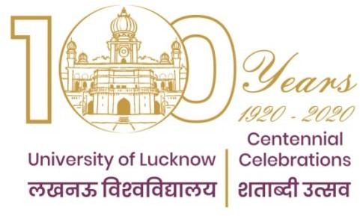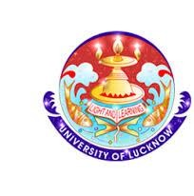

**Faculty of Engineering & Technology**

Bachelor Of Computer Application Session: 2024-27

NBCA-105

Assignment

Real Life Leadership & Team Management

**Submitted By: Submitted To:**

Amrit Utsav Dr. Savya Sacchi

Abhijeet Kumar (Assistant Professor)

Shikhar Srivastav Anurag Pandey

Vibha (Technical specialist)

**CERTIFICATE**

It is hereby certified that Amrit Utsav of Bachelor of Computer Application (B.C.A) has completed this assignment report on "Real Life Leadership & Team Management" in the subject of soft skills & Personality Development to the satisfaction of University of Lucknow.

The project was developed under the guidance of Dr. Savya Sacchi during the academic year (2024-27). The student demonstrated significant effort, attention to detail, and adherence to the assignment timeline, making this work suitable for evaluation.

This is also certified that this student has completed his assignment under the guidance of our company "*PhysicsWallah*" and having no objections regarding this assignment

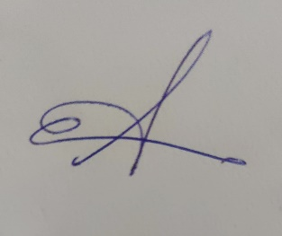

Anurag Pandey

Technical specialist

(IT service & operations)  
HCL Technologies

_____________  
  
Signature of Teacher