# **Dashboard:**

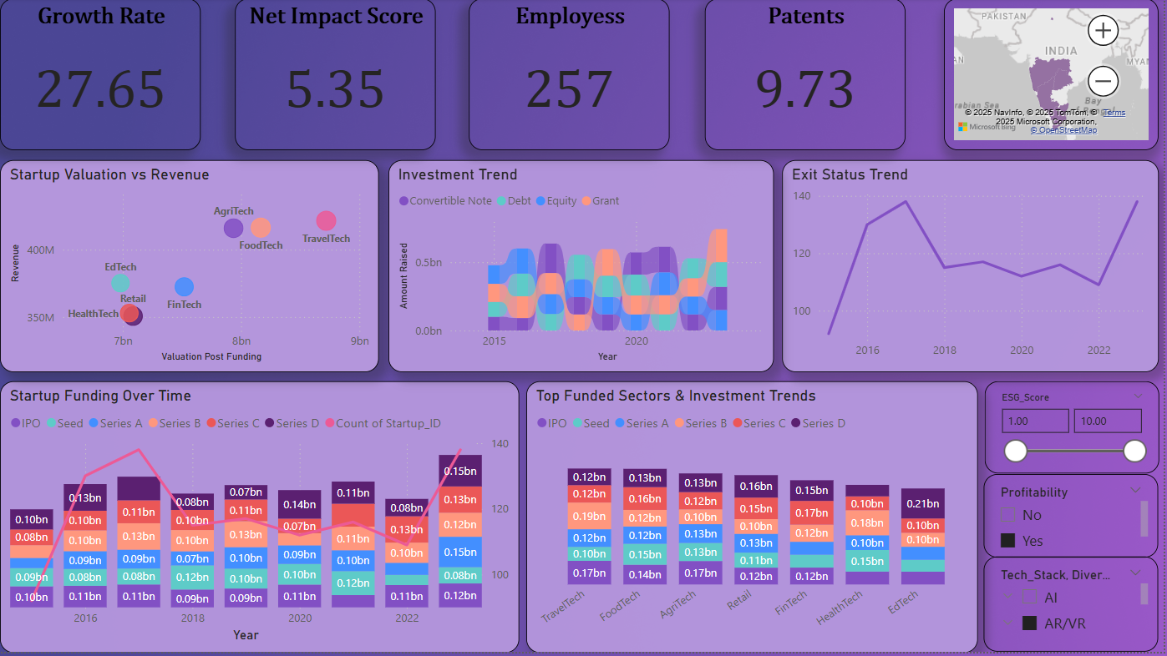

# **Problem Statements:**

1. How has total startup funding changed from **2016 to 2022**?
2. Which funding stage (**Seed, Series A, B, C, D, IPO**) received the most investment each year?
3. Which **sectors** received the highest funding amounts?
4. How do startup **valuations** compare to their **revenue** across different industries?
5. How has the **number of startup exits** changed from 2015 to 2023?
6. Which investment type (**Equity, Debt, Convertible Notes, Grants**) was most used in different years?
7. Which year saw the **highest amount** of total startup funding?
8. Which **Indian states** have the highest number of startups?
9. How did **funding distribution** across sectors change over time?
10. In which years did IPO funding remain **stable or fluctuate**?

# **Key Insights from Startup Funding Trends**

## 1. Startup Funding Over Time

* **Consistent Investment Across Stages**: From **2016 to 2018**, total funding across different stages (Seed, Series A, B, C, D, and IPO) remained steady at **$1.1B–$1.2B** annually, indicating a stable investment climate without significant fluctuations.
* **IPO Funding Stability**: The predictable funding levels for IPOs suggest a mature public market, with startups consistently securing capital upon going public.
* **Sustained Startup Activity**: The number of funded startups fluctuated with a high increase in 2020, reflecting a steady influx of new ventures.

**Key Takeaway**: The startup funding landscape during this period exhibited **stability and maturity**, with no extreme fluctuations, signaling balanced investor confidence.

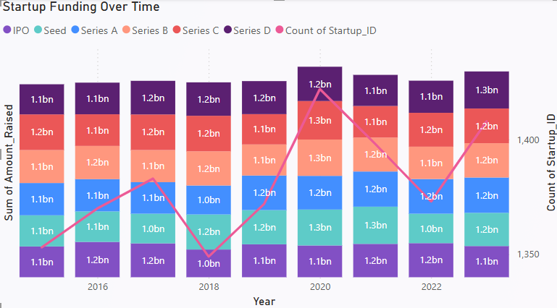

## 2. Sector-Wise Funding & Investment Trends

* **Significant Capital Inflows**: Investments ranged between **$1.5B–$1.9B**, with some sectors consistently attracting **$1.1B–$1.2B**, highlighting investor preference for specific industries.
* **Sectoral Focus**: Sectors like **fintech, traveltech and retail** dominated with **high-growth. Preference for Late-Stage Startups**: The largest funding rounds (e.g., **$1.5B, $1.6B**) were distributed across all stages, demonstrating a strong investor inclination toward startups with **proven scalability and lower risk profiles**.

**Key Takeaway**: Investors are prioritizing **high-growth sectors.**

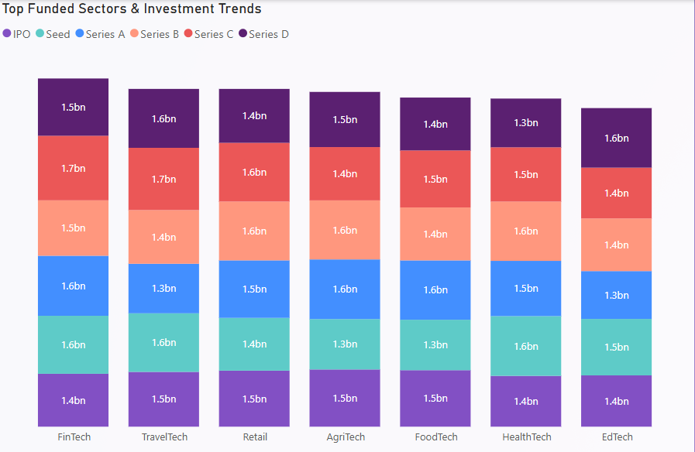

## 3. Startup Valuation vs. Revenue

* **Revenue Scale**: Startups in the dataset report significant revenues, ranging from **$4.35B–$4.7B**, positioning them as well-established businesses.
* **High Valuations**: Despite strong revenues, valuations post-funding are significantly higher (**$86B, $90B, $92B**), indicating investor confidence in **long-term scalability and market potential**.
* **Sector-Based Valuation Premiums**: Industries such as **EdTech ($86B) and AgriTech ($90B)** command lower valuations while FinTech and FoodTech command high valuations, reinforcing investor confidence in **technology-driven business models**.

**Key Takeaway**: The **disparity between revenue and valuation** suggests that investors are **betting on future growth and market disruption**, rather than immediate profitability.

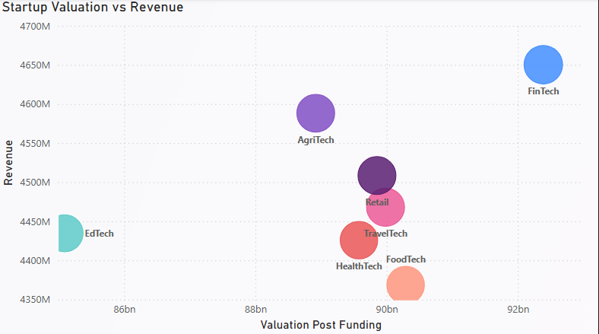

## 4. Exit Status Trends

* **Tracking Exit Trend**: Data from **2015 to 2023** highlights exit patterns, which are critical indicators of ecosystem maturity.
* **Trends**: Exit trends reveal:
  + A fluctuating increase of exit throughout the years.
  + In years like 2017 and 2020 there was a major boost in exit.
  + Periodic slowdowns in exits, possibly influenced by market conditions.

**Key Takeaway**: A fluctuating ecosystem of exit throughout startups across India.

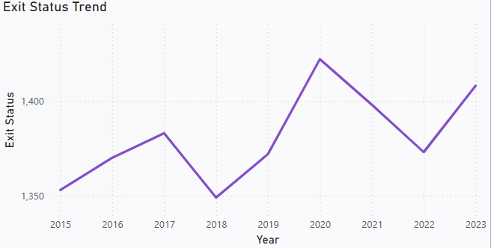

## 5. Investment Trends (2016–2022)

### **Balanced Funding Mix:** Investments are distributed across **Equity, Debt, Convertible Notes, and Grants**, reflecting a mature startup ecosystem.

### **Equity and Debt as Key Drivers:** Equity remains a preferred choice for long-term growth, while debt financing is strategically used for scalability without ownership dilution.

### **Convertible Notes for Flexibility:** Early-stage startups leverage **convertible notes** to raise capital while deferring valuation discussions.

### **Stable Investment Levels with 2022 Peak:** Annual funding fluctuated between **$1.6B and $2.1B**, with a notable peak in 2022, likely due to post-pandemic recovery and investor confidence.

### **Key Takeaway:** The diversified investment landscape supports **sustainable startup growth**. The 2022 surge highlights market optimism and expanding funding opportunities.

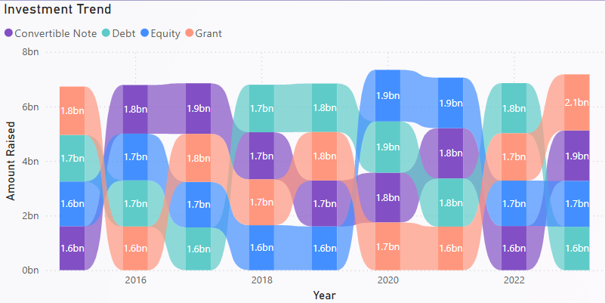

## 6. Startup Distribution Across Indian States

* **Key Startup Hubs Identified:** The map highlights startup activity in **Maharashtra, Karnataka, Tamil Nadu, and Delhi**.
* **Concentration in Economic Centers:** These states are known for **major business hubs** like Mumbai, Bengaluru, Chennai, and Delhi, which provide **strong infrastructure and investor networks**.
* **Southern and Western Dominance:** The startup ecosystem is primarily concentrated in the **western and southern regions**, indicating **regional economic strengths**.
* **Limited Presence in Other Regions:** No visible startup activity in **eastern and northern states**, suggesting **potential gaps or emerging markets**.

### **Key Takeaway:**

* **Maharashtra, Karnataka, Tamil Nadu, and Delhi** are key startup destinations.
* The **absence of startups in other states** highlights **opportunities for expansion into underrepresented regions**.

### 

# **Strategic Insights & Recommendations**

### **1. Investor Priorities**

* Investors are favoring **high-growth, technology-driven sectors** such as **EdTech and AgriTech**.
* Late-stage startups with **proven scalability** are receiving the majority of funding.
* Valuations are **driven by growth potential**, rather than current revenue performance.

### **2. Competitive Early-Stage Funding**

* While the funding landscape remains stable, early-stage startups face **greater challenges in securing investments**.
* Startups must emphasize **market disruption, scalability, and innovation** to attract investors.

### **3. Importance of Exit Trends**

* A healthy **IPO and acquisition environment** is critical for maintaining a strong startup ecosystem.
* Investors and policymakers should track **exit activity** to assess long-term investment viability.

### **4. 2022: A High-Growth Year**

* The surge in funding in **2022** indicates a **post-pandemic resurgence**, with heightened investor confidence in **emerging technologies and market expansion**.

# Actionable Recommendations

### **For Investors**

✔ Prioritize **high-growth sectors and late-stage startups** for risk-mitigated, high-return opportunities.  
✔ Diversify portfolios by selectively investing in **early-stage startups with strong innovation potential**.

### **For Startups**

✔ Emphasize **scalability, disruptive potential, and technological innovation** to secure funding.  
✔ Consider **convertible notes or grants** as alternative early-stage funding mechanisms.

### **For Policymakers & Industry Leaders**

✔ Support early-stage funding by introducing **grants and incentives**, particularly in **technology-driven sectors**.  
✔ Strengthen **capital markets** to facilitate **smooth exit strategies**, ensuring long-term investor participation.