Week 3 Progress Summary
MIT ACT — Crennotech Group Project (Smart Document Scan AI) · 3–9 August 2026

1. Jira — What We Did
Task | Status
Elicit data-extraction requirements | Done
Define confidence-scoring rules (individual task) | Done
Functional & non-functional requirements | Done
Validate requirements against CleanTasker fit | Done
All 4 Week 3 tasks moved to Done by Sunday 9 August.

2. Team
Team member | Role
Amrit Dahal | Project Manager
Madhab Poudel | Business Analyst
Subham Giri | Technical Lead
Sujit Budhathoki | Team Member (confidence-scoring rules, this week's individual task)

3. Data-Extraction Field List
Fields the system needs to pull out of every SOW document:
- Client name & site address
- Building type
- Areas (lobby, kitchen, restrooms, etc.)
- Cleaning tasks & frequencies
- Periodic services
- Consumables
- Compliance notes & site settings

4. Functional & Non-Functional Requirements

Import formats supported
PDF, Word, Excel, email, and image-based/scanned PDF (via OCR).

Key functional requirements
- Extract all fields from the Data-Extraction Field List
- Show a confidence score for each extracted field
- Let staff review, edit and approve data before saving

Key non-functional requirements
- Fast turnaround (minutes, not hours) per document
- Usable by non-technical CleanTasker staff

5. Confidence-Scoring Rules
Level | Meaning
High (90%+) | Clear match — quick check only
Medium (60–89%) | Unusual format/wording — review before saving
Low (below 60%) | Guessed/missing/poor scan — must be corrected manually

Rules checked against how CleanTasker already flags fields needing review — no separate review process needed.

6. GitHub — What We Did
Date | Action | Folder / Tag | What was pushed
5 Aug | Push | /requirements | Data-Extraction Field List
7 Aug | Push | /requirements | Functional & Non-Functional Requirements doc
8 Aug | Push | /requirements | Confidence-Scoring Rules (individual evidence — Sujit); requirements validated against CleanTasker fit
9 Aug | Tag | v0.3-week3 | Final push for the week; tag release; repo commit-history screenshot

Jira board screenshot

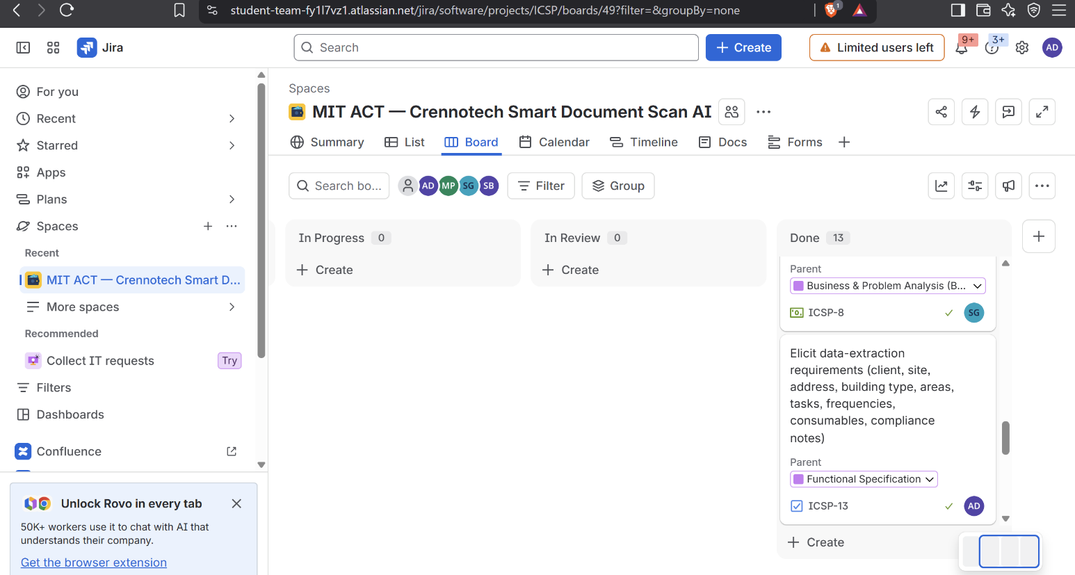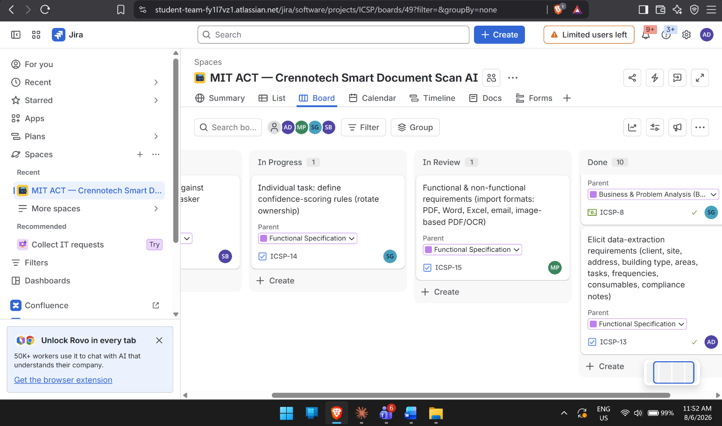

GitHub commit history screenshot (v0.3-week3)

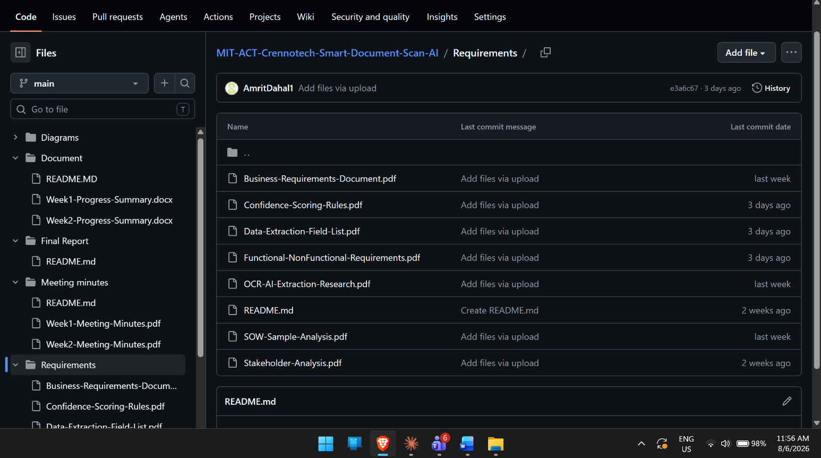

7. Meeting Minutes Summary
- Mon 3 Aug: agreed field list & requirements approach; assigned confidence-scoring task to Sujit.
- Thu 6 Aug: reviewed functional/non-functional requirements draft; discussed import formats.
- Fri/Sat: validated requirements against CleanTasker fit before pushing final versions.

