Week 4 Progress Summary
MIT ACT — Crennotech Group Project: SiteChat · 10–16 August 2026

1. Jira — What We Did
Task | Status
Design overall SiteChat architecture | Done
Design Firestore collection structure & security rules (individual task) | Done
Design real-time messaging & notification workflow (sequence diagrams) | Done
Peer review architecture & Firestore design draft | Done
All 4 Week 4 tasks moved to Done by Sunday 16 August.

2. Team
Team member | Role
Amrit Dahal | Project Manager
Madhab Poudel | Business Analyst (Firestore design & security rules, this week's individual task)
Subham Giri | Technical Lead
Sujit Budhathoki | Team Member

3. SiteChat Architecture
Main components: React web app, Flutter mobile app, Firebase (Firestore, Cloud Functions, Cloud Messaging, Storage), and existing CleanTasker REST APIs / Azure-hosted backend.
- React & Flutter apps sign in using CleanTasker's existing authentication
- Firestore stores chat rooms, messages and Site membership
- Cloud Functions post automatic system messages from CleanTasker events
- Cloud Messaging sends push notifications for messages, mentions and job/inspection updates

4. Messaging & Notification Flows
- Send/receive message: written to Firestore → synced live to other users → push notification if app is closed
- Mention notification: detected on message save → targeted push sent to the mentioned user
- CleanTasker system message: event occurs in CleanTasker → Cloud Function posts a tagged system message into the Site's chat

5. Firestore Collections & Security Rules
Collection | Purpose
sites | One document per CleanTasker Site
sites/{siteId}/messages | Messages for that Site's chat room
sites/{siteId}/members | Who can access this Site's chat
users | Basic profile info & push notification tokens

Key rule: a user can only read/write a Site's messages if listed in that Site's members — checked on every request, not just at login, to keep different companies' data separated.

6. Security Risks Identified
Risk | Mitigation
Misconfigured rules expose one company's chats to another | Rules checked against Site membership; peer-reviewed
User impersonates a system message | Only Cloud Functions can post type: system messages
Unsafe/oversized attachment uploads | File-type & size checks in Storage rules

7. GitHub — What We Did
Date | Action | Folder / Tag | What was pushed
12 Aug | Push | /diagrams | SiteChat Architecture
14 Aug | Push | /diagrams | Sequence Diagrams (messaging, mentions, system messages)
15 Aug | Push | /requirements | Firestore Collection Structure & Security Rules (individual evidence — Madhab)
15 Aug | Push | /risk | Security Risk Notes
16 Aug | Tag | v0.4-week4-sitechat | Final push for the week; tag release; repo commit-history screenshot

Jira board screenshot

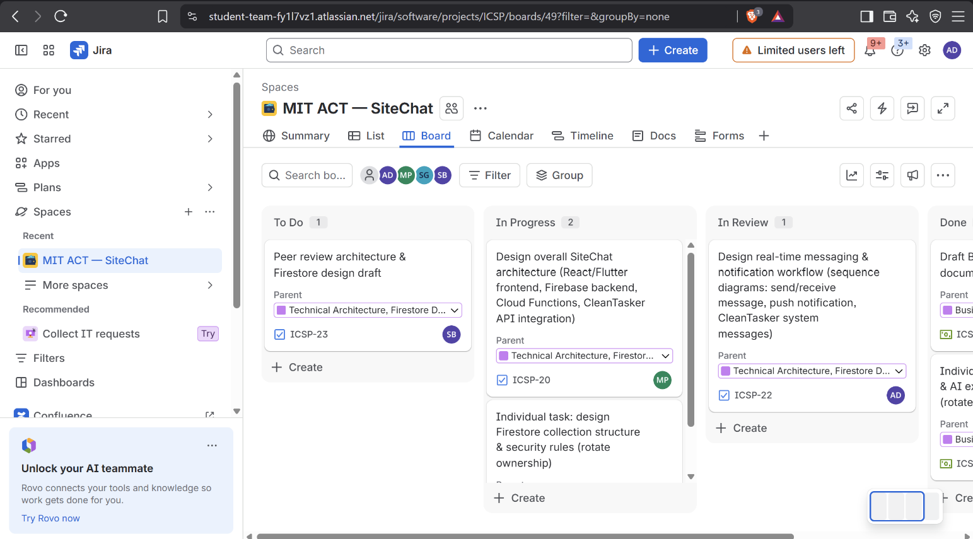

GitHub commit history screenshot (v0.4-week4-sitechat)
