Week 2 Progress Summary
MIT ACT — Crennotech Group Project (Smart Document Scan AI) · 27 July – 2 August 2026

1. Jira — What We Did
Task | Status
Analyse real-world SOW samples & document structures | Done
Identify common/inconsistent SOW layouts & terminology | Done
Research OCR & AI extraction technologies (individual task) | Done
Draft Business Requirements document | Done
All 4 Week 2 tasks moved to Done by Sunday 2 August.

2. Team
Team member | Role
Amrit Dahal | Project Manager
Madhab Poudel | Business Analyst
Subham Giri | Technical Lead
Sujit Budhathoki | Team Member

3. SOW Sample Analysis
Looked at real SOW documents to see how they're laid out and what fields they usually contain.
Format | How common
PDF (text-based) | Most common
Word (.docx) | Common
Excel (.xlsx) | Common for task lists
Scanned / image PDF | Occasional — needs OCR

Key inconsistency: formats and terminology differ between customers (e.g. "daily" vs "5x/week"; "periodic services" vs "deep clean").

4. OCR & AI Extraction Research
Tool | Good for
Tesseract OCR | Scanned/image PDFs (free)
Google Document AI / AWS Textract / Azure Form Recognizer | Cloud OCR + structured field extraction
GPT-based extraction | Handling messy or inconsistent wording

Early direction: use OCR first to get plain text, then an AI step to map it onto our standard fields, with a confidence score per field.

5. Business Requirements (draft)
- Accept SOW documents in PDF, Word, Excel, scanned and email form
- Pull out client, site, address, building type, areas, tasks, frequencies, consumables and compliance notes
- Handle different wording/layouts between customers
- Show a confidence level for each extracted field
- Let staff review and correct extracted data before saving

6. GitHub — What We Did
All 3 documents (SOW Sample Analysis, OCR & AI Research, Business Requirements) pushed to the Requirements folder. Week 2 meeting minutes pushed to the Meeting minutes folder.

Jira board screenshot

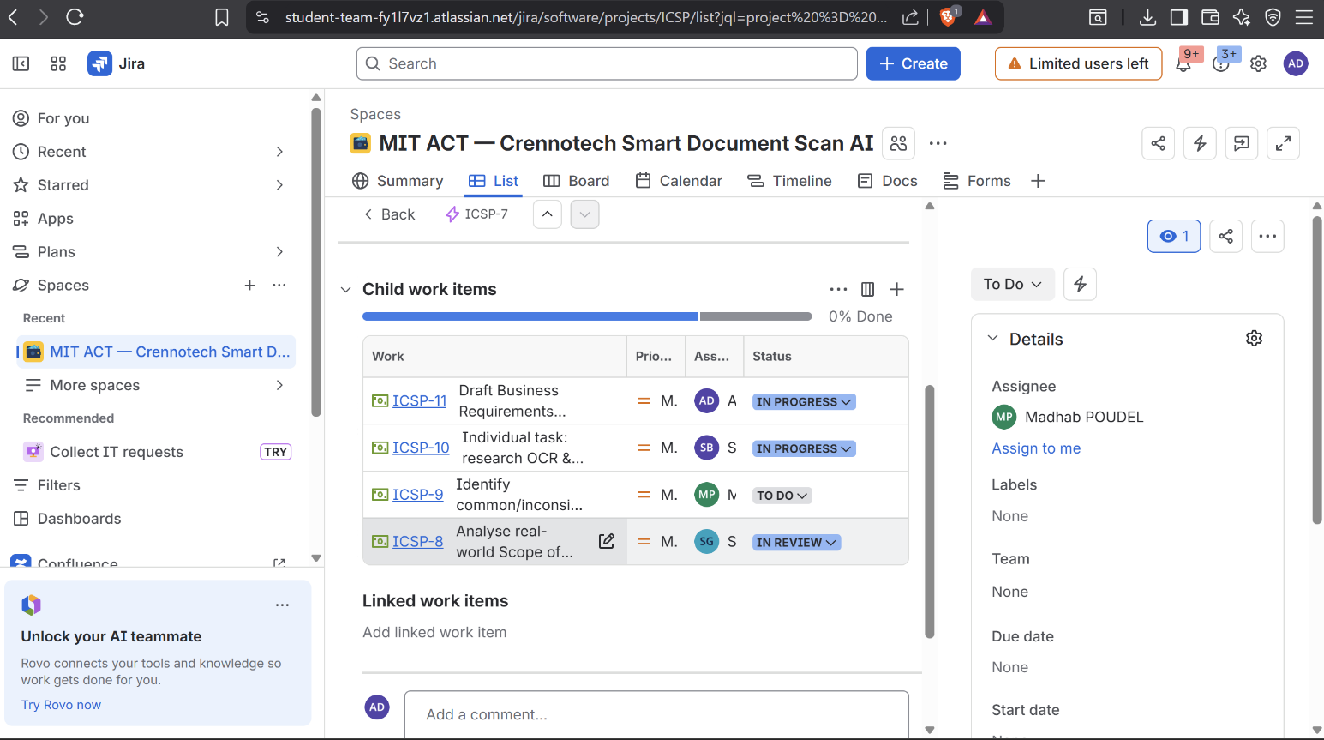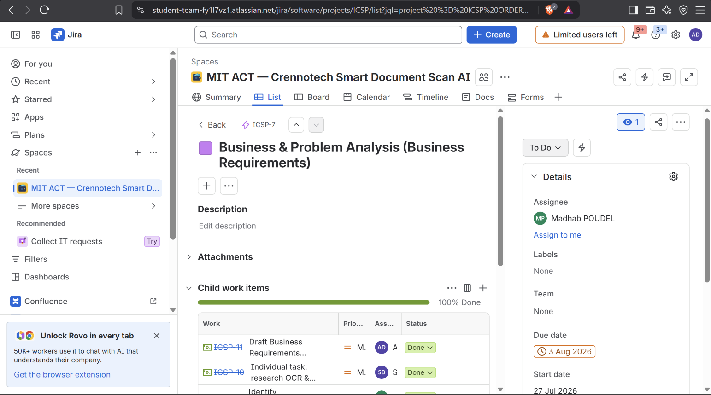

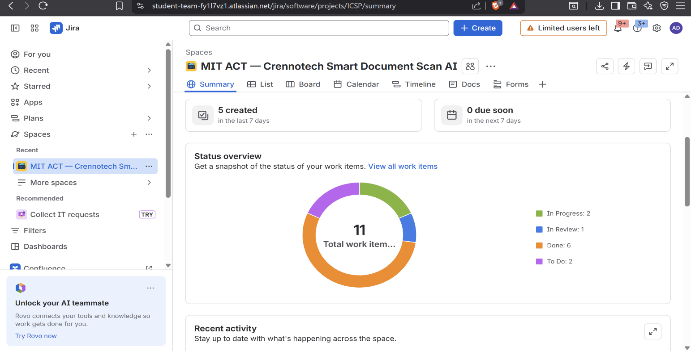

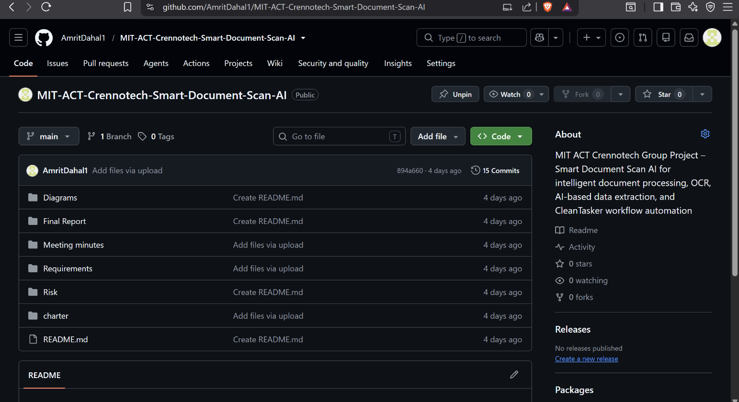
GitHub commit history screenshot

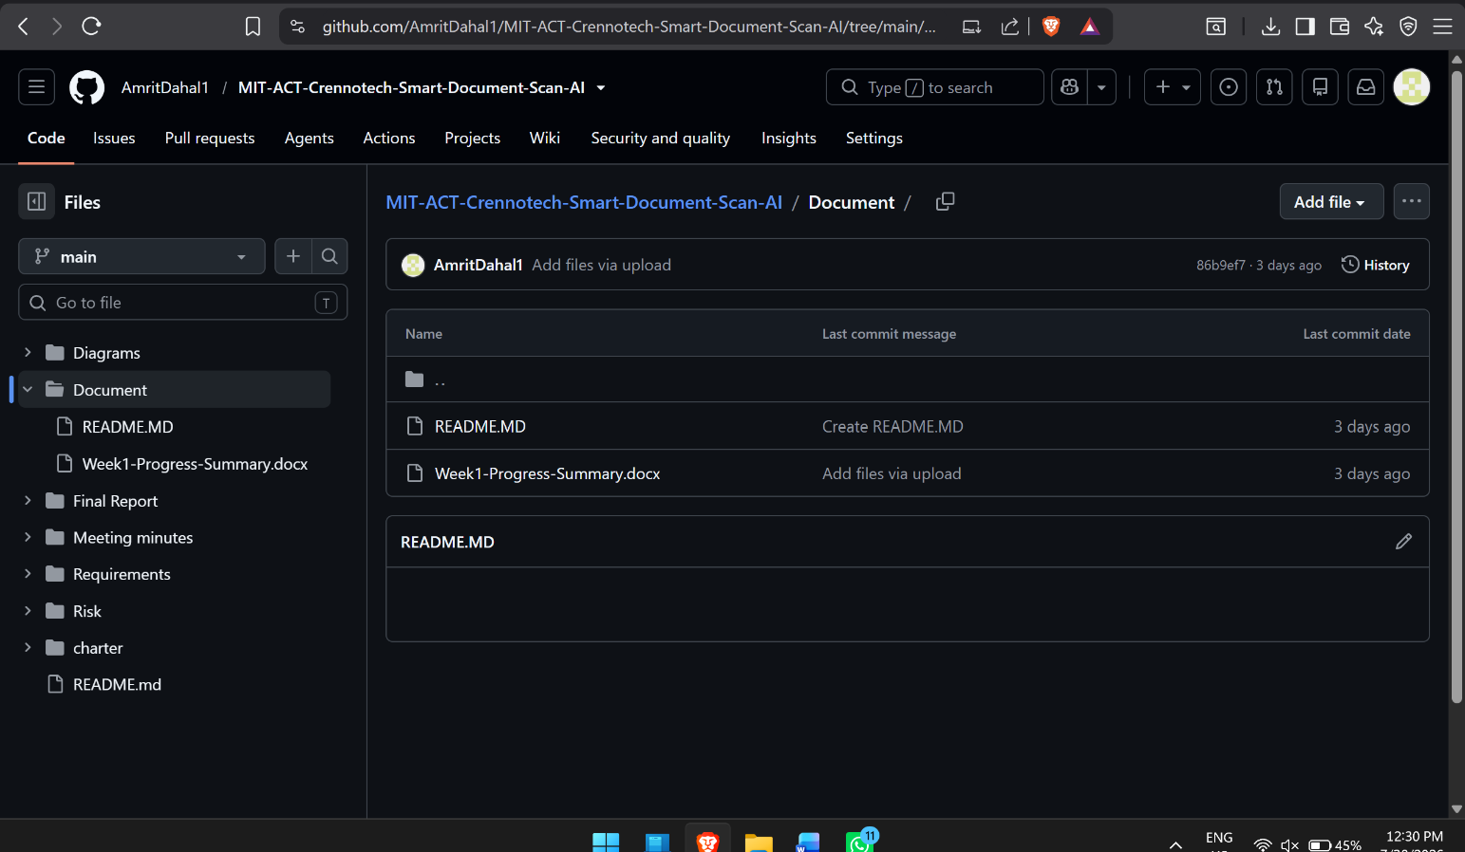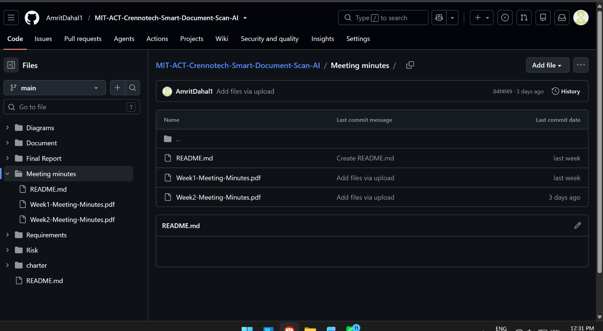

7. Meeting Minutes Summary
- Mon 27 Jul: split up Week 2 work between Madhab, Subham and Amrit; reviewed sample SOWs together.
- Thu 30 Jul: reviewed SOW analysis and OCR/AI research; drafted Business Requirements document together.

